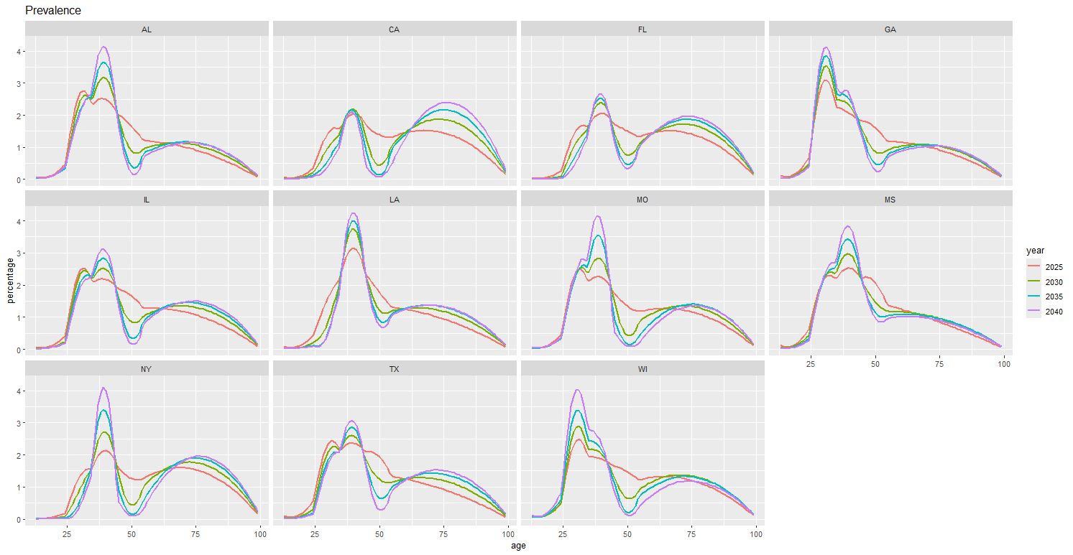

Prevalence as a distribution across age for four different years. The y axis is in percentage of total, so only relative magnitudes matter. The curves come from “restratify.age.counts” on our 5 age categories. The particular shape of the curves and how they always get pinched around 50 seem like artifacts of the restratification algorithm, so I wonder how useful these are.

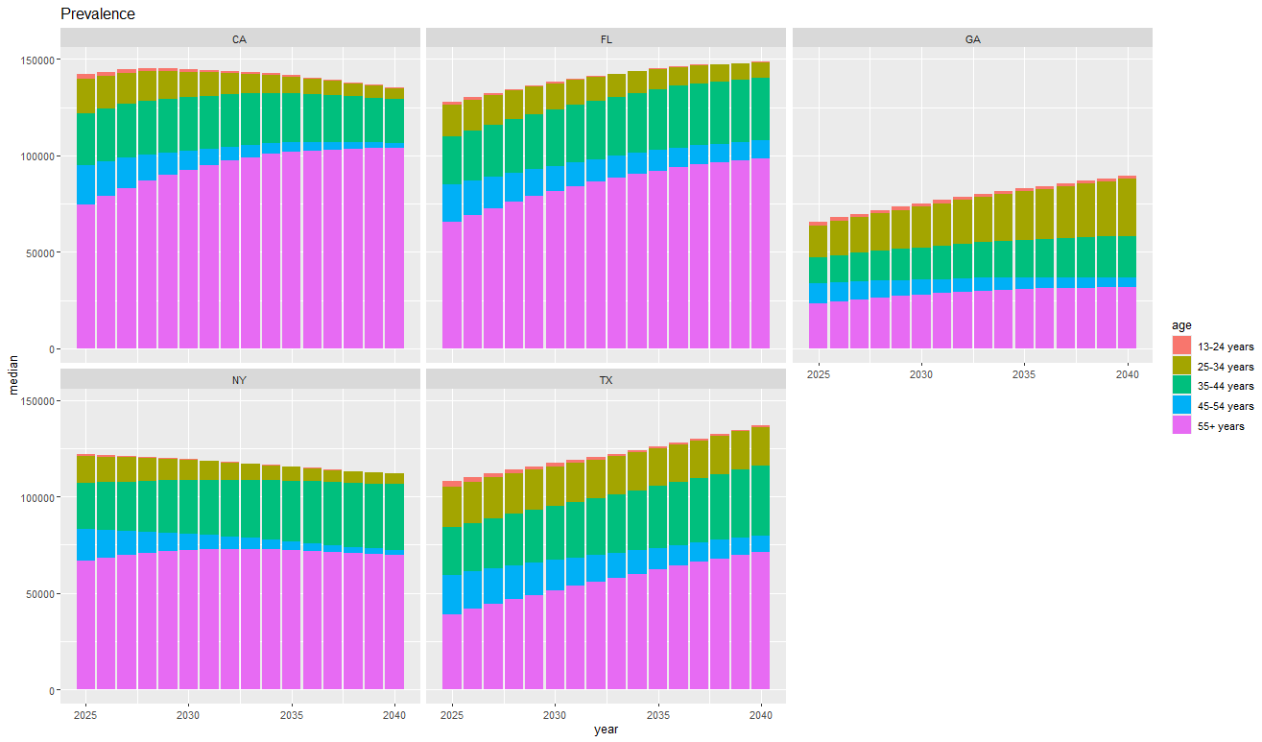

Prevalence per year, stratified by age group, for the big states. We can combine this with the one for the small states if we have separate y axes.

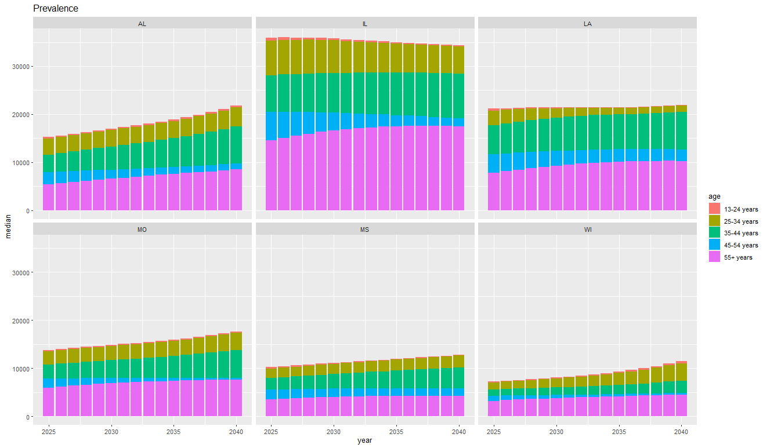

Prevalence for the small states.

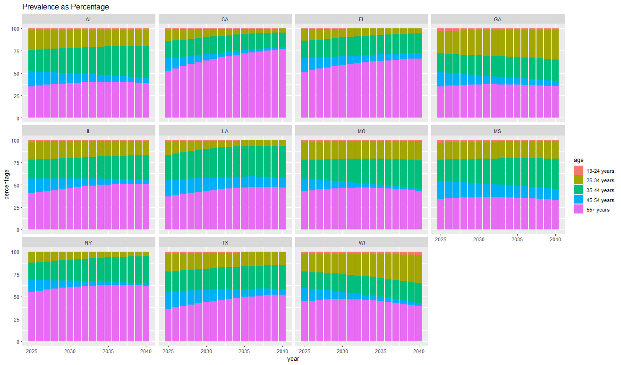

Prevalence as percentage of total by age group. On all these stacked area plots, we can switch the ages to have oldest on top.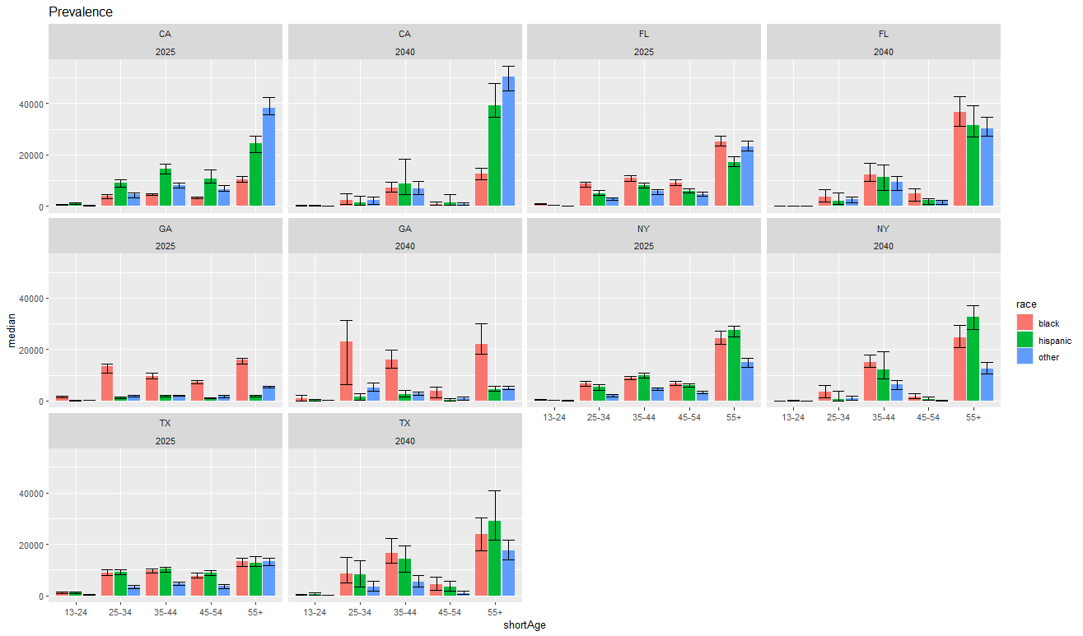

Prevalence by age and race in 2025 and 2040, for the big states.