SHIELD components
The specification file provides the blueprint for the core model. definition of compartments and all the transitions in the model. The figure shows how it connects to other scripts required for running an engine test.
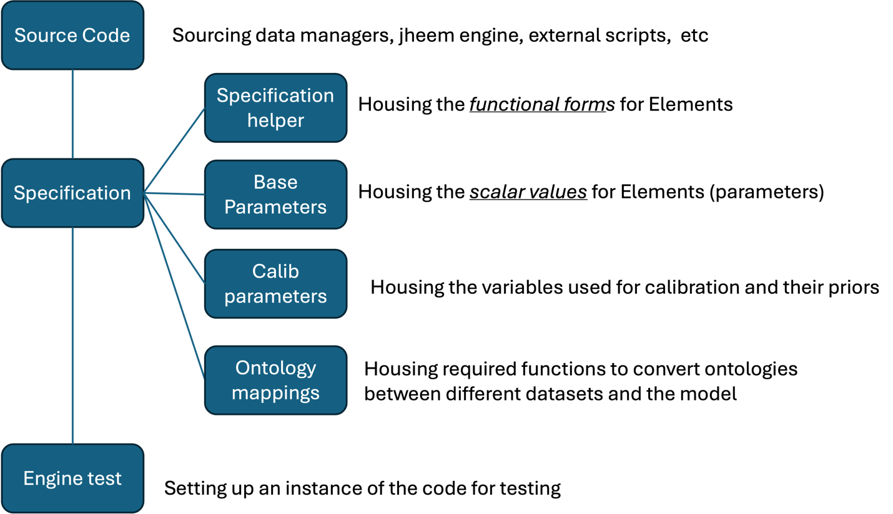
Fig: High-level review of the SHIELD engine and scripts

The specification file is organized as follow:

Initial setup:
SHIELD.SPECIFICATION: defining the blueprint of compartments and various strata (age, race, sex, etc).
- The model represents the U.S. population through three distinct sex and sexual behavior categories: heterosexual_male(males engaging in heterosexual sex), msm (men who have sex with men), and female (females, which may include both heterosexual and bisexual behaviors). These categories are further divided by race and ethnicity into three groups: Black, Hispanic, and Other, allowing for the analysis of differences in risk behaviors and infection transmission dynamics by demographic factors. The population is also subdivided into 11 age groups: 0-15 years, 16-20 years, 21-25 years, 26-30 years, 31-35 years, 36-40 years, 41-45 years, 46-50 years, 51-55 years, 56-65 years, and 65+ years. These age categories enable the model to track changes in risk and disease progression over the course of an individual's life.
- The population is further categorized into two main groups: infected and uninfected. The infected group is divided into two primary categories: the continuum of infection, which includes individuals who are either undiagnosed or diagnosed but untreated, and the disease stages, which represent the progression of infection through different phases: ps (primary or early stage), el (early latent stage), ll (late latent stage), and ter (terminal or advanced stage). This distinction allows for the modeling of the progression of infection from undiagnosed to untreated to advanced stages of disease.
- For the uninfected population, the model defines two key states: susceptible, representing individuals who are at risk of infection but have not yet been diagnosed, and diagnosed.treated, representing individuals who are diagnosed and receiving treatment for conditions related to HIV/STI. This helps differentiate between at-risk individuals and those who are under care, capturing both the uninfected and treated segments of the population.
- The model starts in 1940 and projects the population through to 2040, providing a dynamic view of infection dynamics, treatment, and transmission risks across time. This time span allows the model to simulate long-term trends and shifts in the population’s health status, helping to understand the impact of historical and future interventions on public health.
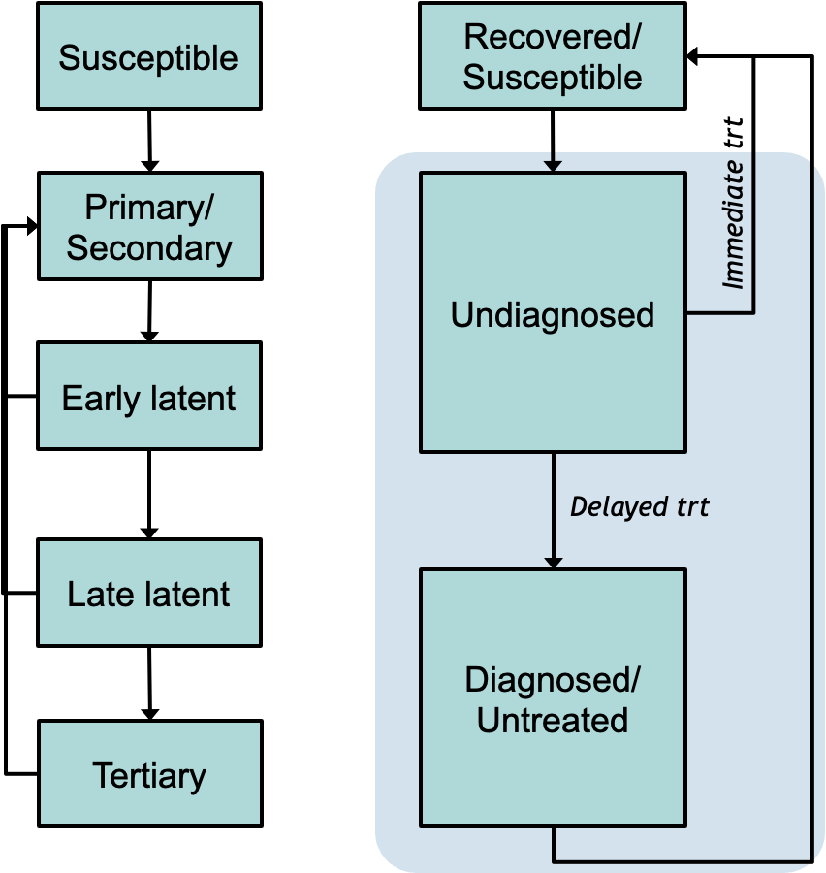

Simulation modules
The specification file includes several modules that define the composition of the initial population, as well as the various transitions that occur over time. These transitions are crucial for modeling the dynamics of the population and the spread of syphilis, with each module describing a different aspect of the population's health, behavior, and demographic changes.
- Initial Population Composition: The initial population composition is defined based on demographic characteristics such as age, sex, race/ethnicity, and sexual behavior. This underlying population is informed by U.S. census data, with full demographic composition only available from 2010 onward. As such, we assume a fixed population size and composition up to the year 2010. Capturing earlier periods prior to 2010 helps us reflect the syphilis epidemiology more closely, while after 2010, we allow for the natural evolution of population size and composition.
- Births and Deaths: The model captures demographic transitions related to births and deaths, which are key factors in shaping the population's size and structure over time. Births are modeled based on fertility rates, while deaths occur due to a combination of natural causes and disease progression. Deaths in the infected population, particularly those in the late latent and terminal stages of syphilis, are critical for modeling disease outcomes. These transitions ensure that the model reflects the reality of population turnover, with individuals entering and exiting the population through both natural processes and disease-related mortality.
- Differential Aging Rates: These rates are included in the model to reflect how the population ages at different rates across various demographic groups. Aging is modeled as a gradual process, where individuals transition between age categories over time. The rate of aging may vary by race or health status. This factor is crucial for capturing the evolution of the population's composition over time
- Sexual Transmission: One of the primary transitions modeled is sexual transmission, which describes how syphilis and other STIs are transmitted between individuals. This includes transitions between the uninfected and infected states (e.g. from susceptible to undiagnosed or diagnosed.untreated, and vice versa). Sexual transmission is influenced by behavior (e.g., whether individuals engage in heterosexual or MSM sexual activities) and demographic factors, including age and race/ethnicity. This dynamic allows the model to capture how infection spreads through the population over time, particularly within different sexual networks and risk groups.
- Syphilis Continuum of Care: The syphilis continuum of care defines the transitions that individuals with syphilis undergo as they progress through the stages of infection and treatment. This includes transitions from undiagnosed to diagnosed, from diagnosed to treated, and from untreated individuals progressing through various disease stages, including primary/early, early latent, late latent, and terminal. The model tracks these transitions to simulate the impact of treatment and diagnosis on the course of the disease, as well as the overall burden of syphilis in the population. This structure is critical for assessing how interventions at different points in the continuum—such as testing, treatment initiation, and follow-up—can affect disease outcomes and reduce transmission.
Together, these transitions provide a dynamic framework for modeling the spread of syphilis and other STIs in the population, as well as the health outcomes of different demographic groups. By capturing sexual transmission, births, deaths, aging, and the continuum of care, the model simulates the long-term effects of public health interventions and demographic changes. This helps in offering insights into how to reduce syphilis prevalence and improve population health outcomes over time

Parameters
The specification file includes instructions for describing transitions between different compartments in the model, which are often represented by rates. In the simplest case, the rate of an event is fixed over time and informed by literature. However, in more advanced scenarios, the rate can be dynamic: changing over time and differentiated by factors such as age, sex, race, or other variables (i.e., it has a functional form). This allows the model to capture more complex behaviors and interactions within the population.
JHEEM uses a distinct construct for defining parameters in the model:
- Elements: These are scalar values or functional forms. They represent the basic building blocks of the model and can be constants or dynamic functions that describe various processes (e.g., infection rates, mortality rates). Elements can be used directly or combined to define more complex quantities.
- Quantities: These are more complex constructs that can represent combinations of elements and other quantities. A quantity can be equivalent to another quantity or an element, or it can be an expression or function of other quantities. Quantities are used to inform the model's compartments and the transitions between them, allowing the model to capture relationships between different variables in a more nuanced way.
Together, elements and quantities provide a flexible framework for modeling the dynamic relationships between different factors, enabling the specification of rates, transitions, and compartments that reflect real-world epidemiological processes.

Outputs
There are two primary methods to capture outputs in the model: Compartment Outputs and Transition Outputs. These methods allow for tracking different aspects of the model's dynamics and assessing the impact of various processes on the population.
- Compartment Outputs: Compartment outputs refer to the frequency values of specific compartments, such as the population size in each compartment. These outputs can be captured in different ways depending on the desired level of detail:
  - track.point.outcome(): This method captures a static outcome at a specific moment in time. For example, it could be used to track the number of individuals in a specific compartment at the start or end of a year (Jan 1st). This provides a snapshot of the population at a given point.
  - track.integrated.outcome(): This method integrates the point estimates over a specific time period, such as a year (Jan 1st to Dec 31st). It is more useful for calibration as it accounts for the average values across the entire timeframe rather than just a single moment. This method is preferred when looking for a more comprehensive measure of a compartment's population size or other attributes across time.
track.point.outcome(…, name='point.population', …)
track.integrated.outcome(…, name='population',
value.to.integrate = 'point.population',….)

- Transition Outputs: Transition outputs capture the movement or event rates between compartments, representing the dynamics of individuals moving from one state to another (e.g., from susceptible to infected, or from diagnosed to treated). These outputs provide insight into how the population is changing over time due to various events and processes.
  - track.transition(): This method captures dynamic outcomes, indicating the movement of individuals between specific starting and ending compartments. It provides information on the flow between compartments, such as how many individuals transition from an undiagnosed to a diagnosed state over a specific period.
  - track.dynamic.outcome(): This method captures outcomes that account for individuals entering the model without specifying a starting or ending compartment. It is useful for tracking events that involve the population entering the model (e.g., through birth or migration) or when individuals do not fit neatly into defined starting or ending states.
  - track.cumulative.outcome(): This method sums multiple dynamic outcomes over time, providing an overall measure of the cumulative effect of transitions across different compartments. It is particularly useful for capturing the total impact of specific processes or events, such as the total number of individuals who have been diagnosed with syphilis over a set period.
track.dynamic.outcome(SHIELD.SPECIFICATION,
name='births.from',…)
track.cumulative.outcome(SHIELD.SPECIFICATION,
name='fertility.rate',
value=expression(births.from/population),….)
For dynamic transitions that change over time (e.g., testing), the anchor points are coded at the beginning of the year (e.g., if transmission changes from 2000 to 2020, these dates represent jan 1st of those years)
By using these output tracking methods, the model can provide valuable insights into both the state of the population at different times (compartment outputs) and the dynamics of transitions between compartments (transition outputs). These outputs are essential for understanding the long-term effects of interventions and changes in the model's parameters.

Initial population
The SHIELD model begins in 1940. However, since census data on age, race, and sex is only available back to 2010, we need to select a baseline year before 2010 to set the population composition. Without data to inform earlier years, modeling dynamic changes would not add value here.
Fixed Strata Year: Birth data begins in 2007, and deaths are reported in two time frames, modeled as static parameters. This makes 2007 a suitable year for setting initial strata sizes. Thus, we start the model in 1940 but keep the population size and demographic composition fixed at 2007 levels until we introduce dynamic changes over time.
Initial Population: We model three subgroups based on the intersection of sex and HIV acquisition risk, including females, heterosexual males, and males who have sex with males (MSM). Census data provides the population sizes for females and males. To further segment the male population, we estimate the proportion of males who are MSM.
Determining MSM Population Size:
Proportion of MSM in the Male Population: We have two key data sources for estimating the MSM population size:
- County-Level Data from Emory: This provides estimates of the total proportion of males who are MSM, available at the county level in the Surveillance Manager. The basic approach is to compute a weighted average of these county-level proportions based on each county’s population size. This would give us an MSA-level estimate that we could apply uniformly across age and race groups. However, this method overlooks potential racial heterogeneity.
- MSA-Level Data from BRFSS: The Behavioral Risk Factor Surveillance System (BRFSS) provides race-specific proportions of males reporting same-sex behavior at the MSA level.
Race-Specific MSM Risk Adjustment: Using the BRFSS data, we first apply race-specific MSM proportions to the male population by race in each county to estimate an initial count of MSM males.
We then compare this initial estimate to the county-level MSM proportion from Emory and adjust the race-specific proportions to better fit the Emory data. This method ensures that the final estimates align with both the overall MSM proportion from Emory and the racial distribution from BRFSS, capturing both racial heterogeneity and county-level variation.
Adjusting Race Categories: There's a slight complication in using BRFSS data because the race categories differ from those in the Census. Here’s how we handle the discrepancies:
- Flattening Race and Ethnicity: We combine race and ethnicity into a single race category, resulting in five groups:
- Hispanic
- American Indian or Alaska Native
- Asian or Pacific Islander
- Black
- White
This structure aligns more closely with Census data, where Hispanic is treated as an ethnicity, and we create a single "Asian or Pacific Islander" category to match the available Census groupings.
- Combining Asian & Pacific Islander Groups: In the BRFSS, Asians and Native Hawaiians/Other Pacific Islanders are reported separately. Instead of taking a simple average, which assumes equal population sizes, we apply a weighted combination based on an expected population ratio of 9:1 (Asian to Pacific Islander). This gives:
’Asian or Pacific Islander’=0.9×(proportion MSM for Asian)+0.1×(proportion MSM for Native Hawaiian/Other Pacific Islander)
This approach provides a more accurate reflection of the population composition in the "Asian or Pacific Islander" group.

DEMOGRAPHIC MODELING
We model births + immigration into and deaths + emigration out of each “compartment”
- Migration (immigration and emigration) doesn’t depend on disease state, so it doesn’t change the disease prevalence in each compartment

Births:
Birth rate= number of births/ population size
Fertility rate= number of births/number of female in childbearing ages
- JHEEM has used “birth rate” (although it’s called fertility rate in the code).
- SHIELD will use “fertility rate” to capture vertical transmissions more accurately

Deaths
There are two components: general mortality and disease-specific mortality rates
Jheem uses state specific death rates, called metro-deaths, these are not reported directly.
To estimate the national-level or MSA-level mortality rate, we extract the counties within each MSA, map these counties to their corresponding states, and then take a weighted average of the state-level death rates to approximate the MSA-level mortality rate
Steps:
- Extract county level death rates
- Extract county level population count
- Compute county weights as proportion of their population relative to the state or national population
- Compute weighted average death rate

Aging
In a compartmental model, the aging process represents individuals transitioning from one age group to the next as they age. The rate at which individuals "age out" of one compartment and enter the next is governed by the aging rate, which is often calculated as the inverse of the duration individuals typically remain in that age group. When individuals in a particular compartment reach the upper age limit, they transition to the next age group at this rate. For example, for each age group i (e.g., 0-15), the aging rate ai​ can be calculated by:
ai=1/duration in age group > 1/15 per year
Issue: Fix aging rates don’t allow for the calibration of models to historical or future trends in aging. These models don’t account for shifts in life expectancy, fertility, or mortality, and could result in inaccurate projections of the age distribution.
Solution: To address the limitations of fixed aging rates, you can incorporate differential aging rates that vary by age group and time

Time-Dependent Aging Rates:
Define aging rates ai​(t) for each age group that can change over time. Rather than assuming a constant rate, aging rates can be modeled as functions of time to reflect evolving demographic factors like healthcare advancements or lifestyle changes.
- Number of parameters? We need to determine the number of parameters required to model differential aging rates effectively. In our model:
  - We have 11 age groups, requiring 10 independent aging rates. The model also considers 3 races and 3 sexes, totaling 90 parameters if we include interactions.
- Dynamic Aging Rate Modeling? Should changes be linear, or should we use a spline-based approach? Generally, we use splines with knots in 2010 and 2020:
  - 2010 is our base year for population calibration.
  - 2020 serves as a recent benchmark to fine-tune projections for the baseline year (2024).
- Differentiating by Infection Status? Whether to differentiate aging rates for infected versus uninfected populations depends on data availability.
  - Uninfected Population: Census data on population age structure helps us calibrate aging among uninfected individuals.
  - HIV-Positive Population: Estimated HIV prevalence by age allows us to capture aging patterns among the infected population.
  - Syphilis: No prevalence estimates are available, so we lack the data to differentiate aging rates for syphilis.
Aging Rates in Shield Model: In the Shield model, we do not differentiate aging rates by infection type. To provide most flexibility, we include 90 parameters for all compartments * 2knots=180 independent parameters.

SEXUAL MIXING

AGE Mixing Model Overview
The model for mixing considers three key components: age, sex, and race.
In general, we model contacts between the following groups:
- MSM (men who have sex with men) with other MSM, heterosexual men, or women.
- Heterosexual men with MSM, other heterosexual men, or women.
- Women with MSM or heterosexual men.

Age Mixing Model
For the age component, Todd utilized data from a study in Australia that reported the ages of each pair of partners. Based on these data, the following model was assumed to represent differences in partner ages:
Age difference=N(μ,σ) where
μ=B0+B1×a
σ=L0+L1×a
This gives us:
Diff(a)=N(B0+B1×a,L0+L1×a)
Here, a represents the age of the individual, and B0,B1, L0, and L1 are coefficients estimated from the data.

Using this model, we estimate three separate age models for females, heterosexual men, and MSM. These are stored in PAIRING.INPUT.MANAGER$sex.age.models.

Age Mixing Matrices
The next step is to compute the age mixing matrices, which represent the proportion of contacts that occur between different age groups. Since we have categorical age groups, we need to determine the proportion of the population that falls into specific age years. For example, within the age group 25-34, we calculate the proportion of individuals who are 25, 26, 27, and so on.
In a simplified case, we can assume a uniform distribution across ages within an age group, meaning that each year represents 1 tenth of the total population for that group. We can then estimate the proportion of contacts from a "mixture normal distribution."
For example, to estimate the proportion of contacts for women aged 25-34 that occur with individuals in the 13-24 age group:
P(13−24)=0.1×pnorm(13−24, μ25, σ25)+0.1×pnorm(13−24,μ26,σ26)+…+0.1×pnorm(13−24,μ34,σ34)P(13−24)

In JHEEM, Todd used a more sofisticated method for maping popualtion proportions based on census in each location
- get.heterosexual.male.single.year.age.counts()
- get.female.single.year.age.counts()
- get.msm.single.year.age.counts()

Using this approach, we estimate three age mixing matrices: one for females, one for heterosexual males, and one for MSM.

Age of Sexual Debut and Availability
Additionally, we must model the reduction in sexual availability for the youngest and oldest age groups. This is handled using the get.sexual.availability() function, which maps changes in sexual availability across ages. The model reflects an increase in sexual activity starting from age 13, reaching 100% at ages 20 to 64, and gradually tapering off until age 85, the final age group.

Calibration
All the parameters introduced so far are estimated from data and remain fixed. However, we include one additional parameter specifically for calibration—a multiplier applied to the standard deviation in the age model. This calibration parameter adjusts the variability in age assortativity (age.mixing.sd.mult)
- Larger values of the multiplier increase the variability in age differences, resulting in less age assortativity (i.e., individuals tend to partner with others from a wider range of ages).
- Smaller values decrease the variability in age differences, leading to greater age assortativity (i.e., individuals tend to partner with others closer to their own age).
This allows us to fine-tune the model to reflect observed patterns in age mixing.

Sex Mixing Model
We aim to construct a 3x3 matrix representing the proportion of partnerships between females, heterosexual males, and MSM (men who have sex with men). In this model, only female-female partnerships are excluded, while all other pairings can have a positive value.
Logic
Consider the case for females: if there is no sex assortativity, the proportion of female partners who are MSM or heterosexual males is proportional to their population distribution in a given location. For example, if 20% of men in Baltimore are MSM, then females would be expected to have 20% MSM and 80% heterosexual male partners. This implies that the observed-to-expected (OE) ratio for MSM partnerships would be equal to 1. However, when there is assortativity (i.e., a preference for partnering within specific groups), the OE ratio will deviate from 1—being either greater than or less than one, depending on the degree of assortativity.

Estimating proportion of females contacts with msm and male hetrosexuals
We estimate the prior value for the OE ratio from a single study:
name=′oe.female.pairings.with.msm′, value=0.0895(Pathela 2006)

Using this value, we can estimate the proportion of female partnerships that are with MSM or heterosexual males in each location as follows:
- Pmsm=0.089×prop.males.msm / (0.089×prop.males.msm+prop.males.not.msm)
- Phet.male=prop.males.not.msm/ (0.089×prop.males.msm+prop.males.not.msm)
Since these are the only two options, the total must satisfy:
- Pmsm+Phet.male=1
This approach allows us to estimate the proportions of MSM and heterosexual male partnerships for females across different locations.
The oe.female.pairings.with.msm is also used for calibration

Estimating proportion of male contacts with msm and male heterosexuals
What fraction of hetrosexual males have contact with other men: fraction.heterosexual.male.pairings.with.male, value =0.004
What fraction of msm

Race mixing model
Similar to sex mixing, this relies on observed to expected proportion of contact between difference racial groups

SYPHILIS TESTING
#probability of having received a HIV test in the last year (used to approximate syphilis screening rate)
#needs a functional form

#assuming X% of people with genital ulcer/rash will seek care, now the quesiton is what proportion of people develop genital ulcer/rash
# 40% have ulcer, 90% seek care = 36% of people with syphilis will seek care
# duration 4 monts -> rate: 36% = 1- e-rt

# look for time to diagnosis for people who are diagnosed, and the look for proportion not diagnosed

Improving efficiency and equity
- Drone operation: medical supply delivery
US department of transportation, NSF
- Deployment telehealth kiosk
Focus on rural
Network design modeling
Identify the objectives and constraints

- Changes in demand distribution in relation with existing facilities

Hospitals and health centers are clustered at more populated areas
Rural areas lack access
Depending on the current state of the system, we can estimate the demand: any change in system’s condition can change the demand for the future

Population size
The decennial U.S. Census provides a full count of the population every 10 years (e.g., 2010, 2020). However, population numbers in non-census years are estimates, which fall into two main categories:
- Intercensal Estimates: These estimates use two census counts (e.g., 2010 and 2020) as anchors and interpolate population changes for the years in between. By incorporating both the start and end points of a decade, intercensal estimates adjust for any errors in the previous census and are generally more accurate.

- Postcensal Estimates: These estimates start with the most recent census count (e.g., 2020) and project population changes forward based on demographic data like births, deaths, and migration. Because postcensal estimates lack a second census count for correction, they tend to be less accurate over time as the projection extends farther from the anchor year.
Both types of estimates rely on the Cohort-Component Method, which updates the base population by accounting for:
- Births and Deaths: Data collected from state and local vital statistics offices.
- Migration: Estimates of both domestic and international migration derived from administrative records (e.g., IRS, Medicare, and Department of Homeland Security data) and surveys like the American Community Survey (ACS).

In summary, intercensal estimates provide more reliable population figures due to their ability to reconcile errors with two census anchors. Postcensal estimates, while still useful for planning and decision-making, are less precise, especially in years further from the last census.

CALIBRATION ISSUE:
The challenge we're facing is that the Census Bureau has not yet published the 2010-2020 intercensal estimates. The Census Bureau provides the following update on its guidance page:
“The 2010-2020 Intercensal Estimates of Population by Demographic Characteristics are tentatively scheduled to be released in Fall 2025 (specific timeline for release forthcoming). The Vintage 2020 estimates were modified to account for differences between these estimates and the results of the 2020 Census, resulting in a consistent time series from the 2010 Census to the 2020 Census.”

This statement explains why there is a noticeable jump in population counts between 2019 and 2020, reflecting adjustments made to align the Vintage 2020 estimates with the results of the 2020 Census. We had hoped the intercensal estimates would be available this year to inform our final calibration. However, with their release now delayed until at least 2025, we’ll need to address the associated uncertainties in a more systematic and principled way.

Capturing Misclassification Error for Syphilis Diagnosis
In this model, we aim to simulate the classification process for diagnosing early latent (EL) and late latent (LL) syphilis, while considering the misclassification errors that may arise during diagnosis.

We define the following parameters:
- μ1: Simulated number of early latent (EL) syphilis diagnoses.
- μ2: Simulated number of late latent (LL) syphilis diagnoses.

Let z1 and z2 represent the true number of EL and LL syphilis diagnoses, respectively.
Assuming the simulation model is unbiased, the true number of diagnoses can be approximated using a Poisson distribution. Specifically, the true number of diagnoses follow a Poisson distribution with predicted means μ1 and μ2 as follows:
- Z1∼Poisson(μ1)
- Z2∼Poisson(μ2)

This means that the number of diagnoses for each group (EL and LL) is randomly distributed and occurs independently, with a constant average rate of occurrence, as described by the Poisson distribution. If the model is unbiased, the expected (average) number of simulated diagnoses will closely match the true population values. The Poisson distribution is well-suited for modeling rare events like syphilis diagnoses because its mean equals its Variance and assumes that events occur randomly and independently.

Misclassification Probabilities
In this model, we assume that the probability of correctly classifying each stage of syphilis (EL and LL) is known:
- p1: The probability that an EL case is correctly classified as EL.
- p2: The probability that an LL case is correctly classified as LL.

We define the following:
- m1: The number of EL diagnoses correctly classified as EL.
- m2: The number of LL diagnoses correctly classified as LL.

Given these definitions, we model the number of correct classifications for each stage using a binomial distribution:
- m1∼Binomial(z1,p1)
- m2∼Binomial(z2,p2)

The number of EL diagnoses correctly classified as EL follows a binomial distribution, where z1 is the true number of EL diagnoses and p1 is the probability of correctly classifying an EL case. Similarly, the number of LL diagnoses correctly classified as LL follows a binomial distribution, where z2 is the true number of LL diagnoses and p2 is the probability of correctly classifying an LL case.
This setup allows us to model the number of correct classifications while accounting for the misclassification probabilities of each stage.

Observed Diagnoses and Reporting
Let O1 and O2 represent the observed numbers of reported early latent (EL) and late latent (LL) syphilis diagnoses, respectively, accounting for misclassification.
Based on the earlier definitions, we can express the observed diagnoses as follows:

o1 (Observed EL cases): The true number of EL cases correctly classified as EL (m1) plus the true number of LL cases misclassified as EL (z2 - m2):
- o1=m1+(z2−m2)

o2 (Observed LL cases): The true number of LL cases correctly classified as L (m2) plus the true number of EL cases misclassified as LL (z1 - m1):
- o2=m2+(z1−m1)

Reporting in Surveillance
The final reported values in the surveillance report for each stage are assumed to follow a normal distribution with means o1 and o2, respectively, and a common measurement error Variance, σ². Specifically:
- y1∼N(o1,σ2)
- y2​∼N(o2​,σ2)

This final model accounts for both misclassification in the diagnosis process and the measurement error in reporting syphilis cases in surveillance systems.

Calculating the Conditional Likelihood Function
To capture the likelihood of observing the reported syphilis diagnoses, we need to account for five key components that reflect both the true values and the misclassification errors. The components are as follows:

Expected Value of Y1 & Y2
We start by calculating the expected number of observed early latent (EL) diagnoses, E(y1 | p1, z1), which is the expected number of m1 (true EL cases correctly classified) plus the number of true LL cases misclassified as EL (z2 - m2).

E(y1∣p1,z1)=E(m1+z2−m2)=p1z1+z2−p2z2=p1z1+(1−p2)z2

And similarly we can conclude:
E(y2∣p2,z2)=E(m2+z1−m1)=p2z2+z1−p1z1=p2z2+(1−p1)z1

Variance of Y1 & Y2
Next, we calculate the Variance of the observed EL diagnoses, Var(y1 |∣p1,p2,z1,z2). This Variance accounts for the Variance due to misclassification and measurement error. We break it down as follows:

- Var(y1∣p1,p2,z1,z2)=Var(y1∣o1)=Var(o1∣p1,z1)+σ2

Here, σ² is the measurement error Variance.

Expanding the Variance of o1:
- Var(o1∣p1,z1)=Var(m1+z2−m2)=Var(m1)+Var(z2)+Var(m2)+2Cov(m1,z2)−2Cov(m1,m2)−2Cov(m1,z2)

Since m1 and m2 follow a binomial distributions, we can follow:
  - Var(m1​)=z1​p1​(1−p1​)
  - Var(m2)= z2p2(1-p2)

Because z2 is a constant, Var(z2) = Cov(m1, z2) = Cov(m2, z2) = 0, And because m1 and m2 are independent, Cov(m1, m2) =0

So it follows:
  - Var(y1∣p1,p2,z1,z2)=z1p1(1-p1)+ z2p2(1-p2) +σ2

Using a similar process, we can compute:
  - Var(y2∣p1,p2,z1,z2)=z1p1(1-p1)+ z2p2(1-p2) +σ2

Covariance y1 and y2

Cov(y1,y2|p1,p2,z1,z2)= Cov(m1+z2−m2,m2+z1−m1)

Using the properties of Covariance:
Cov(Y1,Y2)=Cov(m1,m2)+Cov(m1,z1)−Cov(m1,m1)+Cov(z2,m2)+Cov(z2,z1)−Cov(z2,m1)-Cov(m2,m2)-Cov(m2,z1)+Cov(m2,m1)
=-Cov(m1,m1) −Cov(m2,m2)
= -Var(m1) – Var(m2) = -z1p1(1-p1) – z2p2(1-p2)

Conditional Likelihood: The likelihood function is constructed by combining the conditional expectation and Variance components calculated above, as well as incorporating the measurement error. The likelihood will typically involve normal distributions due to the assumption that the observed data (Y1, Y2) are normally distributed with their respective means and Variances.
The final likelihood function can be represented as:
TBD

Numerical example
Peterman, et. al (2005) review records in 6 US jurisdictions to determine if reported cases met the Centers for Disease Control and Prevention case definitions. Table 1 reports the stage of syphilis as classified by the sites and reclassified by the authors using the CDC case definition. Assuming the reclassified cases represent the ‘true’ distribution of stages, we use this data to calculate the number of records correctly-classified and those misclassified by stage and estimate the misclassification error for the EL and LL/Unknown stages

SHIELD> inputs> input_misclassification_error.R

incorporating incompelte reporting into MSA estiamtes
The Shield model includes the top 40 U.S. Metropolitan Statistical Areas (MSAs) with the highest syphilis diagnosis burden from 2020 to 2025. Each MSA consists of multiple counties, with surveillance data primarily reported at the county level, segmented by age, sex, race, and year. To build aggregate estimates for the MSAs modeled in Shield, we consolidate the county-level data. For case counts (e.g., number of diagnoses), this is typically done by weighting county-level estimates according to population size and simply adding the data. For proportions (e.g., proportion receiving PrEP), we weight the county-level estimates by population density, which represents the denominator for the given proportion (e.g., the number of people eligible for PrEP in each county).

In some cases, estimates for certain counties within an MSA may be missing. In such cases, we have generally relied on two strategies in the past:
- Limiting MSA-level estimates to those capturing 100% of counties: For example, if a county-level estimate is missing, the MSA estimate is set to "NA" (not available).
- Allowing MSA-level estimates to represent any available county-level estimate: In this approach, the MSA-level estimate is calculated based on the available county-level data, even if some counties are missing estimates.

We now consider a third option to report a completeness index, representing the proportion of the population captured among counties with available data. This approach will provide an estimate of how much of the population within an MSA is accounted for, based on the counties with available data, offering a more nuanced understanding of data completeness in cases where some county-level estimates are missing.
We can use this index to incorporate additional error that may be introduced into our aggregate estimate by incorporating it into our likelihood function. This index represents the additional uncertainty in the MSA-level estimate due to missing county-level data. If the index is 100%, it indicates that the entire population within the MSA is captured by the available data, meaning there is no additional uncertainty. As the index reduces toward 0%, the uncertainty increases, reflecting the unknown characteristics of the population missing from the available data in that MSA. This helps us quantify and account for the uncertainty associated with incomplete data in the modeling process.

Let's assume rr is the quantity of interest at the MSA level, with several counties. The estimate for rr is derived as a weighted mean of county-level estimates, with data on both known and unknown counties.
r=w_{known}⋅r_{known}+w_{unknown}⋅r_{unknown}
Where:
r_{known}is the estimate of r from counties with available data.
r_{unknown}​ is the estimate of r for the counties with missing data (often assumed to be unknown or imputed).
w_{known}​ is the weight for counties with available data.
w_{unknown}​ is the weight for counties with missing data.

We now compute the expected value and standard deviation of r based on known and unknown values.

Expected Value of r: To compute the expected value of r, we can express the conditional expectation of r, given that we know known​ for the counties with available data.

E(r∣r_{known})=w_{known}⋅E(r_{known}∣r_{known})+w_{unknown}⋅E(r_{unknown}∣r_{known})
Where:
- E(r_{known}∣r_{known})=r_{known}​, because for the counties with available data, the expected value of r is just the observed value.
- E(r_{unknown}∣r_{known})=r_{known}, assuming that the expected value of r for the unknown counties can be approximated by the estimate from the known counties (or we might assume some form of similarity).

So, the expected value simplifies to:
E(r∣r_{known})=w_{known}⋅r_{known}+w_{unknown}⋅r_{known} =r_{known}​

Thus, the expected value of r at the MSA level is simply known​, which is the weighted average of the county-level estimates, with the same value for both known and unknown counties

Sandard Deviation of r: The standard deviation of r would depend on the variance of the known and unknown county-level estimates.

Var(r)=w_{known}^{2⋅}Var(r_{known}|r_{known})+w_{unknown}²⋅Var(r_{unknown}|r_{known})+Cov(r_{known},r_{unknown}|r_{known})
Where:
- Var(r_{known}|r_{known})=0); the variance of known values is zero because the estimate is already given for the known counties
- Var(r_{unknown}|r_{known}) is the variance of the unknown counties.
- Cov(r_{known},r_{unknown}|r_{known}) =0; the covariance between the known and unknown values is zero, assuming independence between the two
Substituting the assumptions:
Var(r)=w_{unknown}²​⋅Var(r_{unknown}​∣r_{known}​)

