Can Doxy-PEP for MSM Bend the Syphilis Curve? Coverage Thresholds and Population Impact Across 10 High-Burden US Metropolitan Areas

JAMA limits: 3000 words. 5 Figs/Tables

Introduction
Syphilis remains among the most consequential reportable infections in the United States (US). Although primary and secondary (P&S) syphilis declined 21.7% between 2023 and 2024, to 41,496 cases, total syphilis remained above 190,000 cases, and congenital syphilis rose for the 12th consecutive year, reach 3,941 cases (1). The epidemic was historically concentrated among men who have sex with men (MSM), who accounted for 77-84% of all P&S syphilis cases between 2009-2012 [REF]. However, this pattern has shifted, and the epidemic is no longer concentrated in a single population: the proportion of P&S diagnoses among MSM has declined substantially over time, reaching 32% in 2023, while the number of cases among heterosexual groups has increased (2). Women accounted for 29% of P&S diagnoses in 2024, and sustained heterosexual transmission is the proximate driver of congenital disease [REF]. These trends underscore the urgent need for effective prevention strategies that can extend beyond targeted populations and interrupt transmission across diverse sexual networks.
Doxycycline post-exposure prophylaxis (doxy-PEP) is the first biomedical tool for the prevention of bacterial sexually transmitted infections (STI) in decades. In randomized trials among MSM and transgender women, doxy-PEP reduced syphilis incidence by 73–87% (3, 4), whereas a trial among Kenyan cisgender women found no protective effect (5). Following these findings, the US Centers for Disease Prevention and Control (CDC) recommended doxy-PEP in June 2024 for MSM and transgender women with a bacterial STI in the preceding 12 months, while making no recommendation for cisgender women or heterosexual men (6). Early evidence suggest meaningful uptake, including ~19.5% of eligible PrEP users/MSM in Kaiser Permanente Northern California (7) and ~30% among transgender men in a large sexual health clinic(8). However, the real-world evidence remains concentrated in California and Northwest regions, leaving uncertainties about the national uptake and disparities in access among people with HIV and other populations at risk.
A key policy question is how much doxy-PEP is needed to produce a meaningful population-level reduction in syphilis, and whether that threshold differs across epidemics. This question is particularly important because increasing coverage would also increase antibiotic exposure and potentially intensify concerns about tetracycline resistance (9-11). Prior transmission models have estimated the impact of doxy-PEP among MSM in individual settings (12, 13), but these results are not generalizable to heterosexual subgroups and/or other local jurisdictions.
Using SHIELD, a suite of syphilis transmission models calibrated separately to 10 high-burden US metropolitan statistical areas (MSAs), we sought to address four key questions. First, what level of Doxy-PEP coverage among MSM is required to achieve a 50% reduction in incident syphilis cases by 2030 relative to 2022 levels? Second, what is the impact of increasing Doxy-PEP coverage on syphilis incidence and the number of infections averted among MSM compared with a no-intervention scenario? Third, what are the indirect population-level effects of Doxy-PEP use among MSM on syphilis incidence among women and heterosexual men? Finally, what MSA-level factors are associated with variation in these indirect effects, including characteristics of the underlying epidemic and its projected trajectory? By addressing these questions across diverse high-burden US MSAs, this study aims to provide evidence to inform future Doxy-PEP implementation strategies and syphilis prevention efforts.

Methods
Model overview and population. SHIELD is a deterministic, compartmental model of syphilis transmission and care in the US, implemented within the Joint HIV Epidemiologic and Economic Modeling (JHEEM) framework (14), built and calibrated separately for each of 10 high-burden MSAs that together accounted for 30% of P&S syphilis diagnoses in the US in 2023, including: Atlanta, Baltimore, Chicago, Houston, Los Angeles, Miami, New York City, Philadelphia, Phoenix, and Seattle. Each MSA model represents an open population with age- and race-specific births, deaths, and net migration, projected forward on an annual time step. The population is stratified by sex and sexual behavior (women, heterosexual men, and MSM), by race and ethnicity (Black or African American, Hispanic, and other), and by 11 age groups (0–14 years, followed by 5-year intervals through 65+ years). Sexual mixing is captured separately for heterosexual and MSM partnerships, with assortativity by age and race, and transmission is governed by stratum-specific contact rates and per-partnership transmission probabilities. Full structural detail, parameter values, prior distributions, and data sources are provided in the Online Supplement, Section1.
Natural history and cascade of care. Individuals enter the model susceptible and may acquire syphilis through sexual contact (Figure 1). Following infection, they progress sequentially through primary, secondary, and early latent stages, all of which are infectious, and then to late latent infection after the first year. Untreated late latent infection may persist for years, and a fraction of individuals progress to tertiary disease; central nervous system involvement, including neurosyphilis, may occur at any stage. The care cascade is represented in parallel. Individuals with symptomatic undiagnosed infection may present for symptom-driven testing; asymptomatic infection may be detected through routine STI screening in the general population, screening linked to HIV testing and PrEP care among MSM, and prenatal syphilis screening among women of reproductive age. Syphilis diagnosis is stage-specific, and the model tracks risk of stage misclassification at diagnosis(15). Diagnosed individuals may be treated immediately or experience a treatment delay, with continued opportunity for treatment thereafter. Successfully treated individuals return to the susceptible state and may be reinfected; the model does not confer partial immunity.
Calibration targets. Each MSA model was calibrated to local surveillance and demographic data from 1970 through 2021. Demographic targets comprised population size, deaths, and in- and out-migration by age, race, and sex from the US Census Bureau and American Community Survey [REF]. Epidemiologic targets included annual counts of total reported syphilis diagnoses, P&S diagnoses, early latent diagnoses, and diagnoses of late or unknown infections, each stratified by sex, age, and race where available, drawn from CDC national and MSA-level STI surveillance reports (1)[REF]. Because MSM-specific surveillance data were unavailable, we used state-reported proportion of male diagnoses among MSM to inform MSA calibration to corresponding state-level trends. Care-related targets included HIV testing coverage [REF], used to inform the rate STI screening. A complete list of all targets is provided in Table SX. We deliberately excluded all reported data from 2022 and 2023 from calibration so that the baseline models represent a doxycycline-free era and serve as an unbiased counterfactual for the intervention analysis.
Calibration approach and convergence. Models were calibrated within a Bayesian framework using adaptive Metropolis-Hastings Markov chain Monte Carlo (MCMC). Calibration proceeded sequentially in three stages, with each stage fitting a subset of targets and using the resulting posterior to initialize the next stage. Convergence and mixing were assessed using an effective-sample-size–based statistic for each calibrated parameter and visual inspection of trace plots. The final production run included four parallel chains of 250,000 iterations, with the first half discarded as burn-in and thinning every 500 iterations, yielding 250 posterior draws per chain, for a total of 1,000 total posterior simulations for each MSA.
Simulation scenarios. All scenarios were projected from 2022 through 2030 across the 1,000 posterior simulations in each MSA. The no-intervention scenario continued calibrated screening and treatment patterns without doxy-PEP. In intervention scenarios, doxy-PEP was offered beginning in Jan 2023 to sexually active MSM aged 15–65 years, with coverage rising linearly from 2023 to a target level in 2030. Doxy-PEP effectiveness was drawn from randomized trials and implemented as a combined measure of adherence and biological efficacy reducing the per-contact probability of syphilis acquisition by 80%. To incorporate uncertainty, we parameterized a lognormal distribution for the relative risk and sampled 1,000 random values to inform Doxy-PEP efficacy in each posterior simulation. Doxy-PEP target coverage was varied from 5% to 50%, representing a range of feasible program uptake.
Outcomes. The primary outcome was syphilis incidence, reported as annual incident case counts, incidence rates per 100,000 persons, and cumulative incidence over 2022–2030, overall and by sex/behavior group. Incidence reductions relative to 2022 baseline were assessed using case counts rather than rates, a more stringent criterion given projected population growth. We additionally report absolute reductions in incidence rates and infections averted by subgroup.
To quantify spillover effects of Doxy-PEP among women relative to MSM, we defined a “Relative Spillover Effect” as the ratio of the relative reduction in incidence among women to that among MSM by 2030. The coefficient was bounded below by 0, with higher values indicating greater impact of Doxy-PEP among women compared to MSM. We also defined a “Het-to-MSM Incidence Growth Ratio” as the log ratio of incidence growth among heterosexual groups to that among MSM, where incidence growth was defined as the fold change in incidence between 2022 and 2030.
Secondary outcomes included total and P&S syphilis diagnoses and the detection ratio, defined as P&S diagnoses per incident infection. Results are reported as medians with 95% credible intervals, defined by the 2.5th and 97.5th percentiles across the 1,000 posterior simulations.
Heterogeneity and sensitivity analyses. We first assessed whether variation in the relative spillover effect of Doxy-PEP to women across MSAs was associated with key epidemic characteristics at baseline (2022), including syphilis incidence rates, population size, and incidence rate ratios comparing women with MSM. We also examined whether the relative spillover effect was associated with projected heterosexual-to-MSM incidence growth through 2030 in the absence of Doxy-PEP.
Separately, we conducted a model-parameter sensitivity analysis to identify inputs most strongly associated with key outcomes, including the relative reduction in MSM incidence by 2030 and the relative spillover effect of Doxy-PEP. We calculated partial rank correlation coefficients (PRCCs) between each calibrated parameter and each outcome across the posterior simulations. For parameters showing the strongest associations, we conducted one-way sensitivity analyses by comparing outcomes among simulations in the highest and lowest 20% of the parameter's posterior distribution with the baseline projection.
Data availability. Analyses were conducted in R version X.X. The SHIELD model is released under XX license.

Results

Baseline projections without Doxy-PEP, 2022-2030
In the absence of Doxy-PEP, the syphilis epidemic was projected to continue growing over the next decade in nine of the ten modeled MSAs: Between 2022 and 2030, the population incidence rate was projected to rise by a median of 3.4-fold, ranging from 1.4-fold in Atlanta (95% Uncertainty Range 1.13–1.75) to 5.3-fold in Houston (4.17–6.77) – Figure 2. By 2030, the greatest burden was projected in Houston (960 per 100,000 person-years; 718–1,356), followed by Phoenix (844; 558–1,085) and Miami (792; 471–1,045) – Table 1. Baltimore was the exception, with a projected fold-change of 0.72 (0.53–1.24) in incidence rate between 2022 and 2030. Rates of P&S diagnosis were projected to rise in parallel across the nine growing MSAs, from 15–38 to 28–142 per 100,000 person-years. The detection ratio (P&S diagnoses per incident infection) had a median of 0.20 across the ten modeled MSAs in 2022 (range 0.12–0.27) and declined modestly to 0.17 by 2030 (range 0.10–0.28), indicating that most incident infections were not detected during the primary or secondary stage, when infectiousness is greatest.
Subgroup projections showed a consistent shift in the composition of the epidemic. Across all modeled MSAs except Atlanta and Baltimore, the MSM share of incident infections was projected to decline, from a 2022 range of 28–59% to a 2030 range of 6–37%, such that women and heterosexual men together were projected to account for the majority of new infections (63–94%) by 2030. The relative decline was largest in Chicago (31% to 6%), Phoenix (28% to 11%), and LA (29% to 12%). Atlanta and Baltimore were the exceptions, with MSM remaining the predominant risk group through 2030, accounting for 70% (51–75) and 60% (37–77) of incident infections, respectively – Figure 2E.

Critical Doxy-PEP Coverage Needed
Among MSM, the Doxy-PEP coverage required to halve incidence relative to its 2022 level varied roughly four-fold across MSAs (Figure 3A). Baltimore and Chicago had already exceeded a 50% reduction at the lowest modeled coverage of 10% (54% and 64%, respectively); LA reached the target at 20%; Atlanta, NYC, Philadelphia, Phoenix and Seattle at 30%; and Houston and Miami at 40%. By 2030, all ten MSAs achieved at least a 50% reduction in MSM incidence relative to 2022, with a median critical coverage of 30%.
Measured against the no-intervention counterfactual in the same year rather than against 2022, the same coverage levels averted considerably more infections (Figure 3C). At 20% coverage every MSA averted at least half of MSM incidence (range 51–69%), and at 50% coverage, 88–95% of infections were averted. The divergence between the two measures was widest where the underlying epidemic grew fastest: in Houston, 30% coverage left MSM incidence only 17% below its 2022 level yet averted 72% of the infections projected to occur without Doxy-PEP.
Impact on the total population was consistently smaller and far more heterogenous: Compared with 2022 levels, most MSAs did not achieve meaningful reductions in total-population incidence under the modeled scenarios (Figure 3B). The main exceptions were Atlanta and Baltimore, where Doxy-PEP rollout was projected to reduce total-population incidence by more than 50% at 30% and 10% coverage, respectively. Relative to the no-intervention projection for 2030, the median proportion of total-population incidence averted was 21% at 10% coverage and increased to 62% at 50% coverage (Figure 3D). The critical coverage required to achieve a 50% reduction in total-population incidence varied substantially across MSAs, ranging from 20% in Atlanta to 50% in Houston; Chicago and LA did not reach this target at any modeled coverage level.

Doxy-PEP Impact at the local level
Impact on the total population. At 30% Doxy-PEP coverage among MSM, the median relative reduction in syphilis incidence across the 10 MSAs was 48.3% by 2030, with nearly five-fold variation, ranging from 14.7% in Chicago to 72.4% in Atlanta (Figure 4 A,D,G). Five MSAs – Atlanta, Baltimore, Philadelphia, New York City, and Seattle – achieved the 50% reduction target by 2030 relative to the no-intervention scenario, whereas the remaining five did not. Absolute reductions showed a different pattern: the median projected reduction across the 10 MSAs was 181 infections per 100,000 population, and the largest reductions were projected in Miami (357), Phoenix (349), and Houston (347), which had the highest projected 2030 incidence in the absence of intervention (792, 844, and 960 per 100,000, respectively; Table S1). Conversely, Atlanta had the largest relative reduction but a smaller absolute reduction of 99 infections per 100,000, reflecting its lower projected counterfactual incidence of 138 per 100,000. Cumulatively, Doxy-PEP was projected to avert 493,481 infections across the 10 MSAs from 2022 through 2030, including 127,224 (25.8%) in New York City alone.
Impact among MSM. Relative reductions among MSM were both larger and far more uniform than in the total population (Figure 4 B,E,H). The median reduction was 76.9%, ranging only from 70.3% in Miami to 83.1% in Seattle – a 1.18-fold spread across MSAs. Every MSA exceeded 70%, and all 10 met the 50% reduction target relative to the no-intervention scenario. Absolute reductions, by contrast, varied 14.5-fold: the median was 2,621 infections averted per 100,000 MSM, with the largest reductions in Miami (6,205) and Houston (5,555) and the smallest in Chicago (428). Cumulatively, 249,078 infections were averted among MSM over 2022–2030, accounting for 50.5% of the all infections averted, with New York City accounting for 76,989.
Impact among women and heterosexual men. Reductions in the heterosexual strata were lower than those among MSM but broadly similar to one another (Figure 4 C,F,I). Among women, the median relative reduction in incidence was 41.7%, ranging from 11.2% in Chicago to 62.4% in Atlanta; among heterosexual men, the corresponding median was 39.6%, ranging from 10.7% in Chicago to 64.0% in Atlanta (Table S1). The median reduction among women was 54% of that observed among MSM, and only three MSAs - Atlanta, Philadelphia, and Baltimore - achieved the 50% reduction target in both strata. Absolute reductions were substantially smaller than among MSM, with a median of 101 infections per 100,000 women (range, 9 in Baltimore to 277 in Phoenix) and 120 per 100,000 heterosexual men (range, 12 to 296), with Phoenix and Houston showing the largest reductions in both groups. Cumulatively, Doxy-PEP was projected to avert 118,430 infections among women and 124,882 among heterosexual men.

Correlates of Relative Spillover Effect to Women
The projected relative spillover impact of Doxy-PEP among women varied substantially across MSAs (Figure 5). The relative spillover ratio ranged from 0.15 in Chicago to 0.80 in Atlanta. Among the factors examined, the strongest association was observed with baseline female incidence in 2022 (Spearman’s $ρ=-0.59$, Figure 4A), with MSAs having lower female incidence generally experiencing greater projected spillover from Doxy-PEP. The proportion of incident infections occurring among MSM was positively associated with the spillover ratio, as was the MSM-to-female incidence rate ratio in 2022 (Figure 4B-C).
Furthermore, the Het-to-MSM incidence growth ratio, which captured the relative trajectory of heterosexual versus MSM incidence in the absence of Doxy-PEP, was negatively associated with the spillover coefficient (Spearman’s $ρ=-0.54$, Figure 4D). MSAs in which heterosexual incidence was projected to grow faster relative to MSM incidence tended to experience smaller reductions in female incidence attributable to Doxy-PEP. Conversely, greater alignment between the heterosexual and MSM epidemic trajectories was associated with greater projected spillover among females.

Sensitivity analysis

Discussion
Our findings suggest that expanding access to Doxy-PEP among MSM could substantially reduce syphilis incidence. Achieving an average coverage of approximately 30% among eligible MSM across the ten high-burden MSAs modeled could halve syphilis incidence by 2030 relative to 2022 levels, and reduce incidence by more than 70% relative to projected 2030 levels in the absence of Doxy-PEP. However, the magnitude of the indirect effects on the heterosexual epidemic varied substantially and appeared to depend on the structure of the sexual network and baseline epidemic composition. Thus, while Doxy-PEP could have a substantial impact on syphilis among MSM, its effects on the heterosexual epidemic, particularly among women, may be limited, highlighting the need for additional prevention and care services tailored to heterosexual populations.
Beyond its direct effects among treated individuals, Doxy-PEP may reduce transmission across sexual networks, including among heterosexual populations not directly reached by the intervention. Our results confirmed this pattern: relative reductions in incidence among MSM were similar across the ten MSAs, while substantial variation in population-level impacts was driven largely by differences in spillover effect to heterosexual groups rather than in the direct effect among treated MSM. Notably, the relative spillover was greater in settings where syphilis burden was more concentrated among MSM. For example, Atlanta had one of the highest projected spillover effects among women (spillover ratio, 0.80). It also had one of the lowest baseline female incidence rates (29 per 100,000 women), the highest concentration of incident infections among MSM (67%), and a high MSM-to-female incidence rate ratio (IRR) of 84.2 in 2022 (Table S2). In contrast, the smallest projected spillover ratio impact was projected in Chicago (0.15), accompanied with a lower proportion of incident infections occurring among MSM (31%) and a substantially lower MSM-to-female IRR (21.3). This spillover effect was also more limited in settings where the heterosexual epidemic was projected to grow faster than the MSM epidemic over the subsequent decade. Taken together, these findings suggest that the population-level reach of Doxy-PEP depends not only on its effectiveness among MSM, but also on the epidemiologic context in which it is implemented, particularly the distribution and current trajectory of syphilis across sexual networks.
Our model projected a sustained increase in syphilis incidence to 2030 in the absence of additional interventions. The model was deliberately calibrated to data available through the end of 2021 to represent a pre-Doxy-PEP baseline. Notably, baseline projections indicated that epidemic trajectories could differ substantially across populations, even in the absence of Doxy-PEP. The proportion of male syphilis diagnoses occurring among MSM was projected to decline across all modeled MSAs between 2022-2030, with the exception of Baltimore and Atlanta where it remained relatively sustained (Figure S1). This divergence suggests that, in most MSAs, the projected growth in overall syphilis burden increasingly reflected transmission among heterosexual populations, including women and heterosexual men, rather than continued growth of the MSM epidemic.
Our findings underscore that Doxy-PEP implementation among MSM alone may be insufficient to alter the population-level trajectory of the syphilis epidemic, particularly among women. The heterosexual syphilis epidemic is shaped by transmission dynamics, risk factors, and healthcare access patterns distinct from those driving transmission among MSM [REF], and is therefore unlikely to be meaningfully addressed by an intervention targeted exclusively at MSM. Achieving reductions in heterosexual – and particularly female – syphilis incidence will likely require complementary strategies, such as expanded routine and risk-based syphilis testing among heterosexual populations, universal prenatal screening to prevent congenital transmission, partner notification and treatment services, and broader sexual health support services addressing the social and structural determinants of STI risk among heterosexual women [REF]. Without such measures, the benefit of Doxy-PEP to women may remain limited to indirect spillover from reduced transmission in MSM networks – a pathway that varies substantially by setting and is not a substitute for interventions targeting the heterosexual epidemic directly.
Although recent analysis of surveillance data has linked increasing Doxy-PEP uptake with declines in syphilis diagnoses (16), observational data cannot establish the causality or predict the scope of future impact. In our analysis, the relative spillover impact to women compared to MSM was ~50% in Seattle, suggesting the corresponding population-level reduction in incidence is expected to be substantially smaller than the reduction observed among MSM alone. These findings underscore the importance of distinguishing reductions among the population targeted for intervention from the overall population-level impact when interpreting surveillance trends and projecting the potential benefits of Doxy-PEP.

This study has several limitations. First, the model does not account for congenital syphilis, an important component of syphilis burden, particularly among heterosexual populations, and may therefore underestimate the potential benefit of interventions that reduce heterosexual transmission. Second, Doxy-PEP coverage was defined as the proportion of eligible MSM reached, without stratifying coverage by underlying STI acquisition risk. In practice, eligibility and risk are shaped by factors not captured in our model, including sexual network position and HIV status. Thus, estimated population coverage cannot be directly translated into the amount of doxycycline use required to achieve a given target. This distinction is particularly relevant to concerns surrounding antimicrobial resistance, as selection pressure may depend not only on overall coverage but also on the volume and distribution of doxycycline use across risk groups. Finally, although the model was calibrated to more than 20 targets spanning population demographics and syphilis surveillance, important data gaps remain. We lacked direct measures of syphilis-specific testing and therefore used HIV testing data to calibrate expected screening patterns. Given the sustained rise in syphilis diagnoses and increased emphasis on syphilis testing over the past decade, this approach may underestimate the rate of syphilis testing at the local level, and impact our future projections. We also lacked MSA-level estimates of the proportion of syphilis diagnoses occurring among MSM, a key population for transmission dynamics, and therefore used state-level estimates as a proxy. These estimates may not fully capture the concentration of MSM in urban areas or differences in sexual network structure across MSAs.
Given concerns about antimicrobial resistance, an important next step is to identify how Doxy-PEP can be targeted to maximize epidemiologic benefit while minimizing unnecessary antibiotic exposure. Future studies should evaluate whether targeting Doxy-PEP to MSM subgroups defined by age, race and ethnicity, HIV status, recent STI history, or other measures of STI acquisition risk can achieve comparable reductions in incidence with lower overall antibiotic use. Such analyses could help identify the populations in which Doxy-PEP is likely to have the greatest individual and network-level benefit and inform more efficient, risk-stratified implementation strategies. Our model also assumed a linear scale-up to the specified coverage level and sustained use throughout the year, whereas real-world uptake may vary substantially over time and across settings, including early increases followed by declines in initiation or persistence REF. Understanding patterns of Doxy-PEP initiation, discontinuation, and sustained use will therefore be important for translating coverage targets into realistic implementation scenarios and projecting their longer-term epidemiologic impact.
Taken together, our findings suggest that Doxy-PEP has substantial potential to bend the syphilis epidemic curve among MSM, although the coverage required to achieve a 50% reduction in incidence by 2030 relative to 2022 can vary substantially at the local level. In contrast, projected spillover to heterosexual populations was more limited and may be insufficient to achieve comparable reductions by decade’s end. Doxy-PEP should therefore be viewed as an important component of syphilis prevention among MSM, but not as a standalone strategy for reducing the broader epidemic. Complementary testing, screening, treatment, and prevention services – particularly those addressing the needs of heterosexual populations and women – will be needed to curb syphilis rates in the US.

Figs/Tables

Figure1: Model Design
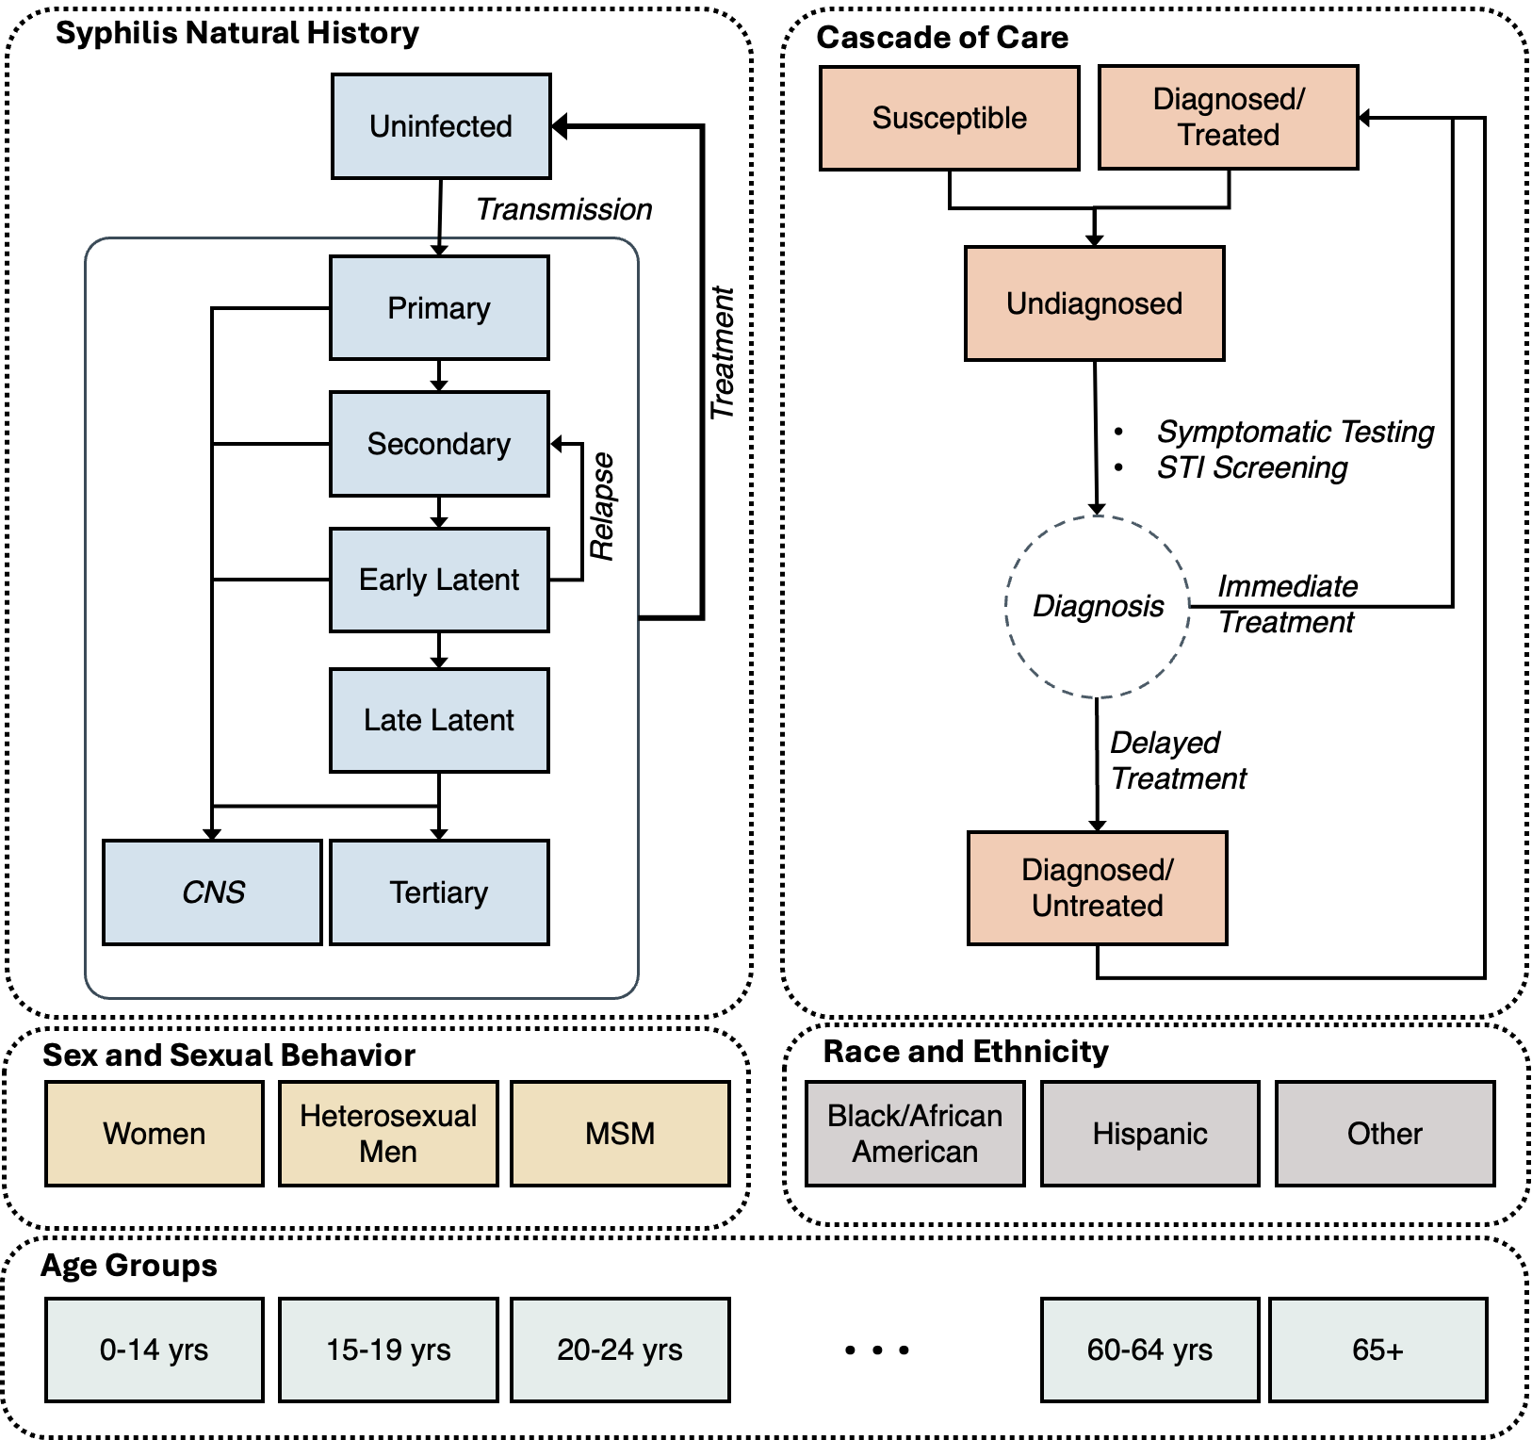
Figure 1: SHIELD model schematic design. Boxes represent model compartments corresponding to groups of individuals in similar health states, while arrows represent transition rates between health states. Blue boxes represent the natural history of syphilis. Individuals enter the model uninfected and susceptible to syphilis infection and may acquire infection through sexual transmission. Following infection, individuals progress through early stages of syphilis, including primary, secondary, and early latent infection. These stages are considered infectious and can contribute to sexual transmission. After the first year of infection, individuals enter the late latent stage. If untreated, late latent infection can persist for years, and some individuals may develop tertiary disease. Central nervous system involvement, including neurosyphilis, can occur at any stage of infection. Orange Boxes represents the cascade of syphilis care. Individuals with undiagnosed symptomatic infection may seek care and undergo symptom-driven testing. The model also includes STI screening in the broader population and syphilis screening during pregnancy for women of reproductive age, consistent with clinical screening practices. Following diagnosis, individuals may receive treatment immediately or experience a delay in treatment, with ongoing opportunities to receive treatment in the future. Individuals who are successfully treated can subsequently become reinfected with syphilis. The simulated population is stratified by sex and sexual behavior, including women, heterosexual men, and men who have sex with men (MSM), as well as by race and ethnicity, including Black or African American, Hispanic, and other. The population was further stratified into 11 age groups, comprising ages 0–14 years and subsequent 5-year age intervals.

Figure2: Calibration & Baseline projection
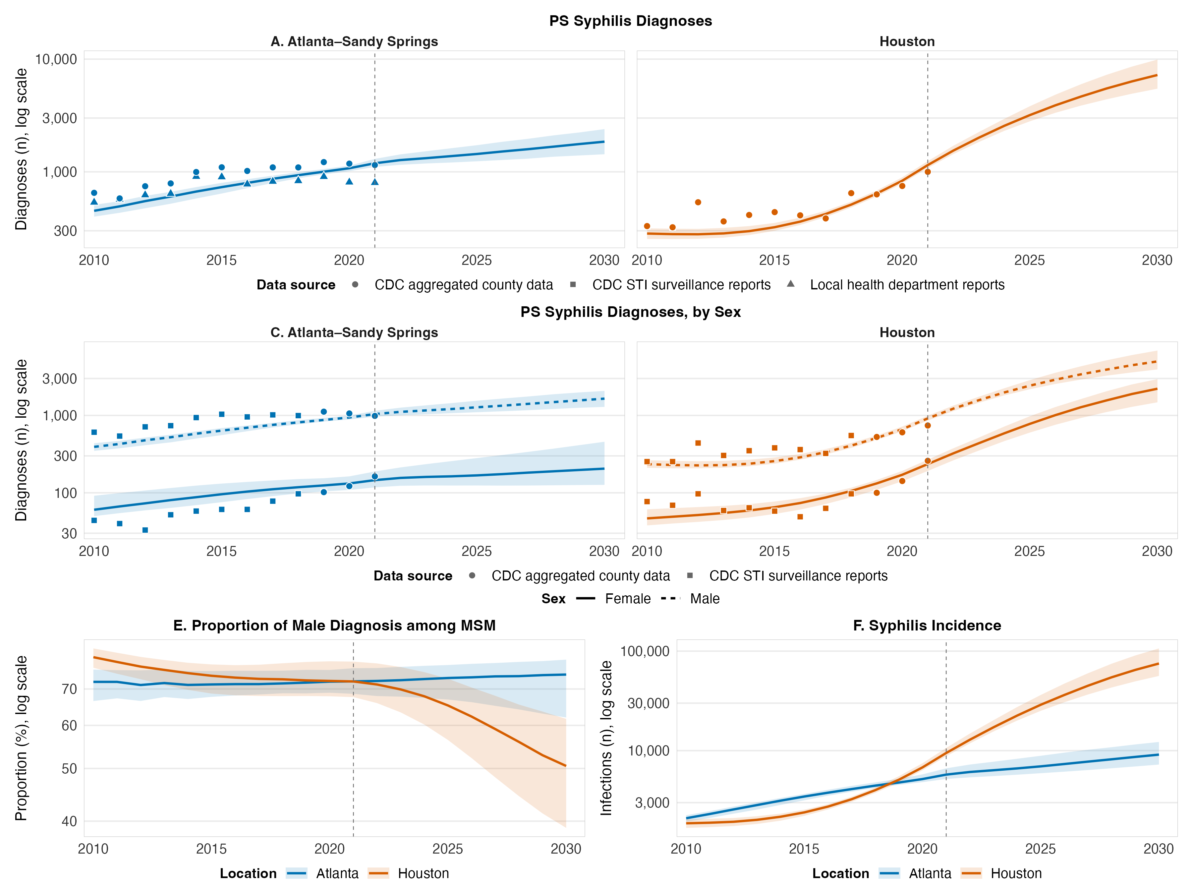
Figure 2. SHIELD model calibration and baseline projections of syphilis burden in absence of Doxy-PEP, Atlanta–Sandy Springs and Houston MSAs, 2010–2030. Solid and dashed lines show the posterior median of simulated outcomes and shaded bands the corresponding 05% uncertainty range across 1,000 posterior simulations. Points show observed surveillance data, with shape denoting the reporting source. The vertical dashed line marks the last year of observed data; values to its right are baseline projections under continuation of current screening and treatment practice, with no Doxy-PEP rollout. All y-axes are log-scaled. Panels A&B represents primary and secondary (P&S) syphilis diagnoses, all sexes, in each MSA. Panels C&D represents P&S syphilis diagnoses stratified by sex in each location. Panel E represents proportion of male P&S syphilis diagnoses occurring among MSM. Panel E represents total syphilis incidence, all stages, with both MSAs overlaid. Color denotes metropolitan area throughout (blue, Atlanta–Sandy Springs; orange, Houston). Points show observed surveillance data.

Table 1: Baseline Projections
Table1: Projected trend in syphilis epidemiology in absence of Doxy-PEP, 2022-2030
MSA | Incidence rate  (per 100,000 persons) |  | Fold-change rate | Total diagnosis rate  (per 100,000 persons) |  | Primary and secondary diagnoses per incident infection |  | MSM share of incidence (%)
 | 2022 | 2030 | 2030 vs 2022 | 2022 | 2030 | 2022 | 2030 | 2022 | 2030
Atlanta | 101 | 138 | 1.37 | 86 | 121 | 0.21 | 0.2 | 67 | 70
 | [88-119] | [107-190] | [1.13-1.75] | [79-95] | [98-155] | [0.19-0.22] | [0.19-0.21] | [60-70] | [51-75]
Baltimore | 67 | 50 | 0.72 | 63 | 52 | 0.27 | 0.28 | 53 | 60
 | [60-84] | [32-106] | [0.53-1.24] | [59-72] | [39-94] | [0.27-0.28] | [0.27-0.28] | [43-63] | [37-77]
Chicago | 77 | 217 | 2.77 | 55 | 107 | 0.2 | 0.17 | 31 | 6
 | [67-93] | [102-439] | [1.45-5.29] | [51-59] | [66-187] | [0.17-0.21] | [0.13-0.18] | [27-36] | [3-10]
Houston | 182 | 960 | 5.3 | 103 | 551 | 0.12 | 0.1 | 38 | 19
 | [165-211] | [718-1356] | [4.17-6.77] | [97-109] | [441-725] | [0.11-0.13] | [0.08-0.1] | [32-42] | [14-24]
LA | 182 | 406 | 2.2 | 109 | 225 | 0.15 | 0.12 | 29 | 12
 | [156-203] | [178-968] | [1.13-4.8] | [102-114] | [138-407] | [0.14-0.17] | [0.11-0.16] | [25-37] | [6-33]
Miami | 230 | 792 | 3.41 | 148 | 467 | 0.13 | 0.11 | 53 | 34
 | [208-256] | [471-1045] | [2.13-4.5] | [139-157] | [321-562] | [0.12-0.14] | [0.1-0.13] | [48-60] | [27-54]
NYC | 103 | 340 | 3.32 | 77 | 216 | 0.19 | 0.17 | 59 | 37
 | [95-115] | [248-525] | [2.41-5.08] | [73-85] | [176-296] | [0.18-0.2] | [0.16-0.18] | [57-63] | [31-50]
Philadelphia | 87 | 291 | 3.38 | 59 | 176 | 0.23 | 0.22 | 47 | 24
 | [75-99] | [152-438] | [1.96-4.83] | [54-64] | [108-235] | [0.21-0.25] | [0.18-0.24] | [42-53] | [14-40]
Phoenix | 209 | 844 | 3.99 | 111 | 449 | 0.18 | 0.17 | 28 | 11
 | [187-238] | [558-1085] | [2.84-4.99] | [104-119] | [327-532] | [0.16-0.2] | [0.15-0.2] | [24-32] | [8-15]
Seattle | 99 | 388 | 3.89 | 61 | 215 | 0.24 | 0.23 | 38 | 18
 | [78-116] | [204-516] | [2.15-5.11] | [50-68] | [124-275] | [0.22-0.25] | [0.21-0.25] | [31-44] | [11-27]

Figure3: Heatmaps
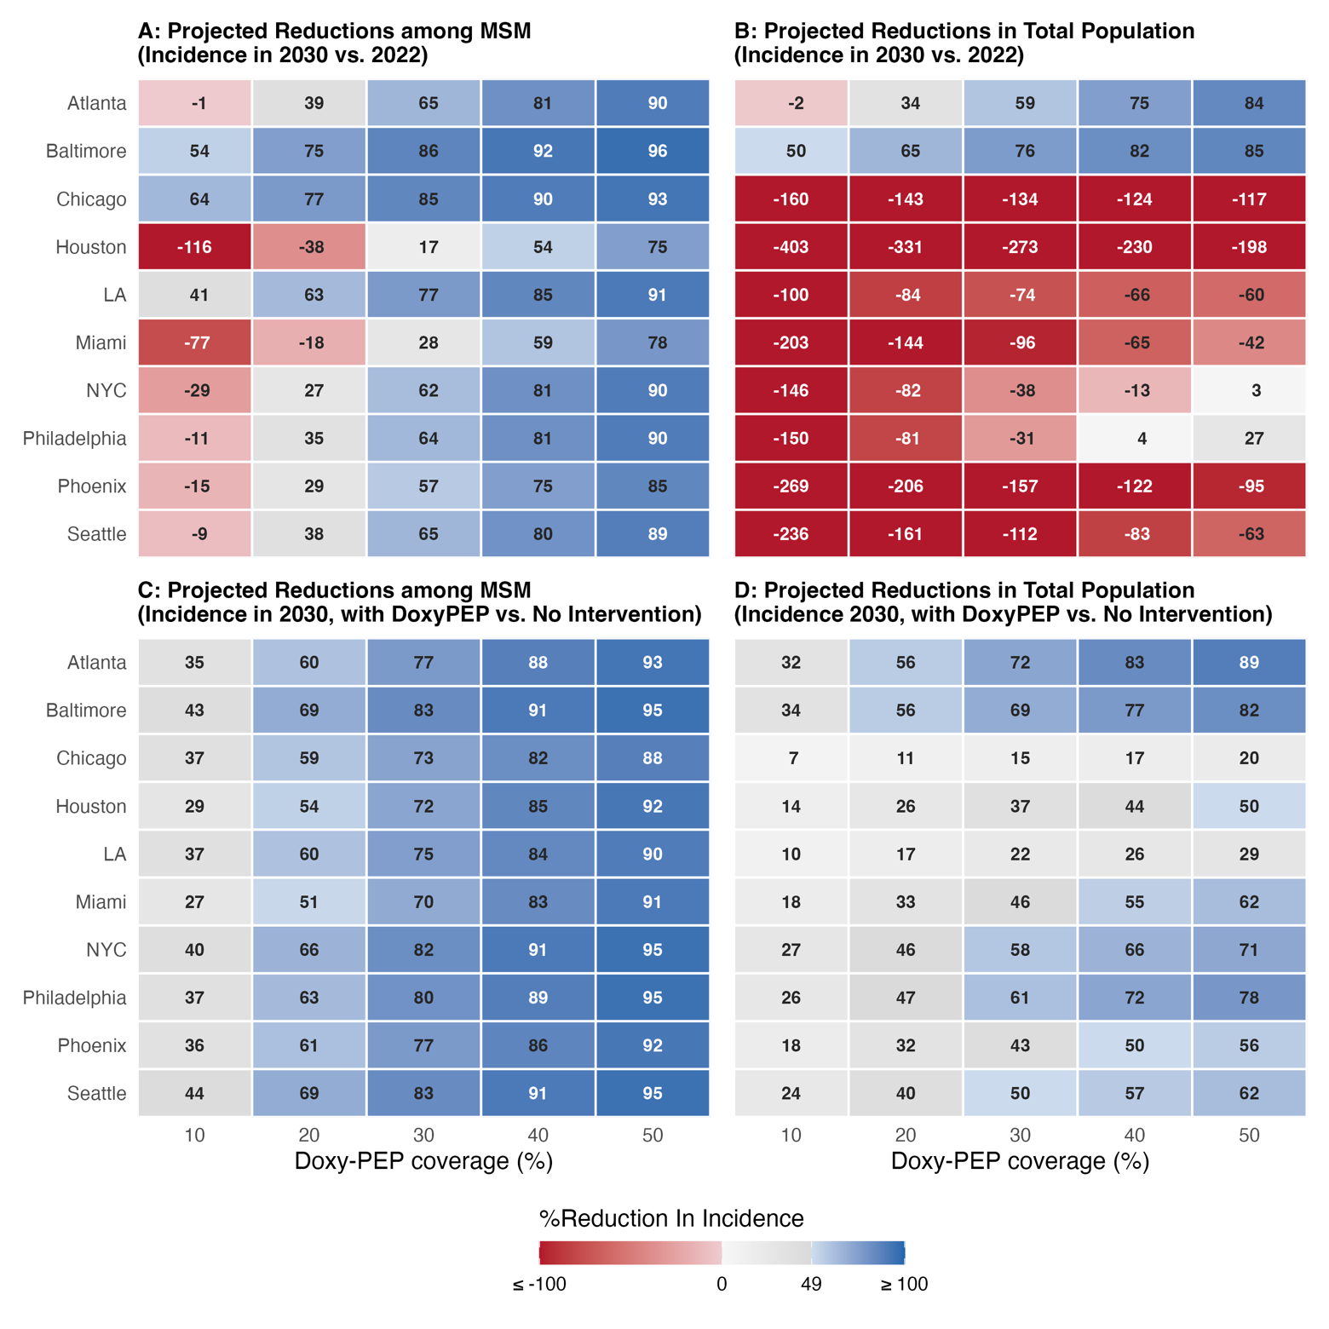Figure 3. Projected effect of Doxy-PEP on syphilis incidence in 2030 across ten US MSAs, by coverage level. Each cell shows the median projected percentage change in syphilis incidence in 2030 under Doxy-PEP coverage of 10% to 50% (x-axis). The two row-pairs use different comparators. Panels A and B represent incidence reduction relative to the 2022 baseline: positive values indicate incidence has fallen below its 2022 level, negative values indicate it remains above it despite Doxy-PEP. Panels C and D represent incidence reduction relative to the no-intervention counterfactual in the same year: positive values are infections averted by Doxy-PEP. Panels A and C are restricted to MSM; panels B and D show the total population. Cells are colored across span three categories: red below 0, grey from 0 to 49%, blue at or above 50%. Cell values are medians across 1,000 posterior simulations. MSAs are ordered based on Panel A.

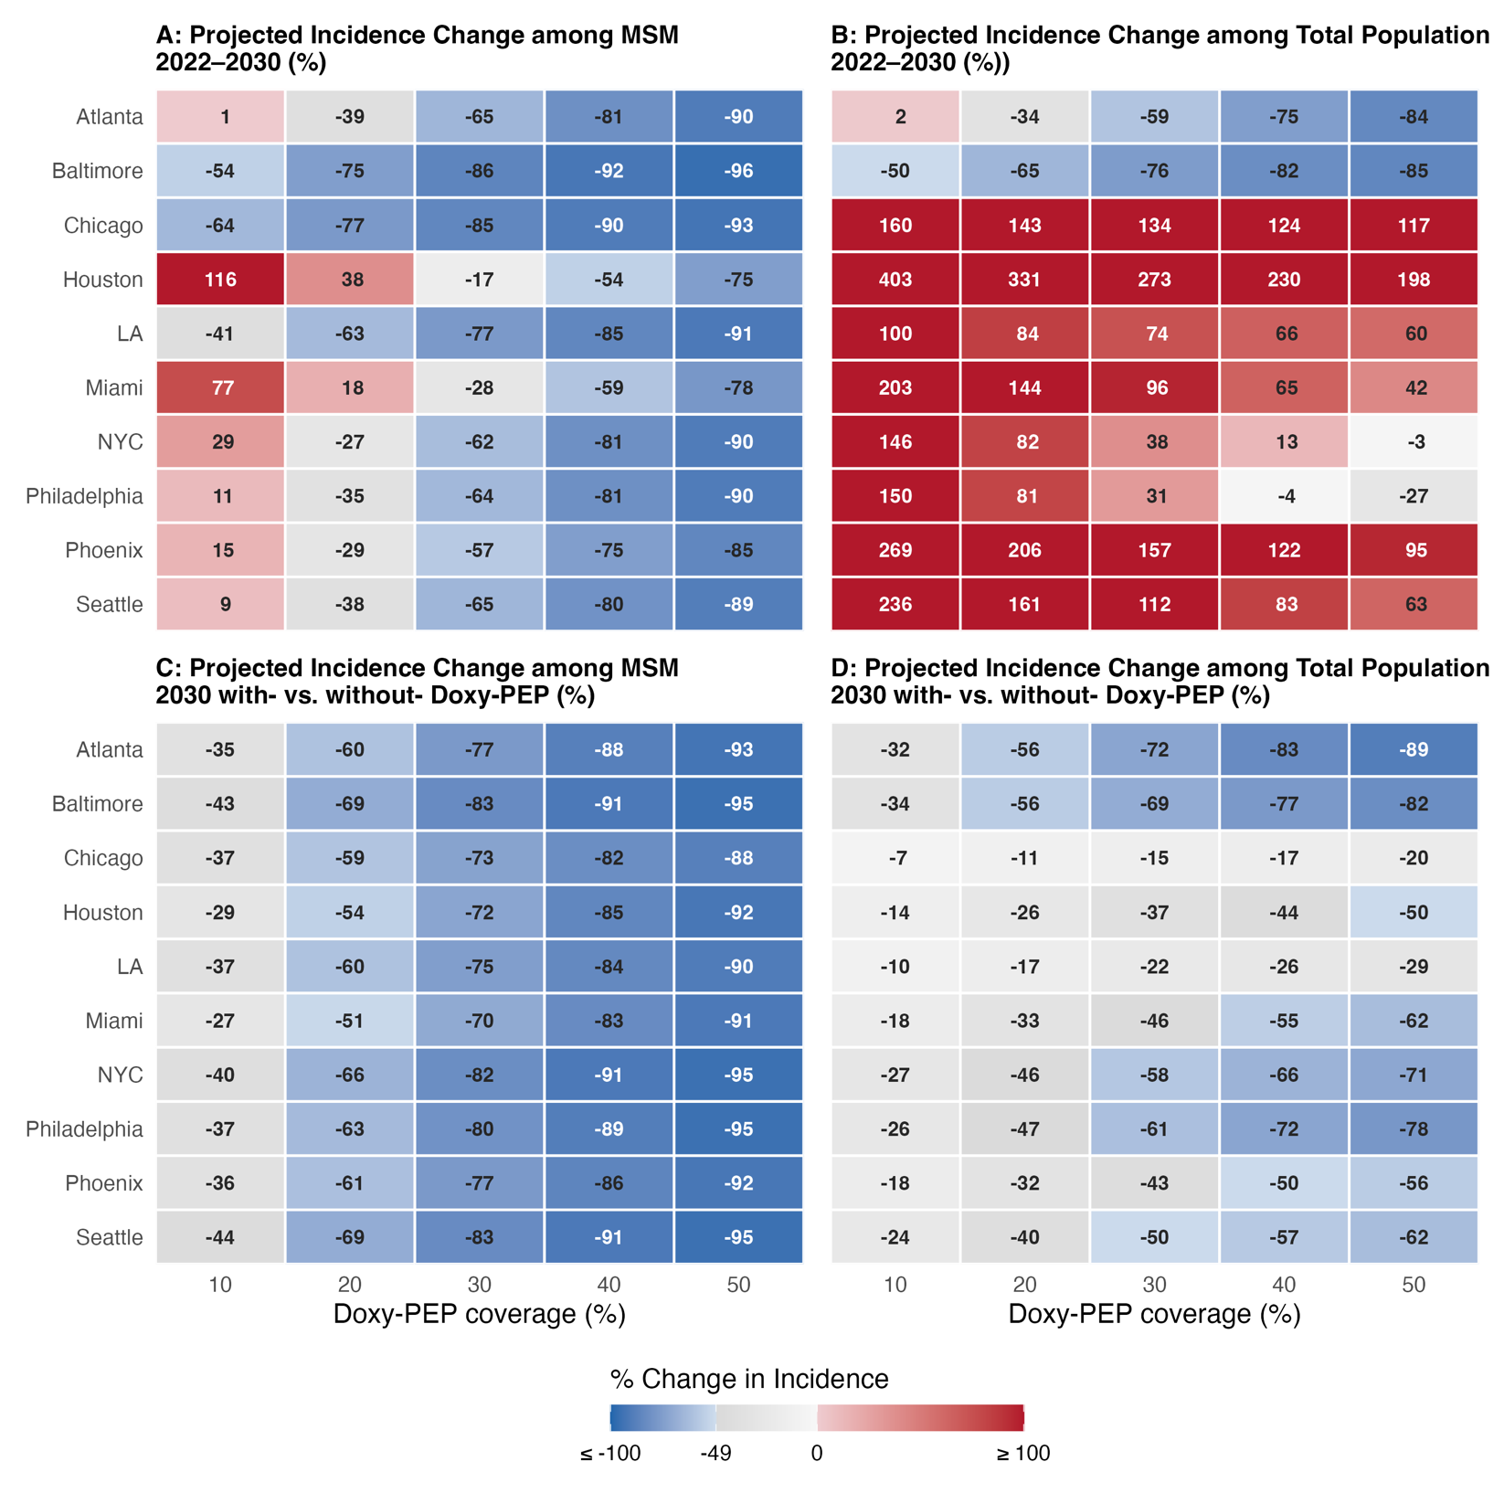

Figure 4: Impact MSM/Women
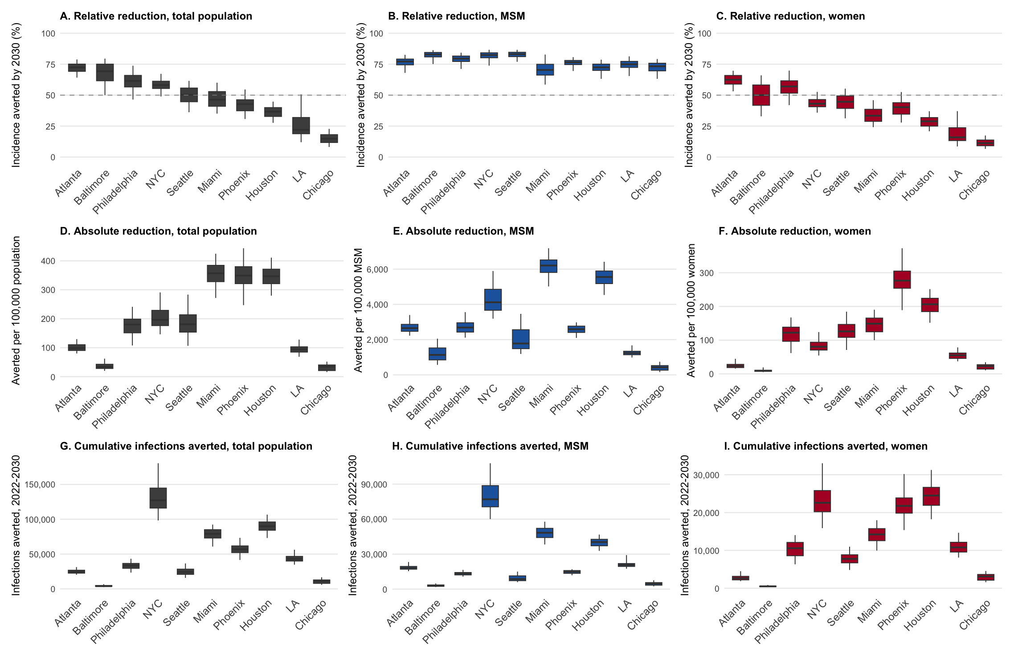
Figure4: Projected impact of Doxy-PEP at 30% coverage among MSM, by MSA, 2030. Panels are arranged with rows corresponding to three measures of impact and columns to three populations: the total population (Panels A, D, G), MSM (Panels B, E, H), and women (Panels C, F, I). Panels A–C show the relative reduction in incidence in 2030 relative to the no-intervention counterfactual in the same year, expressed as the percentage of incidence averted; the dashed line marks a 50% reduction. Panels D–F show the corresponding absolute reduction, expressed as incident infections averted per 100,000 persons in that population. Panels G–I show the cumulative number of infections averted between 2022 and 2030. Within each panel, boxes denote the interquartile range and the midline the median across 1,000 posterior simulations; whiskers extend to the 2.5th and 97.5th percentiles and therefore span the 95% credible interval. MSAs are ordered by the median total-population relative reduction and appear in the same order in all nine panels. Heterosexual men are not displayed, so the counts in Panels H and I do not sum to those in Panel G.

Figure 5. Correlates
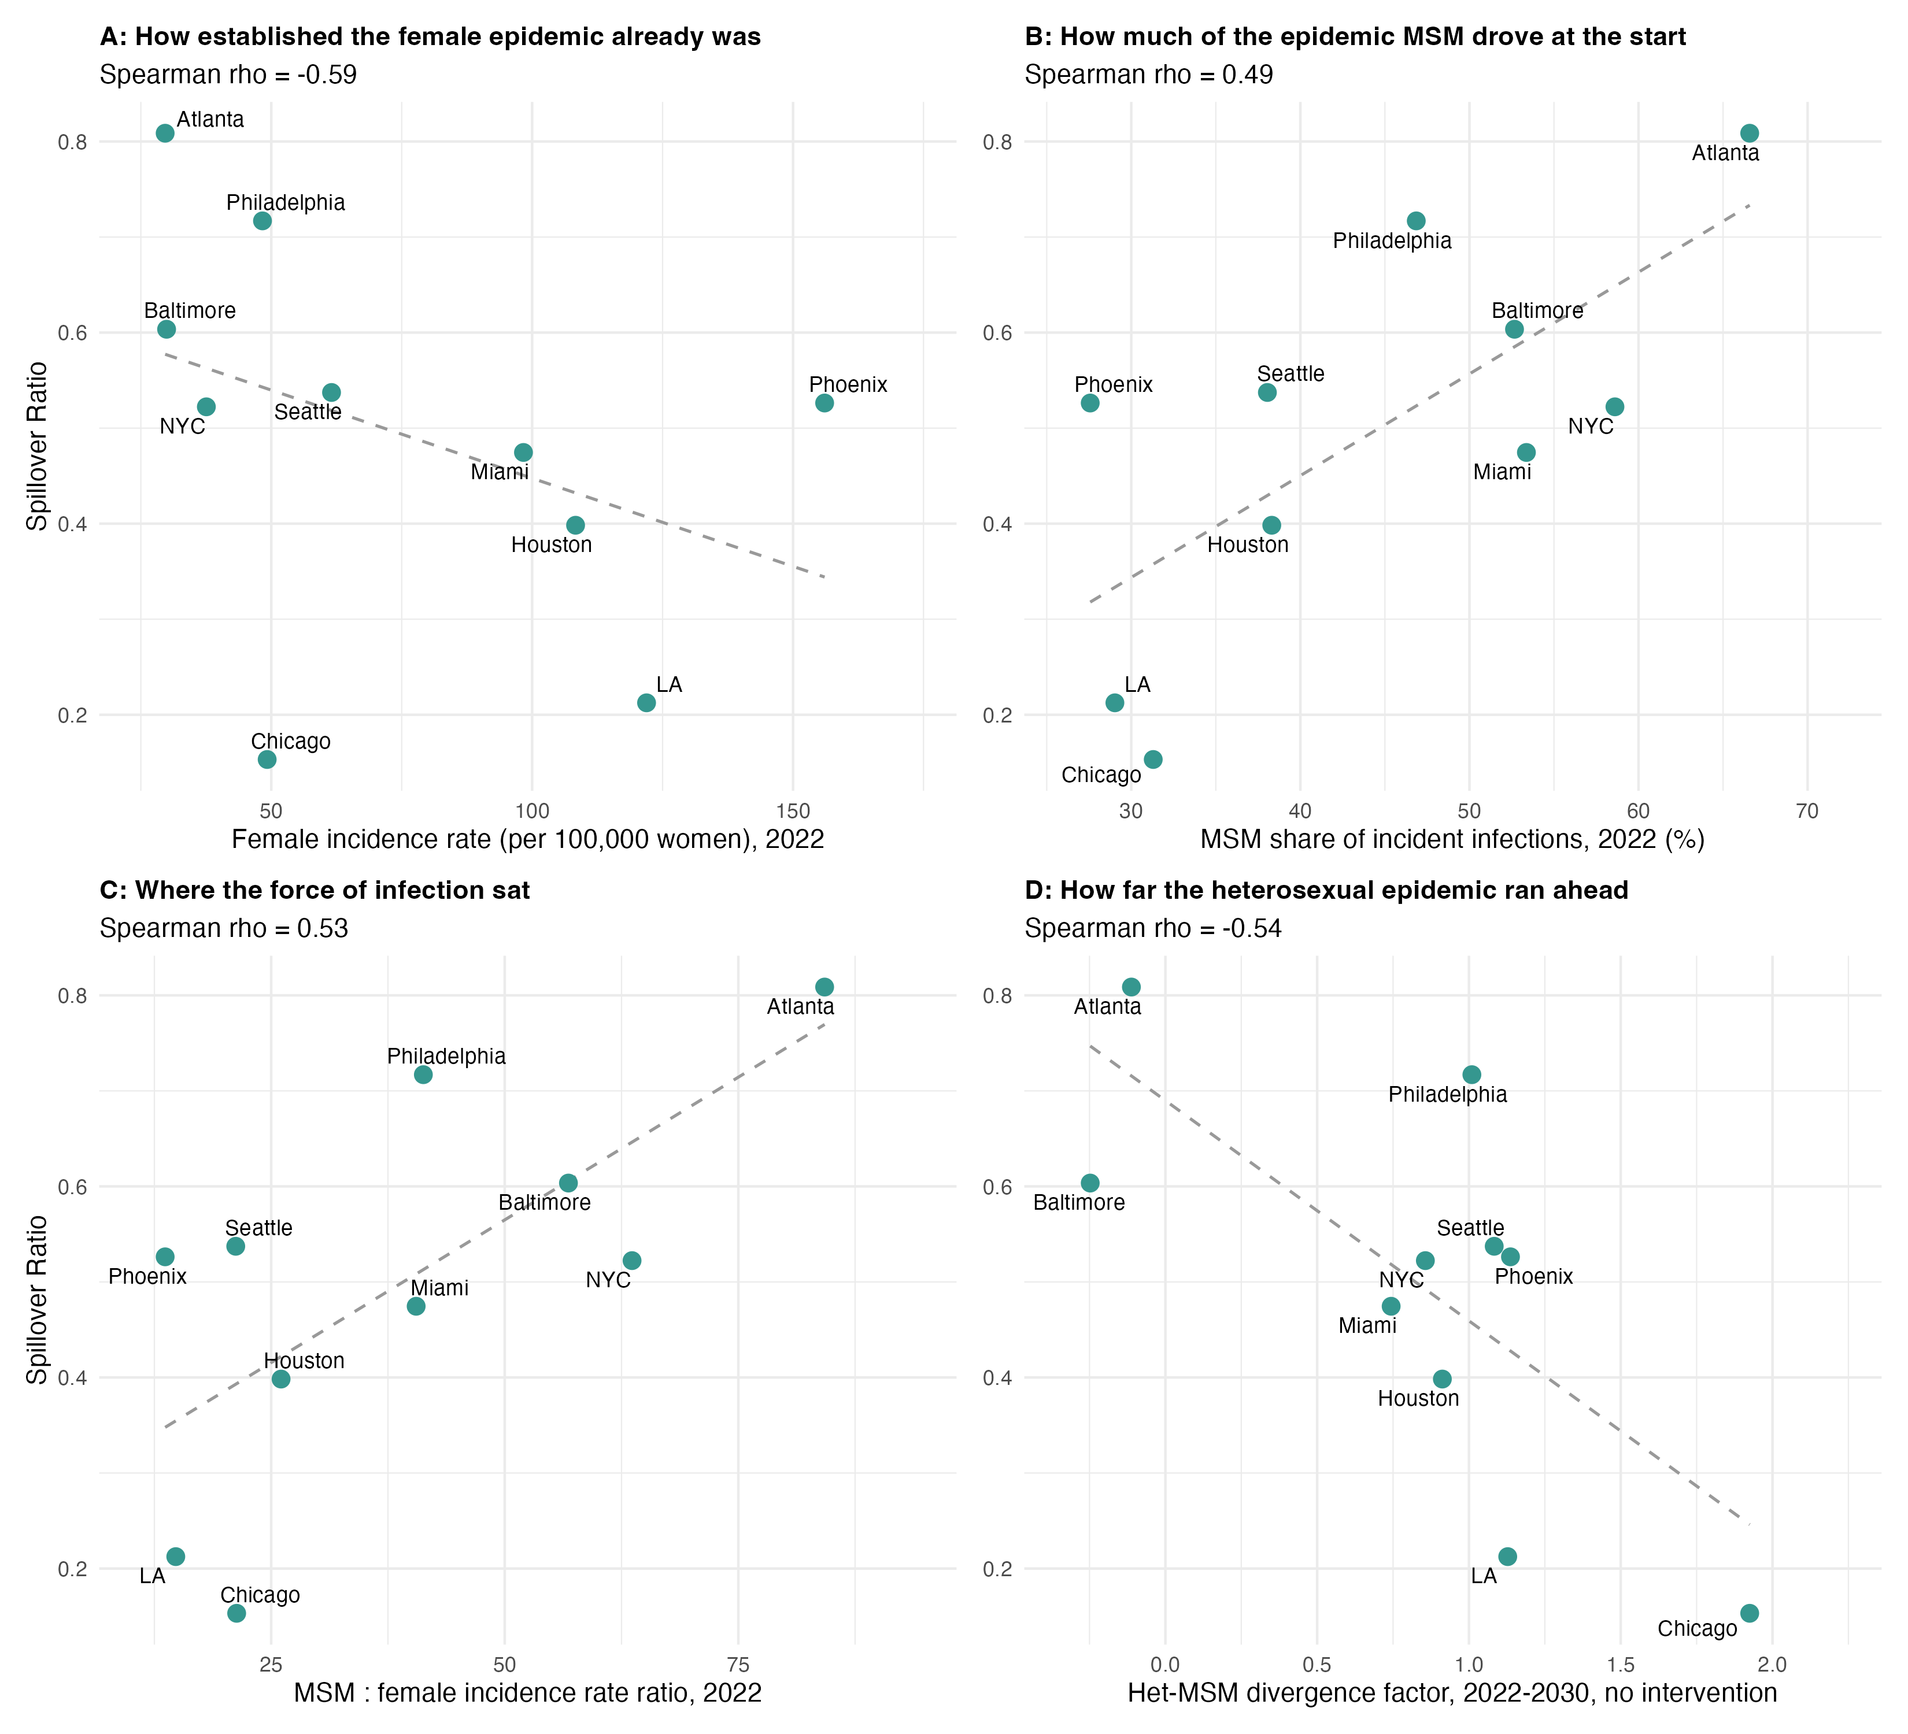
Figure 4. Variation in projected Doxy-PEP spillover across modeled MSAs. The spillover coefficient, shown on the y-axis, was calculated as the proportional reduction in female syphilis incidence relative to the proportional reduction in MSM incidence by 2030 under 30% Doxy-PEP coverage. Greater values indicate a greater proportional reduction among females. Each panel shows the association between the spillover coefficient and a different MSA-level factor shown on the x-axis, including female syphilis incidence rate in 2022 (per 100,000 persons) in Panel A; proportion of incident syphilis infections occurring among MSM in 2022 in Panel B; MSM-to-female syphilis incidence rate ratio in 2022 in Panel C; and the Het-MSM divergence factor, calculated as the natural logarithm of the ratio of heterosexual to MSM incidence fold-change between 2022 and 2030 in Panel D. Spearman rank correlation coefficients ($ρ$) are shown at the top of each panel. Dashed line represents the fitted linear regression for each factor.
Log(growth Het/growth MS) > fold-change 2030-2022

Supplement

Table S1
Projected Impact of Doxy-PEP reaching 30% coverage by 2030. Rows are grouped by MSA and population (total, MSM, heterosexual men, women). Columns show incident cases and incidence rates per 100,000 in 2022 and 2030 under no intervention and under 30% coverage; the percentage of incidence averted in 2030 relative to the no-intervention counterfactual in the same year; the corresponding absolute reduction in incidence rate per 100,000; and the cumulative number of infections averted between 2022 and 2030. Percentages averted and rate differences are single-year quantities for 2030; the final column is cumulative over the whole scale-up window and is therefore substantially smaller as a proportion, because coverage ramps from zero in 2023. Denominators are stratum-specific: rates on an MSM row are per 100,000 MSM, and on a female row per 100,000 women. Values are medians across 1,000 posterior simulations with 95% credible intervals beneath.

MSA | Population | Incidence 2022, No Intervention | Incidence 2030, No Intervention | Incidence 2030, Doxy Coverage 30% | Incidence Rate (per 100,0000 population) 2022, No Intervention | Incidence Rate (per 100,0000 population) 2030, No Intervention | Incidence Rate (per 100,0000 population) 2022, Doxy Coverage 30% | Incidence Rate (per 100,0000 population) 2030, Doxy Coverage 30% | Incidence averted (%), 2030 | Incidence averted per 100,000 population, 2030 | Cumulative infections averted, 2022-2030
Atlanta | Total | 6098 | 9117 | 2470 | 101 | 138 | 101 | 38 | 72.4 | 99 | 24492
 |  | [5388-7250] | [7241-12238] | [1610-4180] | [88-119] | [107-190] | [88-119] | [23-64] | [64.2-78.8] | [80.2-129.8] | [20209-31284]
Baltimore | Total | 1875 | 1412 | 449 | 67 | 50 | 67 | 16 | 69.3 | 33.9 | 3988
 |  | [1664-2349] | [920-3068] | [245-1287] | [60-84] | [32-106] | [60-84] | [9-45] | [50.1-79.5] | [20.2-62.4] | [2649-6726]
Chicago | Total | 7187 | 20100 | 17101 | 77 | 217 | 77 | 182 | 14.7 | 34.8 | 11218
 |  | [6291-8708] | [9374-40913] | [7455-36748] | [67-93] | [102-439] | [67-93] | [79-397] | [8.1-22.8] | [16.1-52] | [5855-16642]
Houston | Total | 12846 | 75203 | 48031 | 182 | 960 | 182 | 609 | 36.7 | 346.7 | 89991
 |  | [11791-14825] | [57067-106465] | [31901-76361] | [165-211] | [718-1356] | [165-211] | [408-973] | [27.7-44.8] | [279.7-410.9] | [73077-106652]
LA | Total | 23782 | 54087 | 42452 | 182 | 406 | 182 | 319 | 22 | 94.8 | 43006
 |  | [20407-26602] | [22679-123353] | [12308-107976] | [156-203] | [178-968] | [156-203] | [95-837] | [12-50.6] | [68.8-128.1] | [34780-56220]
Miami | Total | 13973 | 51891 | 27851 | 230 | 792 | 230 | 426 | 46.2 | 356.8 | 79003
 |  | [12588-15878] | [29225-69033] | [11651-44155] | [208-256] | [471-1045] | [208-256] | [189-670] | [35-60.1] | [271.9-424.6] | [60744-92325]
NYC | Total | 19993 | 66834 | 27600 | 103 | 340 | 103 | 141 | 58.2 | 196.5 | 127224
 |  | [18503-22337] | [46951-104566] | [16949-50508] | [95-115] | [248-525] | [95-115] | [89-253] | [48.9-67.2] | [146.3-290.9] | [98266-180436]
Philadelphia | Total | 5253 | 17779 | 6734 | 87 | 291 | 87 | 110 | 61.5 | 180.2 | 33331
 |  | [4558-5927] | [9633-26881] | [2602-13618] | [75-99] | [152-438] | [75-99] | [41-222] | [46.4-73.8] | [107.8-241.3] | [23362-43272]
Phoenix | Total | 10234 | 47014 | 26616 | 209 | 844 | 209 | 482 | 42.7 | 349.1 | 56900
 |  | [9185-11598] | [31174-59866] | [14493-41032] | [187-238] | [558-1085] | [187-238] | [260-737] | [30.7-54.6] | [246.9-443.4] | [41548-73341]
Seattle | Total | 3953 | 17125 | 8362 | 99 | 388 | 99 | 188 | 50.3 | 181 | 24328
 |  | [3111-4593] | [8888-23488] | [3955-14457] | [78-116] | [204-516] | [78-116] | [88-322] | [36.2-61.5] | [106.6-283.4] | [15820-36518]
Atlanta | msm | 4008 | 6097 | 1407 | 2499 | 3428 | 2499 | 792 | 77.2 | 2650.3 | 18248
 |  | [3664-4836] | [5194-8187] | [966-2431] | [2254-3095] | [2879-4681] | [2254-3095] | [517-1413] | [68-82.6] | [2226.3-3397.3] | [15391-23255]
Baltimore | msm | 985 | 816 | 134 | 1701 | 1358 | 1701 | 221 | 82.8 | 1133.6 | 2973
 |  | [806-1233] | [439-1599] | [67-337] | [1335-2105] | [691-2529] | [1335-2105] | [106-549] | [75.1-86.4] | [568.8-2054.6] | [1806-4866]
Chicago | msm | 2309 | 1323 | 351 | 1049 | 601 | 1049 | 158 | 73.3 | 427.6 | 4733
 |  | [1895-2712] | [539-2194] | [158-550] | [885-1210] | [244-969] | [885-1210] | [72-247] | [63.2-79.2] | [161.1-745] | [2361-7618]
Houston | msm | 4854 | 14784 | 4028 | 2823 | 7732 | 2823 | 2107 | 72.4 | 5555 | 40346
 |  | [4355-5357] | [11762-17043] | [2765-5835] | [2539-3179] | [6453-8844] | [2539-3179] | [1498-3021] | [63.2-78.7] | [4535-6419.4] | [32791-46776]
LA | msm | 6839 | 6258 | 1581 | 1803 | 1681 | 1803 | 422 | 74.9 | 1240.2 | 20696
 |  | [6221-7917] | [4690-8463] | [938-2634] | [1602-2044] | [1246-2290] | [1602-2044] | [253-718] | [65.4-81.3] | [985.8-1674.9] | [17485-29198]
Miami | msm | 7430 | 17961 | 5326 | 3984 | 8909 | 3984 | 2645 | 70.3 | 6205.1 | 48312
 |  | [6611-8671] | [12491-24353] | [2192-9268] | [3505-4338] | [6229-11076] | [3505-4338] | [1128-4315] | [58.5-82.8] | [5017.7-7187.1] | [38287-57819]
NYC | msm | 11763 | 25257 | 4482 | 2390 | 5024 | 2390 | 896 | 82.4 | 4119.2 | 76989
 |  | [10746-13492] | [18804-37598] | [2626-9315] | [2143-2784] | [3737-7534] | [2143-2784] | [534-1762] | [73.8-86.6] | [3189-5895] | [60054-107899]
Philadelphia | msm | 2476 | 4380 | 895 | 1995 | 3396 | 1995 | 699 | 79.5 | 2688.4 | 13300
 |  | [2220-2773] | [3483-5738] | [605-1411] | [1714-2311] | [2662-4547] | [1714-2311] | [471-1117] | [71.2-84.3] | [2111.6-3559.7] | [10722-16545]
Phoenix | msm | 2846 | 5114 | 1213 | 2131 | 3412 | 2131 | 804 | 76.5 | 2590.9 | 14879
 |  | [2462-3239] | [4121-5903] | [873-1659] | [1830-2464] | [2756-3977] | [1830-2464] | [579-1109] | [69.5-80.7] | [2099.6-2980] | [11894-17042]
Seattle | msm | 1439 | 2763 | 494 | 1305 | 2161 | 1305 | 397 | 83.1 | 1781.5 | 8602
 |  | [1191-1805] | [1741-5047] | [264-871] | [1052-1638] | [1408-4118] | [1052-1638] | [213-708] | [76.9-86.6] | [1186.8-3462.7] | [5974-15037]
Atlanta | female | 921 | 1231 | 451 | 30 | 37 | 30 | 13 | 62.4 | 23.3 | 2639
 |  | [763-1184] | [815-2697] | [247-1238] | [25-38] | [24-82] | [25-38] | [7-37] | [53.1-69.7] | [15.7-44.8] | [1863-4499]
Baltimore | female | 432 | 276 | 152 | 30 | 19 | 30 | 10 | 50 | 9.1 | 491
 |  | [295-567] | [143-770] | [51-480] | [21-39] | [10-52] | [21-39] | [3-32] | [32.9-66] | [5.5-19.1] | [314-860]
Chicago | female | 2354 | 8973 | 7835 | 49 | 186 | 49 | 162 | 11.2 | 22.9 | 3107
 |  | [2069-3040] | [4117-18583] | [3439-17176] | [43-64] | [85-389] | [43-64] | [72-355] | [6.6-17.4] | [10.6-34.6] | [1595-4547]
Houston | female | 3857 | 28450 | 20259 | 108 | 720 | 108 | 509 | 28.8 | 206.5 | 24493
 |  | [3361-4924] | [20063-42764] | [13249-32956] | [94-138] | [504-1066] | [94-138] | [337-826] | [20.8-37] | [151.6-251.5] | [18236-31262]
LA | female | 8096 | 22245 | 18881 | 122 | 331 | 122 | 280 | 15.9 | 55.2 | 10794
 |  | [6267-9462] | [7810-53966] | [4939-49321] | [94-142] | [117-827] | [94-142] | [75-746] | [8.6-37.1] | [37.2-78.5] | [8099-14662]
Miami | female | 3083 | 15570 | 10452 | 98 | 457 | 98 | 310 | 33.4 | 148.9 | 14228
 |  | [2577-3577] | [7460-23045] | [4206-17228] | [82-113] | [231-682] | [82-113] | [127-513] | [24.1-45.9] | [100-190.4] | [9955-17978]
NYC | female | 3759 | 18893 | 10600 | 38 | 187 | 38 | 106 | 43 | 80.6 | 22580
 |  | [3334-4193] | [11838-31527] | [5830-19350] | [33-42] | [120-308] | [33-42] | [59-189] | [35.8-52.6] | [54.4-124.1] | [15882-33037]
Philadelphia | female | 1518 | 6775 | 2833 | 48 | 216 | 48 | 91 | 57 | 122.2 | 10578
 |  | [1178-1743] | [2976-10962] | [979-6005] | [38-56] | [93-343] | [38-56] | [30-189] | [41.9-69.8] | [61.7-167.3] | [6311-14043]
Phoenix | female | 3861 | 20033 | 11880 | 156 | 717 | 156 | 426 | 40.3 | 276.7 | 21760
 |  | [3391-4563] | [13087-26318] | [6408-18727] | [137-184] | [468-939] | [137-184] | [225-661] | [27.8-52.5] | [189.1-372.7] | [15362-30183]
Seattle | female | 1235 | 6647 | 3618 | 62 | 297 | 62 | 163 | 44.6 | 126 | 7760
 |  | [963-1468] | [3358-9467] | [1697-6467] | [48-73] | [153-417] | [48-73] | [76-286] | [31.3-55.2] | [71-184.5] | [4827-10975]
Atlanta | heterosexual_male | 1120 | 1545 | 551 | 40 | 49 | 40 | 18 | 64 | 32.7 | 3403
 |  | [929-1386] | [1022-3074] | [303-1392] | [33-50] | [33-103] | [33-50] | [10-46] | [53.8-71.4] | [22.8-57.4] | [2470-5277]
Baltimore | heterosexual_male | 471 | 308 | 166 | 36 | 23 | 36 | 12 | 52.3 | 12.2 | 582
 |  | [342-607] | [170-836] | [63-523] | [27-47] | [13-63] | [27-47] | [5-39] | [32.6-69.9] | [7.6-24.9] | [390-1006]
Chicago | heterosexual_male | 2474 | 9988 | 8955 | 57 | 234 | 57 | 203 | 10.7 | 26.7 | 3193
 |  | [2172-3180] | [4501-20819] | [3784-19284] | [49-73] | [106-486] | [49-73] | [88-452] | [6.4-16.4] | [12.6-40.1] | [1676-4671]
Houston | heterosexual_male | 4143 | 32230 | 23407 | 124 | 876 | 124 | 632 | 27.2 | 234.1 | 25553
 |  | [3625-5184] | [22960-49633] | [15353-39363] | [108-155] | [617-1333] | [108-155] | [421-1049] | [19.7-34.8] | [176.3-286.8] | [19643-32113]
LA | heterosexual_male | 8840 | 25622 | 21990 | 146 | 415 | 146 | 359 | 15.1 | 66 | 11442
 |  | [6816-10444] | [8732-61223] | [5690-56137] | [111-171] | [142-1045] | [111-171] | [94-948] | [8.2-34.9] | [43.5-95.4] | [8301-15809]
Miami | heterosexual_male | 3427 | 17536 | 11964 | 124 | 594 | 124 | 408 | 32.9 | 190.6 | 15800
 |  | [2883-3974] | [8420-26248] | [4737-19727] | [105-144] | [300-879] | [105-144] | [166-670] | [23.6-45.4] | [127.9-241.7] | [11019-19930]
NYC | heterosexual_male | 4436 | 22540 | 12551 | 50 | 248 | 50 | 140 | 43.7 | 109.5 | 27294
 |  | [3921-4974] | [14592-37795] | [6986-23245] | [44-56] | [165-413] | [44-56] | [79-254] | [35.7-53.1] | [77.3-165.7] | [20328-39064]
Philadelphia | heterosexual_male | 1260 | 6713 | 3038 | 45 | 238 | 45 | 106 | 54.2 | 129.5 | 9634
 |  | [943-1617] | [2587-11755] | [909-6695] | [33-58] | [91-413] | [33-58] | [31-237] | [39.9-66.9] | [59.2-185.7] | [5111-13129]
Phoenix | heterosexual_male | 3575 | 21613 | 13478 | 155 | 827 | 155 | 519 | 37 | 295.9 | 20185
 |  | [2885-4054] | [13507-28524] | [7146-20911] | [125-177] | [521-1100] | [125-177] | [274-807] | [25.5-48.3] | [199.3-383.6] | [14195-26774]
Seattle | heterosexual_male | 1228 | 7324 | 4180 | 65 | 351 | 65 | 201 | 42.1 | 141.2 | 7796
 |  | [946-1507] | [3611-10733] | [1918-7524] | [50-80] | [176-504] | [50-80] | [90-354] | [29.7-52.3] | [78-199.8] | [4678-10855]

TableS2
Table S2: Projected spillover ratio and candidate correlates, by MSA, at 30% Doxy-PEP coverage in 2030. The spillover ratio is the projected percentage reduction in incidence among women divided by the corresponding reduction among MSM. Candidate correlates are measured in 2022 under no intervention and are therefore properties of the epidemic Doxy-PEP enters rather than consequences of it: the MSM share of incident infections in 2022 and 2030; the MSM and female incidence rates and their ratio; the MSM share of the male population; and the detection ratio among MSM. The final three columns describe the untreated epidemic trajectory: the fold-change in incident cases among MSM and among heterosexuals between 2022 and 2030, and the divergence factor, defined as the natural logarithm of their ratio. All correlates are scale-free, so that between-MSA comparisons are not driven by differences in city size. MSAs are ordered by descending spillover ratio.
MSA | Incidence averted, MSM (%) | Incidence averted, heterosexual men (%) | Incidence averted, women (%) | Incidence averted, total population (%) | Spillover ratio (women / MSM) | MSM share of incidence, 2022 (%) | MSM share of incidence, 2030 (%) | MSM incidence rate, 2022 (per 100,000 MSM) | Female incidence rate, 2022 (per 100,000 women) | MSM : female incidence rate ratio | MSM share of the male population, 2022 (%) | P&S diagnoses per incident infection, MSM, 2022 | MSM incidence fold-change, 2022-2030 | Heterosexual incidence fold-change, 2022-2030 | Divergence: log(het growth / MSM growth)
Atlanta | 77.169 | 64.043 | 62.404 | 72.383 | 0.80866669 | 66.575 | 69.707 | 2498.776 | 29.663 | 84.238816 | 5.44005672 | 0.2 | 1.52120758 | 1.36011759 | -0.1119333
Philadelphia | 79.518 | 54.206 | 57.009 | 61.47 | 0.71693202 | 46.855 | 24.384 | 1994.946 | 48.316 | 41.2895521 | 4.28109241 | 0.249 | 1.76898223 | 4.85529158 | 1.00966479
Baltimore | 82.845 | 52.344 | 49.996 | 69.316 | 0.60348844 | 52.666 | 59.841 | 1701.015 | 29.938 | 56.8179237 | 4.3566077 | 0.283 | 0.8284264 | 0.64673311 | -0.2475943
Seattle | 83.09 | 42.123 | 44.646 | 50.316 | 0.53732098 | 38.05 | 18.281 | 1305.392 | 61.551 | 21.2082988 | 5.55940698 | 0.276 | 1.92008339 | 5.67235079 | 1.08323502
Phoenix | 76.517 | 36.977 | 40.27 | 42.743 | 0.52628828 | 27.572 | 11.266 | 2130.632 | 156.056 | 13.6529964 | 5.46587831 | 0.255 | 1.79690794 | 5.60059172 | 1.13680488
NYC | 82.412 | 43.735 | 43.045 | 58.163 | 0.52231471 | 58.605 | 37.219 | 2389.673 | 37.558 | 63.6262048 | 5.23474155 | 0.202 | 2.14715634 | 5.05588774 | 0.85640912
Miami | 70.336 | 32.908 | 33.377 | 46.231 | 0.47453651 | 53.369 | 34.38 | 3984.399 | 98.336 | 40.5182131 | 6.41877877 | 0.157 | 2.41736205 | 5.08540707 | 0.7436982
Houston | 72.415 | 27.193 | 28.846 | 36.662 | 0.39834288 | 38.309 | 19.319 | 2822.945 | 108.323 | 26.0604396 | 4.87191849 | 0.179 | 3.04573548 | 7.585 | 0.91243021
LA | 74.911 | 15.09 | 15.918 | 21.968 | 0.21249216 | 29.031 | 11.625 | 1803.297 | 121.928 | 14.7898514 | 5.87139993 | 0.233 | 0.91504606 | 2.82634624 | 1.12776567
Chicago | 73.285 | 10.685 | 11.225 | 14.747 | 0.15316913 | 31.299 | 6.061 | 1048.503 | 49.213 | 21.3054071 | 4.81832012 | 0.243 | 0.57297531 | 3.92729909 | 1.92486458

Figure S1
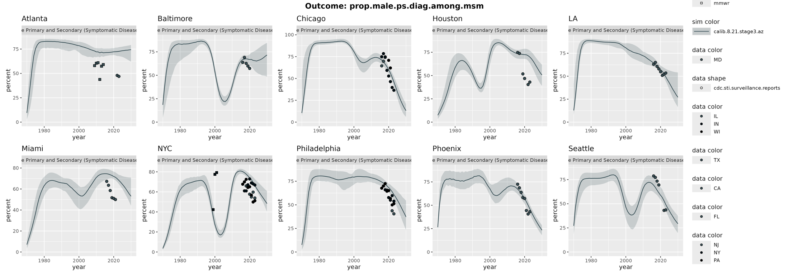

Extensions?
The baseline projects MSM share falling to 6% in Chicago and 11–12% in Phoenix and LA. That drives your central negative finding (limited total-population impact), and it will be the first thing a reviewer attacks, because it runs against what most US P&S surveillance currently shows. The model is calibrated only through 2021 with 2022–23 held out, so the heterosexual expansion is extrapolated ~9 years beyond data. I'd add a sensitivity analysis or at minimum an explicit paragraph defending it – arguably co-equal in priority with writing §3.

Lower baseline female incidence was associated with greater projected spillover. This pattern may reflect differences in the relative concentration of transmission within MSM sexual networks and the resulting potential for downstream reductions among female partners, although the association may also partly reflect the proportional construction of the spillover coefficient

Discussion points: Reducing infections among treated individuals could therefore generate indirect benefits across sexual networks, but the magnitude of this spillover may vary substantially across settings depending on the structure and distribution of transmission.
Although early ecological evidence has linked increasing doxy-PEP uptake with declines in syphilis diagnoses [REF], such observations cannot establish how much coverage is required to shift an epidemic or whether the same level of coverage would have similar effects across settings.

1. Centers for Disease Control and Prevention. NCHHSTP AtlasPlus 2026 [Available from: https://www.cdc.gov/nchhstp/about/atlasplus.html.
2. Centers for Disease Control and Prevention (CDC). Sexually Transmitted Infections Surveillance, 2023 Atlanta: US Department of Health and Human Services; 2024.
3. Luetkemeyer AF, Donnell D, Dombrowski JC, Cohen S, Grabow C, Brown CE, et al. Postexposure doxycycline to prevent bacterial sexually transmitted infections. New England Journal of Medicine. 2023;388(14):1296-306.
4. Molina J-M, Charreau I, Chidiac C, Pialoux G, Cua E, Delaugerre C, et al. Post-exposure prophylaxis with doxycycline to prevent sexually transmitted infections in men who have sex with men: an open-label randomised substudy of the ANRS IPERGAY trial. The Lancet Infectious Diseases. 2018;18(3):308-17.
5. Stewart J, Oware K, Donnell D, Violette LR, Odoyo J, Soge OO, et al. Doxycycline prophylaxis to prevent sexually transmitted infections in women. New England Journal of Medicine. 2023;389(25):2331-40.
6. Bachmann LH. CDC clinical guidelines on the use of doxycycline postexposure prophylaxis for bacterial sexually transmitted infection prevention, United States, 2024. MMWR Recommendations and Reports. 2024;73.
7. Traeger MW, Leyden WA, Volk JE, Silverberg MJ, Horberg MA, Davis TL, et al. Doxycycline postexposure prophylaxis and bacterial sexually transmitted infections among individuals using HIV preexposure prophylaxis. JAMA internal medicine. 2025;185(3):273-81.
8. Spinelli MA, Heise MJ, Roman J, Bena J, Barry MP, Buchbinder SP, et al. Sustained effectiveness of doxycycline post-exposure-prophylaxis in a large sexual health clinic over 96 weeks: an interrupted time series analysis. Clinical Infectious Diseases. 2026;82(6):1075-8.
9. Kohli M, Elliott-Walker T, Saunders J, Fifer H. Doxycycline post-exposure prophylaxis as prevention of STIs–the golden bullet? Expert review of anti-infective therapy. 2025;23(7):445-57.
10. Chu VT, Glascock A, Donnell D, Grabow C, Brown CE, Ward R, et al. Impact of doxycycline post-exposure prophylaxis for sexually transmitted infections on the gut microbiome and antimicrobial resistome. Nature medicine. 2025;31(1):207-17.
11. Fernandez-Ibanez R, Moreno S, Fernandez M. A review of doxycycline post-exposure prophylaxis and its implications for antimicrobial resistance and the human microbiome. Infectious Diseases and Therapy. 2026;15(1):57-84.
12. Zhu J, Takeh BT, David J, Sang J, Moore DM, Hull M, et al. Impact of screening and doxycycline prevention on the syphilis epidemic among men who have sex with men in British Columbia: a mathematical modelling study. The Lancet Regional Health–Americas. 2024;33.
13. Tran NK, Goldstein ND, Welles SL. Countering the rise of syphilis: A role for doxycycline post-exposure prophylaxis? International journal of STD & AIDS. 2022;33(1):18-30.
14. Fojo AT, Schnure M, Kasaie P, Dowdy DW, Shah M. What will it take to end HIV in the United States? A comprehensive, local-level modeling study. Annals of internal medicine. 2021;174(11):1542-53.
15. Peterman TA, Kahn RH, Ciesielski CA, Ortiz-Rios E, Furness BW, Blank S, et al. Misclassification of the stages of syphilis: implications for surveillance. Sexually transmitted diseases. 2005;32(3):144-9.
16. Menza TW, Berzkalns A, Cannon CA, Balkus J, Kerani RP, Dombrowski JC, et al. The Population-Level Impact of Doxycycline Postexposure Prophylaxis on Syphilis in King County, WA: An Interrupted Time Series Analysis. Clinical Infectious Diseases. 2026:ciag209.

