**Dogs Rating**

A study has been made on the ratings given by the Twitter account ***WeRateDog (@dog_rates)*** based on more than 2.000 tweets posted on their page from the 15th of October 2015 to the 1st of August 2017. Among the data analyzed were the dog names, their species, their stage, the given rating, and the related tweet metrics (number of retweets and favorites).

Based on the aforementioned information we made some major observations that we will share with you.

**Observations and visualizations**

Most ratings registered are above 10/10 with a high concentration around the value ***12*** as we can observe in the graph below. We can say without being mistaken that almost all the dogs are ***Good Boys***. There are even some rare instances of ***Super Good Boys*** with a rating of ***1776/10***.

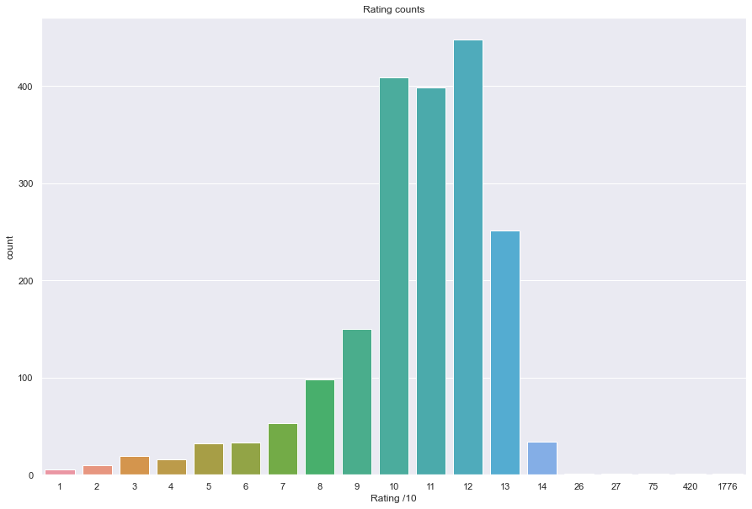

We then ask ourselves, what type of rating do dogs usually receive depending on their stage? The answer is that ***Puppers*** are the ones that usually receive the highest ratings, they are the cutest.

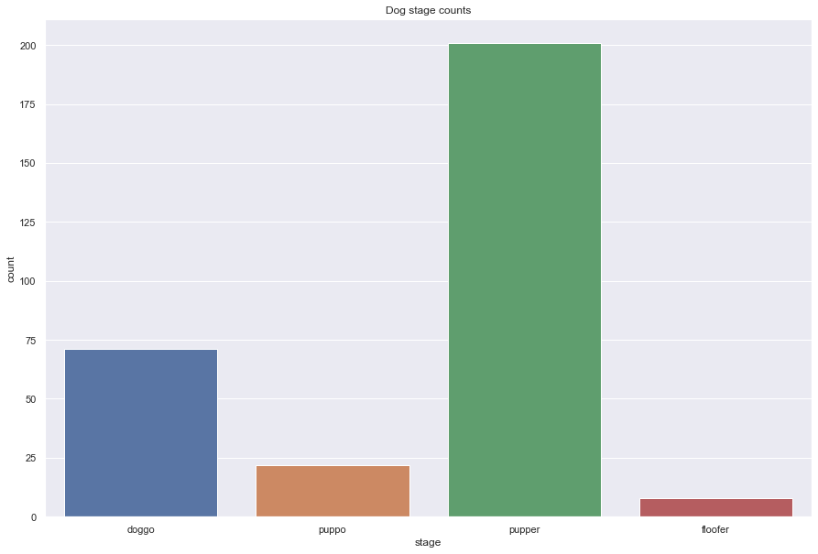

How does the public react to those ratings? Well, the pictures that receive the most likes in average are for dogs at ***doggo*** and ***puppo*** stage as we can see in the graph below.

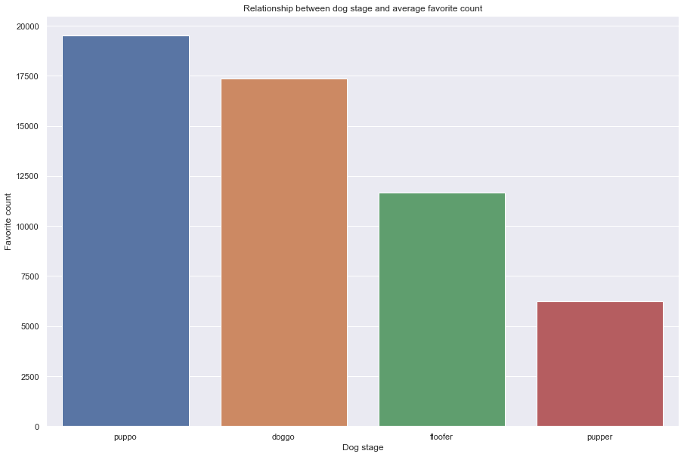

Among all the posts studied, it appears that ***Golden Retrievers*** (***155*** posts), ***Labrador Retrievers*** (***103*** posts), ***Pembroke*** (***94*** posts), and ***Chihuahua*** (***90*** posts) are the 04 most posted dog pictures. Which one of those are the most liked by Twitter Users? As we can see in the graph below, it’s the ***Samoyed*** that receives the most average likes, followed by the ***Golden Retriever*** as expected.

