Tyler Butler

SQL

4/16/18

SQL Final Project

**Part One:**

*Your company receives the following memo. First, based on the memo, create an initial database design (E-R model) for the City Jail that indicates entities, attributes (columns), primary keys, and relationships. In developing your design, consider the columns needed to build relationships between the entities. Use only the entities identified in the memo to develop the E-R model. Second, create a list of additional entities or attributes not identified in the memo that might be applicable to a crime-tracking database.*

Appeals

Sentencing

Crimes

Criminals

Type of sentence

appeal filing date

appeal hearing date

status

Crime ID

start date,

end date,

number of violations

type of sentence

Charges

Crime ID

amount of fine,

court fee,

amount paid,

payment due

date,

charge status

Officer id

Name

precinct,

badge number

phone contact,

status

Officers

Crime id

criminal id

date charged

hearing date

officer id

Officers

Criminal idname, address,

phone number,

violent offender status (yes/no),

probation status (yes/ no)

aliases

Additional Entities:

I added a charges table to handle most of the info dealing with payments in the crimes table. This table has a one to many relationship due to the fact that a crime could have many charges associated with it.

**Part Two:**

In part one, you designed the new database for City Jail. Now you need to create all the tables for the

database. First, create all the tables using the information outlined in Section A (See page 98 – page

101). Second, make the modifications outlined in Section B. Save all SQL statements used to accomplish

these tasks.

Section B

-Add a default value of U for the Classification column of the Crimes table.

Page 2

- Add a column named Date_Recorded to the Crimes table. This column needs to hold date values

and should be set to the current date by default.

- Add a column to the Prob_officers table to contain the pager number for each officer. The

column needs to accommodate a phone number, including area code. Name the column Pager#.

- Change the Alias column in the Aliases table to accommodate up to 20 characters.

**Screen Shots (Section A)**

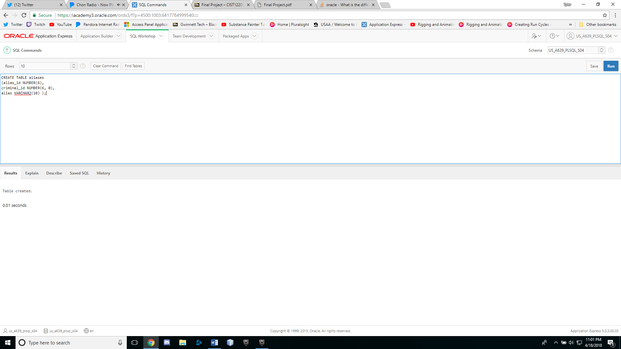

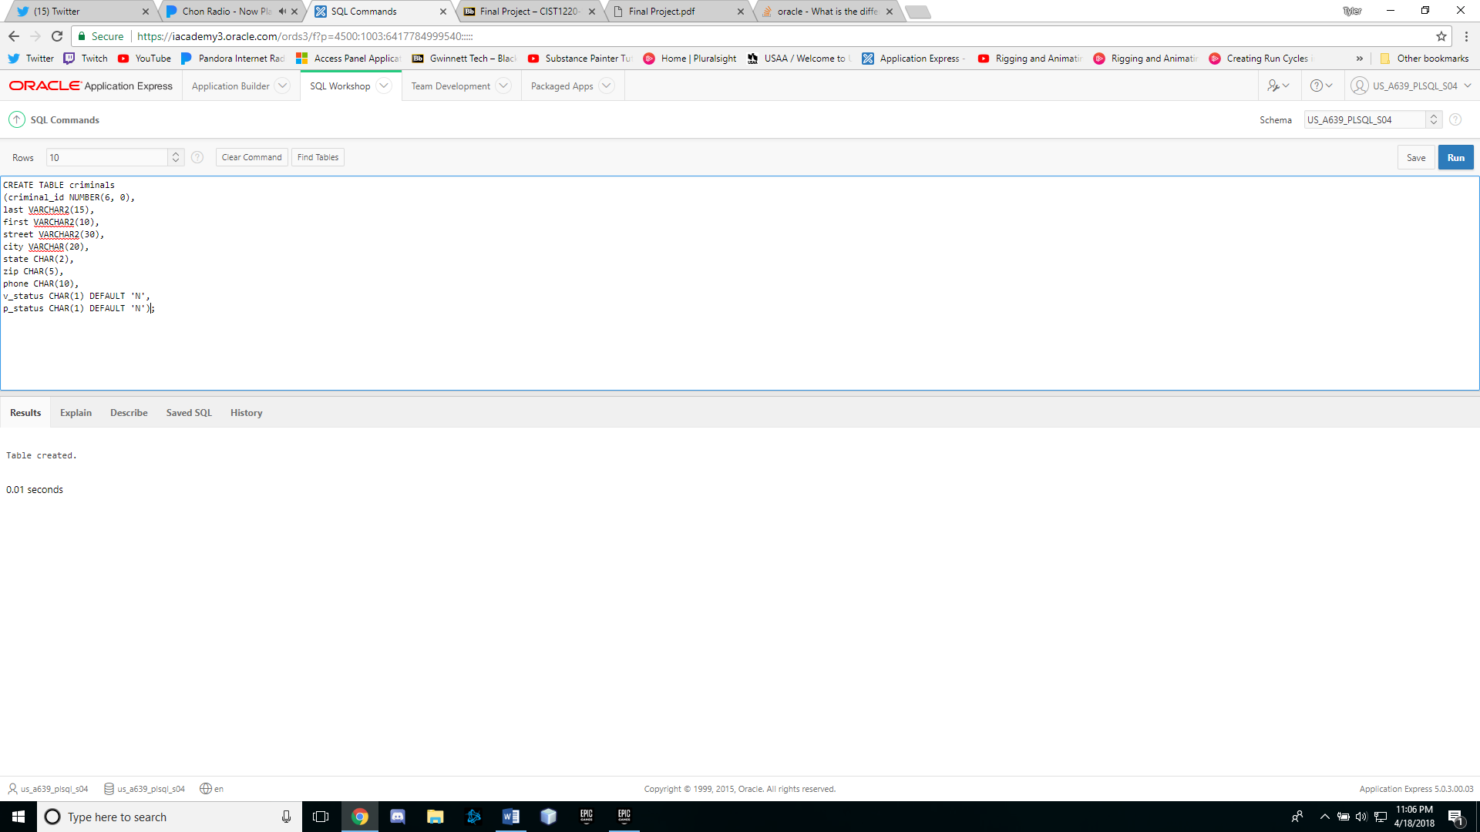

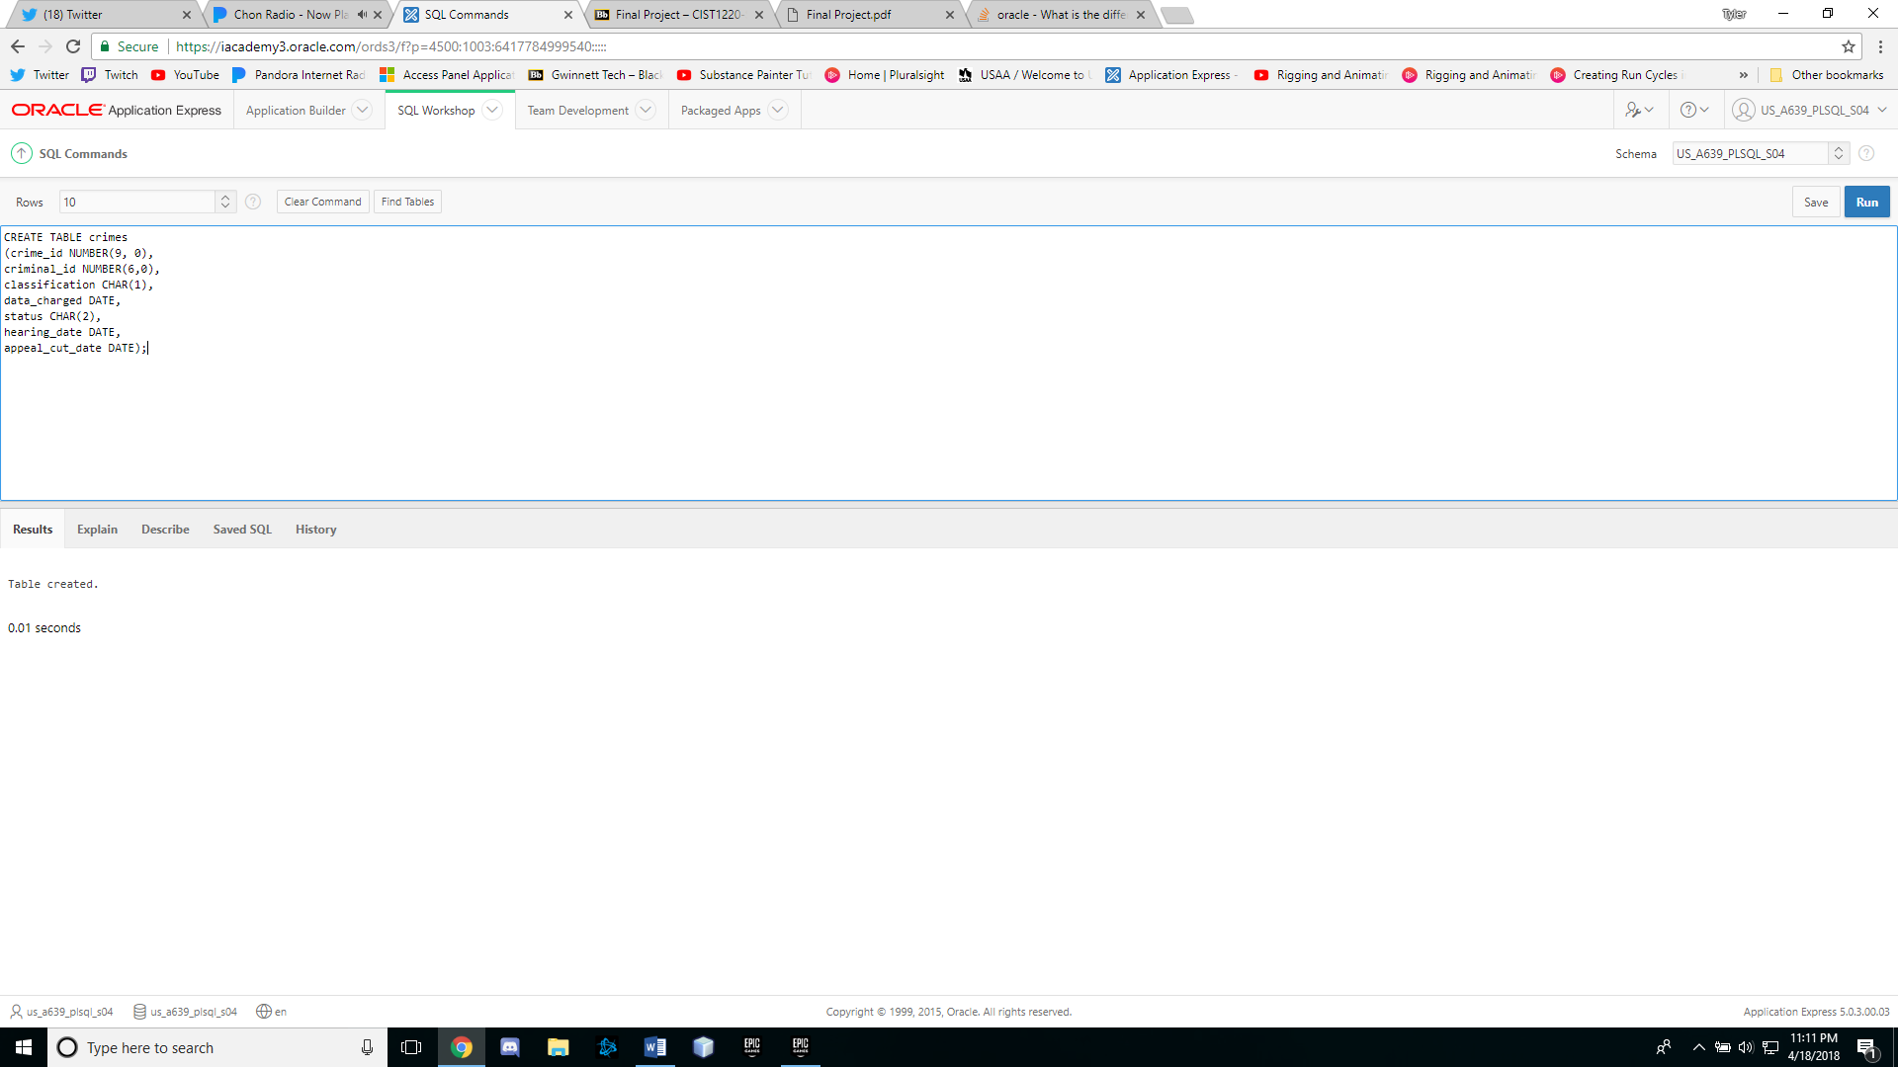

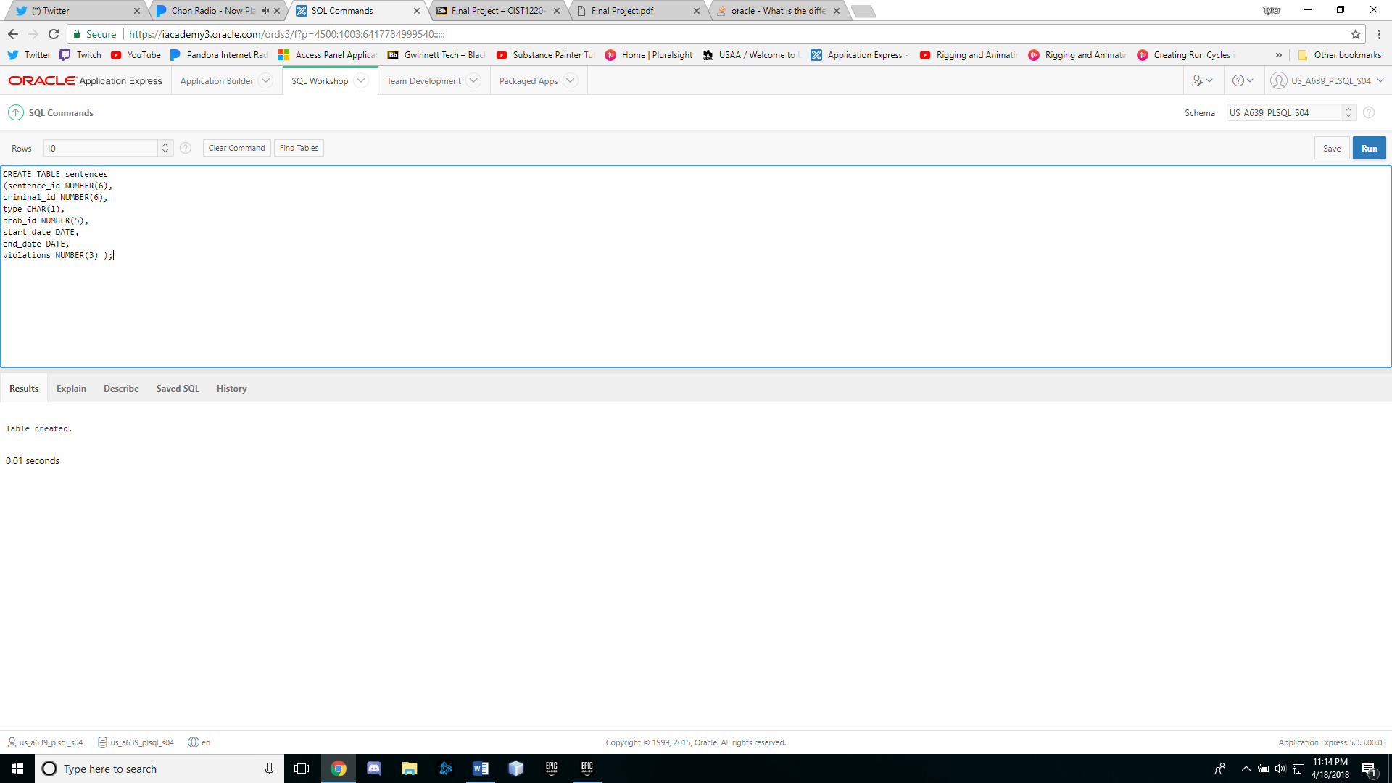

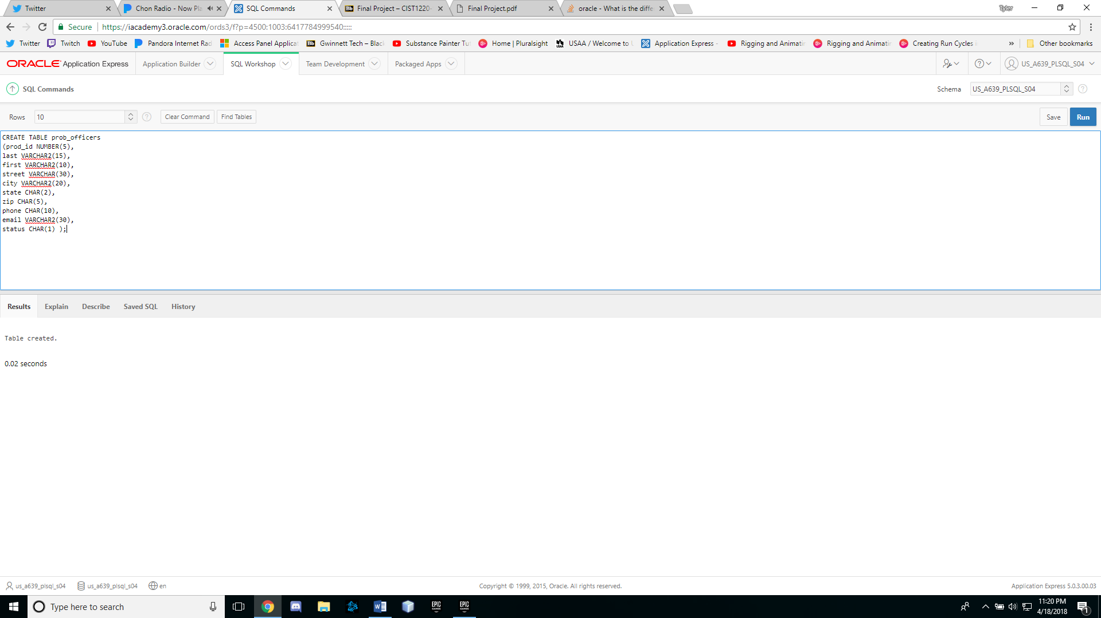

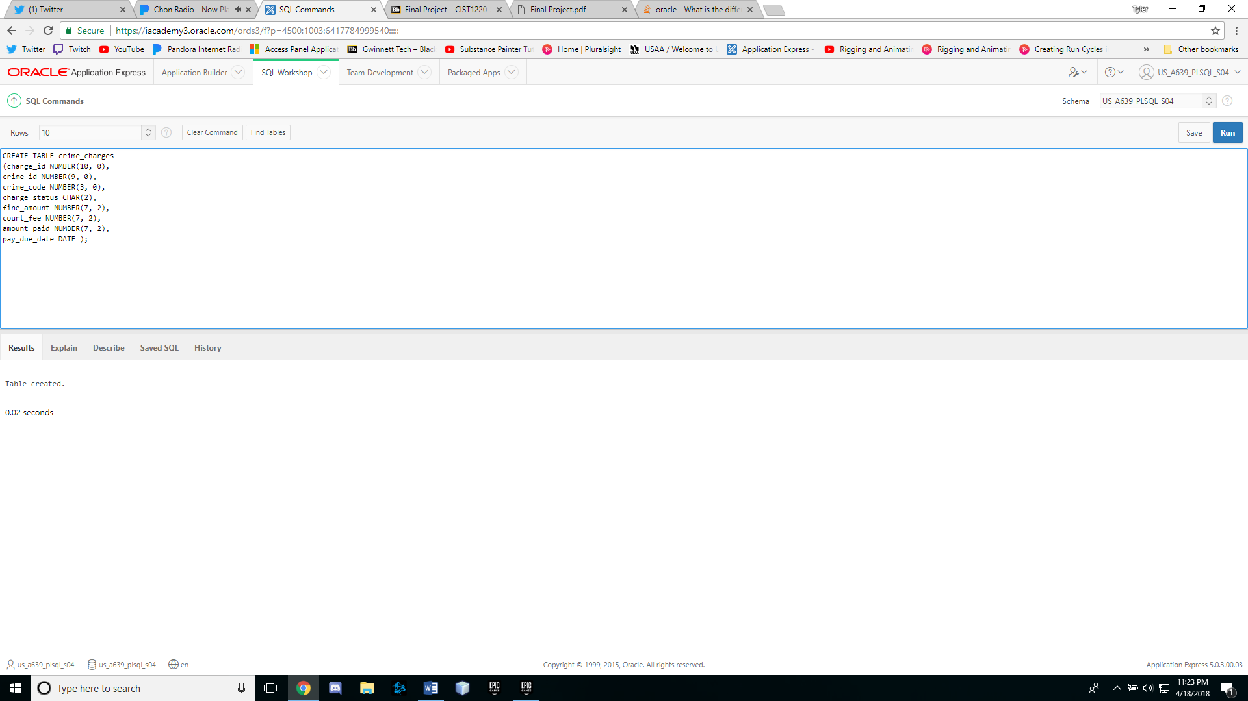

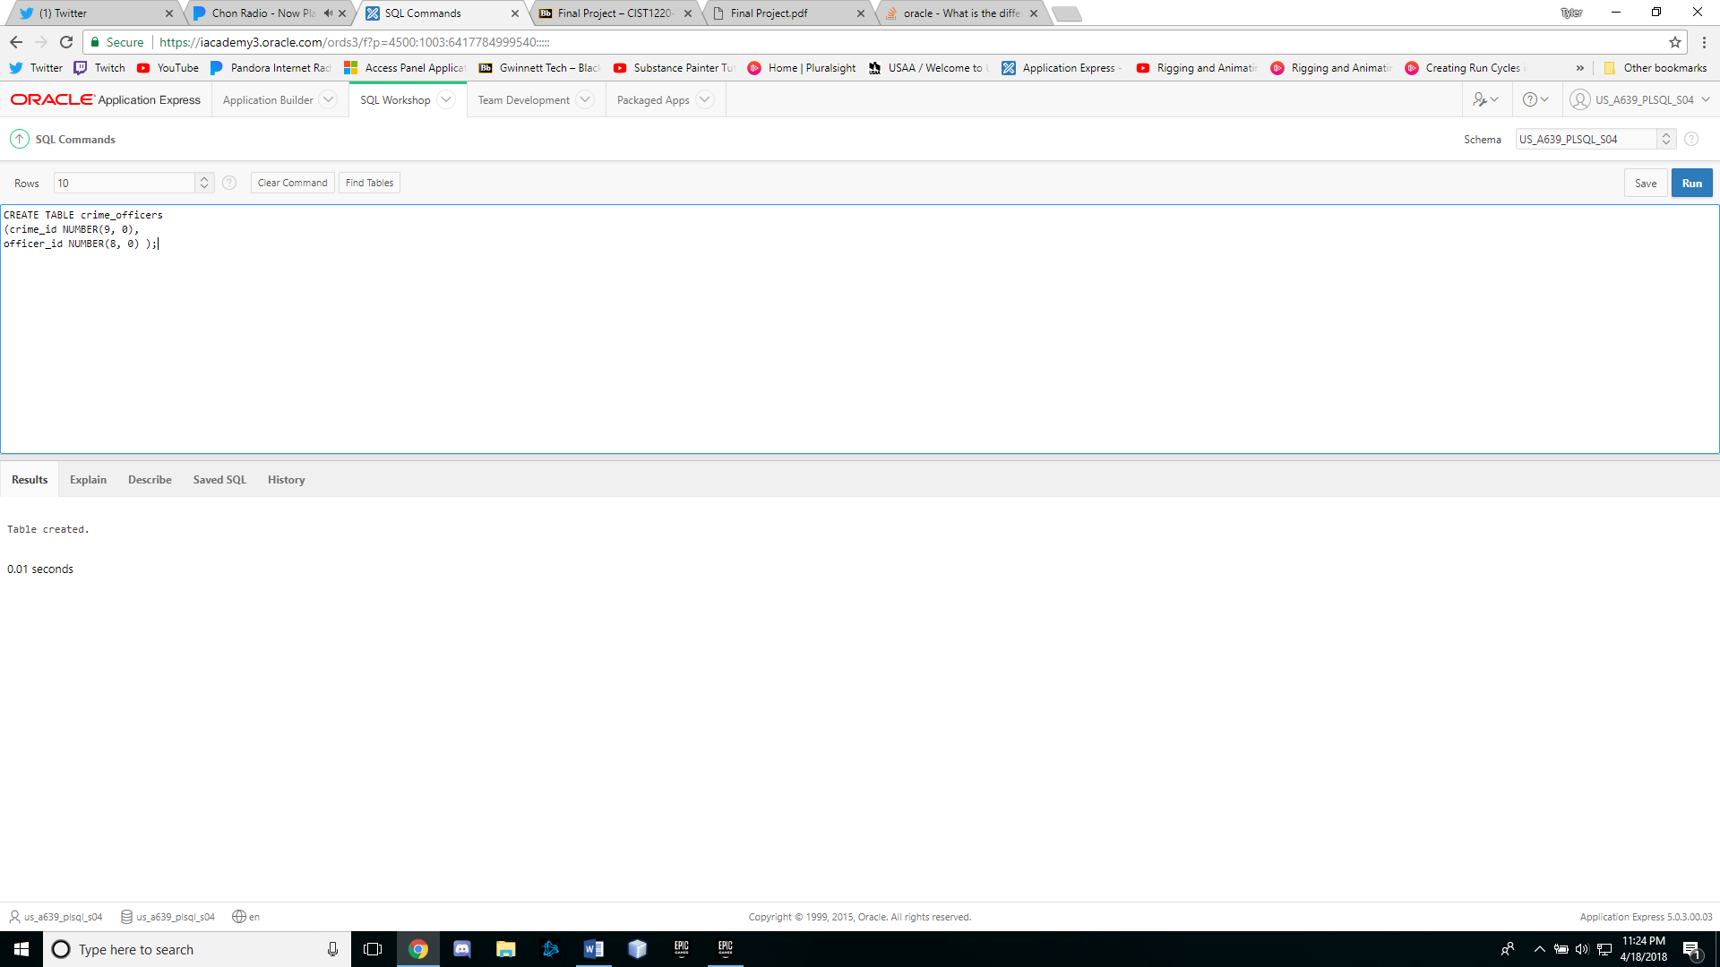

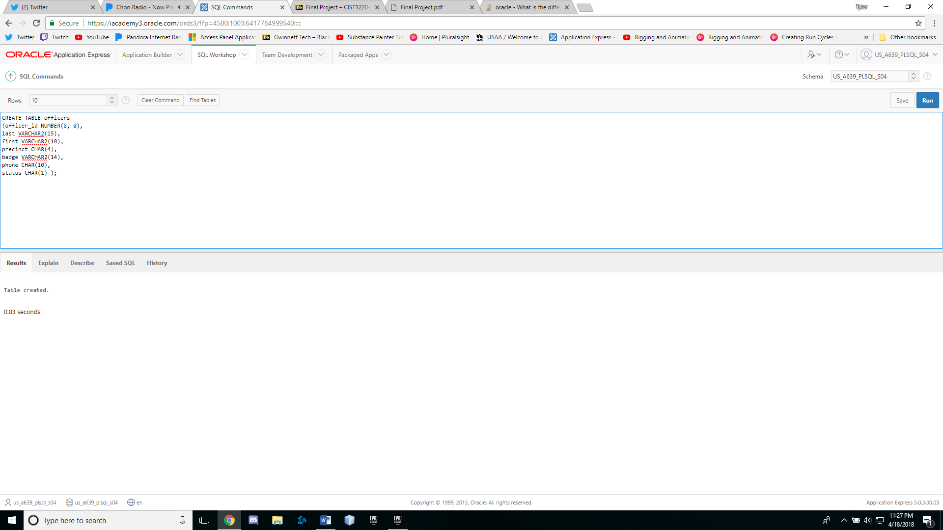

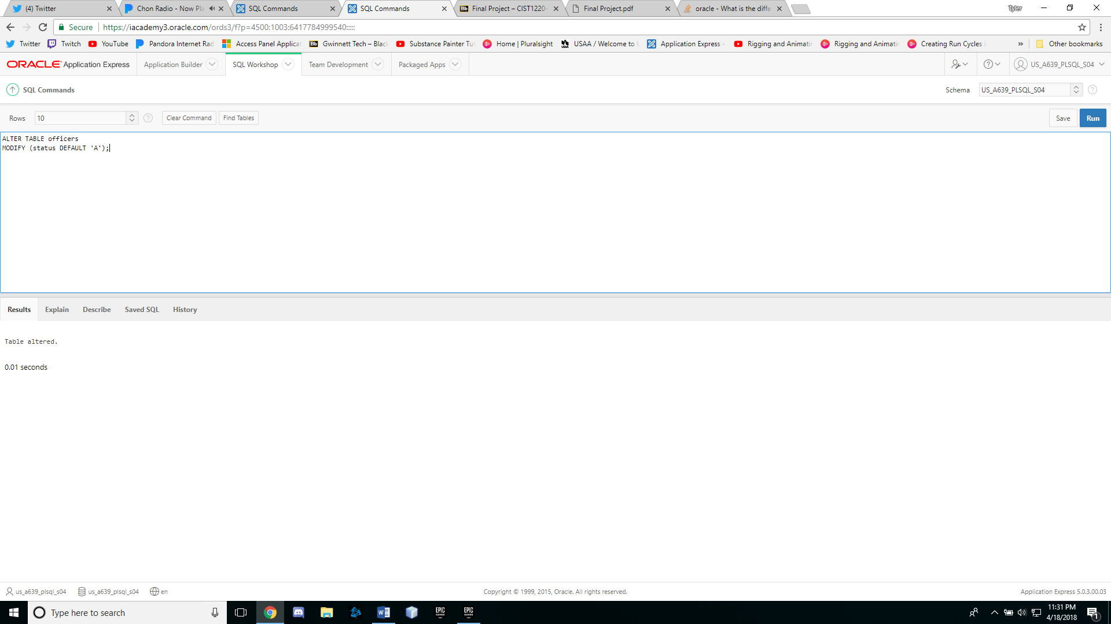

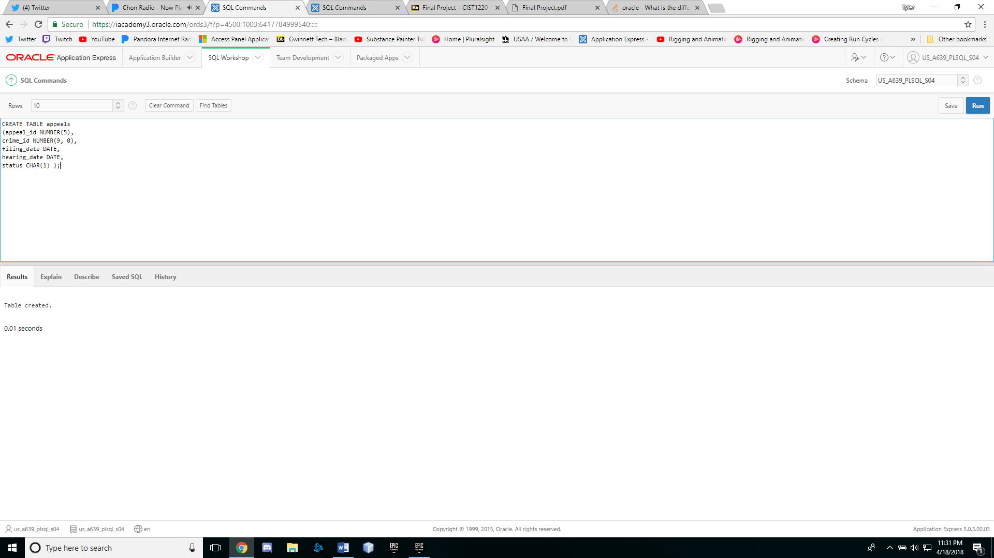

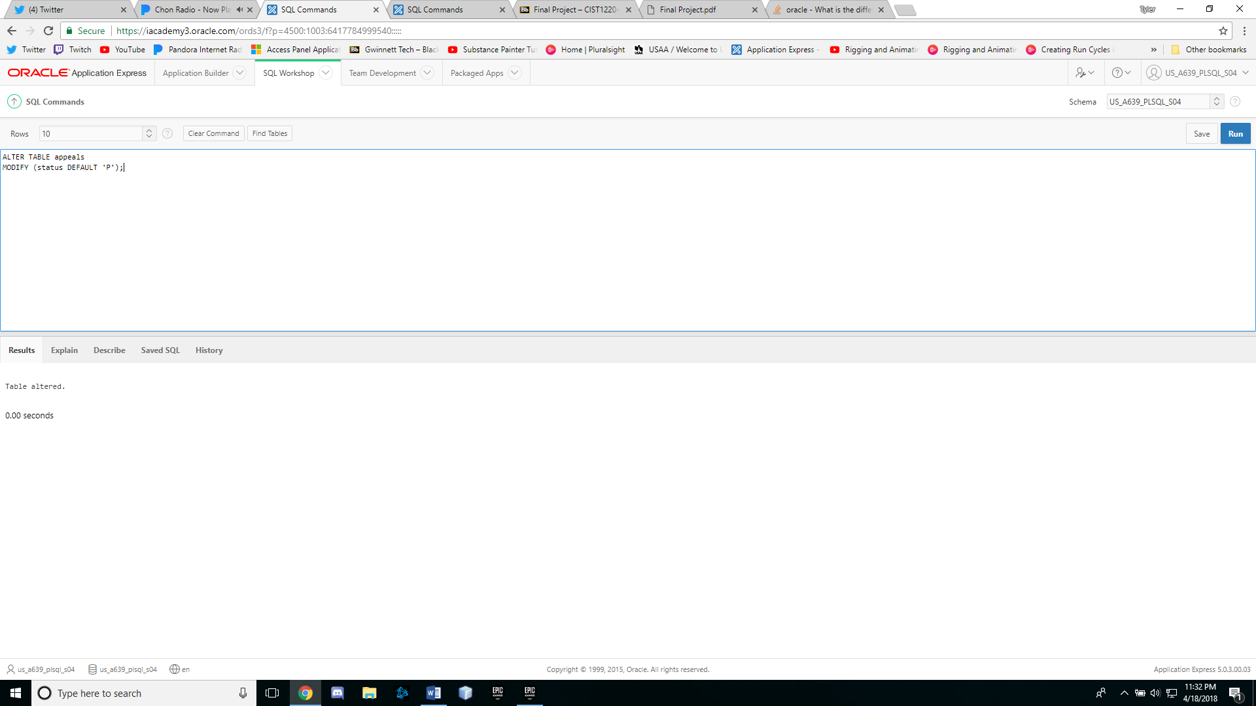

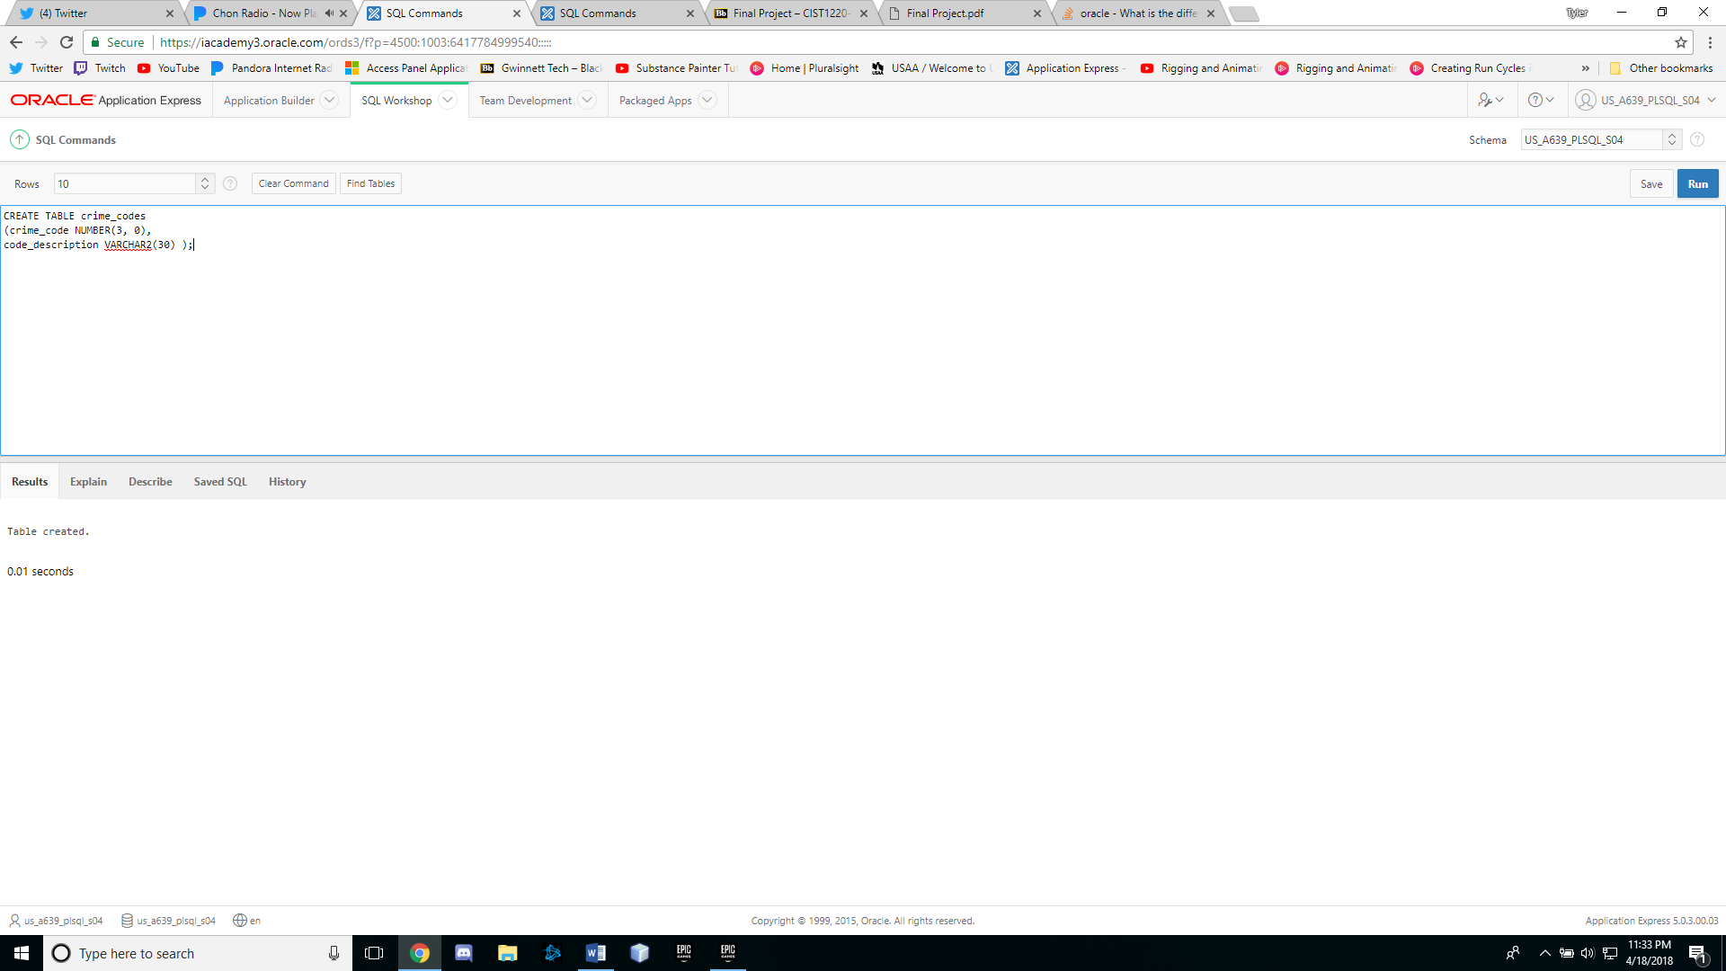

**SCREEN SHOTS (PART 2: SECTION B)**

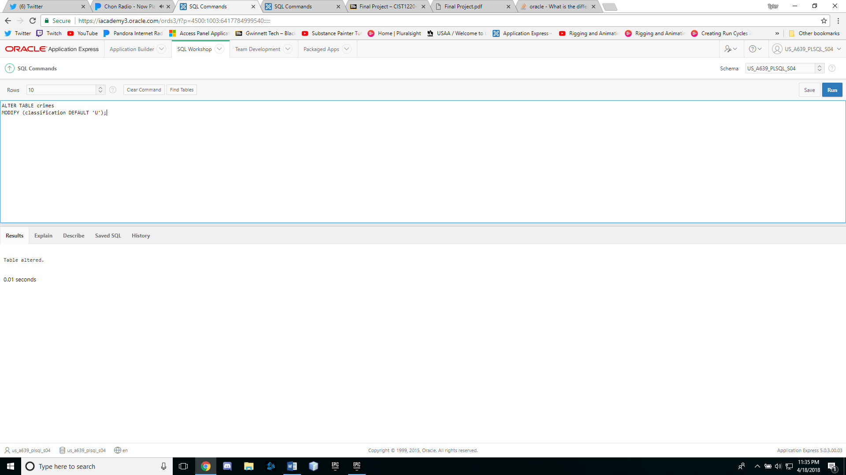

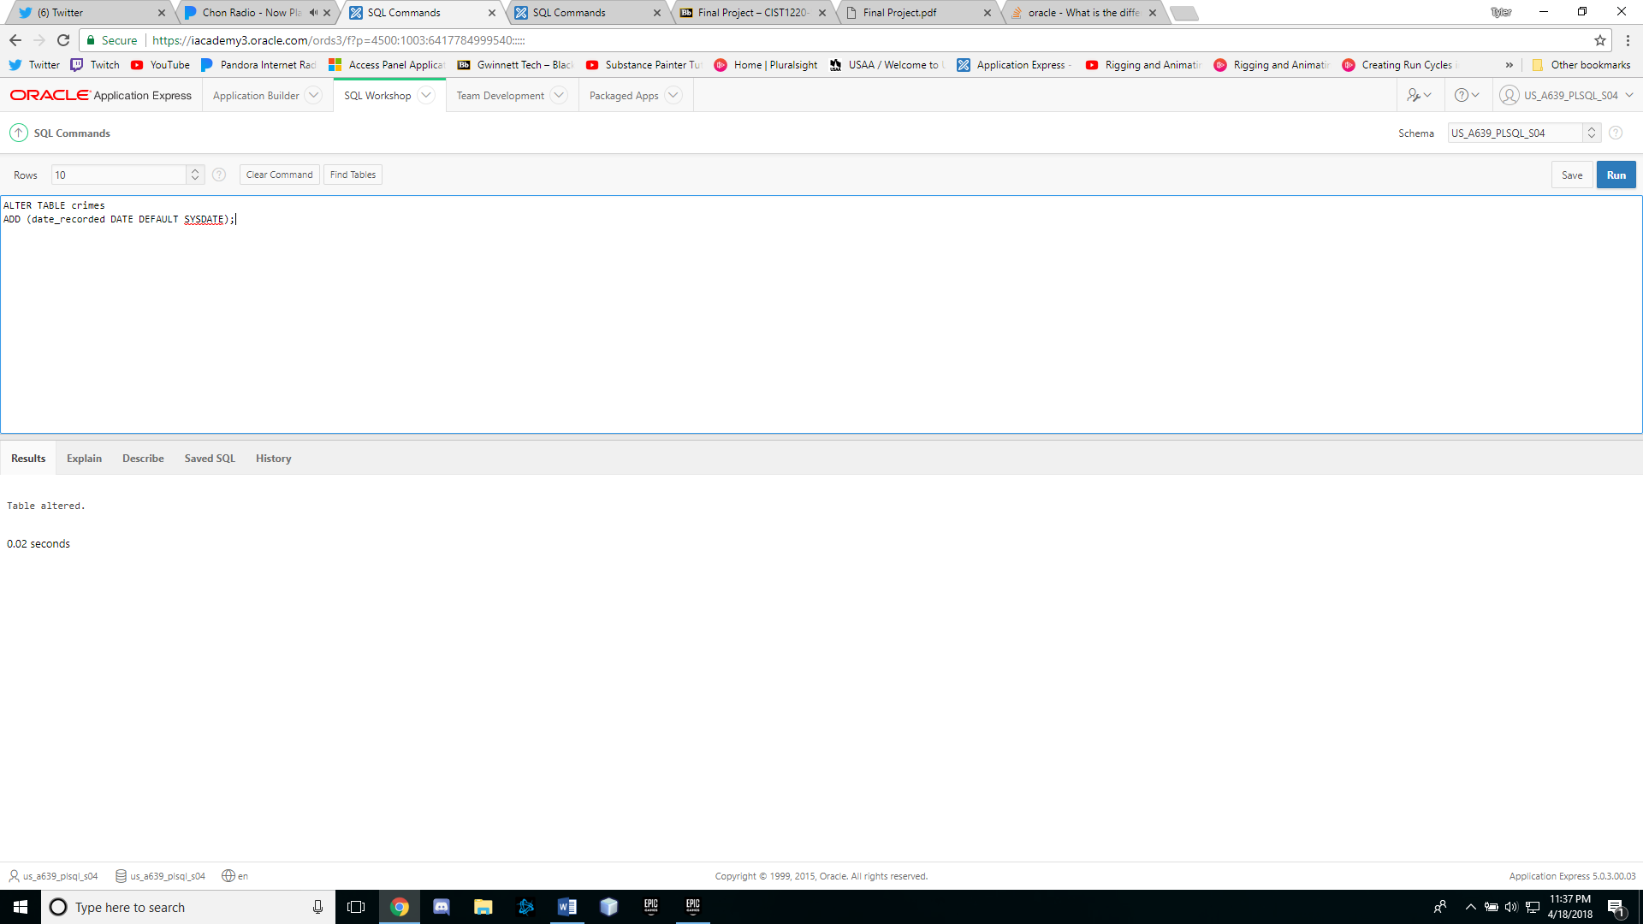

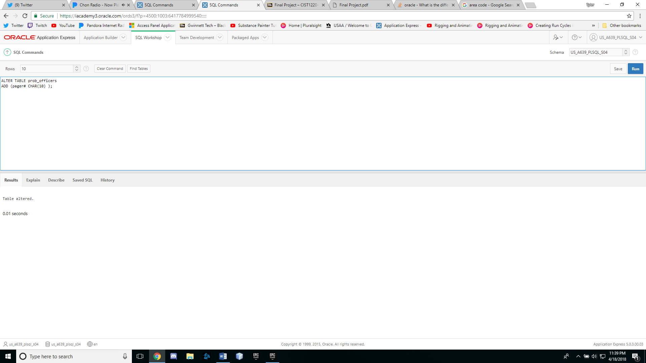

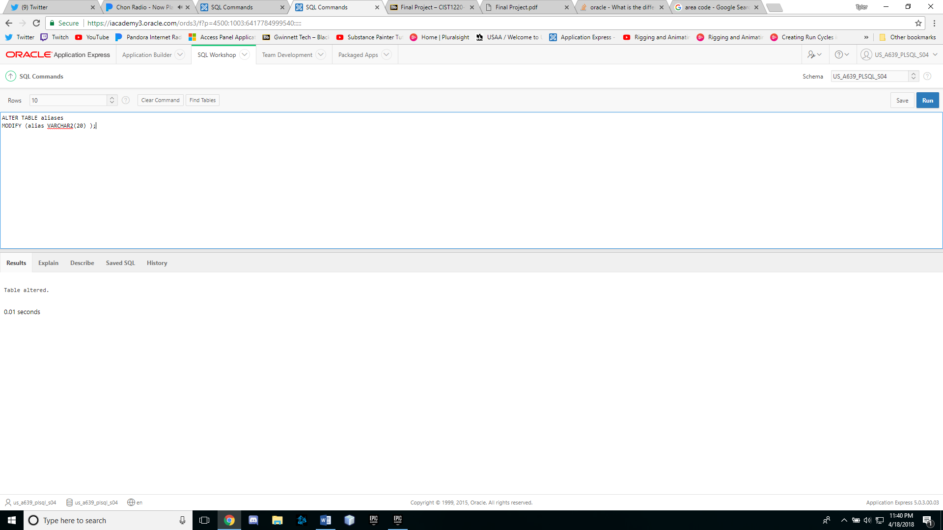

**Part Three:**

In Part2 you have designed and created tables for the City Jail database. These tables don’t include any constraints. Review the information in Chapters 1 and 3 case studies to determine what constraints you might need for the City Jail database.

First, using the format in the following chart, create a list of constraints needed. Second, create and execute all the SQL statements needed to add these constraints. Follow these steps to create and alter the tables:

1. First, drop the APPEALS, CRIME_OFFICERS, and CRIME_CHARGES tables constructed in Chapter 3. These three tables are to be built last, using a CREATE TABLE command that includes all the necessary constraints.

2. Second, use the ALTER TABLE command to add all constraints to the existing tables. Note that the sequence of constraint addition has an impact. Any tables referenced by FOREIGN KEYs must already have the PRIMARY KEY created.

3. Third, use the CREATE TABLE command, including all constraints, to build the three tables dropped in the first step.