Tyler Butler

SQL

4/7/18

Lab 12

1. List the book title and retail price for all books with a retail price lower than the average

retail price of all books sold by JustLee Books.

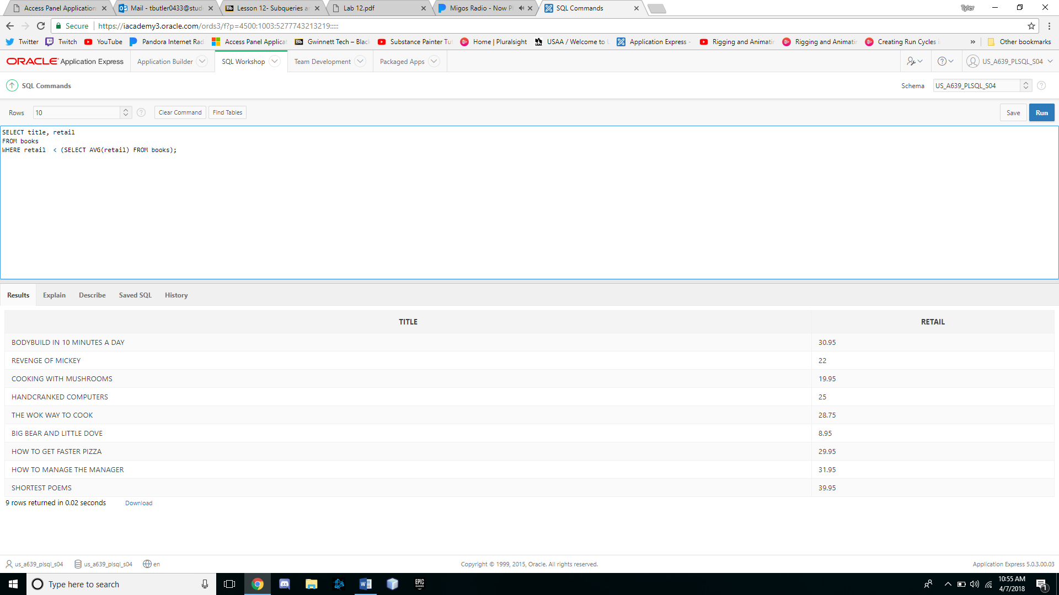

2. Determine which books cost less than the average cost of other books in the same

category.

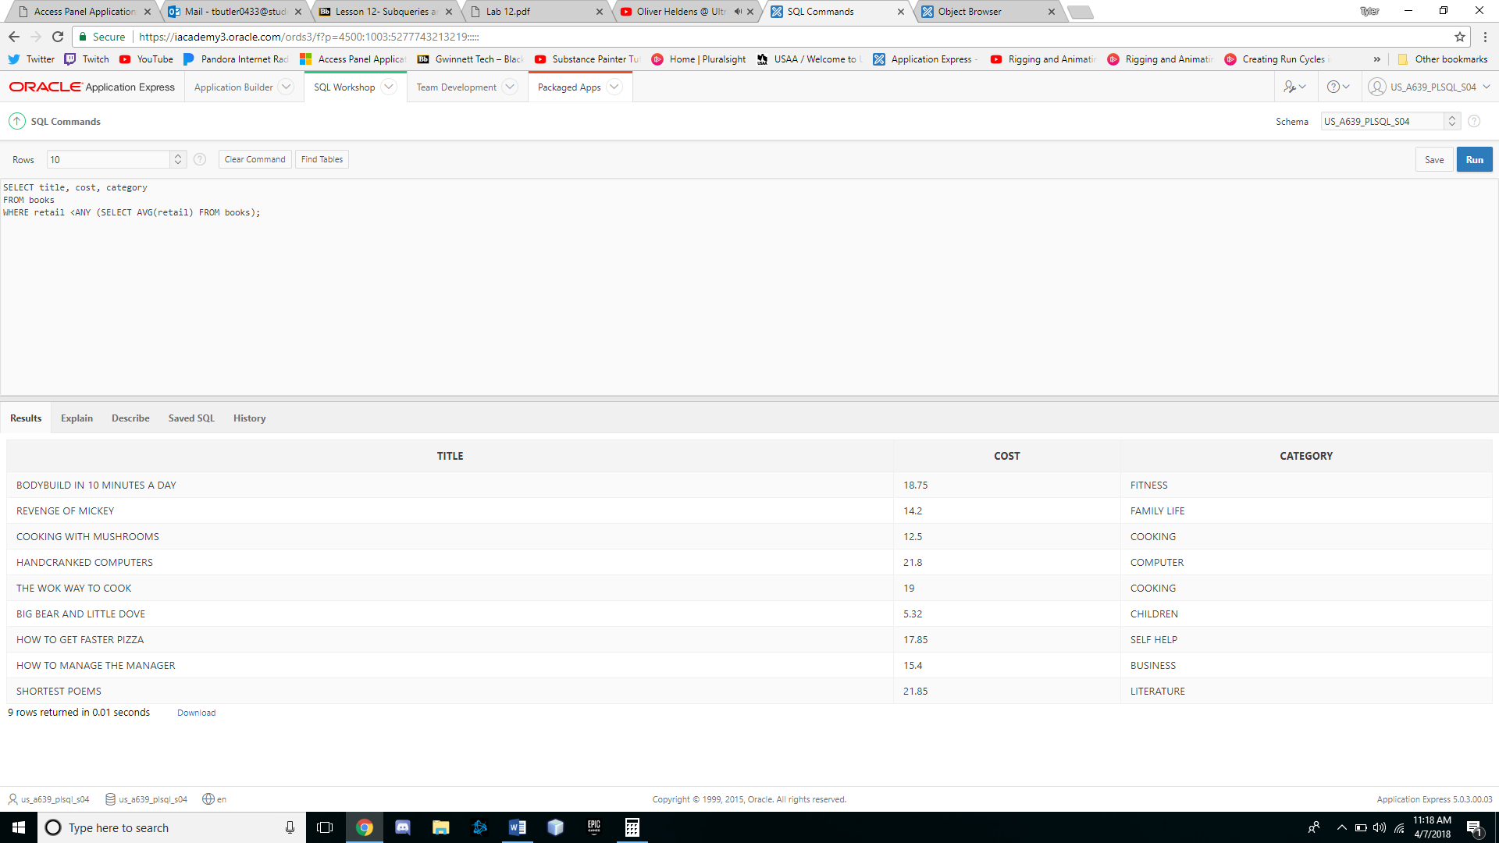

3. Determine which orders were shipped to the same state as order 1014.

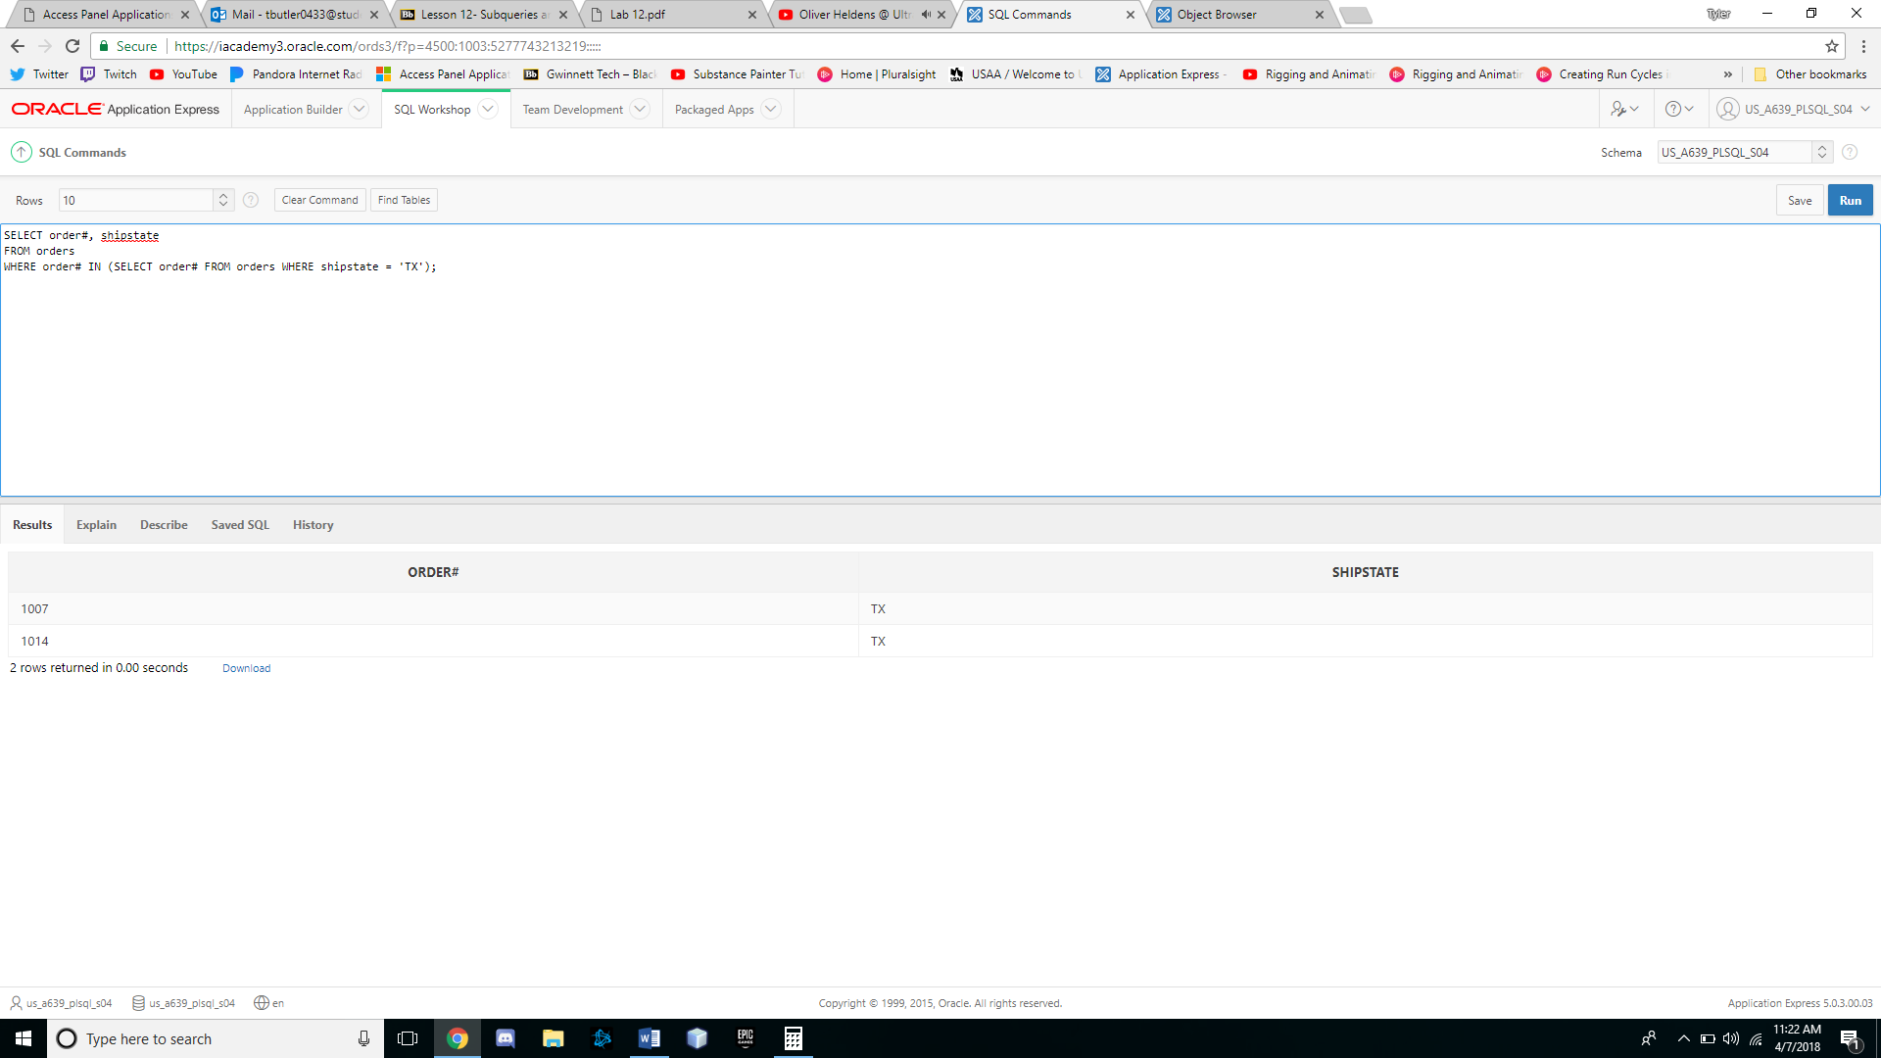

4. Determine which orders had a higher total amount due than order 1008.

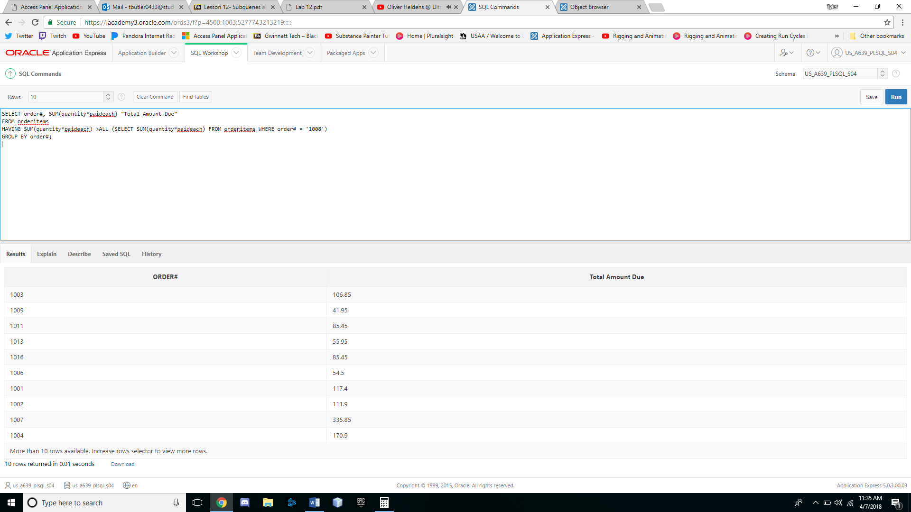

5. Determine which author or authors wrote the books most frequently purchased by

customers of JustLee Books.

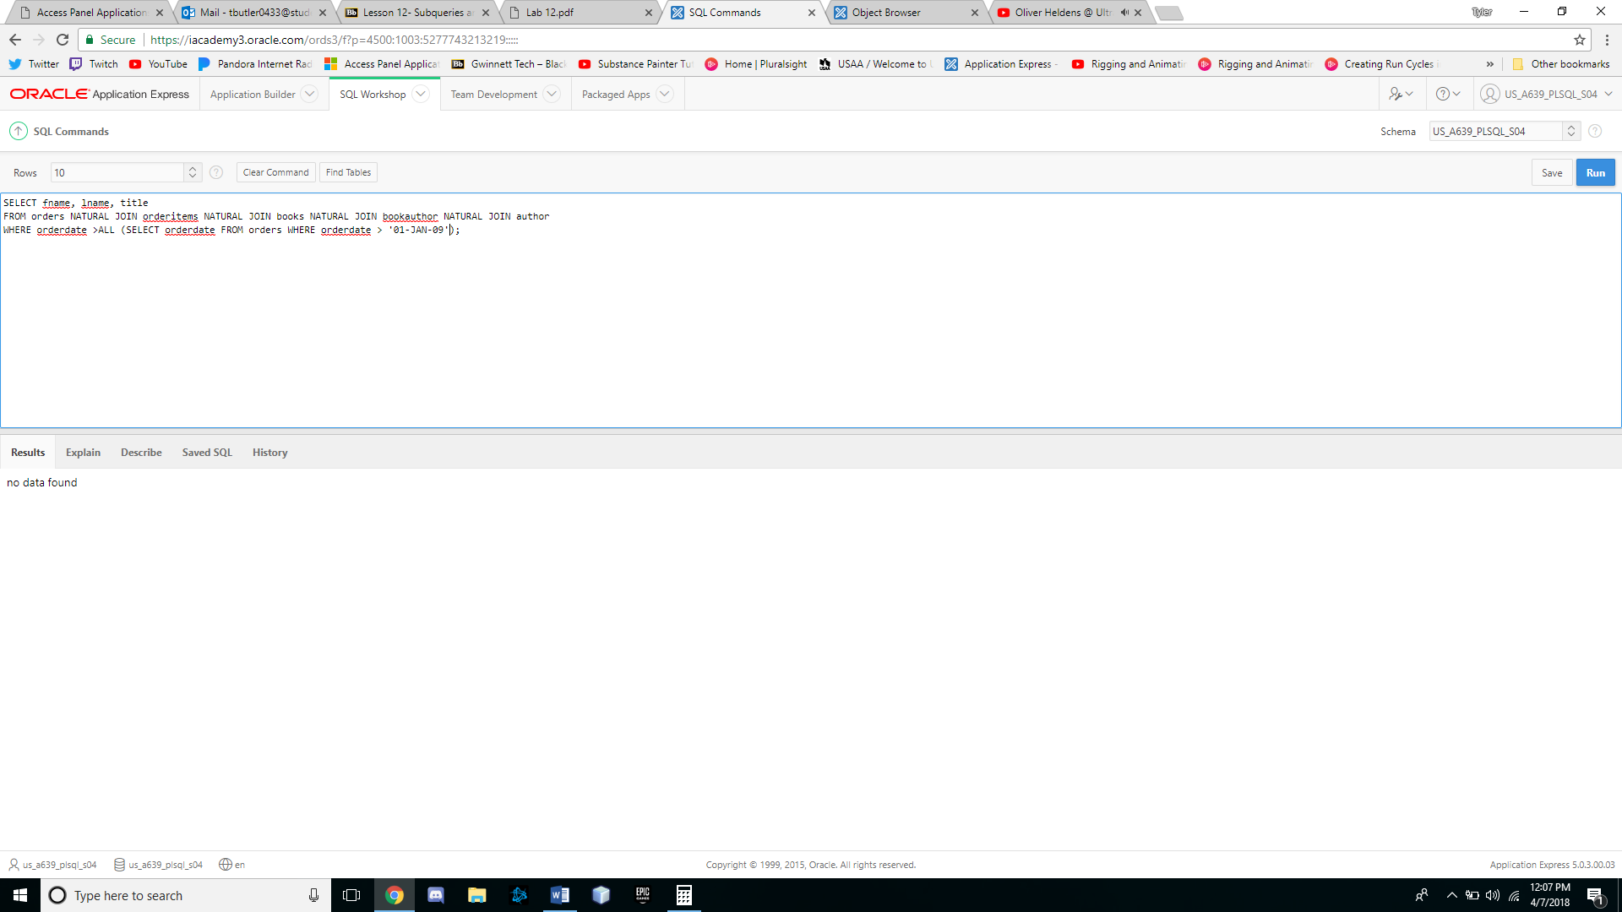

6. List the title of all books in the same category as books previously purchased by

customer 1007. Don’t include books this customer has already purchased.

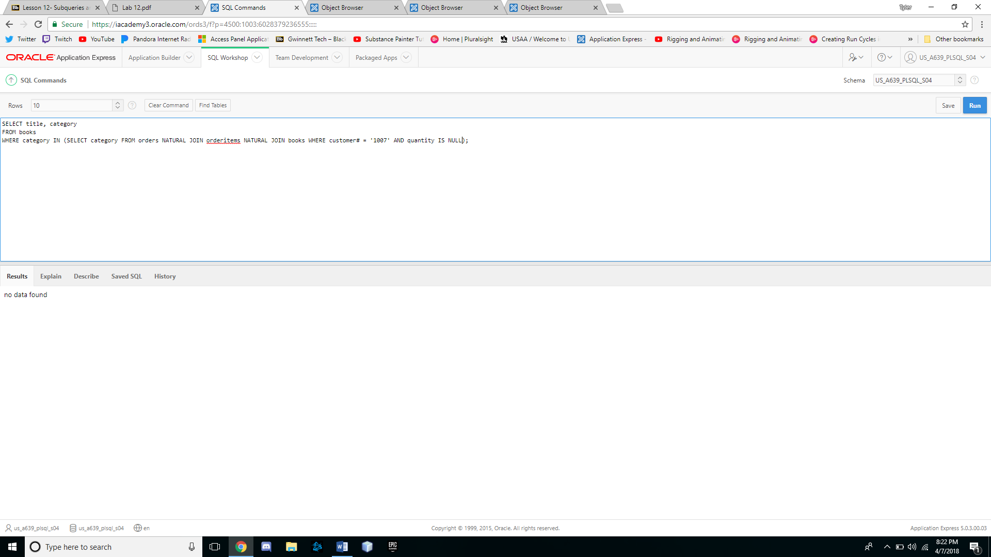

7. List the shipping city and state for the order that had the longest shipping delay.

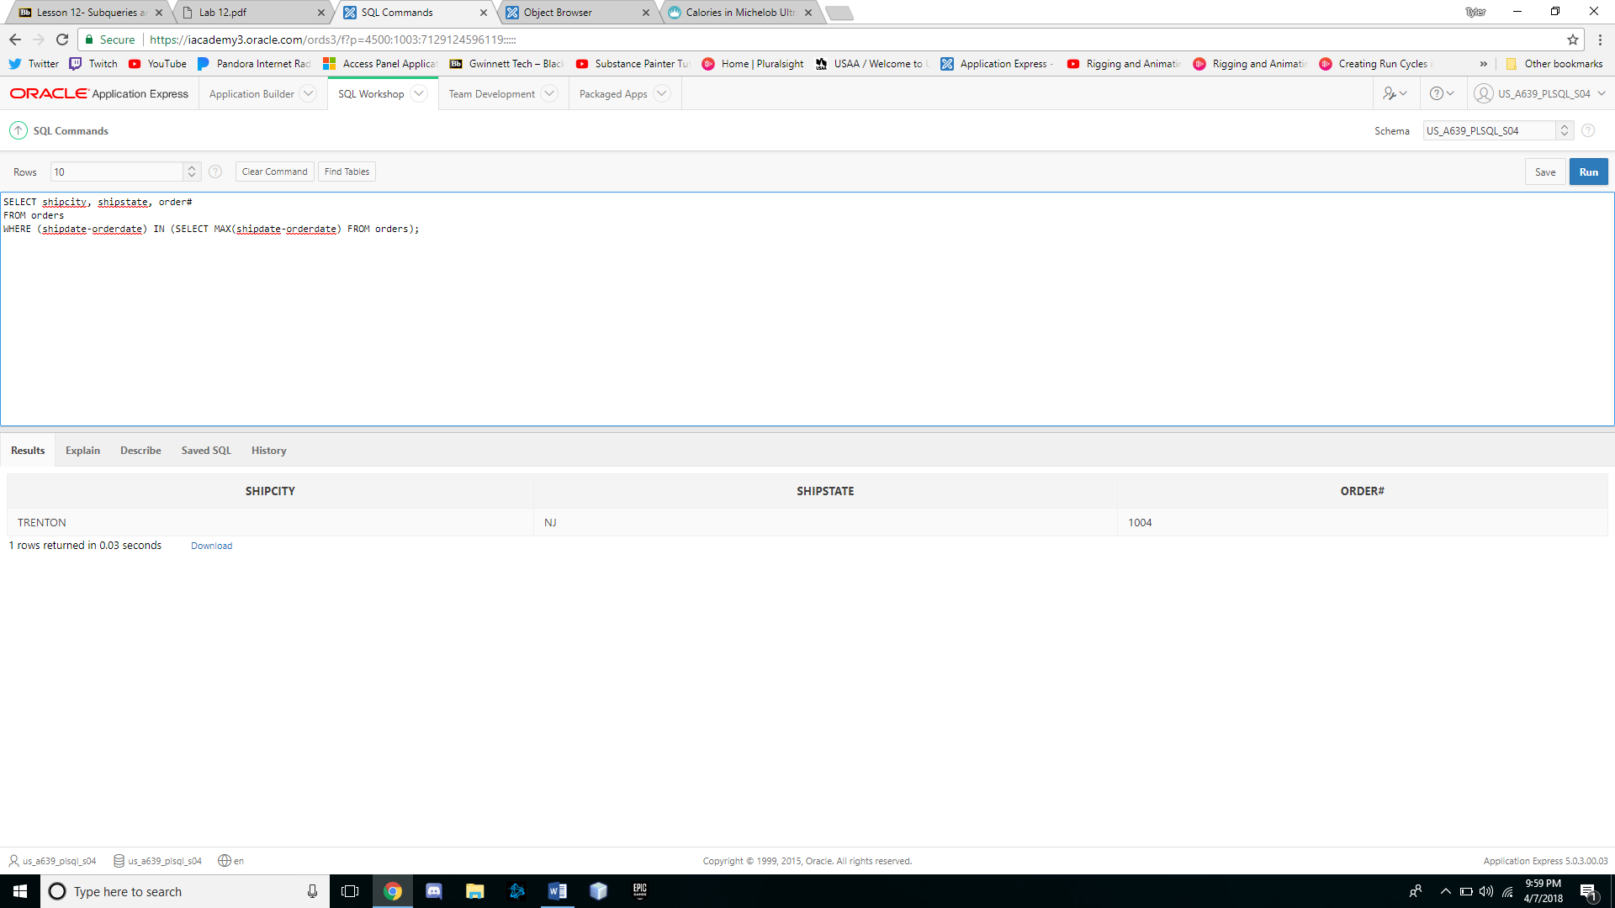

8. Determine which customers placed orders for the least expensive book (in terms of

regular retail price) carried by JustLee Books.

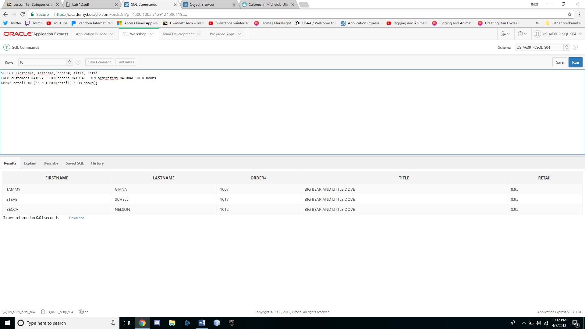

9. Determine the number of different customers who have placed an order for books

written or cowritten by James Austin.

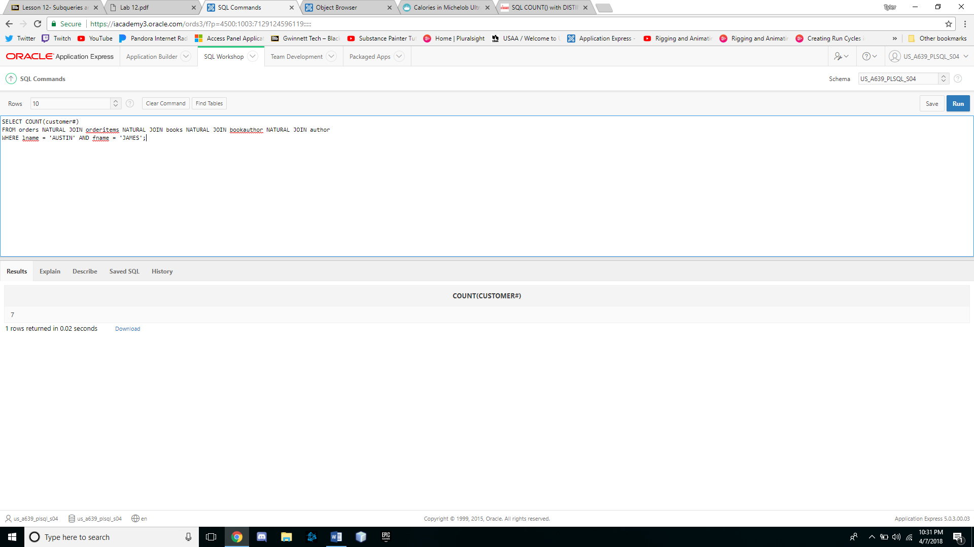

10. Determine which books were published by the publisher of The Wok Way to Cook.

