Tyler Butler

SQL

4/14/18

Lab 13

1. Create a view that lists the name and phone number of the contact person at each

publisher. Don’t include the publisher’s ID in the view. Name the view CONTACT.

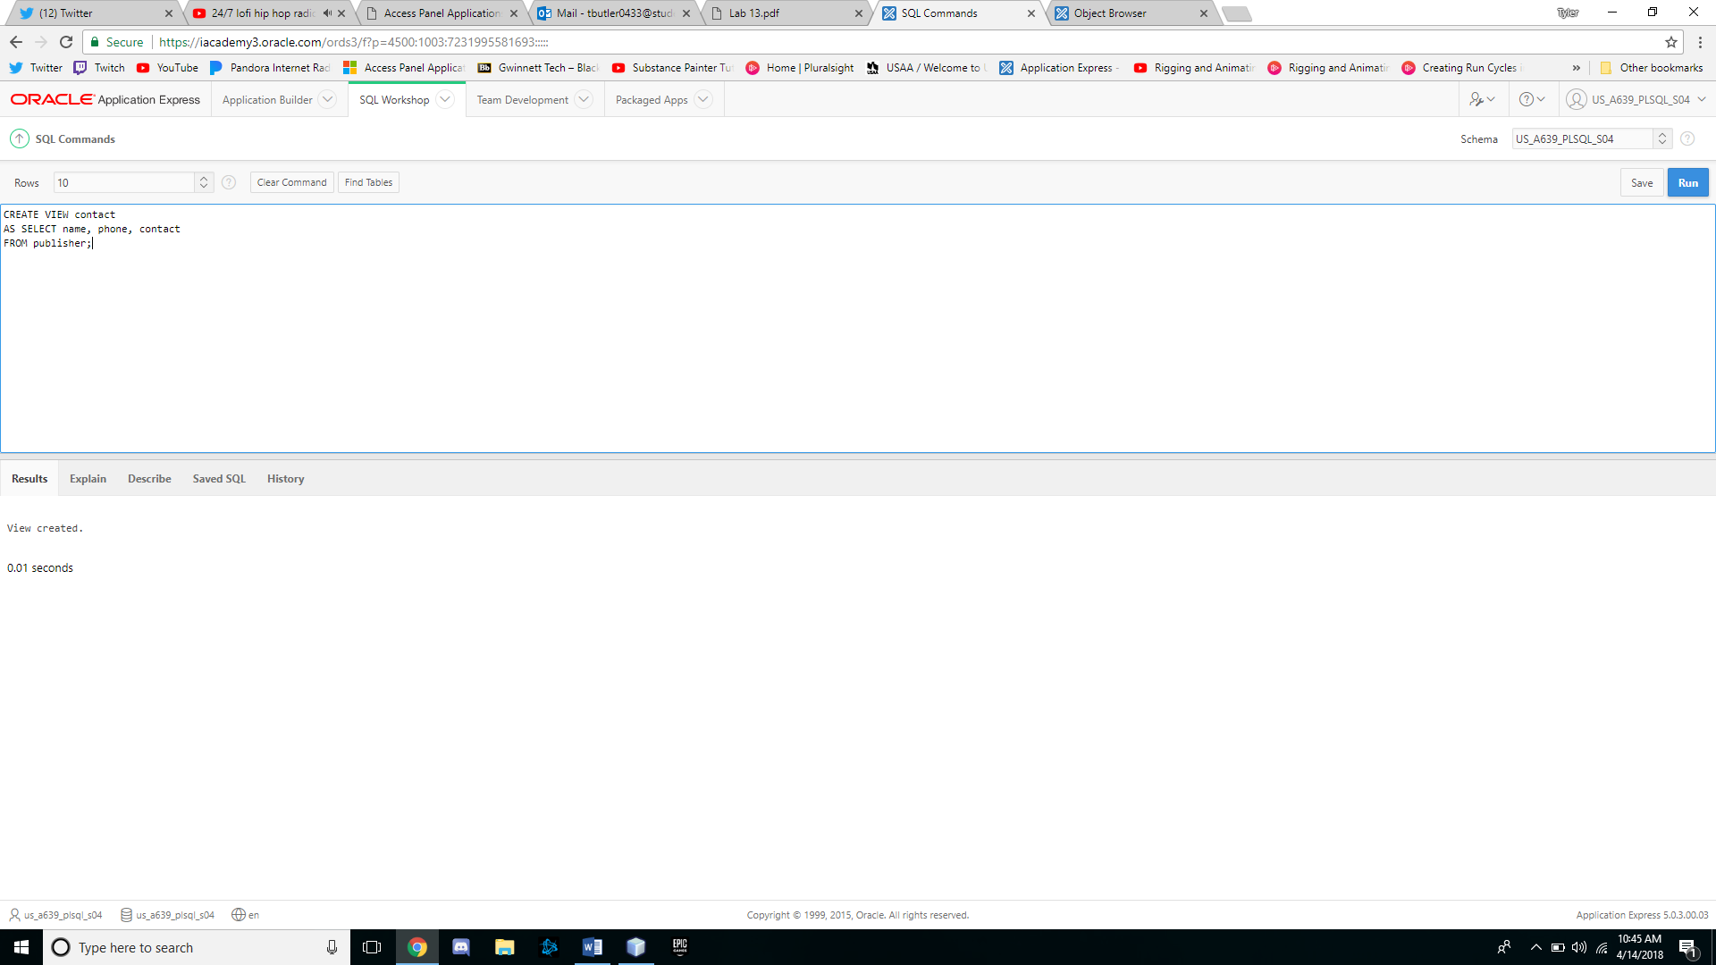

2. Change the CONTACT view so that no users can accidentally perform DML operations on

the view.

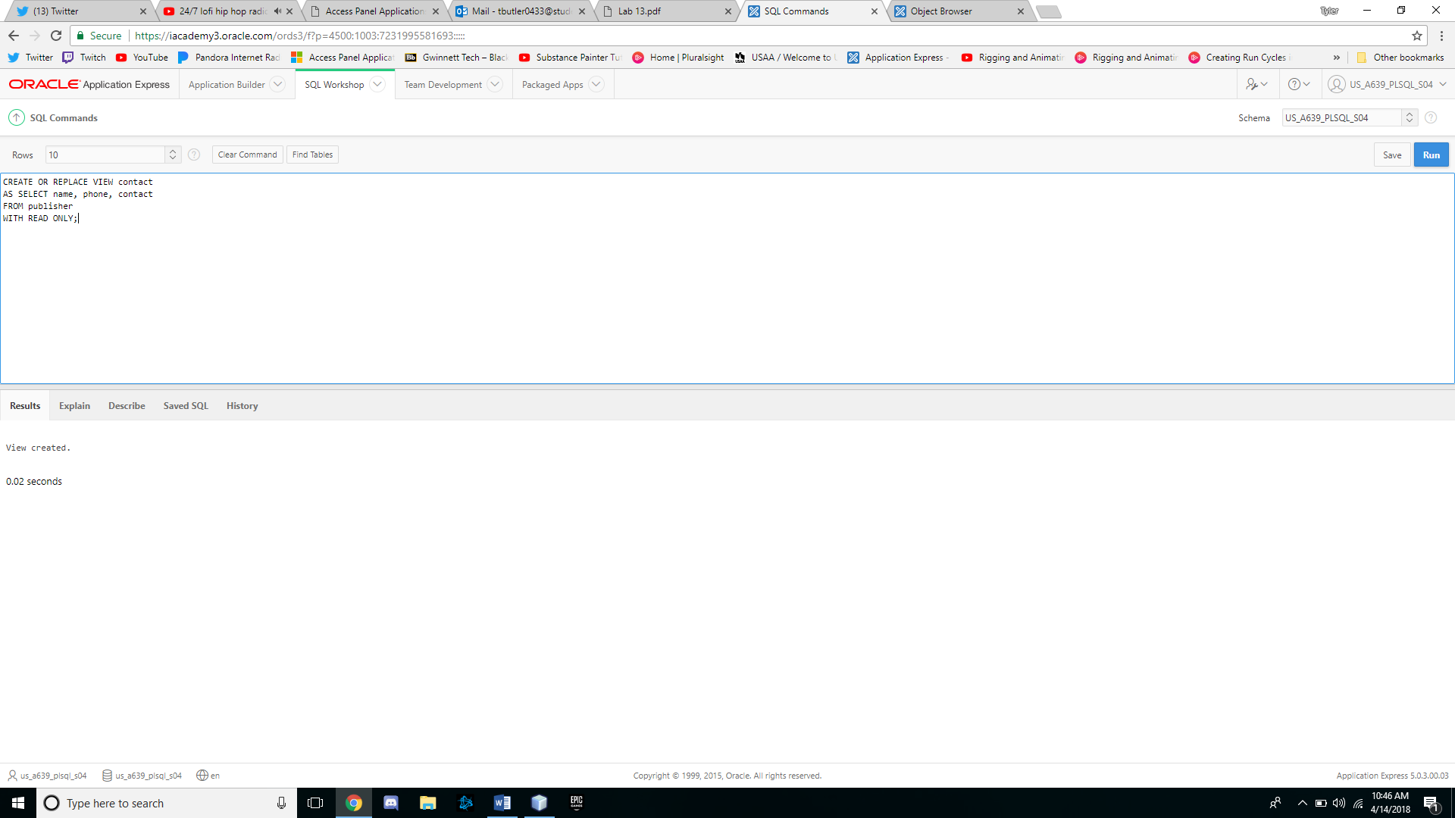

3. Create a view called HOMEWORK13 that includes the columns named Col1 and Col2

from the FIRSTATTEMPT table. Make sure the view is created even if the FIRSTATTEMPT

table doesn’t exist.

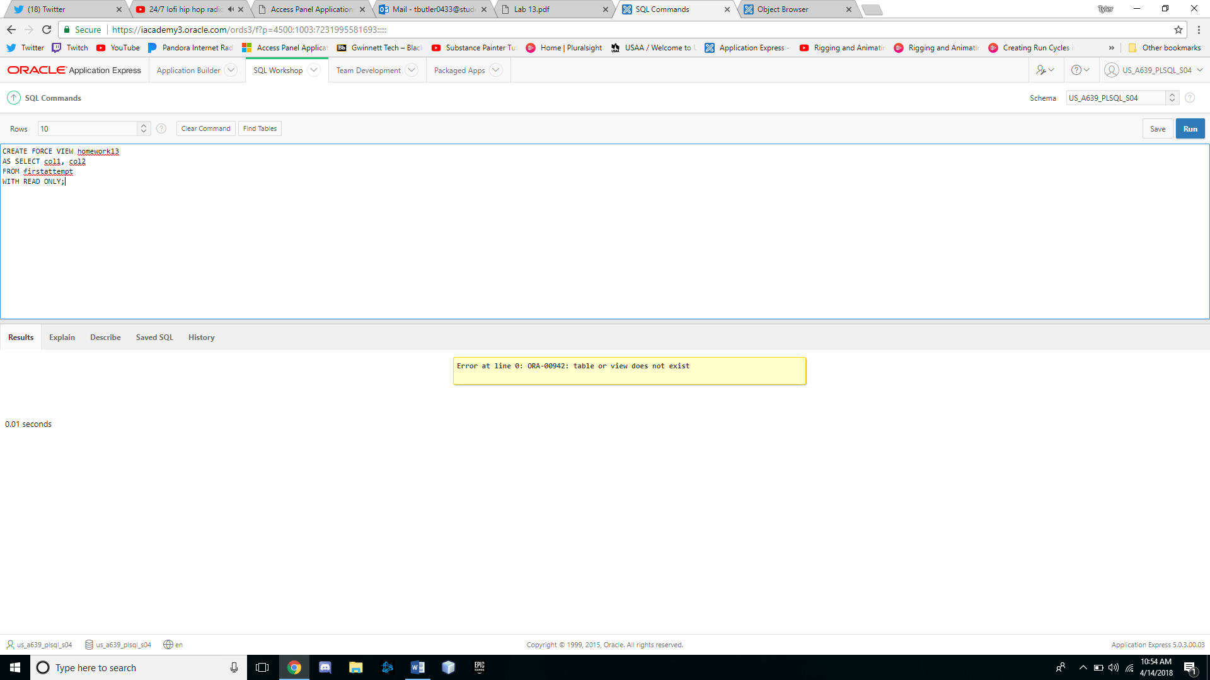

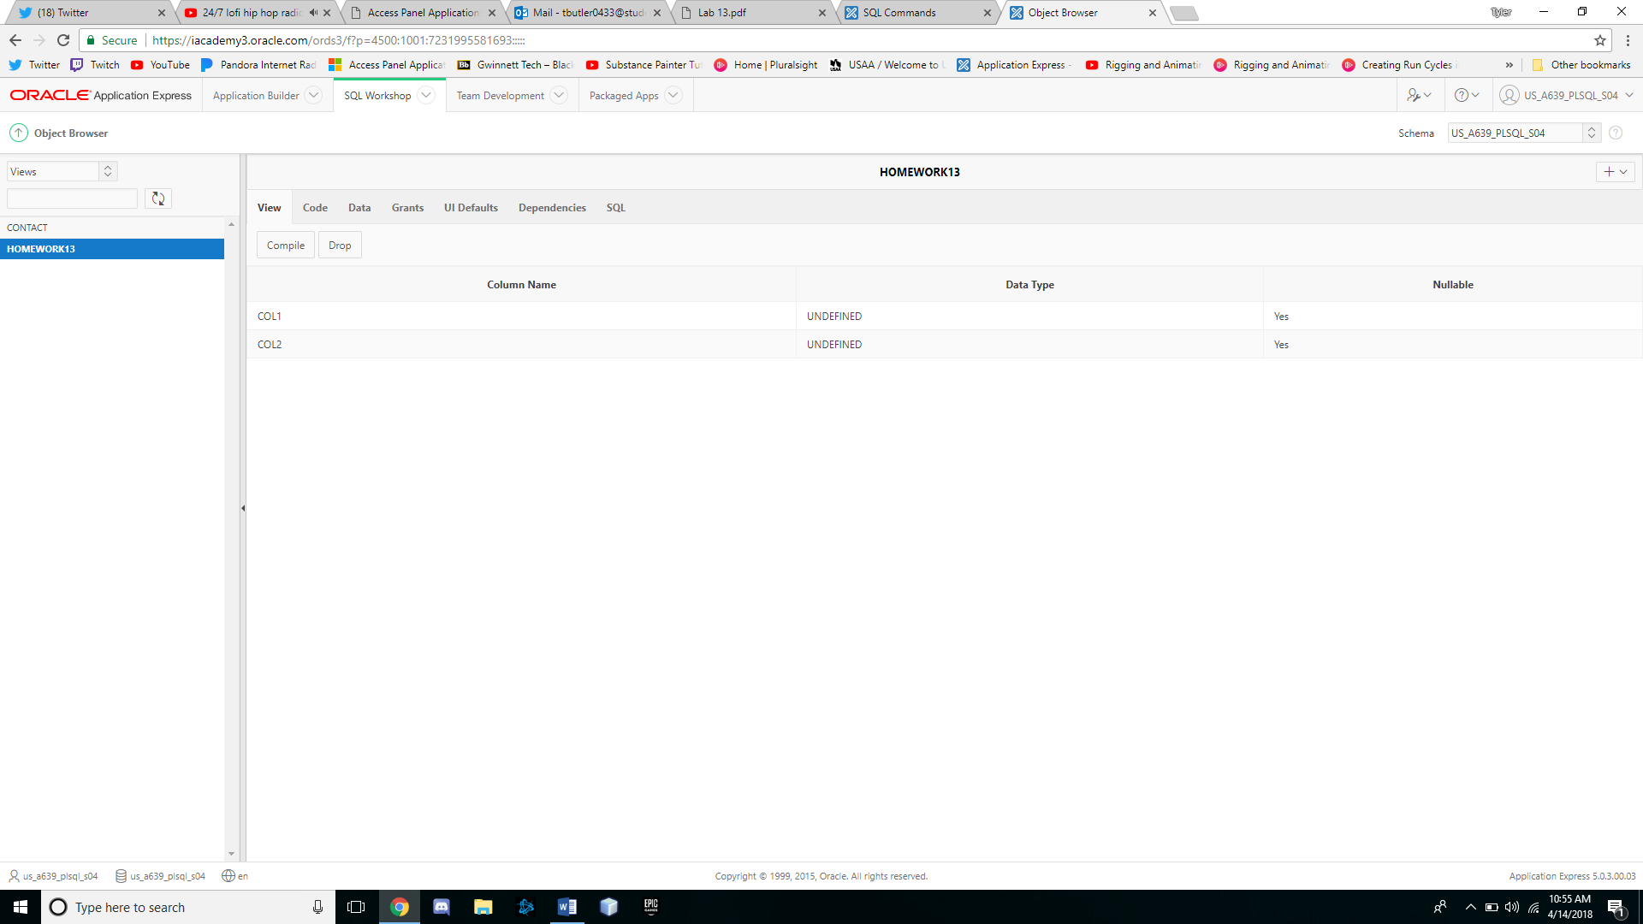

4. Attempt to view the structure of the HOMEWORK13 view.

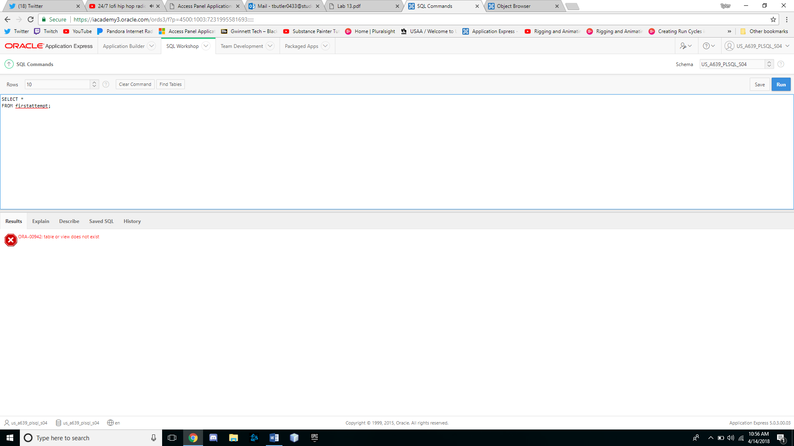

5. Create a view that lists the ISBN and title for each book in inventory along with the

name and phone number of the person to contact if the book needs to be reordered.

Name the view REORDERINFO.

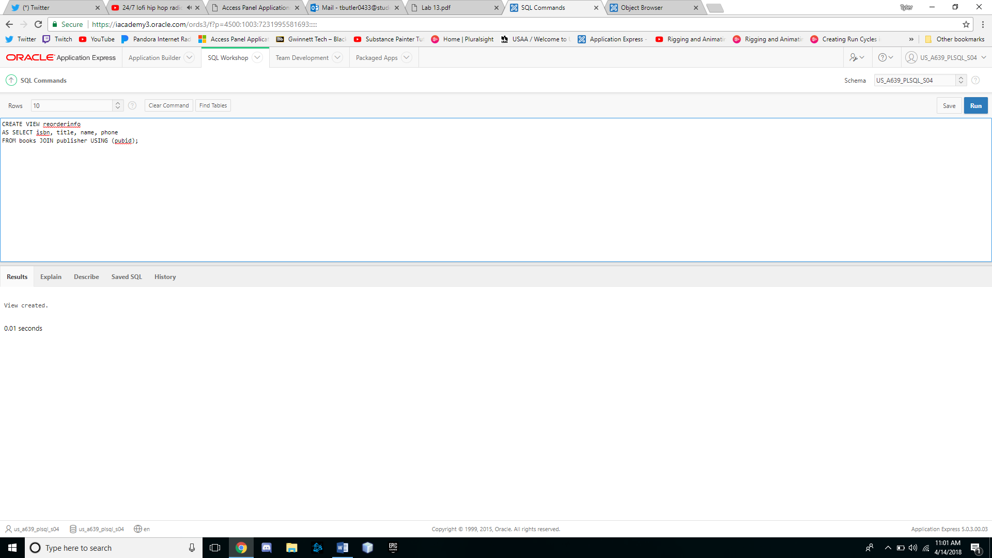

6. Try to change the name of a contact person in the REORDERINFO view to your name.

Was an error message displayed when performing this step? If so, what was the cause

of the error message?

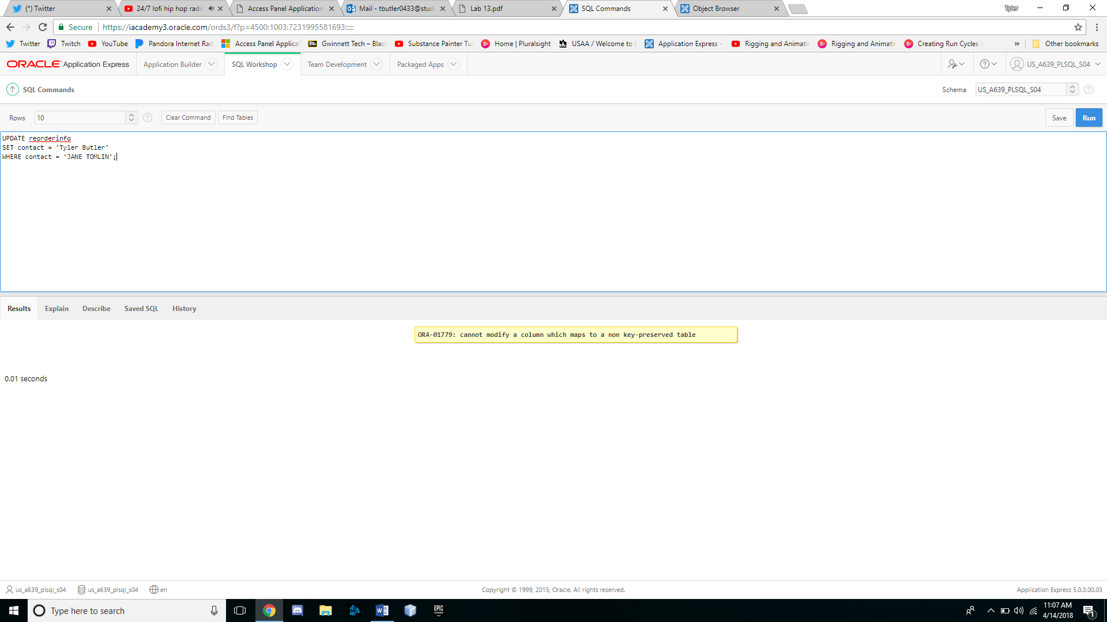

An error was brought up because I tried to update a value that was on a table that the view was not mapped to using a primary key

7. SelectoneofthebooksintheREORDERINFOviewandtrytochangeitsISBN.Wasanerror

message displayed when performing this step? If so, what was the cause of the error

message?

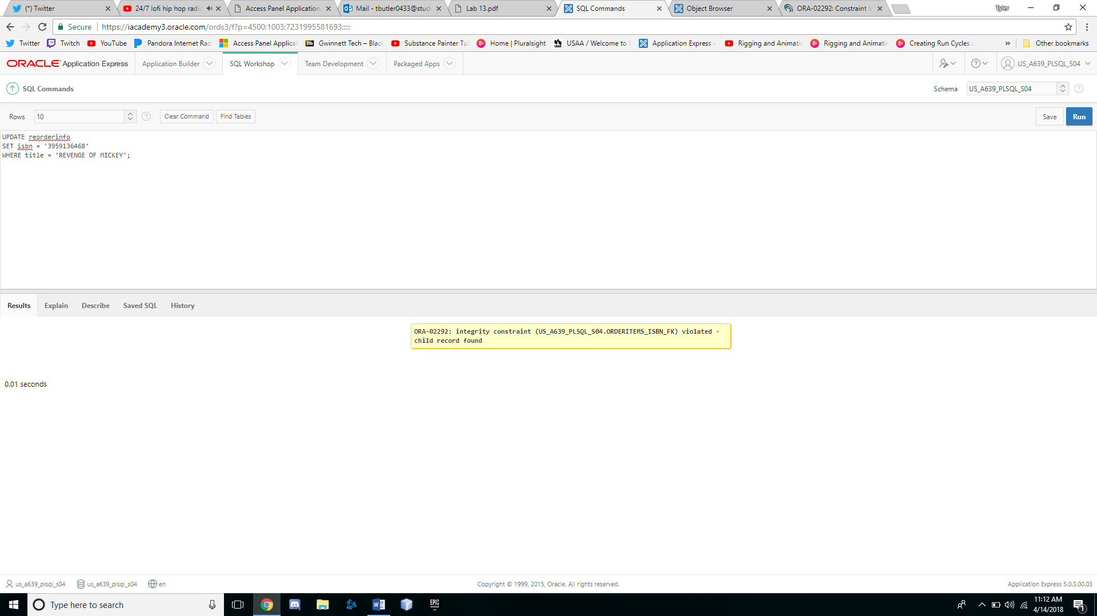

An error was brought up because we were trying to alter a field that is used as a foreign key for the order items table.

8. Delete the record in the REORDERINFO view containing your name. (If you weren’t able to

perform #6 successfully, delete one of the contacts already listed in the table.) Was an

error message displayed when performing this step? If so, what was the cause of the

error message?

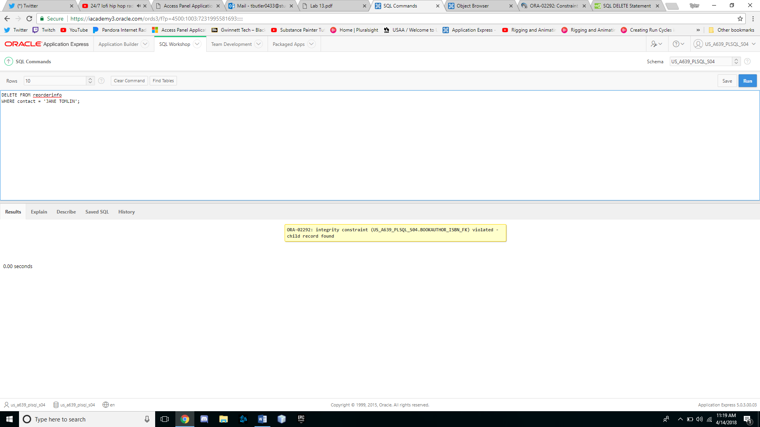

An error popped up because we were trying to delete a record that the bookauthor table uses as a foreign key which flared up a constraint error.

9. Issue a rollback command to undo any changes made with the preceding DML

operations.

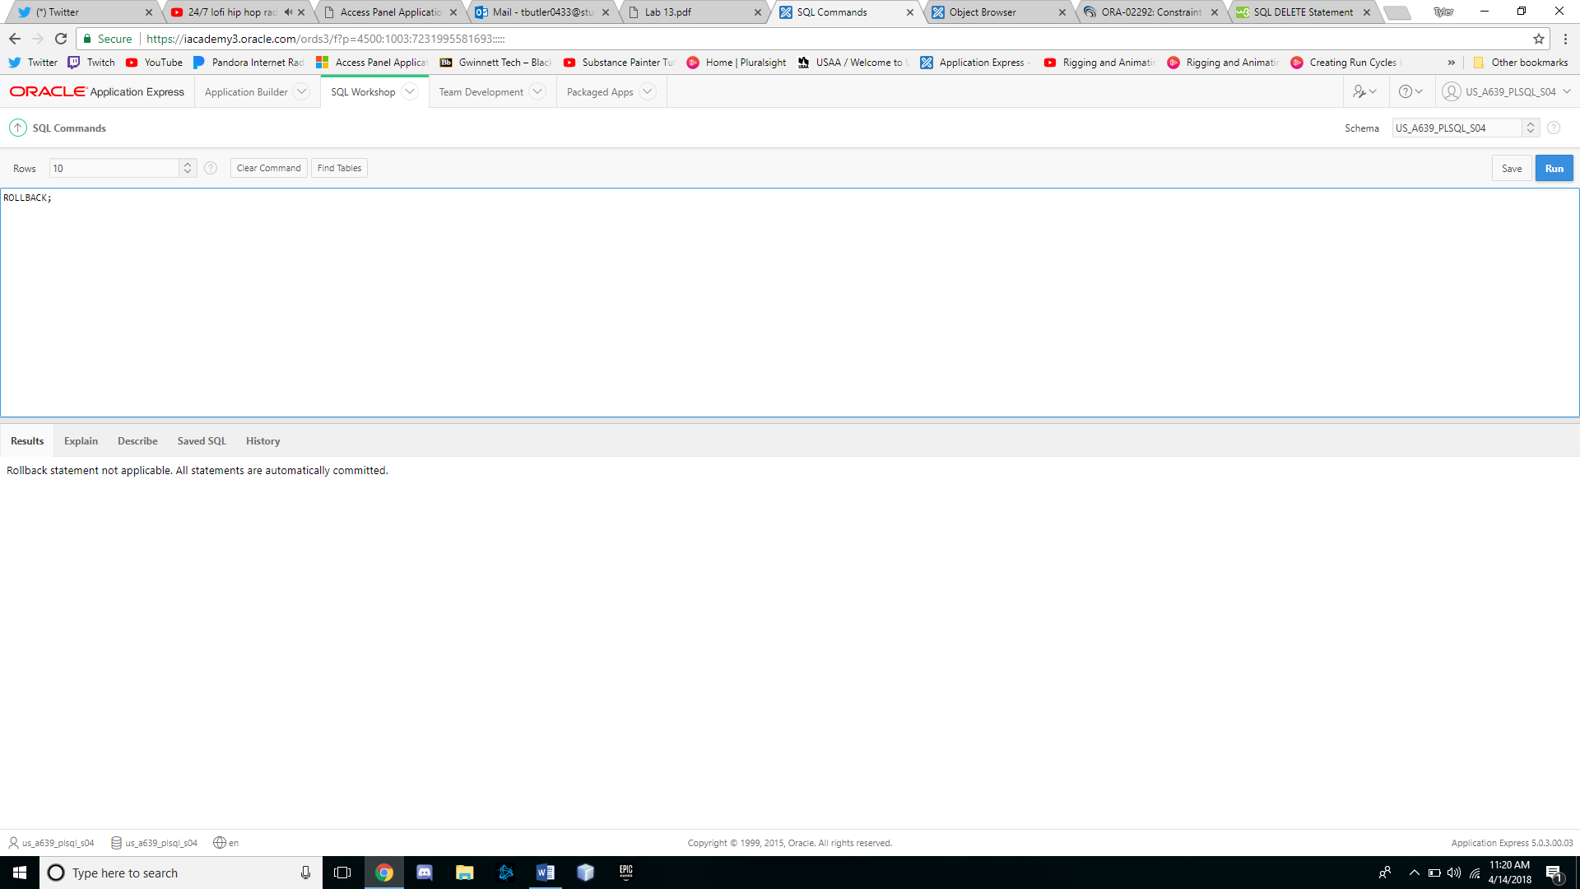

10. Delete the REORDERINFO view.

