Date: | 20 Nov 13
Name: | Tristan Freeman
Course: | APD1
Director: | Wendy Jones
document: | Application Design Document
My Medical

OVERVIEW:[insert link to Overview video]

Application Definition Statement
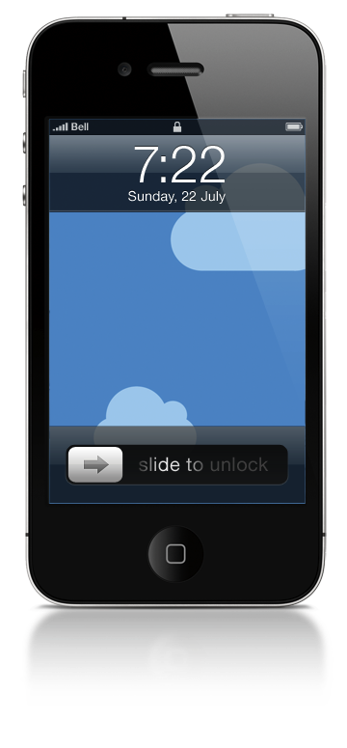
A concise, concrete declaration of the application’s main purpose and its intended audience

Purpose or Main Intent
An app that helps people keep track of their prescription and non-prescription medications and allows users to locate pharmacies using geolocation.

Description of Intended Audience
Anyone who takes multiple medications and needs help remembering what they take when seeing new medical providers.

Core Functionality
Allow users to input medication information in order to have a mobile copy of their current medications and find pharmacy locations near them.

Application User Feature Set
A list of features from the user’s perspective

User Access
- Application enables access to user medication information on the go via password protection.
- Users have access to input and view medical information.
Available Information
- Medication Name
- Medication Form
- Medication Strength
- Medication Qty
- When Medication is Taken
- Rx Number
- Prescribing Physician
- Notes

Pharmacy Locator
- Ability to find pharmacy locations near user geolocation.

Application Layout
The Layout of the Application

Title Screen

Description: The name of the application is My Medical. The logo will consist a medical symbol on the left with the name to the right of the symbol.

Login Screen
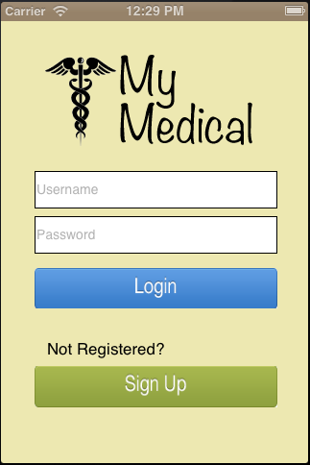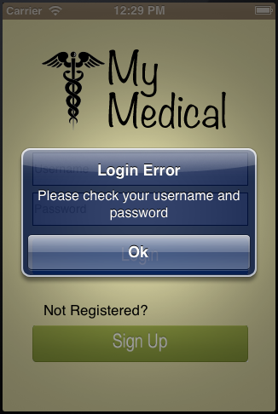

The login screen will ask users for username and password. If submitted information is incorrect or fields are empty, an alert will appear notifying the user that information is missing or incorrect. The login screen also has a sign up button for users who do not currently have an account.

Sign Up Screen
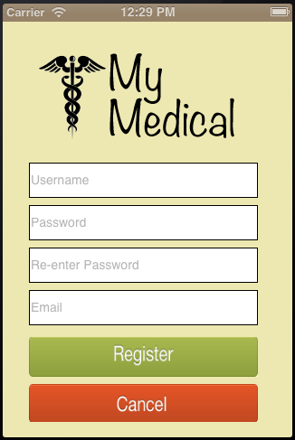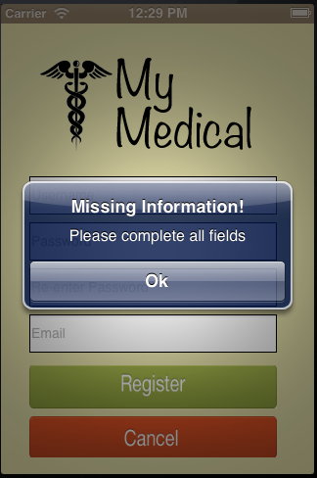

The sign up screen will contain the application logo, cancel button, text fields for username, password, password reentry, and email, with a button to sign up for access to the application. If the information entered in the fields already exists or fields are empty, an alert will let the user know.

Main UI
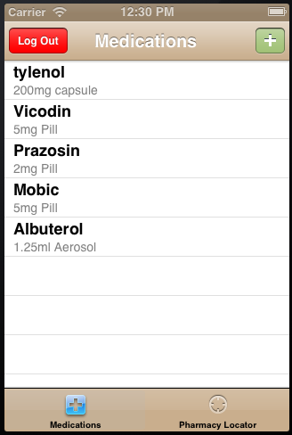
Description: The Main UI will consist of a tabbed controller and navigation bar. The first page lists the medications currently in the system in a UITableView with the medication name, strength, and type. The navigation bar will have a plus button to add a new medication to the list and a log out button to log out the current user. The table implements pull to refresh.

Medication Detail Screen
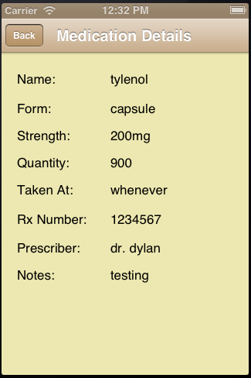

The medication details screen will be accessed from the main tableView and display the details of the selected medication.

Add Medication Screen
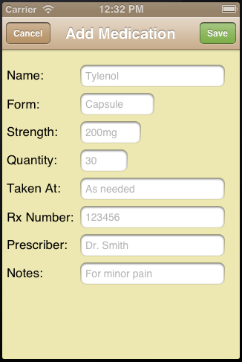

The add medication screen will consist of a navigation bar with cancel and save buttons. The main view will have labels and fields for the user to enter medication name, form, strength, quantity, when taken, rx number, prescriber, and any notes.

Pharmacy Locator Screen
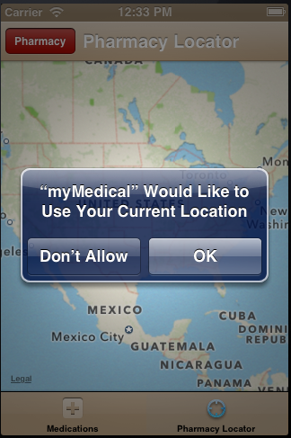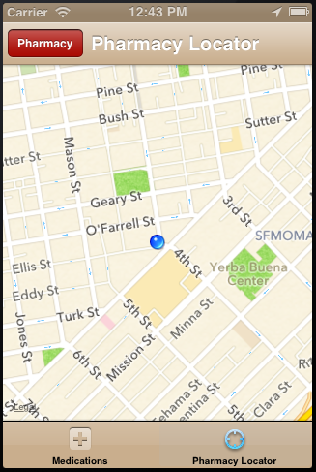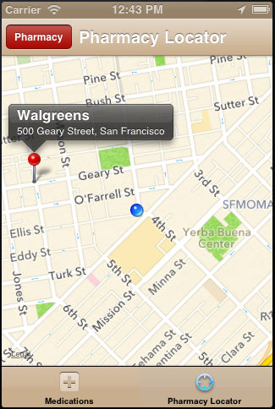

The pharmacy locator screen will consist of a tabbar controller, navigation controller, and mapview showing locations near the users GPS location. The view will ask the user for permission to access their location, zoom into the current user location, and display pharmacy locations within 50,000 meters from the user location when the pharmacy button is pressed.

Application Flow
The Flow of UI through the Application

(Create a full flow chart of your application including connections)
Title

Main View (medication list)

Pharmacy Locator

Login Screen

Sign up Screen

Add Drug Screen

Medication Details

