**Aqua Web Project**



|  |  |
| --- | --- |
| **Made by:** | **Roles:** |
| Hristo Hristov  Email: [hshristov18@codingburgas.bg](mailto:hshristov18@codingburgas.bg) | Scrum Trainer |
| Teodor Smolev  Email: [tfsmolev18@codingburgas.bg](mailto:tfsmolev18@codingburgas.bg) | Frontend Developer |
| Veselin Dimitrov  Email: [vmdimitrov20@codingburgas.bg](mailto:vmdimitrov20@codingburgas.bg) | Backend Developer |
| Nikola Stoyanov  Email: [nmstoyanov20@codingburgas.bg](mailto:nmstoyanov20@codingburgas.bg) | Designer |

# Description of the project

Our goal is to recover the health of the ocean for the sake of our wildlife, our climate and our own wellbeing. Raising awareness and saving the rapid extinction happening in the world nowadays is one of our main projects.

# Diagram of the project

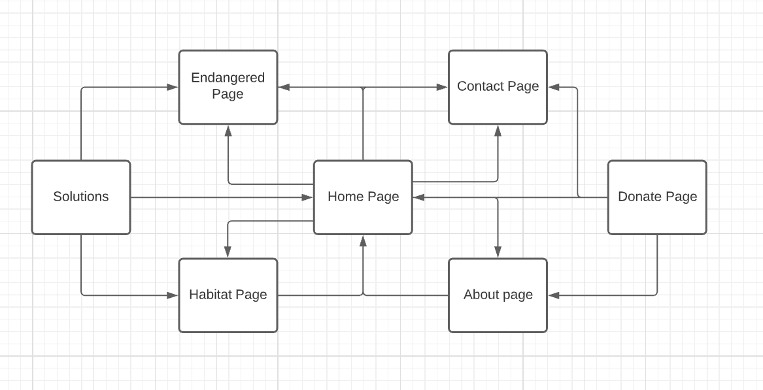

# Team Roles and Their Contribution To the Team

Hristo Hristov (Scrum Master) – Came up with the idea of the project and helped with coding and design of the website. Worked on the presentation, documentation and animations on the website.

Teodor Smolev (Frontend Developer) – Wrote most of the code and worked hand in hand with the Scrum. Did the navigation menu, css and added information to the site

Veselin Dimitrov (Backend Developer) - …

Nikolai Stoyanov (Designer) - …