Approaches to Measuring and Conceptualising Sleep Discrepancy: A Scoping Review

Tom F. Walton

School of Psychological Science, The University of Western Australia

Melissa J. Ree

School of Psychological Science, The University of Western Australia

Simone N. Fueggle

CALHN Neuropsychology, Royal Adelaide Hospital

Romola S. Bucks

School of Psychological Science, The University of Western Australia

2023-07-18

1 Abstract

1.1 Study Objectives

To examine how past studies have conceptualised sleep discrepancy and identify and evaluate the methods used.

1.2 Method

We searched MEDLINE, Embase, PsycINFO, CINAHL Plus, PubMed, Scopus, and Web of Science in April 2022 for studies comparing self-report and objective measures of sleep. Methodological information was extracted from relevant studies and included measures of self-report and objective sleep, sleep variables (e.g., total sleep time), derived discrepancy indices (e.g., difference scores), handling of repeated measurements, and methods of measure comparison (e.g., Bland-Altman analyses).

1.3 Results

Two hundred and forty-four relevant records were identified. Studies varied according to objective sleep measure; actigraphy algorithm, software, and rest interval; polysomnography setting and scoring criteria; sleep variables; self-report sleep measure; number of nights of objective recording; time frame of self-report measure; self-report sleep variable definition; sleep discrepancy derived index; presence and handling of repeated measurements; and statistical method for measure comparison.

1.4 Conclusions

Sleep discrepancy was mostly conceived as discordance in sleep states or sleep time variables, and various forms of this discordance differed in their conceptual distance to sleep misperception. Furthermore, studies varied considerably in methodology with critical conceptual and practical implications that have received little attention to date. Substantive methodological issues were also identified relating to the use of derived indices for operationalising sleep discrepancy, defining objective sleep onset latency, calculating actigraphy rest intervals, measuring correlation and concordance, averaging sleep variables across nights, and defining sleep quality discrepancy.

1.5 Key words

Sleep discrepancy; sleep misperception; scoping review

1.6 Statement of Significance

Sleep discrepancy, the discordance between self-report and objective measures of sleep, is an important feature for theory in insomnia and a key issue in sleep measurement. Despite the considerable research in this area, the status of sleep discrepancy as a concept is unclear and varied methodologies are employed with unknown theoretical or conceptual implications. This scoping review integrates a comprehensive range of methodological details from sleep discrepancy studies, clarifying the concept of sleep discrepancy and critically evaluating approaches to its measurement. The broad view of the literature afforded by the systematic search allows us to identify and discuss conceptual and methodological issues that have received little attention and are critical for the advancement of research in sleep discrepancy.

2 Introduction

Sleep is measured in two principal ways: objectively through polysomnography or actigraphy, and by self-report through questionnaires or sleep diaries. The discordance that can exist between these two forms of measurement is known as subjective-objective sleep discrepancy, or more simply, sleep discrepancy. Sleep discrepancy is a common feature of insomnia disorder, where it is also referred to as sleep misperception or paradoxical insomnia. Individuals with insomnia tend to underestimate total sleep time (TST), and overestimate sleep onset latency (SOL) and wake after sleep onset (WASO) relative to objective measures1–3.

There are diverse ways to conceptualise and measure sleep discrepancy. It may be considered as a spectrum4, ranging from positive (self-report exceeds objective) to negative (objective exceeds self-report), or as a measure of absolute sleep agreement5. Any number of sleep variables such as TST, SOL, or WASO can used to operationalise sleep discrepancy, each differing conceptually and carrying varying theoretical implications. Sleep discrepancy may even be considered beyond these sleep time-based metrics and represent discordance in self-report and objective sleep patterns6, or sleep quality. Sleep discrepancy can be characterised in a sample by directly comparing self-report and objective sleep with a range of statistical techniques. Other studies may derive variables to define sleep discrepancy quantitatively to measure its relationship with other variables, for example using a difference score of self-report TST – objective TST.

To date, there have been few systematic attempts to synthesise or evaluate the varied approaches to investigating sleep discrepancy. Three reviews have been conducted in this area. Castelnovo et al7 conducted a systematic review of quantitative definitions of paradoxical insomnia, an insomnia subvariant defined, in part, by the presence of sleep discrepancy. This excluded studies where sleep discrepancy was not used to form diagnostic criteria. Two subsequent reviews were conducted by Rezaie et al8 and Stephan et al9 focussing on paradoxical insomnia and the correlates of sleep misperception, respectively. Whilst informative discussions of research findings, these studies excluded a focus on concepts or methodology and did not incorporate a systematic search—potentially underrepresenting the breadth of the literature.

Presently, it is not clear how sleep discrepancy should best be defined and the diversity in its measurement and conceptualisation may present a challenge to theory-building for research in insomnia and other areas. A scoping review is a method of research synthesis that aims to map existing literature in a field of interest and identify types of evidence available in a given topic10. We used a scoping review strategy to examine how sleep discrepancy has been conceptualised in the literature and identify and evaluate the methods used to investigate it. A preliminary search of MEDLINE (Ovid), the Cochrane Library, Embase (Ovid), and PsycINFO (Ovid) was conducted to identify existing or in-progress systematic or scoping reviews on the topic. Except for the two reviews mentioned above, no records were identified.

3 Methods

3.1 Protocol and registration

The review was conducted according to guidelines provided by the JBI scoping review methodology group11 and reported according to the Preferred Reporting Items for Systematic reviews and Meta-Analyses extension for Scoping Reviews (PRISMA-ScR) Checklist12. A review protocol was registered with the Open Science Framework on April 4, 2022 (doi: 10.17605/OSF.IO/BCJNQ), prior to conducting searches. Deviations from the protocol are outlined in the appendices ([11.2](http://127.0.0.1:10065/rmd_output/0/#deviations)).

3.2 Eligibility criteria

Participants of all age groups and clinical populations were included in the review. To adequately map the boundaries of sleep discrepancy as a concept, we included any study that compared an objective measure of sleep (e.g., polysomnography, actigraphy) with an equivalent self-report measure of sleep (e.g., sleep diaries, questionnaires), through statistical analysis or composite index scores. For measures of self-report and objective sleep, we included traditional indices of sleep time such as TST, SOL, and WASO, in addition to measures of sleep quality, sleep patterns, or any other sleep-related experience or behaviour.

3.3 Exclusion criteria

Studies were excluded that (i) made no direct comparisons between equivalent self-report and objective sleep measures, (ii) included informant, rather than self-report measures, (iii) were case reports or review articles, (iv) were limited to self-report or objective measures not related to sleep, (v) contained no empirical data, (vi) omitted either a self-report or equivalent objective measure of sleep, or (vii) were a grey literature source including theses, dissertations, and conference abstracts. No records were excluded on the basis of geographic location, cultural factors, or any other contextual feature.

3.4 Search strategy

The search strategy aimed to identify articles published in peer-reviewed journals and, initially, grey literature including theses, dissertations, and conference abstracts. Due to the large number of records returned by initial searches, grey literature was excluded at the full text extraction stage. The following databases were searched: MEDLINE (Ovid), Embase (Ovid), PsycINFO (Ovid), CINAHL Plus, PubMed, Scopus, Web of Science, ProQuest Theses and Dissertations, and OSF Preprints. The search strategy included keywords, index terms, and search operators adapted for each database. Searches across all databases were conducted on the 24th April 2022. The full search strategy for Embase (Ovid) is provided as an example in Table [3.1](http://127.0.0.1:10065/rmd_output/0/#tab:egsearch) below. See Appendix A for full search strategies for other databases.

| Table 3.1: Search strategy for Embase (Ovid) | | |
| --- | --- | --- |
| **Step** | **Terms and Operators** | **Records** |
| 1 | sleep discrepancy or paradoxical insomnia or subjective insomnia or (sleep adj2 misperception).mp | 488 |
| 2 | ((self report* or diary or subjective*) and (objective* or actigraph* or polysomnograph* or polygraph*)).mp. | 193243 |
| 3 | (exp polysomnography/ or exp actimetry/) and exp self report/ | 1676 |
| 4 | (sleep* and (“over estimat*” or ”over report*” or “under estimat*” or ”under report*” or overestimat* or overreport* or underestimat* or underreport* or discrepan* or concordan* or agreement or disagreement or discordan* or congruen* or incongruen*)).mp. | 9362 |
| 5 | 2 or 3 | 193302 |
| 6 | 4 and 5 | 1234 |
| 7 | 1 or 6 | 1569 |

3.5 Sources of evidence selection

Records identified from searches were exported to EndNote 2013 for collation and then uploaded to Rayyan14 for deduplication and title and abstract screening. Two independent reviewers (TW and SF) screened titles and abstracts to identify studies for full-text retrieval using the inclusion criteria. Percentage of agreement between reviewers was 87.6% and conflicts were resolved via discussion. The full-texts of articles passing title and abstract screening were screened independently by TW with reasons for exclusion reported. Due to the unanticipated size of the literature, articles from sources other than peer-reviewed journals were added to exclusion criteria post-hoc.

3.6 Charting the data

Data extraction was performed by TW, independently. Methodological features of included articles were selected on their potential influence on the measurement or operational definition of sleep discrepancy and included the following: objective sleep measure type/hardware, actigraphy algorithm, software, and rest interval, polysomnography setting and scoring criteria, self-report sleep measure, sleep variables (e.g., TST, WASO etc…) and definitions thereof, methods of handling repeated measurements, methods of comparing self-report and objective sleep within groups, and methods for operationalising sleep discrepancy to investigate its relationship with other variables.

3.7 Data items

Extracted data items numbered in the hundreds and are described comprehensively in the codebook available at <https://github.com/tfwalton/sleep-discrepancy-review/raw/main/codebook.xlsx>.

3.8 Synthesis of results

This manuscript, including all tables and figures summarising data were generated using computationally reproducible methods15,16 in R version 4.3.217, with R Studio18 and R Markdown19. Packages used in the code for this manuscript include tidyverse20, bookdown21, knitr22, kableExtra23, english24, and DiagrammeR25. All code and data are available through the Github repository: <https://github.com/tfwalton/sleep-discrepancy-review>.

4 Results

The initial search of databases returned 6,190 from which 3,903 duplicate articles were removed. Details of the review process from article identification, screening, and selection are available in the PRISMA flowchart depicted in [4.1](http://127.0.0.1:10065/rmd_output/0/#fig:PRISMA) below.

Figure 4.1: PRISMA flowchart

4.1 Article characteristics

A total of 248 studies were identified from 244 records, with 4 records reporting two studies or experiments within a single text. Records spanned 32 countries, with the majority originating from the USA (n = 96).

Sample sizes for studies ranged from 8 to 8,438 (median = 66, IQR = 119.5). Most studies included both sexes in their samples (n = 229), whereas 8 and 11 comprised only males or females, respectively. Most studies contained samples of adults of all ages (n = 197). Others reported specific age groups: older adults (n = 23), younger adults (n = 14), adolescents (n = 8), and children (n = 6). Sample characteristics for studies are included in Figure [4.2](http://127.0.0.1:10065/rmd_output/0/#fig:samplechar). For a full list of article characteristics, see the appendices ([11.4](http://127.0.0.1:10065/rmd_output/0/#tab:studychar))

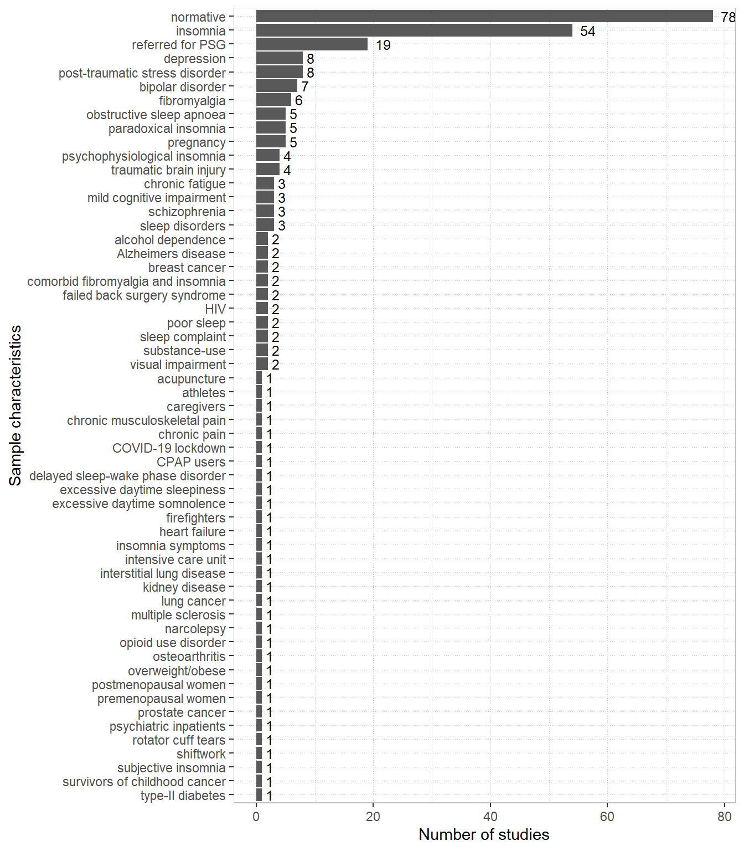

Figure 4.2: Sample characteristics

4.2 Methodological features

4.2.1 Measures of objective sleep

Objective methods of recording sleep formed two major groups: EEG-based methods and movement-based methods. See Figure [4.3](http://127.0.0.1:10065/rmd_output/0/#fig:measures) for number of studies using each method. All movement-based methods involved tri-axial accelerometry through actigraphs or similar devices. PSG was the predominant EEG-based method (n = 106), however a handful of studies used EEG alone, in either single channel (n = 2), standard (n = 4), or high-definition formats (n = 3). A single study used a method of sleep recording that involved recording verbal responses from participants elicited by soft tones played at intervals throughout the night26.

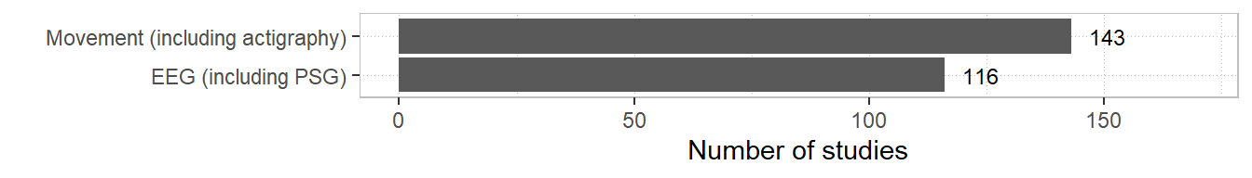

Figure 4.3: Measures of objective sleep

4.2.1.1 Polysomnography

Methodological features charted for PSG included scoring criteria, setting, and recording period. See Figure [4.4](http://127.0.0.1:10065/rmd_output/0/#fig:scoring) for scoring criteria of included studies.

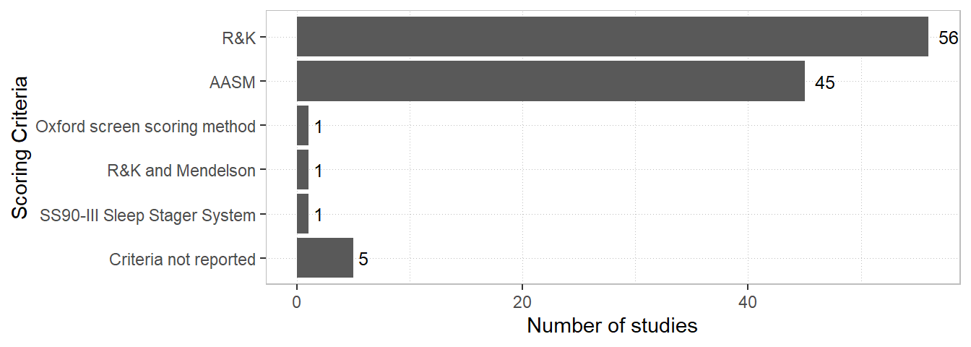

Figure 4.4: PSG scoring methods

Methods for scoring PSG were mostly divided between American Academy of Sleep Medicine (AASM) and Rechtschaffen & Kales (R&K) guidelines. Rogers et al27 used an automated system for sleep staging, the SS90-III Sleep Stager System (Oxford Medicals, Oxford). Vanable et al28 used Mendelson’s29 guidelines in addition to R&K. Edinger2 used combined audio and visual criteria for sleep staging30. Settings for PSG varied and are depicted in Figure [4.5](http://127.0.0.1:10065/rmd_output/0/#fig:setting).

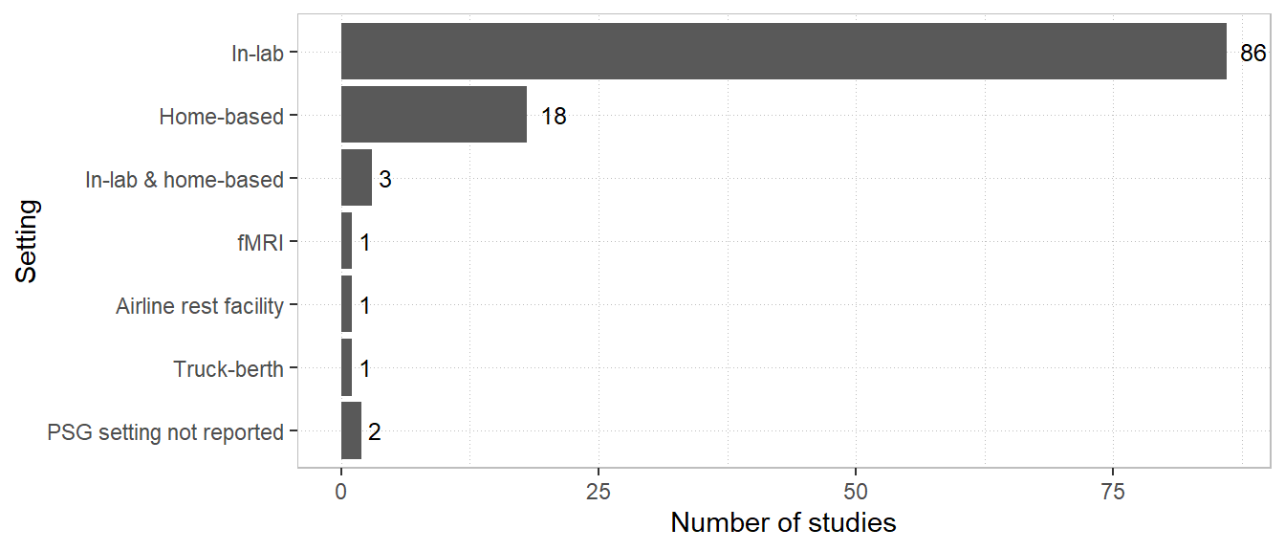

Figure 4.5: PSG setting

In-lab and home-based tests comprised the substantial majority of PSG settings with a handful of more unusual settings noted. As for recording periods, PSG most often occurred during the night although a number of alternative periods were noted. See Figure [4.6](http://127.0.0.1:10065/rmd_output/0/#fig:period) for a depiction of PSG recording periods.

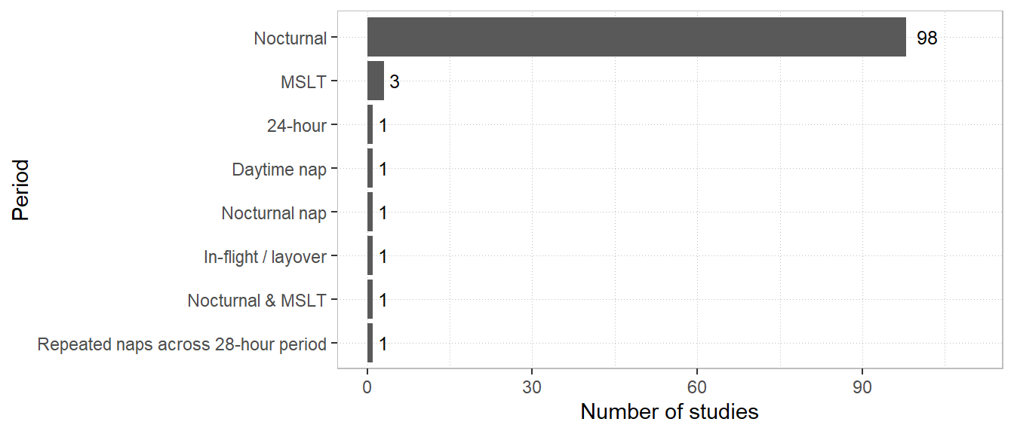

Figure 4.6: PSG recording period

Note, MSLT refers to the multiple sleep latency test.

4.2.1.2 Actigraphy

We recorded features of actigraphy including device name, scoring algorithm, software, and rest interval definition. See Table [11.5](http://127.0.0.1:10065/rmd_output/0/#tab:bigacti) in the appendices for full tabulations of actigraphy characteristics. Actigraphy scoring algorithms are responsible for determining wakefulness and sleep from accelerometer-derived motor activity. Scoring algorithms varied across studies and included Actiware31, MotionWare (CamNTech, UK), SenseWear32, Domino Light33, Cole-Kripke34, Kripke35, Sadeh36, Actiheart37, Fitbit38, UCSD38, ActiLife39, Actillume38, Micro-Electro-Mechanical-Systems40, Sleep Sign Act (Kissei Comtec Co, Japan), IM Systems (Individual Monitoring Systems, Inc., UWA), Machine Learning Alogrithms41, Fatigue Science42, Barouni43, Choi44, Tudor-Locke45, and Troiano46. The frequencies of these algorithms are depicted in Figure [4.7](http://127.0.0.1:10065/rmd_output/0/#fig:algorithms).

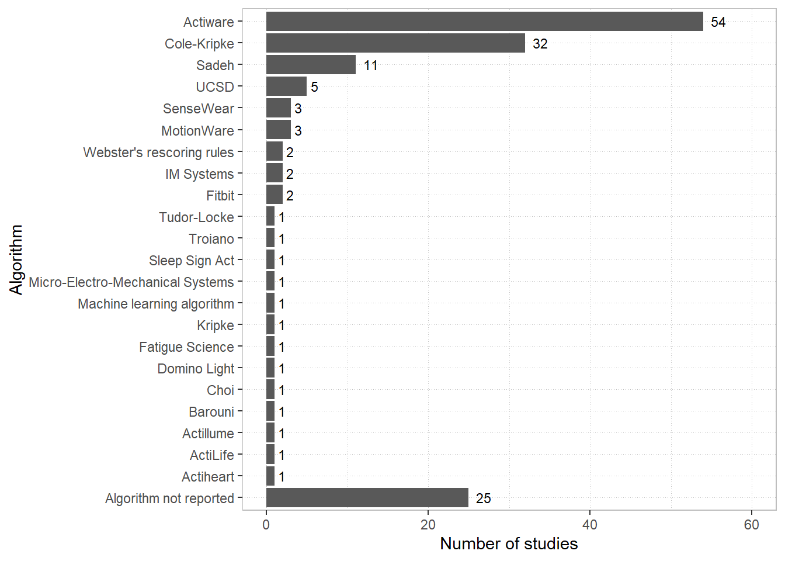

Figure 4.7: Actigraphy algorithms

Studies using Actiware algorithms varied in their selection of thresholds for scoring wakefulness. These are depicted in Figure [4.8](http://127.0.0.1:10065/rmd_output/0/#fig:actiware) below.

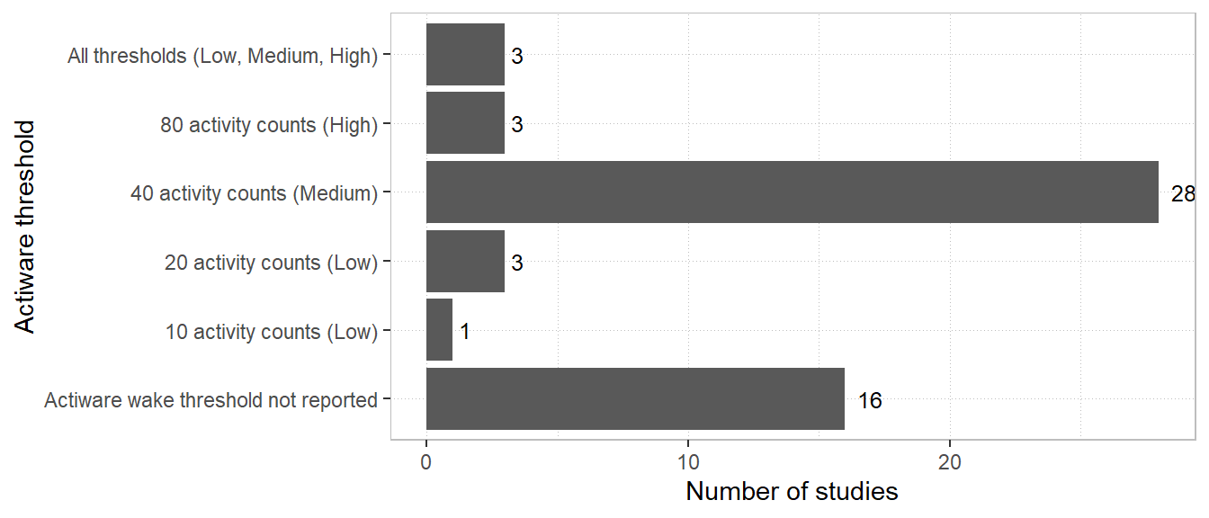

Figure 4.8: Actiware algorithm threshold settings

The rest interval in actigraphy is the period of time where activity is assessed for sleep and is usually intended to coincide with the time the wearer is in bed, attempting to sleep. Information used to define rest intervals varied across reviewed studies and included, singly or in combination, are depicted below in Figure [4.9](http://127.0.0.1:10065/rmd_output/0/#fig:intervals).

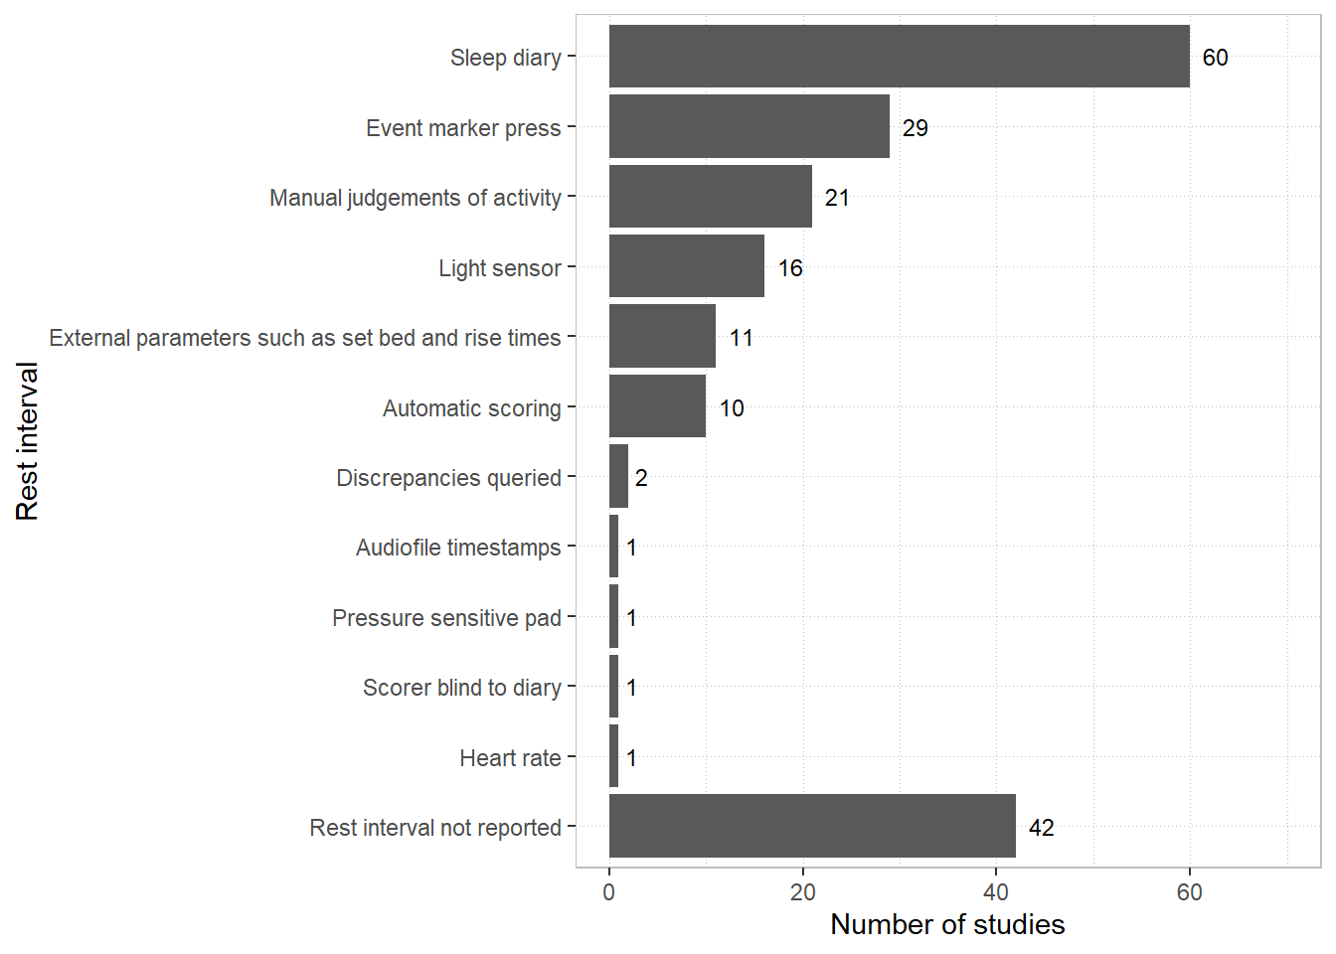

Figure 4.9: Methods for defining rest intervals in actigraphy

The precise combination and order of priority of methods in each study varied markedly. See Table [11.5](http://127.0.0.1:10065/rmd_output/0/#tab:bigacti) in the appendices for qualitative descriptions of rest interval approaches across reviewed studies. “Discrepancies queried” indicates that discrepant sleep diary and actigraphy bed and wake times were queried directly with participants and adjusted following discussion.

4.2.2 Measures of self-report sleep

Self-report sleep measures comprised seven major types. See Figure [4.10](http://127.0.0.1:10065/rmd_output/0/#fig:srmeasure) for the number of studies including each of these.

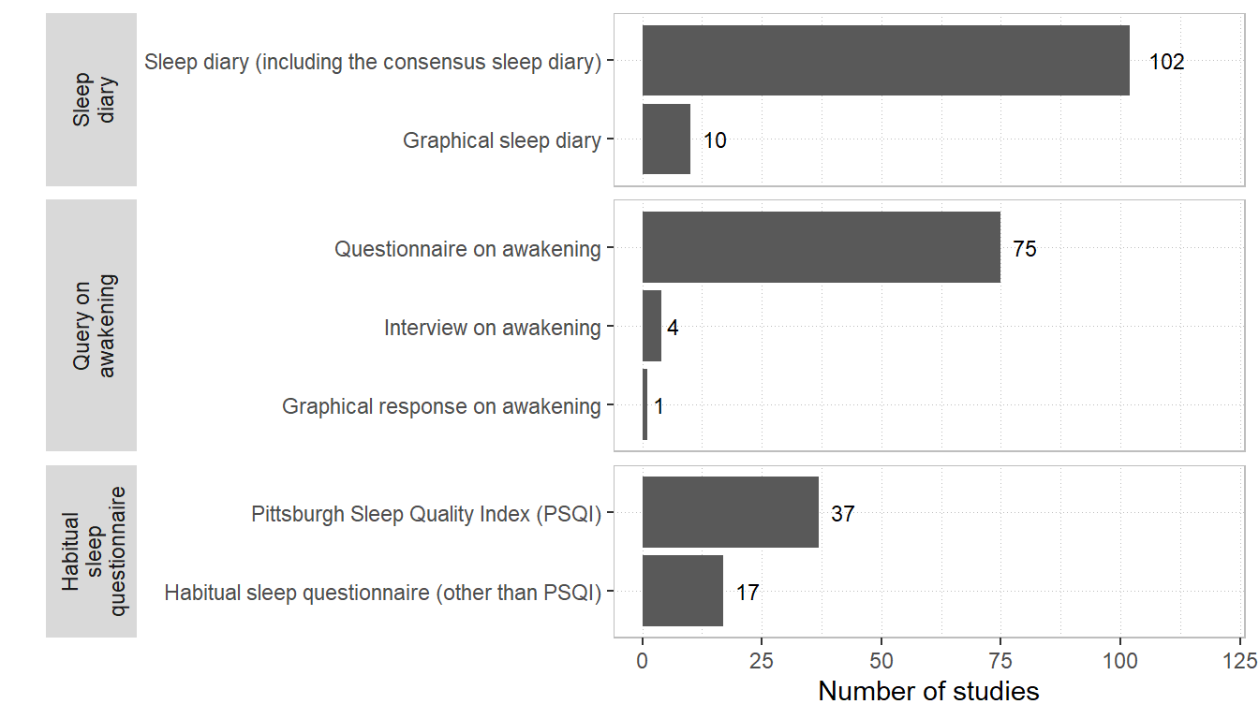

Figure 4.10: Measures of self-report sleep

Sleep diaries and questionnaires on awakening were the most common measure of self-report sleep, followed by habitual sleep questionnaires including the Pittsburgh Sleep Quality Index (PSQI)47. Note, habitual sleep refers to questionnaires that require participants to provide global judgements about their sleep that correspond to a period of time longer than a single night such as a week or a month. Graphical response formats for sleep diaries and questionnaires on awakening required participants to draw their sleep on scales comprising discrete blocks of time. We also recorded whether self-report measures overall attempted to capture habitual sleep or rather *episodic* sleep that occurred night-by-night/episode-by-sleep episode at the same time as objective measures. Results are depicted in Figure [4.11](http://127.0.0.1:10065/rmd_output/0/#fig:habitual) below.

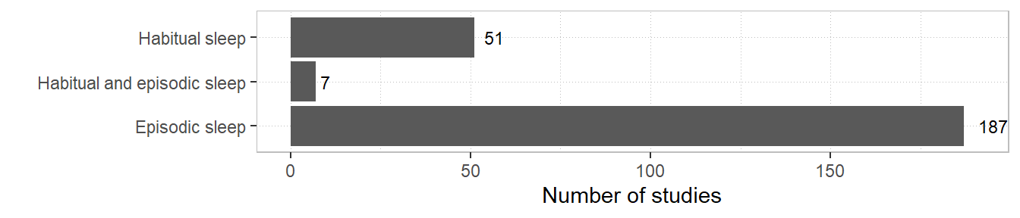

Figure 4.11: Habitual or episodic sleep

4.3 Sleep variables

A range of variables were used to operationalise sleep discrepancy. These are listed below in Table [4.1](http://127.0.0.1:10065/rmd_output/0/#tab:variables) with their usual definitions and equivalent terms.

| Table 4.1: Sleep variables used for operationalising sleep discrepancy | | | |
| --- | --- | --- | --- |
| **Variable** | **Abbreviation** | **Calculation** | **Equivalent terms** |
| Total sleep time | TST | Varied (Objective, Self-report) | Sleep duration |
| Sleep onset latency | SOL | Varied (Objective) | Sleep latency (SL) |
| Wake after sleep onset | WASO | Varied (Self-report) |  |
| Sleep efficiency | SE | Varied (Self-report, Objective) | Sleep efficiency index (SEI) |
| Time in bed | TIB | BT - RT |  |
| Number of awakenings | NWAK |  |  |
| Total wake time | TWT | SOL + WASO + terminal wakefulness (TWAK) |  |
| Sleep period time | SPT | BT - FWT |  |
| Sleep onset time | SOT | Time at sleep onset | Sleep onset (actigraphy) |
| Final wake time | FWT | Time at final awakening |  |
| Bed time | BT | Time where participant is in bed trying to sleep | Lights off (PSG) |
| Rise time | RT | Time getting out of bed | Sleep offset (actigraphy), lights on (PSG) |
| Sleep midpoint |  | (FWT - BT)/2 |  |
| Binary Sleep-Wake agreement |  |  |  |
| Confusion Matrix Sleep-Wake agreement |  |  |  |
| Latency to persistent sleep | LPS | Latency to 10 minutes of uninterrupted sleep |  |
| Sleep during subjective latency | SDSL | Minutes of objective sleep during period defined by self-report sleep latency |  |
| Latency-adjusted total sleep time | LA-TST | Objective total sleep time following the point of subjective sleep onset |  |
| Effective sleep time | EST | TST - WASO - SOL |  |
| Subjective wake time | SWT | WASO + SOL |  |
| Terminal wakefulness | TWAK* | RT - FWT | Wake after sleep offset (WASF) |
| Intermittent wake time | IWT | No definition reported |  |
| *Note:*Binary sleep-wake involved measuring at one or multiple instances whether a participant’s reported sleep state matched the objective sleep state upon which the query was conditional (e.g., participants were only queried during objectively-confirmed sleep). On the other hand, confusion matrix sleep-wake involved measuring at one or multiple instances whether a participant’s reported sleep state matched an objective sleep state that was allowed to vary independent of the query (e.g., participants were queried at a certain time point irrespective of sleep state). The states were called so as the former approach produces a binary outcome whereas the latter produces a confusion matrix. | | | |
| *TWAK was not used to define sleep discrepancy directly by any of the included studies but is included in the table for clarity | | | |

The number of studies that used each sleep variable are depicted below in Figure [4.12](http://127.0.0.1:10065/rmd_output/0/#fig:vargraph).

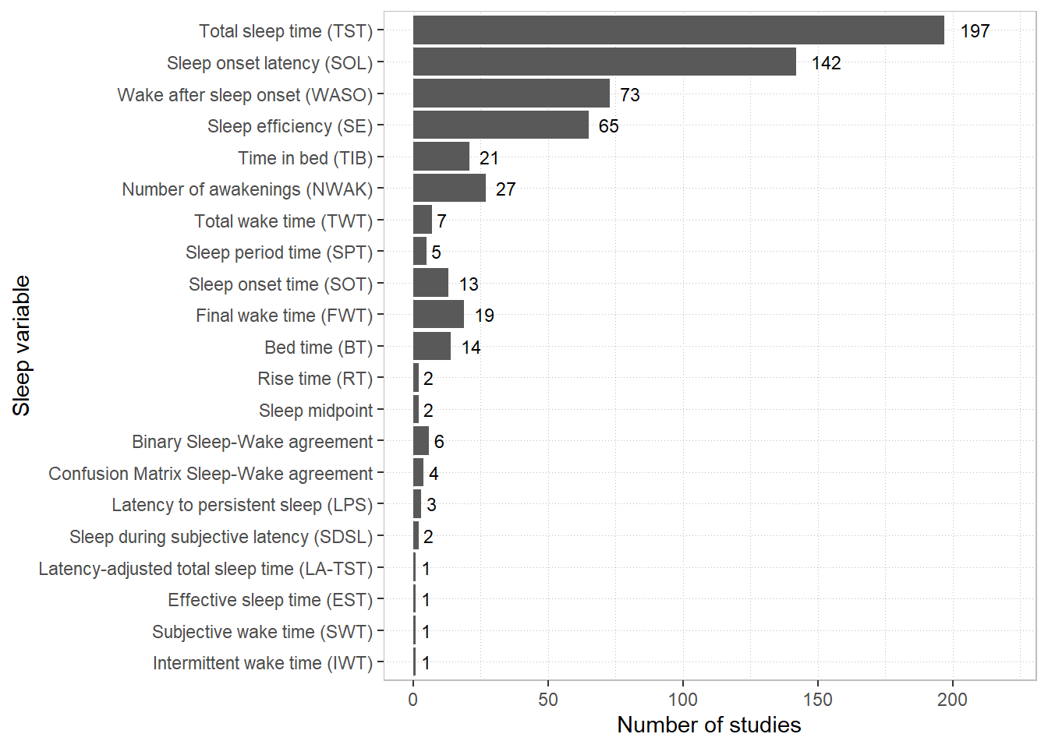

Figure 4.12: Sleep variables

The sleep variables TST, SOL, WASO, and SE were most common and formed the majority of identified parameters. Direct sleep-wake agreement was measured by a small subset of studies. Almost all identified sleep variables were measures related to sleep time or awakenings, although we did note some more unconventional parameters listed below separately from the figure above. Allawati et al6 compared self-report and actigraphic measures of sleep patterns including monophasic, biphasic dawn, biphasic siesta, and polyphasic. Lockley et el48, Dautovich et al49, Hanisch et al50, and Nguyen-Michel et al51 reported discrepancy for naps specifically, including variables such as number of naps, number of days napped, mean duration of naps, and total nap time. Baek et al52 and Chan et al53 compared self-report and actigraphic assessments of variability in TST and other sleep parameters. Thun et al54 compared self-report and actigraphic measures of morningness-eveningness. Finally, McIntyre et al55 investigated self-report-objective discrepancy across a range of sleep behaviours including position at sleep onset, position at wake, number of positional changes, and the presence of leg twitches or jerks.

4.3.1 Self-report sleep variable definitions

Calculation of self-report TST, WASO, SE, and TIB varied across studies. Variations across three major types of self-report TST were observed: TST queried directly (e.g., “how many minutes did you sleep last night”, TST calculated from other parameters such as TIB, SOL, and WASO, and TST calculated from graphical responses. The results for TST definitions are depicted in Figure [4.13](http://127.0.0.1:10065/rmd_output/0/#fig:tstdefinitions) below.

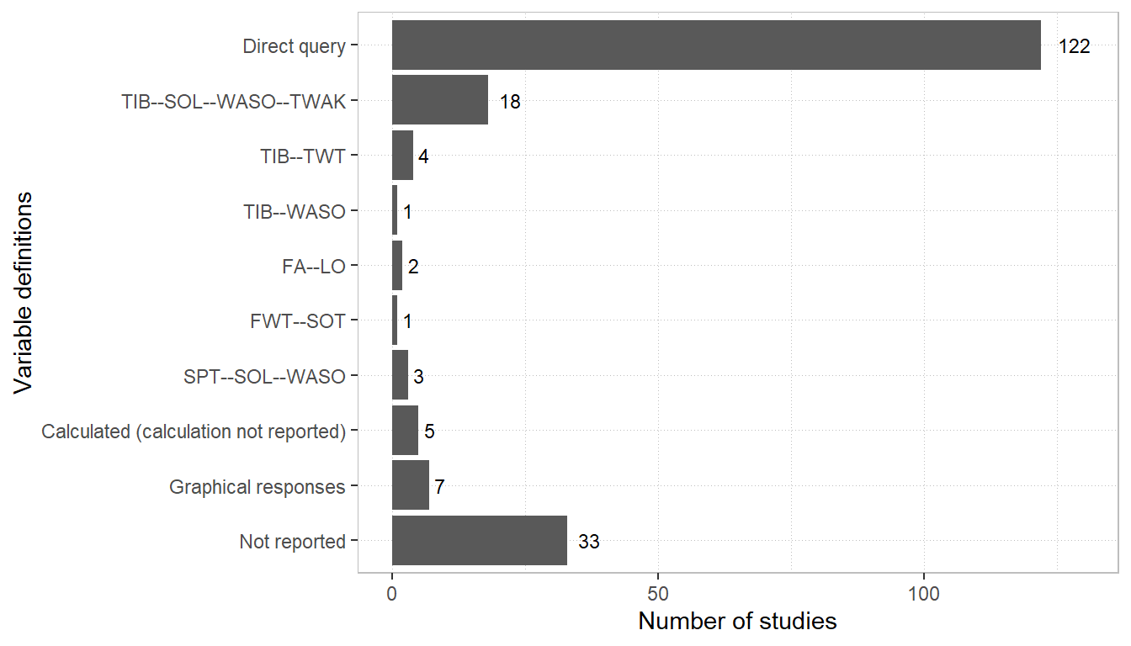

Figure 4.13: Self-report TST definitions

Note, FA–LO indicates lights off to final awakening. By conventional definitions of SPT, SPT–SOL–WASO is equal to TIB–SOL–WASO–TWAK, but is listed separately above to reflect differences in terminology. Definitions for WASO also varied and these are depicted in [4.14](http://127.0.0.1:10065/rmd_output/0/#fig:wasodef) below.

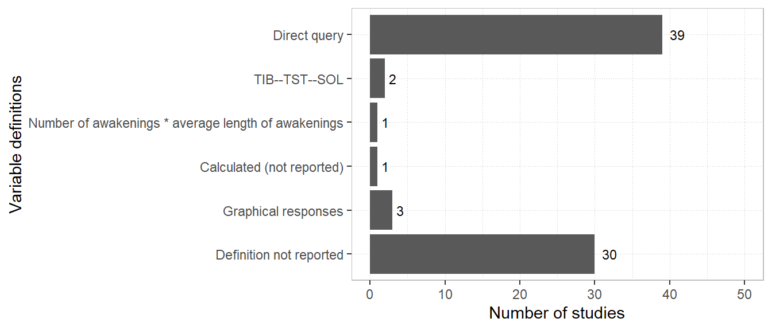

Figure 4.14: Self-report WASO definitions

Definitions for self-report TIB used in operationalising sleep discrepancy are depicted Figure [4.15](http://127.0.0.1:10065/rmd_output/0/#fig:tibdef).

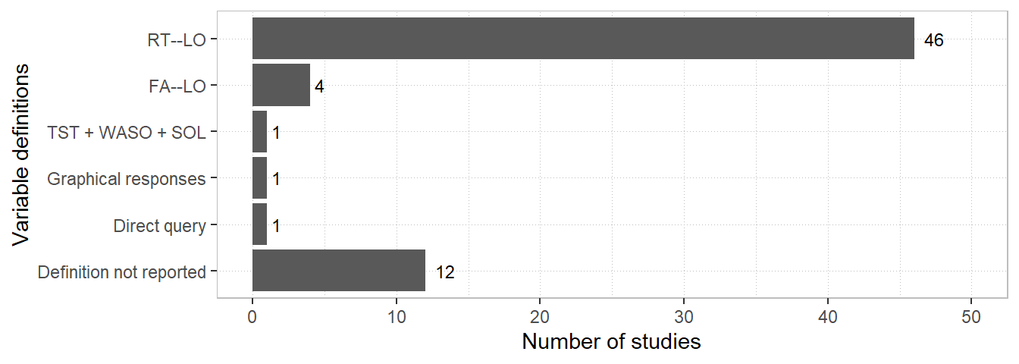

Figure 4.15: Self-report TIB definitions

Note, RT–LO refers to the time between lights off and rise time. SE was almost unanimously calculated as TST/TIB*100 , although varying definitions for the TST and TIB components affect this outcome. One study56 used two definitions of SE, one comprising TST/TIB and the other TST/sleep period time (SPT).

4.3.2 Objective sleep variable definitions

Objective TST was defined very consistently with the exception of Sinclair et al57 who, in addition to providing a standard definition for TST, measured TST across a 24-hour period, such that time spent asleep outside the usual nocturnal period (i.e., naps) contributed to this measurement. Objective definitions for SOL varied considerably and these are depicted in Figure [4.16](http://127.0.0.1:10065/rmd_output/0/#fig:SOL) below.

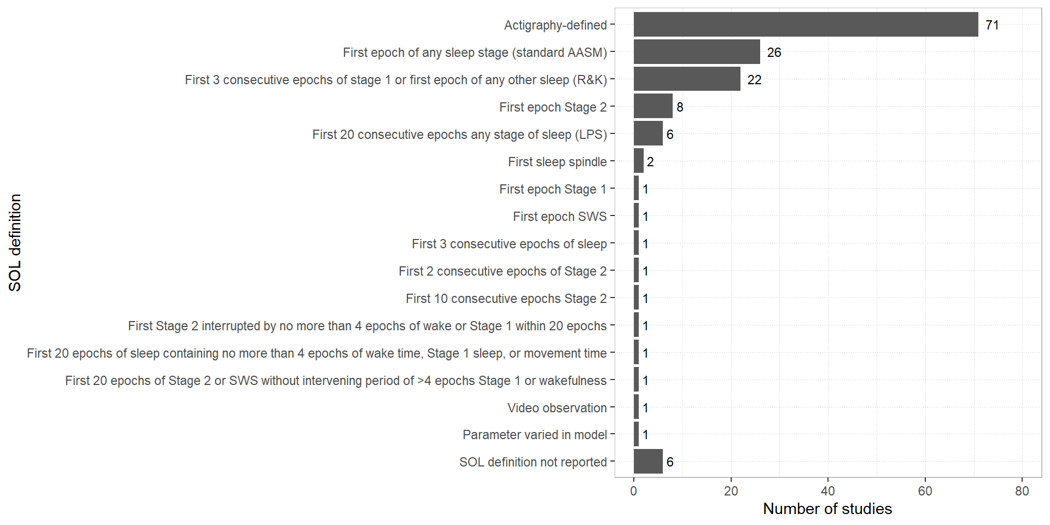

Figure 4.16: SOL definitions

Note that SWS = slow wave sleep, LPS = latency to persistent sleep, AASM = American Academy of Sleep Medicine guidelines, R&K = Rechstaffen & Kales guidelines. Parameter varied in model indicates that the definition of sleep onset was varied within the context of a predictive model. Among PSG studies, the two most common approaches were dependent on standard definitions provided by the R&K58 and AASM59 scoring guidelines.

Most studies used standard PSG or actigraphy criteria for defining objective number of awakenings (i.e., a single epoch of wakefulness). A single exception was Lewis et al60, who stipulated that a period last over a minute to count as an awakening. Neu et al56 used the same definitions for objective SE as they did for self-report SE.

4.3.3 Sleep quality

Sleep quality discrepancy was measured by 14 studies using (on the self-report side) sleep quality ratings (n = 8), PSQI total scores (n = 3), sleep quality factor scores (n = 1), sleep depth ratings (n = 1), or sleep quality composite scores (n = 1). On the objective side, sleep quality measures included SE (n = 7), factor scores from sleep variables (n = 2), sleep architectural variables (n = 7), N3 sleep quantity (n = 1), TWT (n = 1), and a composite variable formed from SOL, WASO, and SE (n = 1). Although approaches varied substantially, the most common combination of sleep quality measures was a sleep quality rating and SE.

4.4 Method of handling repeated measurements

Sleep data often involves repeated measurements of the same individual. Actigraphy and sleep diaries usually involve data collection across 7 to 14 days and multiple consecutive nights of PSG are sometimes recorded. Methods for handling repeated measurements are depicted below in Figure [4.17](http://127.0.0.1:10065/rmd_output/0/#fig:methodrm)

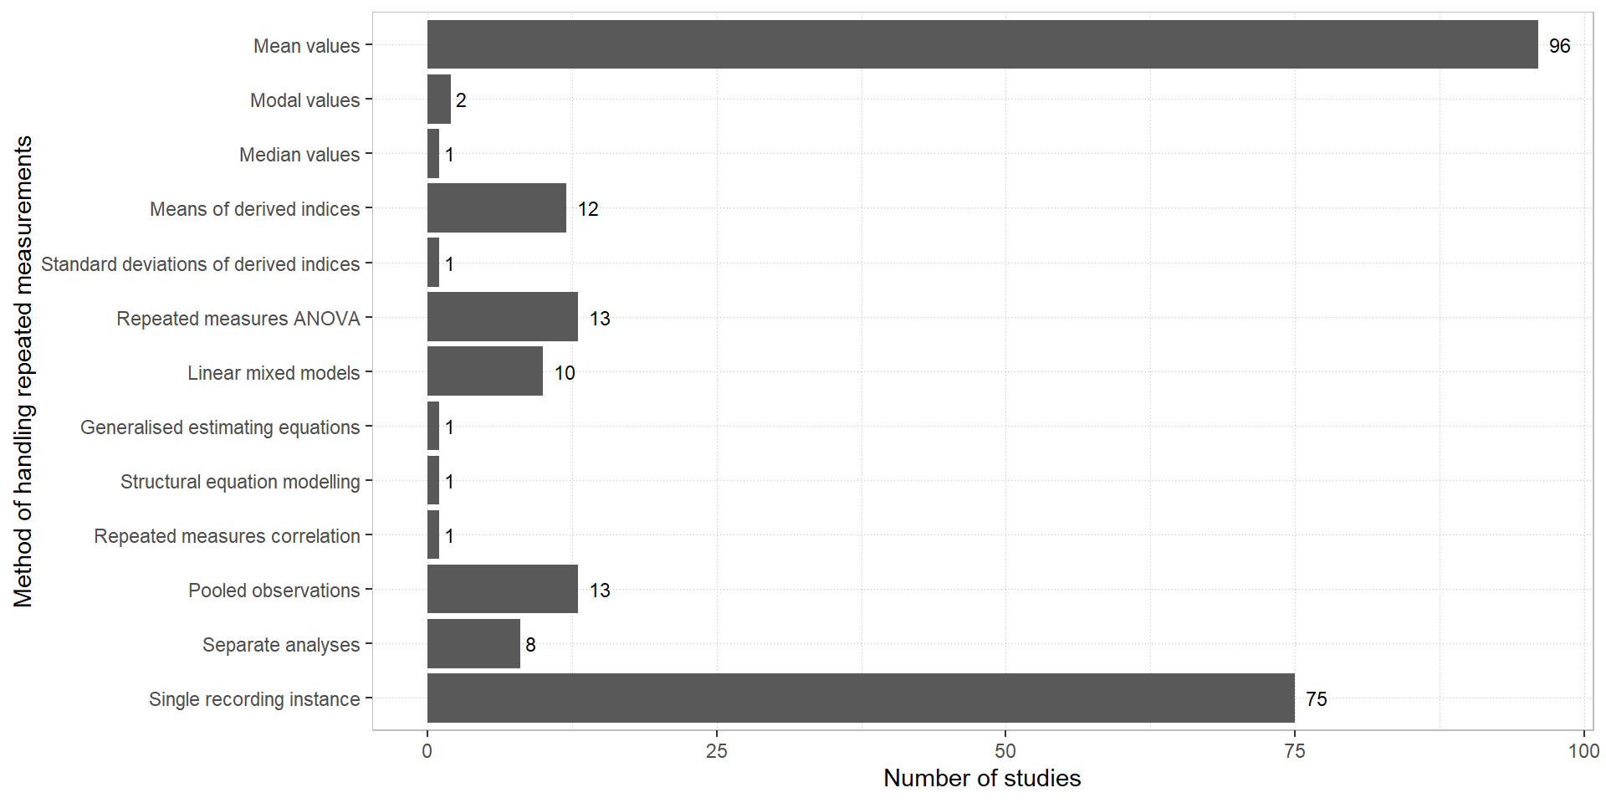

Figure 4.17: Methods for handling repeated measurements

Note that pooled observations involved collapsing data across multiple instances of recording. Separate analyses indicate that analyses were conducting separately for each instance of recording. In addition to the above, some studies measuring naturalistic sleep in the home environment took day of week into consideration for analyses. Three studies calculated a weighted average for sleep variables equal to 5/7* (mean weekday sleep) + 2/7* (mean weekend sleep), and 9 performed analyses for weeknights and weekends separately.

4.5 Direct comparisons of self-report and objective sleep

A total of 172 studies measured sleep discrepancy at the group level by directly comparing self-report and objective sleep. Methods for achieving this varied and are depicted below in Figure [4.18](http://127.0.0.1:10065/rmd_output/0/#fig:group)

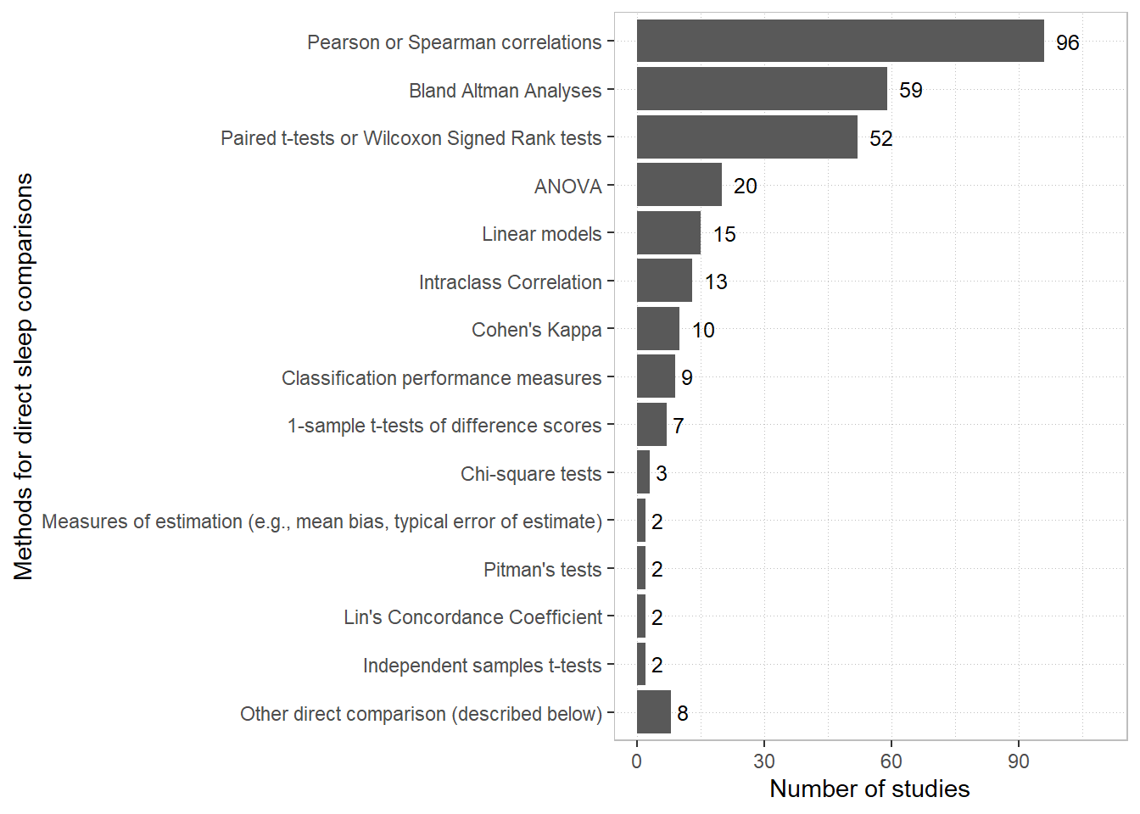

Figure 4.18: Statistical methods for comparing self-report and objective sleep

Note, Bland Altman analyses include Bland Altman plots and the reporting of 95% limits of agreement61. Pitman’s test (also known as the Pitman-Morgan test) is a test of differences of variances between dependent samples62,63 and was used to compare the variability of self-report and objective sleep. One-sample *t*-tests of difference scores are equivalent to paired *t*-tests but are included separately in the figure to reflect differences in reporting. Classification performance measures include percentage agreement, accuracy, sensitivity, specificity, positive predictive value (PPV), and negative predictive value (NPV). Formulae used for the intra-class correlation coefficient varied across studies. Spearman correlations and Wilcoxon Signed Rank Tests were often used to handle the skew of variables such as SOL and WASO. Other methods included the delta coefficient64, partial correlation and factor analysis65, errors-in-variables regression66, repeated measures correlation67, non-parametric limits of agreement68, survival agreement69, latent correlations for testing associations at within-subjects and between-subjects level70, and structural equation modelling71.

4.6 Methods for investigating the relationship of sleep discrepancy with other variables

A total of 133 studies aimed to investigate the relationship of sleep discrepancy with other variables of interest. Most studies achieved this by operationalising sleep discrepancy on the individual level through the calculation of a derived index.

4.6.1 Derived indices

Approximately half (n = 128) of included studies calculated a derived index (e.g., self-report TST–objective TST) to operationalise sleep discrepancy. Some studies used indices directly in statistical analyses (n = 107) whilst others used indices to divide samples into groups (n =18) either dichotomising (n = 12) or trichotomising (n = 6) derived score values. Methods for deriving indices varied across studies and can be broadly categorised into four groups: arithmetic difference scores, where one measure is simply subtracted from the other (e.g., sTST–oTST); absolute difference scores, composed of the absolute value of algebraic difference scores (e.g., |sTST–oTST|); ratio scores, when one measure is divided by the other (e.g., sTST/oTST); and combination scores that incorporate both subtraction and division of component measures (e.g., oTST–sTST/oTST). A list of indices including the number of studies that used them are provided in Figure [4.19](http://127.0.0.1:10065/rmd_output/0/#fig:derived) below.

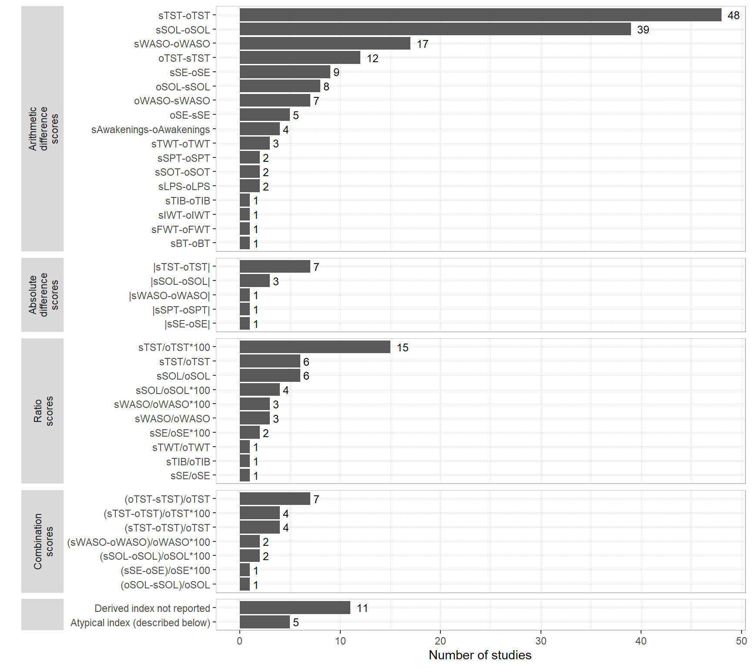

Figure 4.19: Derived indices used for operationalising sleep discrepancy

Overall, the sleep variables TST, SOL, and WASO represented the substantial majority of derived indices. Arithmetic difference scores were the most common derived index and with these objective sleep was subtracted from self-report sleep considerably more often than vice-versa. By contrast, ratio scores did not differ in directionality, and all that were recorded featured self-report sleep as the numerator and objective sleep as the denominator. Absolute differences are unique amongst derived indices for operationalising negative sleep discrepancy as equal to positive sleep discrepancy. With the relatively few absolute difference scores noted here it appears that the literature has mostly conceived of sleep discrepancy as a directional concept. All the combination scores identified followed the general format of an arithmetic difference score divided by a component of the difference.

A handful of more atypical derived scores were identified. Jackowska et al72 created a sleep quality discrepancy index by subtracting a z-transformed self-report sleep quality rating from z-transformed objective SE. Kay et al73 derived a nightly variability index for sSOL–oSOL and sWASO–oWASO by dividing intra-individual standard deviations by the sample-wise standard deviation for each variable. Mendelson et al74 divided self-report sleep following experimental awakenings by objective sleep following experimental awakenings. Winer et al75 derived a difference score from subtracting composite scores composed of the average of z scores of TST, SE, and sleep fragmentation (number of awakenings/SPT*100) from z-transformed PSQI total scores.

4.6.2 Other methods for operationalising sleep discrepancy

A number of other ways to characterise the relationship of sleep discrepancy with other variables of interest were identified and are depicted in Figure [4.20](http://127.0.0.1:10065/rmd_output/0/#fig:otherm) below. Some studies operationalised sleep discrepancy using an interaction term within an ANOVA or other linear model such that the other variable(s) of interest was/were instantiated as the moderator of the relationship between self-report and objective sleep. Others used percentage agreement for sleep or other classification performance metrics in subsequent statistical analyses with other variables. Differences between correlations amongst self-report and objective sleep between groups were also tested with bootstrapped confidence intervals77, or the Fisher transformation78. studies operationalised sleep discrepancy with the Sleep Fragment Perception Index (SFPI), an index that exploits the fact that longer sleep fragments are more likely to be identified as sleep by individuals than shorter fragments79. The SPFI is a parameter modelled to assume the shortest length of objective sleep that is perceived as subjective sleep. For the SFPI, a higher value corresponds to a longer sleep fragment necessary for subjective awareness of sleep and hence greater sleep discrepancy.

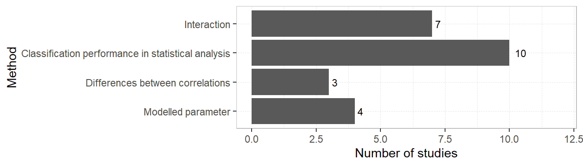

Figure 4.20: Other methods for operationalising sleep discrepancy

4.7 Miscellaneous methodological features

Lastly, we recorded some other methodological features of studies that appeared pertinent to the study of sleep discrepancy. Eleven studies investigated sleep discrepancy during, as a predictor of response to, or as an outcome of, cognitive behaviour therapy for insomnia (CBT-I). Fifteen studies used an experimental awakening paradigm where participants were monitored in-lab and woken by sound probes or technician interventions. A total of 15 studies were conducted with the aim of validating or assessing a particular sleep instrument.

5 Discussion

This study systematically reviewed ways of measuring, conceptualising, and analysing sleep discrepancy. Studies varied considerably across the broad range of recorded methodological characteristics and the number of studies identified indicated a vast literature. At the level of measurement, objective sleep mostly consisted of polysomnography and actigraphy, whilst self-report sleep spanned a range of questionnaires and diaries of varying response formats. Within objective sleep measures, approaches varied according to setting, equipment, and algorithms and procedures to process data. Sleep time-related metrics (e.g., TST, SOL, WASO) preponderated in the identified studies, with a small minority measuring direct sleep-wake agreement and a handful of studies measuring other sleep-related features or behaviours. Sleep quality was also investigated by a small number of studies. Definitions for sleep variables themselves did vary across studies although mainly on the self-report side and principally for the variables TST, WASO, and TIB, although objective SOL varied considerably. At the level of data processing and analysis, a range of strategies were employed to accommodate repeated measurements but for many studies, too, there was a single instance of recording. Direct comparisons were commonly made between self-report and objective sleep and these spanned a number of statistical approaches. Many studies went further than comparing self-report and objective sleep directly and attempted to investigate the relationship between sleep discrepancy and other variables. This was achieved most often with derived indices (e.g., self-report TST–objective TST), although other strategies were also employed. Our findings are discussed below with recommendations for further research where relevant.

5.1 Methodological diversity in sleep discrepancy research represents a conceptual problem

In attempting to measure the discrepancy between two concepts it is useful to know the discrepancy—or variability—within each concept itself. This is so that it can be certain that the discrepancy being measured cannot be accounted for by the amount of variation within each concept. Our results indicate that “self-report sleep” or “objective sleep” are not monolithic entities but variegated in ways that may be important. Take, for example, the simplest methodological distinction in objective sleep measurement: polysomnography versus actigraphy. In comparison with PSG, actigraphy generally overestimates sleep and underestimates wake time, and can have trouble distinguishing sleep from quiescent periods of wakefulness80. These trends have been observed to be greater for samples experiencing chronic medical or psychiatric conditions81. Tryon82 has emphasised that these differences between polysomnography and actigraphy are systematic, rather than random, and it follows from this that the two forms of objective sleep measurement will form distinct kinds of sleep discrepancy.

This issue continues through finer methodological distinctions. For example, within actigraphy, estimation of sleep can vary substantially across the various scoring algorithms identified in this review. There is ample evidence indicating that the concordance of actigraphy to PSG by algorithm can vary according to the sample in question83–86 and algorithm performance can even vary based on the actigraph device used87. A further example can be represented by the sheer range of sleep variables available to operationalise sleep discrepancy. Discrepancy within each variable is likely to have a distinct theoretical meaning. For example, Castelnovo et al7 noted that little overlap was found between individuals that misperceive TST and misperceive SOL. Important distinctions continue even within sleep variables themselves. We identified a range of self-report TST definitions, with the most common being direct queries (e.g., “how many hours did you sleep last night?”) and calculated parameters (e.g., TST = TIB–SOL–WASO–TWAK). Alameddine et al88 compared these two definitions and found that calculated estimates tended to exceed those from direct queries. TST discrepancy was overall negative across their sample for those with and without insomnia and so it is possible that indirect queries produce self-report TST that is closer to objective estimates.

For each of these examples, there are differences in sleep discrepancy across methodological approaches that evidence indicates is likely to be systematic. This is a significant issue for studies investigating the relationship between sleep discrepancy and another construct as the variance accounted for by the span of possible approaches may well exceed that of the effect the researchers are looking for. Addressing this issue may take a number of approaches. A stronger research focus on methods, investigating the impact of changes in methodology would be helpful overall. Specific tools such as structural equation modelling could be used to account for the variance represented by various methodological choices alone or in relation to other constructs. Theoretical justification or some rational account should also be provided for selection of sleep variables where possible, as many are likely to be conceptually distinct. A standardised approach to conducting and scoring actigraphy would reduce methodological variance in this particular area.

5.2 Methodological diversity may influence the rate of false-positive findings

Methodological diversity may also have consequences on the rate of false-positives in the sleep discrepancy literature. The term *researcher degrees of freedom* has been used to refer to the range of possible decisions throughout the data collection and analysis process that can be exploited to yield tests that reach statistical significance89. As evidenced by this review, the amount of researcher degrees of freedom in sleep discrepancy research is considerable, particularly at the data analysis stage, and especially for sleep variable definition and selection. Any combination of the large number of sleep variables identified in this review may be chosen as an alternative analytic decisions during analysis. When the different possible definitions of each of these variables are also enumerated, the number of possible decisions seems endless. Note, this issue is not confined to the case of a researcher deliberately exploring analytical alternatives following a null result. In a problem referred to as the garden of forking paths90, any methodological decision made in response to an observed feature of the data increases the likelihood that findings will be misleading. An example of this would be selecting SE over TST for a subsequent analysis after observing that SE discrepancy best discriminated individuals with and without insomnia. Even though the eventual result is at this point unknown, the decision of sleep variable is contingent on the data, and ultimately, *p*-values will not reflect what would have happened had TST been chosen instead. For any study investigating the relationship of sleep discrepancy with other constructs, pre-registration of hypotheses and plans for data collection and analysis91 is likely to be helpful in minimising inflated Type I error through post-hoc methodological decisions.

5.3 Definitions of objective sleep onset latency are multifarious and mostly arbitrary

Definitions of objective SOL vary considerably in the sleep discrepancy literature. Self-report sleep onset is more likely to coincide with the occurrence of the first sleep spindle, an EEG waveform associated with stage 2 sleep, than with the first incidence of stage 1 sleep92. As such, R&K SOL is likely to have greater correspondence to self-report SOL than AASM SOL. This disparity would be expected to increase with greater sleep fragmentation in the early sleep period and substantial differences in AASM and R&K sleep discrepancy should be expected in samples with disrupted initial sleep. Stricter/longer SOL definitions including the Latency to Persistent Sleep (LPS)93 and complex definitions from Means et al3 and Lehrer et al94 are expected to have the closest correspondence to self-report SOL, as research indicates 22-minutes of uninterrupted sleep is needed for healthy adults to perceive a bout of sleep during the beginning of the night95.

Sleep onset is a continuous process for which it is difficult to identify a clear start-point82. For example, with PSG scored by AASM criteria, 50% of a 30-second epoch is needed to exhibit sleep for the scoring of a first sleep stage. This means sleep latency is defined as the number of epochs preceding the first uninterrupted ~16 seconds of an EEG depicting activity consistent with sleep. An individual could conceivably achieve this 16-second threshold within two minutes, wake up, and not return for another two hours (SOL = 2 minutes). Equally, an individual could spend a two hour period getting 14-second blocks of sleep before achieving a consolidated bout of sleep (SOL = 120 minutes). These are extreme examples, but they highlight the difficulty with defining a single point of sleep onset. Of course, a line needs to be drawn somewhere, but the position of this line appears to be an arbitrary decision.

Saline et al96 noted another problem although only for studies that investigate both TST and SOL concurrently. In the estimation of TST, individuals may attempt to judge the length of time between their subjective sleep onset and final wake time—anchoring their TST estimate to their SOL estimate. In measuring TST and SOL discrepancy, SOL discrepancy is thus being tested for twice: once in SOL and again implicitly in TST. Their solution to this problem was to obtain independent measurements by estimating the amount of objective sleep measured during the subjective sleep latency period (sleep during subjective latency; SDSL) and the amount of objective sleep measured following the subjective sleep latency period (latency adjusted total sleep time; LA-TST).

In view of these issues, three options are recommended in the context of sleep discrepancy research. The first is to proceed with defining objective SOL using latency to persistent sleep (LPS)—the first 20 consecutive epochs of sleep. Due to the considerable time it takes to perceive a bout of sleep and the rarity and limited magnitude of SOL underestimation95,96 it makes sense to use a longer criterion than a shorter one. LPS also has the advantage of being simpler than many of the alternatives we identified. The second option is to use SDSL for the reasons described in the previous paragraph. It should be noted, however, positive discrepancy (i.e., SOL underestimation) is not measurable with this method. The third option is to avoid SOL as a sleep variable and to model sleep perception parameters during the sleep onset period according to Hermans et al95. The latter two options have the added advantage of operationalising sleep discrepancy without the use of derived scores—the problems with which are discussed briefly in a following paragraph.

5.4 Sleep discrepancy is mostly restricted to sleep states or sleep time and varies in its conceptual distance to sleep misperception

To map the boundaries of the concept of sleep discrepancy, we included any studies comparing objective sleep with an equivalent measure of self-report sleep. From the very few studies identified investigating sleep patterns or other sleep-related behaviours it appears that sleep discrepancy is mostly restricted to discordance in sleep states (e.g., wakefulness versus sleep) or discordance in sleep time parameters (e.g., total sleep time). It may be helpful to consider sleep discrepancy, as so defined, in relationship to sleep misperception. These two terms have been used interchangeable in the past and the problems with doing this have been noted by a number of authors82,97. Stated simply, sleep is a complex process for which there no one perfectly valid measure, and using the term *sleep misperception* brings a status to objective measures of sleep that may not be warranted. For example, sleep-like EEG activity can occur during waking consciousness in a phenomenon known as local sleep98, and other dissociations between the EEG and sleep-related physiological processes, have been observed under some conditions99. Moreover, conventional sleep scoring is but one way of classifying EEG data and subtler systems exist, including the cyclic alternative pattern100.

Whilst it may not be possible to directly measure sleep misperception for these reasons, sleep discrepancy can be closer or further to sleep misperception conceptually depending on its operational definition. Closest are studies measuring sleep-wake agreement or classification using EEG under laboratory conditions. In a case where a participant who, being asleep for five minutes, is woken by a technician and reports complete wakefulness for the preceding period, only the fallibility of objective recording can account for a conceptual distinction between sleep discrepancy and true sleep-state misperception. This fundamental sleep discrepancy represented by direct sleep-wake agreement can be contrasted with sleep discrepancy represented by sleep time variables (e.g., TST, SOL). Moving from sleep-wake agreement to sleep time variables introduces additional factors that may account for the incongruence between self-report and objective sleep and hence provides a broader definition of sleep discrepancy. On the objective side, PSG potentially introduces artefact from transient (e.g., <15 second) awakenings101 and the arbitrary nature of SOL definitions (see section [5.3](http://127.0.0.1:10065/rmd_output/0/#sol)). Actigraphy introduces the potential for immobile wake to be scored as sleep84,102 and variance contributed by methodological factors such as choices in scoring algorithms. On the self-report side, sleep diaries and questionnaires introduce memory or reporting biases103 as potential factors contributing to sleep discrepancy. See Harvey et al104 for a discussion of these factors in the context of insomnia. In the present review, we reported a key distinction between *habitual* and *episodic* measures of self-report sleep.

Moving from episodic to habitual measures broadens the concept of yet sleep discrepancy further. A more global sleep discrepancy may be represented by comparisons of habitual self-report sleep with aggregated objective sleep (e.g., mean sleep variables values across 14 nights of actigraphy), the underlying processes for which are likely different to those of individual nights. Where habitual self-report sleep is compared to objective estimates spanning one to a few nights, intra-individual variation in sleep patterns is introduced to sleep discrepancy. In other words, some component of the difference between objective and self-report sleep can be accounted for by the difference between habitual sleep and the circumstances of testing—which may be substantial. If the objective measure is PSG, effects of the laboratory/testing environment (i.e., the first night effect105,106) are additionally introduced.

5.5 Derived indices are common and the use of these as an operational measure of sleep discrepancy is problematic

Derived variables, including difference scores and ratio scores, are overwhelmingly the most common way of operationalising sleep discrepancy to investigate its relationship with other variables. The use of derived variables for such a purpose is associated with a range of conceptual and methodological problems107–109 that are severe enough to warrant discontinuing their use in sleep discrepancy research. Stated briefly, in a relationship with another variable, the effect of each component of a derived index (e.g., a difference score representing the subtraction of self-report from objective TST) is confounded such that it is not possible to determine whether self-report sleep, objective sleep, or some combination of the two are driving the relationship108. Moreover, derived scores impose inappropriate constraints on relationships between other variables that are often not entailed by, or else completely contradictory to, stated hypotheses108. A large range of derived variables were identified by this review, none of which escape the problems described by the aforementioned authors. Fortunately, a number of alternative strategies for characterising relationships between sleep discrepancy and other constructs are available. Such methods identified in this review included using classification performance metrics within conventional statistical analyses, representing sleep discrepancy with moderation/interaction effects, and modelling sleep discrepancy parameters mathematically.

5.6 Averaging sleep variables across multiple nights is a common practice and can cause problems

In the studies identified in this review, the most common way of handling repeated measurements of sleep variables was by averaging across multiple instances of recording. This technique is problematic when applied to concurrent nightly/episodic measurements of self-report and objective sleep as it relies on the assumption that patterns of sleep over/underestimation are consistent across nights. Extreme positive and negative sleep discrepancy occurring alternately on successive nights could result in averages denoting negligible discrepancy. This may be a realistic concern for research in sleep discrepancy and insomnia, for example. Although most individuals with insomnia tend to underestimate sleep, high inter-night variability is observed and some individuals will overestimate sleep110. An exception to this problem exists in the case of comparing aggregated objective sleep against a habitual measure of self-report sleep, such as the PSQI. Here, using means or medians to determine habitual measures of objective sleep is necessary to define sleep discrepancy at the habitual, rather than the nightly level. In other cases, linear mixed models, generalised estimating equations, and structural equation models were methods identified in this review that do not inherit the same problems with averaging across repeated measures.

5.7 Correlations have sometimes been used inappropriately as a measure of concordance

Despite being the most common approach to comparing self-report and objective sleep measures, Pearson or Spearman correlations are broadly inappropriate for the characterisation of agreement or discrepancy. Correlation is strictly a measure of association between two variables and is insensitive to systematic error between measures111. For example, the same correlation coefficient may equally describe a sample where self-report and objective estimates of sleep tend to be equal as one where (i), objective estimates tend to exceed self-report estimates by a given constant (e.g., two hours) or (ii), the value of objective sleep varies proportional to the level of self-report sleep. Measures of agreement including Bland-Altman analyses, intra-class correlation, and Lin’s concordance coefficient were also used by a large number of studies and are preferable for the measurement of discrepancy in equivalent parameters.

5.8 Sleep quality discrepancy is conceptually unclear

Sleep quality discrepancy was measured by a small number of studies in this review, according to varying strategies. Sleep quality discrepancy is a difficult topic for two reasons. First, there is no consensus approach to operationalising sleep quality. A recent review of methods for measuring sleep quality identified an immense range in strategies, especially for objective measures112. Second, there are no clear self-report analogues for objective measures of sleep quality, or vice-versa. An individual is unable to directly estimate their number of EEG arousals, quantity or proportion of N3 sleep, or other features of sleep macro or microstructure unavailable to consciousness. Equally, it is not clear how to compare a sleep quality rating judgement (e.g., on a Likert scale) with objective measures (see Krystal & Edinger113). Overall, investigating the relationships of sleep quality discrepancy to other variables is unlikely to be profitable until the conceptual status of self-report and objective sleep quality is clearer.

5.9 Sleep diaries should not be used to define rest intervals in sleep discrepancy research

Sleep diaries were the most commonly identified method of rest interval definition in this review. Sleep diaries were classified by this review as a self-report measure of sleep. By using sleep diaries to define actigraphic rest intervals, self-report sleep is being used to partially define an objective sleep measure. In this case, the measured discrepancy between the two forms of sleep measurement will not be an accurate representation of their actual incongruence. The high frequency at which sleep diaries are back-filled or misreported103 highlights the significance of this issue. We noted that a single study in the present review addressed this problem directly. Krahn et al114 ensured that manual scorers of the rest intervals for their actigraphy data were blinded to the sleep diary. It may be helpful for further research that alternatives such as these are sought for defining rest interval periods.

5.10 The scope of sleep discrepancy research is likely to have been underestimated

The scope of the literature on sleep discrepancy has been considerably underestimated to date. We intended to identify a broad range of studies in this review that may have captured the concept of sleep discrepancy without necessarily referring to this or related terms. A search across full texts of all studies included in this review returned 63 records making explicit mention of “sleep” and “discrepancy”, leaving 185 that would have otherwise been unidentifiable through simple keyword searching of this concept. A prior review of paradoxical insomnia and subjective-objective sleep discrepancy8 identified a total of 40 records. Although conducted four years prior, this review used broader inclusion criteria extending to paradoxical insomnia, the parameters for which do not typically involve direct comparisons of self-report and objective sleep. A corollary to this underestimation of breadth is that existing sleep discrepancy research across domains may be excessively siloed into respective research areas. Looking at the clinical populations encompassed in this review, there appear to be small but distinguishable sleep discrepancy research programmes in post-traumatic stress disorder, bipolar disorder, pregnancy, traumatic brain injury, and fibromyalgia, to name just a few. Whilst sleep discrepancy is best understood in the context of insomnia, it is possible similar processes underlie the presence of sleep discrepancy in these groups. For example, the role of sleep disturbance as a transdiagnostic factor across psychiatric disorders has been emphasised115 and a mechanistic role for sleep misperception has been suggested for disorders outside of insomnia116.

5.11 Strengths and limitations

This study represents the largest systematic approach to investigating methodology in the area of sleep discrepancy research. We reported a broad range of methodological features across a large number of studies and provided meaningful syntheses of research methods in a diverse field. Two major changes were made to our own methods during the screening process and following registration of the scoping review protocol that may be viewed as limitations. These changes were both made in response to the unanticipated number of records returned following title and abstract screening and in view of limited resources available for charting and synthesis. First, grey literature was removed from inclusion criteria. Although the issues and recommendations discussed in this paper were limited to published research, our findings remain broadly applicable and no syntheses of empirical findings have been made that could be influenced by publication bias. Second, reference lists were not screened for additional studies and the extent to which this review may be considered an exhaustive representation of the literature may be reduced as a result.

5.12 Summary

Methods for investigating sleep discrepancy have varied considerably in the literature across the areas of study design, measurement, data processing, and data analysis. Many of these varied approaches have substantial effects on what sleep discrepancy means as a concept and sometimes are associated with methodological problems that may not be immediately clear. Sleep discrepancy research holds promise for advancing understanding of sleep, its disorders such as insomnia, and mechanisms at play in psychiatric and other disorders. Clear concepts and appropriate methodology is essential to ensure that work in this area remains a progressive science. Measuring discrepancy or congruence is often a deceptively complex undertaking and we hope that this scoping review will prove helpful and informative to those interested in designing or interpreting sleep discrepancy studies.

6 Data availability statement

All code and data underlying this article are available from github: <https://github.com/tfwalton/sleep-discrepancy-review>.

7 Acknowledgements

We would like to thank the librarians at the University of Western Australia library for their assistance with the development of the search strategy.

8 Financial disclosure statement

None.

9 Funding

This work forms part of PhD project funded by the Australian Government Research Training Program.

10 Declaration of competing interest

The authors declared that they had no conflicts of interest with respect to their authorship or the publication of this article.

11 Appendices

11.1 Search strategies

Search strategies for databases searched using the Ovid system are available in Table [11.1](http://127.0.0.1:10065/rmd_output/0/#tab:ovid). Search strategies for other databases are listed in Table [11.2](http://127.0.0.1:10065/rmd_output/0/#tab:databases).

| Table 11.1: Search strategy for Ovid databases | | |
| --- | --- | --- |
| **Step** | **Terms and operators** | **Records** |
| **Embase** | | |
| 1 | sleep discrepancy or paradoxical insomnia or subjective insomnia or (sleep adj2 misperception).mp | 488 |
| 2 | ((self report* or diary or subjective*) and (objective* or actigraph* or polysomnograph* or polygraph*)).mp. | 193243 |
| 3 | (exp polysomnography/ or exp actimetry/) and exp self report/ | 1676 |
| 4 | (sleep* and (“over estimat*” or ”over report*” or “under estimat*” or ”under report*” or overestimat* or overreport* or underestimat* or underreport* or discrepan* or concordan* or agreement or disagreement or discordan* or congruen* or incongruen*)).mp. | 9362 |
| 5 | 2 or 3 | 193302 |
| 6 | 4 and 5 | 1234 |
| 7 | 1 or 6 | 1569 |
| **PsycINFO** | | |
| 1 | sleep discrepancy or paradoxical insomnia or subjective insomnia or (sleep adj2 misperception).mp | 175 |
| 2 | ((self report* or diary or subjective*) and (objective* or actigraph* or polysomnograph* or polygraph*)).mp. | 57592 |
| 3 | (exp polysomnography/ or exp actigraphy/) and exp self report/ | 59 |
| 4 | (sleep* and (“over estimat*” or ”over report*” or “under estimat*” or ”under report*” or overestimat* or overreport* or underestimat* or underreport* or discrepan* or concordan* or agreement or disagreement or discordan* or congruen* or incongruen*)).mp. | 2112 |
| 5 | 2 or 3 | 57592 |
| 6 | 4 and 5 | 346 |
| 7 | 1 or 6 | 471 |
| **Medline** | | |
| 1 | sleep discrepancy or paradoxical insomnia or subjective insomnia or (sleep adj2 misperception).mp | 260 |
| 2 | ((self report* or diary or subjective*) and (objective* or actigraph* or polysomnograph* or polygraph*)).mp. | 139088 |
| 3 | (exp polysomnography/ or exp actigraphy/) and exp self report/ | 561 |
| 4 | (sleep* and (“over estimat*” or ”over report*” or “under estimat*” or ”under report*” or overestimat* or overreport* or underestimat* or underreport* or discrepan* or concordan* or agreement or disagreement or discordan* or congruen* or incongruen*)).mp. | 5280 |
| 5 | 2 or 3 | 139088 |
| 6 | 4 and 5 | 692 |
| 7 | 1 or 6 | 875 |

| Table 11.2: Search strategy for other databases | |
| --- | --- |
| **Terms and operators** | **Records** |
| **Pubmed** | |
| (“sleep discrepancy” OR “paradoxical insomnia” OR “subjective insomnia”) OR (sleep AND misperception) OR ((“self report*” or diary or subjective*) AND (objective* or actigraph* or polysomnograph* or polygraph*)) OR ((”Polysomnography/methods”[MAJR] OR ”Actigraphy/methods”[MAJR]) AND ”Self Report”[MeSH]) AND (sleep* AND (”over estimat*” OR “over report” OR ”under estimat” OR “under report*” OR overestimat* OR overreport* OR underestimat* OR underreport* OR discrepan* OR concordan* OR agreement OR disagreement OR discordan* OR congruen* OR incongruen*)) | 761 |
| **CINAHL Plus** | |
| (“sleep discrepancy” OR “paradoxical insomnia” OR “subjective insomnia”) OR (sleep AND misperception) OR ((“self report*” or diary or subjective*) AND (objective* or actigraph* or polysomnograph* or polygraph*)) AND (sleep* AND (”over estimat*” OR “over report” OR ”under estimat” OR “under report*” OR overestimat* OR overreport* OR underestimat* OR underreport* OR discrepan* OR concordan* OR agreement OR disagreement OR discordan* OR congruen* OR incongruen*)) | 310 |
| **Scopus** | |
| TITLE-ABS-KEY ( ( “sleep discrepancy” OR “paradoxical insomnia” OR “subjective insomnia” ) OR ( sleep AND misperception ) OR ( ( “self report*” OR diary OR subjective* ) AND ( objective* OR actigraph* OR polysomnograph* OR polygraph* ) ) AND ( sleep* AND (”over estimat*” OR “over report” OR ”under estimat” OR “under report*” OR overestimat* OR overreport* OR underestimat* OR underreport* OR discrepan* OR concordan* OR agreement OR disagreement OR discordan* OR congruen* OR incongruen* ) ) ) | 826 |
| **Web of Science** | |
| (“sleep discrepancy” OR “paradoxical insomnia” OR “subjective insomnia”) OR (sleep AND misperception) OR ((“self report*” or diary or subjective*) AND (objective* or actigraph* or polysomnograph* or polygraph*)) AND (sleep* AND (”over estimat*” OR “over report” OR ”under estimat” OR “under report*” OR overestimat* OR overreport* OR underestimat* OR underreport* OR discrepan* OR concordan* OR agreement OR disagreement OR discordan* OR congruen* OR incongruen*)) | 1288 |
| **Proquest Theses and Dissertations Global** | |
| noft((“sleep discrepancy” OR “paradoxical insomnia” OR “subjective insomnia”) OR (sleep AND misperception) OR (((“self report*” or diary or subjective*) AND (objective* or actigraph* or polysomnograph* or polygraph*)) AND (sleep* AND (”over estimat*” OR “over report” OR ”under estimat” OR “under report*” OR overestimat* OR overreport* OR underestimat* OR underreport* OR discrepan* OR concordan* OR agreement OR disagreement OR discordan* OR congruen* OR incongruen*)))) | 90 |

11.2 List of deviations from protocol

The following are a list of deviations from the scoping review protocol registered on the Open Science Framework (doi: 10.17605/OSF.IO/BCJNQ).

1. The term actimetry in Medline and PSYCinfo searches was changed to actigraphy
2. The scoping review protocol listed an incorrect number of duplicates records following searches
3. All records that were not peer reviewed journal articles were excluded at the full-text screening stage in the final review
4. Other items were added to the exclusion criteria at the full-text screening stage including:

* study measured informant-report rather than strictly self-report sleep
* study did not include statistical comparison of self-report and objective sleep (e.g., numerical comparisons only, single-case design)

1. Reference lists were not searched for additional citations as planned in the protocol

11.3 PRISMA-ScR checklist

| Table 11.3: Preferred Reporting Items for Systematic reviews and Meta-Analyses extension for Scoping Reviews (PRISMA-ScR) Checklist. | | | |
| --- | --- | --- | --- |
| **Section** | **Item** | **PRISMA-ScR Checklist Item** | **Location reported** |
| **Title** | | | |
| Title | 1 | Identify the report as a scoping review. | [1](http://127.0.0.1:10065/rmd_output/0/#abstract) |
| **Abstract** | | | |
| Structured summary | 2 | Provide a structure summary that includes (as applicable): background, objectives, eligibility criteria, sources of evidence, charting methods, results, and conclusions that relate to the review questions and objectives. | [1](http://127.0.0.1:10065/rmd_output/0/#abstract) |
| **Introduction** | | | |
| Rationale | 3 | Describe the rationale for the review in the context of what is already known. Explain why the review questions/ objectives lend themselves to a scoping review approach | [2](http://127.0.0.1:10065/rmd_output/0/#introduction) |
| Objectives | 4 | Provide an explicit statement of the questions and objectives being addressed with reference to their key elements (e.g., population or participants, concepts, and context) or other relevant key elements used to conceptualise the review questions and/or objectives. | [2](http://127.0.0.1:10065/rmd_output/0/#introduction) |
| **Methods** | | | |
| Protocol and registrations | 5 | Indicate whether a review protocol exists; state if and where it can be accessed (e.g., a Web address); and if available, provide registration information, including the registration number. | [3.1](http://127.0.0.1:10065/rmd_output/0/#protocol) |
| Eligibility criteria | 6 | Specify characteristics of the sources of evidence used as eligibility criteria (e.g., years considered, language, and publication status), and provide a rationale. | [3.2](http://127.0.0.1:10065/rmd_output/0/#item6) |
| Information sources | 7 | Describe all information sources in the search (e.g., databases with dates of coverage and contact with authors to identify additional sources), as well as the date the most recent search was executed. | [3.4](http://127.0.0.1:10065/rmd_output/0/#item7) |
| Search | 8 | Present the full electronic search strategy for at least 1 database, including any limits used, such that it could be repeated. | [3.1](http://127.0.0.1:10065/rmd_output/0/#tab:egsearch) |
| Selection of sources of evidence | 9 | State the process for selecting sources of evidence (i.e., screening and eligibility) included in the scoping review. | [3.5](http://127.0.0.1:10065/rmd_output/0/#item9) |
| Data charting process | 10 | Describe the methods of charting data from the included sources of evidence (e.g., calibrated forms or forms that have been tested by the team before their use, and whether data charting was done independently or in duplicate) and any processes for obtaining and confirming data from investigators. | [3.6](http://127.0.0.1:10065/rmd_output/0/#item10) |
| Data items | 11 | List and define all variables for which data were sought and any assumptions and simplifications made | [3.7](http://127.0.0.1:10065/rmd_output/0/#item11) |
| Critical appraisal of individual sources of evidence | 12 | If done, provide a rationale for conducting a critical appraisal of included sources of evidence; describe the methods used and how this information was used in any data synthesis (if appropriate). | Formal quality assessment was not conducted |
| Synthesis of results | 13 | Describe the methods of handling and summarizing the data that were charted | [3.8](http://127.0.0.1:10065/rmd_output/0/#item13) |
| **Results** | | | |
| Selection of sources of evidence | 14 | Give numbers of sources of evidence screen, assessed for eligibility, and included in the review, with reasons for exclusions at each stage, ideally using a flow diagram. | [4](http://127.0.0.1:10065/rmd_output/0/#item14) |
| Characteristics of sources of evidence | 15 | For each source of evidence, present characteristics for which data were charted and provide the citations. | [11.4](http://127.0.0.1:10065/rmd_output/0/#tab:studychar) |
| Critical appraisal within sources of evidence | 16 | If done, present data on critical appraisal of included sources of evidence (see item 12). | Formal quality assessment was not conducted |
| Results of individual sources of evidence | 17 | For each included source of evidence, present the relevant data that were charted that relate to the review questions and objectives. | [4.2](http://127.0.0.1:10065/rmd_output/0/#resultsandsynthesis) |
| Synthesis of results | 18 | Summarize and/or present the charting results as they relate to the review questions and objectives. | [4.2](http://127.0.0.1:10065/rmd_output/0/#resultsandsynthesis) |
| **Discussion** | | | |
| Summary of evidence | 19 | Summarize the main results (including an overview of concepts, themes, and types of evidence available), link to the review questions and objectives, and consider the relevance to key groups | [5](http://127.0.0.1:10065/rmd_output/0/#item19) |
| Limitations | 20 | Discuss the limitations of the scoping review process. | [5.11](http://127.0.0.1:10065/rmd_output/0/#item20) |
| Conclusions | 21 | Provide a general interpretation of the results with respect to the review questions and objectives, as well as potential implications and/or next steps. | [5.12](http://127.0.0.1:10065/rmd_output/0/#item21) |
| **Funding** | | | |
| Funding | 22 | Describe sources of funding for the included sources of evidence, as well as sources of funding for the scoping review. Describe the role of the funders of the scoping review. | [9](http://127.0.0.1:10065/rmd_output/0/#item22) |

11.4 Additional tables

Full descriptions of study characteristics are available in Table [11.4](http://127.0.0.1:10065/rmd_output/0/#tab:studychar).

| Table 11.4: Characteristics of included studies | | | |
| --- | --- | --- | --- |
| **Study** | **Country of origin** | **Sample characteristics** | **Sample size** |
| Ahn et al117 | Korea | Patients >55 years with insomnia disorders | 33 |
| Al Lawati et al6 | Oman | Healthy Omani nationals | 321 |
| Alameddine et al88 | USA | Participants referred to a sleep centre for PSG | 879 |
| Ansok et al118 | USA | Patients with rotator cuff tears | 18 |
| Argyropoulos et al119 | United Kingdom | Outpatients with moderate to severe depression, without psychotic features, in an RCT of two antidepressants | 40 |
| Aritake-Okada et al120 | Japan | Healthy males | 22 |
| Arora et al121 | United Kingdom | Adolescents aged 11-13 | 255 |
| Auger et al122 | USA | Patients referred to an academic sleep centre | 84 |
| Baek et al52 | Korea | Shiftwork nurses | 94 |
| Baillet et al5 | France | Older adults with no sleep disorders, sleep medications, or depressive symptomatology | 45 |
| Baker et al123 | South Africa | Healthy young subjects | 20 |
| Barbosa et al124 | Brazil | Visually impaired individuals and participants without visual impairment | 77 |
| Bastien et al125 | Canada | Individuals with chronic psychophysiological insomnia, paradoxical insomnia and good sleepers | 88 |
| Bean et al126 | New Zealand | Chronic pain patients | 47 |
| Bensen-Boakes et al127 | Australia | Participants with comborbid insomnia and OSA | 145 |
| Bian et al128 | China | Inpatients with schizophrenia | 148 |
| Bianchi et al129 | USA | Patients referred to a sleep centre | 312 |
| Bianchi et al93 | USA | Healthy subjects undergoing in-lab sleep experiment | 44 |
| Billings130 | USA | Firefighters | 24 |
| Bonnet & Moore92 | USA | Young adults | 12 |
| Broomfield & Espie131 | United Kingdom | Individuals complaining of sleep-onset insomnia | 34 |
| Brychta et al132 | Iceland | 15-year, then 17-year old students of the same cohort | 144 |
| Caia et al133 | Australia | Professional rugby league athletes | 63 |
| Campanini et al134 | Brazil | School teachers | 163 |
| Carter et al135 | USA | Collegiate athletes | 121 |
| Castelnovo et al136 | Switzerland | Patients with insomnia | 249 |
| Castillo et al137 | USA | Patients referred to a sleep centre for PSG | 405 |
| Cederberg et al138 | USA | Patients with multiple sclerosis | 49 |
| Chan et al139 | USA | Community dwelling older adults with insomnia | 62 |
| Chan et al53 | USA | Individuals with fibromyalgia and Insomnia | 223 |
| Chen et al140 | Taiwan | Individuals with osteoarthritis | 30 |
| Chervin & Guilleminault141 | USA | Patients referred to a sleep centre for an MSLT for suspected excessive daytime somnolence | 147 |
| Cho et al142 | Korea | Participants from the sleep heart health study | 2540 |
| Choi et al143 | Korea | Patients referred to a sleep centre for PSG in addition to healthy volunteers | 420 |
| Chou et al144 | USA | Cognitively normal and mildly impaired older adults | 293 |
| Chung et al145 | Korea | Outpatients with schizophrenia | 66 |
| Combertaldi & Rasch146 | Switzerland | Young healthy students | 24 |
| Conroy et al147 | USA | Individuals experiencing insomnia in recovery from alcohol dependence | 21 |
| Creti et al148 | Canada | Participants with chronic fatigue syndrome | 49 |
| Crönlein et al149 | Germany | Patients receiving CBT-I for insomnia | 92 |
| Currie et al150 | Canada | Individuals experiencing insomnia in recovery from alcohol dependence | 56 |
| Curtis et al151 | USA | Participants with fibromyalgia and insomnia | 199 |
| D’Aoust et al152 | USA | Informal caregivers of persons with dementia | 53 |
| Dautovich et al49 | USA | Older adults who nap habitually | 100 |
| De Francesco et al78 | United Kingdom | People with HIV and people without HIV matched on demographic variables | 461 |
| De Jaeger et al153 | Belgium | Failed back surgery syndrome (FBSS) patients treated with spinal cord stimulation | 19 |
| Dean et al154 | USA | Adults with inoperable non-small cell lung cancer | 26 |
| Devine et al155 | USA | Army Reserve Officers’ Training Corp Cadets | 286 |
| Dietch & Taylor156 | USA | Representative community-based normative sample | 80 |
| Dinapoli et al157 | Italy | Older adults with mild cognitive impairment and subsyndromal depression | 59 |
| Dittoni et al158 | Italy | Chronic primary insomnia patients | 66 |
| Dorrian et al159 | Australia | Commercial passenger airline pilots | 306 |
| Dorsey & Bootzin160 | USA | Undergraduate students | 31 |
| Downey & Bonnet161 | USA | Subjective insomniacs | 10 |
| Duarte et al162 | Brazil | Patients undergoing PSG for suspected sleep-disordered breathing | 727 |
| Duarte et al163 | Brazil | Individuals with sleep disorders and contrls | 2004 |
| Dunican et al164 | Australia | Judo athletes | 23 |
| Dzierzewski et al165 | USA | Older adults with insomnia | 159 |
| Edinger & Fins2 | USA | Outpatients with insomnia presenting to a sleep disorders centre | 173 |
| Espie et al26 | United Kingdom | Individuals with insomnia | 20 |
| Etain et al166 | France | Adults with bipolar disorder and healthy controls | 154 |
| Facco et al167 | USA | Nulliparous women enrolled in the first trimester of pregnancy | 752 |
| Feige et al168 | Germany | Insomnia patients and good sleeper controls | 100 |
| Feige et al169 | Germany | Individuals with paradoxical insomnia and good sleeper controls | 200 |
| Feng & Svetnik70 | United Kingdom | Primary insomnia patients | n/a |
| Fernandez-Mendoza et al170 | USA | Insomniacs and controls | 866 |
| Finan et al171 | USA | Participants with opioid use disorder | 55 |
| Franklin & Svanborg172 | Sweden | Individuals referred to sleep center for suspected OSA | 100 |
| Friedmann et al71 | Germany | Women with PTSD after childhood abuse, mentally healthy women with a history of child abuse, and nontraumatised mentally healthy women | 184 |
| Gaina et al173 | Japan | Healthy junior high school children | 42 |
| Ghadami et al174 | Iran | War veterans diagnosed with chronic PTSD | 32 |
| Gibson et al67 | Australia | Australian army recruits | 59 |
| Girschik et al64 | Australia | Women recruited from the community | 56 |
| Gonzalez et al175 | USA | Individuals with bipolar type I | 39 |
| Gooneratne et al176 | USA | Older adults with and without insomnia complaint | 200 |
| Goudman et al177 | Belgium | Patients with failed back surgery syndrome treated with spinal chord stimulation | 39 |
| Goulart et al178 | Brazil | Healthy males with normal sleep randomised to three experimental groups | 31 |
| Guedes et al69 | Brazil | Adolescents | 37 |
| Gökce et al179 | Germany | Young adults in Munich | 74 |
| Hall et al180 | USA | Women with PTSD secondary to interpersonal violence | 45 |
| Hanisch et al50 | USA | Prostate cancer patients undergoing androgen therapy | 60 |
| He et al181 | China | Adults participants subject to COVID-19 lockdown provisions in China | 70 |
| Heath et al182 | Australia | Adolescents | 385 |
| Herbert et al183 | United Kingdom | Individuals with insomnia symptoms | 42 |
| Hermans et al184 | Netherlands | Older adults involved in a double-blind crossover study with zopiclone and placebo | 46 |
| Hermans et al79 | Netherlands | Insomnia patients and healthy controls | 231 |
| Hermans et al185 | Netherlands | Older adults with and without insomnia | 41 |
| Hermans et al95 | Netherlands | Participants with insomnia on a waitlist for CBT-I | 31 |
| Herring et al186 | USA | Urban low-income pregnant women | 80 |
| Hita-Yañez et al187 | Spain | Patients with MCI and healthy elderly | 50 |
| Hodges et al188 | USA | Cocaine-dependent persons admitted to an inpatient research facility | 43 |
| Hoogerhoud et al189 | Netherlands | Patients receiving index or maintenance ECT for a depressive episode | 12 |
| Hsiao et al190 | Taiwan | Healthy young adults | 36 |
| Huang et al191 | China | Primary insomnia patients and healthy controls | 170 |
| Hughes et al192 | USA | Vulnerable older adults participating in a Veterans Administration Adult Day Health Care (ADHC) program | 59 |
| Hur et al193 | Canada | Patients with interstitial lung disease | 111 |
| Ihler et al194 | France, Norway | Individuals with bipolar disorder and healthy controls | 196 |
| Jackowska et al72 | United Kingdom | Women working at University College London and neighbouring institutions | 179 |
| Jackson et al76 | USA | Adults enrolled in a large longitudinal study | 1910 |
| Jackson et al77 | USA | African-American adults | 821 |
| Janků et al195 | Czech Republic | Insomnia patients | 36 |
| Jungquist et al196 | USA | Community-dwelling adults | 300 |
| Kang et al197 | USA | Individuals with major depressive disorder, individuals with primary insomnia, and normal sleeping controls | 82 |
| Kaplan et al198 | USA | Individuals with bipolar disorder and age and sex-matched controls | 54 |
| Kaufmann et al199 | USA | Individuals with bopolar disorder and healthy controls | 85 |
| Kawada200 | Japan | Healthy university students | 76 |
| Kay et al201 | USA | Individuals with paradoxical insomnia and good sleeper controls | 62 |
| Kay et al202 | USA | Older adults with and without insomnia | 114 |
| Kay et al73 | USA | Older adults with and without sleep complaint | 103 |
| Keklund & Akerstedt203 | Sweden | Individuals involved in a study of early morning work or a study of sleep in a truck-berth | 37 |
| Kennedy et al204 | Ireland | Patients with advanced chronic kidney disease or end-stage kidney disease | 54 |
| Khou et al205 | USA | Community dwelling older adults with and without mild Alzheimers disease | 86 |
| King et al206 | USA | Female undergraduates enrolled in an interior design programme | 28 |
| Kishikawa et al207 | Japan | Outpatients with primary insomnia undergoing CBT-I | 52 |
| Kobayashi et al208 | USA | Urban-residing African Americans with and without trauma exposure and PTSD | 103 |
| Kolling et al209 | Germany | German undergraduate and graduate physical education students | 72 |
| Kong et al210 | China | Children recruited from primary and secondary schools in Hong King | 133 |
| Krahn et al114 | USA | Psychiatric inpatients | 30 |
| Kreutz et al211 | Germany | Breast cancer patients starting neoadjuvant chemotherapy | 54 |
| Krishnamurthy et al212 | USA | Bipolar disorder patients and healthy controls similar in age, race, and sex | 54 |
| Kryger et al213 | Canada | Patients with chronic insomnia | 16 |
| Krystal & Edinger214 | USA | Patients with primary insomnia with sleep maintenance difficulty evident in subjective sleep measures | 30 |
| Krystal et al215 | USA | Individuals with subjective insomnia, objective insomnia and normal controls | 50 |
| Kundu et al216 | India | Individuals with chronic insomnia and obstructive sleep apnoea | 32 |
| Kung et al217 | Taiwan | Taiwanese adults with major depression | 30 |
| Lan Chun Yang et al218 | Canada | Participants diagnosed with mTBI/concussion | 37 |
| Laranjeira et al219 | Brazil | Individuals referred to a sleep centre | 248 |
| Lastella et al220 | Australia | Well-trained male soccer players | 12 |
| Lauderdale et al66 | USA | Young adults enrolled in the Coronary Artery Risk Development in Young Adults study | 647 |
| Lecci et al (study 2)221 | Switzerland | Insomnia patients and healthy subjects | 34 |
| Lecci et al221 | Switzerland | Population-based sample | 2092 |
| Lee et al222 | Korea | Patients with OSA | 707 |
| Lee et al223 | Korea | Adults with insomnia | 105 |
| Lee224 | United Kingdom | Adults aged 20 or above | 8438 |
| Lehrer et al94 | USA | Middle-aged community-dwelling women | 323 |
| Lewis60 | United Kingdom | Healthy young men | 8 |
| Lipinska & Thomas225 | South Africa | Women with PTSD, trauma exposure with no PTSD, and healthy controls | 60 |
| Liu et al226 | China | Patients diagnosed with OSA | 355 |
| Liu et al227 | China | Healthy young adults | 10 |
| Locihova et al228 | Czech Republic | Patients admitted to an intensive care unit of a hospital | 20 |
| Lockley et al48 | United Kingdom | Blind individuals | 49 |
| Lubas et al229 | USA | Participants enrolled in a longitudinal study of survivors of childhood cancer | 477 |
| Lund et al230 | USA | Older adults with comorbid insomnia | 60 |
| Ma et al231 | USA | Individuals with insomnia, insomnia & comorbid OSA, OSA only, and normal sleep controls | 638 |
| Maes et al232 | Belgium | Female patients diagnosed with primary insomnia and healthy female controls | 28 |
| Maich et al233 | Canada | Individuals with insomnia and good sleeper controls | 74 |
| Majer et al234 | USA | Individuals with chronic fatigue and non-fatigued controls | 75 |
| Manconi et al (study 2)235 | Italy | 159 patients with primary insomnia | 159 |
| Manconi et al235 | Italy, USA | Normal subjects | 288 |
| Maric et al236 | Switzerland | Healthy right-hand males | 14 |
| Martinez et al237 | Brazil | Patients referred to a university-affiliated sleep clinic for PSG | 5764 |
| Matousek et al238 | Czech Republic | Patients with minor depression, complaining of insomnia | 28 |
| Mazza et al239 | France | Children aged 8-9 years recruited from elementary schools | 76 |
| McCall & McCall240 | USA | Patients diagnosed with current major depressive episode and chronic insomnia | 54 |
| McCall et al241 | USA | Individuals undergoing PSG for suspected sleep apnoea | 84 |
| McIntyre et al55 | New Zealand | Healthy women late in third trimester | 30 |
| Means et al3 | USA | Middle-aged and older individuals with insomnia and matched normal sleepers | 101 |
| Mendelson et al74 | USA | Individuals with insomnia and age and sex matched controls | 20 |
| Mendelson242 | USA | Participants who complained of poor sleep | 8 |
| Mercer et al243 | USA | Individuals with insomnia and good sleepers | 22 |
| Meyer et al244 | United Kingdom | Outpatients with schizophrenia | 14 |
| Miner et al245 | USA | Community-dwelling older adults | 5835 |
| Moore et al246 | USA | 43 women with insomnia who had completed treatment for breast cancer | 43 |
| Most et al247 | Netherlands | Older adults with early and late stage alzheimers disease or healthy controls | 81 |
| Mundt et al248 | USA | Adults with insomnia and fibromyalgia randomised to CBT-I, CBT for pain, or waitlist control | 113 |
| Nam et al249 | Korea | Patients referred to a sleep clinic for evaluation of snoring/OSA | 50 |
| Narisawa et al250 | Japan | Participants with subjective sleep difficulty | 50 |
| Nazem et al251 | USA | Male veterans with traumatic brain injury | 19 |
| Neu et al56 | Belgium | Individuals with chronic fatigue and female controls | 40 |
| Nguyen-Michel et al51 | France | Older adults referred for insomnia complaints or suspected sleep apnoea | 135 |
| Normand et al252 | Canada | Paradoxical insomnia, psychophysiological insomnia, good sleepers | 70 |
| O’Brien et al253 | USA | Treatment-seeking overwieght/obese participants | 63 |
| Okifuji & Hare254 | USA | Patients with fibromyalgia | 75 |
| Okun et al255 | USA | Pregnant women | 104 |
| Orta et al256 | Chile | Female primary caregivers of children with disabilities | 175 |
| Ouellet & Morin257 | Canada | Patients with mild to severe traumatic brain injury and healthy good sleepers | 28 |
| Park et al258 | USA | Postmenopausal women | 384 |
| Perlis et al259 | USA | Female fibromyalgia patients | 20 |
| Perlis et al260 | USA | Individuals with primary insomnia, insomnia secondary to depression, and good sleeper controls | 27 |
| Pinto Jr et al261 | Brazil | Individuals selected from a university sleep laboratory | 199 |
| Provencher et al262 | Canada | Individuals with psychophysiological insomnia, paradoxical insomnia, and good sleepers | 67 |
| Reess et al263 | Germany | Patients with insomnia, sleep-related movement disorders (SMD), hypersomnia, and parasomnia | 159 |
| Regestein et al65 | USA | Healthy, postmenopausal women having hot flash activity | 88 |
| Richardson et al264 | Australia | Adolescents diagnosted with delayed sleep-wake phase disorder | 103 |
| Ritter et al265 | Germany | Euthymic outpatients with bipolar disorder and healthy volunteers | 50 |
| Rogers et al27 | USA | Patients with narcolepsy and matched controls | 50 |
| Saline et al96 | USA | Adult patients referred to a clinical sleep laboratory | 643 |
| Santos et al266 | Brazil | Participants in a longitudinal study | 2036 |
| Sato et al267 | Japan | Patients experiencing psychophysiological insomnia | 20 |
| Scarlett et al268 | Ireland | Community-dwelling older adults | 1520 |
| Schneider-Helmert & Kumar269 | Switzerland | Participants with primary insomnia | 128 |
| Schokman et al270 | Sri Lanka | Sri Lankan adults | 175 |
| Schulz & Walther271 | Germany | Individuals referred to a sleep centre for investigation of sleep disorders | 117 |
| Segura-Jimenez et al272 | Spain | Women with fibromyalgia and healthy controls | 198 |
| Sharkey et al273 | USA | Patients in a methadone maintenance therapy for opioid dependence | 62 |
| Sharman et al274 | United Kingdom | Healthy sleepers | 16 |
| Short et al275 | Australia | Adolescents | 385 |
| Signal et al276 | USA | Flight crew | 21 |
| Silva et al277 | USA | Participants over 40 | 2113 |
| Sinclair et al57 | Australia | Patients with traumatic brain injury and non-injured controls | 42 |
| Slightam et al278 | USA | Veterans with PTSD and demographically similar controls | 120 |
| Smagula et al279 | USA | Males | 2850 |
| So et al280 | USA | Prepubertal children | 55 |
| Somma et al281 | Italy | Participants with insomnia and community dwelling adults matched on demographic variables | 60 |
| Spielmanns et al282 | Germany | CPAP users | 26 |
| Spinweber et al283 | USA | Laboratory-qualified poor sleepers laboratory-disqualified poor sleepers who were male students at a naval school | 60 |
| Sprajcer et al284 | Australia | Healthy adult male on-call workers | 72 |
| St-Onge et al285 | USA | Multi-racial, multi-ethnic sample of adults | 113 |
| Stout et al286 | USA | Military veterans and active-duty service members, 17 with PTSD, 20 without PTSD | 37 |
| Sun-Suslow et al287 | USA | People with and without HIV | 94 |
| Takano et al288 | Belgium | Adults | 54 |
| Tang & Harvey (study 2)289 | United Kingdom | Healthy good sleepers | 93 |
| Tang & Harvey289 | United Kingdom | Healthy good sleepers | 54 |
| Tang & Harvey290 | Various | Individuals with primary insomnia | 48 |
| Tang et al (study 2)291 | United Kingdom | Patients with primary insomnia split into a clock-monitoring group and display unit-monitoring group | 38 |
| Tang et al291 | United Kingdom | Poor and good sleepers | 60 |
| Thun et al54 | Norway | University students | 166 |
| Thurman et al68 | USA | Healthy participants | 30 |
| Tomita et al292 | Japan | patients complaining of excessive daytime sleepiness | 28 |
| Topalidis et al293 | Various | Healthy participants | 21 |
| Trajanovic et al4 | Serbia, USA | Patients referred to a sleep clinic | 136 |
| Tremaine et al294 | Australia | Children aged 11-16 | 65 |
| Tremaine et al295 | Australia | Children and adolescents | 66 |
| Trimmel et al296 | Austria | Patients with a range of sleep disorders who underwent laboratory or ambulatory PSG | 303 |
| Trimmel et al296 | Austria | Patients referred to sleep clinic in a department of neurology | 303 |
| Tsuchiyama et al297 | Japan | Patients with major depression admitted to a psychiatric hospital | 23 |
| Usui et al298 | Japan | Older and younger adults | 39 |
| Valko et al299 | Switzerland | Patients referred to a sleep clinic for PSG | 3303 |
| Vallieres & Morin300 | Canada | Participants with chronic primary insomnia | 17 |
| Van Den Berg et al301 | Netherlands | Community-dwelling older adults | 969 |
| Vanable et al28 | USA | Patients referred to sleep clinic with various sleep disorders | 104 |
| Wang et al302 | Taiwan | Heart failure patients | 43 |
| Wang et al303 | Canada | Naval sailors | 66 |
| Werner et al304 | USA | Women with PTSD experiencing PTSD-related sleep disturbance | 51 |
| Williams et al305 | USA | Community-dwelling older adults | 142 |
| Wilson et al306 | Canada | Individuals experiencing insomnia associated with chronic musculoskeletal pain | 40 |
| Wilson et al307 | Australia | Women in third trimester and first trimester of pregnancy and non-pregnant women | 64 |
| Winer et al75 | USA | Cognitively normal older adults | 89 |
| Wolfson et al308 | USA | High school students | 302 |
| Xu et al309 | China | Young adults | 47 |
| Yamakita et al310 | Japan | School-aged children | 58 |
| Yeung et al311 | China | Individuals with insomnia undergoing placebo acupuncture | 86 |
| Yoon et al312 | Korea | Patients with insomnia | 150 |
| Zak et al313 | USA | Healthy premenopausal women | 71 |
| Zhu et al314 | USA | Adults with type II diabetes | 53 |
| Zinkhan et al315 | Germany | Participants recruited from the community | 100 |
| Zou et al316 | China | Insomnia disorder patients and well-matched healthy controls | 64 |
| te Lindert et al110 | Netherlands | Individuals with insomnia disorder and individuals without sleep complaints | 236 |

Full qualitative methodological details for actigraphy studies are available in Table [11.5](http://127.0.0.1:10065/rmd_output/0/#tab:bigacti).

| Table 11.5: Qualitative actigraphy characteristics | | | | | | |
| --- | --- | --- | --- | --- | --- | --- |
|  | **Study** | **Actigraph device** | **Software** | **Algorithm** | **Algorithm reference** | **Rest interval definition** |
| 1 | Chou et al144 | Actiwatch 2 | Actiware | Actiware Low (20) | 31 | Not reported |
| 3 | Janků et al195 | MotionWatch 8 | MotionWare | MotionWare | CamNTech, UK | Event marker –> sleep diary |
| 4 | King et al206 | Actiwatch Spectrum Plus | not reported | Actiware Medium (40) | 31 | Not reported |
| 5 | Lehrer et al94 | Actiwatch AW64 | Actiware | Actiware Medium (40) | 31 | Informed by sleep diaries, decided by study staff |
| 7 | Segura-Jimenez et al272 | SenseWear Pro3 Armband | SenseWear Professional | SenseWear | 32 | Set intervals |
| 8 | Slightam et al278 | Actiwatch AW64 | Actiware | Actiware Medium (40) | 31 | Event markers –> activity, sleep diary |
| 10 | Williams et al305 | Actiwatch-L | Actiware-Sleep | Actiware (not reported) | 31 | Not reported |
| 11 | Al Lawati et al6 | SOMNOwatch plus | Domino Light | Domino Light | 33 | Manual scoring |
| 12 | Ansok et al118 | Actiwatch Spectrum Plus | not reported | Cole-Kripke | 34 | Event markers –> sleep diary |
| 14 | Auger et al122 | Actiwatch AW64 | Actiware | Kripke | 35 | Automated –> sleep diary |
| 15 | Baillet et al5 | MotionWatch 8 | MotionWare | MotionWare | CamNTech, UK | Event markers –> sleep diary |
| 18 | Billings130 | ActiGraph wGT3X-BT | ActiLife | Cole-Kripke | 34 | Sleep diary, inconsistenies reviewed with participant |
| 19 | Brychta et al132 | ActiGraph GT3X+ | ActiLife | Sadeh | 36 | Visual inspection, sleep diaries |
| 20 | Cederberg et al138 | ActiGraph GT3X+ | ActiLife | Cole-Kripke | 34 | Sleep diary |
| 21 | Chan et al53 | Actiwatch 2 | not reported | not reported |  | Complex criteria involving sleep diary, activity levels, light |
| 25 | Currie et al150 | Mini Motionlogger | not reported | Cole-Kripke | 34 | Event marker |
| 26 | Dietch & Taylor156 | Actiwatch Spectrum | Actiware | Actiware Low (10) | 31 | Event markers –> sleep diaries –> activity/light patterns |
| 28 | Dunican et al164 | not reported | Readiband Sync | not reported |  | Not reported |
| 29 | Facco et al167 | not reported | not reported | Actiware Medium (40) | 31 | Not reported |
| 32 | Ghadami et al174 | not reported | not reported | not reported |  | Not reported |
| 33 | Girschik et al64 | Actiwatch Spectrum | Actiware | Actiware Medium (40) | 31 | Event marker –> sleep diary |
| 36 | Herring et al186 | Actiwatch AW64 | Actiware | Actiware (not reported) | 31 | Event markers –> sleep diary |
| 37 | Hoogerhoud et al189 | not reported | not reported | Actiware (not reported) | 31 | Not reported |
| 38 | Ihler et al194 | Actiwatch AW7 | Actiwatch activity & sleep analysis | Actiware (not reported) | 31 | Event markers |
| 39 | Jackowska et al72 | Actiheart monitor | Actiheart | Actiheart | 37 | Sleep logs; heart rate; activity |
| 41 | Kaplan et al198 | Actiwatch AW64 | Actiware | Actiware (Low, Medium, High) | 31 | Set to lights off and lights-on from PSG |
| 42 | Kawada200 | Actiwatch | not reported | Actiware Medium (40) | 31 | Not reported |
| 43 | Kay et al202 | Actiwatch 2 | Actiware | Actiware Medium (40), Cole-Kripke | 31;34 | Event marker; sleep diary; activity; light |
| 44 | Kay et al73 | Actiwatch-L | not reported | Actiware High (80) | 31 | Not reported |
| 47 | Khou et al205 | ActiGraph GT3X+ | ActiLife | Cole-Kripke | 34 | Self-report sleep logs compared against ActiLife defined bed and wake times, lux, movement data. If self-report within 30mins of actilife–interval set to self-report, if missing or invalid, ActiLife defined interval used |
| 48 | Kong et al210 | not reported | not reported | not reported |  | Not reported |
| 49 | Krahn et al114 | not reported | not reported | Cole-Kripke | 34 | Scored manually (tech was blinded to sleep diary) |
| 52 | Liu et al227 | Fitbit Alta | Fitbit software | Fitbit | 86 | Automatic (heart rate + activity) |
| 53 | Lockley et al48 | Motionlogger, Mini Motionlogger | Action 3 | not reported |  | Sleep diaries |
| 58 | Mazza et al239 | Actiwatch 2 | Actiware | Actiware Medium (40) | 31 | Event marker, activity, light |
| 61 | Moore et al246 | Actiwatch 2 | Actiware | Actiware Medium (40) | 31 | Not reported |
| 62 | Most et al247 | Actiwatch | Actiware | Actiware (not reported) | 31 | Vinyl-covered pressure sensitive pad and light-dependent resistor |
| 63 | Mundt et al248 | Actiwatch 2 | Actiware | Actiware High (80) | 31 | Sleep diaries |
| 65 | Nazem et al251 | Actiwatch 2 | Actiware | Actiware (not reported) | 31 | Not reported |
| 67 | Okifuji & Hare254 | Micro Mini Motionlogger | Action | not reported |  | Not reported |
| 68 | Orta et al256 | ActiSleep | ActiLife | Cole-Kripke | 34 | Not reported |
| 71 | Regestein et al65 | not reported | not reported | Actiware Medium (40) | 31 | Sleep diary |
| 72 | Ritter et al265 | SOMNOWatch Plus | Domino Light | Cole-Kripke | 34 | Event markers |
| 74 | Sato et al267 | not reported | not reported | Cole-Kripke | 34 | Not reported |
| 76 | Sharman et al274 | Actiwatch AW4 | Actiwatch Activity and Sleep Analysis | Actiware Medium (40) | 31 | Event markers –> sleep diary, verification from audio file timestamps |
| 78 | Spielmanns et al282 | PAM Polar A300 | not reported | not reported |  | N/a |
| 82 | Wang et al303 | Micro Motionlogger | Action 4 | not reported |  | Event markers |
| 83 | Werner et al304 | not reported | Action W | UCSD | 38 | Automatic |
| 87 | Barbosa et al124 | ActiGraph GT3X+ | ActiLife | Cole-Kripke | 34 | Sleep diary, activity, light |
| 90 | Broomfield & Espie131 | Actiwatch 2 | not reported | not reported |  | Event markers |
| 91 | Caia et al133 | Actiwatch 2, ActiGraph GT3X+, Readiband | not reported | not reported |  | Not reported |
| 92 | Campanini et al134 | Actiwatch 2 | Actiware | Actiware Medium (40) | 31 | Algorithms supplemented by event marker |
| 93 | Carter et al135 | Actiwatch Spectrum Pro | not reported | Actiware Medium (40) | 31 | Light |
| 97 | Chung et al145 | Actiwatch 2 | Actiware | Actiware Medium (40) | 31 | Event marker or sleep diary |
| 98 | Dautovich et al49 | Actiwatch-L | Actiware-Sleep | Actiware High (80) | 31 | Naps identified in sleep diaries, Webster’s rules (daily sleep logs, notes, illumination channel) |
| 99 | De Jaeger et al153 | Actiwatch Spectrum Plus | Actiware | Actiware (not reported) | 31 | Not reported |
| 100 | Dean et al154 | Octagonal Sleep Watch | Action 3 | not reported |  | Sleep diary |
| 104 | Gonzalez et al175 | Motionlogger | Action | UCSD | 38 | Not reported |
| 105 | Goudman et al177 | Actiwatch Spectrum Plus | Actiware | Actiware (not reported) | 31 | Not reported |
| 107 | Hanisch et al50 | Actiwatch AW64 | Actiware-Sleep | Actiware (not reported) | 31 | Sleep diary |
| 111 | Hughes et al192 | Actiwatch Spectrum | not reported | Actiware Medium (40) | 31 | Not reported |
| 112 | Kaufmann et al199 | Actisleep-BT | not reported | not reported |  | Not reported |
| 113 | Kreutz et al211 | ActiGraph wGT3X-BT | ActiLife | Cole-Kripke, Tudor-Locke | 34;45 | Tudor-Locke algorithm |
| 114 | Krishnamurthy et al212 | not reported | ActiLife | ActiLife | 39 | Not reported |
| 118 | Lauderdale et al66 | Actiwatch AW16 | not reported | not reported |  | Event markers –> sleep log |
| 119 | Lubas et al229 | Motionlogger | not reported | not reported |  | Event markers |
| 120 | Maich et al233 | Actiwatch Score | Mini-Mitter Actiwatch Software | Actiware Low (20) | 31 | Not reported |
| 126 | Okun et al255 | Actiwatch | Actiware | Actiware Medium (40) | 31 | Autointerval option with event markers |
| 127 | Park et al258 | Actillume I | Actillume Algorithm | Actillume | 38 | Sleep diary, notes, light, Webster’s rules |
| 131 | Scarlett et al268 | GENEactiv | GENEactive | Micro-Electro-Mechanical Systems | 40 | N/a |
| 132 | Schokman et al270 | Actiwatch Spectrum Pro | Actiware | Actiware Medium (40) | 31 | Manual: visual inspection, sleep diary entry, Actiwatch timestamps (according to neurosleep manual) |
| 133 | Stout et al286 | Micro Sleep Watch | not reported | not reported |  | Not reported |
| 134 | Tang & Harvey289 | Mini Motionlogger Basic | not reported | Cole-Kripke, Webster’s rescoring rules | 34 | Defined in-lab |
| 135 | Thun et al54 | Actiwatch AW7 | Actiwatch Activity and Sleep Analysis | Actiware Medium (40) | 31 | Not reported |
| 136 | Tomita et al292 | MicroMini RC | Action W2 | not reported |  | Manually corrected, using diaries where necessary |
| 137 | Tremaine et al295 | not reported | Actiware-Sleep | Actiware Medium (40) | 31 | Not reported |
| 139 | Usui et al298 | Motionlogger | not reported | Cole-Kripke | 34 | N/a |
| 142 | Wilson et al306 | Mini Motionlogger | not reported | Cole-Kripke, Webster’s rescoring rules | 34 | Not reported |
| 143 | Wolfson et al308 | Mini Motionlogger | Action W2 | Sadeh | 36 | Sleep diary |
| 144 | Yamakita et al310 | Lifecorder | Sleep Sign Act | Sleep Sign Act | Kissei Comtec Co, Japan | Set manually |
| 145 | Yeung et al311 | Actiwatch 2 | Actiware, Action W | Actiware (not reported) | 31 | Not reported |
| 148 | Baek et al52 | Actiwatch Spectrum Pro | Actiware | Actiware Medium (40) | 31 | Sleep diary |
| 149 | Chan et al139 | Actiwatch-L | Actiware-Sleep | Actiware Medium (40) | 31 | Sleep diary |
| 150 | Chen et al140 | not reported | not reported | not reported |  | Not reported |
| 154 | Heath et al182 | Micro Mini Motionlogger | Action W2 | Sadeh | 36 | Not reported |
| 156 | Kobayashi et al208 | Mini Motionlogger | Action W2 | Sadeh | 36 | Sleep diary, habitual sleep questionnaire |
| 157 | McCall & McCall240 | Actiwatch AW64 | Actiware | Actiware Medium (40) | 31 | Not reported |
| 159 | Vallieres & Morin300 | IM Systems Actigraph | Individual Monitoring Systems | IM Systems | Individual Monitoring Systems, Inc., USA | Not reported |
| 160 | Zhu et al314 | ActiGraph wGT3X | ActiLife | Actiware Medium (40), Cole-Kripke | 31;34 | Not reported |
| 161 | Hall et al180 | Motionlogger Basic | Action W | UCSD | 38 | N/a |
| 163 | Kolling et al209 | SenseWear MF Armband | SenseWear Professional | SenseWear | 32 | Event marker –> activity |
| 164 | Locihova et al228 | ActiGraph wGT3X-BT | ActiLife | Cole-Kripke | 34 | Externally defined |
| 167 | Winer et al75 | Micro Motionlogger | Action W2 | Sadeh | 36 | Sleep diary and event markers |
| 168 | D’Aoust et al152 | Actiwatch-L | Actiware | Actiware (not reported) | 31 | Sleep diary |
| 169 | Dinapoli et al157 | SenseWear MF Armband | SenseWear | SenseWear | 32 | Not reported |
| 170 | Dorrian et al159 | not reported | Actiware-Sleep | Actiware Medium (40) | 31 | Not reported |
| 173 | O’Brien et al253 | Motionlogger Basic | Action W | Sadeh | 36 | Sleep diary, discrepancies queried |
| 174 | St-Onge et al285 | ActiGraph GT3X+ | not reported | not reported |  | Not reported |
| 176 | Arora et al121 | ActiGraph GT3X+ | not reported | not reported |  | Sleep diary |
| 180 | Curtis et al151 | Actiwatch 2 | Actiware | Actiware (not reported) | 31 | Sleep diary |
| 181 | Devine et al155 | Actiwatch 2 | Actiware | Actiware Medium (40) | 31 | Automatically defined, sleep diary/ other daily schedule info |
| 183 | Dzierzewski et al165 | Actiwatch Spectrum | not reported | Actiware (not reported) | 31 | Not reported |
| 184 | Etain et al166 | Actiwatch AW7 | Actiwatch Activity and Sleep Analysis | Actiware (not reported) | 31 | Sleep diary and event markers |
| 186 | Gibson et al67 | ActiGraph GT9X Link | ActiLife | Cole-Kripke | 34 | Externally defined (platoon sleep record) |
| 187 | Gökce et al179 | ActiGraph wGT3X-BT | Actiware | Cole-Kripke | 34 | Software-defined |
| 188 | Herbert et al183 | MotionWatch 8 | MotionWare | Sadeh | 36 | Sleep diary |
| 191 | Jackson et al76 | Actiwatch Spectrum | Actiware-Sleep | Actiware (not reported) | 31 | Event marker, sleep diary, light sensor |
| 193 | Kung et al217 | Mini Motionlogger | Action W2 | not reported |  | Externally-defined (lights on/off times at psychiatric ward) |
| 196 | Lee224 | ActiGraph GT3X+ | not reported | Machine learning algorithm | 41 | Not reported |
| 199 | Meyer et al244 | Fitbit Charge HR | Sleepsight | Fitbit | 86 | N/a |
| 200 | Kishikawa et al207 | Actiwatch 2 | Actiware | Actiware Medium (40), Cole-Kripke | 31;34 | Event markers |
| 201 | Santos et al266 | Actiwatch 2 | not reported | not reported |  | Event marker |
| 203 | Smagula et al279 | SleepWatch-O | Action W2 | Cole-Kripke, UCSD | 34;38 | Sleep diary –> manual scoring |
| 204 | te Lindert et al110 | GENEactiv | GENEactive | Actiware (Low, Medium, High) | 31 | Sleep diary |
| 205 | Thurman et al68 | Readiband Actigraph SBV2 | Fatigue Science Software | Fatigue Science | 42 | Sleep offset/onset defined by sleep state (9pm-11am) |
| 206 | Topalidis et al293 | Xiaomi Mi Band 3, GT3X ActiGraph | ActiLife | Cole-Kripke | 34 | N/a |
| 207 | Van Den Berg et al301 | Actiwatch AW4 | Actiware | Actiware Low (20) | 31 | Event marker –> sleep diary |
| 208 | Zak et al313 | Mini Motionlogger, Actigraph Model AAM-32 | Action | Cole-Kripke | 34 | Event marker |
| 209 | De Francesco et al78 | ActiGraph wGT3X-BT | not reported | not reported |  | Not reported |
| 210 | Gaina et al173 | Actiwatch | not reported | not reported |  | Sleep diary |
| 211 | Guedes et al69 | Mini Motionlogger Basic | Action W2 | Sadeh | 36 | Sleep/activity log |
| 213 | Sinclair et al57 | not reported | Actiware | Actiware Medium (40) | 31 | Sleep diary |
| 214 | Takano et al288 | ActiGraph wGT3X-BT | Actiware | Cole-Kripke | 34 | Unsure/ not reported |
| 215 | Tang et al291 | Mini Motionlogger Basic | Action W | Cole-Kripke | 34 | Webster’s rules (daily sleep logs, notes, illumination channel) |
| 216 | Tang & Harvey290 | Mini Motionlogger Basic | Action W | Cole-Kripke | 34 | Webster’s rules (daily sleep logs, notes, illumination channel) |
| 217 | Wang et al302 | Motionlogger | Action W2 | not reported |  | Not reported |
| 219 | Creti et al148 | Actitrac | IM Systems Software | IM Systems | Individual Monitoring Systems, Inc., USA | Externally set (PSG) |
| 222 | He et al181 | ActiGraph wGT3X-BT | ActiLife | Cole-Kripke, Choi, Troiano | 34;44;46 | N/a or not reported |
| 223 | Hur et al193 | ActiGraph wGT3X-BT | ActiLife | Cole-Kripke | 34 | Sleep diaries |
| 224 | Jungquist et al196 | Camntech Pro-Diary | MotionWare | MotionWare | CamNTech, UK | Not reported |
| 230 | Short et al275 | Motionlogger | Action W2 | Sadeh | 36 | Sleep diary |
| 231 | So et al280 | Micro Motionlogger | not reported | Sadeh | 36 | Event marker |
| 233 | Sun-Suslow et al287 | ActiGraph GT9X Link | not reported | Cole-Kripke | 34 | Sleep diary –> manual |
| 234 | Tremaine et al294 | not reported | Actiware-Sleep | Actiware Medium (40) | 31 | Sleep diary |
| 235 | Jackson et al77 | ActiGraph GT3X+ | ActiLife | Cole-Kripke | 34 | Manual: sleep diary, activity, light |
| 237 | Bean et al126 | Actiwatch AW64 | Cambridge Neurotechnology Sleep Analysis 5.5 | Actiware (not reported) | 31 | Sleep diary |
| 238 | Miner et al245 | SleepWatch-O | Action W2 | UCSD | 38 | Software and sleep diaries |
| 239 | Richardson et al264 | Micro Mini Motionlogger | not reported | Sadeh | 36 | Manual and sleep diary |
| 241 | Friedmann et al71 | Move II | not reported | Barouni | 43 | Sleep onset during fixed interval: 20:00-00:00 |
| 243 | Signal et al276 | Actiwatch | Actiware-Sleep | Actiware (Low, Medium, High) | 31 | Event marker, sleep diary |
| 244 | Narisawa et al250 | Actiwatch | not reported | not reported |  | Activity levels |
| 245 | Tang & Harvey (study 2)289 | Mini Motionlogger Basic | not reported | Cole-Kripke | 34 | Defined in-lab |
| 248 | Tang et al (study 2)291 | Mini Motionlogger Basic | Action W | Cole-Kripke | 34 | Webster’s rules (daily sleep logs, notes, illumination channel) |
| *Note:*The –> arrow designates the priority given to methods of calculating the rest interval. For example, event markers –> activity, sleep diary, indicates that event marker presses were first used to calculate rest intervals, followed by sleep diary and activity when event marker presses were not available. | | | | | | |

A full list of studies that recorded sleep-wake agreement is available in Table [11.6](http://127.0.0.1:10065/rmd_output/0/#tab:sleepwake) below.

| Table 11.6: Direct sleep-wake agreement studies | | | | | |
| --- | --- | --- | --- | --- | --- |
|  | **Study** | **Sample characteristics** | **Sleep variables** | **Sleep-wake agreement type** | **PSG setting** |
| 60 | Mendelson et al74 | individuals with insomnia and age and sex matched controls | TST, sleep after experimental awakenings, awake/asleep upon awakening (binary) | Binary | in-lab |
| 73 | Rogers et al27 | patients with narcolepsy and matched controls | Sleep/wake agreement (15-minute blocks), 3 time periods (spanning 24hr) transition (lights on/off), sleep period, daytime | Confusion matrix | home-based |
| 101 | Dorsey & Bootzin160 | undergraduate students | SOL (MSLT), sleep / wake agreement [Terminal sleep stage at each sleep latency test (objective), estimated conscious state by subject (subjective)] | Confusion matrix | in-lab |
| 123 | Mendelson242 | participants who complained of poor sleep | Participant report of having been awake/asleep following experimental awakenings | Binary | in-lab |
| 124 | Mercer et al243 | individuals with insomnia and good sleepers | home PSG: TST, SOL, WASO, SE; lab: signal detection for PSG-wake as signal (exp awakenings), TST, sleep between probes | Binary | in-lab, home-based |
| 139 | Usui et al298 | older and younger adults | sleep/ wake agreement, 10-minute epochs | Confusion matrix | n/a |
| 152 | Downey & Bonnet161 | subjective insomniacs | SOL, participant sleep/wake judgement following experimental awakenings | Binary | in-lab |
| 165 | Nguyen-Michel et al51 | older adults referred for insomnia complaints or suspected sleep apnoea | Perception of sleep during nap (binary) | Binary | in-lab |
| 170 | Dorrian et al159 | commercial passenger airline pilots | TST; sleep/wake | Confusion matrix | n/a |
| 229 | Schulz & Walther271 | individuals referred to a sleep centre for investigation of sleep disorders | sleep / wake judgement following induced awakenings | Binary | in-lab |
| *Note:*Binary sleep-wake involved measuring at one or multiple instances whether a participant’s reported sleep state matched the objective sleep state upon which the query was conditional (e.g., participants were only queried during objectively-confirmed sleep). On the other hand, confusion matrix sleep-wake involved measuring at one or multiple instances whether a participant’s reported sleep state matched an objective sleep state that was allowed to vary independent of the query (e.g., participants were queried at a certain time point irrespective of sleep state). The states were called so as the former approach produces a binary outcome whereas the latter produces a confusion matrix. | | | | | |

References

1.

Baglioni C, Regen W, Teghen A, et al. Sleep changes in the disorder of insomnia: a meta-analysis of polysomnographic studies. *Sleep medicine reviews*. 2014;18(3):195-213. doi:[10.1016/j.smrv.2013.04.001](https://doi.org/10.1016/j.smrv.2013.04.001)

2.

Edinger JD, Fins AI. The Distribution and Clinical Significance of Sleep Time Misperceptions Among Insomniacs. *Sleep*. 1995;18(4):232-239. doi:[10.1093/sleep/18.4.232](https://doi.org/10.1093/sleep/18.4.232)

3.

Means M. Accuracy of sleep perceptions among insomnia sufferers and normal sleepers. *Sleep Medicine*. 2003;4(4):285-296. doi:[10.1016/S1389-9457(03)00057-1](https://doi.org/10.1016/S1389-9457(03)00057-1)

4.

Trajanovic NN, Radivojevic V, Kaushansky Y, Shapiro CM. Positive sleep state misperception – A new concept of sleep misperception. *Sleep Medicine*. 2007;8(2):111-118. doi:[10.1016/j.sleep.2006.08.013](https://doi.org/10.1016/j.sleep.2006.08.013)

5.

Baillet M, Cosin C, Schweitzer P, et al. Mood Influences the Concordance of Subjective and Objective Measures of Sleep Duration in Older Adults. *Front Aging Neurosci*. 2016;08. doi:[10.3389/fnagi.2016.00181](https://doi.org/10.3389/fnagi.2016.00181)

6.

Al Lawati I, Zadjali F, Al-Abri MA. Agreement analysis of sleep patterns between self-reported questionnaires and actigraphy in adults. *Sleep Breath*. 2021;25(4):1885-1891. doi:[10.1007/s11325-021-02296-1](https://doi.org/10.1007/s11325-021-02296-1)

7.

Castelnovo A, Ferri R, Punjabi NM, et al. The paradox of paradoxical insomnia: A theoretical review towards a unifying evidence-based definition. *Sleep Medicine Reviews*. 2019;44:70-82. doi:[10.1016/j.smrv.2018.12.007](https://doi.org/10.1016/j.smrv.2018.12.007)

8.

Rezaie L, Fobian AD, McCall WV, Khazaie H. Paradoxical insomnia and subjective–objective sleep discrepancy: A review. *Sleep Medicine Reviews*. 2018;40:196-202. doi:[10.1016/j.smrv.2018.01.002](https://doi.org/10.1016/j.smrv.2018.01.002)

9.

Stephan AM, Siclari F. Reconsidering sleep perception in insomnia: From misperception to mismeasurement. *Journal of Sleep Research*. 2023;32(6):e14028.

10.

Arksey H, O’Malley L. Scoping studies: Towards a methodological framework. *International Journal of Social Research Methodology: Theory and Practice*. 2005;8(1):19-32. doi:[10.1080/1364557032000119616](https://doi.org/10.1080/1364557032000119616)

11.

Peters MDJ, Marnie C, Tricco AC, et al. Updated methodological guidance for the conduct of scoping reviews. *JBI Evidence Synthesis*. 2020;18(10):2119-2126. doi:[10.11124/JBIES-20-00167](https://doi.org/10.11124/JBIES-20-00167)

12.

Tricco AC, Lillie E, Zarin W, et al. PRISMA extension for scoping reviews (PRISMA-ScR): Checklist and explanation. *Annals of internal medicine*. 2018;169(7):467-473.

13.

The EndNote Team. EndNote 20. Published online 2013.

14.

Ouzzani M, Hammady H, Fedorowicz Z, Elmagarmid A. Rayyan—a web and mobile app for systematic reviews. *Systematic Reviews*. 2016;5(1):210. doi:[10.1186/s13643-016-0384-4](https://doi.org/10.1186/s13643-016-0384-4)

15.

Piccolo SR, Frampton MB. Tools and techniques for computational reproducibility. *GigaScience*. 2016;5(1):s13742-016.

16.

Lindsay DS. A plea to psychology professional societies that publish journals: Assess computational reproducibility. *Meta-Psychology*. 2023;7.

17.

R Core Team. *R: A Language and Environment for Statistical Computing*. R Foundation for Statistical Computing; 2023. [https://www.R-project.org/](https://www.r-project.org/)

18.

Posit team. *RStudio: Integrated Development Environment for r*. Posit Software, PBC; 2024. <http://www.posit.co/>

19.

Allaire J, Xie Y, Dervieux C, et al. *Rmarkdown: Dynamic Documents for r*.; 2023. <https://github.com/rstudio/rmarkdown>

20.

Wickham H, Averick M, Bryan J, et al. *Welcome to the tidyverse*. Vol 4.; 2019:1686. doi:[10.21105/joss.01686](https://doi.org/10.21105/joss.01686)

21.

Xie Y. *Bookdown: Authoring Books and Technical Documents with r Markdown*.; 2023. <https://github.com/rstudio/bookdown>

22.

Xie Y. *Knitr: A General-Purpose Package for Dynamic Report Generation in r*.; 2023. <https://yihui.org/knitr/>

23.

Zhu H. *kableExtra: Construct Complex Table with ’Kable’ and Pipe Syntax*.; 2023. <http://haozhu233.github.io/kableExtra/>

24.

Fox J, Venables B, Damico A, Salverda AP. *English: Translate Integers into English*.; 2021. [https://CRAN.R-project.org/package=english](https://cran.r-project.org/package=english)

25.

Iannone R. *DiagrammeR: Graph/Network Visualization*.; 2023. [https://CRAN.R-project.org/package=DiagrammeR](https://cran.r-project.org/package=DiagrammeR)

26.

Espie CA, Lindsay WR, Espie LC. Use of the Sleep Assessment Device (Kelley and Lichstein, 1980) to validate insomniacs’ self-report of sleep pattern. *J Psychopathol Behav Assess*. 1989;11(1):71-79. doi:[10.1007/BF00962700](https://doi.org/10.1007/BF00962700)

27.

Rogers AE, Caruso CC, Aldrich MS. Reliability of Sleep Diaries for Assessment of Sleep/Wake Patterns: *Nursing Research*. 1993;42(6):368???371. doi:[10.1097/00006199-199311000-00010](https://doi.org/10.1097/00006199-199311000-00010)

28.

Vanable PA, Aikens JE, Tadimeti L, Caruana-Montaldo B, Mendelson WB. Sleep Latency and Duration Estimates Among Sleep Disorder Patients: Variability as a Function of Sleep Disorder Diagnosis, Sleep History, and Psychological Characteristics. *Sleep*. 2000;23(1):1-9. doi:[10.1093/sleep/23.1.1d](https://doi.org/10.1093/sleep/23.1.1d)

29.

Mendelson WB. *Human Sleep: Research and Clinical Care*. Springer Science & Business Media; 2012.

30.

Erwin C, Ebersole J. Data reduction of cassette-recorded polysomnographic measures. *Ambulatory EEG monitoring Raven Press: New York*. Published online 1989.

31.

Boyne K, Sherry DD, Gallagher PR, Olsen M, Brooks LJ. Accuracy of computer algorithms and the human eye in scoring actigraphy. *Sleep and Breathing*. 2013;17:411-417.

32.

Lopez GA, Brønd JC, Andersen LB, Dencker M, Arvidsson D. Validation of SenseWear armband in children, adolescents, and adults. *Scandinavian journal of medicine & science in sports*. 2018;28(2):487-495.

33.

Gorny S, Allen R, Krausman D, Earley C. Parametric analyses of factors affecting accuracy for detection of wake epochs after sleep onset based on wrist activity data. *Sleep Res*. 1996;25:490.

34.

Cole RJ, Kripke DF, Gruen W, Mullaney DJ, Gillin JC. Automatic sleep/wake identification from wrist activity. *Sleep*. 1992;15(5):461-469.

35.

Kripke DF, Mullaney D, Messin S, Wyborney VG. Wrist actigraphic measures of sleep and rhythms. *Electroencephalography and clinical neurophysiology*. 1978;44(5):674-676.

36.

Sadeh A, Sharkey M, Carskadon MA. Activity-based sleep-wake identification: An empirical test of methodological issues. *Sleep*. 1994;17(3):201-207.

37.

Barreira TV, Kang M, Caputo JL, Farley RS, Renfrow MS, et al. Validation of the actiheart monitor for the measurement of physical activity. *International Journal of Exercise Science*. 2009;2(1):7.

38.

Jean-Louis G, Kripke DF, Mason WJ, Elliott JA, Youngstedt SD. Sleep estimation from wrist movement quantified by different actigraphic modalities. *Journal of neuroscience methods*. 2001;105(2):185-191.

39.

Peach D, Van Hoomissen J, Callender H. Exploring the ActiLife filtration algorithm: Converting raw acceleration data to counts. *Physiological measurement*. 2014;35(12):2359.

40.

Dunne L, Cronin H, Finucane C, et al. A signal processing framework for objective sleep and physical activity measurement using accelerometry in population studies of older adults. *Age and Ageing*. Published online 2013:15.

41.

John D, Tang Q, Albinali F, Intille S. An open-source monitor-independent movement summary for accelerometer data processing. *Journal for the Measurement of Physical Behaviour*. 2019;2(4):268-281.

42.

Russell C, Caldwell J, Arand D, Myers L, Wubbels P, Downs H. Validation of the fatigue science readiband actigraph and associated sleep/wake classification algorithms. *Arch LLC*. Published online 2000.

43.

Barouni A, Ottenbacher J, Schneider J, et al. Ambulatory sleep scoring using accelerometers—distinguishing between nonwear and sleep/wake states. *PeerJ*. 2020;8:e8284.

44.

Choi L, Liu Z, Matthews CE, Buchowski MS. Validation of accelerometer wear and nonwear time classification algorithm. *Medicine and science in sports and exercise*. 2011;43(2):357.

45.

Tudor-Locke C, Barreira TV, Schuna Jr JM, Mire EF, Katzmarzyk PT. Fully automated waist-worn accelerometer algorithm for detecting children’s sleep-period time separate from 24-h physical activity or sedentary behaviors. *Applied physiology, nutrition, and metabolism*. 2014;39(1):53-57.

46.

Troiano RP, Berrigan D, Dodd KW, et al. Physical activity in the united states measured by accelerometer. *Medicine and science in sports and exercise*. 2008;40(1):181.

47.

Buysse DJ, Reynolds CF3Rd, Monk TH, Berman SR, Kupfer DJ. The Pittsburgh Sleep Quality Index: A New Instrument for Psychiatric Practice and Research. *Psychiatry Res*. 1989;28(2):193-213. doi:[10.1016/0165-1781(89)90047-4](https://doi.org/10.1016/0165-1781(89)90047-4)

48.

Lockley SW, Skene DJ, Arendt J. Comparison between subjective and actigraphic measurement of sleep and sleep rhythms. *J Sleep Res*. 1999;8(3):175-183. doi:[10.1046/j.1365-2869.1999.00155.x](https://doi.org/10.1046/j.1365-2869.1999.00155.x)

49.

Dautovich ND, McCrae CS, Rowe M. Subjective and objective napping and sleep in older adults: Are evening naps “bad” for nighttime sleep? *Journal of the American Geriatrics Society*. 2008;56(9):1681-1686.

50.

Hanisch LJ, Gooneratne NS, Soin K, Gehrman PR, Vaughn DJ, Coyne JC. Sleep and daily functioning during androgen deprivation therapy for prostate cancer: Sleep during androgen deprivation therapy. *European Journal of Cancer Care*. 2011;20(4):549-554. doi:[10.1111/j.1365-2354.2010.01226.x](https://doi.org/10.1111/j.1365-2354.2010.01226.x)

51.

Nguyen-Michel VH, Lévy PP, Pallanca O, et al. Underperception of Naps in Older Adults Referred for a Sleep Assessment: An Insomnia Trait and a Cognitive Problem? *J Am Geriatr Soc*. 2015;63(10):2001-2007. doi:[10.1111/jgs.13660](https://doi.org/10.1111/jgs.13660)

52.

Baek J, Han K, Choi-Kwon S. Sleep diary- and actigraphy-derived sleep parameters of 8-hour fast-rotating shift work nurses: A prospective descriptive study. *International Journal of Nursing Studies*. 2020;112:103719. doi:[10.1016/j.ijnurstu.2020.103719](https://doi.org/10.1016/j.ijnurstu.2020.103719)

53.

Chan WS, Levsen MP, Puyat S, et al. Sleep Discrepancy in Patients With Comorbid Fibromyalgia and Insomnia: Demographic, Behavioral, and Clinical Correlates. *Journal of Clinical Sleep Medicine*. 2018;14(11):1911-1919. doi:[10.5664/jcsm.7492](https://doi.org/10.5664/jcsm.7492)

54.

Thun E, Bjorvatn B, Osland T, et al. An Actigraphic Validation Study of Seven Morningness-Eveningness Inventories. *European Psychologist*. 2012;17(3):222-230. doi:[10.1027/1016-9040/a000097](https://doi.org/10.1027/1016-9040/a000097)

55.

McIntyre JPR, Ingham CM, Hutchinson BL, et al. A description of sleep behaviour in healthy late pregnancy, and the accuracy of self-reports. *BMC Pregnancy Childbirth*. 2016;16(1):115. doi:[10.1186/s12884-016-0905-0](https://doi.org/10.1186/s12884-016-0905-0)

56.

Neu D, Mairesse O, Hoffmann G, et al. Sleep Quality Perception in the Chronic Fatigue Syndrome: Correlations with Sleep Efficiency, Affective Symptoms and Intensity of Fatigue. *Neuropsychobiology*. 2007;56(1):40-46. doi:[10.1159/000110727](https://doi.org/10.1159/000110727)

57.

Sinclair KL, Ponsford J, Rajaratnam SMW. Actigraphic Assessment of Sleep Disturbances following Traumatic Brain Injury. *Behavioral Sleep Medicine*. 2014;12(1):13-27. doi:[10.1080/15402002.2012.726203](https://doi.org/10.1080/15402002.2012.726203)

58.

Rechtschaffen A, Kales A. *A Manual of Standardized Terminology, Techniques and Scoring for Sleep Stages of Human Subjects. Washington, DC: Government Printing Office*. NIH publication; 1968.

59.

Berry RB, Brooks R, Gamaldo CE, et al. The AASM manual for the scoring of sleep and associated events. *Rules, Terminology and Technical Specifications, Darien, Illinois, American Academy of Sleep Medicine*. 2012;176:2012.

60.

Lewis S. Subjective estimates of sleep: An EEG evaluation. *British Journal of Psychology*. 1969;60(2):203-208.

61.

Bland JM, Altman DG. Measuring agreement in method comparison studies. *Statistical methods in medical research*. 1999;8(2):135-160.

62.

Pitman E. A note on normal correlation. *Biometrika*. 1939;31(1/2):9-12.

63.

Morgan W. A test for the significance of the difference between the two variances in a sample from a normal bivariate population. *Biometrika*. 1939;31(1/2):13-19.

64.

Girschik J, Fritschi L, Heyworth J, Waters F. Validation of Self-Reported Sleep Against Actigraphy. *Journal of Epidemiology*. 2012;22(5):462-468. doi:[10.2188/jea.JE20120012](https://doi.org/10.2188/jea.JE20120012)

65.

Regestein QR, Friebely J, Shifren JL, et al. Self-reported sleep in postmenopausal women. *Menopause*. 2004;11(2):198-207. doi:[10.1097/01.GME.0000097741.18446.3E](https://doi.org/10.1097/01.GME.0000097741.18446.3E)

66.

Lauderdale DS, Knutson KL, Yan LL, Liu K, Rathouz PJ. Self-Reported and Measured Sleep Duration: How Similar Are They? *Epidemiology*. 2008;19(6):838-845. doi:[10.1097/EDE.0b013e318187a7b0](https://doi.org/10.1097/EDE.0b013e318187a7b0)

67.

Gibson N, Drain JR, Larsen P, Williams S, Groeller H, Sampson JA. Subjective Measures of Workload and Sleep in Australian Army Recruits; Potential Utility as Monitoring Tools. *Military Medicine*. 2023;188(3-4):670-677. doi:[10.1093/milmed/usab551](https://doi.org/10.1093/milmed/usab551)

68.

Thurman SM, Wasylyshyn N, Roy H, et al. Individual differences in compliance and agreement for sleep logs and wrist actigraphy: A longitudinal study of naturalistic sleep in healthy adults. Ferri R, ed. *PLoS ONE*. 2018;13(1):e0191883. doi:[10.1371/journal.pone.0191883](https://doi.org/10.1371/journal.pone.0191883)

69.

Guedes LG, Abreu GDA, Rodrigues DF, Teixeira LR, Luiz RR, Bloch KV. Comparison between self-reported sleep duration and actigraphy among adolescents: Gender differences. *Rev bras epidemiol*. 2016;19(2):339-347. doi:[10.1590/1980-5497201600020011](https://doi.org/10.1590/1980-5497201600020011)

70.

Feng D, Svetnik V. Using the Latent Correlations to Measure the Association Between Continuous and Binary Markers With Repeated Measurements. *Statistics in Biopharmaceutical Research*. 2018;10(4):244-254. doi:[10.1080/19466315.2017.1379432](https://doi.org/10.1080/19466315.2017.1379432)

71.

Friedmann F, Hill H, Santangelo P, et al. Women with abuse-related posttraumatic stress disorder sleep more fitfully but just as long as healthy controls: An actigraphic study. *Sleep*. 2022;45(2):zsab296. doi:[10.1093/sleep/zsab296](https://doi.org/10.1093/sleep/zsab296)

72.

Jackowska M, Dockray S, Hendrickx H, Steptoe A. Psychosocial Factors and Sleep Efficiency: Discrepancies Between Subjective and Objective Evaluations of Sleep. *Psychosomatic Medicine*. 2011;73(9):810-816. doi:[10.1097/PSY.0b013e3182359e77](https://doi.org/10.1097/PSY.0b013e3182359e77)

73.

Kay DB, Dzierzewski JM, Rowe M, McCrae CS. Greater Night-to-Night Variability in Sleep Discrepancy Among Older Adults with a Sleep Complaint Compared to Noncomplaining Older Adults. *Behavioral Sleep Medicine*. 2013;11(2):76-90. doi:[10.1080/15402002.2011.602775](https://doi.org/10.1080/15402002.2011.602775)

74.

Mendelson WB, James SP, Garnett D, Sack DA, Rosenthal NE. A psychophysiological study of insomnia. *Psychiatry Research*. 1986;19(4):267-284. doi:[10.1016/0165-1781(86)90120-4](https://doi.org/10.1016/0165-1781(86)90120-4)

75.

Winer JR, Morehouse A, Fenton L, et al. Tau and β-Amyloid Burden Predict Actigraphy-Measured and Self-Reported Impairment and Misperception of Human Sleep. *J Neurosci*. 2021;41(36):7687-7696. doi:[10.1523/JNEUROSCI.0353-21.2021](https://doi.org/10.1523/JNEUROSCI.0353-21.2021)

76.

Jackson CL, Patel SR, Jackson WB, Lutsey PL, Redline S. Agreement between self-reported and objectively measured sleep duration among white, black, Hispanic, and Chinese adults in the United States: Multi-Ethnic Study of Atherosclerosis. *Sleep*. 2018;41(6). doi:[10.1093/sleep/zsy057](https://doi.org/10.1093/sleep/zsy057)

77.

Jackson CL, Ward JB, Johnson DA, Sims M, Wilson J, Redline S. Concordance between self-reported and actigraphy-assessed sleep duration among African-American adults: Findings from the Jackson Heart Sleep Study. *Sleep*. 2020;43(3):zsz246. doi:[10.1093/sleep/zsz246](https://doi.org/10.1093/sleep/zsz246)

78.

De Francesco D, Sabin CA, Winston A, et al. Agreement between self-reported and objective measures of sleep in people with HIV and lifestyle-similar HIV-negative individuals. *AIDS*. 2021;35(7):1051-1060. doi:[10.1097/QAD.0000000000002852](https://doi.org/10.1097/QAD.0000000000002852)

79.

Hermans LWA, Van Gilst MM, Regis M, et al. Modeling sleep onset misperception in insomnia. *Sleep*. 2020;43(8):zsaa014. doi:[10.1093/sleep/zsaa014](https://doi.org/10.1093/sleep/zsaa014)

80.

Marino M, Li Y, Rueschman MN, et al. Measuring sleep: Accuracy, sensitivity, and specificity of wrist actigraphy compared to polysomnography. *Sleep*. 2013;36(11):1747-1755.

81.

Conley S, Knies A, Batten J, et al. Agreement between actigraphic and polysomnographic measures of sleep in adults with and without chronic conditions: A systematic review and meta-analysis. *Sleep medicine reviews*. 2019;46:151-160.

82.

Tryon WW. Issues of validity in actigraphic sleep assessment. *Sleep*. 2004;27(1):158-165. doi:[10.1093/sleep/27.1.158](https://doi.org/10.1093/sleep/27.1.158)

83.

Gao C, Li P, Morris CJ, et al. Actigraphy-based sleep detection: Validation with polysomnography and comparison of performance for nighttime and daytime sleep during simulated shift work. *Nature and Science of Sleep*. Published online 2022:1801-1816.

84.

Souza L de, Benedito-Silva AA, Pires MLN, Poyares D, Tufik S, Calil HM. Further validation of actigraphy for sleep studies. *Sleep*. 2003;26(1):81-85.

85.

Quante M, Kaplan ER, Cailler M, et al. Actigraphy-based sleep estimation in adolescents and adults: A comparison with polysomnography using two scoring algorithms. *Nature and science of sleep*. Published online 2018:13-20.

86.

Haghayegh S, Khoshnevis S, Smolensky MH, Diller KR, Castriotta RJ. Accuracy of wristband fitbit models in assessing sleep: Systematic review and meta-analysis. *Journal of medical Internet research*. 2019;21(11):e16273.

87.

Kripke DF, Hahn EK, Grizas AP, et al. Wrist actigraphic scoring for sleep laboratory patients: Algorithm development. *Journal of sleep research*. 2010;19(4):612-619.

88.

Alameddine Y, Ellenbogen JM, Bianchi MT. Sleep-Wake Time Perception Varies by Direct or Indirect Query. *Journal of Clinical Sleep Medicine*. 2015;11(02):123-129. doi:[10.5664/jcsm.4456](https://doi.org/10.5664/jcsm.4456)

89.

Simmons JP, Nelson LD, Simonsohn U. False-positive psychology: Undisclosed flexibility in data collection and analysis allows presenting anything as significant. *Psychological science*. 2011;22(11):1359-1366.

90.

Gelman A, Loken E. The garden of forking paths: Why multiple comparisons can be a problem, even when there is no “fishing expedition” or “p-hacking” and the research hypothesis was posited ahead of time. *Department of Statistics, Columbia University*. 2013;348:1-17.

91.

Nosek BA, Ebersole CR, DeHaven AC, Mellor DT. The preregistration revolution. *Proceedings of the National Academy of Sciences*. 2018;115(11):2600-2606.

92.

Bonnet MH, Moore SE. The Threshold of Sleep: Perception of Sleep as a Function of Time Asleep and Auditory Threshold. *Sleep*. 1982;5(3):267-276. doi:[10.1093/sleep/5.3.267](https://doi.org/10.1093/sleep/5.3.267)

93.

Bianchi MT, Wang W, Klerman EB. Sleep Misperception in Healthy Adults: Implications for Insomnia Diagnosis. *Journal of Clinical Sleep Medicine*. 2012;08(05):547-554. doi:[10.5664/jcsm.2154](https://doi.org/10.5664/jcsm.2154)

94.

Lehrer HM, Yao Z, Krafty RT, et al. Comparing polysomnography, actigraphy, and sleep diary in the home environment: The Study of Women’s Health Across the Nation (SWAN) Sleep Study. *SLEEP Advances*. 2022;3(1):zpac001. doi:[10.1093/sleepadvances/zpac001](https://doi.org/10.1093/sleepadvances/zpac001)

95.

Hermans LWA, Nano MM, Leufkens TR, Van Gilst MM, Overeem S. Sleep onset (mis)perception in relation to sleep fragmentation, time estimation and pre-sleep arousal. *Sleep Medicine: X*. 2020;2:100014. doi:[10.1016/j.sleepx.2020.100014](https://doi.org/10.1016/j.sleepx.2020.100014)

96.

Saline A, Goparaju B, Bianchi MT. Sleep Fragmentation Does Not Explain Misperception of Latency or Total Sleep Time. *Journal of Clinical Sleep Medicine*. 2016;12(09):1245-1255. doi:[10.5664/jcsm.6124](https://doi.org/10.5664/jcsm.6124)

97.

Moul DE, Hall M, Pilkonis PA, Buysse DJ. Self-report measures of insomnia in adults: Rationales, choices, and needs. *Sleep Medicine Reviews*. 2004;8(3):177-198. doi:[10.1016/S1087-0792(03)00060-1](https://doi.org/10.1016/S1087-0792(03)00060-1)

98.

Krueger JM, Nguyen JT, Dykstra-Aiello CJ, Taishi P. Local sleep. *Sleep medicine reviews*. 2019;43:14-21.

99.

Krueger JM, Huang YH, Rector DM, Buysse DJ. Sleep: A synchrony of cell activity-driven small network states. *European Journal of Neuroscience*. 2013;38(2):2199-2209.

100.

Parrino L, Ferri R, Bruni O, Terzano MG. Cyclic alternating pattern (CAP): The marker of sleep instability. *Sleep Medicine Reviews*. 2012;16(1):27-45. doi:[10.1016/j.smrv.2011.02.003](https://doi.org/10.1016/j.smrv.2011.02.003)

101.

Smith S, Trinder J. The effect of arousals during sleep onset on estimates of sleep onset latency. *Journal of sleep research*. 2000;9(2):129-135.

102.

Paquet J, Kawinska A, Carrier J. Wake detection capacity of actigraphy during sleep. *Sleep*. 2007;30(10):1362.

103.

Clegg-Kraynok M, Barnovsky L, Zhou ES. Real, misreported, and backfilled adherence with paper sleep diaries. *Sleep Medicine*. 2023;107:31-35.

104.

Harvey AG, Tang NKY. (Mis)perception of sleep in insomnia: A puzzle and a resolution. *Psychological Bulletin*. 2012;138(1):77-101. doi:[10.1037/a0025730](https://doi.org/10.1037/a0025730)

105.

Agnew HW, Webb WB, Williams RL. The first night effect: an EEG study of sleep. *Psychophysiology*. 1966;2(3):263-266. doi:[10.1111/j.1469-8986.1966.tb02650.x](https://doi.org/10.1111/j.1469-8986.1966.tb02650.x)

106.

Newell J, Mairesse O, Verbanck P, Neu D. Is a one-night stay in the lab really enough to conclude? First-night effect and night-to-night variability in polysomnographic recordings among different clinical population samples. *Psychiatry research*. 2012;200(2-3):795-801.

107.

Cronbach LJ, Furby L. How we should measure "change": Or should we? *Psychological Bulletin*. 1970;74(1):68-80. doi:[10.1037/h0029382](https://doi.org/10.1037/h0029382)

108.

Edwards JR. Alternatives to difference scores: Polynomial regression and response surface methodology. *Advances in measurement and data analysis*. Published online 2002:350-400.

109.

Kronmal RA. Spurious Correlation and the Fallacy of the Ratio Standard Revisited. *Journal of the Royal Statistical Society: Series A (Statistics in Society)*. 1993;156(3):379-392.

110.

Lindert BHW, Blanken TF, Meijden WP, et al. Actigraphic multi‐night home‐recorded sleep estimates reveal three types of sleep misperception in Insomnia Disorder and good sleepers. *J Sleep Res*. 2020;29(1). doi:[10.1111/jsr.12937](https://doi.org/10.1111/jsr.12937)

111.

Liu J, Tang W, Chen G, Lu Y, Feng C, Tu XM. Correlation and agreement: Overview and clarification of competing concepts and measures. *Shanghai archives of psychiatry*. 2016;28(2):115-120.

112.

Mendonça F, Mostafa SS, Morgado-Dias F, Ravelo-Garcia AG, Penzel T. A review of approaches for sleep quality analysis. *Ieee Access*. 2019;7:24527-24546.

113.

Krystal AD, Edinger JD. Measuring sleep quality. *Sleep medicine*. 2008;9:S10-S17.

114.

Krahn LE, Lin SC, Wisbey J, Rummans TA, O’Connor MK. Assessing Sleep in Psychiatric Inpatients: Nurse and Patient Reports versus Wrist Actigraphy. *Ann of Clinical Psychiatry*. 1997;9(4):203-210. doi:[10.3109/10401239709147799](https://doi.org/10.3109/10401239709147799)

115.

Harvey AG, Murray G, Chandler RA, Soehner A. Sleep disturbance as transdiagnostic: Consideration of neurobiological mechanisms. *Clinical psychology review*. 2011;31(2):225-235.

116.

Richardson CE, Gradisar M, Barbero SC. Are cognitive “insomnia” processes involved in the development and maintenance of delayed sleep wake phase disorder? *Sleep Medicine Reviews*. 2016;26:1-8.

117.

Ahn JS, Bang YR, Jeon HJ, Yoon IY. Effects of subjective-objective sleep discrepancy on the response to cognitive behavior therapy for insomnia. *Journal of Psychosomatic Research*. 2022;152:110682. doi:[10.1016/j.jpsychores.2021.110682](https://doi.org/10.1016/j.jpsychores.2021.110682)

118.

Ansok CB, Khalil LS, Muh S. Objective assessment of sleep quality in patients with rotator cuff tears. *Orthopaedics & Traumatology: Surgery & Research*. 2020;106(1):61-66. doi:[10.1016/j.otsr.2019.09.033](https://doi.org/10.1016/j.otsr.2019.09.033)

119.

Argyropoulos SV, Hicks JA, Nash JR, et al. Correlation of subjective and objective sleep measurements at different stages of the treatment of depression. *Psychiatry Research*. 2003;120(2):179-190. doi:[10.1016/S0165-1781(03)00187-2](https://doi.org/10.1016/S0165-1781(03)00187-2)

120.

Aritake-Okada S, Higuchi S, Suzuki H, et al. Diurnal fluctuations in subjective sleep time in humans. *Neuroscience Research*. 2010;68(3):225-231. doi:[10.1016/j.neures.2010.07.2040](https://doi.org/10.1016/j.neures.2010.07.2040)

121.

Arora T, Broglia E, Pushpakumar D, Lodhi T, Taheri S. An Investigation into the Strength of the Association and Agreement Levels between Subjective and Objective Sleep Duration in Adolescents. Xia Y, ed. *PLoS ONE*. 2013;8(8):e72406. doi:[10.1371/journal.pone.0072406](https://doi.org/10.1371/journal.pone.0072406)

122.

Auger R, Varghese R, Silber M, Slocumb N. Total sleep time obtained from actigraphy versus sleep logs in an academic sleep center and impact on further sleep testing. *NSS*. Published online October 2013:125. doi:[10.2147/NSS.S48970](https://doi.org/10.2147/NSS.S48970)

123.

Baker FC, Maloney S, Driver HS. A comparison of subjective estimates of sleep with objective polysomnographic data in healthy men and women. *Journal of Psychosomatic Research*. 1999;47(4):335-341. doi:[10.1016/S0022-3999(99)00017-3](https://doi.org/10.1016/S0022-3999(99)00017-3)

124.

Barbosa DG, Andrade RD, Santos MDO, Silva RCD, Beltrame TS, Gomes Felden ÉP. Assessment of sleep in subjects with visual impairment: Comparison using subjective and objective methods. *Chronobiology International*. 2017;34(7):895-902. doi:[10.1080/07420528.2017.1331355](https://doi.org/10.1080/07420528.2017.1331355)

125.

Bastien CH, Turcotte I, St-Jean G, Morin CM, Carrier J. Information Processing Varies Between Insomnia Types: Measures of N1 and P2 During the Night. *Behavioral Sleep Medicine*. 2013;11(1):56-72. doi:[10.1080/15402002.2012.660896](https://doi.org/10.1080/15402002.2012.660896)

126.

Bean DJ, Horne J, Lee AC, Johnson MH. Pre-sleep cognitive arousal exacerbates sleep disturbance in chronic pain: An exploratory daily diary and actigraphy study. *Scandinavian Journal of Pain*. 2021;21(4):724-731. doi:[10.1515/sjpain-2020-0185](https://doi.org/10.1515/sjpain-2020-0185)

127.

Bensen-Boakes DB, Osman A, Lack L, et al. The Effect of Cognitive Behavioural Therapy for Insomnia (CBT-I) on Subjective–Objective Sleep Discrepancy in Individuals with Co-Morbid Insomnia and Sleep Apnoea: A Randomised Controlled Trial. *Applied Sciences*. 2022;12(4):1787. doi:[10.3390/app12041787](https://doi.org/10.3390/app12041787)

128.

Bian Y, Wang ZX, Le Han X, Chen L, Zhu Y, Wu CJ. Sleep state misperception in schizophrenia: Are negative symptoms at work? *Comprehensive psychiatry*. 2016;67:33-38.

129.

Bianchi MT, Williams KL, Mckinney S, Ellenbogen JM. The subjective-objective mismatch in sleep perception among those with insomnia and sleep apnea. *J Sleep Res*. 2013;22(5):557-568. doi:[10.1111/jsr.12046](https://doi.org/10.1111/jsr.12046)

130.

Billings JM. Firefighter sleep: A pilot study of the agreement between actigraphy and self-reported sleep measures. *Journal of Clinical Sleep Medicine*. 2022;18(1):109-117. doi:[10.5664/jcsm.9566](https://doi.org/10.5664/jcsm.9566)

131.

Broomfield NM, Espie CA. Initial Insomnia And Paradoxical Intention: An Experimental Investigation Of Putative Mechanisms Using Subjective And Actigraphic Measurement Of Sleep. *Behav Cognit Psychother*. 2003;31(3):313-324. doi:[10.1017/S1352465803003060](https://doi.org/10.1017/S1352465803003060)

132.

Brychta RJ, Rögnvaldsdóttir V, Guðmundsdóttir SL, et al. Longitudinal Change in Adolescent Bedtimes Measured by Self-Report and Actigraphy. *Journal for the Measurement of Physical Behaviour*. 2019;2(4):282-287. doi:[10.1123/jmpb.2019-0021](https://doi.org/10.1123/jmpb.2019-0021)

133.

Caia J, Thornton HR, Kelly VG, et al. Does self-perceived sleep reflect sleep estimated via activity monitors in professional rugby league athletes? *Journal of Sports Sciences*. 2018;36(13):1492-1496. doi:[10.1080/02640414.2017.1398885](https://doi.org/10.1080/02640414.2017.1398885)

134.

Campanini MZ, Lopez-Garcia E, Rodríguez-Artalejo F, González AD, Andrade SM, Mesas AE. Agreement between sleep diary and actigraphy in a highly educated Brazilian population. *Sleep Medicine*. 2017;35:27-34. doi:[10.1016/j.sleep.2017.04.004](https://doi.org/10.1016/j.sleep.2017.04.004)

135.

Carter JR, Gervais BM, Adomeit JL, Greenlund IM. Subjective and objective sleep differ in male and female collegiate athletes. *Sleep Health*. 2020;6(5):623-628. doi:[10.1016/j.sleh.2020.01.016](https://doi.org/10.1016/j.sleh.2020.01.016)

136.

Castelnovo A, Ferri R, Galbiati A, et al. Extreme sleep state misperception: From psychopathology to objective-subjective sleep measures. *International Journal of Psychophysiology*. 2021;167:77-85. doi:[10.1016/j.ijpsycho.2021.06.011](https://doi.org/10.1016/j.ijpsycho.2021.06.011)

137.

Castillo J, Goparaju B, Bianchi MT. Sleep–wake misperception in sleep apnea patients undergoing diagnostic versus titration polysomnography. *Journal of Psychosomatic Research*. 2014;76(5):361-367. doi:[10.1016/j.jpsychores.2014.03.001](https://doi.org/10.1016/j.jpsychores.2014.03.001)

138.

Cederberg KLJ, Mathison BG, Schuetz ML, Motl RW. Discrepancies between self-reported and device-measured sleep parameters in adults with multiple sclerosis. *Journal of Clinical Sleep Medicine*. 2022;18(2):415-421. doi:[10.5664/jcsm.9586](https://doi.org/10.5664/jcsm.9586)

139.

Chan WS, Dautovich ND, McNamara JPH, et al. Sleep Discrepancy in a Randomized Controlled Trial of Brief Behavioral Therapy for Chronic Insomnia in Older Adults. *Behavioral Sleep Medicine*. 2021;19(2):221-231. doi:[10.1080/15402002.2020.1726750](https://doi.org/10.1080/15402002.2020.1726750)

140.

Chen CJ, McHugh G, Campbell M, Luker K. Subjective and Objective Sleep Quality in Individuals with Osteoarthritis in Taiwan: Sleep Quality in Osteoarthritis Patients in Taiwan. *Musculoskelet Care*. 2015;13(3):148-159. doi:[10.1002/msc.1094](https://doi.org/10.1002/msc.1094)

141.

Chervin RD, Guilleminault C. Overestimation of Sleep Latency by Patients With Suspected Hypersomnolence. *Sleep*. 1996;19(2):94-100. doi:[10.1093/sleep/19.2.94](https://doi.org/10.1093/sleep/19.2.94)

142.

Cho SE, Kang JM, Ko KP, et al. Association Between Subjective-Objective Discrepancy of Sleeping Time and Health-Related Quality of Life: A Community-Based Polysomnographic Study. *Psychosom Med*. 2022;84(4):505-512. doi:[10.1097/PSY.0000000000001070](https://doi.org/10.1097/PSY.0000000000001070)

143.

Choi SJ, Suh S, Ong J, Joo EY. Sleep Misperception in Chronic Insomnia Patients with Obstructive Sleep Apnea Syndrome: Implications for Clinical Assessment. *Journal of Clinical Sleep Medicine*. 2016;12(11):1517-1525. doi:[10.5664/jcsm.6280](https://doi.org/10.5664/jcsm.6280)

144.

Chou CA, Toedebusch CD, Redrick T, et al. Comparison of single-channel EEG, actigraphy, and sleep diary in cognitively normal and mildly impaired older adults. *SLEEP Advances*. 2020;1(1):zpaa006. doi:[10.1093/sleepadvances/zpaa006](https://doi.org/10.1093/sleepadvances/zpaa006)

145.

Chung KF, Poon YPYP, Ng TK, Kan CK. Subjective-Objective Sleep Discrepancy in Schizophrenia. *Behavioral Sleep Medicine*. 2020;18(5):653-667. doi:[10.1080/15402002.2019.1656077](https://doi.org/10.1080/15402002.2019.1656077)

146.

Combertaldi SL, Rasch B. Healthy Sleepers Can Worsen Their Sleep by Wanting to Do so: The Effects of Intention on Objective and Subjective Sleep Parameters. *NSS*. 2020;Volume 12:981-997. doi:[10.2147/NSS.S270376](https://doi.org/10.2147/NSS.S270376)

147.

Conroy DA, Todd Arnedt J, Brower KJ, et al. Perception of sleep in recovering alcohol-dependent patients with insomnia: Relationship with future drinking. *Alcoholism: Clinical and Experimental Research*. 2006;30(12):1992-1999.

148.

Creti L, Libman E, Baltzan M, Rizzo D, Bailes S, Fichten CS. Impaired Sleep in Chronic Fatigue Syndrome: How Is It Best Measured? *J Health Psychol*. 2010;15(4):596-607. doi:[10.1177/1359105309355336](https://doi.org/10.1177/1359105309355336)

149.

Crönlein T, Lehner A, Schüssler P, Geisler P, Rupprecht R, Wetter TC. Changes in Subjective-Objective Sleep Discrepancy Following Inpatient Cognitive Behavior Therapy for Insomnia. *Behavior Therapy*. 2019;50(5):994-1001. doi:[10.1016/j.beth.2019.03.002](https://doi.org/10.1016/j.beth.2019.03.002)

150.

Currie SR, Malhotra S, Clark S. Agreement Among Subjective, Objective, and Collateral Measures of Insomnia in Postwithdrawal Recovering Alcoholics. *Behavioral Sleep Medicine*. 2004;2(3):148-161. doi:[10.1207/s15402010bsm0203_4](https://doi.org/10.1207/s15402010bsm0203_4)

151.

Curtis AF, Miller MB, Boissoneault J, et al. Discrepancies in sleep diary and actigraphy assessments in adults with fibromyalgia: Associations with opioid dose and age. *J Sleep Res*. 2019;28(5). doi:[10.1111/jsr.12746](https://doi.org/10.1111/jsr.12746)

152.

D’Aoust RF, Brewster G, Rowe MA. Depression in informal caregivers of persons with dementia. *Int J Older People Nurs*. 2015;10(1):14-26. doi:[10.1111/opn.12043](https://doi.org/10.1111/opn.12043)

153.

De Jaeger M, Goudman L, De Groote S, Rigoard P, Monlezun O, Moens M. Does Spinal Cord Stimulation Really Influence Sleep? *Neuromodulation: Technology at the Neural Interface*. 2019;22(3):311-316. doi:[10.1111/ner.12850](https://doi.org/10.1111/ner.12850)

154.

Dean GE, Ziegler P, Chen H, Steinbrenner LM, Dickerson SS. Trajectory of insomnia symptoms in older adults with lung cancer: Using mixed methods. *Support Care Cancer*. 2019;27(6):2255-2263. doi:[10.1007/s00520-018-4488-3](https://doi.org/10.1007/s00520-018-4488-3)

155.

Devine JK, Choynowski J, Burke T, et al. Practice parameters for the use of actigraphy in the military operational context: The Walter Reed Army Institute of Research Operational Research Kit-Actigraphy (WORK-A). *Military Med Res*. 2020;7(1):31. doi:[10.1186/s40779-020-00255-7](https://doi.org/10.1186/s40779-020-00255-7)

156.

Dietch JR, Taylor DJ. Evaluation of the Consensus Sleep Diary in a community sample: Comparison with single-channel electroencephalography, actigraphy, and retrospective questionnaire. *Journal of Clinical Sleep Medicine*. 2021;17(7):1389-1399. doi:[10.5664/jcsm.9200](https://doi.org/10.5664/jcsm.9200)

157.

DiNapoli EA, Gebara MA, Kho T, et al. Subjective-Objective Sleep Discrepancy in Older Adults With MCI and Subsyndromal Depression. *J Geriatr Psychiatry Neurol*. 2017;30(6):316-323. doi:[10.1177/0891988717731827](https://doi.org/10.1177/0891988717731827)

158.

Dittoni S, Mazza M, Losurdo A, et al. Psychological functioning measures in patients with primary insomnia and sleep state misperception. *Acta Neurol Scand*. 2013;128(1):54-60. doi:[10.1111/ane.12078](https://doi.org/10.1111/ane.12078)

159.

Dorrian J, Darwent D, Dawson D, Roach GD. Predicting pilot’s sleep during layovers using their own behaviour or data from colleagues: Implications for biomathematical models. *Accident Analysis & Prevention*. 2012;45:17-21. doi:[10.1016/j.aap.2011.09.019](https://doi.org/10.1016/j.aap.2011.09.019)

160.

Dorsey CM, Bootzin RR. Subjective and psychophysiologic insomnia: An examination of sleep tendency and personality. *Biological Psychiatry*. 1997;41(2):209-216. doi:[10.1016/0006-3223(95)00659-1](https://doi.org/10.1016/0006-3223(95)00659-1)

161.

Downey R, Bonnet MH. Training Subjective Insomniacs to Accurately Perceive Sleep Onset. *Sleep*. 1992;15(1):58-63. doi:[10.1093/sleep/15.1.58](https://doi.org/10.1093/sleep/15.1.58)

162.

Duarte RLM, Mendes BA, Oliveira-e-Sá TS, Magalhães-da-Silveira FJ, Gozal D. Perception of sleep duration in adult patients with suspected obstructive sleep apnea. Rowley JA, ed. *PLoS ONE*. 2020;15(8):e0238083. doi:[10.1371/journal.pone.0238083](https://doi.org/10.1371/journal.pone.0238083)

163.

Duarte RLM, Magalhães-da-Silveira FJ, Gozal D. Gender-related sleep duration perception in a Brazilian sleep clinic cohort. *Sleep Breath*. 2022;26(2):641-647. doi:[10.1007/s11325-021-02438-5](https://doi.org/10.1007/s11325-021-02438-5)

164.

Dunican IC, Martin DT, Halson SL, et al. The Effects of the Removal of Electronic Devices for 48 Hours on Sleep in Elite Judo Athletes. *Journal of Strength and Conditioning Research*. 2017;31(10):2832-2839. doi:[10.1519/JSC.0000000000001697](https://doi.org/10.1519/JSC.0000000000001697)

165.

Dzierzewski JM, Martin JL, Fung CH, et al. CBT for late-life insomnia and the accuracy of sleep and wake perceptions: Results from a randomized-controlled trial. *J Sleep Res*. 2019;28(4):e12809. doi:[10.1111/jsr.12809](https://doi.org/10.1111/jsr.12809)

166.

Etain B, Krane‐Gartiser K, Hennion V, Meyrel M, Scott J. Do self‐ratings of the Pittsburgh Sleep Quality Index reflect actigraphy recordings of sleep quality or variability? An exploratory study of bipolar disorders versus healthy controls. *Journal of Sleep Research*. 2022;31(3). doi:[10.1111/jsr.13507](https://doi.org/10.1111/jsr.13507)

167.

Facco FL, Parker CB, Hunter S, et al. Association of Adverse Pregnancy Outcomes With Self-Reported Measures of Sleep Duration and Timing in Women Who Are Nulliparous. *Journal of Clinical Sleep Medicine*. 2018;14(12):2047-2056. doi:[10.5664/jcsm.7534](https://doi.org/10.5664/jcsm.7534)

168.

Feige B, Baglioni C, Boehm P, et al. Event-related potentials in insomnia reflect altered perception of sleep. *Sleep*. 2021;44(10):zsab137.

169.

Feige B, Al-Shajlawi A, Nissen C, et al. Does REM sleep contribute to subjective wake time in primary insomnia? A comparison of polysomnographic and subjective sleep in 100 patients. *J Sleep Res*. 2008;17(2):180-190. doi:[10.1111/j.1365-2869.2008.00651.x](https://doi.org/10.1111/j.1365-2869.2008.00651.x)

170.

Fernandez-Mendoza J, Calhoun SL, Bixler EO, et al. Sleep Misperception and Chronic Insomnia in the General Population: Role of Objective Sleep Duration and Psychological Profiles. *Psychosomatic Medicine*. 2011;73(1):88-97. doi:[10.1097/PSY.0b013e3181fe365a](https://doi.org/10.1097/PSY.0b013e3181fe365a)

171.

Finan PH, Mun CJ, Epstein DH, et al. Multimodal assessment of sleep in men and women during treatment for opioid use disorder. *Drug and Alcohol Dependence*. 2020;207:107698. doi:[10.1016/j.drugalcdep.2019.107698](https://doi.org/10.1016/j.drugalcdep.2019.107698)

172.

Franklin KA, Svanborg E. The accuracy of subjective sleep time in sleep apnoea recordings. *Respiratory Medicine*. 2000;94(6):569-573. doi:[10.1053/rmed.1999.0777](https://doi.org/10.1053/rmed.1999.0777)

173.

Gaina A, Sekine M, Chen X, Hamanishi S, Kagamimori S. Validity of Child Sleep Diary Questionnaire among Junior High School Children. *Journal of Epidemiology*. 2004;14(1):1-4. doi:[10.2188/jea.14.1](https://doi.org/10.2188/jea.14.1)

174.

Ghadami MR, Khaledi-Paveh B, Nasouri M, Khazaie H. PTSD-related paradoxical insomnia: An actigraphic study among veterans with chronic PTSD. *J Inj Violence Res*. 2014;7(2). doi:[10.5249/ jivr.v7i2.607](https://doi.org/10.5249/%20jivr.v7i2.607)

175.

Gonzalez R, Tamminga C, Tohen M, Suppes T. Comparison of objective and subjective assessments of sleep time in subjects with bipolar disorder. *Journal of Affective Disorders*. 2013;149(1-3):363-366. doi:[10.1016/j.jad.2013.02.013](https://doi.org/10.1016/j.jad.2013.02.013)

176.

Gooneratne NS, Bellamy SL, Pack F, et al. Case-control study of subjective and objective differences in sleep patterns in older adults with insomnia symptoms: Sleep patterns in older adults with insomnia symptoms. *Journal of Sleep Research*. 2011;20(3):434-444. doi:[10.1111/j.1365-2869.2010.00889.x](https://doi.org/10.1111/j.1365-2869.2010.00889.x)

177.

Goudman L, Smet I, Mariën P, et al. Is the self-reporting of failed back surgery syndrome patients treated with spinal cord stimulation in line with objective measurements? *Neuromodulation: Technology at the Neural Interface*. 2018;21(1):93-100.

178.

Goulart LI, Pinto LR, Perlis ML, et al. Effects of different sleep deprivation protocols on sleep perception in healthy volunteers. *Sleep Medicine*. 2014;15(10):1219-1224. doi:[10.1016/j.sleep.2014.05.025](https://doi.org/10.1016/j.sleep.2014.05.025)

179.

Gökce F, Ehring T, Werner GG, Takano K. Misperception of sleep is associated with intrinsic motivation toward thinking about sleep. *Journal of Behavior Therapy and Experimental Psychiatry*. 2020;69:101591. doi:[10.1016/j.jbtep.2020.101591](https://doi.org/10.1016/j.jbtep.2020.101591)

180.

Arditte Hall KA, Werner KB, Griffin MG, Galovski TE. Exploring predictors of sleep state misperception in women with posttraumatic stress disorder. *Behavioral Sleep Medicine*. 2023;21(1):22-32.

181.

He L, Zhao W, Gao Y, Gao X, Lei X. The effect of COVID-19 lockdowns on sleep time perception: Comparing actigraphy and sleep diary measures. *International Journal of Psychophysiology*. 2021;167:86-93. doi:[10.1016/j.ijpsycho.2021.07.001](https://doi.org/10.1016/j.ijpsycho.2021.07.001)

182.

Heath M, Johnston A, Dohnt H, Short M, Gradisar M. The role of pre-sleep cognitions in adolescent sleep-onset problems. *Sleep Medicine*. 2018;46:117-121. doi:[10.1016/j.sleep.2018.03.002](https://doi.org/10.1016/j.sleep.2018.03.002)

183.

Herbert V, Pratt D, Emsley R, Kyle S. Predictors of Nightly Subjective-Objective Sleep Discrepancy in Poor Sleepers over a Seven-Day Period. *Brain Sciences*. 2017;7(12):29. doi:[10.3390/brainsci7030029](https://doi.org/10.3390/brainsci7030029)

184.

Hermans LWA, Regis M, Fonseca P, et al. Assessing sleep-wake survival dynamics in relation to sleep quality in a placebo-controlled pharmacological intervention study with people with insomnia and healthy controls. *Psychopharmacology*. 2021;238(1):83-94. doi:[10.1007/s00213-020-05660-3](https://doi.org/10.1007/s00213-020-05660-3)

185.

Hermans LWA, Leufkens TR, Van Gilst MM, et al. Sleep EEG characteristics associated with sleep onset misperception. *Sleep Medicine*. 2019;57:70-79. doi:[10.1016/j.sleep.2019.01.031](https://doi.org/10.1016/j.sleep.2019.01.031)

186.

Herring SJ, Foster GD, Pien GW, et al. Do pregnant women accurately report sleep time? A comparison between self-reported and objective measures of sleep duration in pregnancy among a sample of urban mothers. *Sleep Breath*. 2013;17(4):1323-1327. doi:[10.1007/s11325-013-0835-2](https://doi.org/10.1007/s11325-013-0835-2)

187.

Hita-Yañez E, Atienza M, Cantero JL. Polysomnographic and Subjective Sleep Markers of Mild Cognitive Impairment. *Sleep*. 2013;36(9):1327-1334. doi:[10.5665/sleep.2956](https://doi.org/10.5665/sleep.2956)

188.

Hodges SE, Pittman B, Morgan PT. Sleep Perception and Misperception in Chronic Cocaine Users During Abstinence. *Sleep*. 2017;40(3). doi:[10.1093/sleep/zsw069](https://doi.org/10.1093/sleep/zsw069)

189.

Hoogerhoud A, Hazewinkel AWP, Reijntjens RHAM, et al. Short-Term Effects of Electroconvulsive Therapy on Subjective and Actigraphy-Assessed Sleep Parameters in Severely Depressed Inpatients. *Depression Research and Treatment*. 2015;2015:1-7. doi:[10.1155/2015/764649](https://doi.org/10.1155/2015/764649)

190.

Hsiao FC, Tsai PJ, Wu CW, et al. The neurophysiological basis of the discrepancy between objective and subjective sleep during the sleep onset period: An EEG-fMRI study. *Sleep*. 2018;41(6). doi:[10.1093/sleep/zsy056](https://doi.org/10.1093/sleep/zsy056)

191.

Huang L, Zhou J, Li Z, Lei F, Tang X. Sleep perception and the multiple sleep latency test in patients with primary insomnia: *Sleep perception and MSLT in insomnia*. *J Sleep Res*. 2012;21(6):684-692. doi:[10.1111/j.1365-2869.2012.01028.x](https://doi.org/10.1111/j.1365-2869.2012.01028.x)

192.

Hughes JM, Song Y, Fung CH, et al. Measuring Sleep in Vulnerable Older Adults: A Comparison of Subjective and Objective Sleep Measures. *Clinical Gerontologist*. 2018;41(2):145-157. doi:[10.1080/07317115.2017.1408734](https://doi.org/10.1080/07317115.2017.1408734)

193.

Hur SA, Guler SA, Khalil N, Camp PG, Guenette JA, Ryerson CJ. Characterization and determinants of sleep measured by self-report and wrist actigraphy in patients with interstitial lung disease. *Canadian Journal of Respiratory, Critical Care, and Sleep Medicine*. 2022;6(2):88-96. doi:[10.1080/24745332.2020.1822221](https://doi.org/10.1080/24745332.2020.1822221)

194.

Ihler HM, Meyrel M, Hennion V, et al. Misperception of sleep in bipolar disorder: An exploratory study using questionnaire versus actigraphy. *Int J Bipolar Disord*. 2020;8(1):34. doi:[10.1186/s40345-020-00198-x](https://doi.org/10.1186/s40345-020-00198-x)

195.

Janků K, Šmotek M, Fárková E, Kopřivová J. Subjective–objective sleep discrepancy in patients with insomnia during and after cognitive behavioural therapy: An actigraphy study. *J Sleep Res*. 2020;29(4). doi:[10.1111/jsr.13064](https://doi.org/10.1111/jsr.13064)

196.

Jungquist CR, Mund J, Aquilina AT, et al. Validation of the Behavioral Risk Factor Surveillance System Sleep Questions. *Journal of Clinical Sleep Medicine*. 2016;12(03):301-310. doi:[10.5664/jcsm.5570](https://doi.org/10.5664/jcsm.5570)

197.

Kang SG, Mariani S, Marvin SA, Ko KP, Redline S, Winkelman JW. Sleep EEG spectral power is correlated with subjective-objective discrepancy of sleep onset latency in major depressive disorder. *Progress in Neuro-Psychopharmacology and Biological Psychiatry*. 2018;85:122-127. doi:[10.1016/j.pnpbp.2018.04.010](https://doi.org/10.1016/j.pnpbp.2018.04.010)

198.

Kaplan KA, Talbot LS, Gruber J, Harvey AG. Evaluating sleep in bipolar disorder: Comparison between actigraphy, polysomnography, and sleep diary. *Bipolar disorders*. 2012;14(8):870-879.

199.

Kaufmann CN, Nakhla MZ, Lee EE, et al. Inaccuracy between subjective reports and objective measures of sleep duration and clinical correlates in bipolar disorder. *Journal of Affective Disorders*. 2019;250:226-230. doi:[10.1016/j.jad.2019.03.014](https://doi.org/10.1016/j.jad.2019.03.014)

200.

Kawada T. Agreement rates for sleep/wake judgments obtained via accelerometer and sleep diary: A comparison. *Behavior Research Methods*. 2008;40(4):1026-1029. doi:[10.3758/BRM.40.4.1026](https://doi.org/10.3758/BRM.40.4.1026)

201.

Kay DB, Karim HT, Soehner AM, et al. Subjective–Objective Sleep Discrepancy Is Associated With Alterations in Regional Glucose Metabolism in Patients With Insomnia and Good Sleeper Controls. *Sleep*. 2017;40(11). doi:[10.1093/sleep/zsx155](https://doi.org/10.1093/sleep/zsx155)

202.

Kay DB, Buysse DJ, Germain A, Hall M, Monk TH. Subjective-objective sleep discrepancy among older adults: Associations with insomnia diagnosis and insomnia treatment. *J Sleep Res*. 2015;24(1):32-39. doi:[10.1111/jsr.12220](https://doi.org/10.1111/jsr.12220)

203.

Keklund G, Akerstedt T. Objective components of individual differences in subjective sleep quality. *J Sleep Res*. 1997;6(4):217-220. doi:[10.1111/j.1365-2869.1997.00217.x](https://doi.org/10.1111/j.1365-2869.1997.00217.x)

204.

Kennedy C, Kane T, Costello R, Conlon P. Screening for sleep disorders in patients with advanced chronic kidney disease or end-stage kidney disease. *CN*. 2020;93(1):17-23. doi:[10.5414/CN109818](https://doi.org/10.5414/CN109818)

205.

Khou CS, Rendzia B, Watts A. Evaluation of waist-worn actigraphy monitors for the assessment of sleep in older adults with and without Alzheimer’s disease. *Journal of Rehabilitation and Assistive Technologies Engineering*. 2018;5:205566831877798. doi:[10.1177/2055668318777989](https://doi.org/10.1177/2055668318777989)

206.

King E, Daunis M, Tami C, Scullin MK. Sleep in Studio Based Courses: Outcomes for Creativity Task Performance. *Journal of Interior Design*. 2017;42(4):5-28. doi:[10.1111/joid.12104](https://doi.org/10.1111/joid.12104)

207.

Nishikawa K, Kuriyama K, Yoshiike T, et al. Effects of Cognitive Behavioral Therapy for Insomnia on Subjective–Objective Sleep Discrepancy in Patients with Primary Insomnia: A Small-Scale Cohort Pilot Study. *IntJ Behav Med*. 2021;28(6):715-726. doi:[10.1007/s12529-021-09969-x](https://doi.org/10.1007/s12529-021-09969-x)

208.

Kobayashi I, Huntley E, Lavela J, Mellman TA. Subjectively and Objectively Measured Sleep With and Without Posttraumatic Stress Disorder and Trauma Exposure. *SLEEP*. Published online July 2012. doi:[10.5665/sleep.1960](https://doi.org/10.5665/sleep.1960)

209.

Kölling S, Endler S, Ferrauti A, Meyer T, Kellmann M. Comparing Subjective With Objective Sleep Parameters Via Multisensory Actigraphy in German Physical Education Students. *Behavioral Sleep Medicine*. 2016;14(4):389-405. doi:[10.1080/15402002.2015.1017096](https://doi.org/10.1080/15402002.2015.1017096)

210.

Kong AP, Wing YK, Choi KC, et al. Associations of sleep duration with obesity and serum lipid profile in children and adolescents. *Sleep Medicine*. 2011;12(7):659-665. doi:[10.1016/j.sleep.2010.12.015](https://doi.org/10.1016/j.sleep.2010.12.015)

211.

Kreutz C, Müller J, Schmidt ME, Steindorf K. Comparison of subjectively and objectively assessed sleep problems in breast cancer patients starting neoadjuvant chemotherapy. *Support Care Cancer*. 2021;29(2):1015-1023. doi:[10.1007/s00520-020-05580-0](https://doi.org/10.1007/s00520-020-05580-0)

212.

Krishnamurthy V, Mukherjee D, Reider A, et al. Subjective and objective sleep discrepancy in symptomatic bipolar disorder compared to healthy controls. *Journal of Affective Disorders*. 2018;229:247-253. doi:[10.1016/j.jad.2017.12.100](https://doi.org/10.1016/j.jad.2017.12.100)

213.

Kryger MH, Steljes D, Pouliot Z, Neufeld H, Odynski T. Subjective Versus Objective Evaluation of Hypnotic Efficacy: Experience with Zolpidem. *Sleep*. 1991;14(5):399-407. doi:[10.1093/sleep/14.5.399](https://doi.org/10.1093/sleep/14.5.399)

214.

Krystal AD, Edinger JD. Sleep EEG predictors and correlates of the response to cognitive behavioral therapy for insomnia. *Sleep*. 2010;33(5):669-677.

215.

Krystal AD, Edinger JD, Wohlgemuth WK, Marsh GR. NREM sleep EEG frequency spectral correlates of sleep complaints in primary insomnia subtypes. *Sleep*. 2002;25(6):626-636.

216.

Kundu K, Sharma G, Saini L, Gupta R. Polysomnographic Characteristics of the Patients Having Chronic Insomnia and Obstructive Sleep Apnea: Evidence for Paradoxical Insomnia and Comorbid Insomnia with OSA (COMISA). *Indian Journal of Psychological Medicine*. 2022;44(4):384-391. doi:[10.1177/02537176211048322](https://doi.org/10.1177/02537176211048322)

217.

Kung PY, Chou KR, Lin KC, Hsu HW, Chung MH. Sleep Disturbances in Patients With Major Depressive Disorder: Incongruence Between Sleep Log and Actigraphy. *Archives of Psychiatric Nursing*. 2015;29(1):39-42. doi:[10.1016/j.apnu.2014.09.006](https://doi.org/10.1016/j.apnu.2014.09.006)

218.

Lan Chun Yang T, Colantonio A, Mollayeva T. Misperception of sleep duration in mild traumatic brain injury/concussion: A preliminary report. *Brain Injury*. 2021;35(2):189-199. doi:[10.1080/02699052.2020.1863468](https://doi.org/10.1080/02699052.2020.1863468)

219.

Laranjeira CDM, Barbosa ERF, Rabahi MF. Is subjective sleep evaluation a good predictor for obstructive sleep apnea? *Clinics*. 2018;73:e355. doi:[10.6061/clinics/2018/e355](https://doi.org/10.6061/clinics/2018/e355)

220.

Lastella M, Roach GD, Miller DJ, Versey N, Romyn G, Sargent C. Athletes underestimate sleep quantity during daytime nap opportunities. *Chronobiology International*. 2018;35(6):869-871. doi:[10.1080/07420528.2018.1466787](https://doi.org/10.1080/07420528.2018.1466787)

221.

Lecci S, Cataldi J, Betta M, Bernardi G, Heinzer R, Siclari F. Electroencephalographic changes associated with subjective under- and overestimation of sleep duration. *Sleep*. 2020;43(11):zsaa094. doi:[10.1093/sleep/zsaa094](https://doi.org/10.1093/sleep/zsaa094)

222.

Lee SA, Im K, Yang H. Factors associated with sleep state misperception in patients with obstructive sleep apnea. *Sleep Breath*. 2022;26(4):1921-1930. doi:[10.1007/s11325-021-02543-5](https://doi.org/10.1007/s11325-021-02543-5)

223.

Lee J, Jung HY, Lee SI, Youn H, Kim SG. Smartphone Addiction Proneness Is Associated With Subjective-Objective Sleep Discrepancy in Patients With Insomnia Disorder. *Psychiatry Investig*. 2021;18(11):1035-1043. doi:[10.30773/pi.2020.0360](https://doi.org/10.30773/pi.2020.0360)

224.

Lee PH. Validation of the National Health And Nutritional Survey (NHANES) single-item self-reported sleep duration against wrist-worn accelerometer. *Sleep Breath*. 2022;26(4):2069-2075. doi:[10.1007/s11325-021-02542-6](https://doi.org/10.1007/s11325-021-02542-6)

225.

Lipinska G, Thomas KGF. Better Sleep in a Strange Bed? Sleep Quality in South African Women with Posttraumatic Stress Disorder. *Front Psychol*. 2017;8:1555. doi:[10.3389/fpsyg.2017.01555](https://doi.org/10.3389/fpsyg.2017.01555)

226.

Liu Y, Tan H, Yu Y, Zeng Y, Xiao L. Analysis of Clinical Characteristics and Polysomnography Indicators of Obstructive Sleep Apnea–Hypopnea Syndrome Patients Based on Sleep Perception Types. *Front Neurol*. 2020;11:988. doi:[10.3389/fneur.2020.00988](https://doi.org/10.3389/fneur.2020.00988)

227.

Liu J, Wong WT, Zwetsloot IM, Hsu YC, Tsui KL. Preliminary Agreement on Tracking Sleep Between a Wrist-Worn Device Fitbit Alta and Consensus Sleep Diary. *Telemedicine and e-Health*. 2019;25(12):1189-1197. doi:[10.1089/tmj.2018.0202](https://doi.org/10.1089/tmj.2018.0202)

228.

Locihová H, Axmann K, Žiaková K, Šerková D, Černochová S. Sleep quality assessment in intensive care: Actigraphy vs. Richards-Campbell sleep questionnaire. *Sleep Science*. 2020;13(4):235.

229.

Lubas MM, Szklo-Coxe M, Mandrell BN, et al. Concordance between self-reported sleep and actigraphy-assessed sleep in adult survivors of childhood cancer: The impact of psychological and neurocognitive late effects. *Support Care Cancer*. 2022;30(2):1159-1168. doi:[10.1007/s00520-021-06498-x](https://doi.org/10.1007/s00520-021-06498-x)

230.

Lund HG, Rybarczyk BD, Perrin PB, Leszczyszyn D, Stepanski E. The Discrepancy between Subjective and Objective Measures of Sleep in Older Adults Receiving CBT for Comorbid Insomnia: Discrepancy Between Measures of Sleep. *J Clin Psychol*. 2013;69(10):1108-1120. doi:[10.1002/jclp.21938](https://doi.org/10.1002/jclp.21938)

231.

Ma Y, Goldstein MR, Davis RB, Yeh GY. Profile of subjective-objective sleep discrepancy in patients with insomnia and sleep apnea. *Journal of Clinical Sleep Medicine*. 2021;17(11):2155-2163. doi:[10.5664/jcsm.9348](https://doi.org/10.5664/jcsm.9348)

232.

Maes J, Verbraecken J, Willemen M, et al. Sleep misperception, EEG characteristics and Autonomic Nervous System activity in primary insomnia: A retrospective study on polysomnographic data. *International Journal of Psychophysiology*. 2014;91(3):163-171. doi:[10.1016/j.ijpsycho.2013.10.012](https://doi.org/10.1016/j.ijpsycho.2013.10.012)

233.

Maich KHG, Lachowski AM, Carney CE. Psychometric Properties of the Consensus Sleep Diary in Those With Insomnia Disorder. *Behavioral Sleep Medicine*. 2018;16(2):117-134. doi:[10.1080/15402002.2016.1173556](https://doi.org/10.1080/15402002.2016.1173556)

234.

Majer M, Jones JF, Unger ER, et al. Perception versus polysomnographic assessment of sleep in CFS and non-fatigued control subjects: Results from a population-based study. *BMC Neurol*. 2007;7(1):40. doi:[10.1186/1471-2377-7-40](https://doi.org/10.1186/1471-2377-7-40)

235.

Manconi M, Ferri R, Sagrada C, et al. Measuring the error in sleep estimation in normal subjects and in patients with insomnia: Quantification of sleep misperception. *Journal of Sleep Research*. 2010;19(3):478-486. doi:[10.1111/j.1365-2869.2009.00801.x](https://doi.org/10.1111/j.1365-2869.2009.00801.x)

236.

Maric A, Bürgi M, Werth E, Baumann CR, Poryazova R. Exploring the impact of experimental sleep restriction and sleep deprivation on subjectively perceived sleep parameters. *J Sleep Res*. 2019;28(3):e12706. doi:[10.1111/jsr.12706](https://doi.org/10.1111/jsr.12706)

237.

Martinez D, Breitenbach TC, Lenz MDCS. Light sleep and sleep time misperception – Relationship to alpha–delta sleep. *Clinical Neurophysiology*. 2010;121(5):704-711. doi:[10.1016/j.clinph.2010.01.005](https://doi.org/10.1016/j.clinph.2010.01.005)

238.

Matousek M, Cervena K, Zavesicka L, Brunovsky M. Subjective and objective evaluation of alertness and sleep quality in depressed patients. *BMC Psychiatry*. 2004;4(1):14. doi:[10.1186/1471-244X-4-14](https://doi.org/10.1186/1471-244X-4-14)

239.

Mazza S, Bastuji H, Rey AE. Objective and Subjective Assessments of Sleep in Children: Comparison of Actigraphy, Sleep Diary Completed by Children and Parents’ Estimation. *Front Psychiatry*. 2020;11:495. doi:[10.3389/fpsyt.2020.00495](https://doi.org/10.3389/fpsyt.2020.00495)

240.

Mccall C, Mccall WV. Comparison of actigraphy with polysomnography and sleep logs in depressed insomniacs: Actigraphy, PSG and sleep logs in depressed insomniacs. *Journal of Sleep Research*. 2012;21(1):122-127. doi:[10.1111/j.1365-2869.2011.00917.x](https://doi.org/10.1111/j.1365-2869.2011.00917.x)

241.

McCall WV, Turpin E, Reboussin D, Edinger JD, Haponik EF. Subjective Estimates of Sleep Differ From Polysomnographic Measurements in Obstructive Sleep Apnea Patients. *Sleep*. 1995;18(8):646-650. doi:[10.1093/sleep/18.8.646](https://doi.org/10.1093/sleep/18.8.646)

242.

Mendelson WB. Effects of time of night and sleep stage on perception of sleep in subjects with sleep state misperception. *Psychobiology*. 1998;26(1):73-78.

243.

Mercer JD, Bootzin RR, Lack LC. Insomniacs’ Perception of Wake Instead of Sleep. *Sleep*. 2002;25(5):559-566. doi:[10.1093/sleep/25.5.559](https://doi.org/10.1093/sleep/25.5.559)

244.

Meyer N, Kerz M, Folarin A, et al. Capturing Rest-Activity Profiles in Schizophrenia Using Wearable and Mobile Technologies: Development, Implementation, Feasibility, and Acceptability of a Remote Monitoring Platform. *JMIR Mhealth Uhealth*. 2018;6(10):e188. doi:[10.2196/mhealth.8292](https://doi.org/10.2196/mhealth.8292)

245.

Miner B, Stone KL, Zeitzer JM, et al. Self-reported and actigraphic short sleep duration in older adults. *Journal of Clinical Sleep Medicine*. 2022;18(2):403-413. doi:[10.5664/jcsm.9584](https://doi.org/10.5664/jcsm.9584)

246.

Moore CM, Schmiege SJ, Matthews EE. Actigraphy and Sleep Diary Measurements in Breast Cancer Survivors: Discrepancy in Selected Sleep Parameters. *Behavioral Sleep Medicine*. 2015;13(6):472-490. doi:[10.1080/15402002.2014.940108](https://doi.org/10.1080/15402002.2014.940108)

247.

Most EIS, Aboudan S, Scheltens P, Van Someren EJW. Discrepancy Between Subjective and Objective Sleep Disturbances in Early- and Moderate-Stage Alzheimer Disease. *The American Journal of Geriatric Psychiatry*. 2012;20(6):460-467. doi:[10.1097/JGP.0b013e318252e3ff](https://doi.org/10.1097/JGP.0b013e318252e3ff)

248.

Mundt JM, Crew EC, Krietsch K, et al. Measuring Treatment Outcomes in Comorbid Insomnia and Fibromyalgia: Concordance of Subjective and Objective Assessments. *Journal of Clinical Sleep Medicine*. 2016;12(02):215-223. doi:[10.5664/jcsm.5488](https://doi.org/10.5664/jcsm.5488)

249.

Nam H, Lim JS, Kim JS, Lee KJ, Koo DL, Lee C. Sleep Perception in Obstructive Sleep Apnea: A Study Using Polysomnography and the Multiple Sleep Latency Test. *J Clin Neurol*. 2016;12(2):230. doi:[10.3988/jcn.2016.12.2.230](https://doi.org/10.3988/jcn.2016.12.2.230)

250.

Narisawa H, Komada Y, Usui A, Inoue Y. Characteristics of Insomniacs Having Sleep State Misperception. *NBE*. 2015;2(3):138-141. doi:[10.2174/2213385203666150601214401](https://doi.org/10.2174/2213385203666150601214401)

251.

Nazem S, Forster JE, Brenner LA, Matthews EE. Actigraphic and Sleep Diary Measures in Veterans With Traumatic Brain Injury: Discrepancy in Selected Sleep Parameters. *Journal of Head Trauma Rehabilitation*. 2016;31(2):136-146. doi:[10.1097/HTR.0000000000000225](https://doi.org/10.1097/HTR.0000000000000225)

252.

Normand MP, St-Hilaire P, Bastien CH. Sleep Spindles Characteristics in Insomnia Sufferers and Their Relationship with Sleep Misperception. *Neural Plasticity*. 2016;2016:1-10. doi:[10.1155/2016/6413473](https://doi.org/10.1155/2016/6413473)

253.

O’Brien E, Hart C, Wing RR. Discrepancies Between Self-Reported Usual Sleep Duration and Objective Measures of Total Sleep Time in Treatment-Seeking Overweight and Obese Individuals. *Behavioral Sleep Medicine*. 2016;14(5):539-549. doi:[10.1080/15402002.2015.1048447](https://doi.org/10.1080/15402002.2015.1048447)

254.

Okifuji A, Hare BD. Nightly Analyses of Subjective and Objective (Actigraphy) Measures of Sleep in Fibromyalgia Syndrome: What Accounts for the Discrepancy? *The Clinical Journal of Pain*. 2011;27(4):289-296. doi:[10.1097/AJP.0b013e31820485db](https://doi.org/10.1097/AJP.0b013e31820485db)

255.

Okun ML, Kohl V, Feliciano L. Comparison of longitudinal diary and actigraphy-assessed sleep in pregnant women. *Sleep Medicine*. 2021;88:149-156. doi:[10.1016/j.sleep.2021.09.015](https://doi.org/10.1016/j.sleep.2021.09.015)

256.

Orta O, Barbosa C, Velez JC, et al. Associations of self-reported and objectively measured sleep disturbances with depression among primary caregivers of children with disabilities. *NSS*. Published online June 2016:181. doi:[10.2147/NSS.S104338](https://doi.org/10.2147/NSS.S104338)

257.

Ouellet MC, Morin CM. Subjective and objective measures of insomnia in the context of traumatic brain injury: A preliminary study. *Sleep Medicine*. 2006;7(6):486-497. doi:[10.1016/j.sleep.2006.03.017](https://doi.org/10.1016/j.sleep.2006.03.017)

258.

Park DH, Kripke DF, Louis GJ, et al. Self-Reported Sleep Latency in Postmenopausal Women. *J Korean Med Sci*. 2007;22(6):1007. doi:[10.3346/jkms.2007.22.6.1007](https://doi.org/10.3346/jkms.2007.22.6.1007)

259.

Perlis ML, Giles DE, Bootzin RR, et al. Alpha Sleep and Information Processing, Perception of Sleep, Pain, and Arousability in Fibromyalgia. *International Journal of Neuroscience*. 1997;89(3-4):265-280. doi:[10.3109/00207459708988479](https://doi.org/10.3109/00207459708988479)

260.

Perlis ML, Smith MT, Andrews PJ, Orff H, Giles DE. Beta/Gamma EEG Activity in Patients with Primary and Secondary Insomnia and Good Sleeper Controls. *Sleep*. 2001;24(1):110-117. doi:[10.1093/sleep/24.1.110](https://doi.org/10.1093/sleep/24.1.110)

261.

Pinto LR, Pinto MCR, Goulart LI, et al. Sleep perception in insomniacs, sleep-disordered breathing patients, and healthy volunteers – An important biologic parameter of sleep. *Sleep Medicine*. 2009;10(8):865-868. doi:[10.1016/j.sleep.2008.06.016](https://doi.org/10.1016/j.sleep.2008.06.016)

262.

Provencher T, Fecteau S, Bastien C. Patterns of Intrahemispheric EEG Asymmetry in Insomnia Sufferers: An Exploratory Study. *Brain Sciences*. 2020;10(12):1014. doi:[10.3390/brainsci10121014](https://doi.org/10.3390/brainsci10121014)

263.

Reess T, Steinig J, Lanz M, Dempewolf S, Bunten S, Happe S. Perception of sleep: Subjective vs. Objective sleep parameters in patients with insomnia, hypersomnia, parasomnia, and sleep-related movement disorders. *Somnologie*. 2010;14(4):253-259. doi:[10.1007/s11818-010-0491-8](https://doi.org/10.1007/s11818-010-0491-8)

264.

Richardson CE, Micic G, Cain N, Bartel K, Maddock B, Gradisar M. Cognitive “insomnia” processes in delayed sleep–wake phase disorder: Do they exist and are they responsive to chronobiological treatment? *Journal of Consulting and Clinical Psychology*. 2019;87(1):16-32. doi:[10.1037/ccp0000357](https://doi.org/10.1037/ccp0000357)

265.

Ritter PS, Sauer C, Pfeiffer S, Bauer M, Pfennig A. Comparison of Subjective and Objective Sleep Estimations in Patients with Bipolar Disorder and Healthy Control Subjects. *Sleep Disorders*. 2016;2016:1-5. doi:[10.1155/2016/4031535](https://doi.org/10.1155/2016/4031535)

266.

Santos RB, Giatti S, Aielo AN, et al. Self-reported versus actigraphy-assessed sleep duration in the ELSA-Brasil study: Analysis of the short/long sleep duration reclassification. *Sleep Breath*. 2022;26(3):1437-1445. doi:[10.1007/s11325-021-02489-8](https://doi.org/10.1007/s11325-021-02489-8)

267.

Sato M, Yamadera W, Matsushima M, Itoh H, Nakayama K. Clinical efficacy of individual cognitive behavior therapy for psychophysiological insomnia in 20 outpatients. *Psychiatry and Clinical Neurosciences*. 2010;64(2):187-195. doi:[10.1111/j.1440-1819.2009.02060.x](https://doi.org/10.1111/j.1440-1819.2009.02060.x)

268.

Scarlett S, Nolan HN, Kenny RA, O’Connell MDL. Discrepancies in self-reported and actigraphy-based sleep duration are associated with self-reported insomnia symptoms in community-dwelling older adults. *Sleep Health*. 2021;7(1):83-92. doi:[10.1016/j.sleh.2020.06.003](https://doi.org/10.1016/j.sleh.2020.06.003)

269.

Schneider-Helmert D, Kumar A. Sleep, its subjective perception, and daytime performance in insomniacs with a pattern of alpha sleep. *Biological Psychiatry*. 1995;37(2):99-105. doi:[10.1016/0006-3223(94)00162-V](https://doi.org/10.1016/0006-3223(94)00162-V)

270.

Schokman A, Bin YS, Simonelli G, et al. Agreement between subjective and objective measures of sleep duration in a low-middle income country setting. *Sleep Health*. 2018;4(6):543-550. doi:[10.1016/j.sleh.2018.08.008](https://doi.org/10.1016/j.sleh.2018.08.008)

271.

Schulz H, Walther BW. Intra-Night Sleep Perception in Patients with Sleep Disorders. *Sleep Vigilance*. 2017;1(2):89-95. doi:[10.1007/s41782-017-0023-8](https://doi.org/10.1007/s41782-017-0023-8)

272.

Segura-Jiménez V, Camiletti-Moirón D, Munguı́a-Izquierdo D, et al. Agreement between self-reported sleep patterns and actigraphy in fibromyalgia and healthy women. *Clin Exp Rheumatol*. 2015;33(1 Suppl 88):S58-S67.

273.

Sharkey KM, Kurth ME, Anderson BJ, Corso RP, Millman RP, Stein MD. Assessing sleep in opioid dependence: A comparison of subjective ratings, sleep diaries, and home polysomnography in methadone maintenance patients. *Drug and Alcohol Dependence*. 2011;113(2-3):245-248. doi:[10.1016/j.drugalcdep.2010.08.007](https://doi.org/10.1016/j.drugalcdep.2010.08.007)

274.

Sharman RL, Perlis ML, Bastien CH, Barclay NL, Ellis JG, Elder GJ. Pre-Sleep Cognitive Arousal Is Negatively Associated with Sleep Misperception in Healthy Sleepers during Habitual Environmental Noise Exposure: An Actigraphy Study. *Clocks & Sleep*. 2022;4(1):88-99. doi:[10.3390/clockssleep4010010](https://doi.org/10.3390/clockssleep4010010)

275.

Short MA, Gradisar M, Lack LC, Wright H, Carskadon MA. The discrepancy between actigraphic and sleep diary measures of sleep in adolescents. *Sleep Medicine*. 2012;13(4):378-384. doi:[10.1016/j.sleep.2011.11.005](https://doi.org/10.1016/j.sleep.2011.11.005)

276.

Signal TL, Gale J, Gander PH. Sleep Measurement in Flight Crew: Comparing Actigraphic and Subjective Estimates to Polysomnography. 2005;76(11).

277.

Silva GE, Walsleben JA. Relationship Between Reported and Measured Sleep Times: The Sleep Heart Health Study (SHHS). 2007;3(6).

278.

Slightam C, Petrowski K, Jamison AL, et al. Assessing sleep quality using self-report and actigraphy in PTSD. *J Sleep Res*. 2018;27(3):e12632. doi:[10.1111/jsr.12632](https://doi.org/10.1111/jsr.12632)

279.

Smagula SF, Sofer T, Guo N, et al. Spectral sleep electroencephalographic correlates of sleep efficiency, and discrepancies between actigraphy and self‐reported measures, in older men. *J Sleep Res*. 2021;30(2). doi:[10.1111/jsr.13033](https://doi.org/10.1111/jsr.13033)

280.

So CJ, Palmer CA, Gonzalez RD, Bower JL, Lau S, Alfano CA. Which objective sleep elements predict children’s perceptions of good sleep quality? A preliminary investigation based on polysomnography and actigraphy. *Sleep Health*. 2021;7(1):65-71. doi:[10.1016/j.sleh.2020.07.001](https://doi.org/10.1016/j.sleh.2020.07.001)

281.

Somma A, Marelli S, Barranca M, et al. Executive Functioning and Personality Traits in Insomnia Disorder: A Preliminary Report on the Clinical Importance of Objective and Subjective Reduction of Total Sleep Time. Published online 2020.

282.

Spielmanns M, Bost D, Windisch W, et al. Measuring Sleep Quality and Efficiency With an Activity Monitoring Device in Comparison to Polysomnography. *J Clin Med Res*. 2019;11(12):825-833. doi:[10.14740/jocmr4026](https://doi.org/10.14740/jocmr4026)

283.

Spinweber CL, Johnson LC, Chin LA. Disqualified and qualified poor sleepers: Subjective and objective variables. *Health Psychology*. 1985;4(6):569-578. doi:[10.1037/0278-6133.4.6.569](https://doi.org/10.1037/0278-6133.4.6.569)

284.

Sprajcer M, Vincent GE, Jay SM, Vakulin A, Lack L, Ferguson SA. Perception versus Reality: The Relationship between Subjective and Objective Measures of Sleep When On-call under Simulated Laboratory Conditions. *Behavioral Sleep Medicine*. 2021;19(4):533-546. doi:[10.1080/15402002.2020.1807985](https://doi.org/10.1080/15402002.2020.1807985)

285.

St-Onge MP, Campbell A, Salazar I, Pizinger T, Liao M, Aggarwal B. Information on Bedtimes and Wake Times Improves the Relation Between Self-Reported and Objective Assessments of Sleep in Adults. *Journal of Clinical Sleep Medicine*. 2019;15(07):1031-1036. doi:[10.5664/jcsm.7888](https://doi.org/10.5664/jcsm.7888)

286.

Stout JW, Beidel DC, Alfano CA, Mesa F, Trachik B, Neer SM. Sleep Disturbances Among Combat Military Veterans: A Comparative Study Using Subjective and Objective Sleep Assessments. *Military Psychology*. 2017;29(3):189-201. doi:[10.1037/mil0000161](https://doi.org/10.1037/mil0000161)

287.

Sun-Suslow N, Campbell LM, Tang B, et al. Use of digital health technologies to examine subjective and objective sleep with next-day cognition and daily indicators of health in persons with and without HIV. *J Behav Med*. 2022;45(1):62-75. doi:[10.1007/s10865-021-00233-x](https://doi.org/10.1007/s10865-021-00233-x)

288.

Takano K, Boddez Y, Raes F. I sleep with my Mind’s eye open: Cognitive arousal and overgeneralization underpin the misperception of sleep. *Journal of Behavior Therapy and Experimental Psychiatry*. 2016;52:157-165. doi:[10.1016/j.jbtep.2016.04.007](https://doi.org/10.1016/j.jbtep.2016.04.007)

289.

Tang NKY, Harvey AG. Effects of cognitive arousal and physiological arousal on sleep perception. *Sleep*. 2004;27(1):69-78.

290.

Tang NKY, Harvey AG. Altering misperception of sleep in insomnia: Behavioral experiment versus verbal feedback. *Journal of Consulting and Clinical Psychology*. 2006;74(4):767-776. doi:[10.1037/0022-006X.74.4.767](https://doi.org/10.1037/0022-006X.74.4.767)

291.

Tang NKY, Anne Schmidt D, Harvey AG. Sleeping with the enemy: Clock monitoring in the maintenance of insomnia. *Journal of Behavior Therapy and Experimental Psychiatry*. 2007;38(1):40-55. doi:[10.1016/j.jbtep.2005.07.004](https://doi.org/10.1016/j.jbtep.2005.07.004)

292.

Tomita S, Kitajima T, Mekata T, et al. Comparison of sleep diary and actigraphy to evaluate total sleep time in hypersomnia patients: Sleep diary versus actigraphy in hypersomnia. *Sleep and Biological Rhythms*. 2013;11(2):65-73. doi:[10.1111/sbr.12004](https://doi.org/10.1111/sbr.12004)

293.

Topalidis P, Florea C, Eigl ES, Kurapov A, Leon CAB, Schabus M. Evaluation of a Low-Cost Commercial Actigraph and Its Potential Use in Detecting Cultural Variations in Physical Activity and Sleep. *Sensors*. 2021;21(11):3774. doi:[10.3390/s21113774](https://doi.org/10.3390/s21113774)

294.

Tremaine RB, Dorrian J, Blunden S. Measuring sleep habits using the Sleep Timing Questionnaire: A validation study for school-age children: Validation of the STQ for children. *Sleep and Biological Rhythms*. 2010;8(3):194-202. doi:[10.1111/j.1479-8425.2010.00446.x](https://doi.org/10.1111/j.1479-8425.2010.00446.x)

295.

Tremaine RB, Dorrian J, Blunden S. Subjective and objective sleep in children and adolescents: Measurement, age, and gender differences. *Sleep and Biological Rhythms*. 2010;8(4):229-238.

296.

Trimmel K, Eder HG, Böck M, Stefanic-Kejik A, Klösch G, Seidel S. The (mis)perception of sleep: Factors influencing the discrepancy between self-reported and objective sleep parameters. *Journal of Clinical Sleep Medicine*. 2021;17(5):917-924. doi:[10.5664/jcsm.9086](https://doi.org/10.5664/jcsm.9086)

297.

Tsuchiyama K, Nagayama H, Kudo K, Kojima K, Yamada K. Discrepancy between subjective and objective sleep in patients with depression. *Psychiatry Clin Neurosci*. 2003;57(3):259-264. doi:[10.1046/j.1440-1819.2003.01114.x](https://doi.org/10.1046/j.1440-1819.2003.01114.x)

298.

Usui A, Ishizuka Y, Hachuda M, Noda T, Kanba S. Elderly people often have naps that are not subjectively recognized as naps. *Sleep and Biological Rhythms*. 2003;1(2):141-142. doi:[10.1046/j.1446-9235.2003.00025.x](https://doi.org/10.1046/j.1446-9235.2003.00025.x)

299.

Valko PO, Hunziker S, Graf K, Werth E, Baumann CR. Sleep-wake misperception. A comprehensive analysis of a large sleep lab cohort. *Sleep Medicine*. 2021;88:96-103. doi:[10.1016/j.sleep.2021.10.023](https://doi.org/10.1016/j.sleep.2021.10.023)

300.

Vallières A, Morin CM. Actigraphy in the Assessment of Insomnia. *Sleep*. 2003;26(7):902-906. doi:[10.1093/sleep/26.7.902](https://doi.org/10.1093/sleep/26.7.902)

301.

Van Den Berg JF, Van Rooij FJ, Vos H, et al. Disagreement between subjective and actigraphic measures of sleep duration in a population-based study of elderly persons. *Journal of sleep research*. 2008;17(3):295-302.

302.

Wang MY, Hung HL, Tsai PS. The Sleep Log and Actigraphy: Congruency of Measurement Results for Heart Failure Patients. *Journal of Nursing Research*. 2011;19(3):173-180. doi:[10.1097/JNR.0b013e318229c42f](https://doi.org/10.1097/JNR.0b013e318229c42f)

303.

Wang W, Peng H, Bouak F. Measuring sleep parameters of naval sailors: A comparison between subjective self-report and wrist actigraphy. *Applied Ergonomics*. 2022;102:103744. doi:[10.1016/j.apergo.2022.103744](https://doi.org/10.1016/j.apergo.2022.103744)

304.

Werner KB, Griffin MG, Galovski TE. Objective and subjective measurement of sleep disturbance in female trauma survivors with posttraumatic stress disorder. *Psychiatry Research*. 2016;240:234-240. doi:[10.1016/j.psychres.2016.04.039](https://doi.org/10.1016/j.psychres.2016.04.039)

305.

Williams JM, Kay DB, Rowe M, McCrae CS. Sleep Discrepancy, Sleep Complaint, and Poor Sleep Among Older Adults. *The Journals of Gerontology Series B: Psychological Sciences and Social Sciences*. 2013;68(5):712-720. doi:[10.1093/geronb/gbt030](https://doi.org/10.1093/geronb/gbt030)

306.

Wilson KG, Watson ST, Currie SR. Daily diary and ambulatory activity monitoring of sleep in patients with insomnia associated with chronic musculoskeletal pain: *Pain*. 1998;75(1):75-84. doi:[10.1016/S0304-3959(97)00207-8](https://doi.org/10.1016/S0304-3959(97)00207-8)

307.

Wilson DL, Fung A, Walker SP, Barnes M. Subjective Reports Versus Objective Measurement of Sleep Latency and Sleep Duration in Pregnancy. *Behavioral Sleep Medicine*. 2013;11(3):207-221. doi:[10.1080/15402002.2012.670674](https://doi.org/10.1080/15402002.2012.670674)

308.

Wolfson AR, Carskadon MA, Acebo C, et al. Evidence for the Validity of a Sleep Habits Survey for Adolescents. *Sleep*. 2003;26(2):213-216. doi:[10.1093/sleep/26.2.213](https://doi.org/10.1093/sleep/26.2.213)

309.

Xu B, Cai Q, Mai R, Liang H, Huang J, Yang Z. Sleep EEG characteristics associated with total sleep time misperception in young adults: An exploratory study. *Behav Brain Funct*. 2022;18(1):2. doi:[10.1186/s12993-022-00188-2](https://doi.org/10.1186/s12993-022-00188-2)

310.

Yamakita M, Sato M, Ando D, Suzuki K, Yamagata Z. Availability of a simple self-report sleep questionnaire for 9- to 12-year-old children: Simple sleep questionnaire for children. *Sleep and Biological Rhythms*. 2014;12(4):279-288. doi:[10.1111/sbr.12072](https://doi.org/10.1111/sbr.12072)

311.

Yeung WF, Chung KF, Yu BYM, Lao L. Response to placebo acupuncture in insomnia: A secondary analysis of three randomized controlled trials. *Sleep Medicine*. 2015;16(11):1372-1376. doi:[10.1016/j.sleep.2015.07.027](https://doi.org/10.1016/j.sleep.2015.07.027)

312.

Yoon G, Lee MH, Oh SM, Choi JW, Yoon SY, Lee YJ. Negative and positive sleep state misperception in patients with insomnia: Factors associated with sleep perception. *Journal of Clinical Sleep Medicine*. 2022;18(7):1789-1795. doi:[10.5664/jcsm.9974](https://doi.org/10.5664/jcsm.9974)

313.

Zak RS, Zitser J, Jones HJ, Gilliss CL, Lee KA. Sleep Self-Report and Actigraphy Measures in Healthy Midlife Women: Validity of the Pittsburgh Sleep Quality Index. *Journal of Women’s Health*. 2022;31(7):965-973. doi:[10.1089/jwh.2021.0328](https://doi.org/10.1089/jwh.2021.0328)

314.

Zhu B, Bronas UG, Fritschi C. Sleep assessment in aging adults with type 2 diabetes: Agreement between actigraphy and sleep diaries. *Sleep Medicine*. 2018;46:88-94. doi:[10.1016/j.sleep.2018.03.008](https://doi.org/10.1016/j.sleep.2018.03.008)

315.

Zinkhan M, Berger K, Hense S, et al. Agreement of different methods for assessing sleep characteristics: A comparison of two actigraphs, wrist and hip placement, and self-report with polysomnography. *Sleep Medicine*. 2014;15(9):1107-1114. doi:[10.1016/j.sleep.2014.04.015](https://doi.org/10.1016/j.sleep.2014.04.015)

316.

Zou G, Li Y, Liu J, et al. Altered thalamic connectivity in insomnia disorder during wakefulness and sleep. *Hum Brain Mapp*. 2021;42(1):259-270. doi:[10.1002/hbm.25221](https://doi.org/10.1002/hbm.25221)