ANTARCTICA

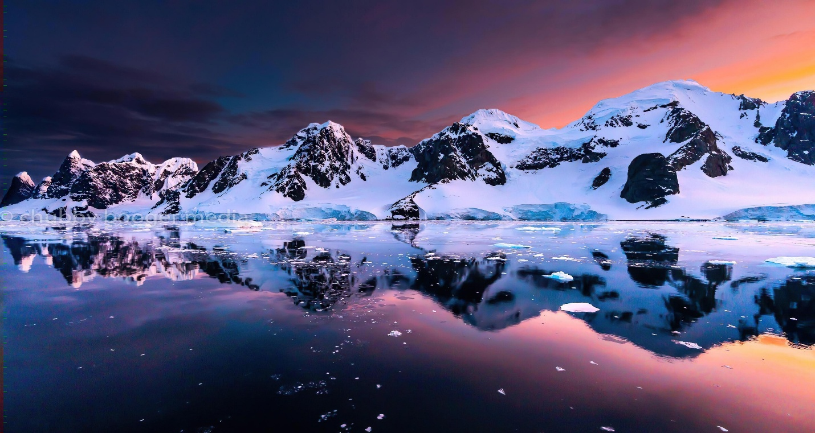*EKANSH JAISWAL IX B*

ABOUT

Antarctica is the southernmost continent on Earth, located at the South Pole. It is the fifth-largest continent in terms of area, covering approximately 14 million square kilometers. Antarctica is surrounded by the Southern Ocean and is the coldest, driest, and windiest continent on Earth.  
  
Antarctica is a unique and fragile ecosystem that is home to a variety of wildlife, including penguins, seals, whales, and seabirds. The continent also contains important scientific research stations that study climate change, geology, and other fields.  
  
Due to its extreme conditions, Antarctica is largely uninhabited by humans, with only a few thousand people living on the continent during the summer months. The Antarctic Treaty, signed in 1959, designates Antarctica as a scientific preserve and prohibits military activity and mineral extraction on the continent.

CLIMATE

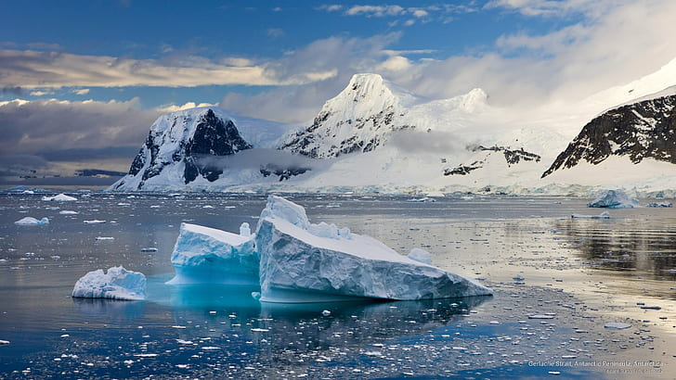

Antarctica has a polar climate, with extremely cold temperatures and strong winds. The average temperature at the South Pole is around -49°C (-56°F), although temperatures can drop as low as -89°C (-128°F) during the winter months. The continent is also extremely dry, with very little precipitation and low humidity levels.

During the summer months, temperatures can rise to around -10°C (14°F) along the coast, but inland areas remain much colder. The continent experiences 24 hours of daylight during the summer and 24 hours of darkness during the winter.

Antarctica’s climate is influenced by a number of factors, including its location at the South Pole, the continent’s high elevation, and the surrounding Southern Ocean. The continent’s ice sheet also plays a role in regulating its climate, reflecting sunlight back into space and helping to cool the planet

Wildlife and biodiversity in Antarctica

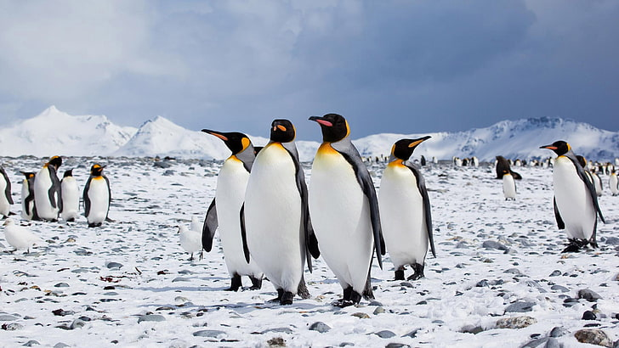

*Antarctica is home to a unique and diverse range of wildlife, despite its extreme climate and harsh conditions. Some of the most iconic animals found in Antarctica include penguins, seals, whales, and seabirds. There are also a variety of invertebrates, such as krill and other small crustaceans, which form the basis of the food chain in the Southern Ocean.*

*Many of the species found in Antarctica are adapted to survive in the extreme cold and harsh conditions. For example, emperor penguins have a thick layer of blubber and feathers to keep them warm, while Weddell seals can dive to great depths and hold their breath for long periods of time.*

*1*

*In addition to the iconic animals, there are also a variety of lesser-known species that inhabit Antarctica, including mosses, lichens, and fungi. These organisms play an important role in the ecosystem, helping to break down organic matter and recycle nutrients.*

*Despite the importance of Antarctica’s biodiversity, many species are facing threats from human activities such as overfishing, pollution, and climate change. Conservation efforts are underway to protect these unique ecosystems and ensure that they remain intact for future generations.*

_______________________________________________________________________________

Research and scientific exploration in

Antarctica

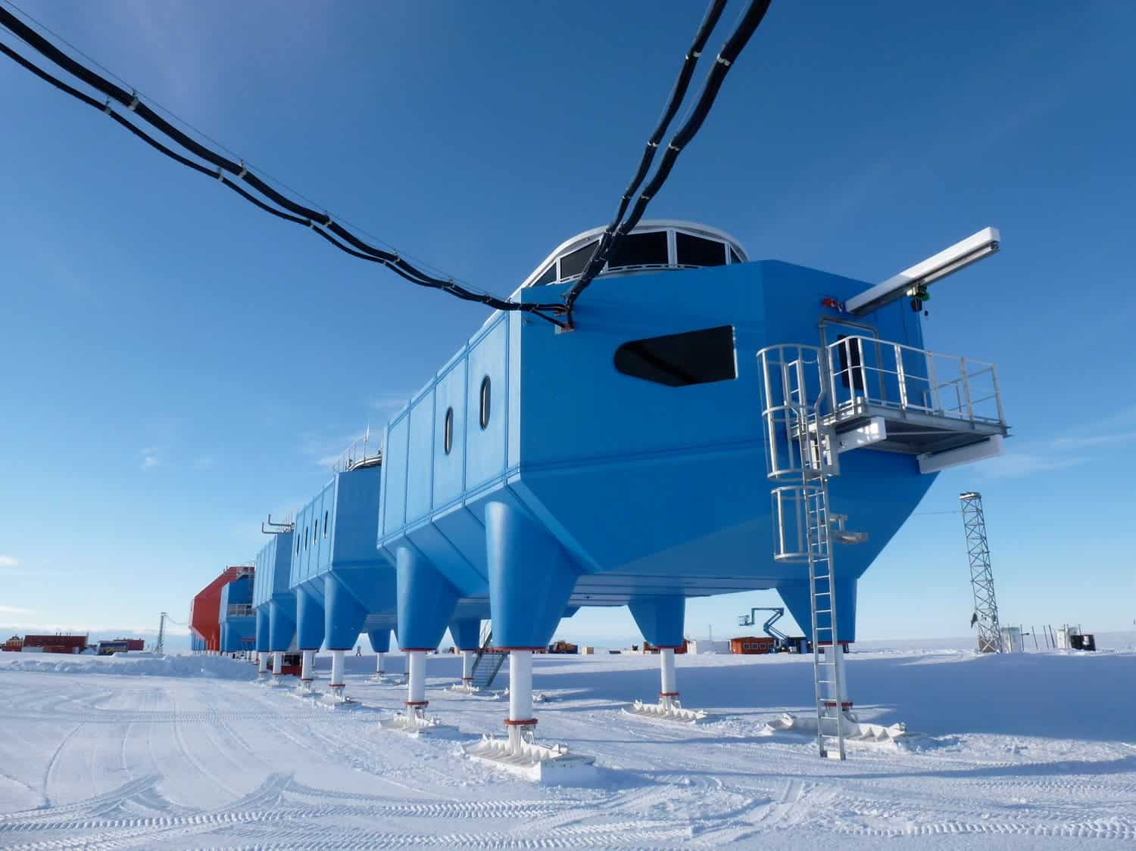

*Antarctica is also a hub for scientific research and exploration, with scientists from around the world conducting studies on topics such as climate change, geology, and biology. The extreme conditions and isolation of Antarctica make it an ideal location for studying the impacts of climate change and other environmental factors on the planet.*

*Research stations and bases are scattered throughout Antarctica, with many countries maintaining a presence on the continent. These stations provide researchers with access to state-of-the-art equipment and facilities, as well as logistical support for fieldwork in remote areas.*

*One of the most famous research stations in Antarctica is the McMurdo Station, operated by the United States Antarctic Program. This station serves as a hub for scientific research and logistics, providing support for a wide range of research*

**_______________________________________________________________________________**

Tourism and travel to Antarctica

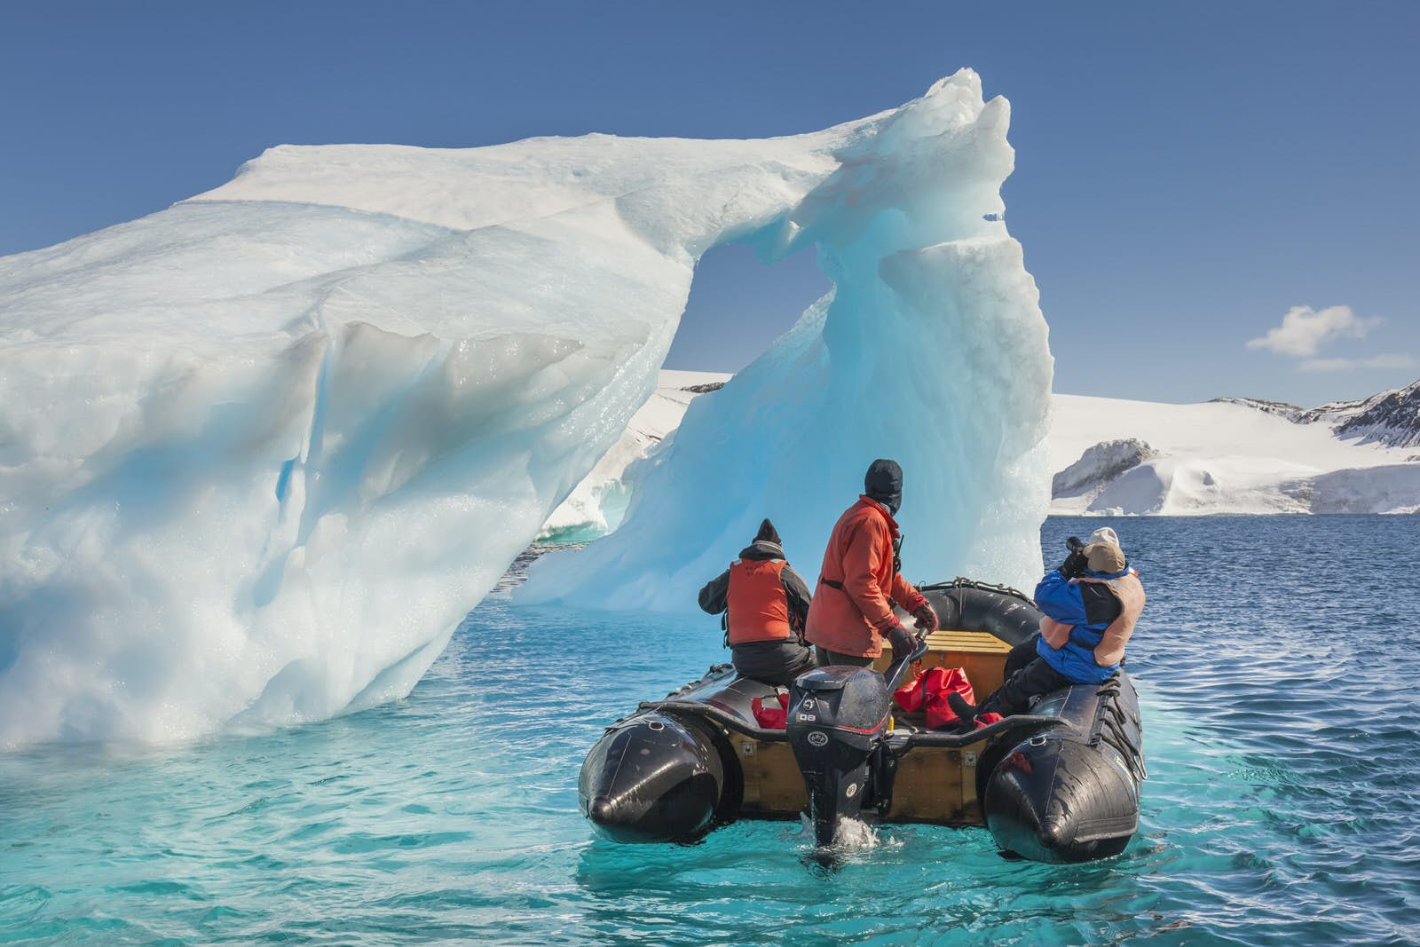

*Tourism in Antarctica is tightly regulated by the Antarctic Treaty System, which aims to protect the continent’s unique environment and wildlife. Visitors must obtain permits and follow strict guidelines to minimize their impact on the ecosystem.*

*Most tourists visit Antarctica by ship, with cruise ships departing from ports in South America, New Zealand, and Australia. These ships typically offer guided tours and activities such as wildlife watching, kayaking, and visiting research stations.*

*Overall, Antarctica remains a fascinating and important destination for scientific research and exploration, as well as for tourism. With proper management and stewardship, we can continue to learn from and appreciate this unique and fragile continent.*

**_______________________________________________________________________________**

Human activities and impact on Antarctica

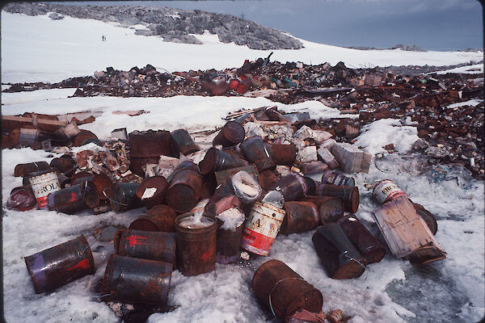

*Human activities and impact on Antarctica have been a concern for many years. While tourism is one aspect of this impact, other activities such as scientific research, fishing, and mineral exploration also pose risks to the delicate ecosystem.*

*Pollution from human activities can have serious consequences for the environment and wildlife in Antarctica. Waste disposal and oil spills are major concerns, as they can harm marine life and contaminate the water. Invasive species brought in by humans can also disrupt the delicate balance of the ecosystem.*

*Climate change is another major concern for Antarctica. Rising temperatures and melting ice can have significant impacts on the continent’s wildlife and ecosystems, as well as contributing to rising sea levels around the world.*

Economic resources in Antarctica, such as fishing and mining

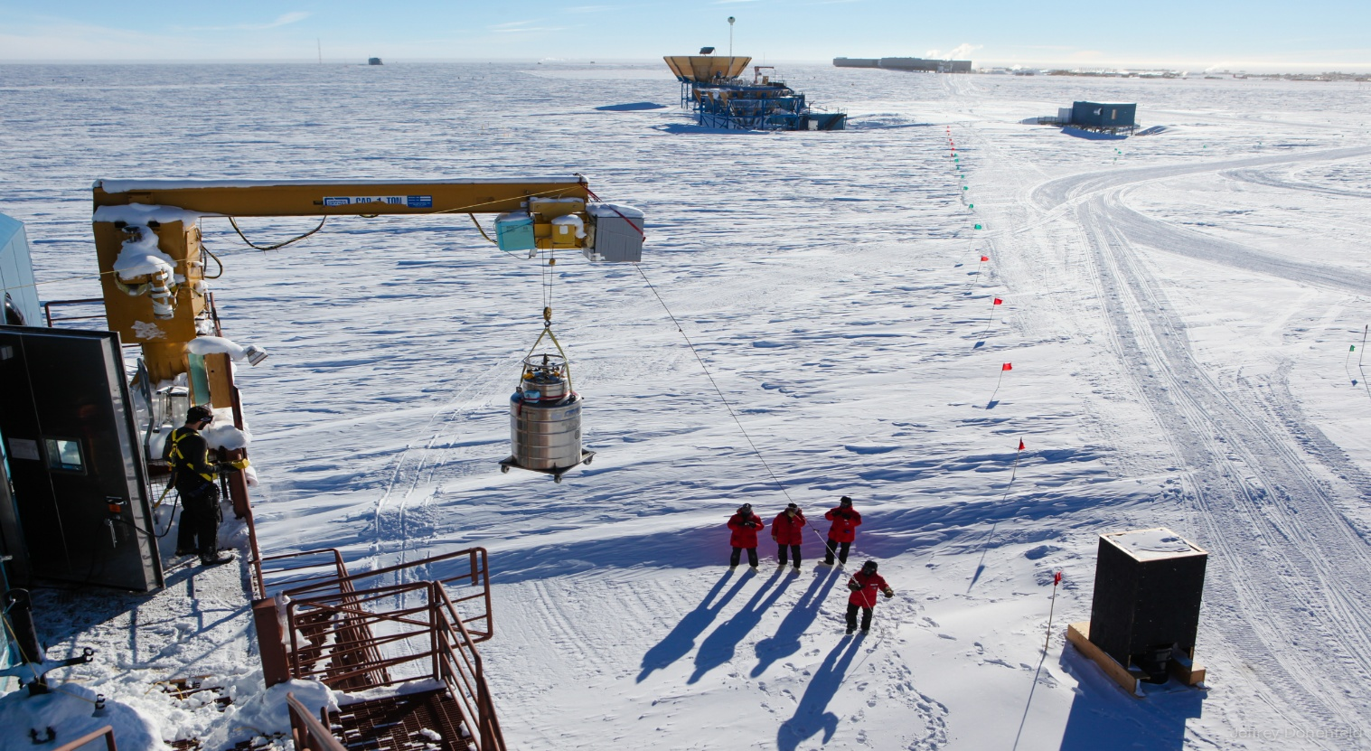

*While these resources can provide economic benefits, they also pose significant risks to the environment. Overfishing can deplete fish populations and disrupt the food chain, while mining can damage habitats and release pollutants into the environment.*

*Currently, there is a ban on mining in Antarctica under the Protocol on Environmental Protection to the Antarctic Treaty. However, there have been discussions about lifting this ban in the future.*

*It is important to carefully consider the potential impacts of economic activities in Antarctica and prioritize the protection of the unique ecosystem and wildlife. Sustainable practices and responsible management can help balance economic benefits with environmental conservation.*

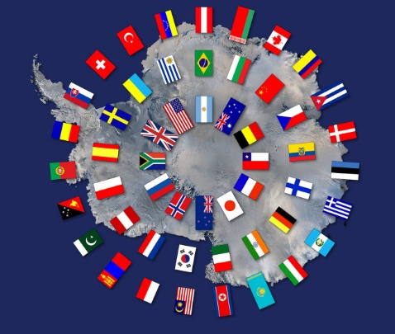Treaty agreements and governance of Antarctica

*Antarctica is governed by the Antarctic Treaty System, which was established in 1959 and currently has 54 member countries. The treaty sets aside Antarctica as a scientific preserve, prohibits military activities, and promotes international cooperation in scientific research.*

*The Protocol on Environmental Protection to the Antarctic Treaty, also known as the Madrid Protocol, was adopted in 1991 and entered into force in 1998. It designates Antarctica as a natural reserve devoted to peace and science, and sets out measures to protect the environment and ecosystems of the continent. The protocol also prohibits all activities relating to mineral resources, except for scientific research.*

*The governance of Antarctica is carried out through meetings of the Consultative Parties, which are the countries that have ratified or acceded to the Antarctic Treaty. These meetings are held annually and provide a forum for the discussion of matters.*

*_______________________________________________________________________________*

Climate change and its effects on Antarctica

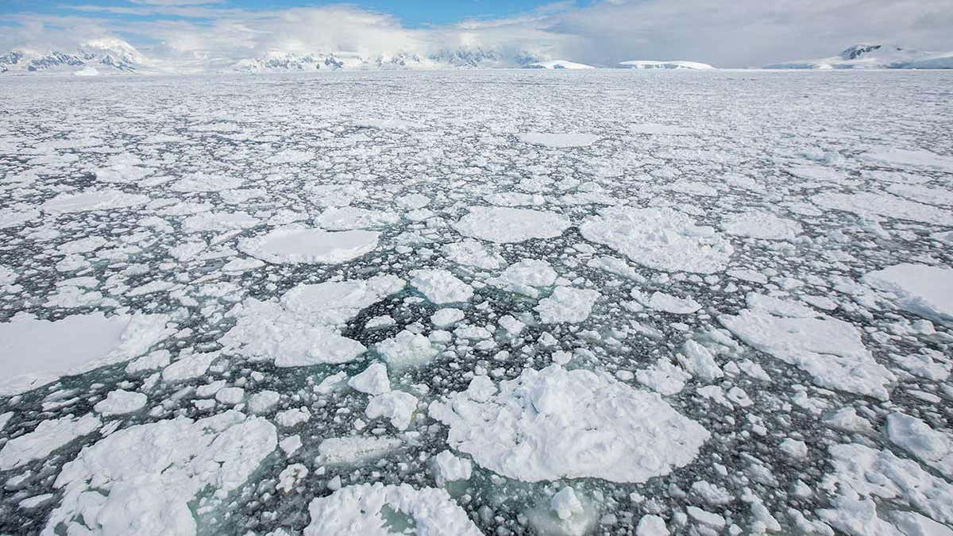

*Antarctica is one of the most rapidly warming regions on Earth, with temperatures rising three times faster than the global average. The warming is causing glaciers and ice shelves to melt, leading to rising sea levels that threaten coastal communities around the world.*

*The melting of Antarctic ice also has a significant impact on the continent’s ecosystem. It can alter ocean currents, affect marine life, and change the distribution of species. The loss of sea ice can also impact the breeding and feeding patterns of penguins, seals, and other animals that rely on it.*

*In addition to warming, Antarctica is also experiencing changes in precipitation patterns. Some areas are becoming drier, while others are receiving more snowfall. This can affect the availability of freshwater and the growth of vegetation, which in turn can impact the food chain.*

Conservation efforts and protection of Antarctica’s environment.

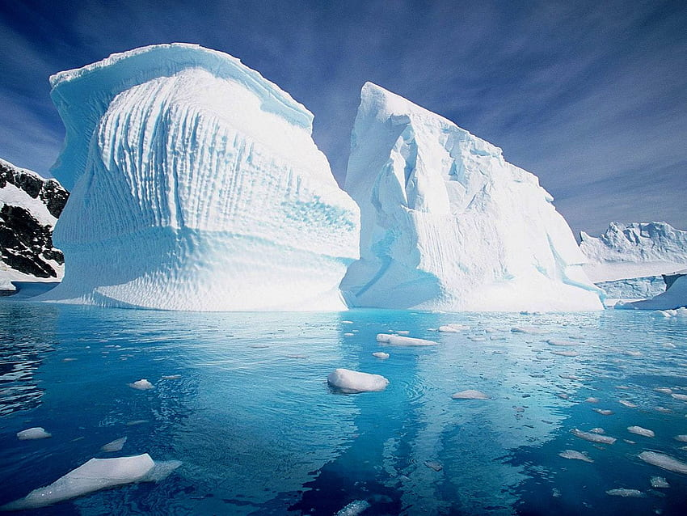

*The Antarctic Treaty System: This international agreement, signed in 1959, aims to preserve Antarctica for peaceful purposes and scientific research. The treaty bans military activities and mining in the region and promotes cooperation among signatories to protect the environment.*

*Environmental Protocol: This protocol, which entered into force in 1998, further strengthened the Antarctic Treaty by prohibiting all activities that could cause significant damage to the environment, such as waste disposal, oil spills, and mining.*

*Protected areas: The Antarctic Treaty System has designated several protected areas in Antarctica to conserve the region’s unique ecosystems. These areas include specially managed areas, where specific activities are regulated or prohibited, and Antarctic Specially Protected Areas (ASPAs), which have unique environmental, scientific, or aesthetic values.*

**_______________________________________________________________________________**