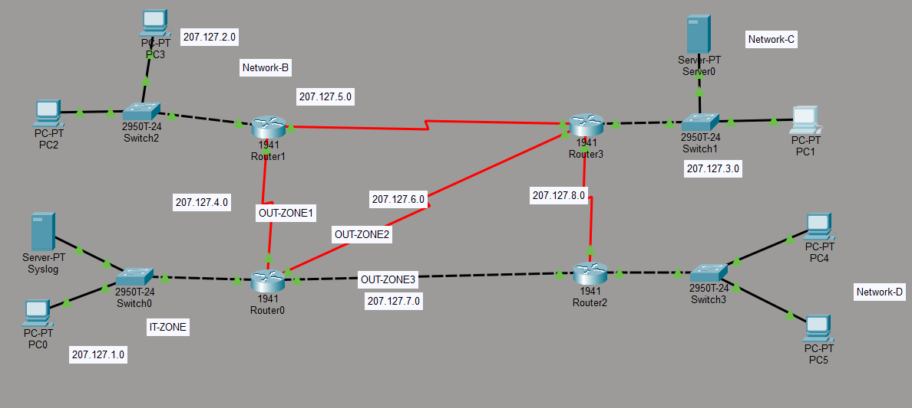

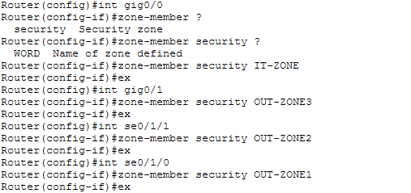

IT-ZONE can access any Other network
Network-C to IT DNS/HTTPs
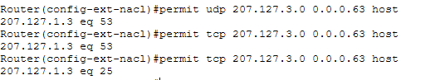
Network-D to IT HTTP only :

Class Map :
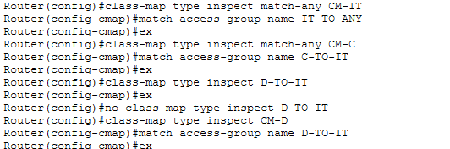

Policy map
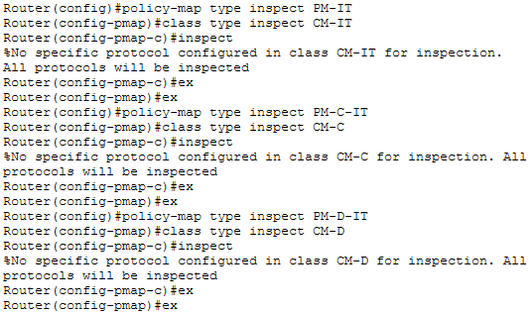

IT to any n/w access
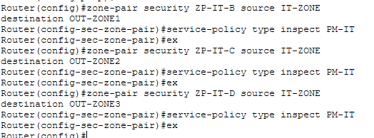

Network D to IT for only http access
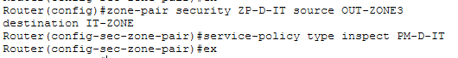

Network C to IT for only DNS/HTTPs access
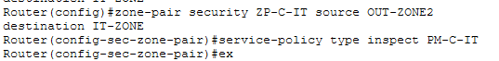

Accessing any network from IT ZONE

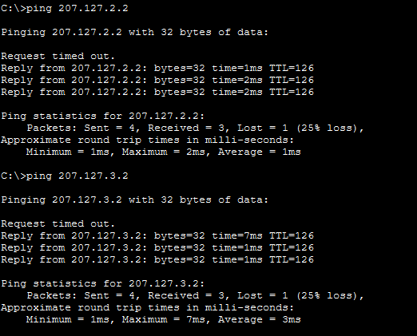

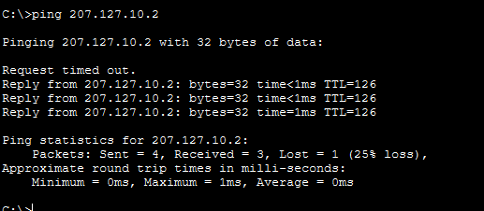

Network B to IT blocked
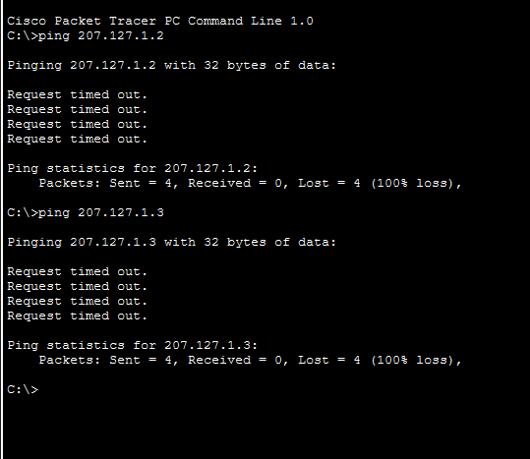

Accessing HTTP service from Network D
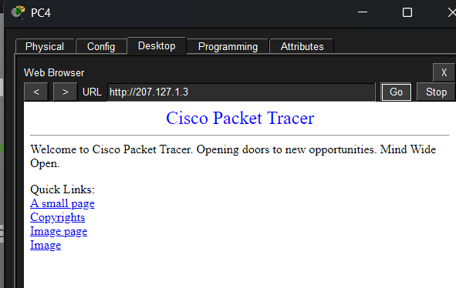

Accessing DNS service from Netwok C
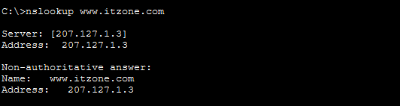

Accessing HTTPS service from Netwok C
