PRACTICAL NO. 09

9. Configure and Verify a Site-to-Site IPsec VPN Using CLI.

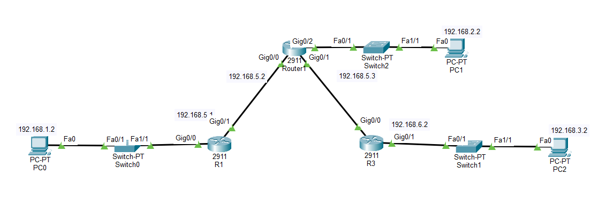

- Configure IPsec Parameters on R1
Installing K9 Package :
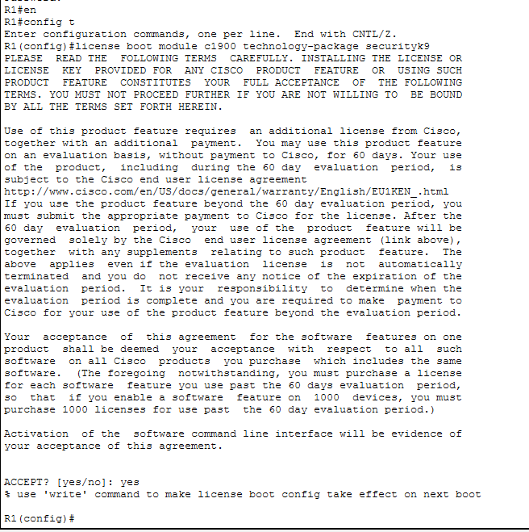

Applying ACL for Router 1
Configure the IKE Phase 1 ISAKMP policy on R1
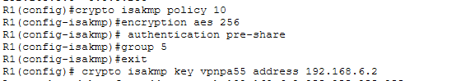
Configuring router R1 for encryption or authentication of packet .
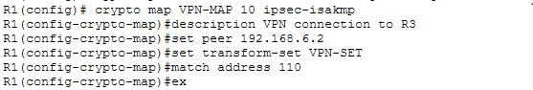
Configure the crypto map on the outgoing interface.

- Configure IPsec Parameters on R3
Applying ACL for Router3
Configure the IKE Phase 1 ISAKMP policy on R3
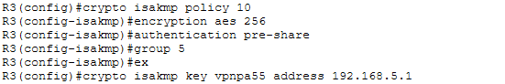
Configuring router R3 for encryption and authentication of packet .
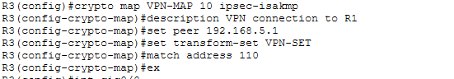

Configure the crypto map on the outgoing interface.
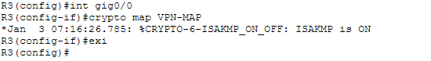

Verifying number of packets .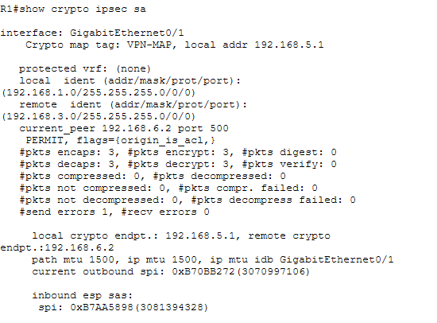

Ping from PC-A to PC-C
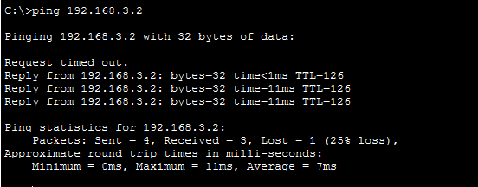
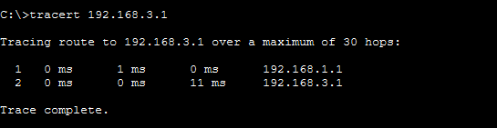

To verify Sender and Receiver(Outbound)
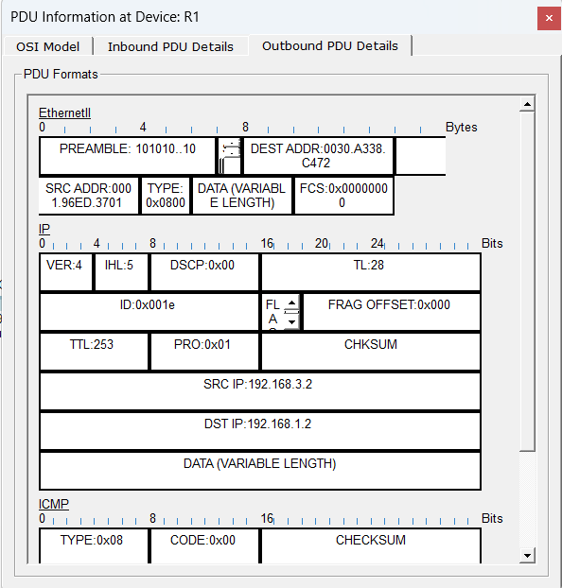

To verify Sender and Receiver(Inbound)
