Configure IP ACLs to Mitigate Attacks and IPV6 ACLs

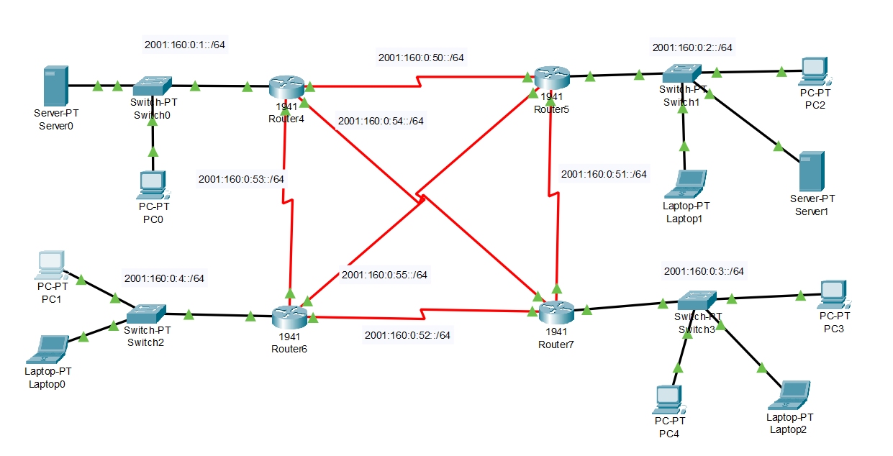
- NETWORK

IPv6 Network Addressing Table

Network | IPv6 Prefix | Connected Router | Devices in Network
Network 1 | 2001:160:0:1::/64 | Router4 | Server0, PC0
Network 2 | 2001:160:0:2::/64 | Router5 | PC2, Laptop1, Server1
Network 3 | 2001:160:0:3::/64 | Router7 | PC3, PC4, Laptop2
Network 4 | 2001:160:0:4::/64 | Router6 | PC1, Laptop0

3. Router Interconnection Networks

Link | IPv6 Network
Router4 ↔ Router5 | 2001:160:0:50::/64
Router5 ↔ Router7 | 2001:160:0:51::/64
Router6 ↔ Router7 | 2001:160:0:52::/64
Router4 ↔ Router6 | 2001:160:0:53::/64
Router4 ↔ Router7 | 2001:160:0:54::/64
Router6 ↔ Router5 | 2001:160:0:55::/64

- Enable IPv6 on Router

Router>en
Router#config t
Enter configuration commands, one per line. End with CNTL/Z.
Router (config) #ipv6 unicast-routing

- Configuring the IP address of IPV6

Router>en
Router#config t
Enter configuration commands, one per line. End with CNTL/Z.
Router (config) #interface gigabitEthernet 0/0
Router (config-if) #ipv6 address 2001:160:0:1 :: 1/64
Router (config-if) #no shutdown
$LINK-5-CHANGED: Interface GigabitEthernet0/0, changed state to
up
$LINEPROTO-5-UPDOWN: Line protocol on Interface
GigabitEthernet0/0, changed state to up

- Enable RIP routing in IPV6

- Creating the Riping Process

Router(config)#ipv6 router rip R1
Router(config-rtr)#exit

- Enabling RIP on Each Router
Router(config)#interface serial 0/1/1
Router(config-if)#ipv6 rip R1 enable
Router(config-if)#exit

- Verification of Connectivity of Network

Ping from LAN 2001:160:0:1::2 to LAN 2001:160:0:2::3

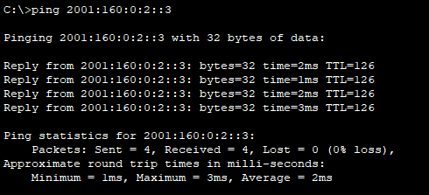

- ACL -: IPv6 Access List: MY_POLICY
This access list controls which traffic is allowed or denied in the IPv6 network.
1.permit tcp 2001:160:0:3::/64 host 2001:160:0:1::3 eq www
Allows all devices in network 2001:160:0:3::/64 to access the web server 2001:160:0:1::3 using HTTP (port 80).
2.permit tcp 2001:160:0:3::/64 host 2001:160:0:1::3 eq 443
Allows all devices in network 2001:160:0:3::/64 to access the web server 2001:160:0:1::3 using HTTPS (port 443).
3.permit tcp host 2001:160:0:4::3 host 2001:160:0:2::4 eq www
Allows the specific host 2001:160:0:4::3 to access host 2001:160:0:2::4 using HTTP (port 80).
4.permit tcp host 2001:160:0:4::3 host 2001:160:0:2::4 eq 443
Allows the specific host 2001:160:0:4::3 to access host 2001:160:0:2::4 using HTTPS (port 443).
5.permit tcp any any eq 22
Allows SSH connections (port 22) between any IPv6 devices for secure remote login.
6.permit tcp any any eq telnet
Allows Telnet connections (port 23) between devices for remote management.
7.permit icmp any any
Allows ICMP traffic such as ping and network discovery, which is required for normal IPv6 communication.

8.deny ipv6 any any
Blocks all other IPv6 traffic that is not permitted by the previous rules.
This ensures only the defined traffic is allowed.

Actual Commands for Creating an ACL -:
Router>en
Router#config t
Enter configuration commands, one per line. End with CNTL/Z.
Router(config)#ipv6 access-list MY_POLICY
Router(config-ipv6-acl)# permit tcp 2001:160:0:3::/64 host 2001:160:0:1::3 eq 80
Router(config-ipv6-acl)# permit tcp 2001:160:0:3::/64 host 2001:160:0:1::3 eq 443
Router(config-ipv6-acl)# permit tcp host 2001:160:0:4::3 host 2001:160:0:2::4 eq 80
Router(config-ipv6-acl)# permit tcp host 2001:160:0:4::3 host 2001:160:0:2::4 eq 443
Router(config-ipv6-acl)# permit tcp any any eq 22
Router(config-ipv6-acl)# permit tcp any any eq 23
Router(config-ipv6-acl)# permit icmp any any
Router(config-ipv6-acl)# deny ipv6 any any
Router(config-ipv6-acl)#exit

Implement the ACL rule on an Interface

Router(config)#interface gigabitEthernet 0/0
Router(config-if)#ipv6 traffic-filter MY_POLICY in
Router(config-if)#exit

To view the Implemented ACL

Router#show ipv6 access-list
IPv6 access list MY_POLICY
permit tcp 2001:160:0:3::/64 host 2001:160:0:1::3 eq www
permit tcp 2001:160:0:3::/64 host 2001:160:0:1::3 eq 443
permit tcp host 2001:160:0:4::3 host 2001:160:0:2::4 eq www
permit tcp host 2001:160:0:4::3 host 2001:160:0:2::4 eq 443
permit tcp any any eq 22
permit tcp any any eq telnet
permit icmp any any
deny ipv6 any any

Verification of ACL Working –:

We access the server (2001:160:0:2::4) from laptop0 (2001:160:0:4::3)

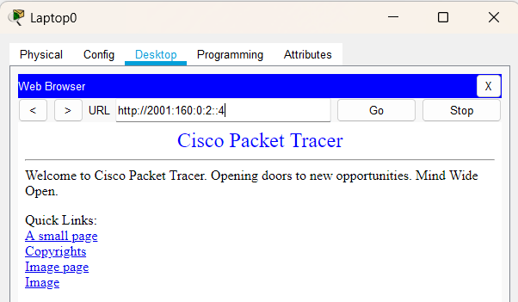

We access the server (2001:160:0:2::4) from PC1 (2001:160:0:4::2)

