DataMining Project 5.1: YouTube Data

By Casey Franek and Thea Gab

Introduction
Researchers in British Columbia performed numerous crawls of YouTube data throughout 2007 and 2008. This data started with the most popular videos for the day, and then went on to the new videos that they had links to and so forth, for up to four levels of depth. This data is available at http://netsg.cs.sfu.ca/youtubedata/

A basic description of the attributes follows:
video ID | an 11-digit string, which is unique
uploader | a string of the video uploader's username
age | an integer number of days between the date when the video was uploaded and Feb.15, 2007 (YouTube's establishment)
category | a string of the video category chosen by the uploader
length | an integer number of the video length (in seconds)
views | an integer number of the views
rate | a float number of the video rate from 0 to 5 (average of all ratings given)
ratings | an integer number of the ratings
comments | an integer number of the comments
related IDs | up to 20 strings of the related video IDs

Example of Data:
gFa1YMEJFag sxephil 1135 Entertainment 270 101384 4.72 3407 2887 QuRYeRnAuXM 3TYqkBJ9YRk rSJ8QZWBegU nRcovJn9xHg UEvVksP91kg sVkuOk4jmCo ZTopArY7Nbg 0RViGi2Rne8 HT_QlOJbDpg ShhClb6J-NA g9e1alirMhc YZev1imoxX8 I4yKEK9o8gA 1GKaVzNDbuI yuZhwV24PmM zQ83d_D2MGs DomumdGQSg8 pFUYi7dp1WU 2l6vwAIAqNU hiSmlmXp-aU

Exploring the Data
While initially exploring the data, we decided that there was way too much data to do any processing in a reasonable amount of time with reasonable equipment. So, we picked a crawl from one day, March 27, 2008. Even this proved to be a massive amount of data. We decided to eliminate the ID's of related videos, preferring to concentrate just on the individual videos and their specific statistics.

There were many interesting things that we discovered about the data while exploring with some initial classification and clustering. Strong linear correlations were discovered between the attributes views, comments, and ratings. The following two images (Figure 1 and Figure 2) show examples of these relationships. We realized that these attributes were definitely related to real user interactions (for example, a video cannot be commented on or rated unless it is viewed- so these numbers will tend to be similar). However, we decided to leave these attributes in our data because of the possibility that they could suggest new relationships (for example, perhaps political videos may have more comments per views than music videos).

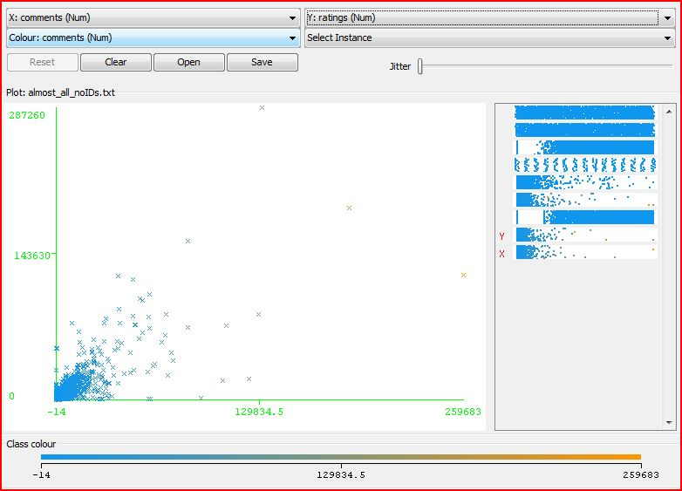
Figure 1 Comments v. Ratings

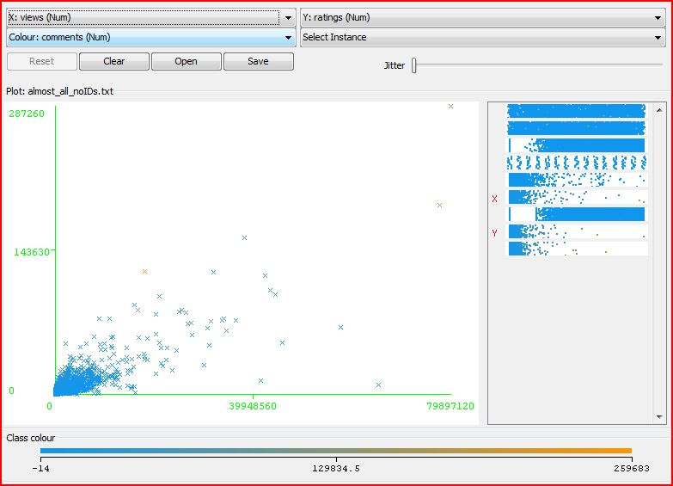
Figure 2 Views v. Ratings

We also noticed that the rate attribute (what rating was given to each video) had striations corresponding to integer numbers and common fractions (see Figure 3). We attributed this characteristic to the fact that the videos were rated on an integer scale of 0-5, therefore the average ratings will tend to fall on these specific lines. This attribute was also very “top heavy”, there were very few lower ratings (besides 0) and almost none between 0 and 1 (look at the gap at the bottom of Figure 3). However, the majority of ratings fell between 4 and 5.

It is also interesting to note the gap between the line of data to the left of this graph. There were quite a few videos that were put up right around when YouTube started, but then there is a gap for quite a while before we have videos again. This relationship emerged on different days for different crawls also.

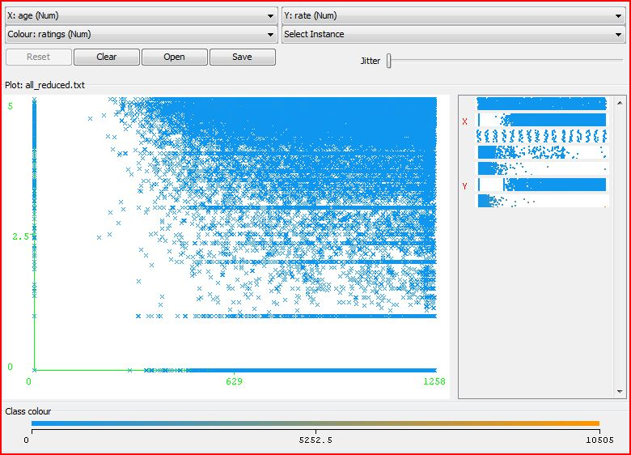
Figure 3 Age v. Rate

This anomaly in age somewhat affected our initial clustering. Cluster 8 (the teal one towards the bottom) in Figure 4 appears to be grouped around the fact that these videos were all posted during the beginnings of YouTube. Also, this clustering brings out some emerging categories (the videos in these categories all tend to be more recent): Nonprofits & Activism, Science & Technology, and Education.
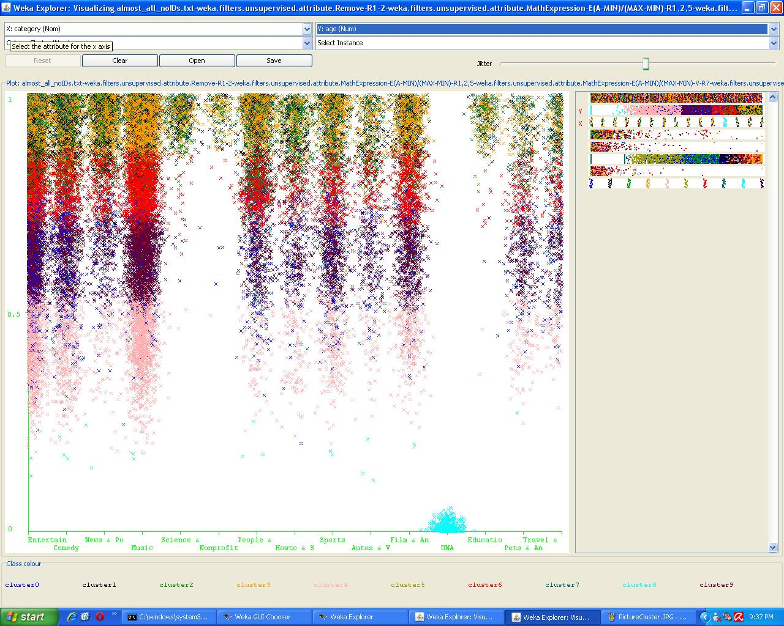
Figure 4 Category v. Age Clusters

Coming Up With Our Research Idea
In order to dig deeper into the data, we decided that clustering and classification techniques would work best for this dataset. These two approaches are discussed as follows.

Approach 1: Clustering

While we didn't start with a clear focus of what to cluster on, most of our efforts were focused on making clusters with the same attribute. The first cluster analysis we tried was to cluster across views, rate, ratings, comments, length, and age without any preprocessing of the data. The result was the data got clustered on number of views, but this result didn't show any meaningful relationships between views and any other attributes because views was dominating the clustering. Looking back on the data a second time this result made sense, since we used k-means clustering with Euclidean distance as the metric. Since views is the highest number in the attributes that we clustered on, the square of the difference is going to tend to be the highest, which causes the clusters to build themselves up around that difference alone.

To counter this we attempted to normalize the views, rate, ratings, comments, and age in a range of [0-1]. (The actual equation was to subtract the minimum value from the row value, and then divide the result by the max-min value) With the data set normalized we tried a cluster analysis again. We got a nice looking cluster picture (figure 5), but the homogenous clusters in the picture show that rate and age were the only attributes being clustered on. After taking a look at the visualization data again, it seemed likely that the equation we were using for normalization was causing the majority of the data to be pushed into a smaller range then [0-1]. Figure 6 shows how just a few very large values can throw off the distribution of the data.

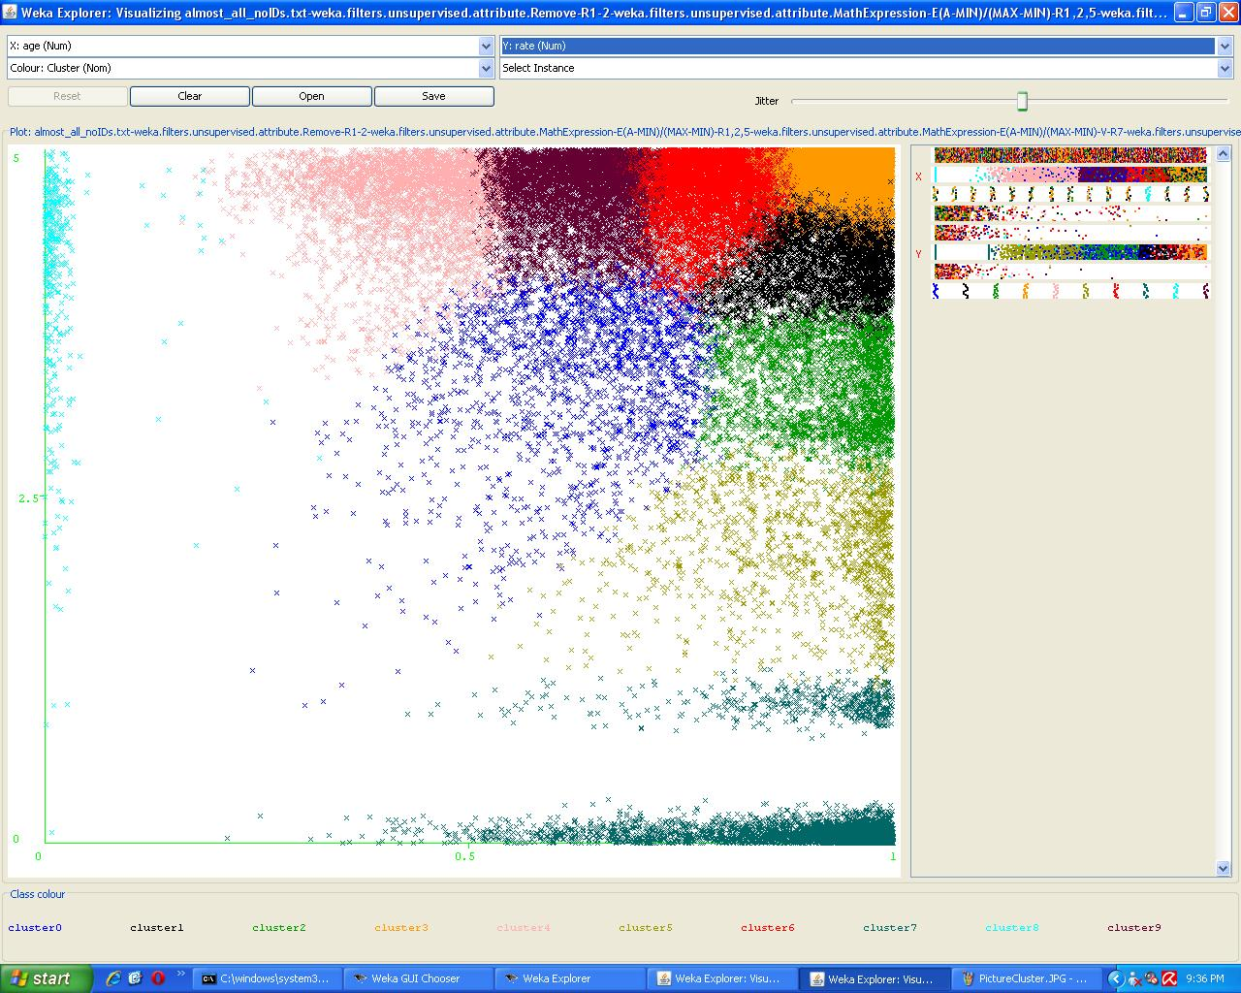
Figure 5 Age v. Rate Clusters
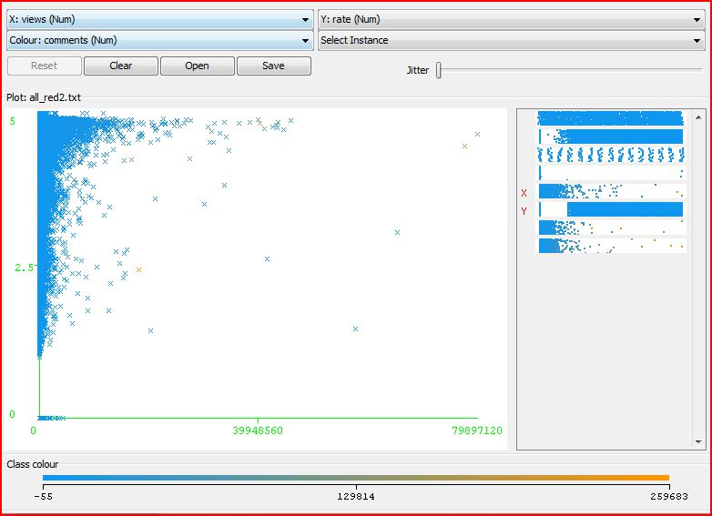
Figure 6 Views v. Rate Distribution

We considered removing the large data values from the dataset and renormalizing it, but we opted to eyeball an approximate max of the heavily populated area and use that in as our max in our normalization equation, which would allow the large outliers to still exist in the dataset. We also created an additional variable that was the number of views divided by the number of ratings. The idea behind this new variable was to find a "views per person" type variable, with the idea that some categories would draw people to watch them time and time again, while others people would only watch once.

This created a lot of different sets of values to cluster on, but none of them really created good clusters for the different video categories.

Approach 2: Classification
After classifying on many different attributes, views (the number of views) returned seemingly excellent results. We were getting in the 98%, 99% range of correctly classified instances. This was really surprising until we realized that the ZeroR classifier for number of views returned around the same result.

Therefore, we decided to see which attributes classification would improve the most (from ZeroR to some other classification technique).

At this point we also realized that the discretization of many of these classes was being affected by the odd distribution of values. Length, views, age, ratings, and comments all presented the problem of having mainly lower values but also a few, widely spread, higher values. Discretization ended up grouping these values into bins that lumped all the lower values together and then made a bunch of bins for the individual higher values. So, we set the useEqualFrequency flag in Weka in order to even out the number of instances to be found in each bin. Also, rate is a continuous rating along a scale from 0 to 5, but it seemed like analysis would be simpler if we discretized this attribute into bins from (0,1] (1,2] etc, so we also did this.

While looking for improvement in classification, the attributes comments, views, and ratings all started out with a pretty low number of correctly classified instances (around 10-12%) and jumped up to 38%-56%. These attributes seemed to be pretty good to classify on, but as far as providing interesting information they weren’t quite as desirable. We wished to predict an attribute such as category or rate (the actual average rating rather than the number of ratings). Also, as pointed out above, we had already seen that these attributes had a strong linear correlation and we wished to predict something a little more independent. Since category performed very poorly with most classification, we set out to improve classification on the rate attribute.

Now that we had a goal defined, we soon ran into the problem of class imbalance. ZeroR returned about 71% correctly classified instances for rate, because most of the ratings fell between 4 and 5. Some of the tree classifiers (such as J48) improved the classification on rate by 1 or 2%, but this was not very much and also, the tree structure was complicated and confusing (see Figure 7).

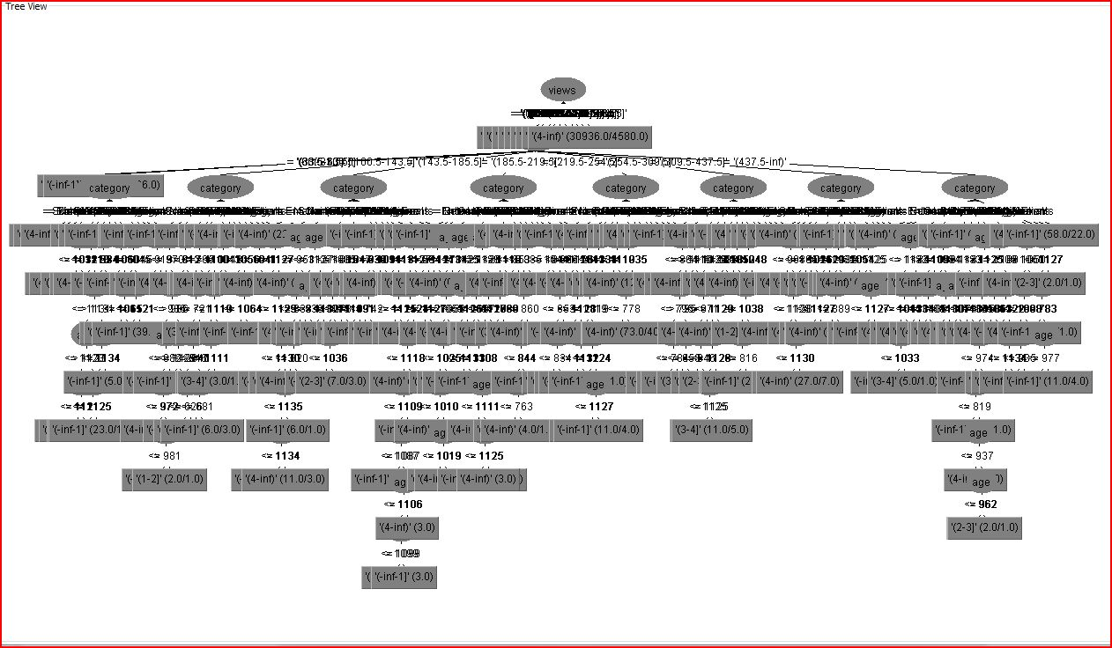
Figure 7 J48 Classifier

To deal with this problem, we took a look at classifiers that focus on minority classes and their proper classification. We finally hit upon AdaBoostM1, which especially takes into account minority classes. This classifier worked the best for this task, giving us about 78% correctly classified instances with just a few simple classification rules:

ratings <= 0.5 : '(-inf-1]'
ratings > 0.5 : '(4-inf)'
ratings is missing : '(4-inf)'

Conclusion
This data taught us a lot about the complications of dealing with real-world situations.

Our data tended to have attributes with very similar means, but very wide standard deviations. This made clustering a very difficult technique to use with this dataset, because lop-sided distribution led to large clumps of similar values.

We realized that is important to know your data. For a situation like ours where distributions turned out to be a big issue we solved this problem both using different methods of normalization, discretization and different classifiers. Some attributes just needed to be normalized so that their distances were reflected more accurately (i.e. views), others needed to be more evenly distributed in bins (i.e. comments, ratings), whereas others (i.e. rate) truly presented a class imbalance problem and needed to be addressed by classifiers that focus on the minority cases.

Overall, we achieved a fairly decent classifier for the rate attribute. Thus, the ranking of various videos may be predicted and assessed. There is probably much more work that could be done in this area, including using more powerful tools to incorporate even more of the YouTube data available into this analysis. However, an improvement of 7% correctly classified instances is very satisfying.

