Ravenous Reversi Functional Specification

Team Members: Monica Noring, Billy Leavenworth, Arka Barman, Thea Gab

Overview
Ravenous Reversi is a simplified implementation of the game Reverso (or Reversi, Othello, etc.) using the Jack language.

Scenarios
Scenario 1: Bob is bored and wants to play a game to pass the time. He starts up “Ravenous Reversi” and an 8 x 8 grid appears with two white and two black discs in the middle. He has never played before so he experiments with moving the cursor around and randomly selects a square in the upper right hand corner. “Ravenous Reversi” pops up an error message that screams “You idiot, you can’t place a disc there.” Bob is thoroughly insulted so he quits the game.

Scenario 2: Alice is also bored out of her mind, so she starts up “Ravenous Reversi.” She has played before, so she makes a legal move for black and the computer responds with a legal move for white. This process continues, back and forth, until the whole board is filled with discs. Alice won, so she exits the game.

Non Goals
We are not attempting to make a “smart” game. The computer’s choices of where to place a disc will be randomly chosen from available, valid positions.

We will also not provide different levels of difficulty. So, we will start with an eight-by-eight grid and not increase beyond these dimensions.
Flowchart
Remaining legal moves?
All discs between old black discs and new one are flipped
Player (black) chooses a square in which to place disc
Valid Move?
No

Yes

Computer (white) chooses a valid square and places a disc
All discs between old white ones and new one are flipped
Board is initialized
Remaining legal moves?
Yes

No

Game over.
Display winner.
Yes
(white
only)

Yes

No

Screen by Screen Specification
1. Initialization of the board, first screen displayed
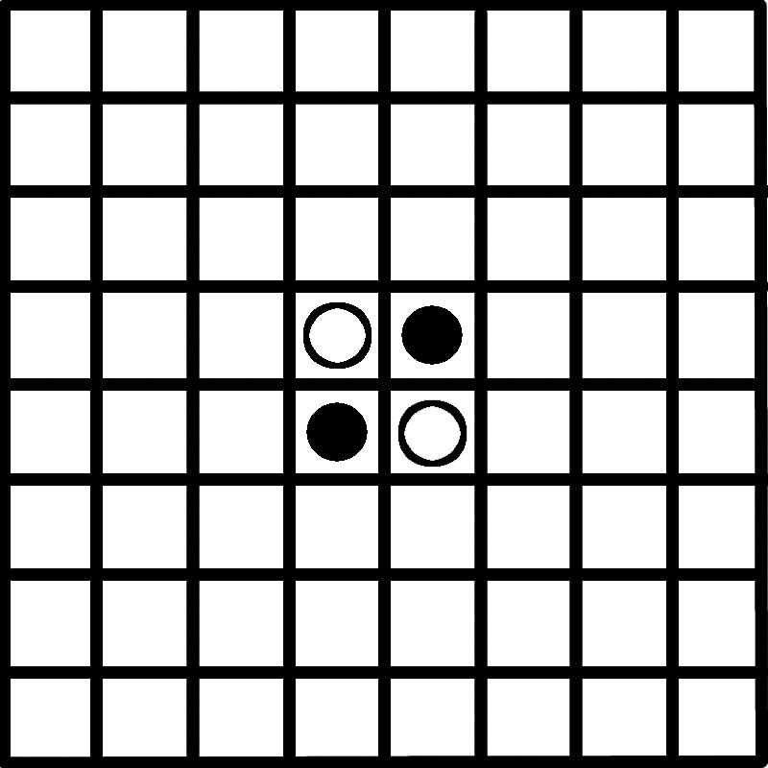

2. Cursor initially placed in upper left-hand corner of board
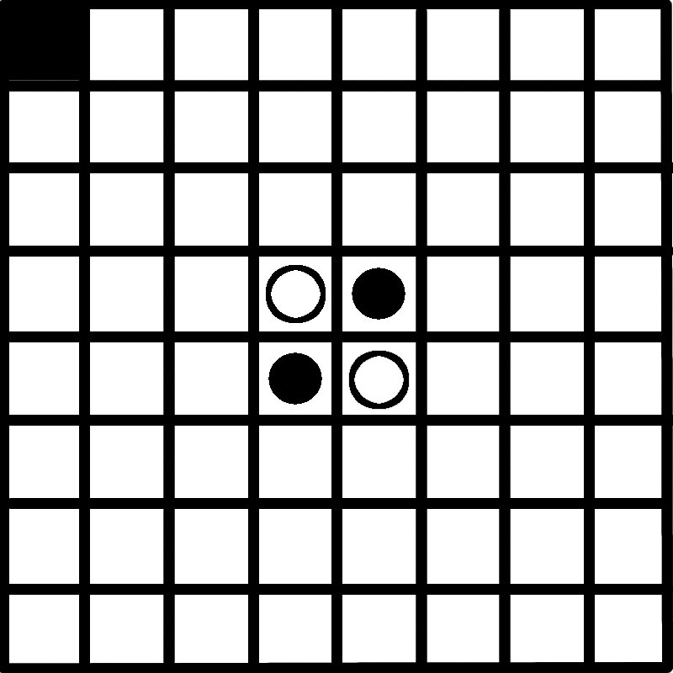

3. Player moves with arrow keys to position where new play is desired
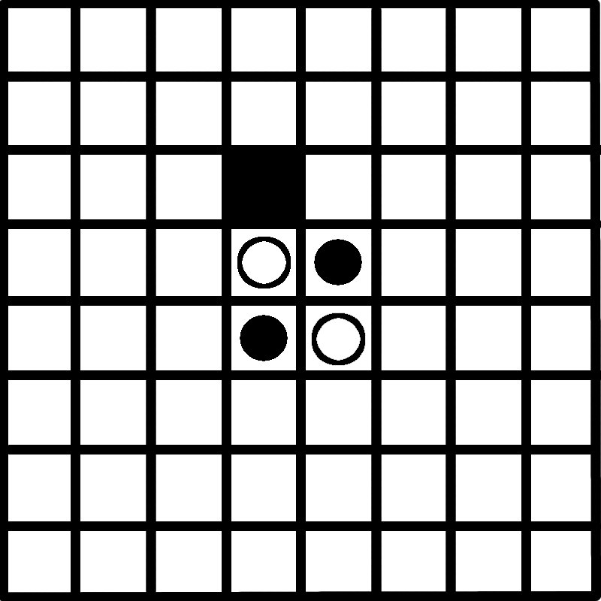

4. Player selects the square and the disc in the middle switches colors
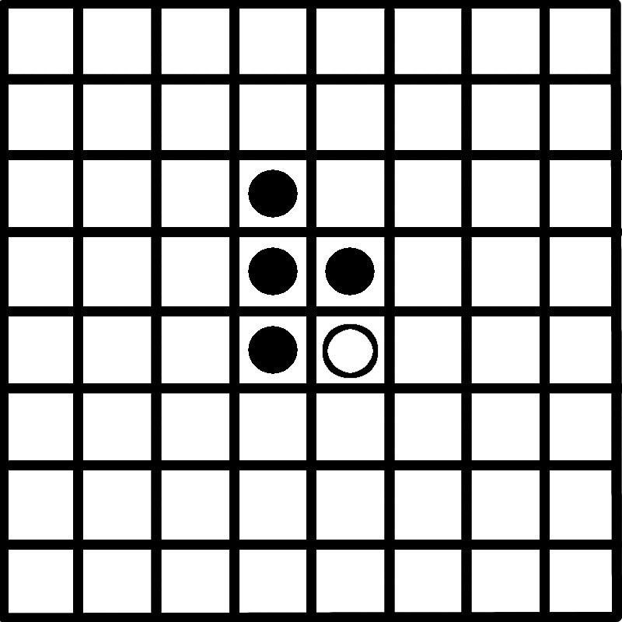

5. Computer selects a square and the disc in the middle switches colors
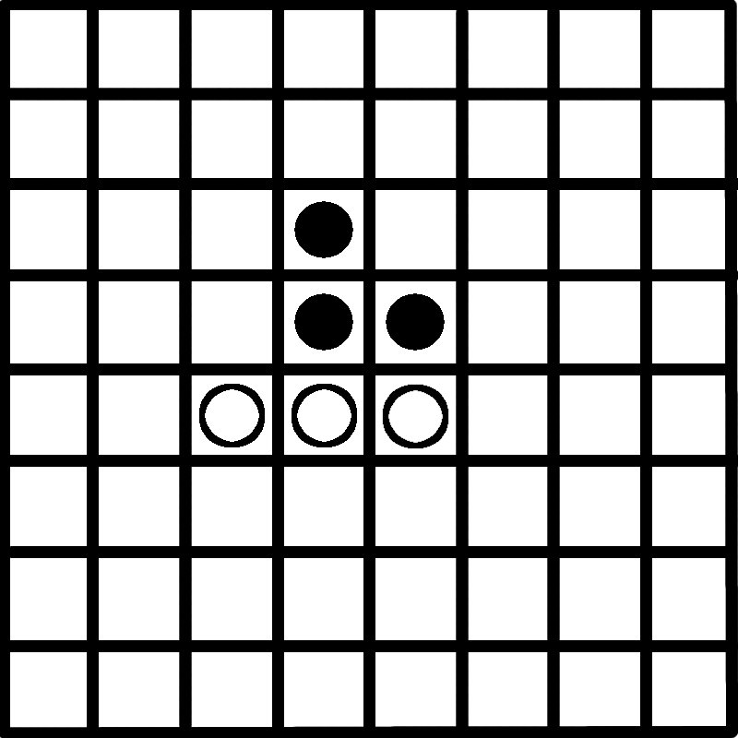

6. Cursor returns control to player, who positions cursor to make next selection
