**Figure 1:** A simplified representation of the transformation of fluorescence exponential decays into the fluorescence lifetime phasor. **(A)** A Fourier transform is used to calculate the modulation (M) and phase shift (φ) relative to the laser pulse excitation source. M and φ are represented graphically for two pure fluorophores (orange dash line, blue dash-dot line) and a sample containing a mix of the two species (green solid line) (1). **(B)** The phasor G and S coordinates are the cosine and sine components of the Fourier transforms. Species closer to the origin of the phasor have long lifetimes, whereas species on the right corner of the phasor have short lifetimes (1). **(C)** Shifts in the phasor coordinates of samples can be indicative of changes in the relative abundance of fluorescence species. For example, in a sample containing two fluorescent species, shifts in the phasor position are associated with shifts in the abundance of the two fluorescent species (1, 2).

**Figure 2: Fluorescent spectra and lifetime phasor of some of the fluorescent metabolites produced by *P. aeruginosa***(two-photon excitation = 740 nm).

(**A**) Florescence emission spectra normalized by max peak intensity of fluorophores which emit in the 400-500 nm window (grey-shaded box). (**B**) Fluorescence lifetime phasor of fluorescent solutions, collected with a Schott BG-39 filter and NADH-targeted optical bandpass emission filter (400-500 nm). Points represent the phasor G and S coordinates from a fluorescence lifetime image, colored by the number of pixels. The large shapes represent the mean G and S values for each fluorescent solution. The mean G and S values for LDH NADH and OLS were determined from previously-reported fluorescence lifetimes (3, 4). LDH = Lactate Dehydrogenase, OHPhz = 1-hydroxyphenazine, OLS = Oxidized Lipid Signal, PVD = pyoverdine, PYO = pyocyanin.

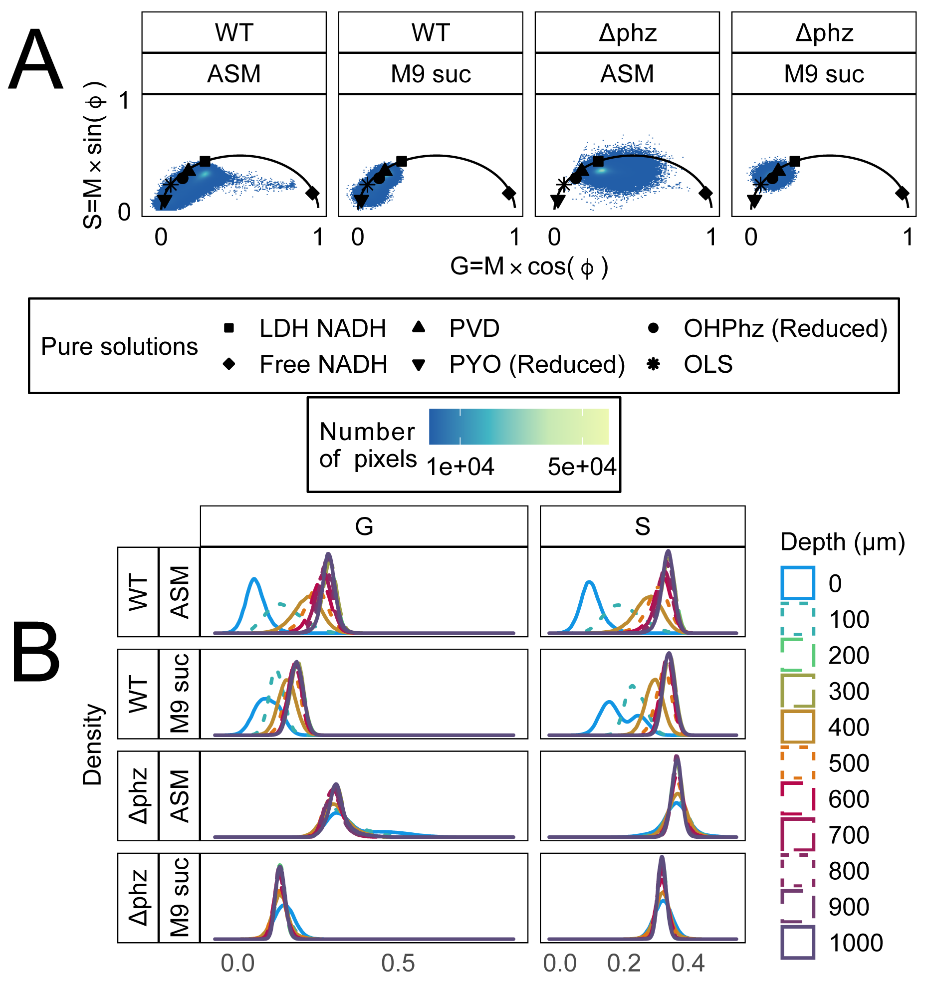

**Figure 3: Fluorescence lifetime at different depths of *P. aeruginosa* PA14 biofilms.** (**A**) Fluorescence lifetime phasor of *P. aeruginosa* PA14 WT and ∆phz strains grown in ASM or M9 succinate soft agar for 72h. Three replicates of biofilms were imaged every 100 µm from the biofilm surface (0 µm) to the bottom (1000 µm) (33 images per strain and media type, 132 images total). The scatter plot points are G and S values of pixels from fluorescence lifetime images, where the color indicates number of pixels at a given G,S coordinate. For reference, mean G and S values of fluorescent solutions from Figure 2 are displayed as black shapes. (**B**) One-dimensional distribution of phasor G and S values, where line type and color are indicative of biofilm depth (0 µm = biofilm surface). The G and S distributions from the surface of the WT biofilms were significantly shifted to the left of the *∆phz* biofilm surfaces in both media types (Wilcoxon rank sum test, p-value < 2.2e-16) *∆phz* = *P. aeruginosa* PA14 *∆phzA1-G1/∆phzA2-G2*; does not produce PYO or OHPhz. LDH = Lactate dehydrogenase, OHPhz = 1-hydroxyphenazine, OLS = Oxidized Lipid Signal, PVD = pyoverdine, PYO = pyocyanin, ASM = artificial sputum medium, suc = succinate.

**Figure 4: Fluorescence intensity and lifetime images at the surface and bottom of *P. aeruginosa* PA14 biofilms.** (**A**) Examples of auto-fluorescent intensity images of *P. aeruginosa* PA14 WT and ∆phz strains grown in ASM or M9 succinate soft agar for 72h. Scale bar = 20 µm. (**B**) The fluorescence lifetime image at the surface and bottom of *P. aeruginosa* biofilms. In the image (**B**) and corresponding phasor (**C**), each pixel in the image is colored based on phasor position. For reference, mean G and S values of fluorescent solutions from Figure 2 are displayed as black shapes (**C**). The same color map was used for all lifetime images, where blue is indicative of a longer lifetime near the origin of the phasor (G=0, S=0) and orange is indicative of shorter lifetime near free NADH (lifetime = 0.4 ns; G=0.96=, S=0.19). ASM = artificial sputum medium, suc = succinate.

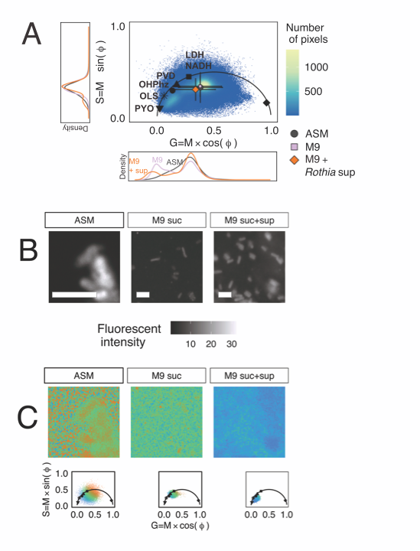

**Figure 5: *P. aeruginosa* PaFLR01** **fluorescence lifetime shifts when cross-fed *Rothia* supernatant.** (**A**) Fluorescence lifetime phasor of *P. aeruginosa* PaFLR01 grown in three media types under hypoxic conditions for 72h. Scatter plot points are G and S coordinates of pixels from fluorescence lifetime images of PaFLR01 grown in hypoxic ASM (14 images), M9 suc (8 images), or M9 suc + sup (7 images). For reference, mean G and S values of fluorescent solutions are displayed on the universal circle as black shapes. Mean G and S values for each media condition are represented by colored shapes with error bars (ASM = grey circle, M9 suc = lavender square, M9 suc + sup = orange diamond). The two-dimensional G and S distributions were significantly different for each pairwise comparison (ASM vs. M9 suc, ASM vs. M9 suc+sup, M9 suc vs. M9 suc+sup; Fasano-Francheschini Test, p-value < 2.2e-16). The one-dimensional distributions of G and S are the side and bottom panels, respectively, and colored by media condition. M9 suc + sup G and S distributions were significantly shifted to the left of the M9 suc and ASM distributions (Wilcoxon rank sum test, p-value < 2.2e-16; **Table 1**). (**B**) Examples of fluorescent intensity images from the cross-feeding experiment. Scale bar = 3 µm. (**C**) The fluorescence lifetime image (top) from three example samples, colored by position on the phasor (bottom). The pixel color in the images corresponds with the color of pixels in the phasor. Blue is indicative of a longer lifetime near the origin of the phasor (0,0). Scale bar = 3 µm. LDH = Lactate Dehydrogenase, OHPhz = 1-hydroxyphenazine, OLS = Oxidized Lipid Signal, PVD = pyoverdine, PYO = pyocyanin, ASM = artificial sputum medium, suc = succinate, sup = supernatant from *Rothia mucilaginosa*.