**Project-3**

**housing_price.csv charts:**

**Basic Graph Functions:**

**Bar plot:**

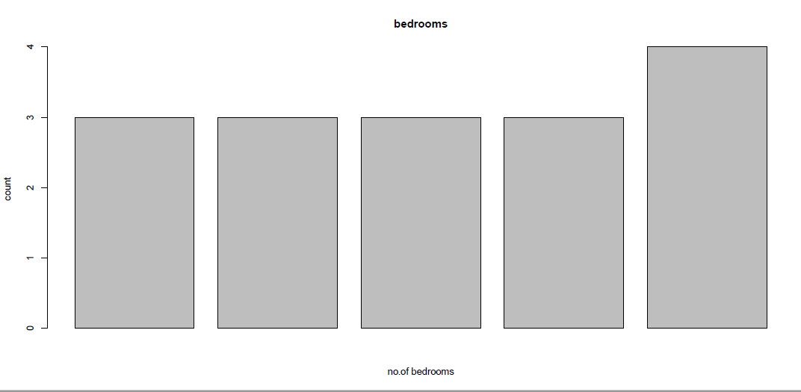

**Line dot:**

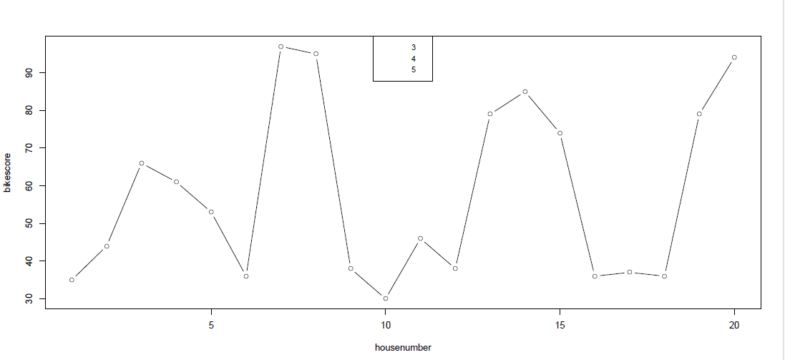

**Charts using functions in the lattice package:**

**Density Plot:**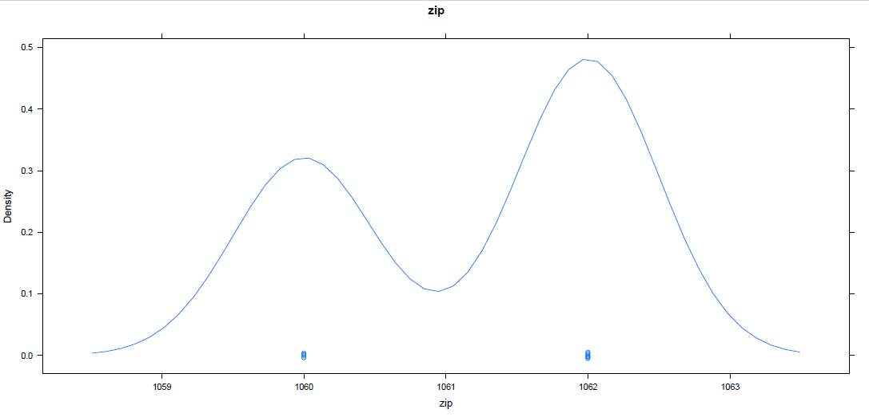

**Scatter plot matrix:**

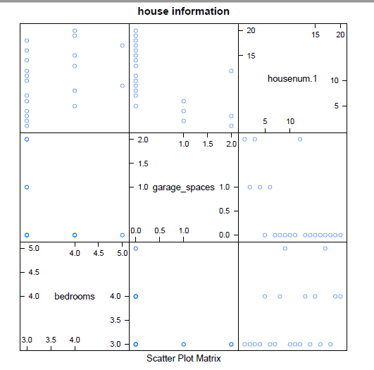

**Chart using functions in the ggplot2 package:**

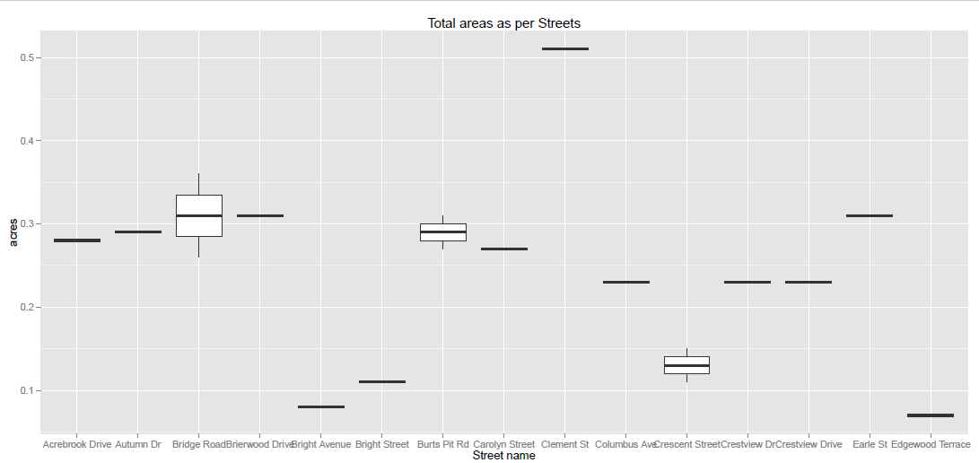

**airport.csv charts:**

**Basic Graph Functions:**

**Bar plot:**

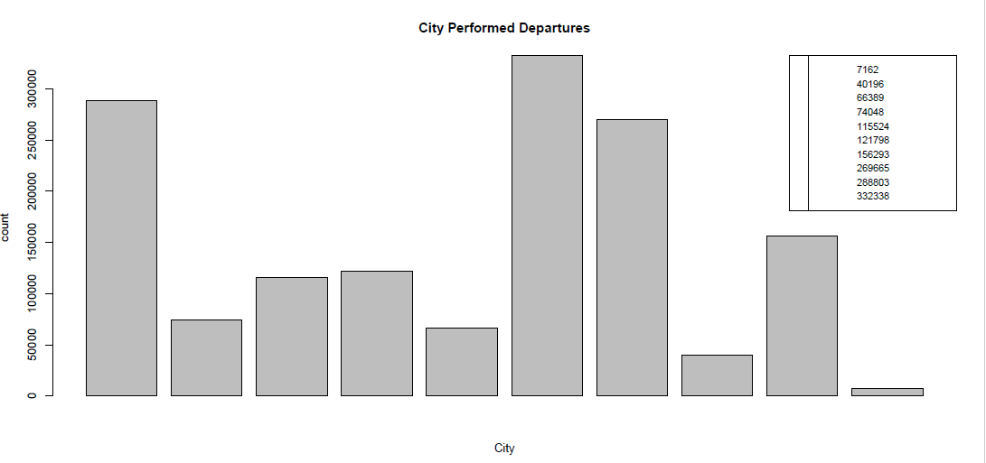

**Line dot:**

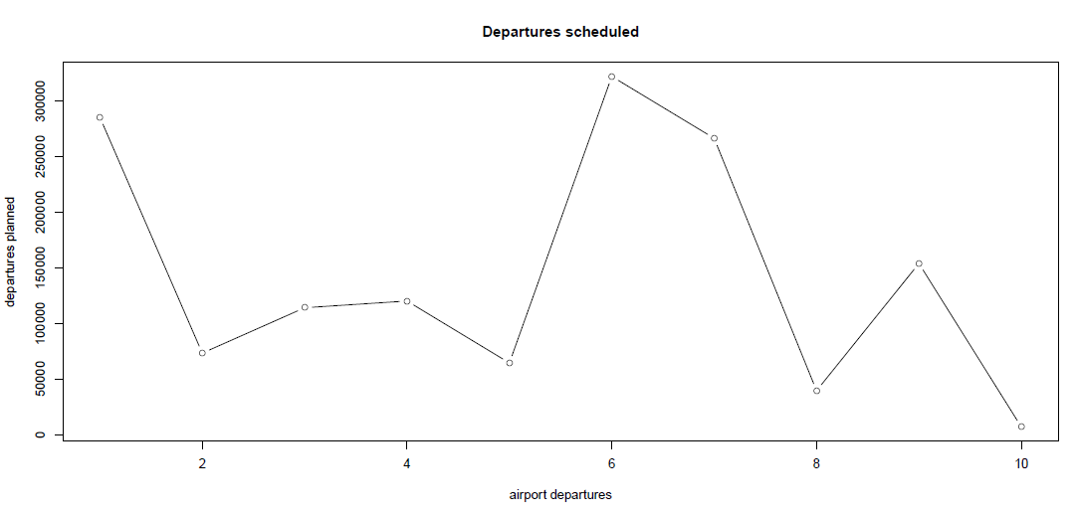

**Charts using functions in the lattice package:**

**Density Plot:**

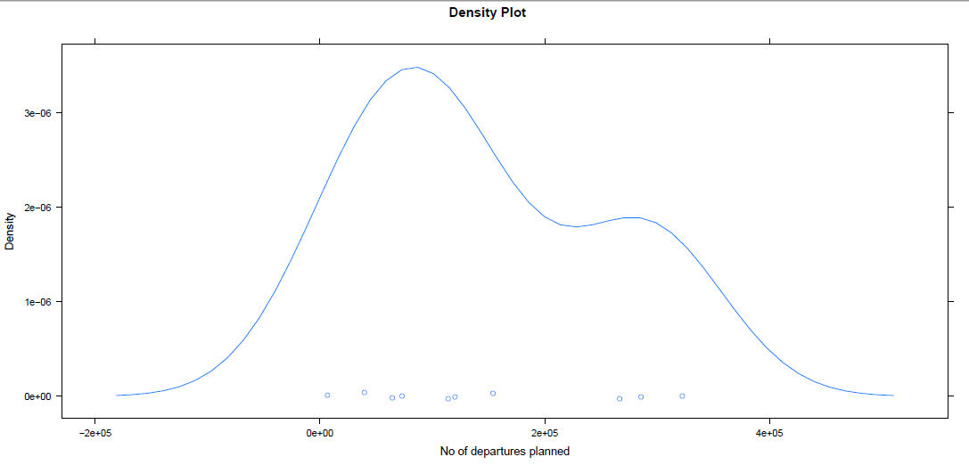

**Scatter plot matrix:**

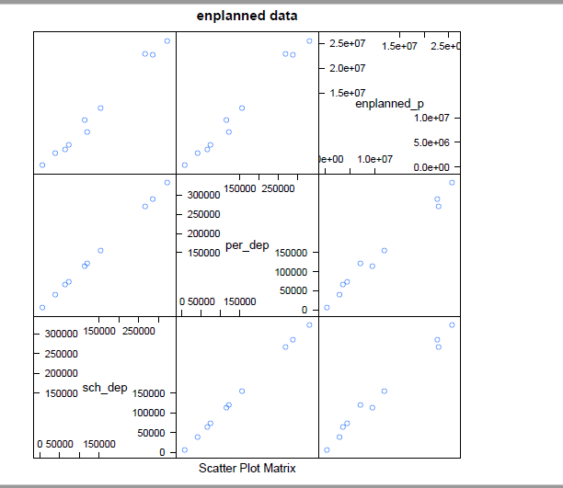

**Chart using functions in the ggplot2 package:**

