**PROJECT-4**

**Visualizations:**

**1)American football data:**

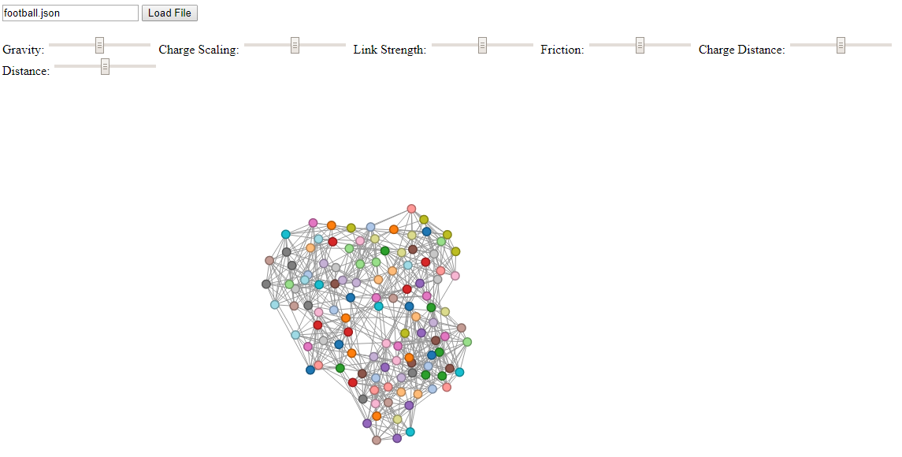

**2) Dolphin social network data:**

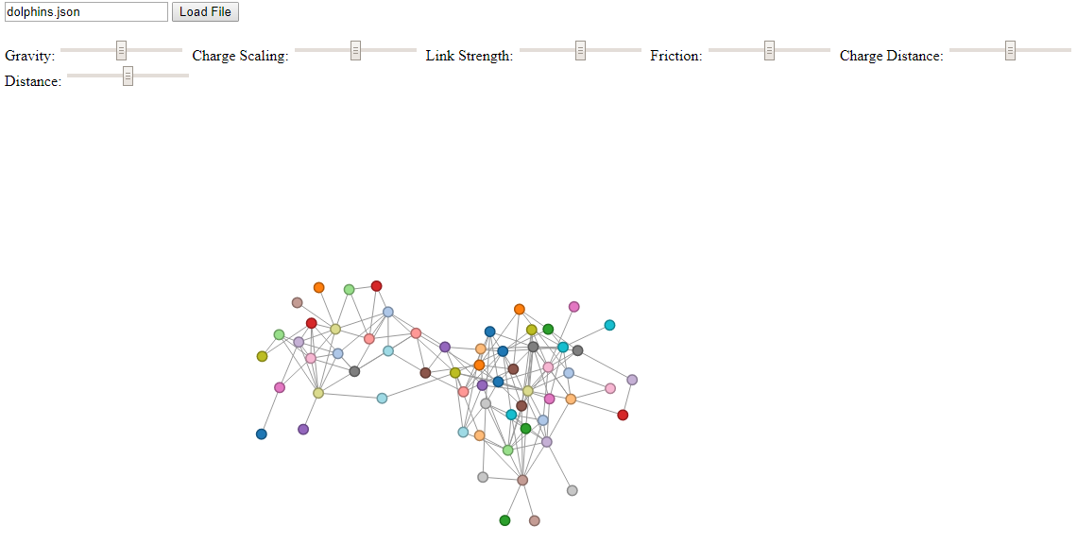

**3) Les Miserables data:**

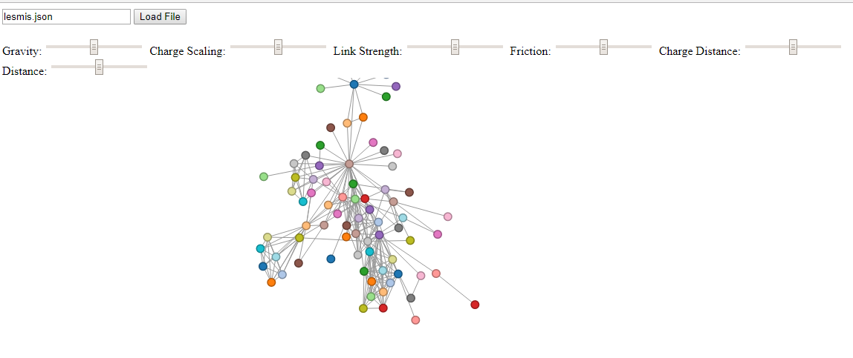

**4) Neural network data of the nematode C. Elegans:**

