# Homework 2

1a)

Below are the data visualizations created for the real estate data. I have created three data visualizations using tableau and a dashboard using the same. Please go through the below link to go to the dashboard. Also, I have taken screenshots of the data visualizations which I have created.

<https://public.tableau.com/profile/thirupathi4121#!/vizhome/RealEstate_78/Dashboard1>

Below is a bar graph showing the number of houses built in each zip code area.

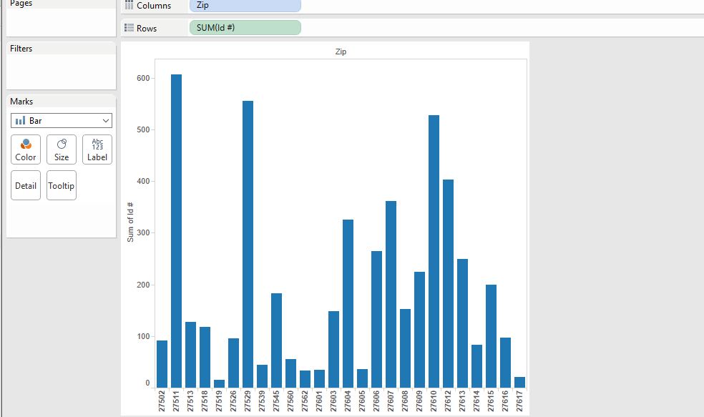

Below is a line graph showing the number of fireplaces and number of baths built as per each year. The contrast formed by orange and blue lines to make it clear for the viewers.

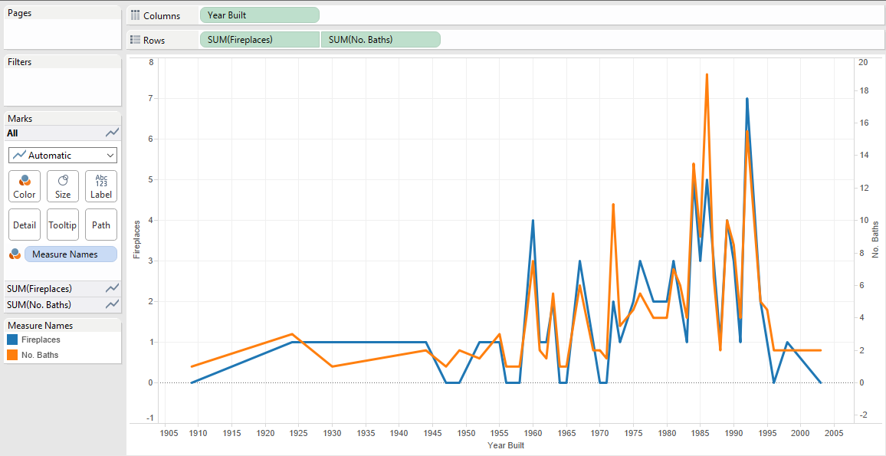

Below is a bubble chart showing the number of buildings created in those locales. The size of the bubble shows the activity of real estate in that area. The bigger the bubble, more the number of houses created.

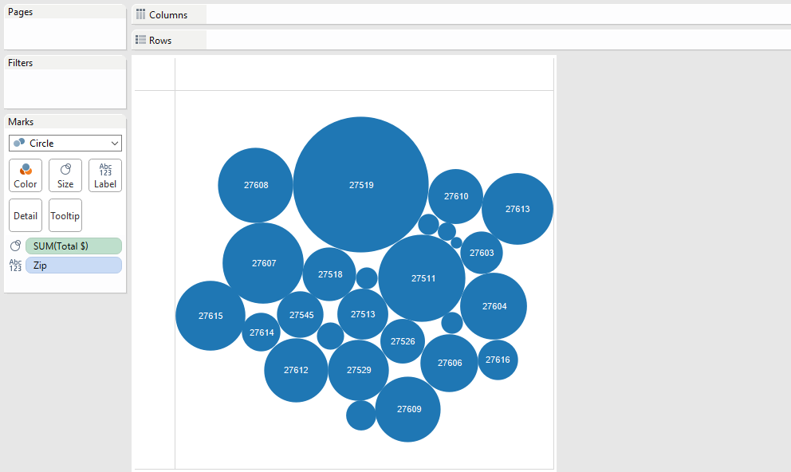

Finally, the dashboard showing us all the three data visualizations altogether.

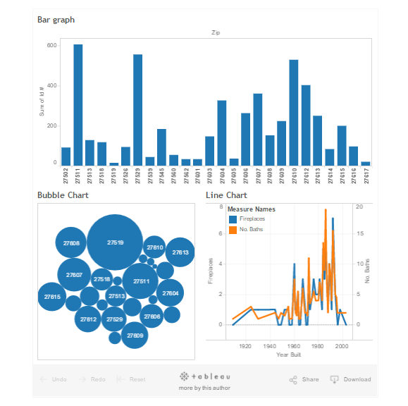

1b)

**About Tableau:**

Firstly, Tableau is a user-friendly application. All the functionalities are easy to use and helps us to make changes then and there. Some of the striking features in Tableau is the data when loaded is assigned with a data type. We can also change the data type into our desired one with just a click. It is very easy to drag and drop fields and create a quick dashboard in minutes. Allows you to get up and running quickly, without waiting for data integration, loading, etc.

Whole integer, Floating number, Geographical, String are some of the features. Tableau also makes usage of the application so simple by allowing to drag and drop to desired functionalities. Also, we can simply zoom in to the data visualization and look at the desired data. It has many of the functionalities of that of a google chart and data can be extracted from excel files and csv files. Also, it allows data from work group or any other place on the internet.

While we have discussed about some of the merits, let us also consider the demerits as well. Tableau is well built application but it does not have the range of features of that of Google maps. Also, it is restricted to the type of data it allows us to work on. It likes relatively clean data in a tabular format which consists of rows and columns.

Tableau also restricts us to having some dimensions and measures which in some scenarios are not helpful. Cannot put multiple metrics on the secondary vertical axis. Also, once the data is loaded, we cannot undo any of the changes. We should restart the process from the beginning. These are some of the advantages and disadvantages of using tableau.

1c)

**Differences between Google Charts and Tableau:**

|  |  |
| --- | --- |
| **Google Charts** | **Tableau** |
| No restrictions on data. We can design data as per our convenience and program the charts to display those visualizations. | There are some restrictions on data and it requires the data hold on to format such as csv or excel sheet. |
| Not so user friendly as compared to tableau. | Tableau is User Friendly. |
| Another important facet of Google charts is it is free. | Some of the features available in tableau are to be purchased. |
| Compared to tableau, Google charts has access to more variety of charts. | Tableau has access to lesser number of charts compared to Google charts. |

Yes, it is possible to develop tableau using Google charts and the most challenging part would be to create the user interface of that of tableau. Also, some of the functionalities of tableau such as changing the type of data i.e. the data type from String to integer to float number or any other data type is easy.

2a)

**About Rainbow color map:**

Following are the reasons which states why rainbow color map is harmful:

* When displaying data with a pseudo color map, the rainbow color map is rarely the optimal choice.
* When the rainbow color map is used, confusion arises among the viewers through its lack of perceptual ordering. It also obscures data through its uncontrolled luminance variation, and actively misleads interpretation through the introduction of non-data dependent gradients.
* We can see that the value decreases with the increase in saturation or vice versa when gradient mapping is used.
* The lighter version is symbolic of holding the smaller/larger value when a gray scale map is considered. But this does not work well for rainbow colors because the saturation and the strength of colors do not add any meaning.
* Whereas the order of rainbow colors must be memorized by the user and then order accordingly.
* To represent the data in the increasing order, user should arrange it Roygbiv/Vibgyor format.
* Users might end up arranging the increase in values in alphabetic or will conclude their own order because it’s difficult to remember the exact format.
* Therefore, considering all the above factors, rainbow color map is not recommended.

2b)

**Example:**

Below is an example where the rainbow color code is being used. You could see from the below screen shot that it is impossible for the viewers to conclude that one of the color code is greater than the other. We could see that the user may not understand the order of Vibgyor/Roy-g-Biv. Though the visualization is given with a legend, it still is difficult for one to refer to the legend and analyze the visualization.

The gray scale map is best suited here as the intensity in color would give a perceptual ability for the user to conclude.

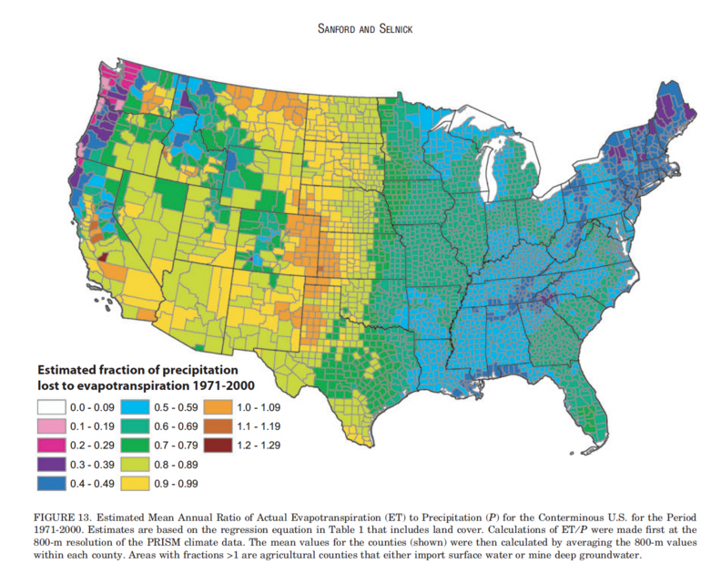

3a)

Some of the tasks supported by tableau in comparisons to Google charts and Google maps are as follows:

* Drag and drop functionality is an ease to users using tableau but the same feature is not found in Google charts and Google maps.
* Show me feature in the tableau lists all the available charts in the tableau application but not in Google charts and Google maps.
* Tableau also provides with filters where we can filter data such as dimensions and measures. The google charts on the other hand does not provide this functionality and the data can be filtered only while writing a query.
* We can sort the items in tableau in ascending or descending order and this would allow us to give a better visualization.
* We can slide through the charts and select a part in the data visualizations and that would filter out the data throughout the dash board. In google charts, filter values are based on different filter values and the item sorting is based on column wise data.
* In tableau it is easy to assign colors to attributes and we can also change the colors using one click while the colors in google charts are predefined in some cases, the color changing attribute isn’t as straight forward as in tableau.
* Details on demand are supported by google charts. While google maps support zoom, overview, Filter, Highlight, Dragging and highlighting a route.

3b)

Seven Tasks according to the Schneiderman’s list are:

1.   Overview

2.   Zoom

3.   Filter

4.   Details on Demand

5.   Relate

6.   History

7.   Extracts

1. Overview Task: Does Tableau, Google Chart, or Google Maps allow you to get an overview of the data set?

Tableau: True

Google Charts: True

Google Maps: True

True indicates that task is there in that tool while false indicates not.

2. Zoom Task: Do Tableau, Google Chart, and Google Maps allow you to dig into the specific details of a data set (e.g. displaying the original spreadsheet, or detailed data)? How does each tool handle this task?

Tableau: False

Google Charts: False

Google Maps: True

3. Filter Task: Does Tableau allow you to query and select the data to be displayed? Does Google Chart allow you to select which column and the range of data to display? Does Google Maps allow you to query and filter the data to be displayed?

Tableau: True

Google Charts: True

Google Maps: True

4. Details on Demand Task: Does Tableau Support Details on Demand Task? Does Google Chart Support Details on Demand Task? Does Google Maps Support Details on Demand Task?

Tableau: True

Google Charts: True

Google Maps: True

5. Relate Task: Does Tableau synchronize one chart with another? Can Google Charts synchronize one chart with another? Can Google Maps be synchronized with other types of charts?

Tableau: True

Google Charts: True

Google Maps: True

6. History Task: Can you undo or redo actions in Tableau? Does Google Charts or Google Maps API support undo or redo certain interactions?

Tableau: True

Google Charts: False

Google Maps: False

7. Extracts Task: Can a user select an area of the visualization or map and extract the corresponding data items? Can the visualization be saved? How does each tool handle this function?

Tableau: False

Google Charts: True

Google Maps: True