# Software for embedded Systems – assignment I

**Submission Date: 14th April 2025 11.50 PM**

**Weightage: 30%**

**Building a Smart Embedded System with Real-Time Capabilities**

**Assignment Title:**

**"Design and Development of a Smart Home Energy Monitoring System"**

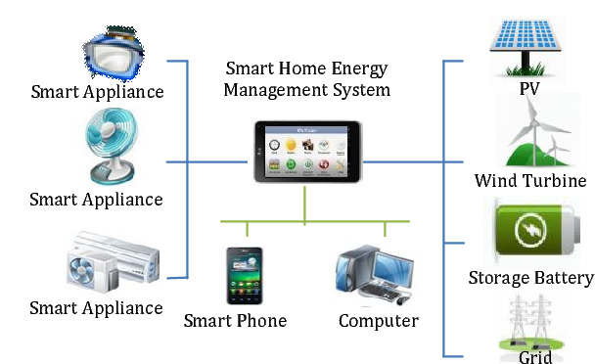

**Objective:**

To apply the concepts of embedded systems by designing a real-time embedded application that monitors and reports energy usage in a smart home environment. This assignment focuses on integrating an embedded operating system, programming languages, and a lightweight database, along with IoT communication protocols.

**Scenario/Description:**

You are tasked with building a **Smart Home Energy Monitoring System** that collects, processes, and visualizes energy usage data from multiple devices in real-time. The system should:

1. Measure **power consumption** of three appliances using sensors (simulated or physical)
2. Store the data locally in an embedded database for real-time access
3. Periodically transmit data to a cloud server (simulated as a local Python/Java server)
4. Allow users to query energy usage statistics via a basic user interface or command-line tool

**Task Breakdown:**

**1. Real-Time Task Management:**

* Use an **embedded OS** to manage:
  + Sensor data acquisition
  + Writing data to the local database
  + Sending aggregated data to the (simulated) cloud server

**2. Programming Language:**

* Use **C/C++/Java/Python** for embedded system tasks
* Use Python/Java to simulate:
  + A cloud server to receive data
  + A simple analytics dashboard to visualize energy usage

**3. Data Storage:**

* Implement a lightweight embedded database such as **SQLite** or store the data in structured files (e.g., JSON or CSV) for local storage
* Design a database schema to include:
  + Device ID
  + Timestamp
  + Power consumption (in watts)

**4. IoT Communication:**

* Implement a communication protocol (e.g., MQTT or HTTP) to send data to the server
* Simulate network latency and ensure your system handles delayed or dropped transmissions gracefully

**5. Error Handling and Reliability:**

* Incorporate error-handling mechanisms for:
  + Sensor disconnections
  + Database write failures
  + Network transmission issues
* Implement a retry mechanism for failed data transmissions

**6. User Interaction:**

* Provide a simple user interface:
  + Query real-time power consumption
  + View statistics like average power usage and peak usage periods

**Deliverables:**

1. **Source Code:**
   * Embedded system code for data acquisition, storage, and communication
   * Server-side code (Python/Java) for receiving and visualizing data
2. **Simulation Logs:**
   * Sample data from sensors and communication with the server
3. **Technical Documentation:**
   * System architecture and design explanation
   * Database schema
4. **Demonstration:**
   * A short video or live demonstration of the working system

Additional Instructions:

* Ensure modularity in your codebase, with separate scripts for each stage.
* Use proper logging and error handling in all scripts.
* Provide detailed documentation, including:
  + Explanation of the pipeline design.
  + Challenges faced and solutions implemented.
* Submit a short video (5–10 minutes) demonstrating your pipeline workflow.

Submission Requirements:

* Source Code: Organized into folders by stage.
* Documentation: Markdown or PDF format.
* Video Walkthrough: Demonstrating the pipeline.
* Final Deliverables: Compressed .zip file with all code, data, and documentation.

General Notes:

* **Although specific tools, products, and platforms are mentioned as examples in the tasks, you are free to choose and justify a toolchain of your preference, provided it aligns with the objectives, expectations, and deliverables of the assignment.**
* **Refer the document used while registering the groups. In case of discrepancies, write to me separately (copying all your group members) with subject line as "SES Group <your_group_number>". email – pravin.pawar@pilani.bits-pilani.ac.in**
* **Using the LMS, only one member of group has to upload the file. No submission over email will be considered.**
* **Make sure that you upload the file well ahead of deadline. At last moments, we have seen several groups have faced issues while doing the submissions.**
* **Note - As it’s a group assignment, only one submission is expected from each group. Unnecessary don’t upload the solution on individual basis. If it’s observed, then the penalty (25% reduction) will be applicable on it.**