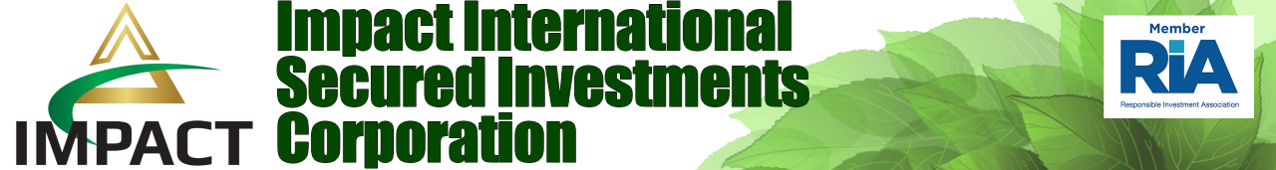

FOR IMMEDIATE RELEASE

First-of-its-Kind Social Impact Bond Planned for British Columbia
Tweet this release: [do we have a twitter account?]

KELOWNA, November 25, 2019 - Impact ISI is fostering The Green Bank Network (TGBN) to lead the way in circular and integrated impact financing. TGBN employs exponential technology including Blockchain, and Smart Contracts intended to reduce market barriers, draw in private investment through blended finance. Whether legal tender, digital coin or tokens, securitization through gold, real estate, and excess goods aims to de-risk large scale social and green investments.
Why now? A global awaking has revealed unbridled environmental degradation and deplorable social conditions despite massive surges in social and green investments over past years. Eroding public confidence in governments and reluctance of private investors to fund impact projects have both stagnated the market and led to urgent calls for superior oversight, monitoring and reporting. Even more weighty has been commitments this year by the World Bank and the European Investment Bank to stop funding fossil fuel projects. This level of disruption has created opportunities to engage local and global finance sectors to mobilize “clean” private capital for public good like never before.
Canada is positioned to make good on diligent work since the 1900s to establish the regulatory and policy floor for compliant social finance investing. Curating this knowledge, Toronto-based MaRS Centre for Impact Investing and the Canadian Task Force on Social Finance supported the Government of Manitoba and partners to issue a first ever Canadian Social Impact Bond issued in 2017. This has opened the door for other provinces to follow suit.
Impact International Secured Investments Corporation (Impact ISI), a World leader in impact investing and facilitating a high-quality impact investing plans to take action in Phase II of a Canadian flagship project nearing the close of Phase I. Consolidating over 17-months of multi-stakeholder engagement, an open community design workshop is scheduled for Nov 29, 30, Dec 1, 2019 in Vanderhoof, British Columbia. Known as the “the heart of it all” situated in the geographic Centre of the Province, Vanderhoof will help crystalize a local vision and action plan for safe passage for all on the Yellowhead Highway (16). In collectively re-imaging the infamous ‘Highway of Tears’, a new relationship with the land can take root.
Impact ISI plans to facilitate the First-ever Social Impact Bond in British Columbia, raising $15 M (US) for Phase II of the Highway 16 security and economic development project. This will enable scaling up and further development of intelligent mobile communications infrastructure, user training and job creation. A direct benefit is an affordable fail-safe communications system for safe passage for all on the Yellowhead Highway (16). Anticipated next is for local communities, First Nations and First Citizens and local business to build economies in a way that sustains the investment and also creates opportunities to individually and collectively generate revenue. In effect, the pivot is away from resource extraction-based investment subsidized by government as the cornerstone of northern Canadian economies.
As a force multiplier, Phase II also effectively chips away at shelved recommendations from past inquires, studies and projects concerning safety and connectivity in BC’s North. Leaning forward, it lends a hand to open the economic gateway for CEO Carol Ann Hilton’s, Indigenomics Institute to advance 12 economic levers for decolonizing economic development. That is, to unleash potential energy to propel forward a new payload – a $100 Billion Indigenous Economy.

For further information, contact:
Mr. L.T. Oliver, Executive Managing Director
Impact International Secured Investments, LLC &
Co-Founder and Managing Partner, The Green Bank Network (TGBN) Canada
Email: Lindsay@impactisi.com
Business Line: 204.995.9001

Dr. Connie Delisle, BA, BA, MSc, PhD
Co-Founder and Managing Partner, The Green Bank Network (TGBN) Canada
LinkedIN: https://www.linkedin.com/in/connie-delisle-0851276

