# AUTOMATIC IDENTIFICATION SYSTEM (AIS)

# AN/URN-31(V)

**Test of Microsoft Edge**

**(NCR: N65236-AIS-NCR-22-0503)**

**October 28, 2022**

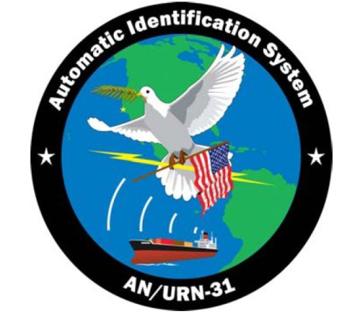

Controlled By: NIWC Atlantic

Controlled By: Code 62400

CUI Category: ISVI

Limited Dissemination Controls: FEDCON

POC: Sherri Holden, 843-218-6865

# INTRODUCTION

## Purpose

This document is a test of Microsoft Edge version 106.0.1370.47 on all AIS systems with Windows 10 version 1709. Test will verify update does not adversely affect system operation.

## Variants To Be Tested

* (V)1/3/9 1709 – 4.1.2.90/4.3.3.90
* (V)2 1709 – 4.2.4.97

## Software Versions To Be Tested

* Windows 10 v1709
* Microsoft Edge version 106.0.1370.47
  + IAVM – 2022-A-0437
  + NCR – N65236-AIS-NCR-22-0503

# OBJECTIVES

The successful completion of this test plan will accomplish the following major objectives:

* Microsoft Edge version 106.0.1370.47 does not adversely affect system operation.

# TEST SETUP

## AIS Lab

* There are no unique safety requirements for AIS testing; standard NIWC-LANT practices apply when using computer equipment in the AIS Lab.
* The AIS Lab supports the security requirements required for an operational AIS system installation. Lab configuration is shown in Figure 1.

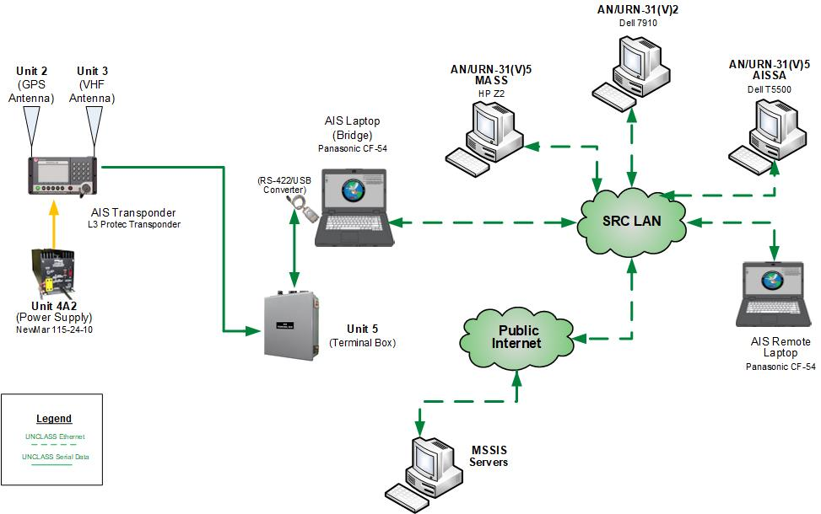

Figure 1

## LAB CONFIGURATION LIMITATIONS

Tested on a Non-DoD Network.

RADMERC not available for testing.

## SOFTWARE ITEMS

Table 1 lists the AIS (V)1/3/9 Windows 10 v1709 software required for AIS testing. Table 2 lists the AIS (V)2 Windows 10 v1709 software required for testing.

Table 1 AIS (V)1/3/9 v1709 Software Requirements

|  | **4.1.2.89/4.3.3.89** | **4.1.2.90/4.3.3.90** |
| --- | --- | --- |
| Intel Graphics Driver | 21.20.16.4550 | 21.20.16.4550 |
| Java JRE | 8.0.3510.10 | 8.0.3510.10 |
| Microsoft Edge | 106.0.1370.42 | 107.0.1418.24 |
| Microsoft NetBanner | 2.1.161 | 2.1.161 |
| Microsoft Visual C++ 2010 x64 Redistributable | 10.0.30319 | 10.0.30319 |
| Microsoft Visual C++ 2010 x86 Redistributable | 10.0.30319 | 10.0.30319 |
| Microsoft Visual C++ 2013 x64 Redistributable | 12.0.30501.0 | 12.0.30501.0 |
| Microsoft Visual C++ 2013 x86 Redistributable | 12.0.30501.0 | 12.0.30501.0 |
| Microsoft Visual C++ 2015 Redistributable (x64) | 14.0.23026.0 | 14.0.23026.0 |
| Paragon Hard Disk Manager 15 Premium SP5 | 10.1.25.1137 | 10.1.25.1137 |
| Realtek High Definition Audio Driver | 6.0.1.6111 | 6.0.1.6111 |
| Pipeline | 4 | 4 |
| sTunnel | 5.63 | 5.63 |
| Synaptics Pointing Device Driver | 19.3.10.45 | 19.3.10.45 |
| Transview 32 | 7.74B, Oct 2012 | 7.74B, Oct 2012 |
| Windows Operating System | 10 v1709 64 Bit | 10 v1709 64 Bit |

Table 2 AIS (V)2 v1709 Software Requirements

|  | **4.2.4.96** | **4.2.4.97** |
| --- | --- | --- |
| AIS Server Software (XCOP) | 4 | 4 |
| Apache Active MQ | 5.16.1 | 5.16.1 |
| Apache Tomcat | 7.0.109 | 7.0.109 |
| Java JRE | 8.0.3510.10 | 8.0.3510.10 |
| Microsoft Edge | 106.0.1370.42 | 107.0.1418.24 |
| Microsoft SQL Server 2008 Native Client | 10.3.5500.0 | 10.3.5500.0 |
| Microsoft NetBanner | 2.1.161 | 2.1.161 |
| Microsoft Visual C++ 2010 x64 Redistributable | 10.0.30319 | 10.0.30319 |
| Microsoft Visual C++ 2010 x86 Redistributable | 10.0.30319 | 10.0.30319 |
| Microsoft Visual C++ 2015 Redistributable (x64) | 14.0.23026.0 | 14.0.23026.0 |
| MySQL Installer | 1.4.17.0 | 1.4.17.0 |
| MySQL Server Essentials | 5.1.72 | 5.1.72 |
| NVIDIA Graphics Driver | 377.83 | 377.83 |
| Paragon Hard Disk Manager 15 Premium SP5 | 10.1.25.1137 | 10.1.25.1137 |
| Realtek Audio COM Components | 1.0.2 | 1.0.2 |
| Realtek High Definition Audio Driver | 6.0.1.6111 | 6.0.1.6111 |
| Synaptics Pointing Device Driver | 19.0.19.1 | 19.0.19.1 |
| Windows Operating System | 10 v1709 64 Bit | 10 v1709 64 Bit |

## HARDWARE ITEMS

Table 5 lists the AIS hardware required for functionality testing.

Table 5. Hardware Requirements

| **Hardware Item** | **AIS Variant** |
| --- | --- |
| Panasonic CF54 Laptop with i7-6600U 2.60GHz processor and 8GB Ram | V1/3/9 |
| Dell 7910 Intel Xeon E5-2620 v3 2.40 GHz CPU, 16 GB Ram | V2 |
| Dell T5500 Intel Xeon 3.46 GHz CPU, 4 GB Ram | V2/5 |

# TESTING

## TEST CONDUCT

Test conduct will consist of an operator experienced in the operation of the AIS system executing the following checklist.

|  |  |  |  |  |  |
| --- | --- | --- | --- | --- | --- |
|  | | | | | |
| **AIS System Functionality Test Checklist** | | | | | |
| **Microsoft Edge 106.0.1370.47/AIS MSU-033-2022** | | | |  | |
| **Tester:** | **Date:** | | |  | |
| **Comments:** |  | |  |  | |
| **Action** | | **ais-op**  **Pass/Fail** | | **ais-secman/ais-admin**  **Pass/Fail** | |
| 1. Login to primary laptop | |  | |  | |
| * Open TV32 – View local contacts | |  | |  | |
| * Open Pipeline – View rolling VDO/VDM messages | |  | |  | |
| * Launch sTunnel, verify worldwide contacts | |  | |  | |
| * Open the IETM on the desktop in Edge | |  | |  | |
| 1. Login to remote laptop | |  | |  | |
| * Open TV32 – verify contacts populating from primary laptop | |  | |  | |
| 1. Login to V2 Server | | **N/A** | |  | |
| * Open the IETM on the desktop in Edge | | **N/A** | |  | |
| * Launch XCOP, verify rolling messages in AIS-NMEA-Server | | **N/A** | |  | |
| * Verify Contacts displayed on Console. Tracks contain AIS information. | | **N/A** | |  | |
| 1. Launch Paragon and make a backup. | |  | |  | |