Abend-Aid:

To activate put //ABNLDUMP dd into JCL step for OS COBOL steps

BATCH File (PC):

If statement looks like this
If exist <path> goto somelabel
REM else
Some other work
:somelabel
some work to be done

if “%1” == “” goto skip %1 is the 1st batch file parm; test to see if it is empty
do something if %1 is not empty

:skip label to bypass when %1 is empty or blank
do something else

save environment var CLASSPATH
set CP = %CLASSPATH%
set CLASSPATH=. Null out var
set CLASSPATH= new path;%CP% set new path info and then orig. CP

- For quicker access use TGPROD.CC.CC12.ACCTDISP the on-line display version of TGPROD.CC.CC07.ACCTHIST

CICS:
When we’re notifying people about issues, testing, problems with T7 we need to add Luanne Smith to the mail message as she may be in it using CMS.

CICS 2.X logon is CSSN; logoff command here is CSSF LOGOFF

Or for CICS 5.x logon is CESN ; logoff command is CESF LOGO

CICA10P3 is an on-line region for the old MSA Accounting system which we used prior to Impact. A few people in Accounting still use this region to sign on and get reports from old data.

CICA10PB is used for Find America and stand alone transactions for Code 1.

TGSYS1.CICS.TESTLIB is load lib for CICA10T7, the main MVSP test CICS region for ISCA.

CICS Commands:

ICEMT INQ FILE(SLS*)
STATUS: RESULTS - OVERTYPE TO MODIFY
Fil(SLSF001 ) Vsa Clo Dis Rea Bro Sha
Dsn( DEVTST.AMS.SYS.DDIO )
Fil(SLSF002 ) Vsa Clo Dis Rea Bro Sha
Dsn( DEVTST.XPC.DDIO )
Fil(SLSF003 ) Vsa Clo Dis Rea Bro Sha

Dsn( CWCD.XPC.R680.DDIO1 )

Show the XPEDITER files used for CICS region SLSF001 is the first XPED file used and F002 is the next and etc…

CEMT INQ PROG(CXOM812)
STATUS: RESULTS - OVERTYPE TO MODIFY
Prog(CXOM812 ) Len(0017456) Cob Pro Ena Pri Ced
Res(000) Use(0000000019) Bel Uex Ful Qua Le3

Show if program is tied up in XPED by the vaule of the RES(xxx) field; if > 000 use
CECI REL PROG(CXOM812) to release resources ; otherwise can’t NEWC program. This an XPED CICS problem.

CEDA DIS to display program and RCT entries

CEDA ALT to modify existing entries for RCT or other resources

COBOL:
TGPROD.BATCH.LOAD.LIB COBOL MVS production loadlib

TGSYS1.CICS.PRODLIB CICS production loadlib

TGSYS1.BATCH.PRODLIB Batch production loadlib

SYSP – System prefix for system proclib

When using OS390 COBOL version 2.2 compiler - if you receive these compiler errors:
IGYAS5125-U The compilation was terminated due to a compiler error in
IGYAS5139-U The symbolic register backstore area capacity was exceeded

Change the compiler option of NOOPT to OPT(STD) or OPT(FULL) this will resolve the problem. A PTF may need to be applied also.

CODE1:

Code1 database expires every 2 months and the code1 interface module used by batch Collection programs is BTL001B, it is also used by some if not all PCBX batch programs. To do proper Y2K testing in MVSD for programs using BTL001B you need to add steplib TGTEST.MFO.CTA.CODE1.Y2K.LOADLIB. This loadlib contains a version of BTL001B with a Y2K switch set to allow Y2K testing.

The test Code 1 Trans id is G1CP

Control-M / Control-D:

Control–D old report ids must be kept when changing to new report ids if there is history on Control–D under the old report id which could be restored by the user or ISCA or Prod. CNTL.

Control-M will return a Job status of Ended Not Ok for any step in a job with a Cond. Code > 0, thus causing the POC to be called. If you want to prevent this you must have Prod. Cntl setup the Job’s Zoom panel for each step where the Cond. Code can be > 0 and the job should have a Control-M status of Ended Ok. Here’s how you would do it for Job Step CHK020 and Proc Step SAS:

On the Job’s Zoom Panel …

ON PGMST SAS PROCST CHK020 CODES C <0003

This tells Control-M that for Job Step CHK020 Proc Step SAS that Cond. Code of

0003 or smaller will allow Control-M to Ended Okay.

ADS Control-D user ids:

VIEW-6-1 for output box T6-1

VIEW-8-2 for output box T8-2

A10IOA (MVSP) –

Job schedule def. DSN TGOPRP.CTM.SCHEDULE

Report def. DSN TGOPRP.CTD.REPORTS

A12IOA (MVSD)

Job schedule def. DSN TGOPRD.CTM.SCHEDULE

Report def. DSN TGOPRD.CTD.REPORTS

Print mission have changed - use PRT4 or PRT5 instead of PRT3.

DACCS Loan Accounting:
Table AC2188_GTYP_PRMMST table must be populated, as of 6/8/06 there should be 8 rows in this table. If this table is empty then posting payments will not work correctly.
All I/O modules (ISDSQLxx) where xx is a value of 00 – 36 must be maintained in each region that runs LA, suchas DEV,DCR,SCR,UAT(UAT1),UVT(UAT2),UMT(UAT3). IF you need change the current processing date(s) in LA, you must change AC024_BNK_PARM_MST table and AC21314_BNKGEN_CTLtables. These are the master and staging bank control table respectively. The TDEF table describes how the ES DBIO, ALOMFLIT modules read the related AL DB2 tables. ES status code 5 says that the TDEF table length for the table is to small. PALD308D job that unloads the main AL ref. table AC2154_REF_TBLDATA has a problem with the TDEF for this table, so it is not unload all the ref data rows (more than 8000 rows and only 247 are unload) this is as of 6/8/06. This impacts PALU022D (Loan sweep) job, there is a control card ALD300C2 that tells LSW whether to read a VSAM file or DB2, so if you need to you can remove the entry from this control card member to force LSW to read DB2. This cause a performance problem. Keep a back up fo the ALD300C2 member in case you need to add back the entry. If you have a problem with the ACLI or ACLI /T AL trans in CICS , bounce the CICS region to help resolve the problems.

Also do not add rows to AC2154_REF_TBLDATA table without going through the ACLS app to do this. This includes using table ACLSVIEW to show all tables defined and then you use this ACLSVIEW to add a new table. Rehab project P375 did not do this and this cause the problems with PALD308D job, Credit Bureau problems and the interest rate roll problems.

DACCS Case Management (CM):
correspondence that is initiated from DG_OFFLINE_REQUEST table that successfully prints via AUTOCORR / BATCHPRINT (via DACCS print server) will be deleted by the PCXU82AD or PCXU82BD jobs via program ISCC246. The PRINT_STATUS must be a value of “S”. A VALUE of spaces means to be printed, a value of “F” means failed. Use a value of “X” on MVSD to say exclude from print. Check DG_OFFLINE_REQUEST table contents before doing 1st correspondence printing (TCXU63AD, TCXU63BD) to see what needs to be cleaned up, remove any PRITN_STATUS “S” rows and any PRINT_STATUS “F” rows.

CO_CASE_PAY_PLAN deletes occur

In STATASGN when a case is routed to IN01 ISCC320 is called which deletes the CO_CASEPAY_PLAN row for the location and case number

IN TRANS when a PURGE trans (915) is processed it will call the ISCC320 program to delete CO_CASE_PAY_PLAN data for a location and case number ( DACCS LA TO CM interface does not generate these 915 transactions).

Some where else in CM processing (nightly, weekly , etc..) the CO_CASE_PAY_PLAN data for hard closed cases is being deleted. This was discovered on the Rehab Data Change exception report where job PCXU723D / CXBM725 is reviewing these hard closed cases to reset rehab data including the user id (Rehab User) on the CO_CASE_PAY_PLAN table. However, since CXBM725 could not find the CO_CASE_PAY_PLAN data it generated the PARA=8100-… CO_CASE_PAY_PLAN not found exception.

DACCS CORR
The DACCS correspondence set up for the server looks like this
A service needs to be running to pick up the ftp request from the Zos job
?CXU63AD/?CXU63BD

The Correspondence folder is located on epmtcor1
Inside it is every environments corr set up for DSNT-CXQ3
There are two config files Correspondence.properties and config.ini
The SQLJ.jar file needs to in the main folder Correspondence

The confgi.ini is in the Service folder
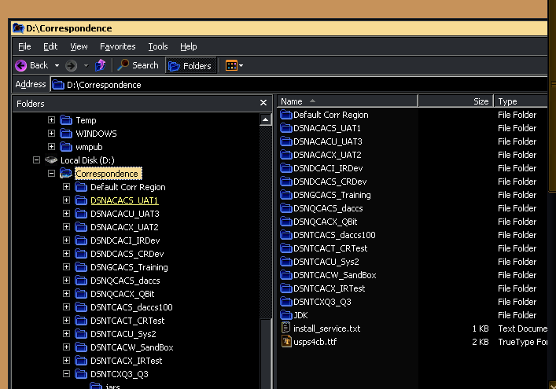
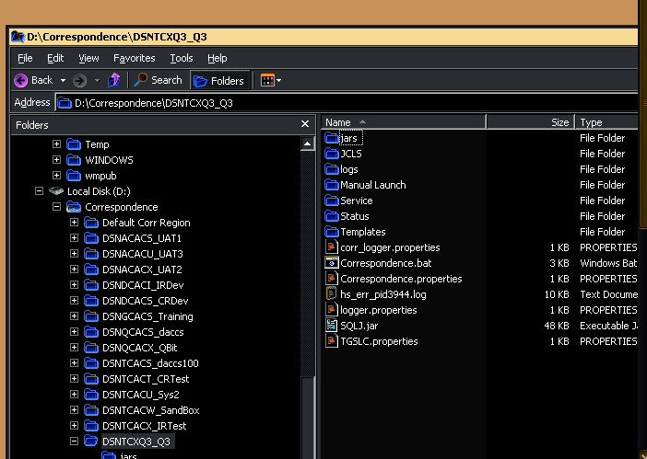
DACCS CORR
The config.ini file in the Service folder is where you can set up the manual run of Corr. You must set the parm. To a Y and set the date
Then open a cmd window, do a cd to the service folder and then run the individual batch files (files must be enclosed in double quotes (“) because the name contains spaces. These must be run in order from Thread 1 , Thread 2, Thread3 and last Thread4.

The Correspondence.bat file will use the STOR ftp command to write the Zos file names back to the Zos box. For Q3 the file names are DEV.Q3.CX.DADP.CORR1 thru DEV.Q3.CX.DADP.CORR4 and DEV.Q3.CX.CLCX.CORR1 thru DEV.Q3.CX.CLCX.CORR4. The server user id must have ftp STOR privileges on the Zos box.

CO_SEQ_GENERATOR table contains the next available number for serveral number values

For DOCTMU data elements the ENTITY-ID = ”ELEMENT-ID”
And the SEQUENCE-NUMBer is the next data element id. There are gaps in this value when you look at the R_CL_ELEMENT table.

So be very careful setting the ELEMENT-ID value in any environment especially DSNA/CXQM and DSNP/CACS

The ENTITY_ID = “SQL-WHERE-ID” is the SQL-WHERE Clause Id for data element Criteria
There are no gaps in these number on the R_CL_SQL_WHERE

DACCS:

CA IVR SCREEN Work CAII095 is the CICS program that is called for the CA95 Trans when the IVR get a called that it routes to the Cust. Asst. group. CAII095 was modified for DACCS from its legacy version. It calls several common modules including TGIO000 and PCIO000 (which will do DB2 work and also call

PCIO001 for IDMS access. CAII095 and PCIO000/PCIO001 are compiled using JCL created for DACCS in DEVTST.AMS.AL.???.EXECJCL, where ??? is test region like DEV, DCR, SCR, SVL, etc… PCIO001 need the CICS & IDMS compile and should be linked into the DEVTST.AMS.AL.???.loadlibO, it has been modified (around 8/1/2005) to user TGIINTRT instead of the TGL92000, so it can use the LGPS interest rate IDMS records instead of a hard-coded program array(TGL92000). Changes to PCIO001 or TGIINTRT must be new copied ( using NEWC trans) in the CICS region where the modifications will be tested. Look at DEVTST.AMS.AL.SVL.EXECJCL for compile JCL for PCIO001 and TGIINTRT. As of 8/1/2005 I don’t know who maintains TGIINTRT, but for our testing we compiled it using the same compile JCL as used for PCIO001 into the SVL CICS region CICTSTPT, so we could use xpediter to look at how it executes.

The AL01 and AL02 IVR trans for DA/DP and Coll, use different programs and different compile JCL all kept in the test region like SVL, again you can look at SVL execjcl to see an example of the JCL.

DACCS Stored Procedures

There many DB2 stored procedures used in DACC CM GUI code and in the batch CX programs.

Here is a list of the DB2 stored procedure names along with the batch 8 character names
DB2 Name used in GUI code | Batch name | Batch / Online
CO_APPENDWORKLIST | ISCC224 | O
CO_GET_CASE_TO_WRK | ISCC163 | O
CO_GET_CSE_2_BRWSE | ISCC162 | O
CO_GETALLOWEDLTRS | ISCC226 | O
CO_GETALLOWEDLTRS2 | ISCC193 | O
CO_GETRESPUSER | ISCC343 | O
CO_INSSTATEQUEUE | ISCC329 | C
CO_LSLTRSND_CAP | ISCC157 | Not used
CO_SETLASTUSERID | ISCC102 | C
CO_UPD_CASE_STATUS | ISCC164 | C
CO_APPENDWORKLIST | ISCC224 | C
ADDR_UPD_CXBFM077 | CXBFM077 | O/B
CODE1_DPV_C1BI102 | C1BI102 | O
CXBFM100_GRAD_CODE | CXBFM100
CXTDC246 | CXTDC246 | O/B

Claims
Testing quirk in MVSD …

-----Original Message-----
From: Castilla, Lora
Sent: Tuesday, May 08, 2007 7:03 AM
To: Morrogh, Heather
Cc: Scharnberg, Jack; Moore, Debra; Reynolds, Kevin; Miller, Laurie
Subject: RE: P818 Supplemental Claims

No tricks. The date on the interface file being different than the AL posting date is just one of those testing quirks we have because of using dates from the machine’s system date vs using dates from the loan accounting calendar and co_date. Not a problem in Production because all the dates are in synch all the time there.

-----Original Message-----
From: Morrogh, Heather
Sent: Monday, May 07, 2007 5:03 PM
To: Castilla, Lora
Cc: Scharnberg, Jack; Moore, Debra; Reynolds, Kevin; Miller, Laurie
Subject: RE: P818 Supplemental Claims

Dan manipulated the table to get them to process correctly but we will need to do another round in a future cycle. Are there any tricks to supplementals that we missed to cause the different dates that were picked up?

Heather Morrogh
Business Process Engineer, Product Management
x2881

-----Original Message-----
From: Castilla, Lora
Sent: Monday, May 07, 2007 1:47 PM
To: Morrogh, Heather
Cc: Scharnberg, Jack; Moore, Debra; Reynolds, Kevin; Miller, Laurie
Subject: RE: P818 Supplemental Claims

Heather – I was out last week with strep throat. Did these get resolved?

-----Original Message-----
From: Morrogh, Heather
Sent: Wednesday, May 02, 2007 11:28 AM
To: Castilla, Lora
Cc: Scharnberg, Jack; Moore, Debra; Reynolds, Kevin; Miller, Laurie
Subject: FW: P818 Supplemental Claims

Lora,
I posted supplemental claims to test a new workflow rule and we ran into some unexpected problems. When I logged the supplemental claim in LA it shows the effective date of the claim paid date and the posting date of my activity (4/12/07 system date). However, when the batch process ran it picked up a posting date of my actual calendar date (4/27/07). Can you review and let us know how to resolve this issue?

Test Cases used:
21095700
24466100
22966900
23240300
28033500

Heather Morrogh
Business Process Engineer, Product Management
x2881

-----Original Message-----
From: Reynolds, Kevin
Sent: Wednesday, May 02, 2007 10:49 AM
To: Morrogh, Heather; DACCS Requests
Cc: Scharnberg, Jack; Moore, Debra
Subject: RE: P818 Supplemental Claims

The process date is 4/13 and the post date is 4/27. The post date is too far in the future to hit the rule. It would have to have been in the last 4 days prior to the process date. It would have to have posted between 4/10 and 4/13. Perhaps it could be hacked to change the Supp Claim Date.
DACCS GUI

DACCS uses SVN/Maven

All pom.xml files are in SVN with root and projects

DACCS is under SVN repo of http://code.tgslc.org/SVNrepos/epmo/daccs/branches/release

Projects

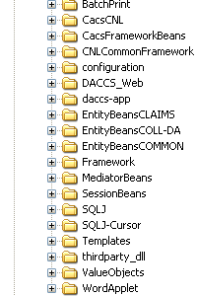

Developer must erequest build from SVN once chagnes have been committed. DACCS Hudson site
http://ci.dev.tgslc.org/hudson/view/DACCS/

daccs-app-branch builds new ear fromSVN: branches\release
daccs-app-trunk builds ear from SVN:trunk
:
DACCS GUI

\\Epmtbea6\deployments\daccsu* is the deployment location depending on the U evnrionment working with. U4 has beenf or CAR work
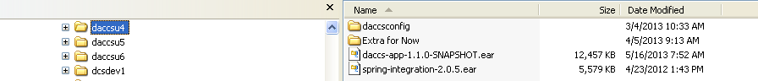

If static content (javascript; images; help files) have been updated added then the static zip file must be deployed to the u* website
\\Epmtbea6\wwwroot\u* web site

DACCS Developer Local parameters to use corr. Templates (DACCSWordApplet.jar)

website – http://daccs.u*.tgslc.org/
share directory - \\epmtbea6\U*Templates

DACCS /RAMS AUTOCORR/BATCHPRINT

The data source for whatever PC/server you use must have two parameter set :

CurrentPackageSet = DCU1COLL or CXU1COLL or collections name

CurrentSQLID = DCU1 or CXU1 or whatever database name for DACCS/RAMS database

Make sure the properties files are set up correctly with template path and
Correct coversheet template id (timestamp)

To do manual printing use the Manual Launch folder and run the
Corr CLCX Thread1.bat - Corr CLCX Thread4.bat script file from CMD window (put script name in Double quotes) Start with Thread1 and run each Thread1 – 4 in ascending numeric order.

For DACCS if you need to run DA/DP correspondences manually use
Corr DADP Thread1.bat - Corr DADP Thread4.bat run in ascending numeric order

To change process date or change the number of days in the past to look for correspondence change setting in Correspondence.properties (days and process date) and TGSLC.properties (template location and coversheet template id).

CO_SEQ_GENERATOR table contains the next available number for serveral number values

For DOCTMU data elements the ENTITY-ID = ”ELEMENT-ID”
And the SEQUENCE-NUMBer is the next data element id. There are gaps in this value when you look at the R_CL_ELEMENT table.

So be very careful setting the ELEMENT-ID value in any environment especially DSND/DCU1 and DSNA/DCQ1

As of 7/26/2013 per Mike Kelley (Shelley, Rob and I) agreed to set the DCU1 ELEMENT-Id value at 132.

The ENTITY_ID = “SQL-WHERE-ID” is the SQL-WHERE Clause Id for data element Criteria
There are no gaps in these number on the R_CL_SQL_WHERE

As of the same date SQL-WHERE-Id is = 122

DPRV:

Weekly processing for Electronic School Reports (ESR) is done using jobs PPCU350W, PPCX540W (Claims pending), PPCX547W (new Cohort year), PPCU550W (RRD text format and hardcopy report), and PPCX025W (data file) RRD-LWC data created.

TG-TABLES ADABAS file is used for providing dates for processing the PRECLAIMS PCU350B table key provides Last run date which is normally a Friday’s date like 09/01/2000 is used by PCU350B to filter out LONRFA data. PRECLAIMS PCU010B table key provides the run date, which will be different that the system date. For PPCU550W processing this date (#DATX) will be the Friday before date, since this job runs on Saturday afternoons. The #DATX field is used for run date needs so it matches the date PCU350B was run. The system date is used on report headings.

CONNECTG sssssssss where sssssssss is the school id like 003537000 table key provides the site id used to tell the ConnecTG server what mailbox the data will go in, since there are several schools that receive either the text ESR via RRD or the Data file (LWC) ESR via RRD. The PSPS school profile denotes what schools get what format if at all. The profile record is under the SR type profile. The PROD-code will be H (hardcopy) B (both Hardcopy and ESR) or E (ESR). The letter format will be T (text ESR) or D (Data file ESR).
DB2 Connect info:

Set up DB2 connect using IBM conf. assistant

For DSNA, DSND, DSNT use host D_REX

Server TG12A (DSNA) , TG12T (DSNT) and TG12D (DSND) and database name

Port number is 33003 (DSNA), 33001 (DSND) and 33009 (DSNT)

DSNP

Host T_REX

Server TG10P and database name

Port 33005

DSNQ

Host T_REX

Server and database name TG10Q

Port 33007

Email from Z/Os job

My JCL:
//SENDNOTE EXEC PGM=IEBGENER
//SYSIN DD DUMMY
//SYSPRINT DD SYSOUT=*
//SYSUT2 DD SYSOUT=(B,SMTP)
//SYSUT1 DD *
helo MVPXSSI
mail from:<michael.pagkos@tgslc.org>
rcpt to:<DACCSTechnicalTeam@tgslc.org>
data
From: michael.pagkos@tgslc.org
To: DACCSTechnicalTeam@tgslc.org
Subject: Email created by JCL
This email was created using JCL on MVSD. If you would like to
learn more, please contact me.
I think this is a great tool that can aid us in our production batch
application.
//
ISPF Editer:
TUTORIAL --------------------- 'FIND' STRINGS ------------------------ TUTORIAL
COMMAND ===>

A picture string is used to describe the type of string to be found
instead of the exact characters to be found.

A picture string is used to describe the type of string to be changed
instead of the exact characters to be changed.

Example - ===> chg all p'¬' 'x' 72 change all non-blanks in column
72 to the character "x"

A picture string is a quoted string that is preceded or followed by the
letter "P". It can contain blanks, alphabetic and numeric characters
which represent themselves, or any of the special characters listed
below, each of which represents a class of characters.
The special characters that can be used in a "from" picture string are:
= - any character . - invalid characters
@ - alphabetic characters - - non-numeric characters
# - numeric characters < - lower case alphabetics
$ - special characters > - upper case alphabetics
¬ - non-blank characters
The special characters that can be used in a "to" picture string are:
= - any character < - lower case alphabetics
> - upper case alphabetics
(continued on next page)
. . . . . . . . . . . . . . . . . . . . . . . . . . .

System panels for some of the ISPF options can be found in
ISP.SISPPENU
Also check
SYS2.ISPF.APPL.PANELS
SYS2.ISPF.PANELS
iSTROBE – TG

iSTROBE

Before you start:
You will need to get CREATE, and READ access for files and sub-directories on \\CORPWEB6\istrobe.
You will need Java Runtime v. 1.4 or later
Items with an “*” are first time only tasks.

STEP 1
From TSO
STROBE the job or STC of your choice

STEP 2∗
From PC
Select My Computer folder.
Select Tools from toolbar.
From the Tools pull down menu select Map Network Drive
In the first box select DRIVE S (or whatever available drive letter)
In the second box select \\corpweb6\istrobe
Check Reconnect at logon box.
Click on FINISH.

STEP 3∗
Signon to TSO
Create a member in your/a JCL library.
The member will have the following single line:
MACHINE istrobe.tgslc.org LOGIN istrobe PASSWORD VewwyB4D

STEP 4
In TSO
From the STROBE menu
Select option 3 <Enter>
Select the job you wish to profile with a “P” <Enter>
Type “F” for option
Type “I” for OUTPUT FORMAT
Press ENTER

STEP 5

If you went through option 3 as described in STEP 4 above you will see the Sample dataset name and the Istrobe dataset name fields already filled in.

SQL ANALYSIS FEATURE REPORTS (Y or N): If your program used DB2 type Y
If your program you are profiling does not use DB2 type N.

SHORT NAME: Give profile a name up to 12 characters. Currently we use program name a dash and a two digit number. (i.e. PLPU630D-01) where the number gets incremented for each new STROBE of that job.
DESCRIPTION: Brief description of job profiled.
CODE PAGE: IBM-STD*

SUBMIT FTP STEP: Y
IP Address: istrobe.tgslc.org *
Root Directory: profiles\xxxxxx
where xxxxxx is the sub-directory id
the current sub-directory id’s are:
DACCS_CX
DACCS_FR
DACCS_AL
MIX
DMR
LP
MVSD
TGCNS

NEW TARGET FILE (Y or N) :
Type Y if you are creating a new profile data set or N if you are replacing an existing profile. If N, overwrite file Y

NETRC file: ‘DEVTST.STROBE.LIB(ISTROBE)’. (use the quotes) *

Press ENTER,

If you selected Y for the SQL ANALYSIS Feature mentioned above you will get a screen a that asks for which DB2 reports you would like to see (you can set all four to Y)

Connect as Authorization id (Y or N) Y Authoriztion id VSWXP
(I always use VSWXP your mileage may vary)
Use existing plan-table (Y or N) N Qualifier ID (can be left blank since using
existing plan-table option in “N”)

DB2 subsystem options:
CATALOG Collection id (leave blank)
DB2 Subsystem (enter the subsystem id that the program ran under I.E. DSNA, DSNT, DSND, DSNP etc.)

Here is how the ISPF screen would look
----------------- STROBE - ISTROBE PERFORMANCE PROFILE OPTIONS ----------------
COMMAND ===>

SAMPLE DATA SET: 'DEVTST.STR.V330.TALUTRA.S001D001'

ISTROBE DATA FILE ===> 'DEVTST.STR.V330.TALUTRA.X001D001'
UNIT ===> VOLUME ===>

SQL ANALYSIS FEATURE REPORTS ===> N (Y OR N)

IDENTIFICATION INFORMATION:
Short Name ===> TGMAP-08
Description ===>
Code Page ===> IBM-STD

DOWNLOAD PARAMETERS:
Submit FTP step ===> Y (Y or N)
IP Address ===> ISTROBE.TGSLC.ORG
Root Directory ===> PROFILES\CLASS
New target file ===> Y (Y or N) If N, overwrite existing file ===> Y
NETRC File ===> 'DEVTST.STROBE.LIB(ISTROBE)'

Press ENTER
STROBE is now building the profile report in XML and it will then FTP the completed report to //CORPWEB6/istrobe/(the root directory name you specified above). This process may take a couple of minutes.

A return code 4 is OK.

STEP 6
FROM PC side start iSTROBE from your browser by entering this URL:
10.10.10.75:8081/istrobe/index.html
Be patient it will take a couple of minutes for java runtime to load and execute.
Select open from PROFILE drop down menu on menu bar.
Select profiles directory to see all profiles or select a specific sub directory in popup window.

STEP 7
Select the profile you wish to review.

MS - MVSD:
DBDC starts up interactive session if not already running in CICS, DCUF SET DBNAME TESTx – where x can be 1 or 2 for SYS or SVL testing for DACCS (AMS);
CICDEV03 starts IDMS DBDC automatically when you login. CICTST02 has IDMSAMS database ( UAT/UVT testing). IDMSTEST, TEST1, TEST2 are for DEV, SYS and SVL respectively.

DMLO is on-line updating tool; OLQ is the on-line querying tool. DMLO has buffers that will not automatically update your screen if another process updates an IDMS record.

At TG PERMAST ties to LONMAST by BORROW-LONMAST and LONMAST ties to GUARTRNF, CLOSCHL, etc… by LONMAST-XTENSION, and using the unique loan id (ssn+G01, S01,C01 etc) with the LONMAST-X01 you can go directly to the LONMAST without going through PERMAST.

CLIST TESTx (where again x is blank, 1 or 2) can be used to start LGPS with TEST, TEST1 or TEST2

DCUF SHOW DBNAME – will show you if the default DB is in use or some other one

MVSP -
JCL:

To allow your // IF/THEN/ELSE/ENDIF code in JCL to work for restart situations you should code it or’ed to test Not Stepx.RUN. where Stepx is the step name of the step where the logical expression used in the IF THEN ELSE ENDIF code refers to. See the example below:

// IF (STEP005.RC = 0 OR NOT STEP005.RUN) THEN
//STEP010 EXEC …
// ENDIF

Alternate way is to code NOT logic with your RC test like following example
// IF NOT (STEP5.RC > 0) THEN
//STEP010 EXEC …
// ENDIF

You can use Symbolic parms. in in-stream JCL with the use of the // SET JCL statement.
You can also nest PROC within a PROC, but you cannot override DD statements in the nested PROC.

//PROC JCLLIB ORDER =(… is another way to specify JCL PROC order, the other know way is with the JOBPARM PROCLIB=PROC02 etc…

//PROCS JCLLIB ORDER=(TCTA.CL.PROCJCL.SYST)

FAT DASD is used where the primary allocation in CYLS of is >= 3000 but <= 4168, However FAT DASD is not able to used secondary allocations. TS James Black is working on this.

DSN quals TGPROD for prod

TGTEST for test/dev

TGTEST.XXX or TGTEST.xxyyy where XXX are initials and xx is TG or VN and yyy are initials

TGTEST.MFO … is Mike O’Donovan

To receive output use /*JOBPARM Room=T5-3

Held output is sent to MSGCLASS=X

Main initiator class for testing is A (see TG tech notebook for more details)
MVS:
MVS ESA OS/390 2.4.0 IBM 9672 R25 processor

JES2

TSO/E use the settings to look at general screen settings like whether command line is at the top of the screen or at the bottom of the screen.
NATURAL
DPRV uses Natural Lib PCONL
TG Natural info. MVSP Test Source is DBID 1 FNR 5; MVSP PROD Source is DBID 2 and FNR 5
On MVSD Test Source is DBID 6 FNR 5

NSLDS:
Monthly extract file is called TGPROD.ED.NSLDS.EXTRACT(0)
Monthly submittal file is called TGPROD.ED.PRB00000.PSTEP090.CURSUB(0)

OCA:

To do recall and update of OCA run the following job s

PCXU615W, PCXU892W and PCXU789W

To do recall confirmation run

PCXD805R, and PCXU806D this would be in adifferent cycle that OCA recall.

Present Value: to calculate the payment amount for x money at y interest rate for z months
Calculate YTM:
PV of an annuity of = P * { (12/i) – (1/ [ (i/12) * (1+(i/12))^N] ) }
i is interest ; P is payment amount ; N is term (number of months)
(12 represents number payments in a year, true value is based on 365/#days) This version gives net amount being finance

To find the payment amount (P) would be
Amount to be financed
_____________________________
{(12/i) – (1/ [ (i/12) * (1+(i/12))^N] ) }

Formulas used for Collections workflow P823 3/1/2008 – 9/30/2008

Formulas for calculating Pmt amts and Term

For initial min pmt amts excluding interest only payments:.
Current payoff (principal + cost + accrued interest) will be used.
Term is defined by either using the collector term limit based on Current payoff amt or 120 for Rehab (if eligible)
To get the PMT amount, use the following formula for Present value of annuity:
PMT=PVi/(1-(1+i)^{-n})
PV = current payoff (principal + cost + accrued interest)
i = interest (since we are using 12 months, this value is i/12)
n = term, expresses in # of months, i.e. 15y=15*12=180 months

To get the Term based on an amt entered. If PMT is too low to meet interest, display error…
N = -1 * (log(1 - (PV * i / PMT) ) / log (1+i))
PV = current payoff (principal + cost + accrued interest)
i = interest (since we are using 12 months, this value is i/12)
PMT = PMT entered.

For interest only payments (assuming they cannot override $amts)
IntPMT = P * i/12

P = current payoff
i is the annual rate of interest as a decimal (5% means r = 0.05)
RAMS:

RAMS uses SVN/Maven just like DACCS

All pom.xml files are saved in SVN at root and project leverl as needed

RAMS is under SVN repo of http://code.tgslc.org/SVNrepos/rams/CompositeApplications/rams-web/trunk

Projects

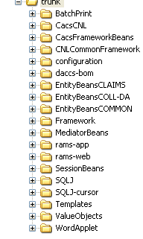
Hudson job rams-web-trunk polls every 5 minutes to see if a build needs to be done and the ear deployed to ramsdev deployment folder:
\\Epmtbea6\deployments\dcsdev1

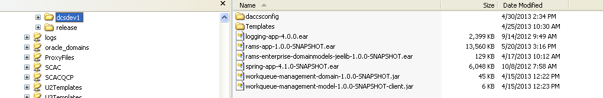
RAMS:

If static content (javascript; images; help files) have been updated added then the static zip file must be deployed to the ramsdev1 website
\\Epmtbea6\wwwroot\dcsdev1 web site

Spring-app-4.1.0-SNAPSHOT.ear is delpoyed as a shared library
So is rams-enterprise-domainmodels-jeelib-1.0.0-SNAPSHOT.ear
And workqueue-management-domain-10.0.-SNAPSHOT.jar
And workqueue-management-model-1.0.0-SNAPSHOT.jar

RAMS Developer Local parameters to use corr. Templates (DACCSWordApplet.jar)

website – rams1.dev.tgslc.org
share directory - \\epmtbea6\DCSTemplates

Also if -805 stored procedure on local PC have DBA check collection id on stored definition in the DB2 subsystem where the stored procedure is defined.

I set the collection id on the stored procedure definition which means that the collection id is not being set on your machine. The definition should have had it anyway.

Printing using Page Defs/Form Defs/Overlays:

To test use new overlay name and run compile of overlay to default overlay loadlib TGSYS1.PSEGLIB the formdefs and pagedefs are also stored here. If you do create a test overlay you must create a test formdef to reference the new overlay. That is the only way via JCL to refer to new overlay. Copy all types form defs , page defs and overlay from production source lib TGPROD.LED.SOURCE. all overlays member names begin with Ovxxxxxx and formdef member names begin with FDxxxxxx and page def member names begin with PDxxxxxx. The source also contains the JCL needed to compile the member. Use the //OUTPUT statement to refer to your test overlay using the test formdef. See example TGTEST.JPS.JCL(TVPCLTR2) and TGTEST.JPS.JCL(TDPCLTR2) to see how to use the formdef and overlay together for testing. The JCL from the production source is set up for Prod. Cntl. use so you will need to revise it for testing again see examples mentioned above details.
SAS

Here is how to take dashes out of a date and keep the numeric parts in format yyyymmdd

Data _null_;
set yourdata;
file print;
wherever_date=compress(put(date,yymmdd10.),"-");
put wherever _date $8.
;
Run;
SORT info:
Also as a very rough draft of TSAP sort guidelines, I have written the following:

- Sort work files are only needed when doing a sort, any Syncsort merge or Syncsort SORT FIELDS=COPY (which we use) steps do not need sort work files at all. Cathy helped me test this, and I know this is true.
- When coding sort work DD statements do the following a) always use CYL allocations, b) use UNIT=SYSALLDA (due to Pro-SMS), c) Don’t code a DSN clause (let the system create the name), d) for sorting < 4 MB of data code RLSE space clause, otherwise don’t
- When using the DYNALLOC sort clause don’t code sort work DD statements in JCL. My test of sorting the CC01 file of 779337 records showed this way was a Cpu second faster than coding sort work files in the JCL.
- To see if your sort work files were defined efficiently look for WER124I sort message, then look at USAGE FACTOR = value, if it is between 1.00 and 1.50 you are using very efficient sort work space. This is according to the Syncsort MVS Programmer’s Guide page 11.11. There is a formula for calculating the amount of sort work spaces needed. The formula as shown on page 11.9 of the Syncsort MVS Programmer’s Guide is as follows: A X B X 1.3 / C; where A is number of records to sort, B is the average record length, and C is the number of bytes in a cylinder on all 3390 devices this is 849,960. The result of the formula should always be rounded up to next whole cylinder value. So I tried sorting the CC01 file using this formula. The CC01 I used had 779,337 records, thus the formula for this sort looks like… 779337 X 507 X 1.3 / 849,960 = 604.33 round this to 605. I tested this value using 4 sort work files code in JCL each with a primary allocation value of 152 (605 / 4 = 151.2) cylinders and no secondary allocations. The sort worked and the WER124I message showed a USAGE FACTOR of 1.11, which is in the range of 1.00 - 1.50. I try the same sort using 151 cylinders primary allocation per work file and 50 cylinders secondary allocation per work file and obtained the same factor of 1.11.

These are guidelines which can change from release to release so don’t use them as absolutes with out any variations.
TAPE Info:
The tape INQ PSWD is USERINQ

TG WHSE: Internal TG application created to handle FTP, POP3 or other data transfers between TG and other entities like vendors (OCAs) or Lenders, School, Servicers (work for lenders), etc…

DB2 tables are used to store profile information about each entity so when TG receives or sends data to these entities TG knows how to handle them. Thus TG WHSE header and trailer data is added to each group of records to be transferred. This may be one per file or many per file. TG WHSE scans for these TG WHSE specific header and trailer in each file that is FTP’d to the TGWHSE server. Each entity has a production account with TG and a test account. For Vendor testing on MVSD the vendor account is like stagXXX01, where XXX is the vendor id like 010, 032, 031, etc…

The TGWHSE FTP site info is kept in DEVTST.CNTLCARD.SECURLIB. The most used JCL proc is WHB00103 and you must provide 3 parms PID, like 5001, 3001, etc, Vendors will be 5001 and Card is the PDS member to id the FTP server login id and password and Filetype ids the file name and the FTP command(s) to be executed. The Card will be in the DEVTST.CNTLCARD.SECURLIB (MVSD) or in TGPROD.CNTLCARD.SECURLIB (MVSP, this is protected and not viewable)

The File Type should be in DEVTST.ADVANTG.LIB (MVSD) or you can override the proc and use a DACCS specific control card lib.
USER / IT SHARED JCL DATASETs:
TGUSERDP.DPRV.SHARE.LIB DPRV
TGTEST.SHARE.LIB BDEV (Matt Steiner)

Weblogic 10.5 info:

Keep all domains together under C:\bea\user_projects\domains\
There are currently 2 domains defined on my machine…

Find Web app timeout for a weblogic server

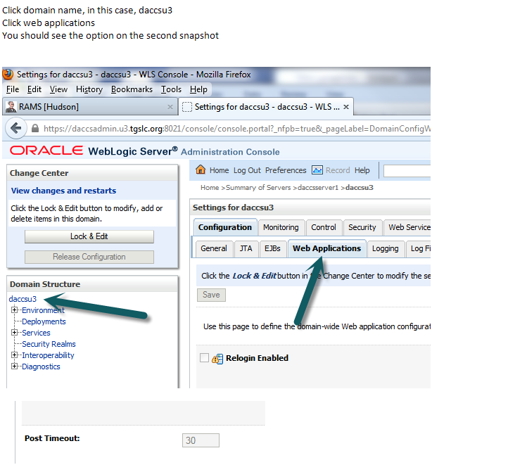
Xpediter:
CWCP – Expediter prefix for MVSP

CWCD – Expediter prefix for MVSD

SYSD – System prefix for MVSD
Xpediter/Xchange
Subsystem is CWXG




