Updated HW1.c

Valgrind Testing
Debugging/profiling with valgrind / kcachegrind to learn how to do so with C/C++ tools.

Original Program (No optimizations) for 1000x1000 board with 1000 iterations:
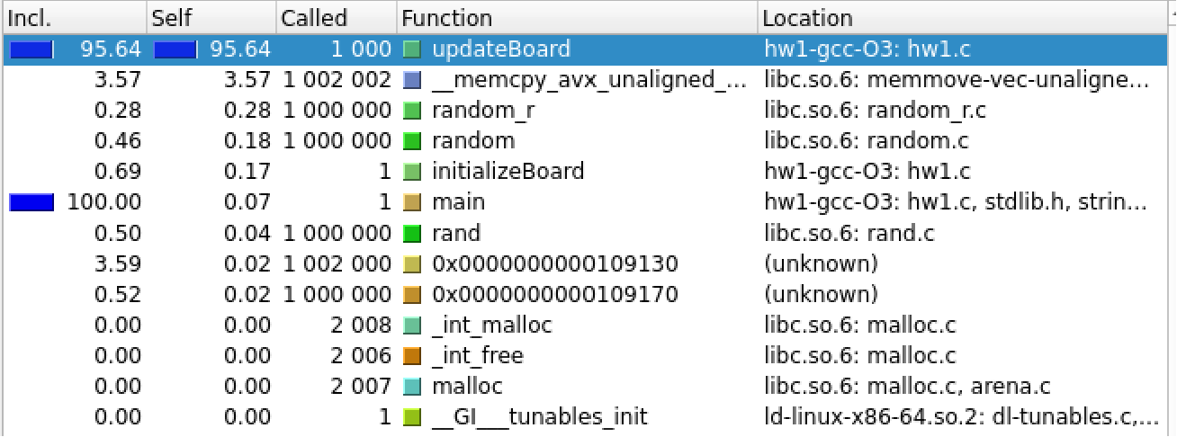
Total time with debugging: 10.081 seconds, without debugging: 1.378 seconds

Running with 5000x5000 board gives error:
==2550255== brk segment overflow in thread #1: can't grow to 0x483f000
Did not complete after 10 minutes of execution

Optimizations

Eliminate memcpy
First optimization, rather than using memcpy, we can swap pointers. This should help based on the valgrind result above.
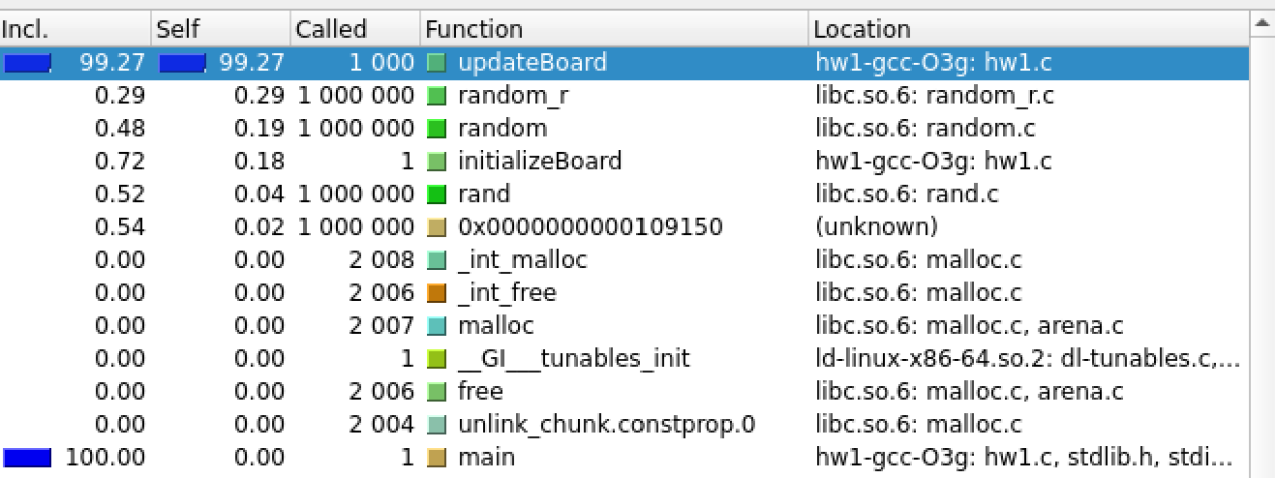
Total time with debugging: 8.261 seconds, without debugging: 1.074 seconds
This is an improvement, so we will keep it as we go forward. It appears the compiler can now inline the code since the function is not required and it can see there are no side effects.

Hardcode Neighbor Sum
Currently the neighbor sum is done via a double loop, but the positions to sum are known ahead of time. Rather than accumulate, we can hard code the positions to sum and treat as const value.
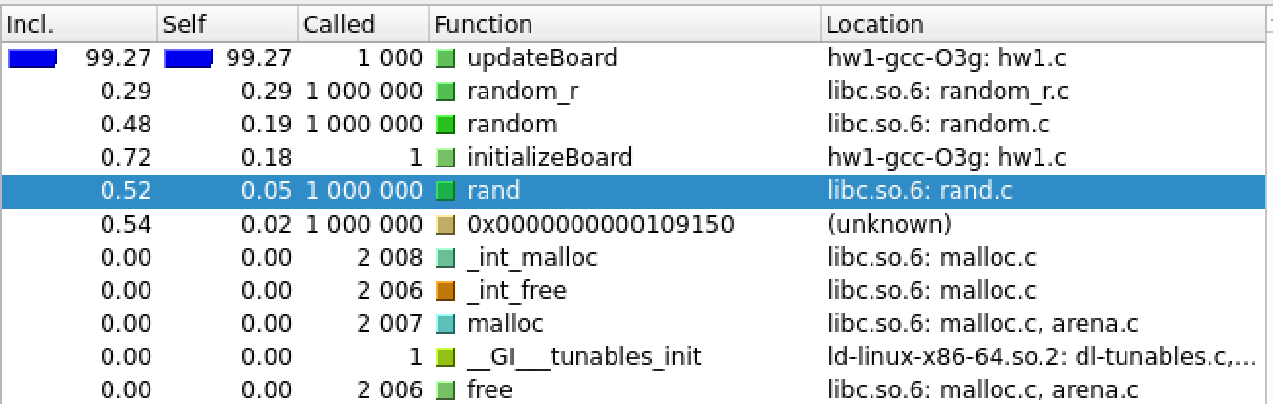
Total time with debugging: 8.252 seconds, without debugging: 1.030 seconds
This results in very little improvement, but it makes sense so we can keep it. Maybe a compiler macro can be used to generate the inline code if we need to sum up to second order. This reduces readability slightly so there is an argument against this.

Initialize Board without Conditional and as Continuous
Initializing the board without conditionals is good practice but only occurs once. Better would be to define the board arrays as continuous in our code, here we do both.

