1.You are given with an array arr which contains integer elements. Sort these elements in ascending order using insertion sort and print the 6th Iteration result.
Example:
Input:98,23,45,14,6,67,33,42
Output:6,14,23,33,45,67,98,42
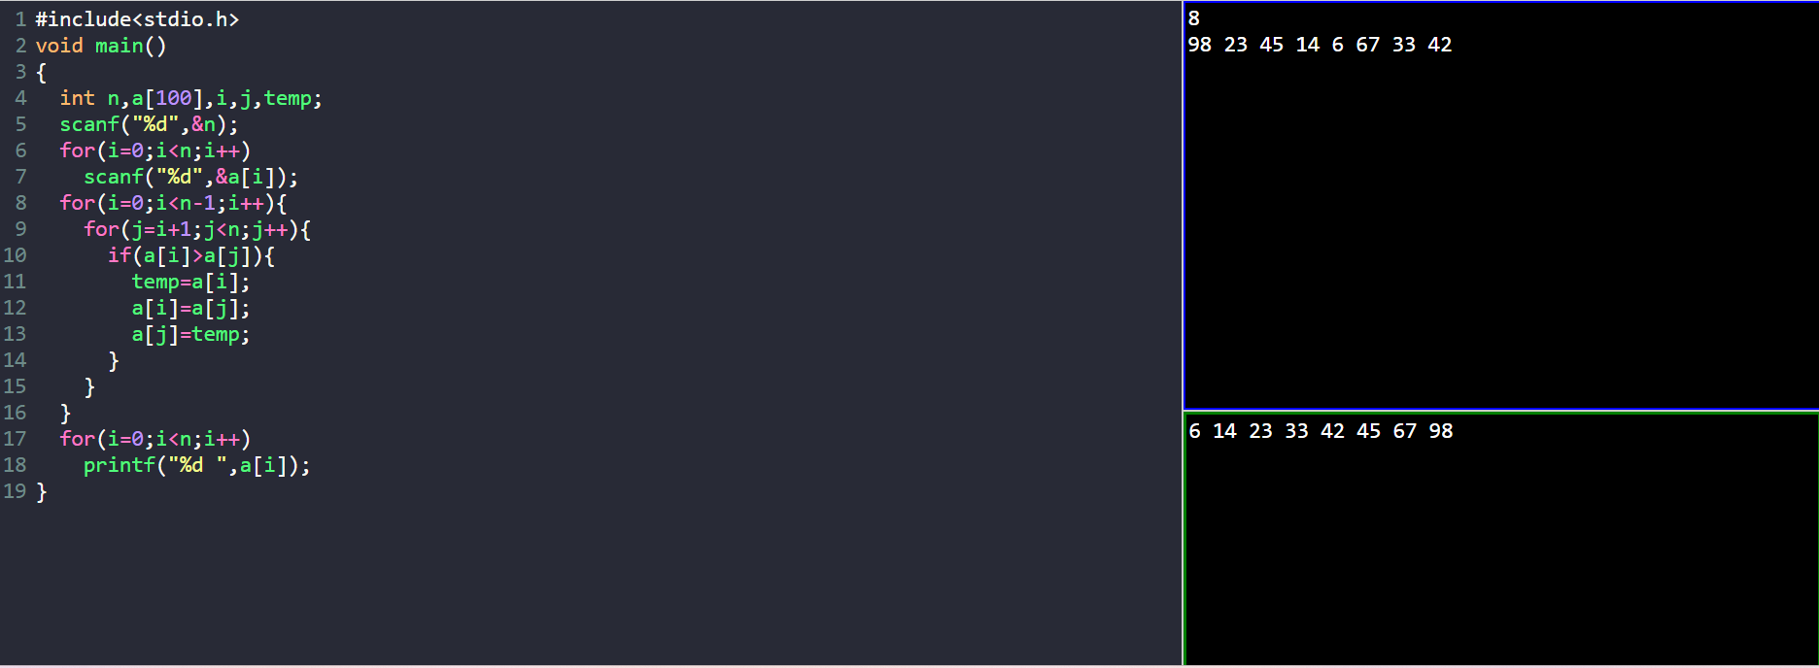

2.You are given an undirected graph G(V, E) with N vertices and M edges. We need to
find the minimum number of edges between a given pair of vertices (u, v).
Examples:
Input: For given graph G. Find minimum number of edges between (1, 5).

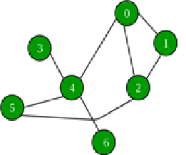
Output: 2
Explanation: (1, 2) and (2, 5) are the only edges resulting into shortest path between 1 and 5.
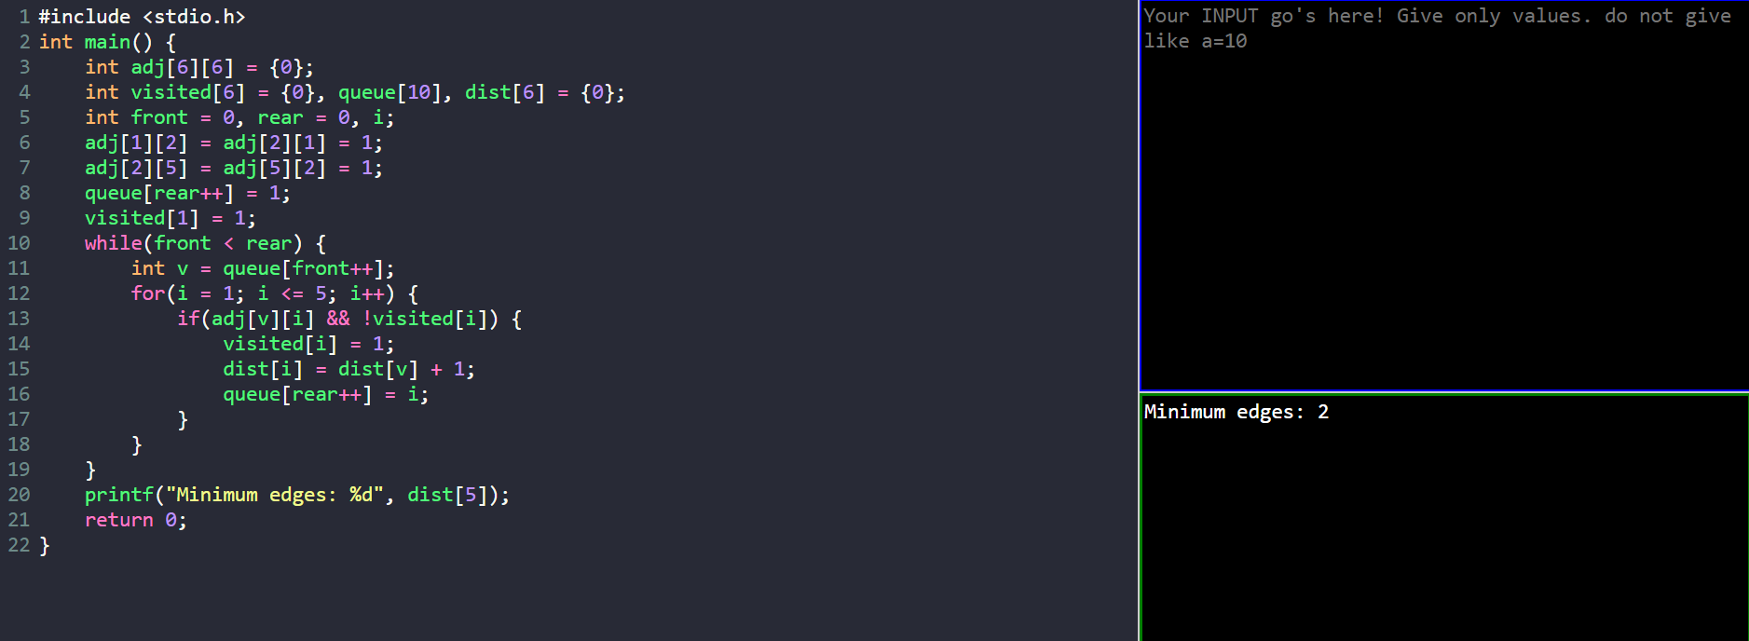

3.Given the head of a singly linked list, return number of nodes present in a linked
Example 1:
1->2->3->5->8
Output 5
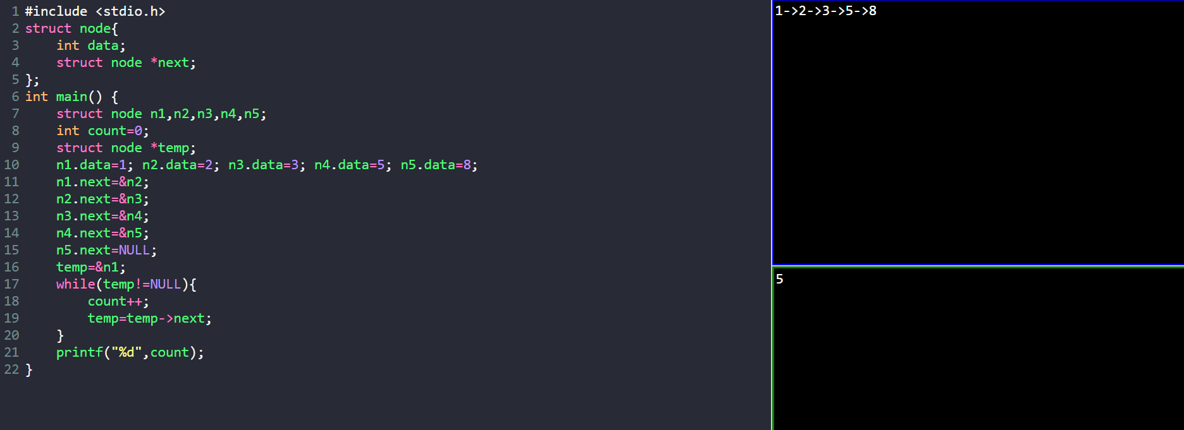

4. Given a number n. the task is to print the Fibonacci series and the sum of the series using recursion.
input: n=10
output: Fibonacci series
0, 1, 1, 2, 3, 5, 8, 13, 21, 34
Sum: 88
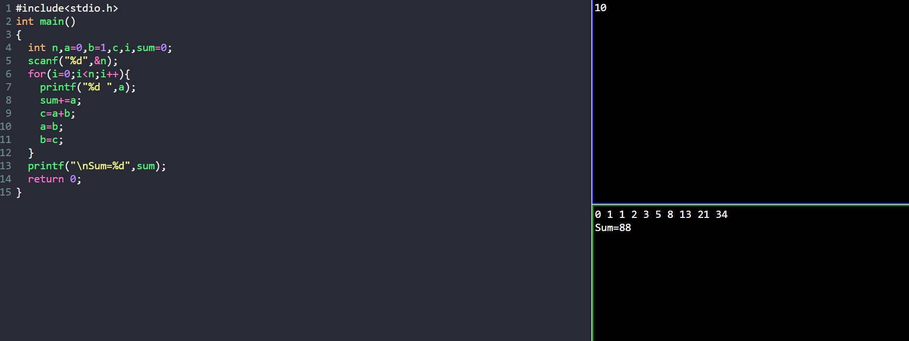

5. You are given an array arr in increasing order. Find the element x from arr using binary search.
Example 1: arr= {1,5,6,7,9,10}, X=6
Output: Element found at location 2
Example 2: arr= {1,5,6,7,9,10}, X=11
Output: Element not found at location 2
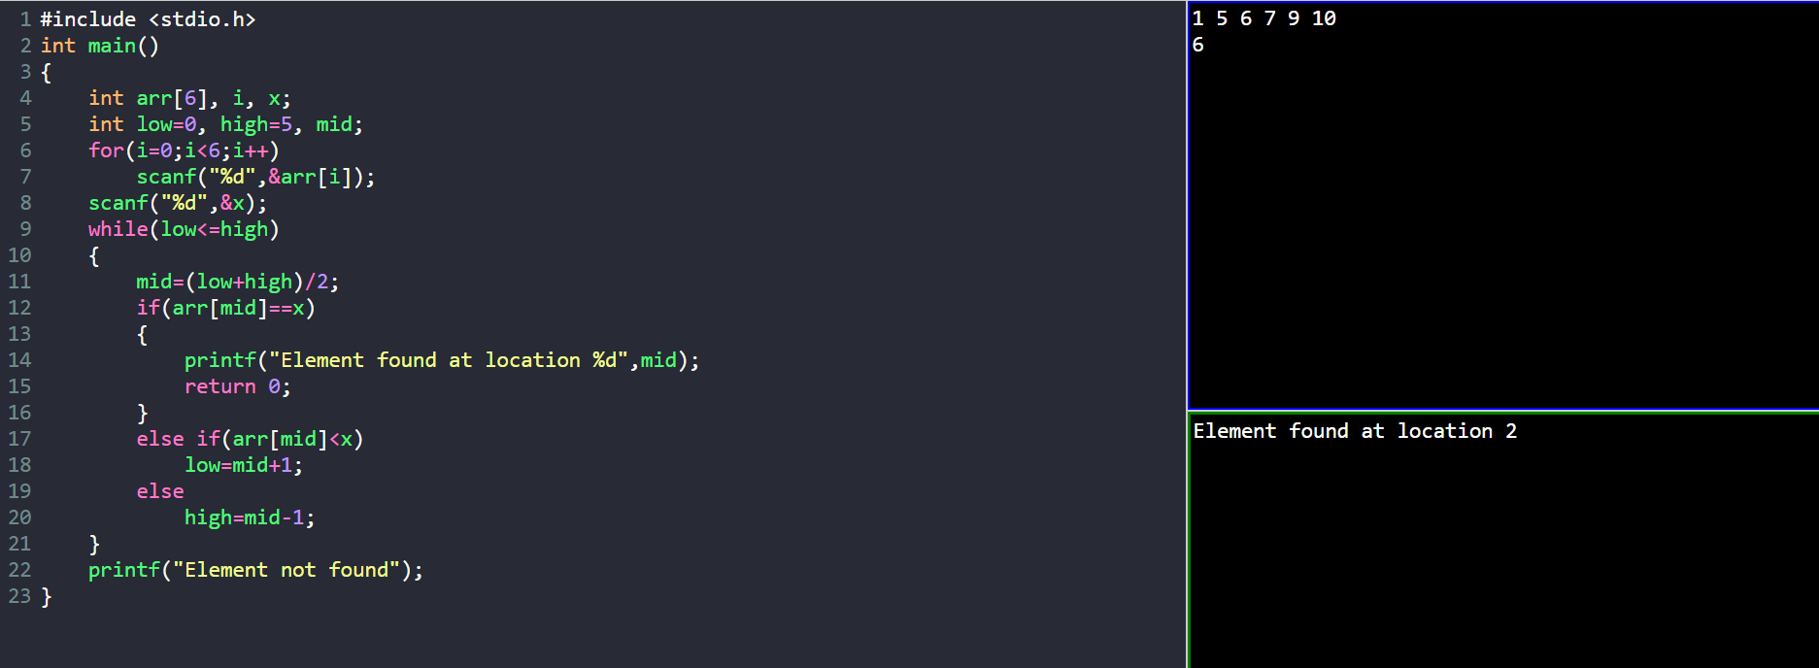

6. Write a program to traverse the nodes present in the following tree in inorder and postorder traversal
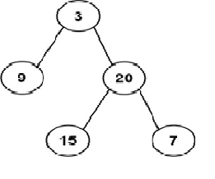
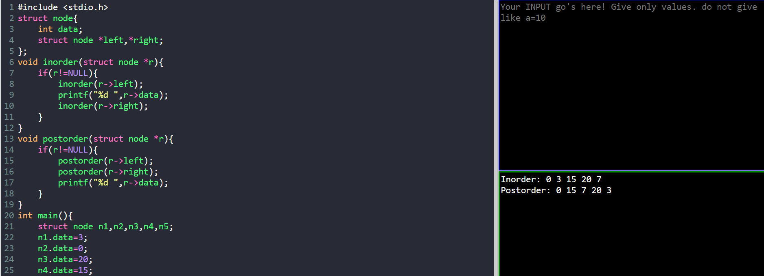

7. Given a string s, sort it in ascending order and find the starting index of repeated character
Input: s = "tree"
Output: "eert", starting index 0
Input: s = "kkj"
Output: "jkk", starting index : 1
Example 2:
Input: s = "cccaaa"
Output: "aaaccc", starting index 0,3
Example 3:
Input: s = "Aabb"
Output: "bbAa", starting index 0,2

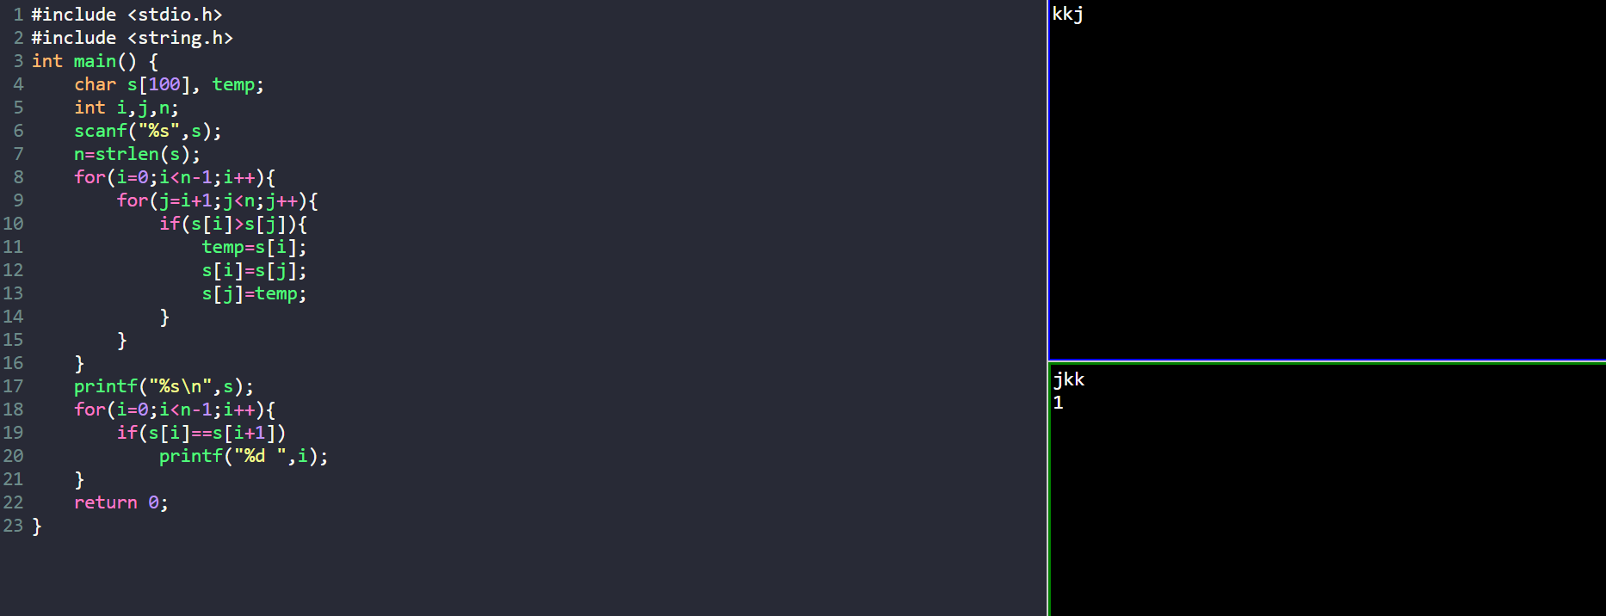

8.Given the head of a singly linked list, return true if it is a palindrome or false otherwise.
Example 1:
Input: head = [1,2,2,1]
Output: true
Example 2:
Input: head = [1,2]
Output: false
Input: R->A->D->A->R->NULL
Output: Yes
Input: C->O->D->E->NULL
Output: No
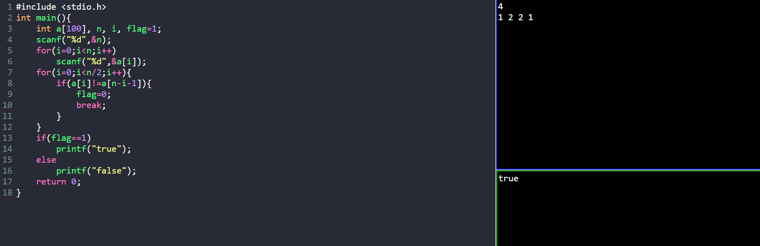
9. Given the root of a binary search tree and K as input, find Kth smallest element in BST.
For example, in the following BST,
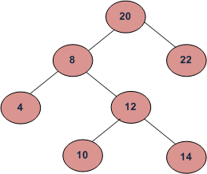
if k = 3, then the output should be 10, and
if k = 5, then the output should be 14.
Sample:
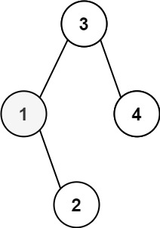
Input: root = [3,1,4, null,2], k = 1
Output: 1
Input: root = [5,3,6,2,4, null, null,1], k = 3
Output: 3

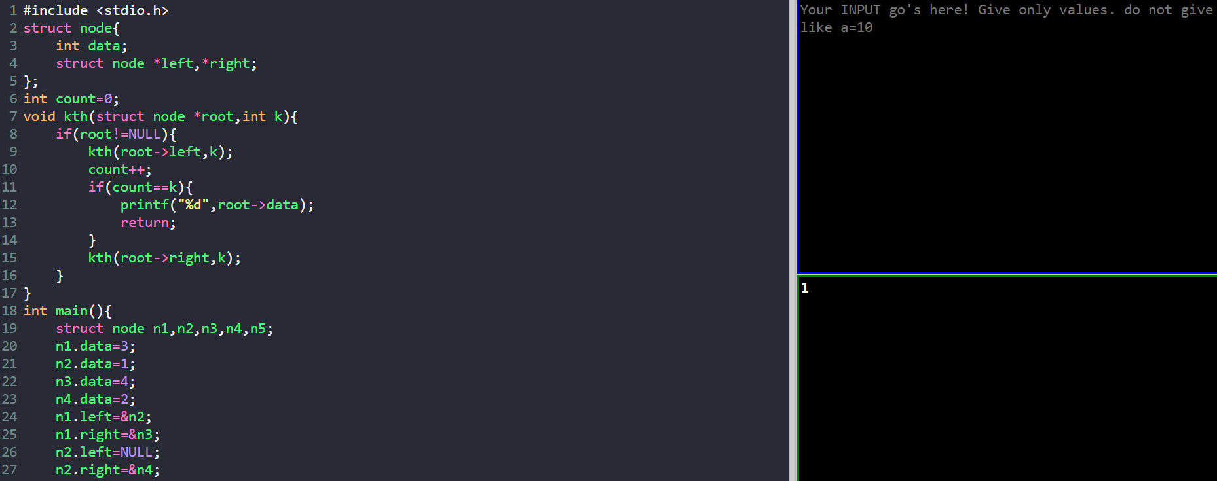

10. Given a string s, find the frequency of characters
Example 1:
Input: s = "tree"
Output t->1, r->1, e->2
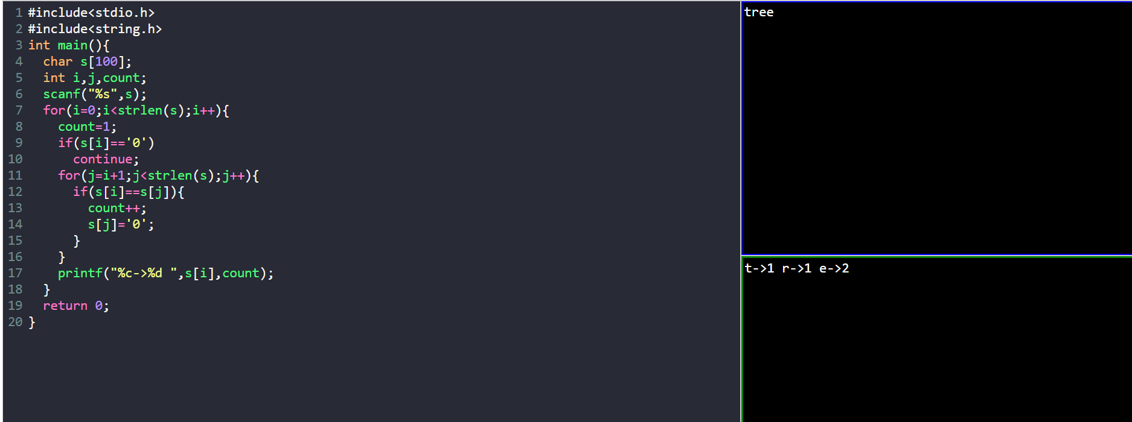

11. Given an unsorted array arr[] with both positive and negative elements, the task
is to find the smallest positive number missing from the array.
Input: arr[] = {2, 3, 7, 6, 8, -1, -10, 15}
Output: 1
Input: arr[] = {2, 3, -7, 6, 8, 1, -10, 15}
Output: 4
Input: arr[] = {1, 1, 0, -1, -2}
Output: 2
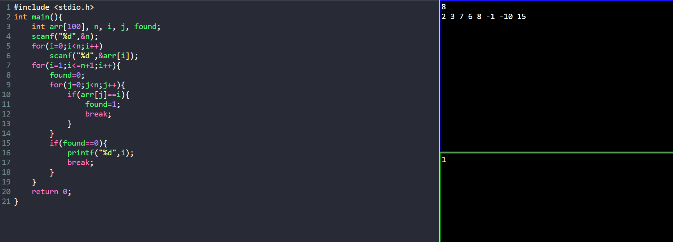

12. Given two integer arrays preorder and inorder where preorder is the preorder
traversal of a binary tree and inorder is the inorder traversal of the same tree,
construct and return the binary tree.
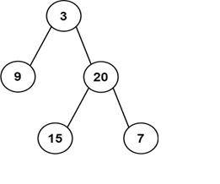
Input: preorder = [3,9,20,15,7], inorder = [9,3,15,20,7]
Output: [3,9,20, null, null,15,7]
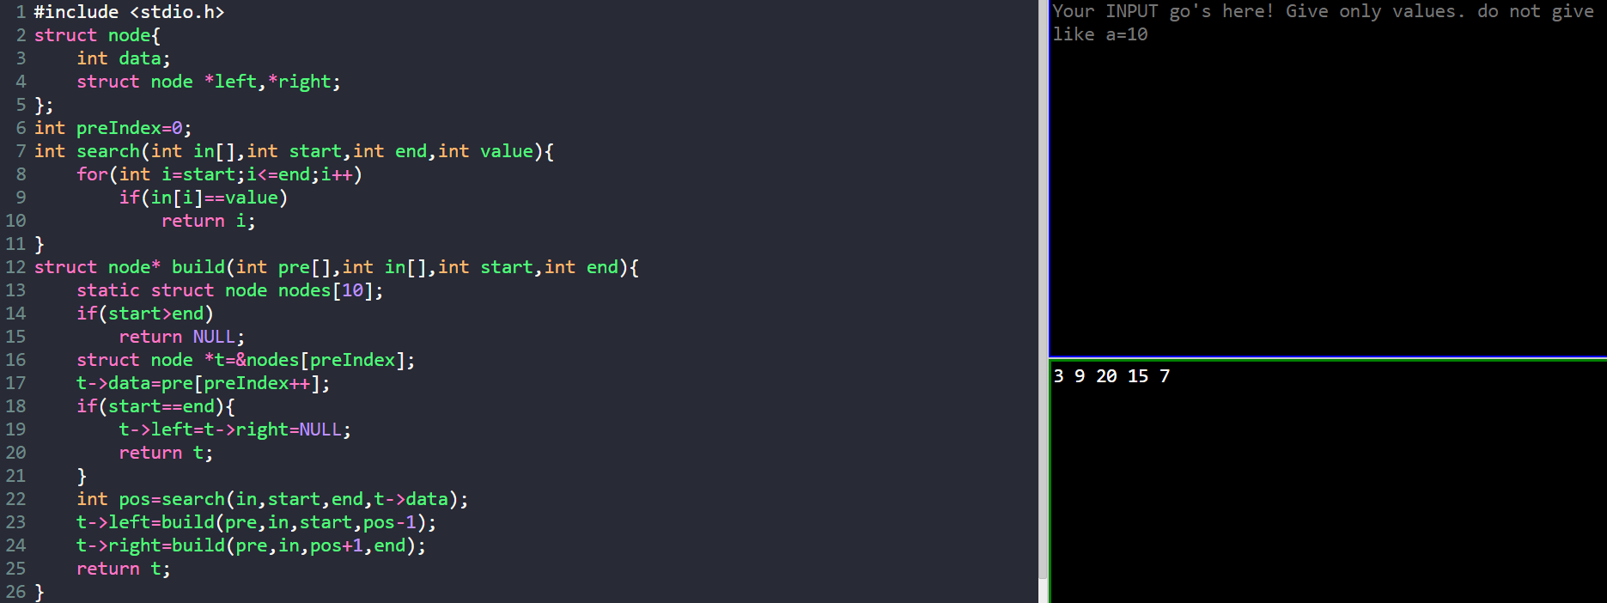

13. Write a program to create and display a linked list
Example 1:
Nodes: 6,7,8,9
Output: 6->7->8->9
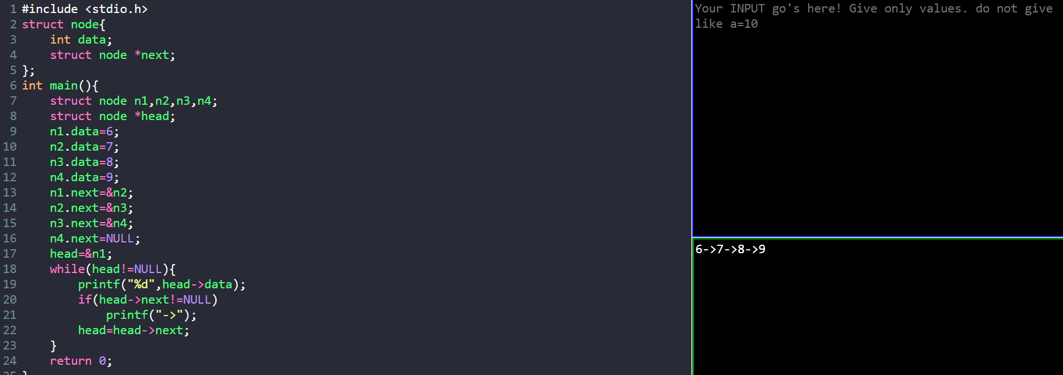

14. Write a program to sort the below numbers in descending order using bubble sort
Input 4,7,9,1,2
Output:9,7,4,2,1
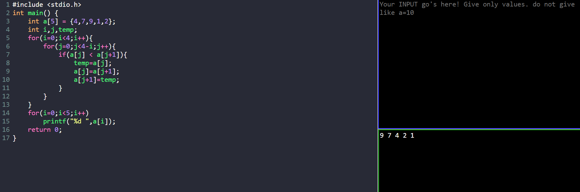

15. Given an array of size N-1 such that it only contains distinct integers in the
range of 1 to N. Find the missing element.
Input:
N = 5
A[] = {1,2,3,5}
Output: 4
Input:
N = 10
A[] = {6,1,2,8,3,4,7,10,5}
Output: 9
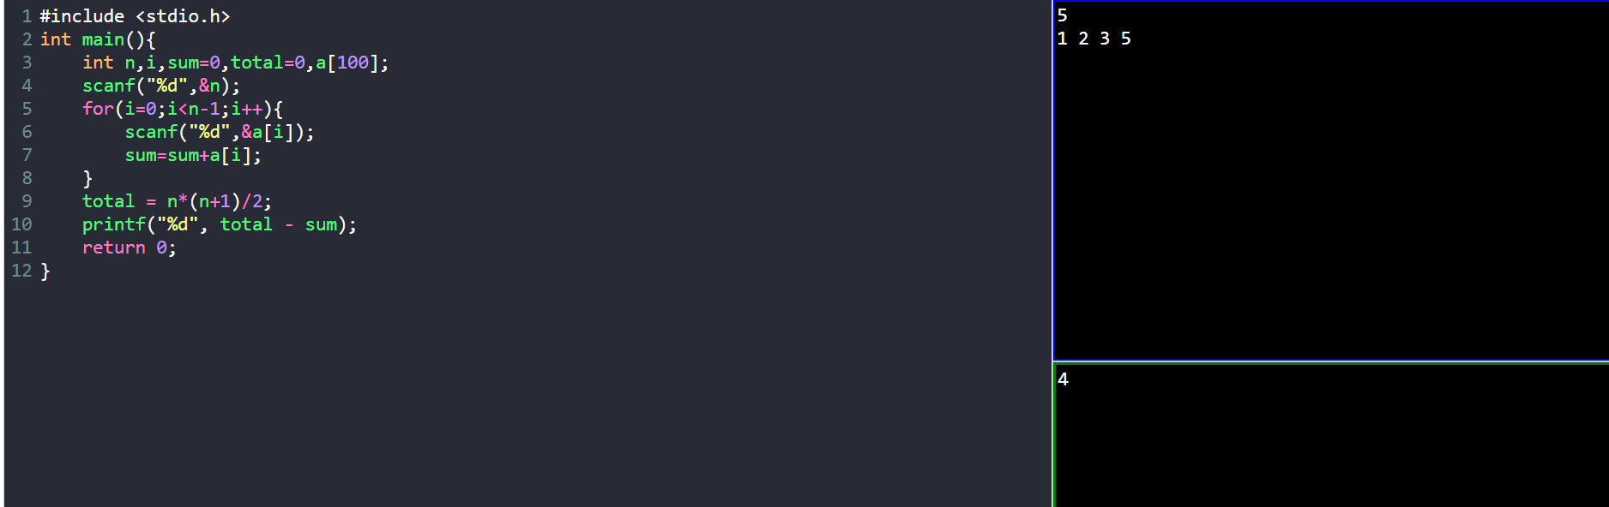

16. Write a program to find odd number present in the data part of a node
Example Linked List 1->2->3->7
Output: 1,3,7
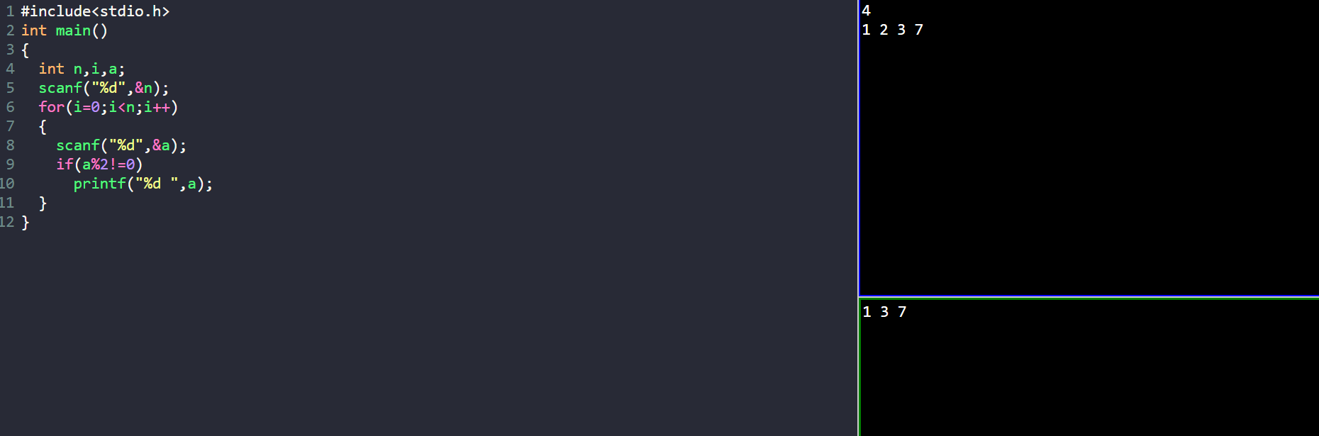

17. Write a program to perform insert and delete operations in a queue
Example: 12,34,56,78
After insertion of 60 content of the queue is 12,34,56,78,60
After deletion of 12, the contents of the queue: 34,56,78,60
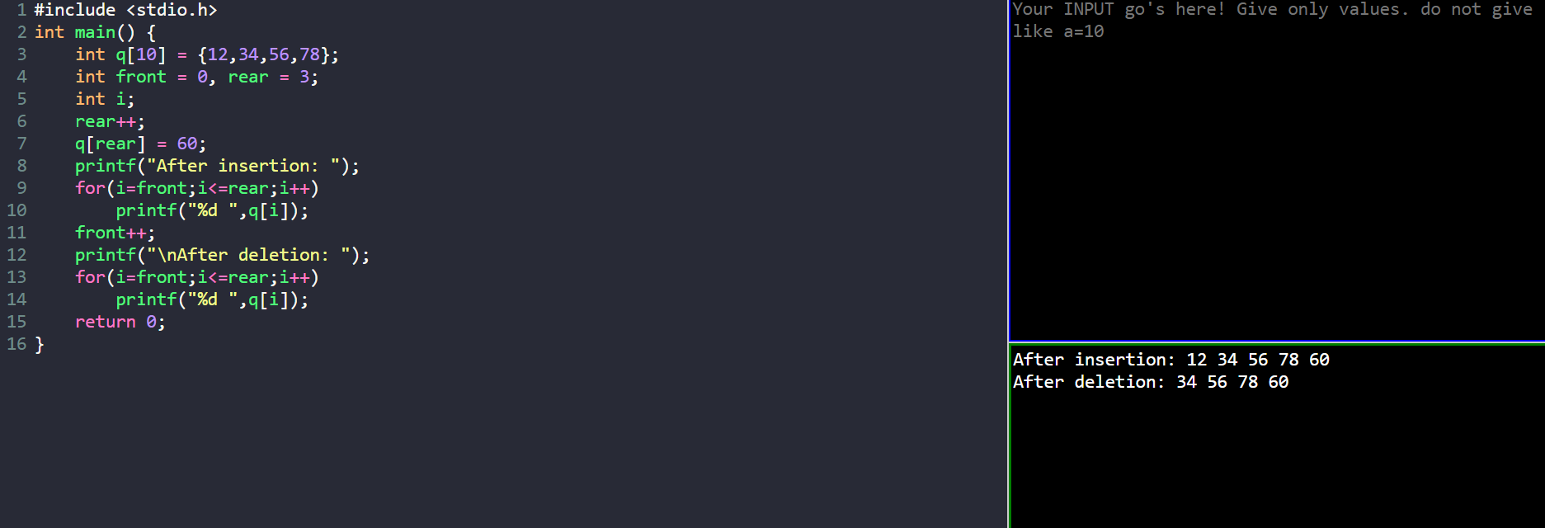

18. Given a string s containing just the characters '(', ')', '{', '}', '[' and ']', determine if the input string is valid.
An input string is valid if:
1. Open brackets must be closed by the same type of brackets.
2. Open brackets must be closed in the correct order.
Input: s = "()"
Output: true
Input: s = "()[]{}"
Output: true
Input: s = "(]"
Output: false
Input: s = "([)]"
Output: false
Input: s = "{[]}"
Output: true
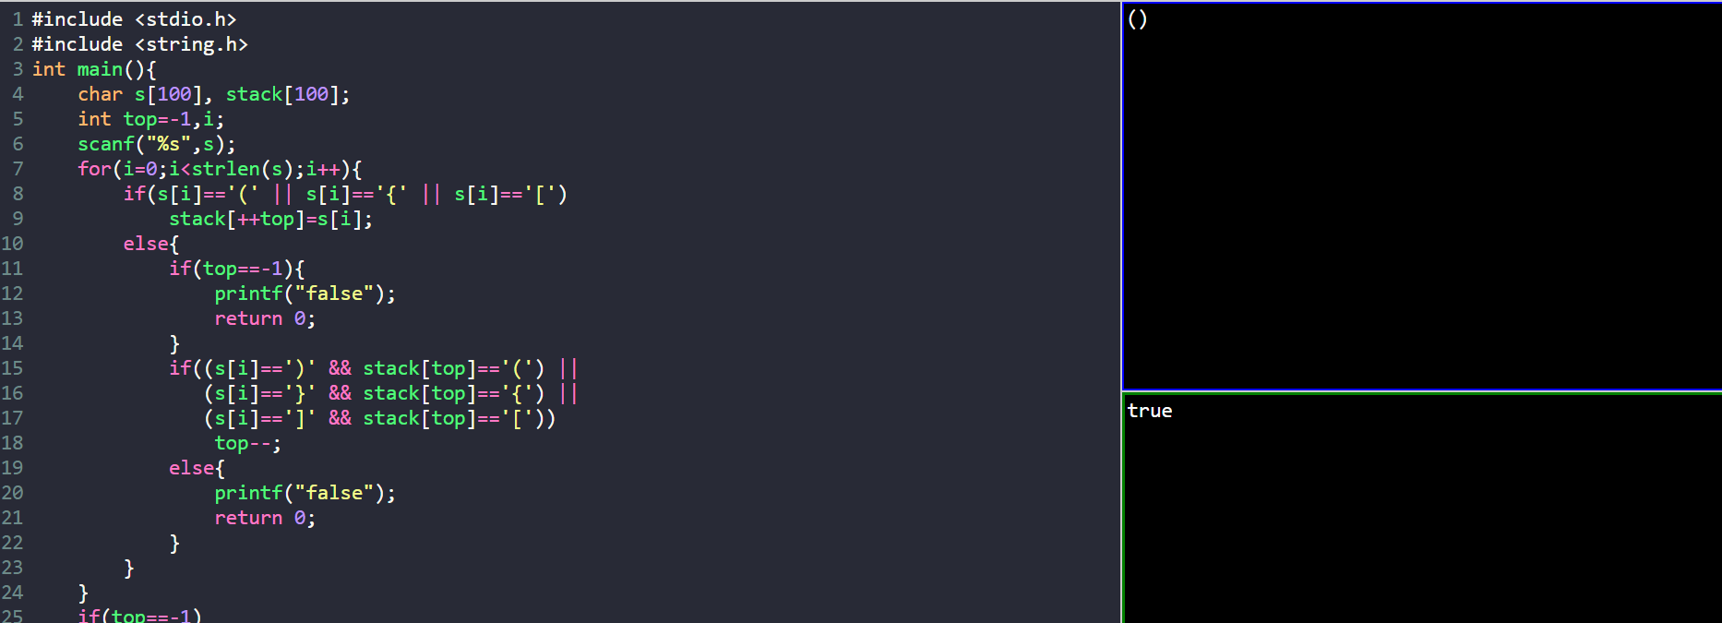

19. Given a number n, the task is to print the Fibonacci series and the sum of the series using Iterative procedure.
input n=10
output
Fibonacci series
0, 1, 1, 2, 3, 5, 8, 13, 21, 34
Sum: 88
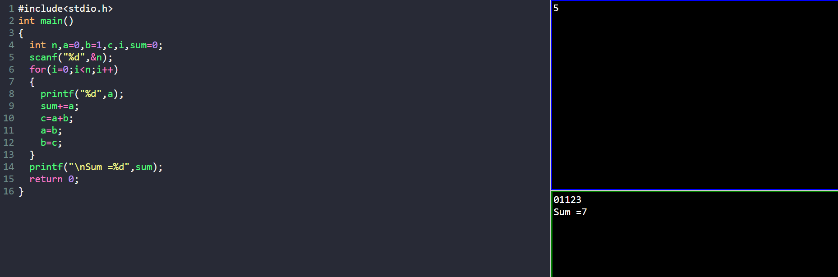

20. Given two strings needle and haystack, return the index of the first occurrence
of needle in haystack, or -1 if needle is not part of haystack.
Example 1:
Input: haystack = "sadbutsad", needle = "sad"
Output: 0
Explanation: "sad" occurs at index 0 and 6.
The first occurrence is at index 0, so we return 0.
Input: haystack = "leetcode", needle = "leeto"
Output: -1
Explanation: "leeto" did not occur in "leetcode", so we return -1.
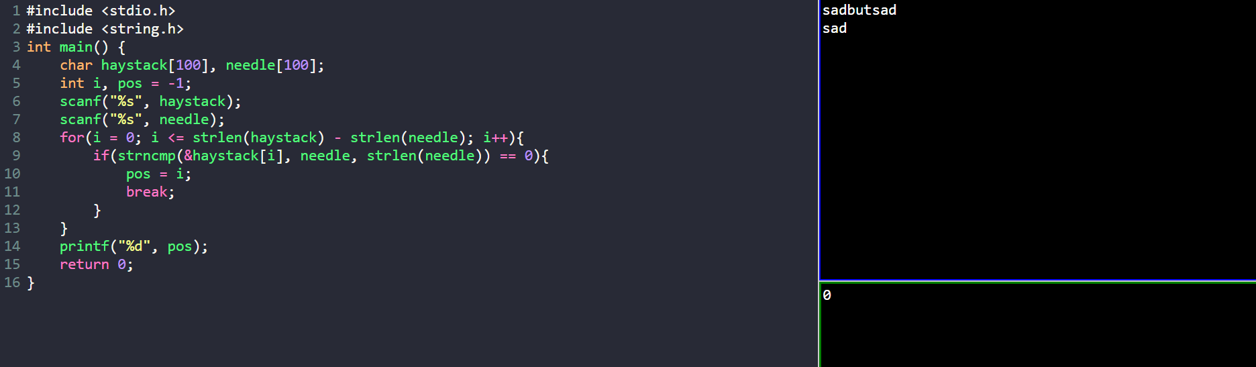

21. Implement a first in first out (FIFO) queue using only two stacks. The
implemented queue should support all the functions of a normal queue (push,
peek, pop, and empty).
Implement the MyQueue class:
1. voidpush (int x) Pushes element x to the back of the queue.
2. int pop () Removes the element from the front of the queue and returns it.
3. int peek () Returns the element at the front of the queue.
4. boolean empty () Returns true if the queue is empty, false otherwise.
Input
["MyQueue", "push", "push", "peek", "pop", "empty"]
[[], [1], [2], [], [], []]
Output
[null, null, null, 1, 1, false]
Explanation
MyQueue myQueue = new MyQueue();
myQueue.push(1); // queue is: [1]
myQueue.push(2); // queue is: [1, 2] (leftmost is front of the queue)
myQueue.peek(); // return 1
myQueue.pop(); // return 1, queue is [2]
myQueue.empty(); // return false
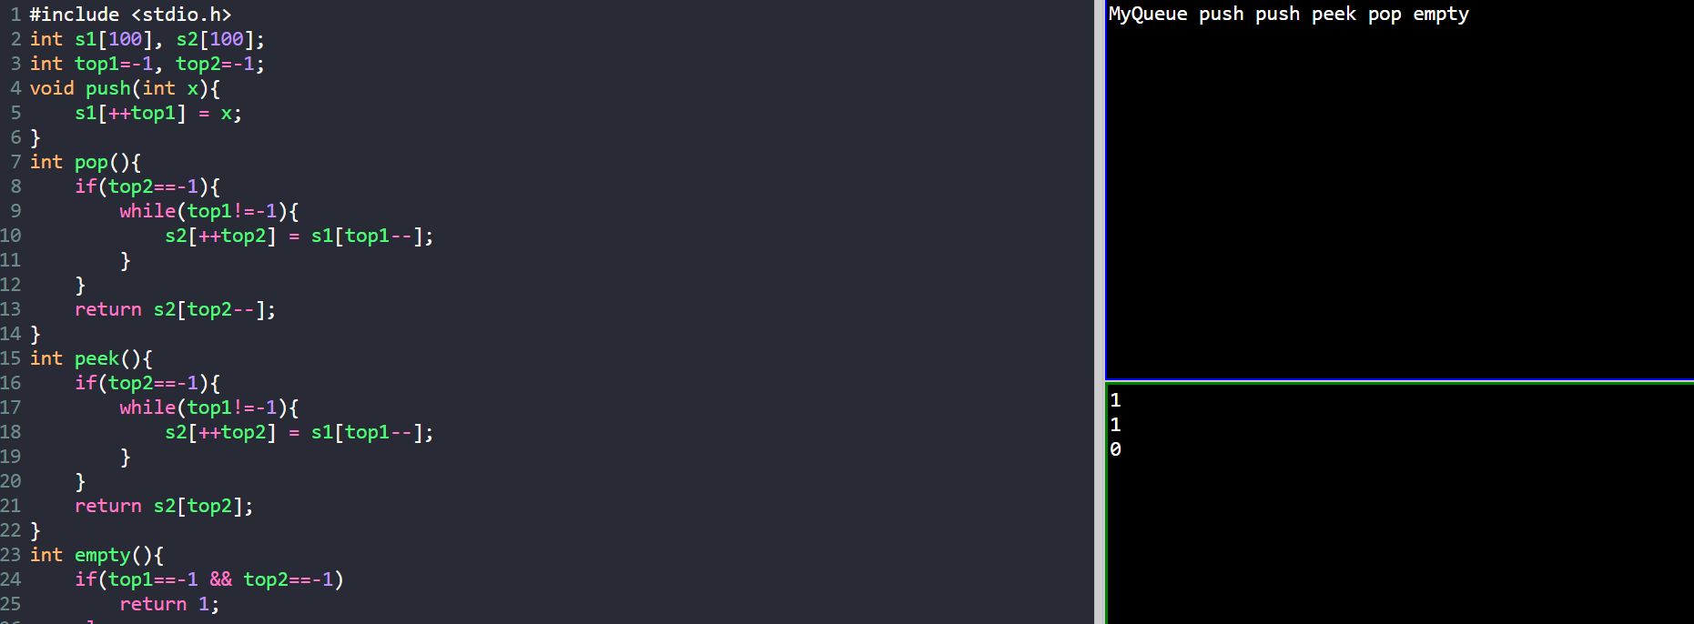
22. Given an array arr, sort the elements in descending order using bubblesort.
Arr= [9, 10, -9,23, 67, -90]
Output: [67,23,10,9, -9, -90]
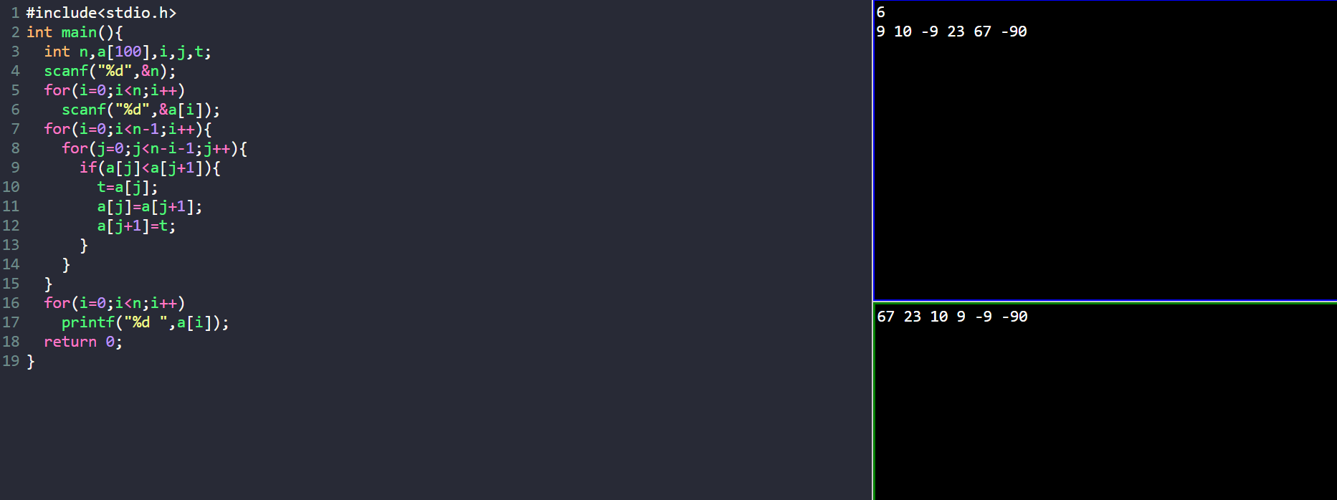

23. You have been given a positive integer N. You need to find and print the
Factorial of this number without using recursion. The Factorial of a positive
integer N refers to the product of all number in the range from 1 to N.
Input: N=2
Output: 2
Input: N=4
Output: 24
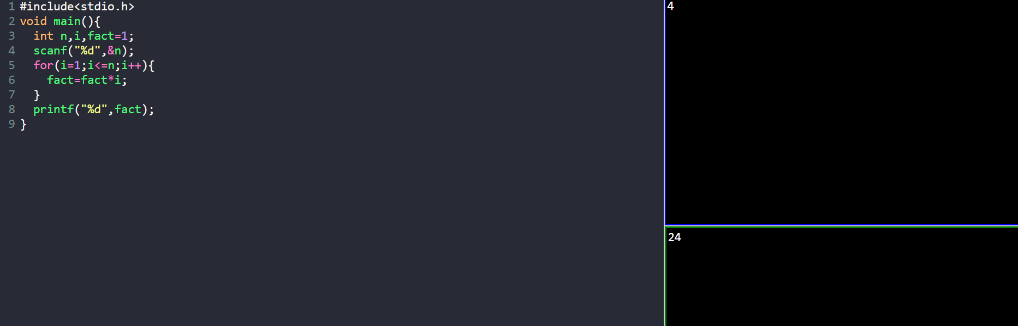
24. Given an array arr, sort the elements in ascending order using Bubble sort.
Arr= [9,10, -9,23,67, -90]
Output: [-90, -9,9,10,23,67]
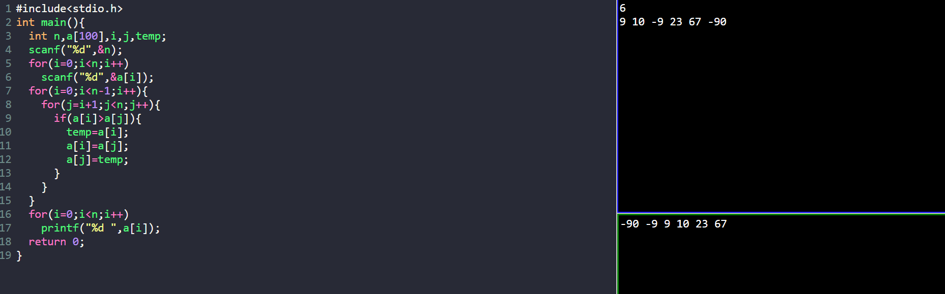

25. Design a stack that supports push, pop, top, and retrieving the minimum element in constant time.
Implement the MinStack class:
1. MinStack() initializes the stack object.
2. void push (int val) pushes the element val onto the stack.
3. void pop () removes the element on the top of the stack.
4. int top () gets the top element of the stack.
5. int getMin() retrieves the minimum element in the stack.
Input
["MinStack","push","push","push","getMin","pop","top","getMin"]
[[], [-2],[0], [-3], [], [], [], []]
Output
[null, null, null, null, -3, null,0, -2]
Explanation
MinStack minStack = new MinStack();
minStack.push(-2);
minStack.push(0);
minStack.push(-3);
minStack.getMin(); // return -3
minStack.pop();
minStack.top(); // return 0
minStack.getMin(); // return -2
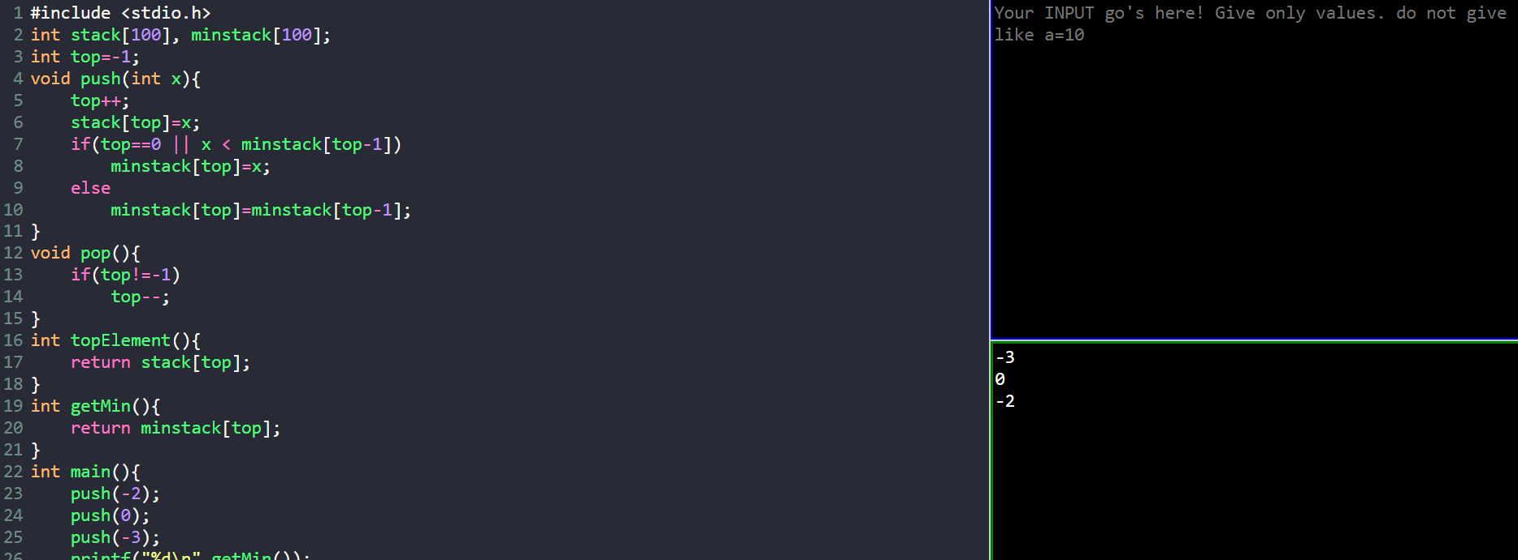

26. Find the factorial of a number using iterative procedure
Input: 3
Output: 6
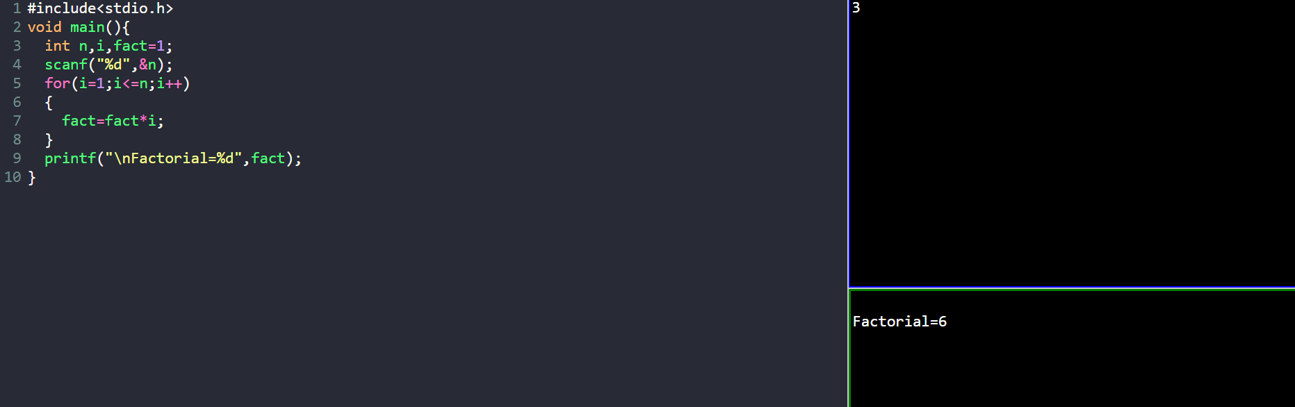

27. Given the head of a linked list, insert the node in nth place and return its head.
Input: head = [1,3,2,3,4,5], p=3 n = 2
Output: [1,3,2,3,4,5]
Input: head = [1], p = 0, n = 1
Output: [0,1]
Input: head = [1,2], p=3, n = 3
Output: [1,2,3]
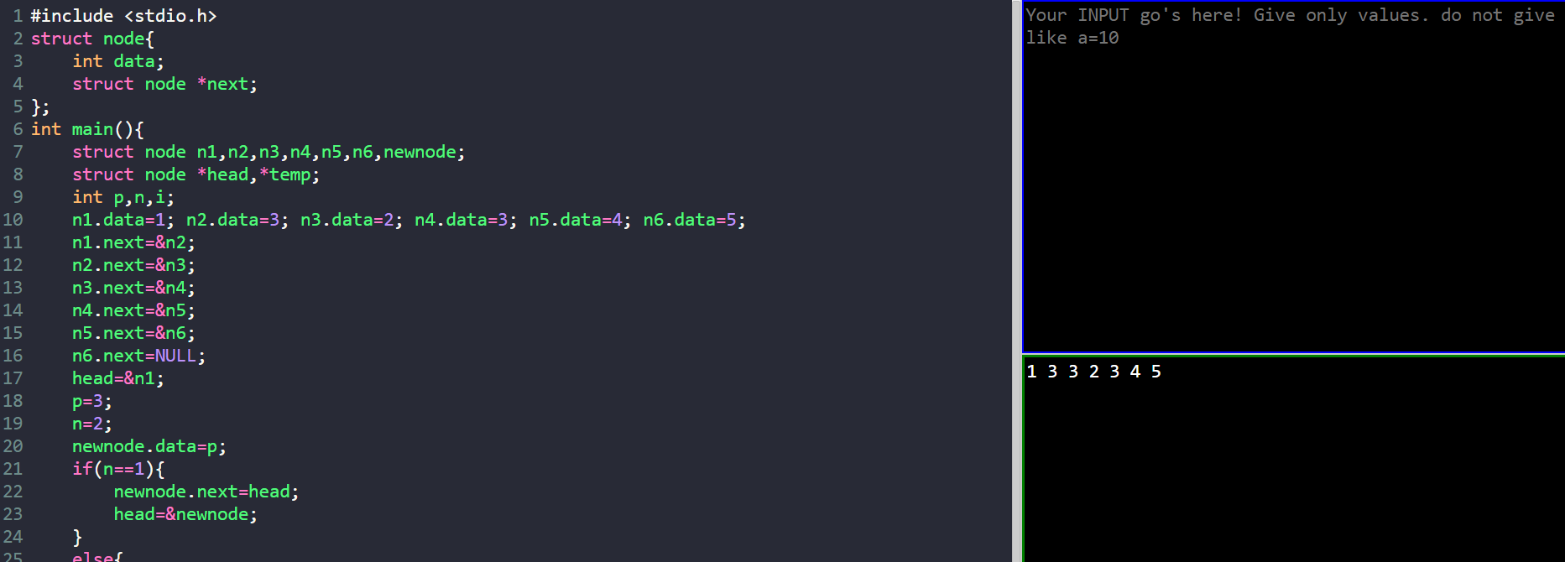

28. Given the head of a singly linked list and two integers left and right where left <= right, reverse the nodes of the list from position left to position right, and return the reversed list.
Input: head = [1, 2, 3, 4, 5], left = 2, right = 4
Output: [1, 4, 3, 2, 5]
Input: head = [5], left = 1, right = 1
Output: [5]
Input: [10,20,30,40,50,60,70], left = 3, right = 6
Output: [10,20,60,50,40,30,70]
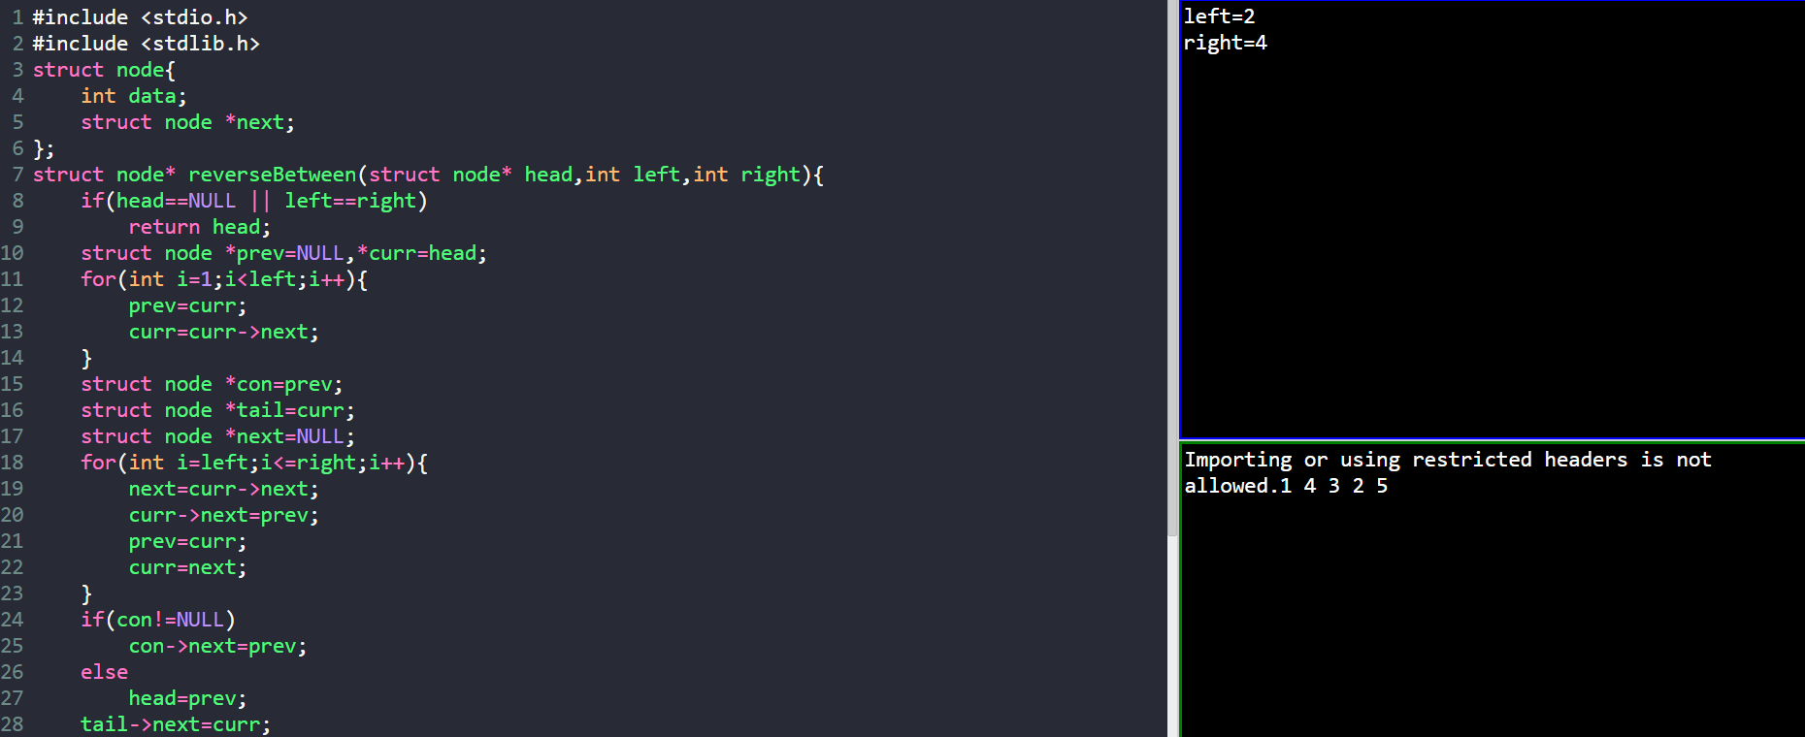

29. You are given with the following linked list
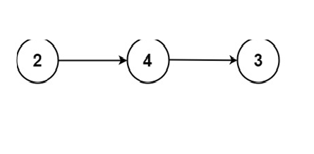
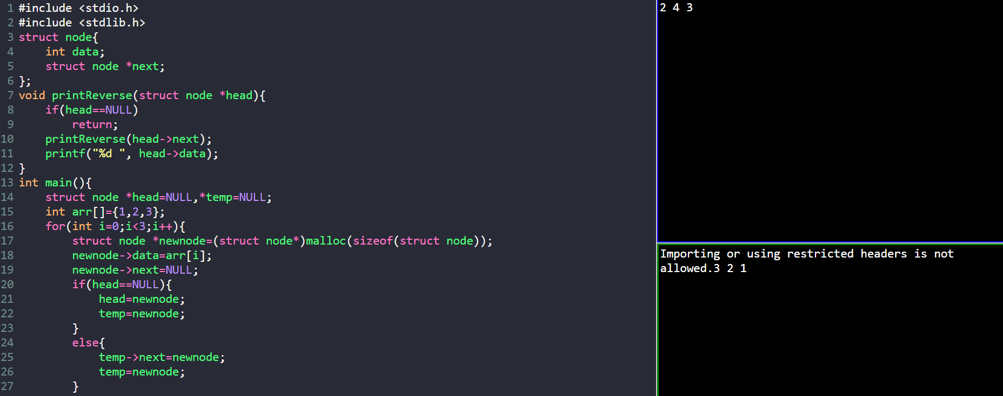

30. Given two sorted arrays nums1 and nums2 of size m and n respectively, return the sum of these two arrays
Example 1:
Input: nums1 = [1,3], nums2 = [2]
Output: 6
Example 2:
Input: nums1 = [1,2], nums2 = [3,4]
Output: 10
