In our class demonstrations we went over the “http” package available from pub.dev. We used it in our Weather App, to get weather data from the OpenWeather API.

We also went over how to use flutters “ListView” and “ListTile” widgets. These demonstrations are available on github, as part of “lab_4_begin”, (available at github.com/robbinl/flutter_2019fall_labs)

Your assignment is to take the project called “lab_4_begin” and add to it, the functionality described below. A screen shot of the running “lab_4_begin/lib/main.dart main() => MyAppLab4()”, is shown below. Notice, that there is no functionality, just a blue button in the lower right corner.

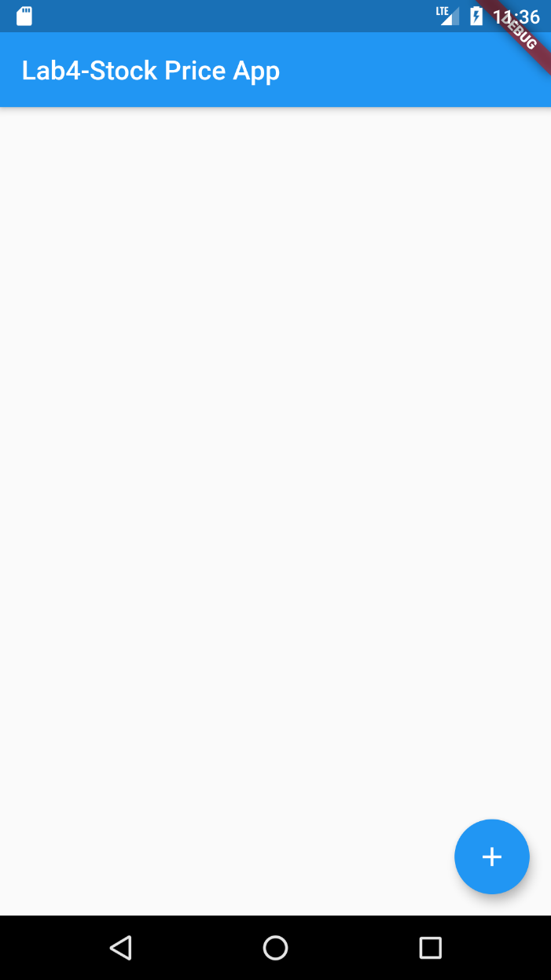

When the user taps the blue button, use the “showDialog method from flutter/material.dart in combination with an “AlertDialog” widget and a TextField widget, to present a dialog box that will allow the user to enter a stock symbol. Also include an “OK” and “Cancel” FlatButton, in the dialog box.

When the user taps the “OK” button you must use Navigator.pop, to make the dialog box die, but only after you have saved the symbol.

Then you are to use the http package to connect to “iexcloud.io” and get the stock data by a stocks ticker symbol that the user entered. This only works for US stocks. For example, “aapl” is Apple Inc.

A TODO list has been placed in the code to help you solve the http problem. The url and apiToken are given to you, in the file stock_service.dart. All you have to do is decode the response.body using jsonDecode from ‘dart:convert’, and return the decoded json to the calling method, which is in main.dart. This will be very similar to what we did in the Weather app.

Then you are to dig out the symbol, companyName, and latestPrice, for the stock and create a new object of the class Stock, also given to you in the file stock.dart. You are to add this stock to a list of Stocks.

You are to add the new Stock to the StockList using ListView.builder, a widget from flutter. This widget will display the data as shown in the screen shots below. Just the frame work of this is given to you. You have to go to flutter.dev and read about how to use ListView.builder to solve this problem.

Every time the blue button is pressed, the user can enter another stock symbol, in small or Caps, and the app will add it to the StockList, and present the data on the screen.

