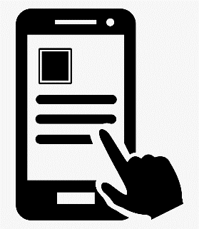

**Mobile app Development Proposal – RESBA**

**(Restaurant Budget App)**

**Prepared for:**

Mahbub Murshed

Mobile Application Development: SODV3203

mmurshed@bowvaley college.ca

**Prepared by:**

Texghn Gordon - 399485

Bow Valley

t.gordon485@mybvc.ca

The world we once knew has change and is now constantly evolving right in front of our eyes. Technology has brought things right to our fingertips through smart devices and has a result we now have an opportunity to be more efficient while being productive. With just one click of a button a user can see what is happening on the other side of the globe. The user can also purchase a product while watching his or her favorite YouTube channel. Multitasking has given us the option to get a lot done in each period. The more technology increases the more developers creates application to appease the users so that everyone can be happy while taking full advantage of technology.

**App Overview**

My goal is to create an app that will utilize the device full functionality, giving you the user a wonderful user experience. The RESBA (Restaurant Budget App) application was created for users that need help decide on which restaurant they want to go on a given day. It also provides the option for those that what to go out for dinner but wants to stay within a specific budget. The app will work with your geolocation to determine which restaurants are close to you and let you know if they are open. You can navigate through the app and chose a restaurant of your liking and view their menu and prices. User can also choose to have the food deliver to their place of resident.

**Features**

* Users can login or logout when choose to.
* Users can view all restaurant in and around their location.
* Users can search by meal price.
* Users can get notification of meal deals at restaurants in the geolocation area.
* User can set their preference of what they are been notified

**Wireframe**

