The secret key value need to be a sha 256 encrypted value of the text which is a concatenation of 3 values,
- Api_key
- request_code
- Api_secret
For example, if following are the values,
Field name | value
Api_key | 18efcbf33b13434d98928d06106b85
request_code | 16f5673c4018ff20.132d5a6daacaeb11ddcdb95abe68bb8ea646f5d7d7d46
Api_secret | 2022.7af7d7232dcf4bc39c4ddfb22d388813ab1c7

Now you need to concatenate all the above three values Api_keyrequest_codeApi_secret
For the above example the concatenated value will be
18efcbf33b13434d98928d06106b8516f5673c4018ff20.132d5a6daacaeb11ddcdb95abe68bb8ea646f5d7d7d462022.7af7d7232dcf4bc39c4ddfb22d388813ab1c7
Now, go to https://emn178.github.io/online-tools/sha256.html
Enter the above concatenated value in the input box and you will get the sha 256 encrypted value in below text box
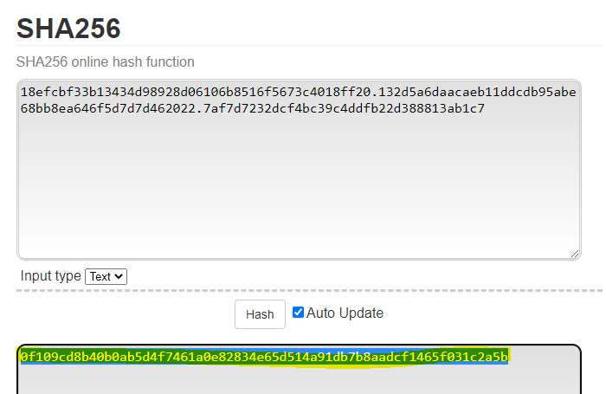
Now in your call to get the token, send the json string as below,
{
"api_key":"18efcbf33b13434d98928d06106b85" ,
"request_code":"16f5673c4018ff20.132d5a6daacaeb11ddcdb95abe68bb8ea646f5d7d7d46",
"api_secret":"0f109cd8b40b0ab5d4f7461a0e82834e65d514a91db7b8aadcf1465f031c2a5b"
}

You will now get the token in response

