2018年第一学期

《软件工程概论》 平时作业(4-5章)

**开课学期： 2018年第一学期（春季）**

**课 时： 32**

**学 分： 2**

**课程属性： 必修**

**考核方式：考试 闭卷笔试 70%**

**课程作业 30%**

**教学班级： 1613011 1613013**

Chapter 4 Capture the Requirements ?

Part 1 Fill Blanks

1． Expression, software behavior

2．Elicitation, analysis, specification, validation

3. clients, customers, users, domain experts, market researcher, lawyers or auditors, software engineers.

4. stakeholders wants and needs, domain models, current situation models,

Reusable requirements, suggested type of requirements, existing

documents, current organization and systems.

5. functional requirements, quality (non-functional)requirement, design constrains, process constrains

6. requirement definition , requirement specification.

7. entity, attribute, relation

8. process, data flow, data store, actor

9. boundary

10. throwaway prototype, evolutionary prototype

Part 2 Brief Description and Exercises

1. See the Page 146-147 ( Fourth Edition)
2. See the page 148-149 ( Fourth Edition )
3. See the page 158 ( Fourth Edition )
4. See the page 192 ( Fourth Edition )
5. Exercise 12

UML use-case diagram for an on-line telephone directory.

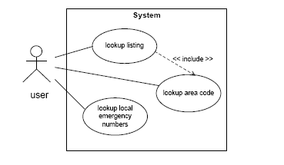

1. Exercise 13

Data-Flow diagram to illustrate the functions and data-flow For an on-line telephone directory system

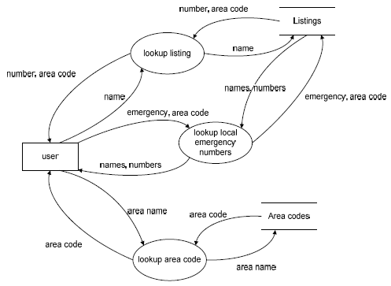

Chapter 5 Design the Architecture

Part 1 Fill Blanks

1. resulting
2. components, connectors, constrains
3. filter,pipe.
4. Server, client
5. peer
6. subscribing, pubulish
7. central data store, data accessing

Part 2 Brief Description and Exercise

1. See the Figure 5.4 and its description..
2. The answer is figure 5.9 in the page 243( Fourth Edition)
3. (1) Piper and Filter:

MIS system of XIDIAN University

(2) Client/Server:

Most transaction processing system(事务处理系统)

Eg. Bank System

(3) Peer to Peer:

Military Individual equipment system

(4) Publish Subscribing:

1. Field ( Reiss 1990),
2. Subscribed Weather Forecast

(5) Repositories

Intelligence Diagnostic and Cure System

(6) Laying

(1) Unix Operating System

(2) OSI model for network communication

End of reference answer for Chapter 4-5.