2018年第一学期
《软件工程概论》平时作业(1-7章) 参考答案

开课学期： 2018年第一学期（春季）
课 时： 32
学 分： 2
课程属性： 必修
考核方式：考试 闭卷笔试 70%
课程作业 30%
教学班级： 1613011 1613013

Chapter 1 Why Software Engineering ?

Part 1 Fill Blanks

1．Programs (Instruction), data (structures), documents
2．systematic, disciplined, measureable
development, operation, and maintenance
3. analyzing synthesizing
4. the software product, the process of development software product,
in business environment
5. customer， client, user
6. analysis, design, construction, verification, management

Part 2 Brief Description

- the requirement analyst work with customer, break down what the customer wants into discrete requirement.
- the designer generate the system-level description of what the system is to do
- the programmer write line of code that implement what requirement specify.
- the tester catches faults that programmer overlook
- the trainer shows users how to use the system

Chapter 2 Modeling the Process and Life Cycle

Part 1 Fill Blanks

- process, steps, activities, constraints, resources
2．Product, lifecycle
3. conception, implementation, delivery, use, maintenance
- requirement analysis and definition, system design, program design, program implementation, unit testing, integration testing, system testing, system delivery, maintenance
- requirement analysis, system design, program design, coding, unit & integration testing, system testing, acceptance testing ,operation & maintenance
- validation, verification
- iteration , rework
- risk, risk control
- prototype

Part 2 Brief Description

- Advantage
As described in the bottom paragraph of test book P49.
Disadvantage of the WatterFall model
See the PPT of this section.

Chapter 3 Planning and Managing the Project

Part 1 Fill Blanks

- Project schedule, phases, tasks , activities
2．Time line
- Items
- Activity, milestone
- Gantt chart
- Real time ,actual time ,available time, slack time, float time, available time , real time
- CPM
- schedule

Part 2 Brief Description
- See middle items in the Page 83 of the test book.( four types of deliverable)
- See middle items in the Page 96 of the test book.( ten aspects)
- Exercise 2
No | Activity leading to | Precursors
1 | A
2 | B | A
3 | C | A
4 | D | A,B
5 | E | A
6 | F | A,C
7 | G | A,E
8 | H | A,C,E,F,G
9 | I | A,B,D
10 | J | A,B,D,E,G,I
11 | K | A..J
12 | L | A..K

No | Activity leading  From..to.. | Earliest Start  Time | Latest Start Time | Slack
1 | A..B | 1 | 1 | 0
2 | B..D | 4 | 4 | 0
3 | B..I | 4 | 5 | 1
4 | D..I | 9 | 9 | 0
5 | I..J | 11 | 11 | 0
6 | A..C | 1 | 5 | 4
7 | C..F | 6 | 10 | 4
8 | F..H | 9 | 13 | 4
9 | A..E | 1 | 4 | 3
10 | E..G | 5 | 8 | 3
11 | G..H | 8 | 14 | 6
12 | G..J | 8 | 11 | 3
13 | H..K | 10 | 14 | 4
14 | J..K | 13 | 16 | 3
15 | J..L | 13 | 13 | 0
16 | K..L | 15 | 18 | 3
17 | L | 21
Critical Path: A-B-D-I-J-L 20 days
- Exercise 3
Critical Path: A-B-C-E-D-I-K-L
24 days

Chapter 4 Capture the Requirements ?

Part 1 Fill Blanks

1． Expression, software behavior
2．Elicitation, analysis, specification, validation
3. clients, customers, users, domain experts, market researcher, lawyers or auditors, software engineers.
4. stakeholders wants and needs, domain models, current situation models,
Reusable requirements, suggested type of requirements, existing
documents, current organization and systems.
5. functional requirements, quality (non-functional)requirement, design constrains, process constrains
6. requirement definition , requirement specification.
7. entity, attribute, relation
8. process, data flow, data store, actor
9. boundary
10. throwaway prototype, evolutionary prototype

Part 2 Brief Description and Exercises

- See the Page 146-147 ( Fourth Edition)
- See the page 148-149 ( Fourth Edition )
- See the page 158 ( Fourth Edition )
- See the page 192 ( Fourth Edition )
- Exercise 12

UML use-case diagram for an on-line telephone directory.
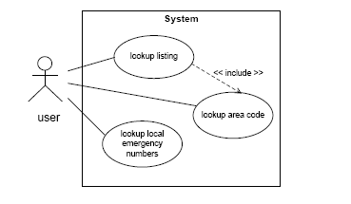

- Exercise 13
Data-Flow diagram to illustrate the functions and data-flow For an on-line telephone directory system

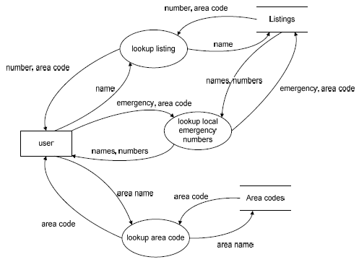

Chapter 5 Design the Architecture

Part 1 Fill Blanks

- resulting
- components, connectors, constrains
- filter,pipe.
- Server, client
- peer
- subscribing, pubulish
- central data store, data accessing

Part 2 Brief Description and Exercise

- See the Figure 5.4 and its description..
- The answer is figure 5.9 in the page 243( Fourth Edition)
- (1) Piper and Filter:
MIS system of XIDIAN University
(2) Client/Server:
Most transaction processing system(事务处理系统)
Eg. Bank System
(3) Peer to Peer:
Military Individual equipment system
(4) Publish Subscribing:
- Field ( Reiss 1990),
- Subscribed Weather Forecast
(5) Repositories
Intelligence Diagnostic and Cure System
(6) Laying
(1) Unix Operating System
(2) OSI model for network communication

Chapter 6 Design the Modules

Part 1 Fill Blanks

- Individual component, write code, implement
- principles , conventions
3. sharp boundary
4. decomposing
5. separation of concern
6. See the Fig.6-2 ( Fourth Edition P. 298)
7. See the Fig.6-5 ( Fourth Edition P. 300)
8. stamp coupling, data coupling
9. temporal

Part 2 Brief Description and Exercises

In next text, the No. 4 is the reference answer for Exercise 7
and No.5 is the reference answer for Exercise 8

Chapter 7 Writing the Programs

Part 1 Fill Blanks

- coorperation, coordination
- style, format, content standard, read
- control structure, algorithm, data structure
- documentation, internal documentation, external documentation
- who, what, why, when, where, how

Part 2 Brief Description and Exercise

- See the six aspects in the page 387( Fourth Edition)
- Reference answer for exercise 6.

End of Reference Answers for Chapter 1-7.

