QView

Welcome to QView
QView is an MQ network explorer, mapping tool and admin console. It has some very powerful features, such as the ability to map your network into an interactive visualisation, invoke a runmqc like interface on a qmgr node remotely at the click of a button, and create reports on your MQ environment.

Contents
QView 1
Welcome to QView 1
What does QView do? 2
Installing the program 2
Getting started 2
Queue and Channel Filters 4
MQ Object Properties 5
Projection – more space! 6
Reports 7
Administration 8
Please provide feedback 9
To make changes and contribute 9

What does QView do?
Qview:
- Automagically maps your MQ network, including queue and channel objects.
- Displays an interactive and printable tree view of your network.
- Provides configurable MONITORING including queue depth and channel status, with sensible defaults.
- Provides a One-click EDITABLE list of attributes for each of your MQ objects.
- Provides a ‘runmqsc’ type interface for each Queue Manger node at the click of a button.
- Provides 2 step channel stop/start, and queue put and get disable/enable.
- Will read, get and parse messages from a queue.
- Will write back or move read messages to any queue.

Installing the program
Download the latest build from https://github.com/tgqc/QView/downloads, in either of 2 varieties, the self installer, or an unzipable package (does not require admin privileges). For those of you who work behind a paranoid firewall, you can download from https://s3.amazonaws.com/keepthing-misc/large-files/qview_v0.6.0_installer.exe .

Kick off <install-dir>/bin/qview.exe to test drive.

Getting started
Once the interface has loaded, a generic MQ network starting point will be created for you, called ‘MQ Network’. You may rename the network, and create additional networks if you wish.
The ‘MQ Network node defines a ‘connection point’ Queue Manager in the properties panel on the right, with the default IP address of ‘localhost’ and the default port of ‘1414’. There is an optional ‘Connection Id’ field as well.
Change these values to target a well connected queue manager on your network, such as a cluster full repository.
Once this is done, right click the ‘MQ Network’ node and hit ‘Discover’, or simply hit the target icon on the menu bar.
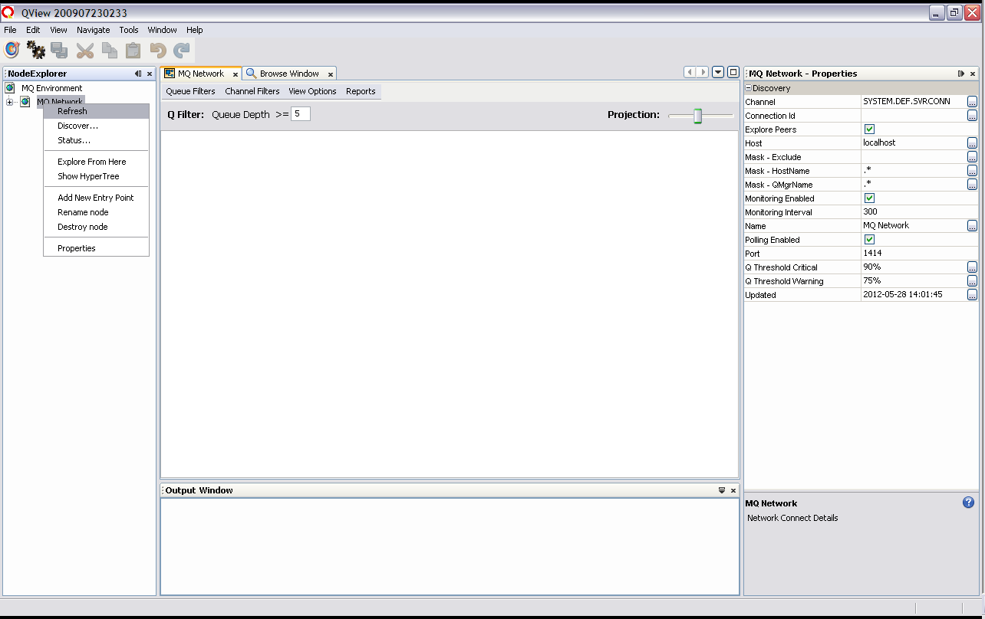

If your network is quiet and well behaved, you may find the default Queue depth filter of ‘5’ will leave your display looking a little stark. If your network is busy, the view may be crowded. You can change the threshold to ‘1’ or any other number, then hit <enter>.
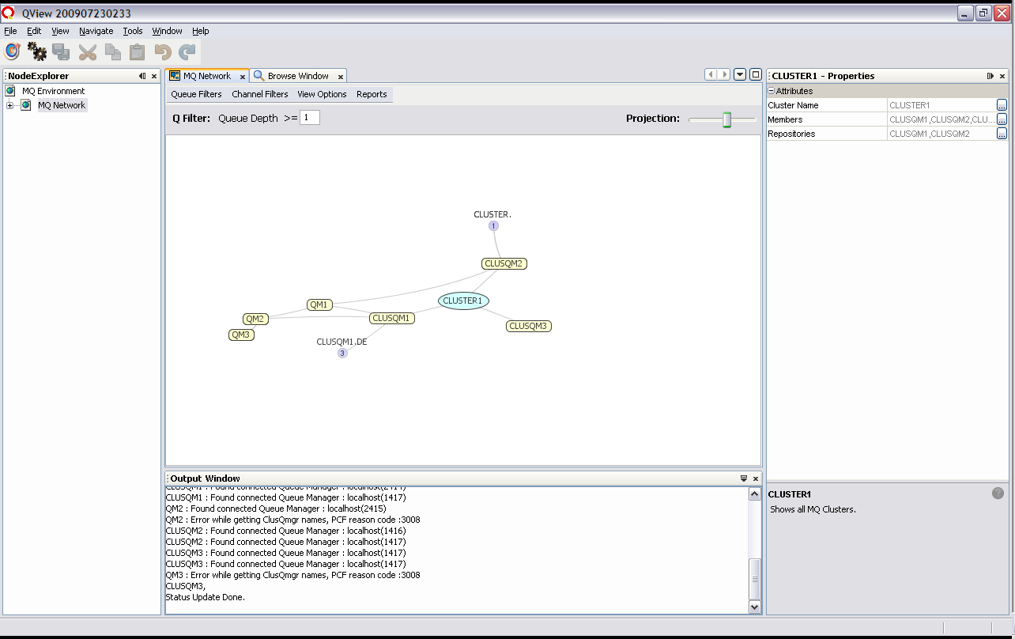

To keep the view ‘clean’, labels on the periphery are automatically truncated. To display all object labels in their entirety, select ‘view’ > ‘Expand Lables’. Deselect to return to truncated view.
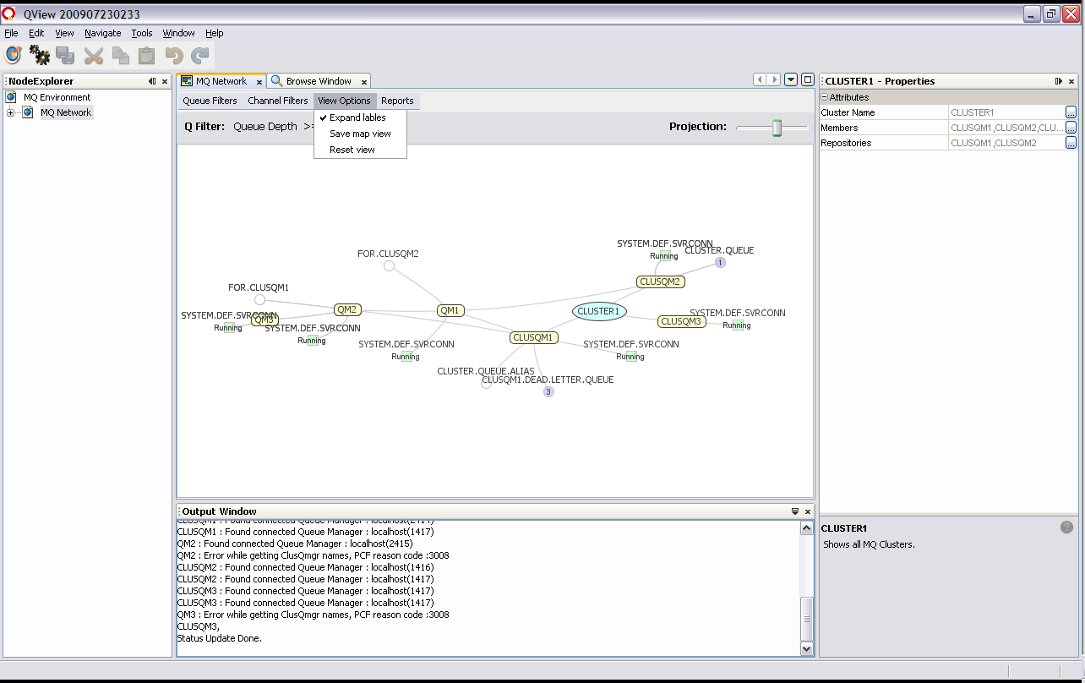

Queue and Channel Filters
Queue and channel filters can be turned on and off from the drop-down menu. Selecting Client/Svrconn will currently also enable ‘System’ channel view, so that your default serverconn channels will be visible – ensure the ‘running’ filter is selected to avoid overcrowding the view.
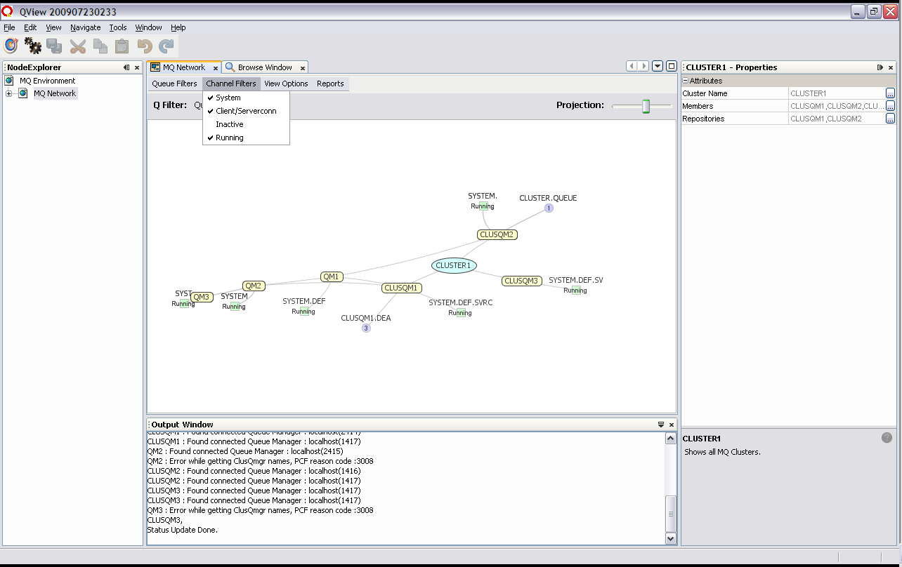

Selecting the queue filter ‘Custom’ will enable a regex field in which you can define custom regex to filter the view. In the example below, the regex ‘.*.EVENT’ has been entered to display only EVENT queues.
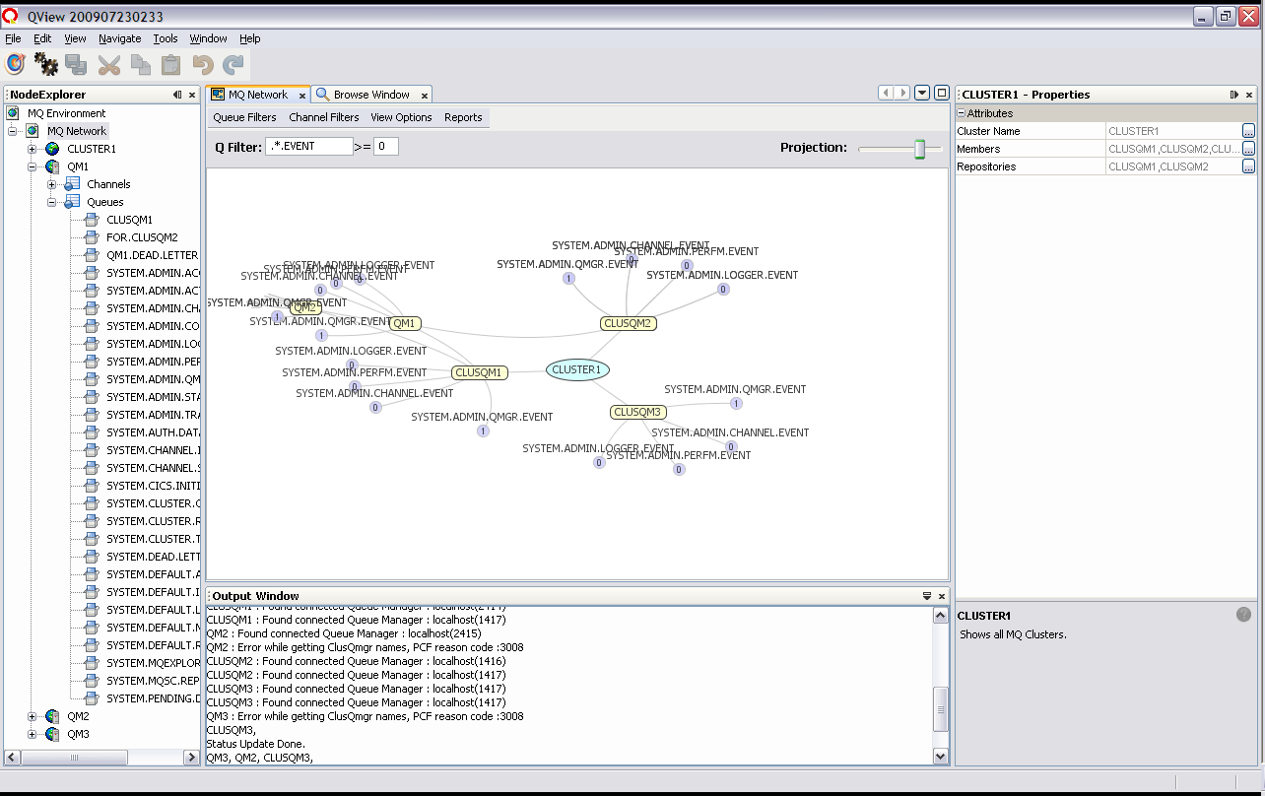

MQ Object Properties
Selecting a node in the network will bring the MQ Object’s properties up in the properties pane. These properties can be found using either the network view or the traditional alphabetically ordered explorer view.
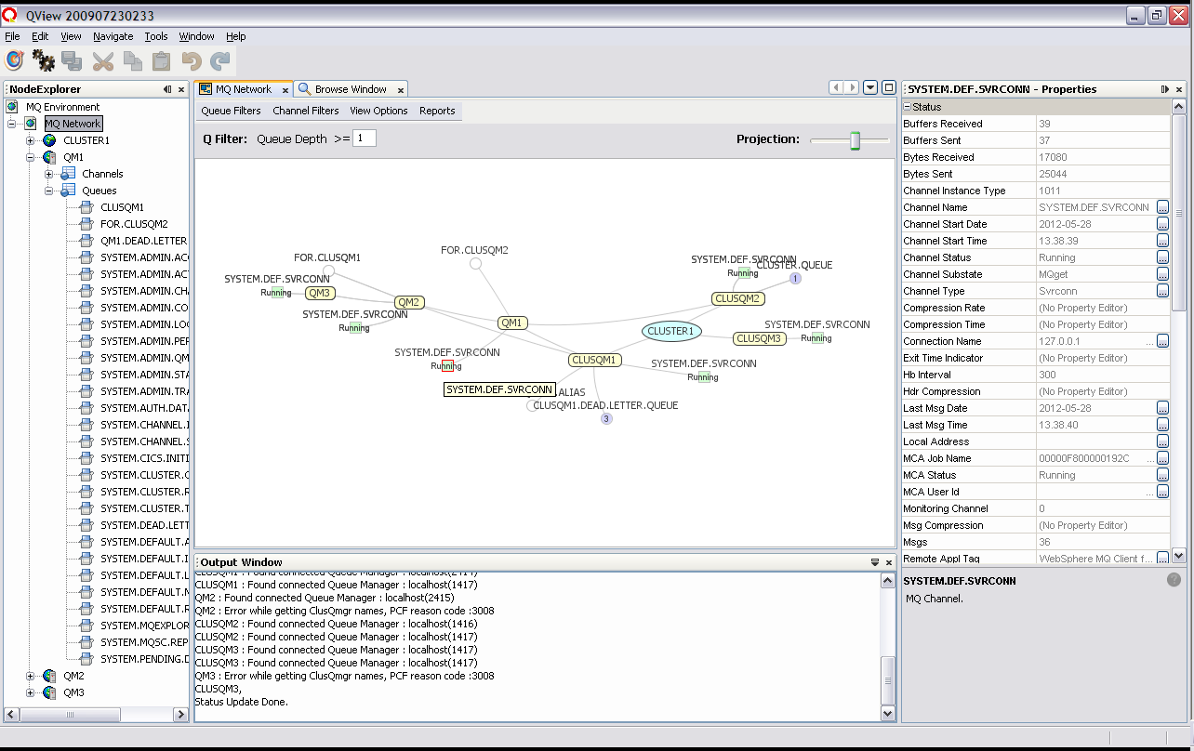

Projection – more space!
The ‘Projection’ slider can spread out the view if it becomes a little cluttered.
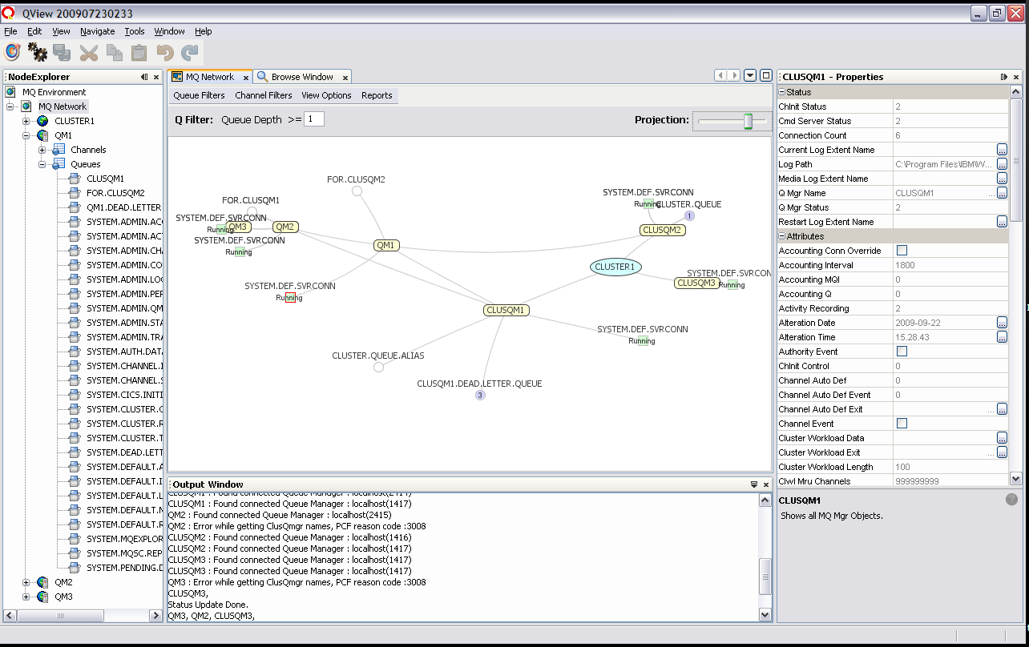

Double-clicking the network tab will expand and collapse the network view to fill the screen if you need more space.
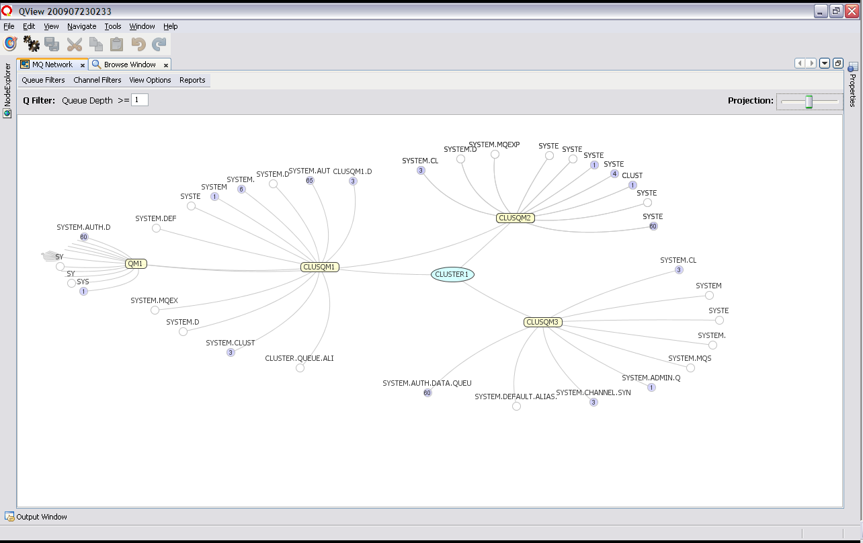

Reports
The reports menu will output MQ network data in pre-designed reports. A report builder is on its way – look out for it in future releases.
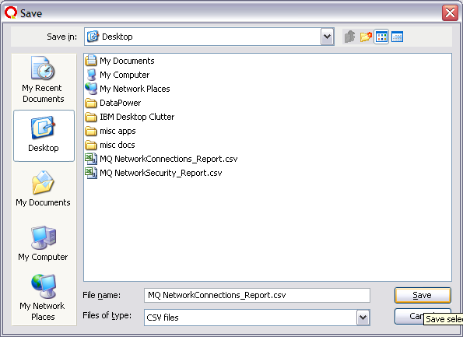
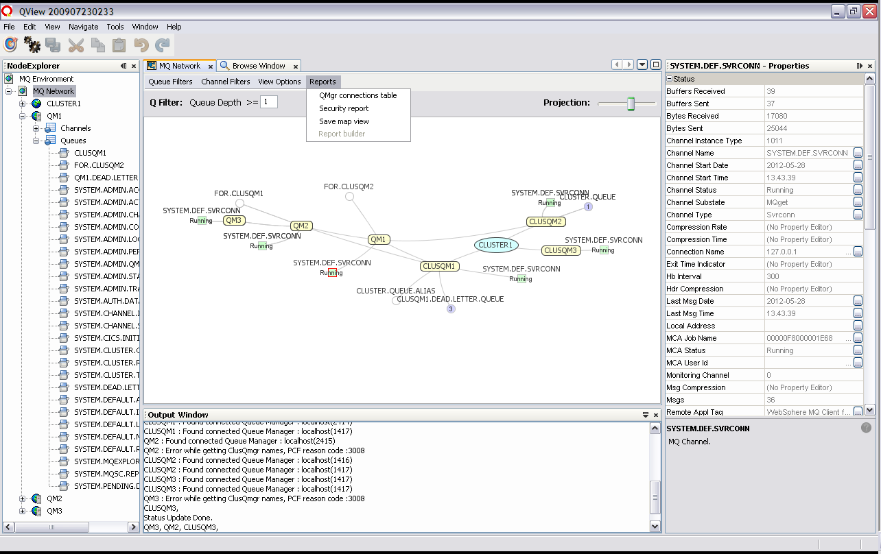

Current reports are a connections table and security report. There is more to be done, and if you have need of a particular report, please email mqsysadmin@gmail.com.
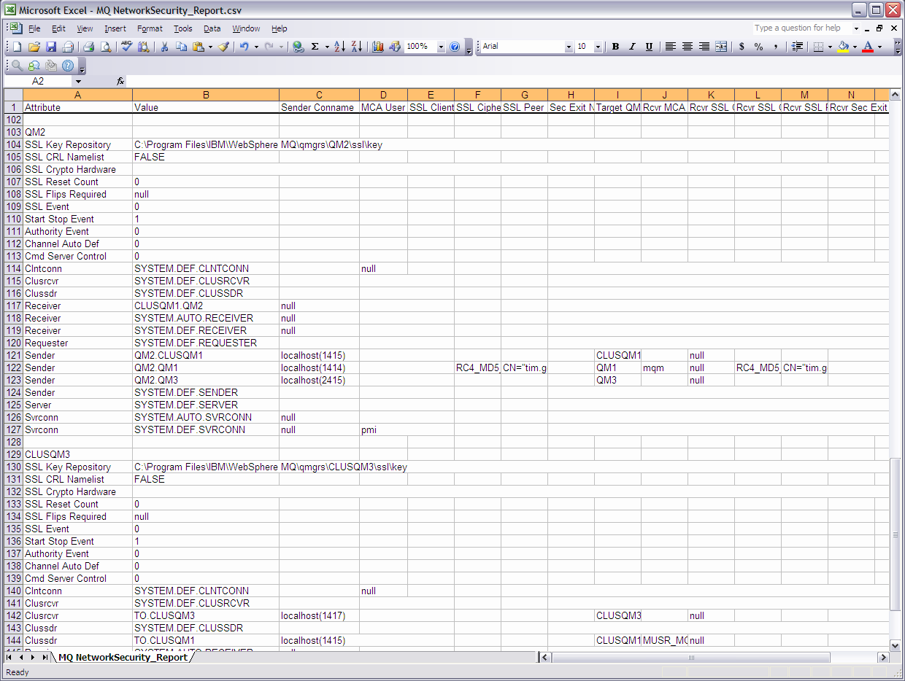
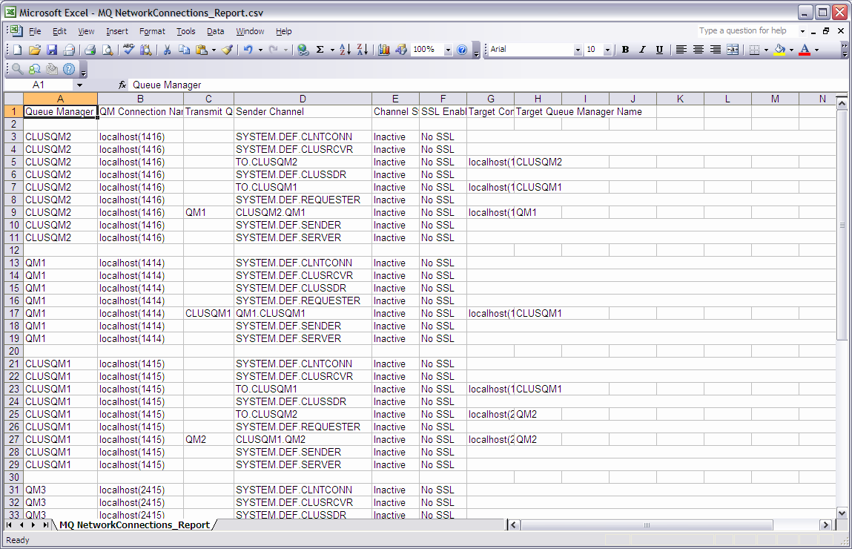

Administration
Administration can be undertaken by updating certain fields on the properties pane. Selected admin tasks may also be undertaken via a right click context menu on Queue Manager, Queue and Channel nodes.
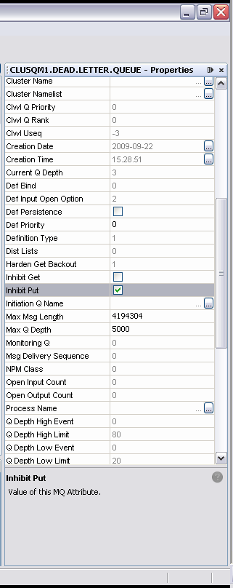
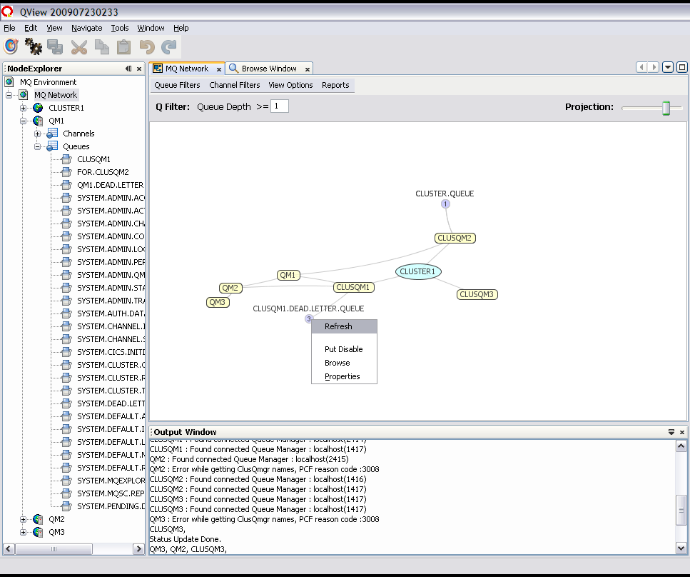

Rudimentary Queue browsing is available as a right-click menu option on any queue.
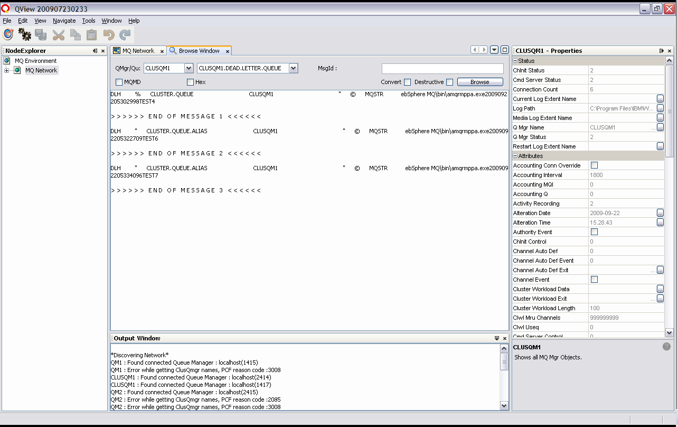
‘remMQSC’ is a right click menu item available on any connected Queue Manager, and will throw up a ‘runMQSC’ like interface.
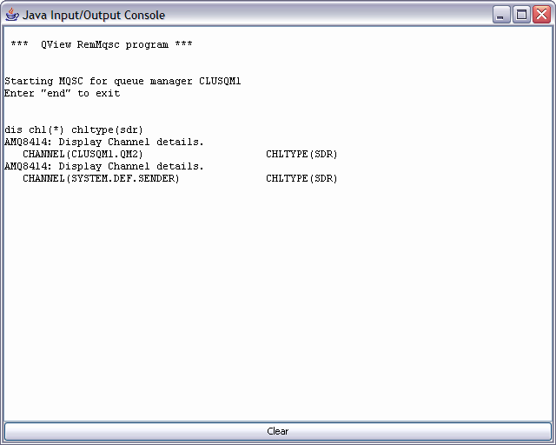
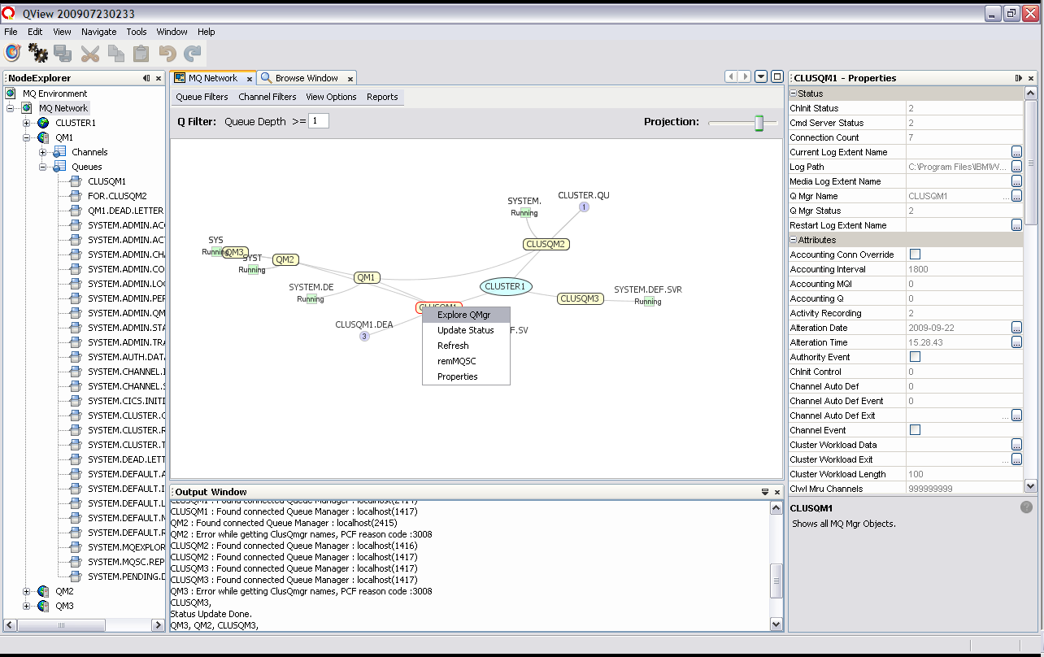

IBM MQ Client classes
IBM retain ownserhip of the 'com.ibm.mq' jave client libraries. Terms and conditions can be found under the 'QView-Suite/com.ibm.mq' and 'QView-suite\com.ibm.mq\release\modules\ext' directories. If you plan to use this tool in a commercial setting, please be confident of your authorization to use these libraries by downloading a free copy of the client code directly from IBM, if you have not already done so.

Please provide feedback
QView explorer has been significantly updated thanks to your feedback.
Keep the feedback coming! What further functionality, filters and reports would you like to see?

Let us know what you think at mqsysadmin@gmail.com.
Issues and bugs can be lodged directly at http://github.com/tgqc/QView .

To make changes and contribute
- Download Git from http://git-scm.com/
- create and CD to a working directory
- type 'git init'
- type 'git remote add origin https://tgqc@github.com/tgqc/QView.git'
- type 'git pull origin master' ... the latest source will dowload.
Using Netbeans to code and test is not essential but recommended. Running the app from source is a one-click trick from the Netbeans IDE.
If you would like to be a regular contributer, let us know. mqsysadmin@gmail.com.

