Miss Sam Howell,
Planning Department,
Swindon Borough Council,
Wat Tyler House,
Beckhampton Street,
Swindon SN1 2JH.

5 December, 2013

Dear Miss Howell,




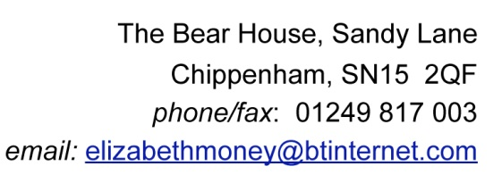
Re.S/OUT/13/1555 Eastern Villages

Our comments on this application are as follows.

Transport Assessments

There are many references to modal shift, reducing car flows and lengths but no real evidence about how this will be achieved. It appears that all the modelling is based on Phases 1 and 1a and then a range of tentative assumptions made about further investigations at the time of Phase 2. This is very unsatisfactory since it is clear that the all important factor, funding, is being obtained on a piecemeal basis and if there is slow delivery of either of the early phases, or the subsequent phases, there will be a lack of delivered accessiblility and services. This has already been seen to be the case at Wichelstowe.

This scenario leaves the site vulnerable to amendments and reduced deliverability of best quality access arrangements. What happens if the CIL or s106 monies fail to deliver the full transport infrastructure on which the premise of this development is based....connectivity to Swindon and interconnectivity between the new build area and existing employment and settlements. What happens when the s106 contributions are spent for supporting bus services beyond a five year period, or whatever time limited period is agreed. Who pays for the services thereafter?
The comment at 6.14 refers to a failsafe fund, but for how long will it run?

The Travel Plan Framework

This refers to two existing bus lines. The 66 and 72. Both are infrequent and have prescriptive routes.
Much is made of having Travel Management Groups and Steering Groups who appear to be going to have to fund and run any form of travel except by car. We take little comfort from the proposal that the membership fees will cover this work, and in any case where will funding for further works be obtained?
All these comments are based on conjecture and have no evidence to support them.

We can see no indication that land is reserved for a rail station. That being the case, we would object to this failure to include rail in the Transport Assessment.

Affordable Housing
The draft SBLP under HA2 requires 30% affordable and we can see no reason why this should be open to negotiation as seen at 2.3.35 of the David Locke Associates document. If the Borough want to achieve the necessary affordable housing for its residents then it must set the bar and keep to it. The arguments put forward with regard to viability have no foundation on a green field site where all the risks should have been fully calculated in advance and the profit margin for the developer is of no concern to the Council.

There is very little on Renewable Energy apart from the mention of Code 3 for Sustainable Homes, which may be scrapped. This is a chance for Swindon to insist on the best insulation and opportunities for houses to generate electricity used. Consider the Austrian technology leading the way on passiv homes and try to bring these concepts to Swindon.

We note the comments on the EIA and general conclusions as stating that there is moderate beneficial effect on the local economy over the 12 yr construction period but it is clear that these are transitory jobs within specific time periods. These do not lead to the creation of new permanent jobs or growing the local economy for the longterm. The management of the Phases and the corresponding, or lack of, growth in the creation of new businesses is crucial.

As the outcome of the Inquiry into the draft SBLP looks to be at least a year away we also have concerns with regard to the overall housing figures which will be agreed for the Borough, and the resulting balance between funding for infrastructure and economic growth. This is based on assumptive figures and until such time as the draft Local Plan is progressed we do not believe that this application can be robustly assessed.

Yours sincerely,

Mrs. Anne Henshaw
Chairman

