Application Summary
Application Number: S/OUT/13/1555
Address: Eastern Villages Land North Of A420 South Marston And Rowborough Swindon Wilts
Proposal: Outline planning permission for a sustainable urban extension for up to 2,380 dwellings, a mixed use local centre and mixed use areas, community uses, sheltered accommodation, a primary school, green infrastructure including formal and informal open space, sports facilities, sustainable drainage, engineering works including ground re-modelling, other infrastructure, demolition and the formation of new accesses from the A420, Old Vicarage Lane, Thornhill Road.
Case Officer: Miss Sam Howell
Customer Details

Adye Goodenough: Wanborough Anti-Flood Group.

We are pointing out that the SUDS on the south east side of the development, is shown to be discharging into the river Cole just down stream of this Network Rail culvert shown in on the map set out below.

As you can see from the first picture the river Cole is at extremely heavy rain condition at this point
and in full flow. The second picture is a plan view of the same culvert in the same condition.
The third picture is showing the Ordnance survey levels at this culvert and normal river conditions.

Having spoken to the developer’s drainage consultant at their open public meeting at South Marston, he stated that they had produced their evidence based on “Normal” river conditions.
As you can see from the pictures there is “No normal” conditions for this river as the water level rises and falls quite considerably.

With an overflowing retention pond connected to this SUD, how can the water from the development discharge here when the river Cole is in full flow at eighty eight metre level? (88m)
The water discharging from the proposed location will have to force its way into the main river flow.
If the outlet was place further north away from this culvert it would stand a better chance of draining the surrounding area.
It is well known that South Marston becomes flooded when the river Cole has reached its capacity on this stretch of the river.

Covingham, Dorcan and Wanborough will be have an even higher flood risk, because of the extra volume of water being discharged behind this culvert fills the river Cole before the water from Covingham, Dorcan and Wanborough gets there. Therefore the excess water from upstream has no where to go, thereby backflooding occurs up the Cole, Dorcan and Liden back to Wanborough.

Absolutely “No” consideration has been taken into account for the “extra water volume” that will be no long retained at Covingham culvert. When this culvert has been rebuilt to “double” its capacity the water volume will end up at the A420/river Cole culvert.

We are also wondering how the “detention” type systems ponds are going to be controlled and were is the flood water going to go when they are all full up.

With reference to:
4.9 On completion of the storm water management system, it is proposed to have the system fully adopted.

We would like to point out the comments from Swindon Borough Council concerning the developer’s statement set out above. (see paragraph The Evening Advertiser)

Be aware of the limitations of IH 124 methodology (see paragraph Key message)

All the evidence is shown below on the developers own map set out below.

2.15 Upstream of the site the River Cole flows through a large expanse of agricultural land south of the site generally in a north easterly direction after leaving the urban extent of Swindon. In this area the River Cole is relatively well defined and in the order of 3m – 5m wide for the most part.

2.16 Flowing in a north easterly direction from the A419, the River Cole has a confluence with a number of unnamed tributaries along with the Dorcan Stream near Longleaze Farm, all of which are in the order of 1.5m wide and appear more densely overgrown than the River Cole.

2.17 From here, the River flows in a northerly direction, passing beneath the railway line and A420 in a large pipe culvert. This is shown on Pictures below.

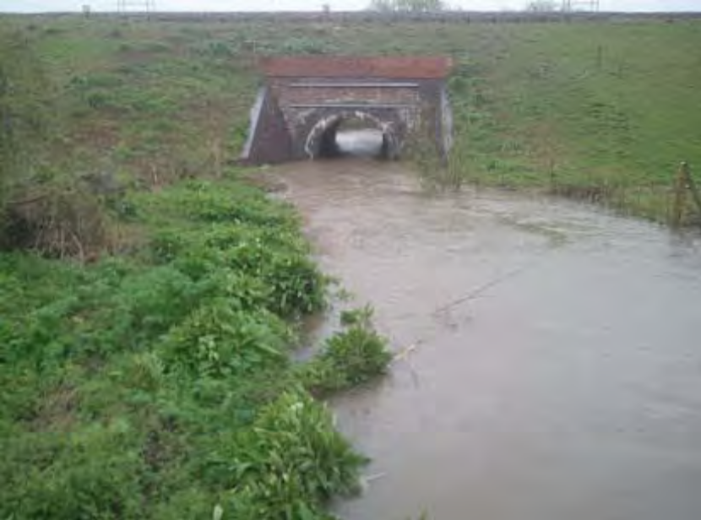

Arial View showing water above the large culvert on A420
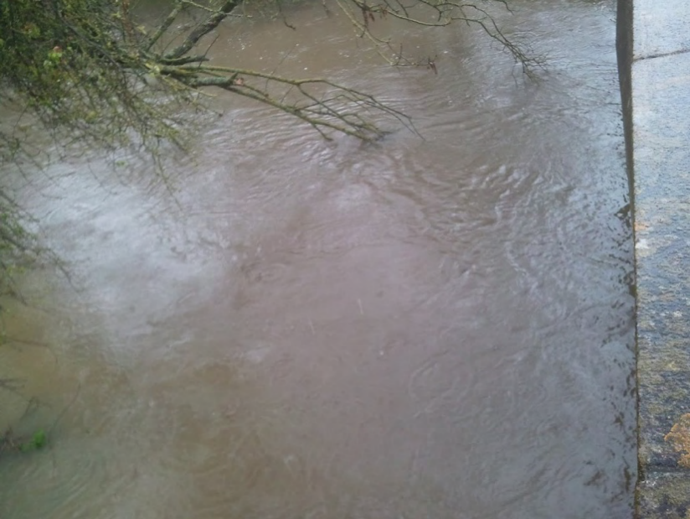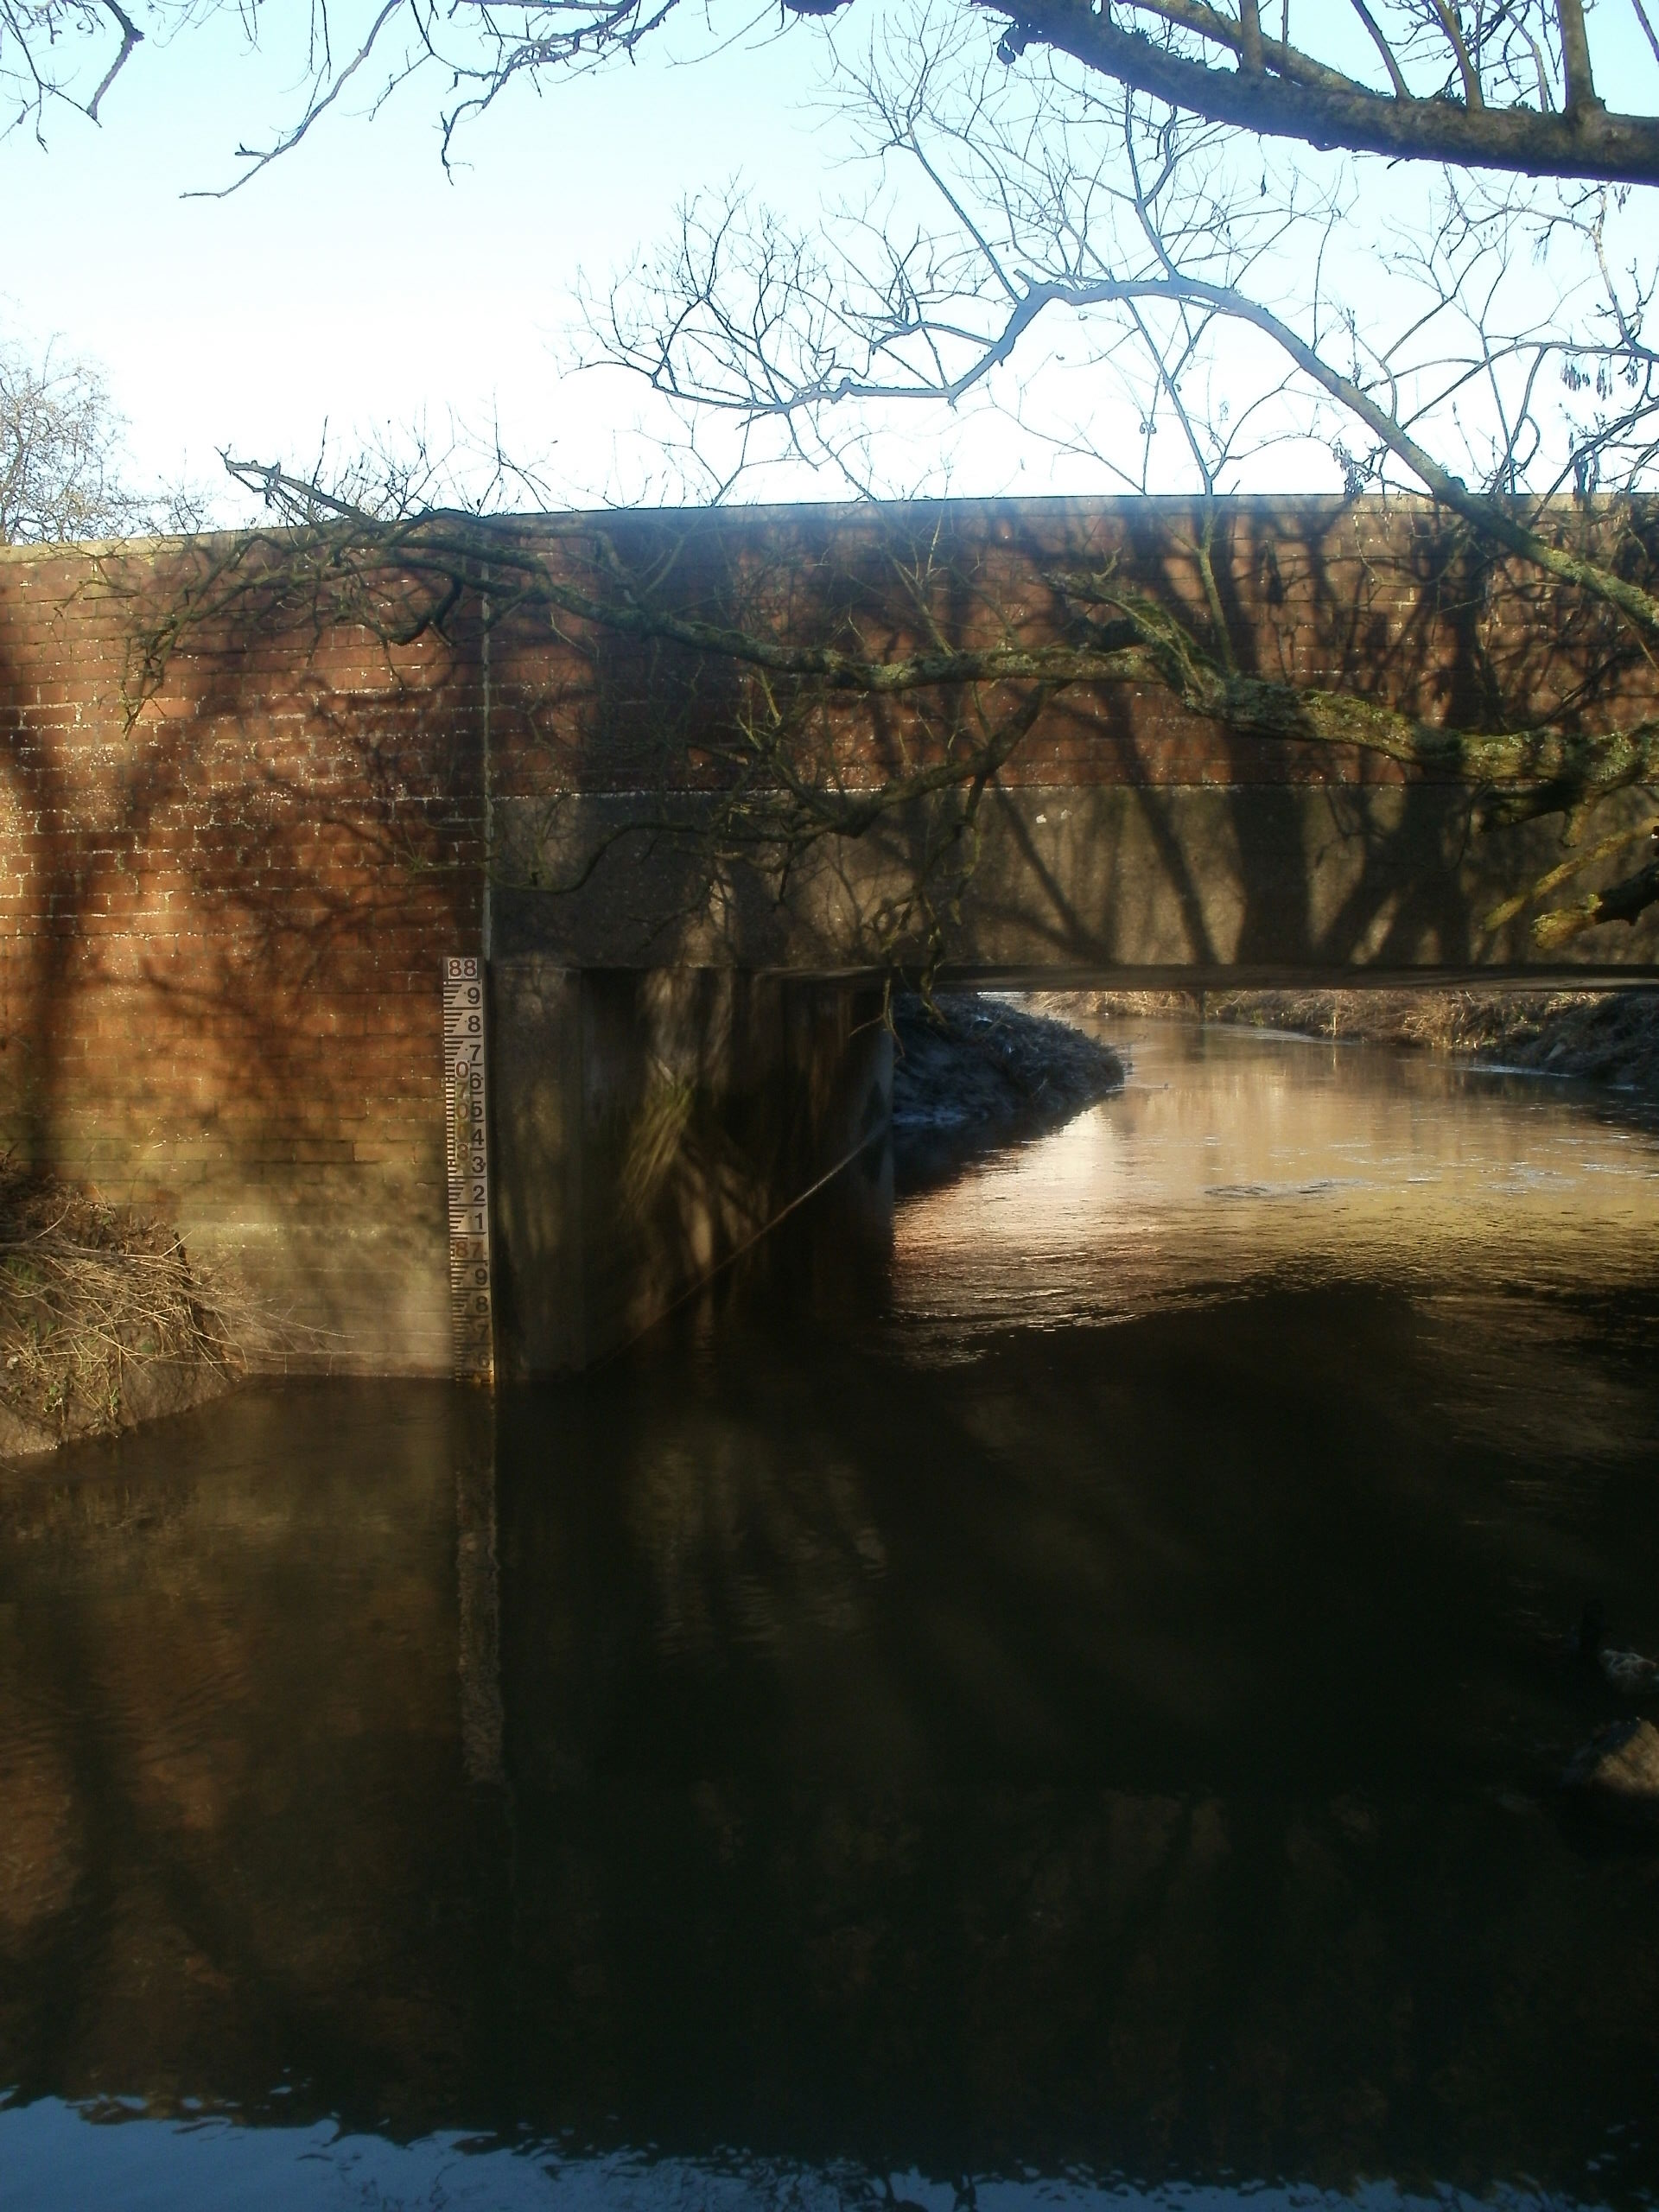

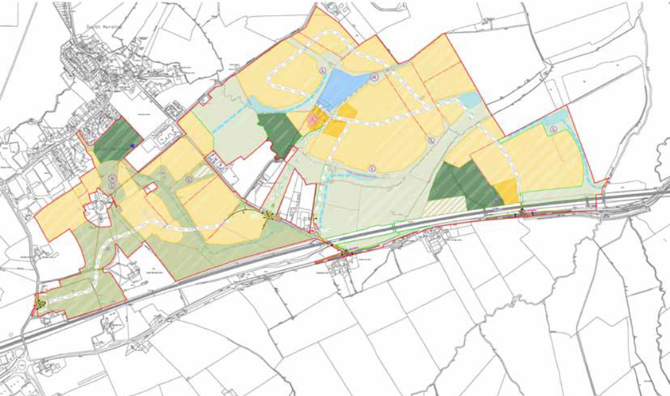

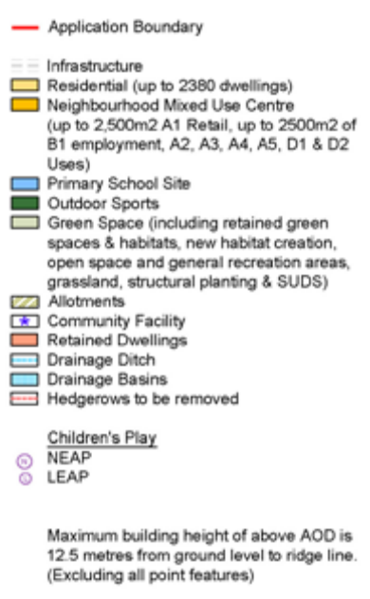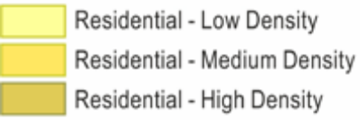
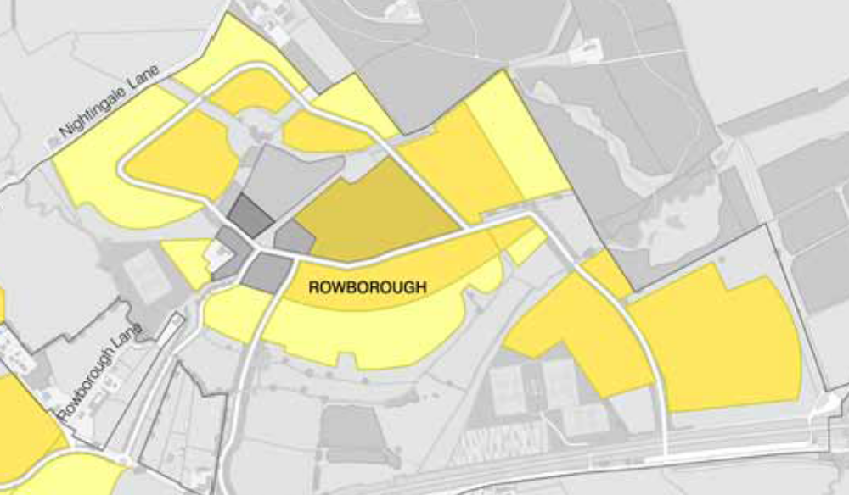

The IoH124 assessment is contained in the Appendix with the baseline rates summarised in Figure 4a below: (l/s)
1 in 1 Year 186.7 3.73
1 in 100 Year 700.7 14.01

Figure 4a: IoH124 Baseline site run‐off
4.5 With the above flow rates being the baseline for the site, post development drainage assessments will be completed, limiting run‐off from the development to these figures, and where possible seeking to reduce run‐off from the development in accordance with the guidance set out in CIRIA 697.

4.6 As source control measures generally rely upon the infiltration of surface water to ground, it is a prerequisite that the ground conditions are appropriate for such. Preliminary geo environmental studies completed to date suggest the geology to consist of mudstone, which is unlikely to be appropriate for a wholly infiltration based drainage strategy.

4.7 SuDS features will therefore primarily rely on ‘detention’ type systems to attenuate flows to the baseline conditions and improve water quality prior to discharge to the receptor. The detention systems will be designed to accommodate the potential effects of 30% increase in rainfall resulting from climatic change as set out in NPPF guidance.

4.9 On completion of the storm water management system, it is proposed to have the system fully adopted.

4.10 Below ground drainage piped drainage will be adopted by Thames Water, Swindon Borough or an alternative water company by way of an Inset Appointment.

4.11 The Floods and Water Management Act gained royal ascent in April 2010. This confers the responsibility to adopt and maintain the SuDS systems to the Local Authority by requiring SuDS Approving Bodies (SAB’s) to be set up within each council.

4.12 The SAB will have a duty to adopt the drainage systems and in accordance with Schedule 3; Para 22 of the Floods and Water Management Act:
22 (1) Where an approving body adopts a drainage system it becomes responsible for maintaining the system.
(2) In maintaining the system the adopting body must comply with national standards for sustainable drainage.

4.13 The SAB will therefore be responsible for developing their framework management plan for maintenance and operation procedures; adjusting the nature of the processes and timing as necessary to ensure the successful operation of the drainage systems.

Objective 11: SuDS systems are to be designed to minimise future maintenance and, prior to any reserved matters application, an appropriate adopting authority will be appointed in accordance with a long term maintenance plan.

From the Evening Advertiser. Friday 8th November 2013
At a Wanborough Flood Group meeting yesterday, Swindon Council’s drainage asset engineer, Simon Masters said while it is the borough’s responsibly to tackle flooding issues it does not have the resources to carry work out.

He said when the Environment Agency was responsible for local flooding, they had teams of trained and experienced staff to enforce the rules but the council does not employ or train anyone especially for the role.

“We don’t have the powers to enforce it,” said Mr Masters. “I can’t comment on what the borough will prioritise in the future. We are a small unitary authority. “Wanborough’s parish chairman Gary Sumner said he was disappointed with the council’s response to the issue.

He said with the Eastern Village Scheme, which could see 8,000 homes being built on floodplains; the borough needs to start taking responsibility for its role.



Key Message
Be aware of the limitations of IH 124 methodology, particularly in the design of SUDS and greenfield run-off assessments. Its tendency to underestimate flood flows will lead to overestimation of storage requirements for developments.

IH 124 tends to underestimate flood flows and accuracy is more dependent upon the size of catchment. The method is based on fewer data and lower resolution data.
ReFH offers the best overall accuracy, the least bias towards over or underestimation and is the least dependent on size of catchment. The method uses higher resolution data and an improved conceptual rainfall/runoff model.

