3 Byron Court
South Marston
Swindon SN3 4TH

Tel: 01793 826243

16th December 2013
Swindon Borough Council
Planning Department
Wat Tyler House
Beckhampton Street
Swindon SN1 2JH

For the attention of Miss Sam Howell.

Dear Sir/Madam

Ref Outline Planning Application S/OUT/13/1555.

Outline planning permission for a sustainable urban extension for up to 2,380 dwellings, a mixed use local centre and mixed use areas, community uses, sheltered accommodation, a primary school, green infrastructure including formal and informal open space, sports facilities, sustainable drainage, engineering works including ground re-modelling, other infrastructure, demolition and the formation of new accesses from the A420, Old Vicarage Lane, Thornhill Road.
Eastern Villages Land North Of A420 South Marston and Rowborough Swindon Wilts.

Objection comments:

Access roads:
Objection:The access onto Old Vicarage Lane (south) should be a left turn only from Rowborough development to feed traffic onto the A420 from this urban development.
Reason: Traffic from the Rowborough development will use this route to avoid the congestion on the A420 and filter through the village to get to the Gablecross junction. Eventually other through traffic will find it an alternative route to avoid the A420. This increase in traffic volume is not suitable for our village roads.

Objection: The road onto Old Vicarage Lane (north) from Rowborough development should be deleted. Access onto OVL should only accommodate the South Marston development.
Reason: This road will be used by the Rowborough development residents and others to avoid the A420, creating a rat run through South Marston. This will increase traffic volumes through the village to an intolerable level and increase the potential for accidents. Residents have constantly put forward the view that a large increase in traffic volume is not suitable for our village road environment. A non-coalescence strategy needs to be in place to maintain the South Marston Village identity and not become an urban settlement being part of Rowborough.

Objection: The new road from the South Marston proposed development onto Thornhill Road should be moved from its current location.
Reason: There is no reason that the road access onto Thornhill Road should not be sited between Oxlease Farm and the Thornhill industrial site. This route is a short route directly into the proposed development. Also when the brownfield site (Thornhill industrial site) is developed it will create a sensible access onto Thornhill Road for that development. The proposed route on the plan is through a non-developed area. This will give developers an opportunity to propose development along both sides of this road in the future. If this route is approved a covenant should be imposed to ensure and protect that no development will be allowed on this green space.

Objection: Access from Thornhill Road onto Gablecross junction is not controlled by traffic signals.
Reason: At present it is difficult at times to access the Gablecross junction. This will only become a greater problem with the increase in traffic. The junction should be controlled by traffic signals.

Other comments: Main vehicular access to and from the Rowborough development should be directly routed onto the A420 under the railway at two locations. Only one has been indicated. This must be in-place before occupancy of the Rowborough development takes place..

Housing:
Objection: The application indicates a request for 580 houses which is not acceptable. The South Marston SPD proposed 500 houses on the developer controlled land. This value was determined through consultation with the village community and was considered a maximum by most residents.
Reason: A value of 500 houses was considered a significant development for South Marston. The overall development of South Marston will also include development of brown field sites and other parcels of land not in the developer controlled land. This will add another significant number of houses to South Marston village. The total development will erode the village identity. The numbers of houses should preferably be decreased and not exceed 500. There are no notional details of housing density levels on the various development areas indicated in the application. This is an important matter for the community to consider.

Infrastructure:
Objection: it is not clear when the proposed infrastructure for the development will be completed.
Reason: Infrastructure for the development will need to be in place prior to housing occupancy. If it has not been constructed then a ring fenced fund should be provided by the developers, including contingency for inflation to ensure infrastructure will be provided. Failure to supply adequate infrastructure is a common practice of developers.

Flooding:
Objection: Being an outline plan there is no design detail of flood management for the existing flood patterns or the future requirement, only propsals. Until a full study has been completed it is difficult to determine how the flooding problem will be dealt with to the satisfaction of the community. However the plan indicates a discharge into the River Cole near Acorn Bridge. This point is currently at its capacity and run off water backs up in the South Marston Brook causing local flooding after periods of heavy or prolonged rain periods. The river is not able to accommodate the excess and it takes time to clear. The picture below is a typical scene of the South Marston Brook which passes through my garden after sustained heavy rain
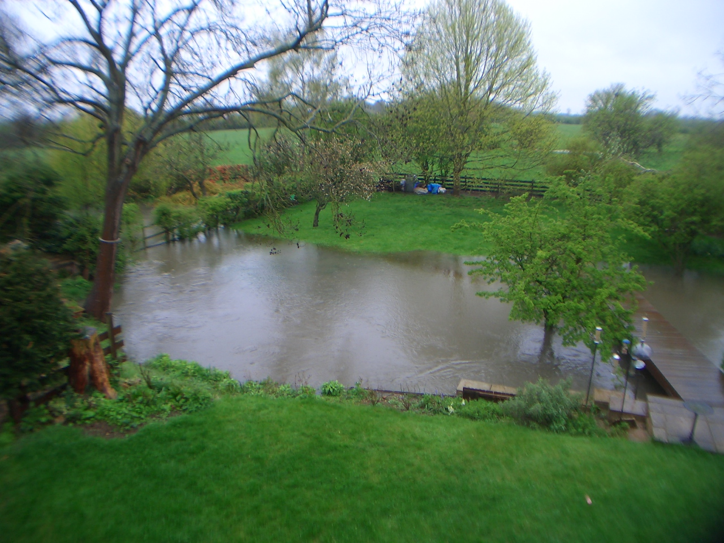

Conclusion: If planning is granted in its present form of the submission the developer will have flexibility to determine and interpretation of the approval to his advantage to the detriment of South Marston. The developers have currently indicated additional housing numbers which I object to, they may request even more when a full application is presented for approval.
I request that this outline planning application be refused.

Yours sincerely

Brian McGlone CEng, MIStructE, MRINA
Email: bmcglone12@gmail.com

