Dear Ed,
15th December 2021

LHL006/TC

Planning Portal Ref: PP10482962
Edward Snook
Senior Planner - Strategic Planning
Planning - Economy and Development
Swindon Borough Council
Civic Offices Euclid Street
Swindon
SN1 2JH

LAND KNOWN AS SOUTH MARSTON AND ROWBOROUGH, LAND NORTH OF A420- LPA REFERENCE S/OUT/13/1555 APPLICATION TO DISCHARGE CONDITION 38 (ARCHAEOLOGY - WRITTEN SCHEME OF INVESTIGATION)

On behalf of Hallam, Hannick and Taylor Wimpey (HHTW), we are pleased to provide you with relevant information to seek the discharge of Condition 38 of Planning Application S/OUT/13/1555 which was approved by Swindon Borough Council on 11th August 2021.

Condition 38 states:

‘Prior to the commencement of development in each sub-phase, a detailed Written Scheme of Investigation for all of the archaeological zones identified within that subphase, in Figures 15 and 16 of the Outline Archaeological Mitigation Strategy (V6 - 31st October 2017) and areas of highway infrastructure within sub-phase areas shown in Figure 17, shall be submitted to and approved in writing by the Local Planning Authority to enable mitigation by archaeological excavation, trial trenching and monitoring. The development shall be carried out in accordance with the approved Written Scheme of
Investigation’

This application submission comprises the following information:

- Site-Wide Over-Arching Archaeological Written Scheme of Investigation December 2021 (Orion Heritage Ltd)
- Location Plan LHL005_144_G

The WSI identifies the works as required by condition 38, notwithstanding the construction of the condition, this submission seeks approval to a site wide WSI, referring as relevant and including extracts of the Outline Archaeological Mitigation Strategy (Orion Heritage 2017), referenced in the condition, to ensure consistency of approach across the site.

The approach and scope of the WSI, in relation to the approved Outline Mitigation Strategy, has been discussed with Wiltshire Council, in their role as archaeological advisor to Swindon Borough Council.

The application has been supported by the requisite fee (£116), paid via the Planning Portal.

Please do not hesitate to contact me or my colleague Sam Wood (swood@davidlock.com) should you have any queries on this submission.

Yours sincerely,

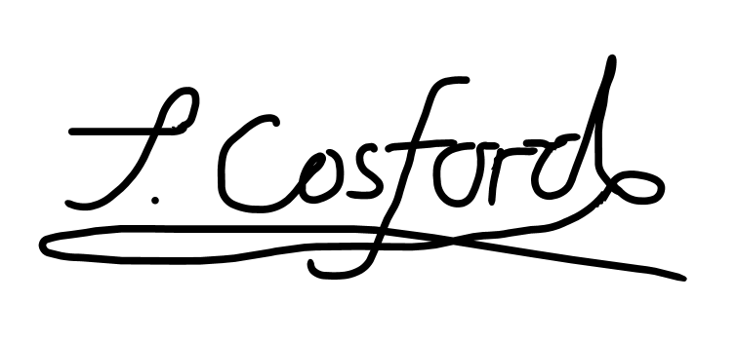

TANYA COSFORD
Associate

Email: tcosford@davidlock.com

Encl.

