# DBAS2104 – Crunch the Data Assignment for Best Run Refreshments – Tristan Gray

## **Approach**

To address this relatively large dataset, I decided Excel would be clunky and time-consuming. As such, I exported the excel file as a .csv to conduct the bulk of my analysis using Python with Pandas, Numpy, and Matplotlib. Here were my preliminary findings:

## **Sales Managers**

Kiran Raj, David Carl, and Janet Bury were by far the most successful Sales Managers by all three major KPIs: Quantity Sold, Gross Margin, and Total Value of Sales.

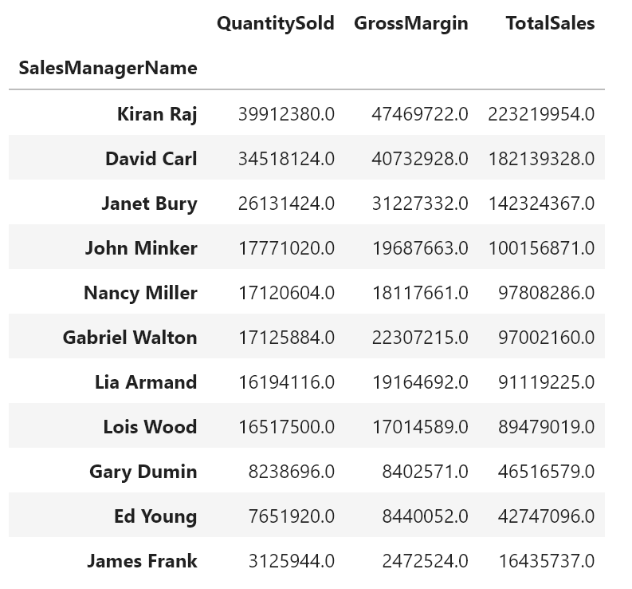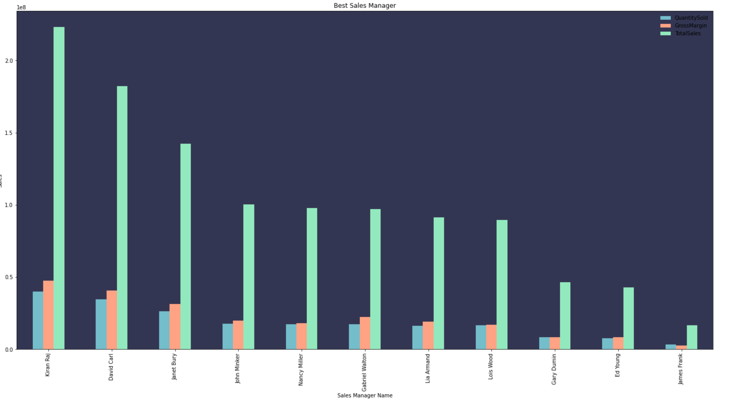

As both this grouped sort and the resultant graph demonstrate, these three Sales Managers were by far the most effective in generating sales and in turn profit. It would be smart to reach out to these mangers not only to reward them and motivate them to continue growing but also to gain insights as to how they were able to flourish so this information can be used to train new Sales Managers.

## **Products and Product Categories**

The data is very clear in terms of which Products are the most successful. The Juice Category absolutely dominates in terms of Quantity Sold, Gross Margin, and Total Sales volume:

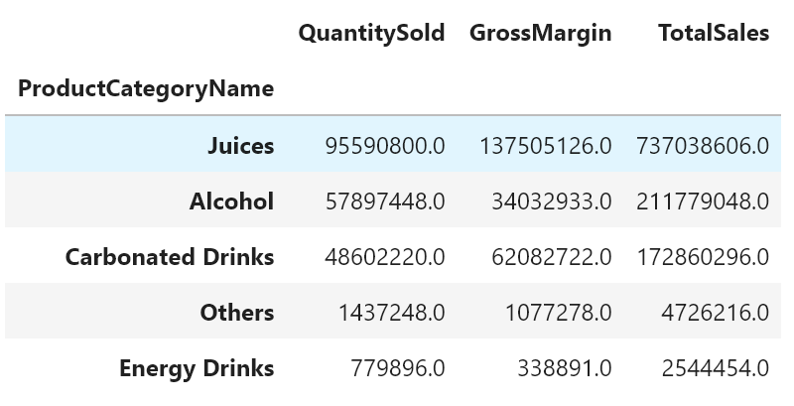

The Juice accounted for ~41% of Gross Margin while Alcohol accounted for ~25% for a combined 66% of Gross Margin. These two categories, Juice and Alcohol, make up the overwhelming amount of Total Sales volume as well as Gross Margin. In stark contrast, Energy Drinks are by far the worst category and performed the worst across all 3 KPIs.

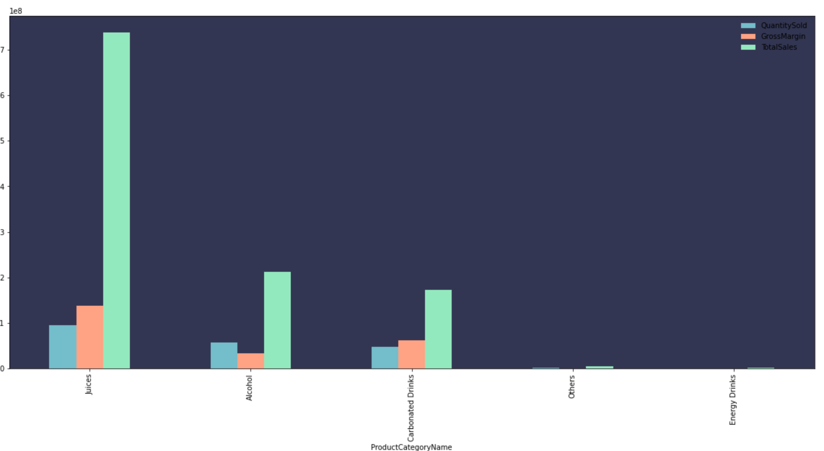

The huge gap between categories becomes even more apparent if we then look at how these Sales Stats break down by individual Products by Total Sales and Gross Margin:

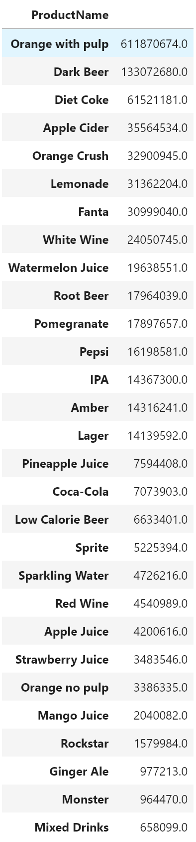 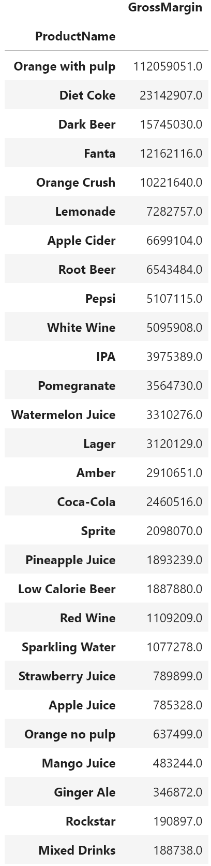

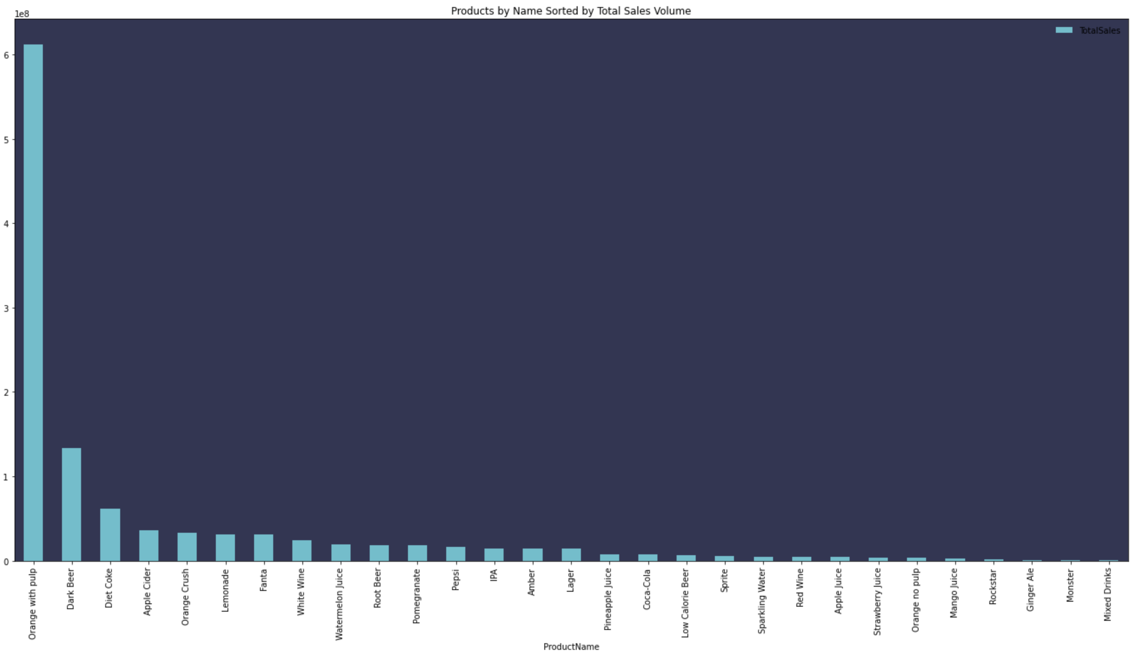

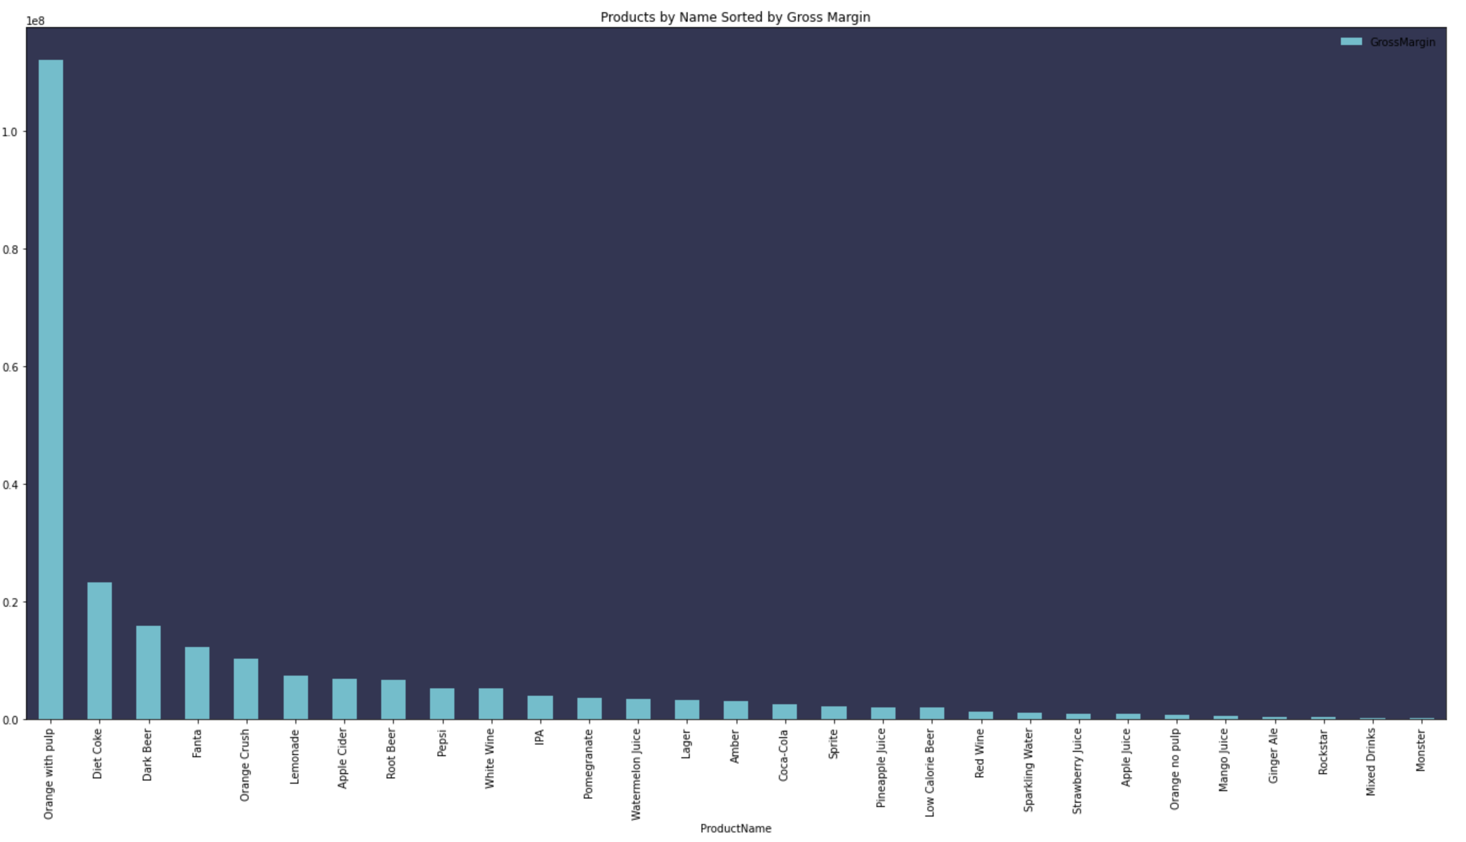

This paints an extremely dim picture for Mixed Drinks and Energy Drinks. Both products have Total Sales volumes but even worse they are among the lowest profitability as well. Energy Drinks have a fairly high cost as does stocking a Bar to make Mixed Drinks. Based on this analysis it seems obvious that Mixed Drinks and Energy Drinks should be eliminated from Best Run Refreshments offerings as soon as possible!

A surprising insight from this analysis is just how strong the preference for Orange Juice With Pulp (strongest performer) is compared to Orange Juice Without Pulp (among the worst performers). For this reason it seems clear that it would make sense to only offer Orange Juice With Pulp.

In addition to removing Mixed Drinks, Energy Drinks, and Orange Juice Without Pulp, it would be a good idea to work on supplier relationships and bulk discounting for Orange Juice With Pulp and potentially for Diet Coke as they represent such a large chunk of Best Run Refreshments’ business.

## **Locations**

It is evident from this analysis the lion’s share of business is still being conducted in California:

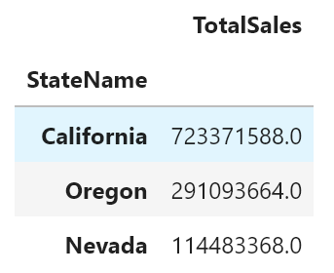 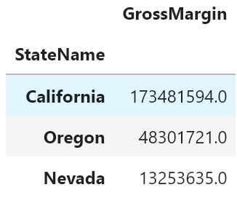

There is a very significant gap between Locations in the Golden State and those in Oregon and Nevada. It makes sense to continue to prioritize California while also looking at opportunities for growth in the surrounding states.

When we look into more specific Locations, it becomes clear how we might be able to improve Supply Chain by concentrating our warehousing closer to our biggest consuming Locations:

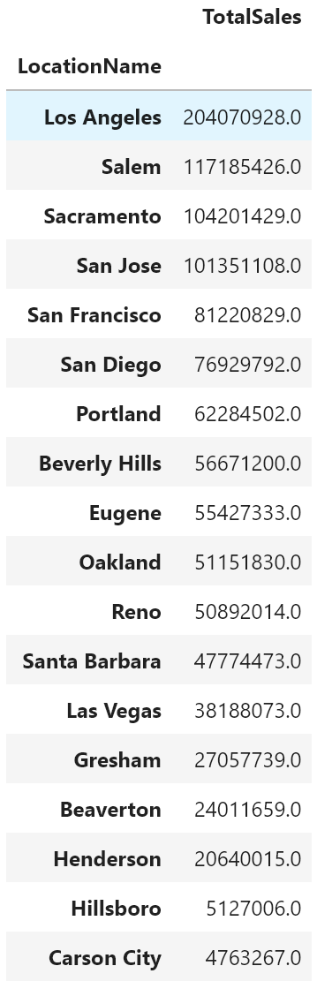 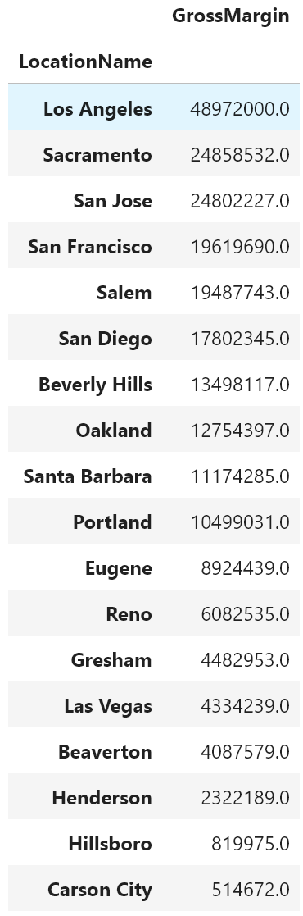

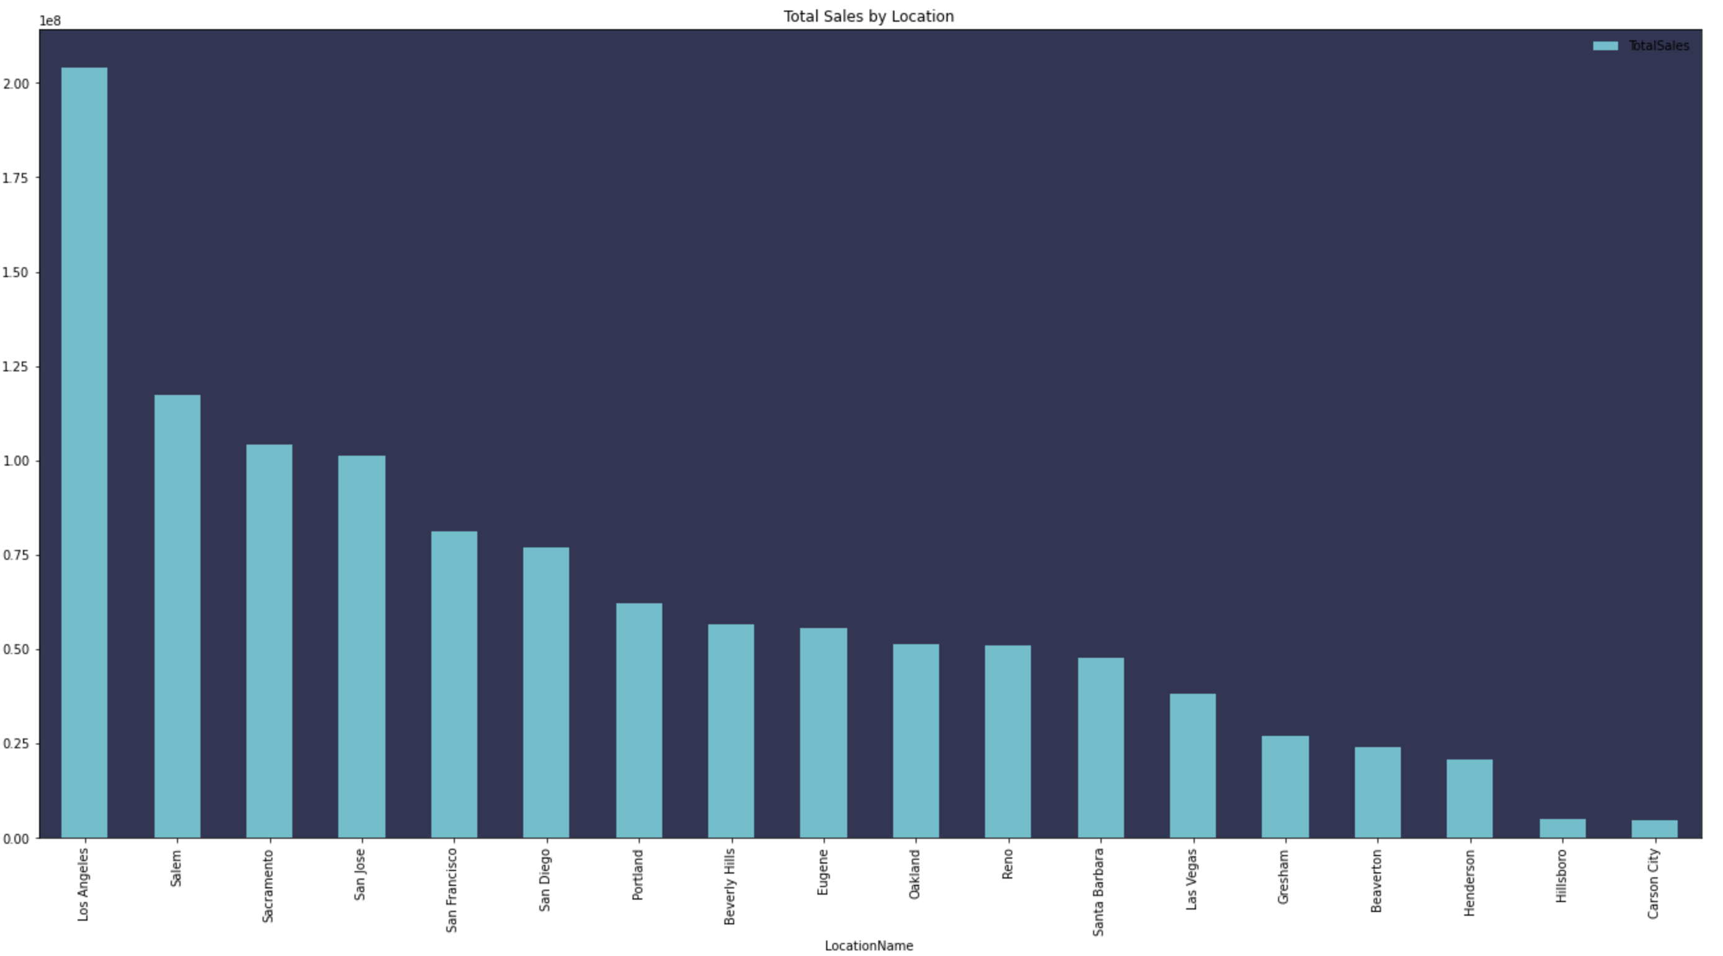

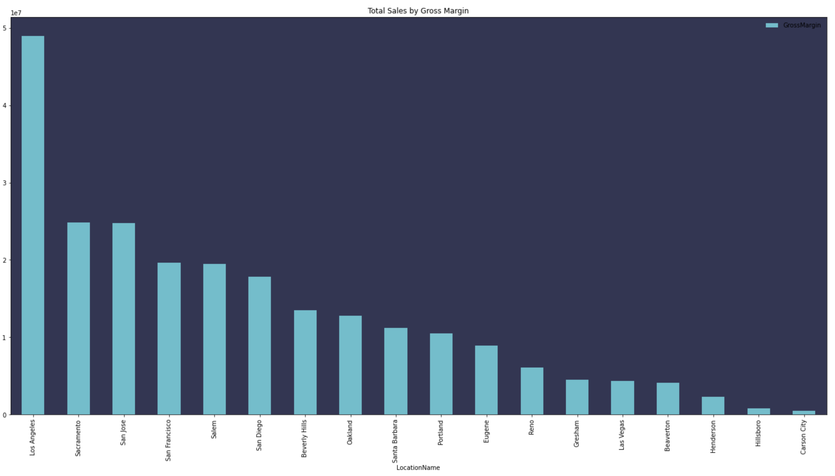

It is clear from these charts that the overwhelming majority of both revenue and Total Sales stems from the area between San Diego and Sacramento. This makes a city like Bakersfield an ideal location for a distribution center that could easily service Best Run Refreshments major markets while also allowing for easy shipping along I-5 to important but more distant markets like Salem, Oregon:

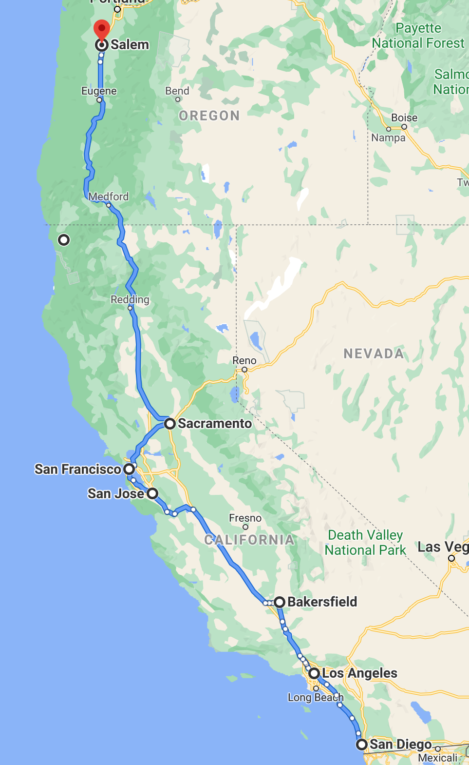

## **Final Recommendations**

With an optimized shipping route along I-5, it would be possible to serve many more locations between Los Angeles and Sacramento with ease. This in addition to success Best Run Refreshments has had in California already suggest that developing more franchises between Los Angeles and Sacramento would be a strong path to greater revenue. Reaching out to Kiran Raj, David Carl, and Janet Bury to encourage them to develop franchises in these key areas is essential for record profits in the coming years.