Nama : Petrus Jangau

Nim : 17230019

Tugas : Percakapan Bahasa Inggris

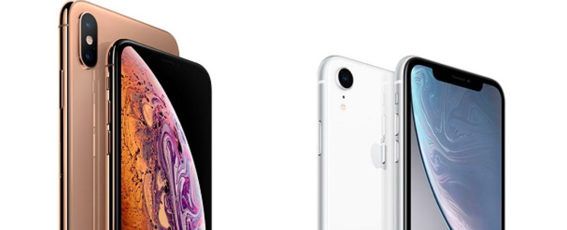

**Iphone Xr And Iphone Xs Comparison**

1. iphone xr body is lighter than iphone xs.
2. The OLED screen on the XS is definitely better than the XR screen which has liquid retina.
3. iPhone camera on XS series is much clearer than xr series.
4. xr battery lasts longer than xs.
5. iphone xr has more color models than xs