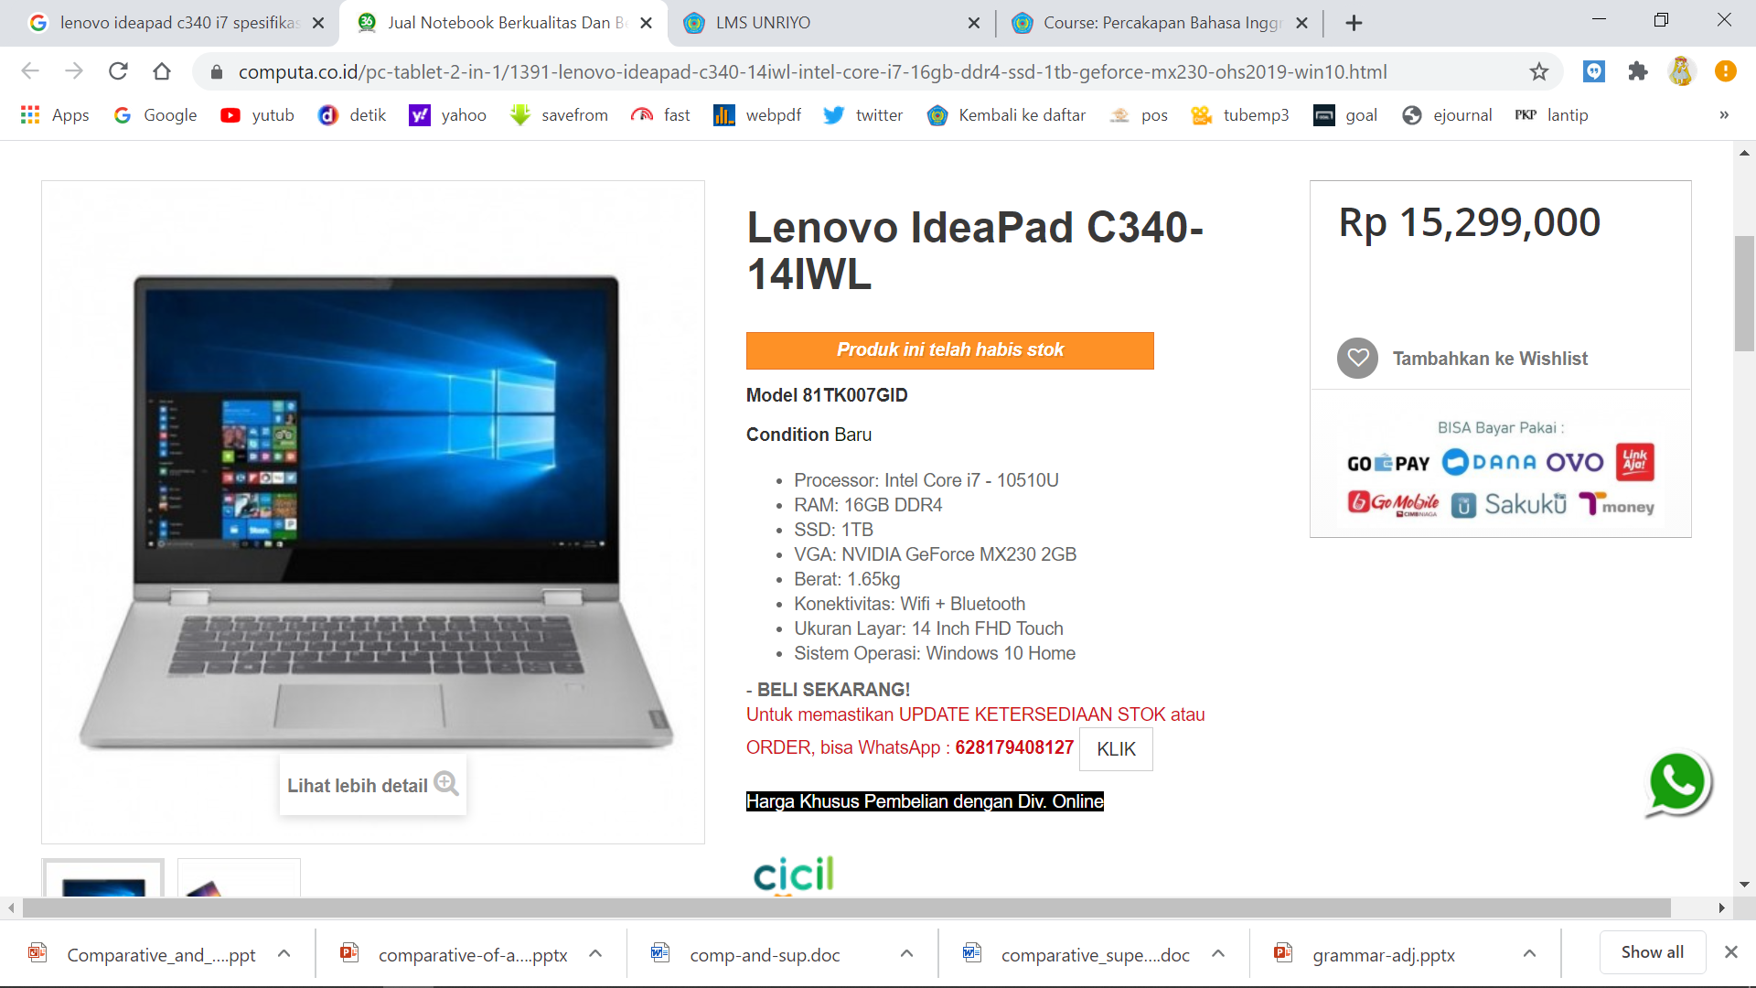

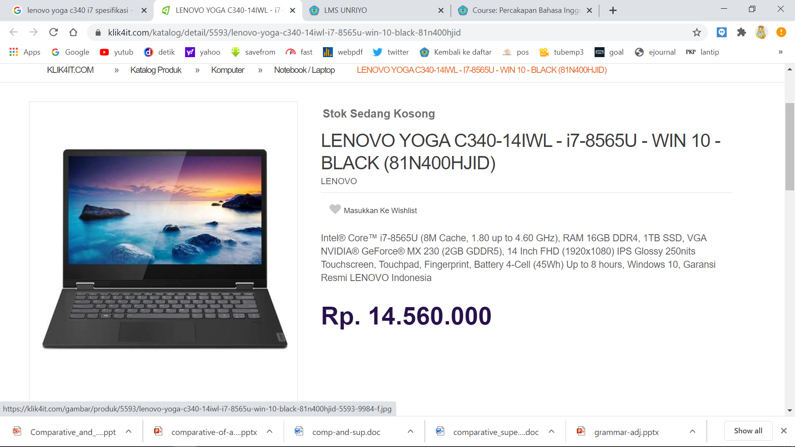

Answer:

1. the price of the lenova ideapad laptop is more expensive than the lenovo yoga
2. lenovo yoga has the same ram capacity as lenovo ideapad
3. the ssd Lenovo ideapad as bigger as the ssd Lenovo yoga.
4. Windows Lenovo yoga is the better than lenova ideapad
5. The screen Lenovo yoga as bigger as the screen Lenovo ideapad