Tyler Grimes Jan. 27, 2016 Homework 3

### Ch. 5 #1, 3

##### 1.) Give a method for generating a random variable having density function

$$f(x)=\frac{e^{x}}{e−1},0≤x≤1$$

##### Derivation

We will use the inverse cdf method. First, we need the cdf of the distribution. We integrate $f$ from $0$ to $x$.

$$\begin{matrix}F(x) & =\int_{0}^{x}{\frac{e^{t}}{e−1}dt} \\ & ={\left[\frac{1}{e−1}e^{x}\right]}_{0}^{x} \\ & =\frac{e^{x}−1}{e−1},0≤x≤1\end{matrix}$$

Next, finding the inverse of $F(x)$, we obtain

$$\begin{matrix}y & =\frac{e^{x}−1}{e−1} \\ ⇒x & =ln(y(e−1)+1)\end{matrix}$$

Considering the domain of $F^{−1}$, when $x=0$, $ln(y(e−1)+1)=0$ and $y=0$. When $x=1$, $ln(y(e−1)+1)=1$ and $y=1$. Now, $F^{−1}$ is an increasing function of $y$, so the domain is $[0,1]$ and we have

$$F^{−1}(x)=ln(x(e−1)+1),0≤x≤1$$

##### Algorithm

To generate a variable from the distribution,

1. Generate $u∼Unif(0,1)$.
2. Evaluate $x=ln(u(e−1)+1)$.

##### Simulation

set.seed(12)  
n <- 1000  
u <- runif(n, 0, 1)  
x <- log(u*(exp(1) - 1) + 1)  
  
points <- seq(0, 1, 1/n)  
graph.x <- (exp(points) - 1)/(exp(1) - 1)  
graph.ecdf <- (ecdf(x))(points)  
plot(x = points, y = graph.x, type = "l", xlab = "x",  
 ylab = "cumulative relative frequency", main = "CDF vs Emerical CDF (red)")  
lines(x = points, y = graph.ecdf, type = "s", col = "red")

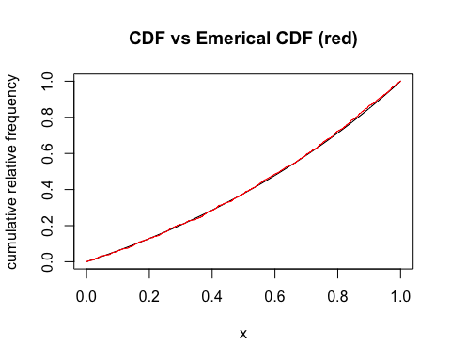

To provide some verification of our method, we generate $n=1000$ random variables using the algorithm described. The emperical cdf of this random sample (the R function ecdf() produces this for us) is graphed against the true cdf. The similarity of these two graphs suggests that our method is generating random variables with the correct distribution. And, if we use $n={10}^{5}$ random variables, the two graphs become indistinguishable (not shown here).

##### 3.) Use the inverse transformation method to generate a random variable having distribution function

$$F(x)=\frac{x^{2}+x}{2},0≤x≤1$$

##### Derivation

First we find the inverse of $F(x)$,

$$\begin{matrix}y & =\frac{x^{2}+x}{2} \\ ⇒2y & =x^{2}+x+\frac{1}{4}−\frac{1}{4} \\ ⇒2y+\frac{1}{4} & ={\left(x+\frac{1}{2}\right)}^{2} \\ ⇒x & =\sqrt{2y+\frac{1}{4}}−\frac{1}{2}\end{matrix}$$

Considering the domain of $F^{−1}$, when $x=0$, $\sqrt{2y+\frac{1}{4}}−\frac{1}{2}=0$ and $y=0$. When $x=1$, $\sqrt{2y+\frac{1}{4}}−\frac{1}{2}=1$ and $y=1$. Now, $F^{−1}$ is an increasing function of $y$, so the domain is $[0,1]$ and we have

$$F^{−1}(x)=\sqrt{2x+\frac{1}{4}}−\frac{1}{2},0≤x≤1$$

##### Algorithm

To generate a variable from the distribution,

1. Generate $u∼Unif(0,1)$.
2. Evaluate $x=\sqrt{2u+\frac{1}{4}}−\frac{1}{2}$.

##### Simulation

u <- runif(n, 0, 1)  
x <- sqrt(2*u + 1/4) - 1/2  
  
points <- seq(0, 1, 1/n)  
graph.x <- (points^2 + points)/2  
graph.ecdf <- (ecdf(x))(points)  
plot(x = points, y = graph.x, type = "l", xlab = "x",  
 ylab = "cumulative relative frequency", main = "CDF vs Emerical CDF (red)")  
lines(x = points, y = graph.ecdf, type = "s", col = "red")

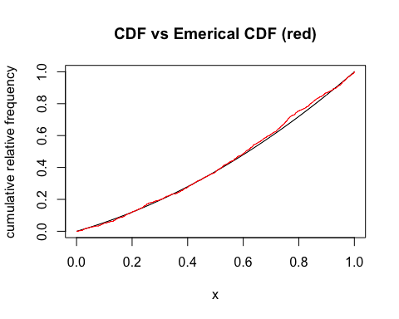

As before, we attempt to give some verification of our method. We generate $n=1000$ random variables using the algorithm described. The emperical cdf is plotted with the true cdf. The similarity of these two graphs suggests that our method is generating random variables with the correct distribution. Also as before, if we use $n={10}^{5}$ random variables, the two graphs become indistinguishable (not shown).