First name: _______________ Last name: __________________________Student ID: ____________

**Instructions:**

1. **Smart phones and smart watches are prohibited. Non-text storing calculators are allowed.**
2. This test contains 3 pages. There are 4 problems for a total of 100 points.
3. You may use an A4-sized double-sided cheat sheet. Any other books or notes are prohibited.
4. Do not use more than 2 decimal places.
5. If you use back of a sheet, you must clearly indicate so.

**Problem 1:** (40 points) You are given the dataset below with three descriptive features (*age, gender, uni_degree*) with *loan_paid* being the target feature.

|  |  |  |  |
| --- | --- | --- | --- |
| age | gender | *uni_degree* | loan_paid |
| 27 | male | true | yes |
| 43 | female | false | no |
| 56 | male | false | no |
| 35 | female | true | yes |
| 32 | female | true | no |

1. (7 points) Compute the impurity of this dataset with respect to the target feature if Entropy is used.
2. (25 points) Which one of the two descriptive features would you split at the root node if you are to use the Entropy split criterion and decide based on information gain: *gender or uni_degree*? Show all your work.

First name: _______________ Last name: __________________________Student ID: ____________

1. (8 points) Suppose you decided to split on the *age* variable with a cutoff value of 40 and you decided to make only one split at the root node. Draw the corresponding decision tree and label the predictions made at each one of the leaf nodes.

**Problem 2:** (20 points) You are given the following dataset that describes shopping patterns of 3 customers on 4 items and whether these customers eventually signed up for a loyalty card, which is denoted by the Signup feature.

|  |  |  |  |  |  |
| --- | --- | --- | --- | --- | --- |
| ID | Item 1 | Item 2 | Item 3 | Item 4 | Signup |
| 1 | True | True | False | False | Yes |
| 2 | False | False | True | False | No |
| 3 | False | True | True | True | Yes |

Consider Chapter 5: Similarity-Based Learning in the textbook and recall that

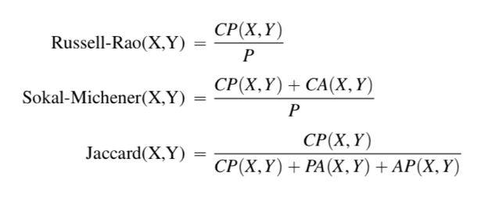

What prediction would you make for the following customer in regards to the Signup feature using the **Sokal-Michener** similarity index? Show all your work for full credit.

|  |  |  |  |  |
| --- | --- | --- | --- | --- |
| ID | Item 1 | Item 2 | Item 3 | Item 4 |
| 4 | True | False | False | True |

First name: _______________ Last name: __________________________Student ID: ____________

**Problem 3:** (25 points, 5 points each) Fill in the blanks with no more than a few words.

1. In a certain class of machine learning problems, there are only descriptive features and no particular target feature. This class of machine learning problems is known as ____________________.
2. There are two kinds of mistakes that can be made in a prediction modeling problem. The first kind of mistake is that the prediction model selected by the algorithm is too simplistic to represent the underlying relationship between the descriptive feature and the target feature. This kind of mistake is called _________________.
3. There are two kinds of mistakes that can be made in a prediction modeling problem. The second type of mistake is that the prediction model selected by the algorithm is so complex that the model fits to the dataset too closely and becomes sensitive to the noise in the data. This kind of mistake is called _________________.
4. In many cases, a unique solution cannot be determined using only the information available in a machine learning problem. This is why machine learning is considered as ___________________ problem.
5. The set of assumptions that define the model selection criteria of a machine learning algorithm is known as ____________________.

**Problem 4:** (15 points, 3 points each) For each one of the scenarios below, **circle** whether the nearest neighbor (NN) or the decision tree (DT) method would be preferable in general. If you circle both choices for a scenario, you will not receive any points.

1. NN / DT: There are many irrelevant descriptive features in the training data.
2. NN / DT: The underlying process is relatively stable and you do not want to continuously re-train the learner as new data becomes available.
3. NN / DT: There are a large number of observations in the training data and you would like to make a prediction rather quickly.
4. NN / DT: You would like to use a lazy learner.
5. Circle the correct answer: True / False: I wrote my name and student ID in a legible manner on the top of **all pages** where indicated.