PROGRAM 1
<!DOCTYPE html>
<html lang="en">
<head>
<meta charset="UTF-8">
<meta name="viewport" content="width=device-width, initial-scale=1.0">
<title>My Resume</title>

<style>
* { margin: 0; padding: 0; box-sizing: border-box;
}

body { font-family: Arial, sans-serif; line-height: 1.6; background: #f2f4f7; color: #333;
}

/* Main Container */ .container { width: 90%; max-width: 1100px; margin: 30px auto; background: white; box-shadow: 0 0 15px rgba(0,0,0,0.1);
}

/* Header */ header { background: #1e3a5f; color: white; padding: 30px; display: flex; justify-content: space-between; align-items: center; gap: 20px;
}

.profile { display: flex; align-items: center; gap: 20px;
}

.profile-img { width: 110px; height: 110px; border-radius: 50%; background: #ddd; border: 4px solid white; display: flex; justify-content: center; align-items: center; color: #555; font-size: 14px;

}

/* Content Layout */ .content { display: flex; gap: 30px; padding: 30px;
}

.left-column { flex: 2;
}

.right-column {
flex: 1;
}

section { margin-bottom: 30px;
}

section h2 { color: #1e3a5f; border-bottom: 3px solid #5bc0eb; padding-bottom: 8px; margin-bottom: 15px;
}

/* Skills - Flexbox */
.skills {
display: flex; flex-wrap: wrap; gap: 10px;
}

.skill { background: #1e3a5f; color: white; padding: 8px 15px; border-radius: 20px;
}

/* Education Table */ table { width: 100%; border-collapse: collapse;
} th, td { border: 1px solid #ddd; padding: 12px; text-align: left; background: #f5f7fa;
}

/* Experience */ .experience { border-left: 4px solid #5bc0eb; padding-left: 20px; margin-bottom: 20px;
}

.experience h3 { color: #1e3a5f;
}
font-weight: bold;
} input, textarea, select { width: 100%; padding: 10px; border: 1px solid #ccc; border-radius: 5px; font-size: 15px;
}

textarea { height: 100px; resize: vertical;
}

button { background: #1e3a5f; color: white; border: none; padding: 12px; border-radius: 5px; cursor: pointer; font-size: 16px;
}

button:hover { background: #5bc0eb; color: #111;
}

/* Footer */ footer { text-align: center; background: #142940; color: white; padding: 20px;
}

/* Responsive Design */
@media (max-width: 768px) {

header { flex-direction: column; text-align: center;
} margin: 8px;
} table { font-size: 14px;
}
}
</style>
</head>
<body>

<div class="container">

<!-- Header -->
<header>
<div class="profile">
<div class="profile-img">
PHOTO
</div>
<a href="#about">About</a>
<a href="#education">Education</a>
<a href="#experience">Experience</a>
<a href="#skills">Skills</a>
<a href="#contact">Contact</a>
</nav>
<div class="content">

<!-- Left Column -->
<main class="left-column">

<!-- About -->
<section id="about"> <h2>About Me</h2>

<p>
I am a passionate web developer interested in creating responsive, user-friendly and modern websites.
I enjoy learning new technologies and solving programming problems.
</p>
</section>

<!-- Experience -->
<section id="experience">
<h2>Work Experience</h2>

<div class="experience">
<h3>Frontend Developer - ABC Technologies</h3>
<p class="date">2024 - Present</p>

<p>
Developed responsive websites using HTML, CSS,
JavaScript and modern frontend techniques.
</p>
</div>

<div class="experience">
<h3>Web Developer Intern - XYZ Solutions</h3>
<p class="date">2023 - 2024</p>

<p>
Assisted in developing web applications and maintaining company websites.
</p>
</div>
</section>

<!-- Education Table -->
<section id="education">
<h2>Education</h2>

<table>
<thead>
<tr>
<th>Qualification</th>
<th>Institution</th>
<th>Year</th>
<th>Percentage</th>
</tr>
</thead>

<tbody>
<tr>
<td>B.Sc Computer Science</td>
<td>ABC College</td>
<td>2024</td>
<td>85%</td>
</tr>
<tr>
<td>Higher Secondary</td>
<td>XYZ School</td>
<td>2021</td>
<td>88%</td>
</tr>

<tr>
<td>SSLC</td>
<td>XYZ School</td>
<td>2019</td>
<td>92%</td>
</tr>
</tbody>
</table>
</section>
</main>
<!-- Right Column -->
<aside class="right-column">
<!-- Skills -->
<section id="skills">
<h2>Skills</h2>
<div class="skills">
<span class="skill">HTML</span>
<span class="skill">CSS</span>
<span class="skill">JavaScript</span>
<span class="skill">Python</span>
<span class="skill">Java</span>
<span class="skill">SQL</span>
<span class="skill">Git</span>
<span class="skill">Figma</span>
</div>
</section>
<input
type="text" id="name" name="name" placeholder="Enter your name"
required
<label for="purpose">Purpose</label>
<select id="purpose" name="purpose">
<option value="job">Job Opportunity</option>
<option value="project">Project</option>
<option value="freelance">Freelance Work</option>
<option value="other">Other</option>
</select>
<label for="message">Message</label>
<textarea
id="message" name="message" placeholder="Write your message..."
></textarea>
<button type="submit">
Send Message
</button>
</form>
</section>
</aside>
</div>
<!-- Footer -->
<footer>
<p>© 2026 John Doe | All Rights Reserved</p>
</footer>
</div>
</body>
</html>

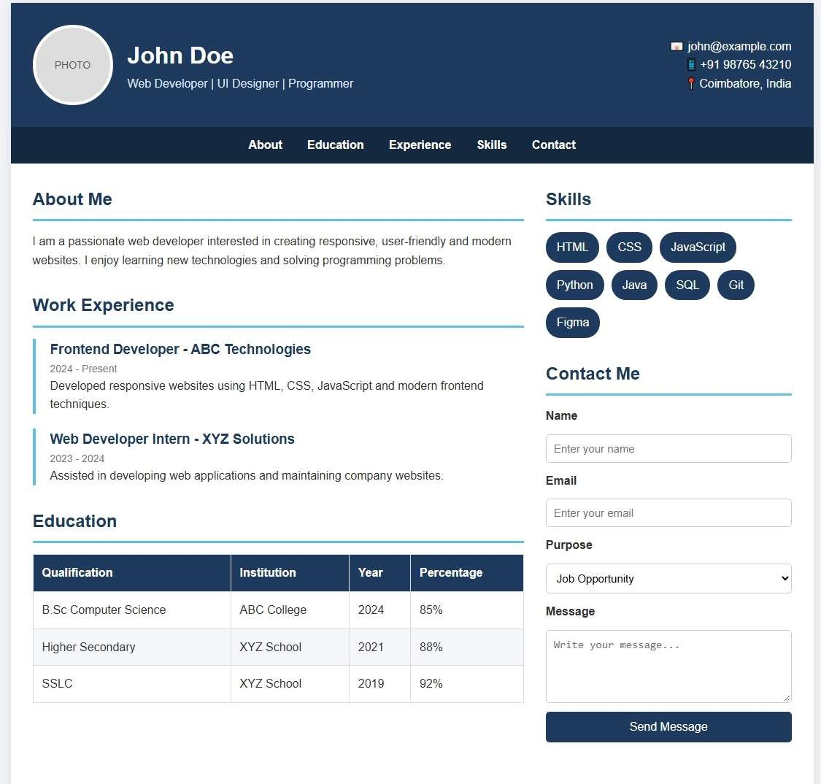

RESULT

Thus, the above program is executed successfully and the output is verified

PROGRAM 2
name = "Alice" # String age = 20 # Integer height = 5.6 # Float is_student = True # Boolean subjects = ["Python", "Math", "Science"] # List print("Basic Data Types:") print("Name:", name) print("Age:", age) print("Height:", height) print("Student:", is_student) print("Subjects:", subjects) def greet(person): """Return a greeting message.""" return "Hello, " + person + "!" def divide(a, b): """Divide two numbers."""
return a / b print("\nFunctions:") print(greet(name)) print("10 / 2 =", divide(10, 2)) print("\nError Handling:")
try:
number = int(input("Enter a number: ")) result = 100 / number

finally:
print("Program execution completed.")

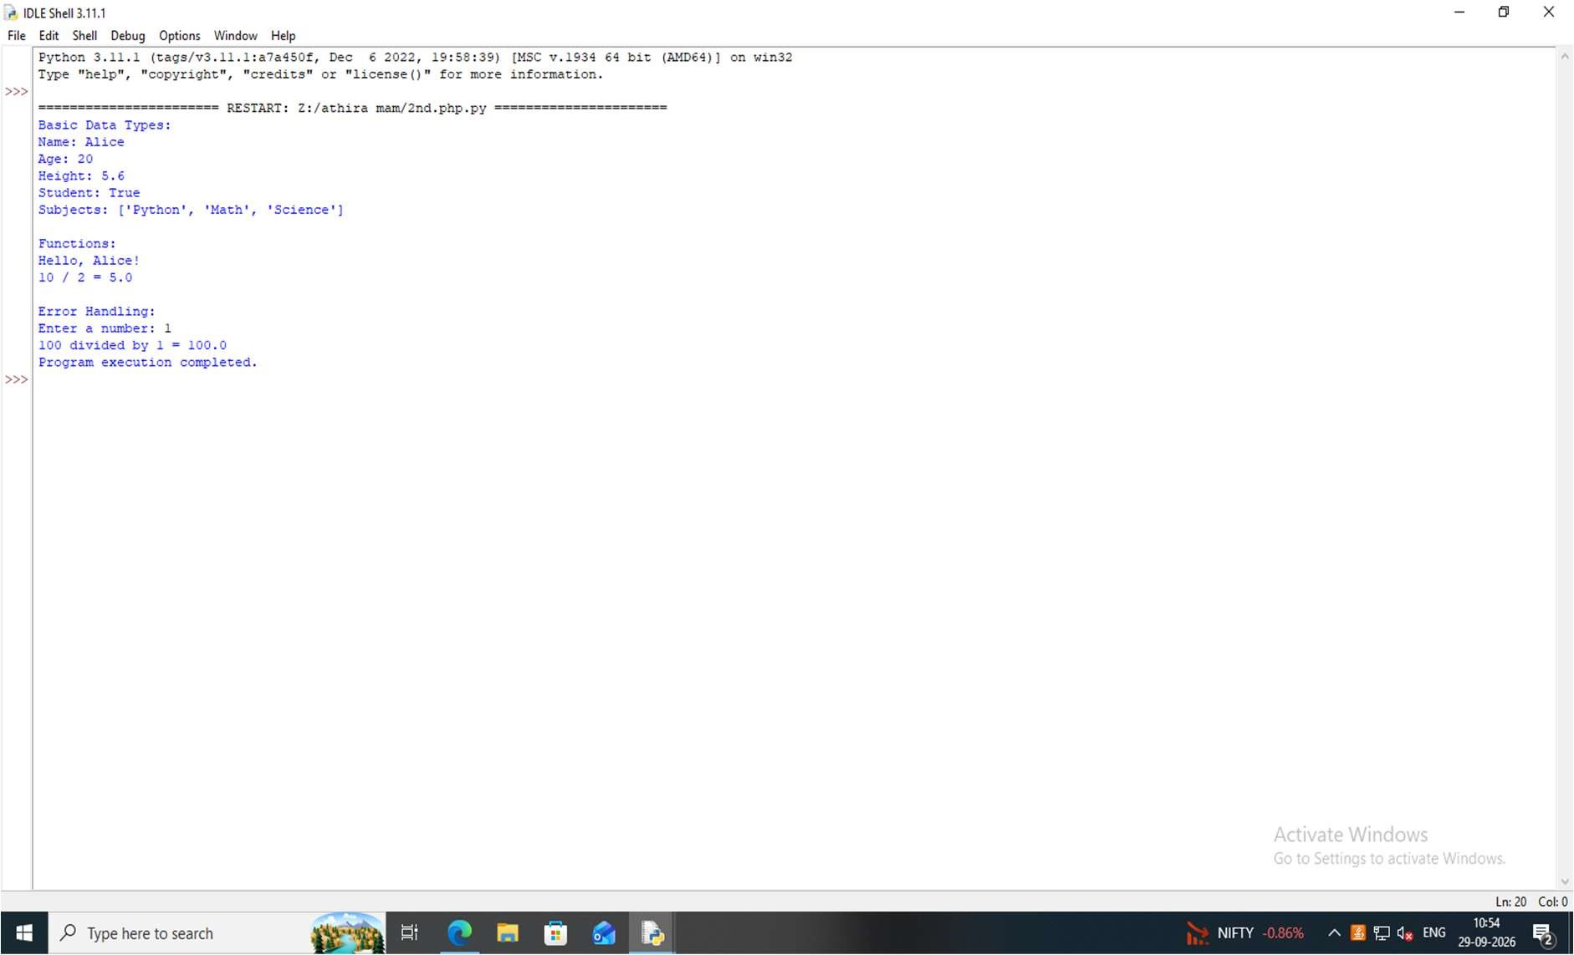

RESULT

Thus, the above program is executed successfully and the output is verified

PROGRAM 3
class Student: def __init__(self, name, age, mark):
self.name = name self.age = age self.mark = mark

def display_details(self): print("Student Name:", self.name) print("Age:", self.age) print("Mark:", self.mark)

def check_result(self): if self.mark >= 40: print("Result: Pass") else:
print("Result: Fail")

student1 = Student("Anu", 20, 85) student2 = Student("Priya", 19, 35) print("Student 1") student1.display_details() student1.check_result() print("\nStudent 2") student2.display_details() student2.check_result()

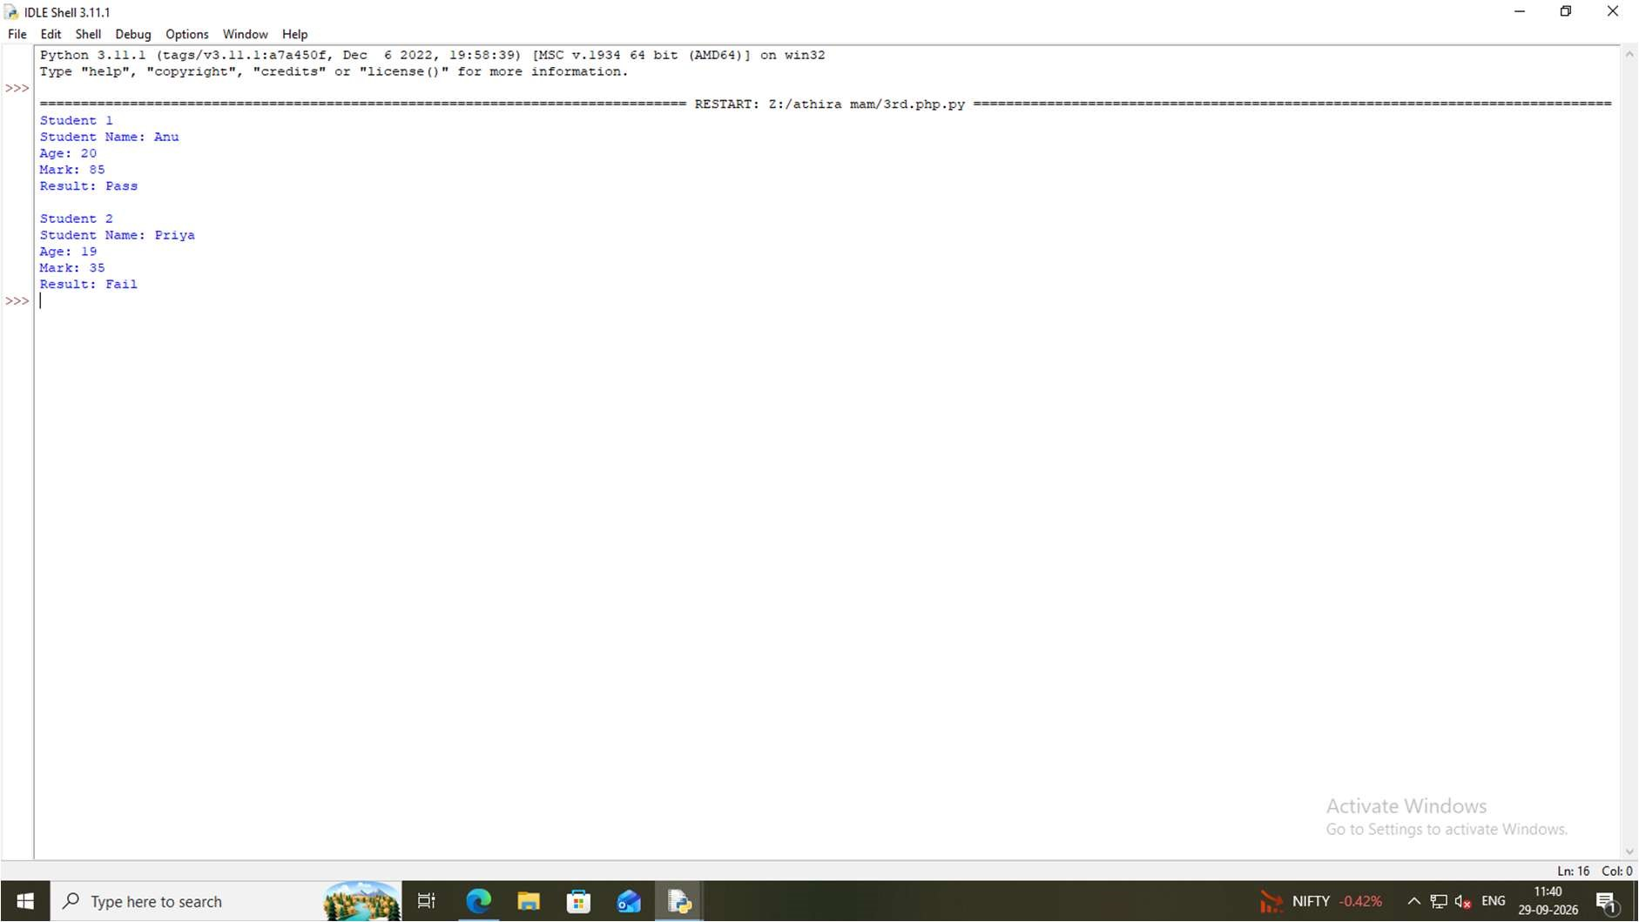

RESULT

Thus, the above program is executed successfully and the output is verified

PROGRAM 4
App.py from flask import Flask, render_template app = Flask(__name__) @app.route("/") def home():
return render_template("index.html")

@app.route("/about") def about():
return render_template("about.html")

@app.route("/hello/<name>") def hello(name):
return f"Hello, {name}!"

if __name__ == "__main__": app.run(debug=True)

About.html
<!DOCTYPE html>
<html>
<head>
<title>About</title>
</head>
<body>
<h1>About Page</h1>
<p>This is a basic Flask application.</p>

<a href="/">Home</a>

</body>
</html>

Index.html
<!DOCTYPE html>
<html>
<head>
<title>Home</title>
</head>
<body>
<h1>Welcome to Flask!</h1>
<p>This is the Home Page.</p>

<a href="/about">About</a>
</body>
</html>

OUTPUT
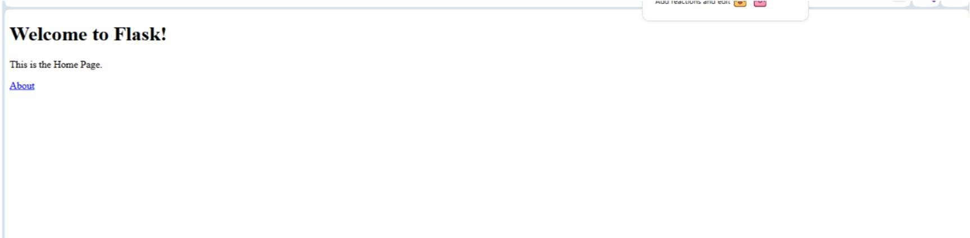

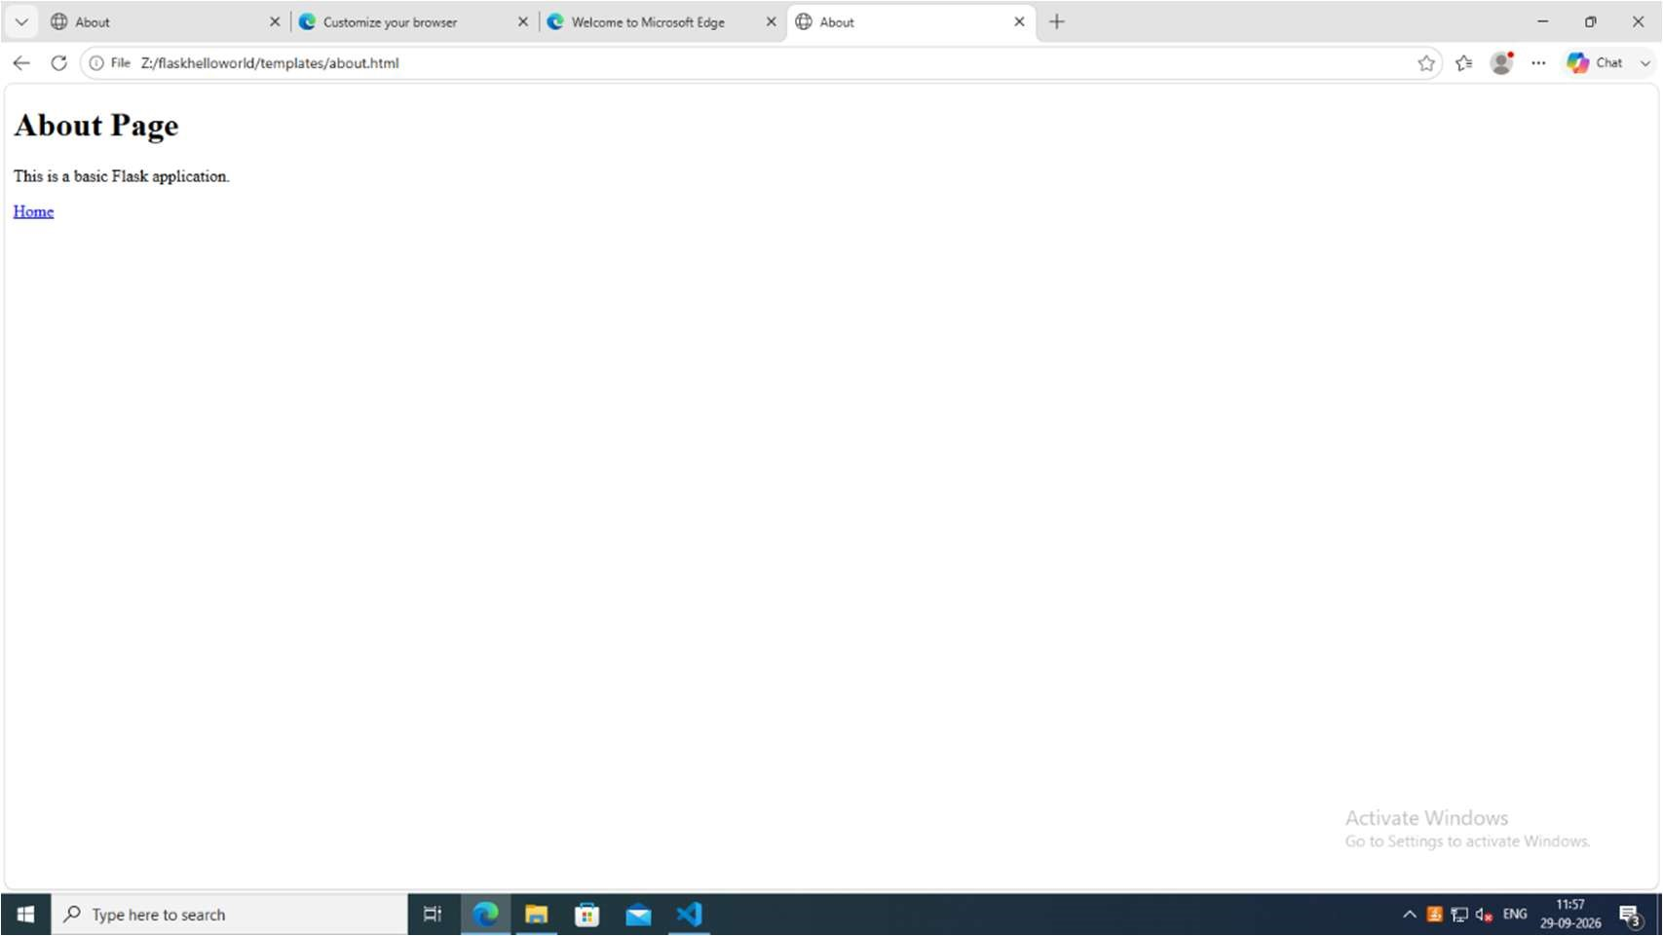

RESULT

Thus, the above program is executed successfully and the output is verified

PROGRAM 5
App.py from flask import Flask, render_template, request

app = Flask(__name__) @app.route("/") def home():
return render_template("form.html") @app.route("/get_form", methods=["GET"]) def get_form():
name = request.args.get("name") email = request.args.get("email")

return render_template( "result.html", method="GET", name=name, email=email
)

@app.route("/post_form", methods=["POST"]) def post_form():
name = request.form.get("name") email = request.form.get("email")

return render_template(
"result.html", method="POST", name=name, email=email
)
if __name__ == "__main__": app.run(debug=True)

Form.html
<!DOCTYPE html>
<html>
<head>
<title>Flask Form Handling</title>
</head>
<body>
<h1>Flask Form Handling</h1>
<h2>GET Method</h2>
<form action="/get_form" method="GET">
<label>Name:</label>
<input type="text" name="name" required>
<br><br>
<label>Email:</label>
<input type="email" name="email" required>
<br><br>
<button type="submit">Submit using GET</button>
</form>
<hr>
<h2>POST Method</h2>
<form action="/post_form" method="POST">
<label>Name:</label>
<input type="text" name="name" required>
<br><br>

<label>Email:</label>
<input type="email" name="email" required> <br><br>

<button type="submit">Submit using POST</button>
</form>

</body>
</html>

Result.html
<!DOCTYPE html>
<html>
<head>
<title>Form Result</title>
</head>
<body>

<h1>Form Submitted Successfully</h1>

<p><strong>Method Used:</strong> {{ method }}</p>
<p><strong>Name:</strong> {{ name }}</p>
<p><strong>Email:</strong> {{ email }}</p>

<br>

<a href="/">Back to Form</a>

</body>
</html>

OUTPUT
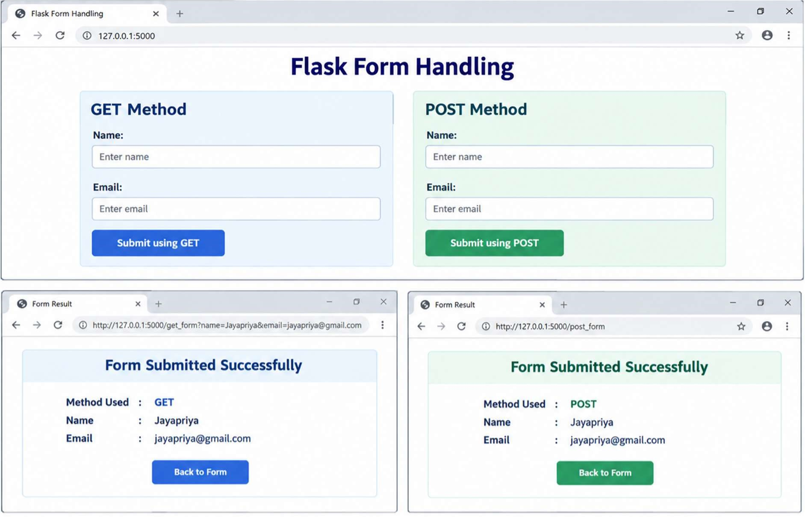

RESULT

Thus, the above program is executed successfully and the output is verified

PROGRAM 6
from flask import Flask, render_template, request, redirect, url_for, session, flash app = Flask(__name__) app.secret_key = "your-secret-key-change-this"
USERS = {
"admin": "password123",
"john": "test123"
}

@app.route("/") def home():
if "user" in session:
return redirect(url_for("dashboard")) return redirect(url_for("login"))

@app.route("/login", methods=["GET", "POST"]) def login():
if request.method == "POST":
username = request.form["username"] password = request.form["password"]

if username in USERS and USERS[username] == password:
session["user"] = username flash("Login successful!", "success") return redirect(url_for("dashboard"))
else:
flash("Invalid username or password.", "danger")

return render_template("login.html")

@app.route("/dashboard") def dashboard(): if "user" not in session:
flash("Please login first.", "warning") return redirect(url_for("login"))

return render_template( "dashboard.html", username=session["user"]
)
@app.route("/logout") def logout():
session.pop("user", None) flash("Logged out successfully.", "info") return redirect(url_for("login")) if __name__ == "__main__": app.run(debug=True)

Dashboard.html
<!DOCTYPE html>
<html>
<head>
<title>Dashboard</title>
</head>
<body>

<h2>Welcome {{ username }}</h2>

<p>You are logged in.</p>

<a href="{{ url_for('logout') }}">Logout</a>

</body>
</html>

Login.html
<!DOCTYPE html>
<html>
<head>
<title>Login</title>
</head>
<body>
<h2>Login</h2>
{% with messages = get_flashed_messages(with_categories=true) %}
{% if messages %}
{% for category, message in messages %}
<p>{{ message }}</p>
{% endfor %}
{% endif %}
{% endwith %}
<form method="POST">
<label>Username</label><br>
<input type="text" name="username" required><br><br>
<label>Password</label><br>
<input type="password" name="password" required><br><br>
<button type="submit">Login</button>
</form>

</body>
</html>

OUTPUT
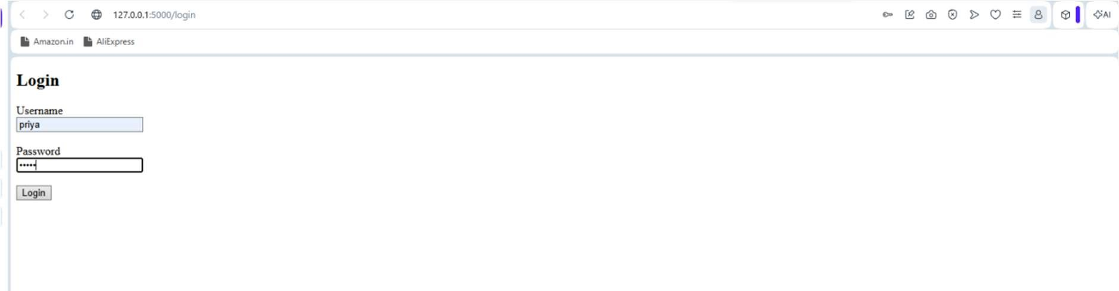

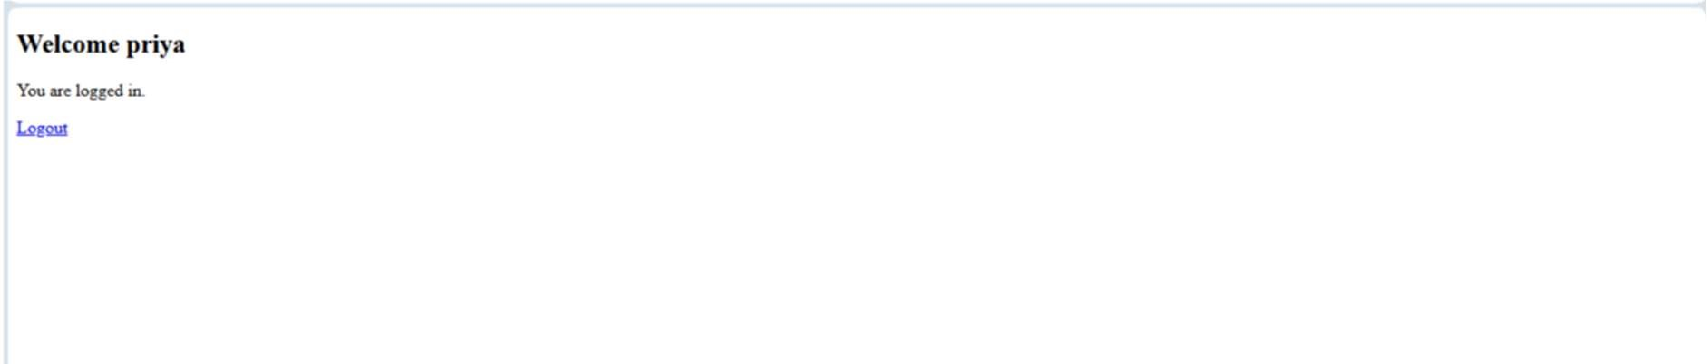

RESULT

Thus, the above program is executed successfully and the output is verified

PROGRAM 7
<!DOCTYPE html>
<html>
<head>
<title>Form Validation</title>
</head>
<body>
<h2>User Registration</h2>
<form id="registrationForm">
<label>Name:</label>
<input type="text" id="name">
<br><br>
<label>Email:</label>
<input type="text" id="email">
<br><br>
<label>Password:</label>
<input type="password" id="password">
<br><br>
<label>Age:</label>
<input type="number" id="age">
<br><br>
<button type="submit">Submit</button>
</form>
<p id="message"></p>
<script> document.getElementById("registrationForm").addEventListener("submit", function(event) { event.preventDefault(); let name = document.getElementById("name").value.trim(); let email = document.getElementById("email").value.trim(); let password = document.getElementById("password").value;
let age = document.getElementById("age").value; let message = document.getElementById("message"); if (name === "") { message.textContent = "Name is required."; message.style.color = "red"; return;
}
let emailPattern = /^[^ ]+@[^ ]+\.[a-z]{2,3}$/;

if (!emailPattern.test(email)) { message.textContent = "Please enter a valid email address."; message.style.color = "red"; return;
}
if (password.length < 6) { message.textContent = "Password must contain at least 6 characters."; message.style.color = "red"; return;
} if (age === "" || age < 18) { message.textContent = "You must be at least 18 years old."; message.style.color = "red"; return;
}
message.textContent = "Form submitted successfully!"; message.style.color = "green";
});
</script>
</body>
</html>

OUTPUT
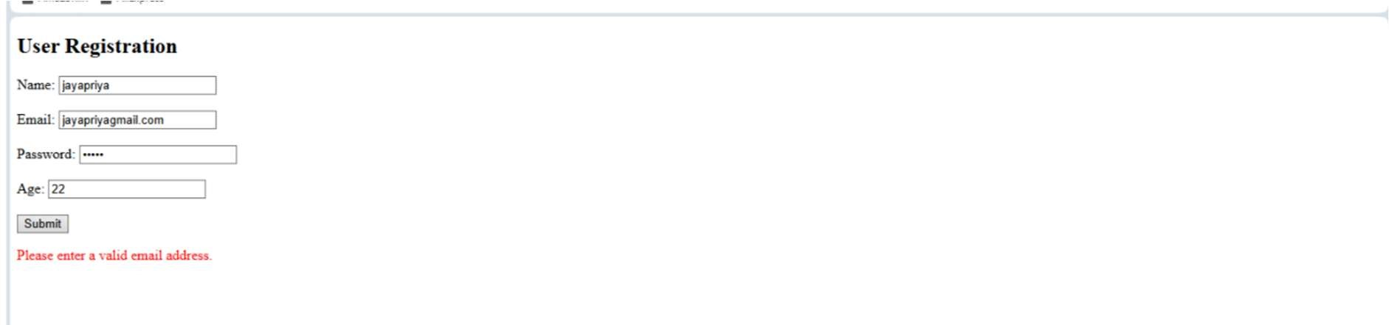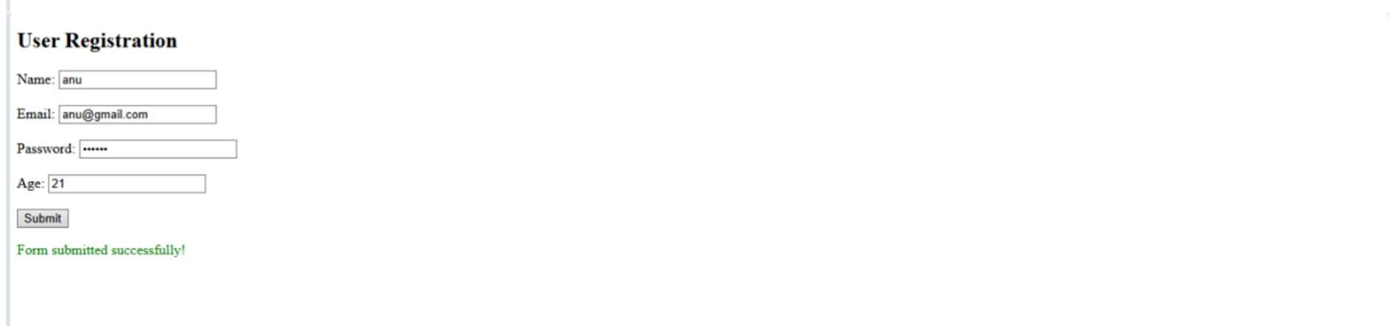

RESULT

Thus, the above program is executed successfully and the output is verified

PROGRAM 8
<!DOCTYPE html>
<html>
<head>
<title>To-Do List</title>

<style>
body { font-family: Arial; text-align: center; margin-top: 50px;
}
input { padding: 10px; width: 250px;
}

button { padding: 10px; margin-left: 5px;
} li { list-style: none; margin: 10px;
}

.delete { background-color: red; color: white; border: none; margin-left: 15px;
}
</style>
</head>
<body>
<h2>My To-Do List</h2>
<input type="text" id="task" placeholder="Enter a task">
<button id="add">Add</button>
<ul id="list"></ul>
<script>
// Get HTML elements let task = document.getElementById("task"); let add = document.getElementById("add"); let list = document.getElementById("list");

// Add task when button is clicked add.addEventListener("click", function() {

if (task.value == "") { alert("Please enter a task"); return;
}

// Create list item let li = document.createElement("li");

// Add task text li.innerHTML = task.value; // Create delete button let deleteBtn = document.createElement("button"); deleteBtn.innerHTML = "Delete"; deleteBtn.className = "delete";

// Delete task deleteBtn.addEventListener("click", function() { li.remove();
});

// Add delete button to list item li.appendChild(deleteBtn);

// Add list item to ul list.appendChild(li);

// Clear input task.value = "";
});

</script>
</body>
</html>

OUTPUT
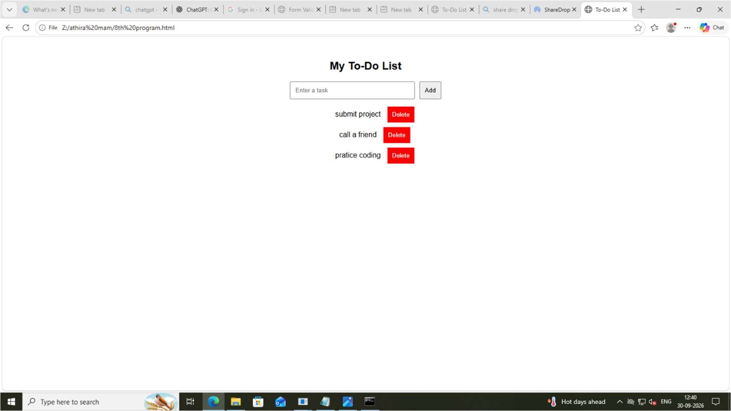

RESULT

Thus, the above program is executed successfully and the output is verified

PROGRAM 9
- CREATE CUSTOMERS TABLE CREATE TABLE customers ( customer_id INT PRIMARY KEY, customer_name VARCHAR2(100), city VARCHAR2(50)
);
- CREATE ORDERS TABLE CREATE TABLE orders ( order_id INT PRIMARY KEY, customer_id INT, product VARCHAR2(100), amount DECIMAL(10,2),
FOREIGN KEY (customer_id) REFERENCES customers(customer_id)
);
- INSERT DATA INTO CUSTOMERS
INSERT INTO customers VALUES (1, 'Arun', 'Coimbatore');
INSERT INTO customers VALUES (2, 'Priya', 'Chennai');
INSERT INTO customers VALUES (3, 'Rahul', 'Bangalore');

- INSERT DATA INTO ORDERS
INSERT INTO orders VALUES (101, 1, 'Laptop', 55000);
INSERT INTO orders VALUES (102, 1, 'Mouse', 800);

- MODIFY PRODUCT COLUMN
ALTER TABLE orders MODIFY product VARCHAR2(15);

- LEFT JOIN
Display all customers, including
-- customers who have no orders

OUTPUT
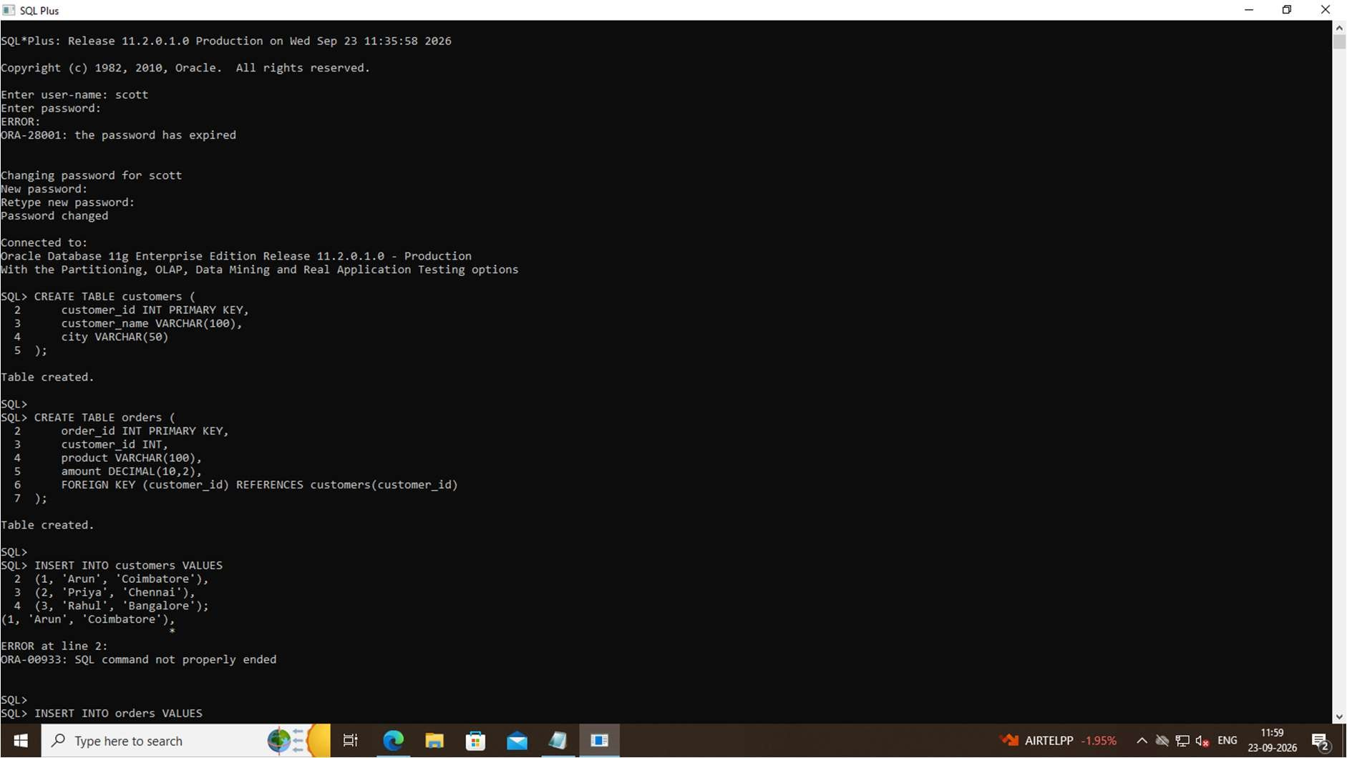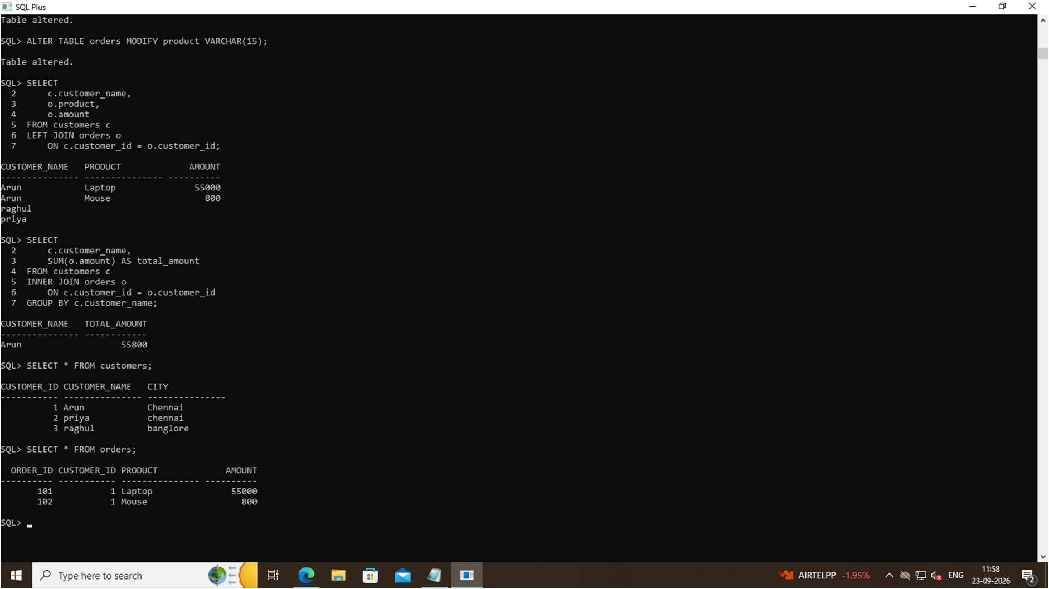

RESULT

Thus, the above program is executed successfully and the output is verified

PROGRAM 10

MYSQL
CREATE DATABASE employee_db;
USE employee_db; CREATE TABLE employees ( id INT AUTO_INCREMENT PRIMARY KEY, name VARCHAR(100) NOT NULL, email VARCHAR(100) NOT NULL, department VARCHAR(100), salary DECIMAL(10,2)
);
INSERT INTO employees (name, email, department, salary)
VALUES
('Jayapriya', 'jayapriya@gmail.com', 'IT', 35000),
('Anitha', 'anitha@gmail.com', 'HR', 30000),
('Priya', 'priya@gmail.com', 'Finance', 40000);

APP.PY
from flask import Flask, render_template, request, redirect, jsonify from db import get_db_connection app = Flask(__name__) @app.route("/") def index():
connection = get_db_connection() cursor = connection.cursor(dictionary=True) cursor.execute("SELECT * FROM employees") employees = cursor.fetchall() cursor.close() connection.close() return render_template("index.html", employees=employees)
@app.route("/add", methods=["GET", "POST"])

INDEX.HTML
<!DOCTYPE html>
<html>
<head>
<title>Employee Management</title>
<link rel="stylesheet" href="{{ url_for('static', filename='style.css') }}">
</head>
<body>
<div class="container">
<h1>Employee Management System</h1>
<a href="/add" class="button">Add Employee</a>
<table>
<tr>
<th>ID</th>
<th>Name</th>
<th>Email</th>
<th>Department</th>
<th>Salary</th>
<th>Actions</th>
</tr>

{% for employee in employees %}
<tr>
<td>{{ employee.id }}</td>
<td>{{ employee.name }}</td>
<td>{{ employee.email }}</td>
<td>{{ employee.department }}</td>
<td>₹{{ employee.salary }}</td>
<td>

<a href="/edit/{{ employee.id }}">
Edit
</a>
<a href="/delete/{{ employee.id }}" onclick="return confirm('Are you sure you want to delete this employee?')">
Delete
</a>

</td>
</tr>
{% endfor %}
</table>
<h3>REST API</h3>
<p>
<a href="/api/employees">
View Employee API
</a>
</p>
</div>
</body>
</html>

STYLE.CSS
body { font-family: Arial, sans-serif; background: #f2f2f2;
} .container { width: 90%; margin: 40px auto; background: white; padding: 30px;
}

h1 { text-align: center; } .button, button { background: #2563eb; color: white; padding: 10px 18px; border: none; text-decoration: none; cursor: pointer; } table { width: 100%; margin-top: 25px; border-collapse: collapse; } th, td { border: 1px solid #ccc; padding: 12px; text-align: center; } th { background: #2563eb; color: white; }

OUTPUT

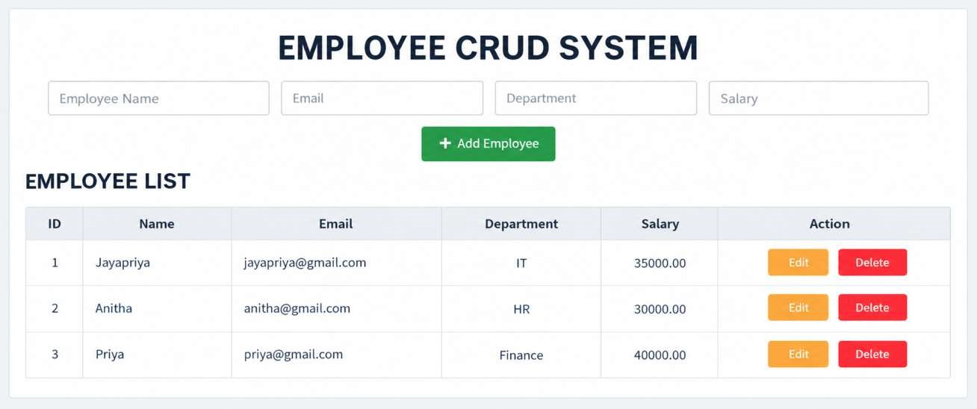

RESULT

Thus, the above program is executed successfully and the output is verified

