HealthTrack Monitoring Dashboard: User Interface Design

Todd Simonson
MSCS 699 Computer Science Capstone
Michael Solomon
November 15, 2026

HealthTrack Monitoring Dashboard: User Interface Design
The dashboard serves rehab clinicians who check a caseload of home patients between other tasks, so it answers three questions in order: who needs attention first, how the readings compare with that patient's own limits, and what action is required.
Layout
A fixed header sits above three columns that read left to right as triage, assessment, and action (Figure 1): the worklist ranked by most severe active alert; the selected patient's prescription, gauges, and trend charts; and the active alerts with their actions (Table 1).
Figure 1
Dashboard During a Critical Heart Rate Alert
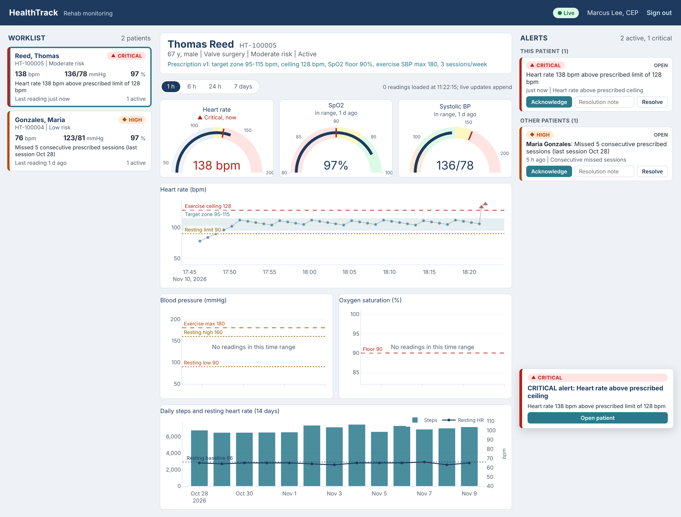
Note. Synthetic data. Thomas Reed's last two exercise readings exceeded his prescribed 128 bpm ceiling, so his card moved to the top, the readings are drawn as red triangles, and a pop-up was sent to his clinician.
Table 1
Components, Data Sources, and Update Method
Component | Purpose | Source | Updates
Worklist cards | Rank patients; latest values and top alert | Monitoring worklist | Each live event
Patient header | Identity, risk, and prescription limits | Patient and prescription | On selection
Gauges | Latest valid value against the patient's limits | Latest readings | Each reading (patched)
Trend charts | Heart rate, blood pressure, and SpO2 with zone and threshold lines | Readings, thresholds | Each reading (appended)
Activity chart | 14 days of steps and resting heart rate against baseline | Daily activity | On selection
Alert panel | Active alerts, acknowledge and resolve | Alert search | Each alert event
Pop-ups | Notifications addressed to this clinician | Notification events | On arrival
Connection pill | Live, or reconnecting with polling | WebSocket state | On change

Interaction Flow
After sign-in the top-ranked patient is already selected, so the highest-priority view takes zero clicks, inside the two-click limit of requirement NFR-15. When an alert arrives, the patient's card moves to the top, the alert joins the panel, and a pop-up offers Open patient. The clinician reviews the charts, acknowledges to take ownership and stop escalation, and resolves the alert with a required note. A link in an email or text opens the same patient after sign-in.
Design Decisions
Meaning never depends on color alone. Each severity has a color, a glyph, and a word, and abnormal points change both color and shape, following WCAG 2.1 guidance on the use of color (World Wide Web Consortium, 2018). Text contrast is at least 4.6:1, and red is reserved for critical alerts.
Charts and alerts share one source of limits. Zone bands and threshold lines are the thresholds the alert engine applies to that patient, so a chart never shows a flagged reading as normal.
Updates are pushed and drawn incrementally. WebSocket events arrive in 250 ms batches; new readings are appended in the browser without a server round trip, gauges get partial updates, and a 15-second poll covers a dropped connection. The 7-day view keeps each interval's high, low, and abnormal readings while thinning normal ones.
Alert fatigue and privacy carry into the screen. Repeats appear as occurrence counts, each alert shows at most one pop-up, and pop-ups close once the alert is acknowledged. The dashboard server holds the access and refresh tokens; the browser receives only a session cookie and a one-time WebSocket ticket.
References
World Wide Web Consortium. (2018). Web content accessibility guidelines (WCAG) 2.1. https://www.w3.org/TR/WCAG21/

