Control Structures in Two Languages: An Employee Shift Scheduler in Go and C++

Todd Simonson
MSCS 632: Advanced Programming Languages
Dr. Jay Thom
September 20, 2026

Control Structures in Two Languages: An Employee Shift Scheduler in Go and C++
Repository
The complete source for both implementations, the shared input file, and a verification script are available at:
https://github.com/tgsimonson/mscs632-shift-scheduler
Overview
This assignment implements a weekly employee shift scheduler twice, once in Go and once in C++. The two languages were selected for contrast rather than similarity: Go is garbage collected with goroutines and channel-based concurrency and a deliberately minimal syntax, while C++ manages resources through RAII, uses operating system threads directly, and provides templates and the STL. Both implementations read the same input file, apply the same scheduling rules, and produce byte-identical output, which was verified with diff rather than assumed.
Scheduling Rules
The company operates seven days a week with morning, afternoon, and evening shifts. No employee works more than one shift per day or more than five days per week, and every shift requires at least two employees. The prompt specifies a minimum of two per shift but no maximum, yet the phrase "the preferred shift is full" has no meaning without one. Both implementations therefore define a named constant setting shift capacity at three.
Input Format
Employee preferences are read from a shared text file. Each line holds a name followed by seven day entries, and each day entry is a ranked preference list separated by the greater-than character. A hyphen marks a day the employee is unavailable. Ranked preferences implement the optional bonus requirement.
name,mon,tue,wed,thu,fri,sat,sun
Alice Nguyen,morning,morning>afternoon,morning,afternoon,morning,-,evening
Kenji Watanabe,morning,morning,morning,morning,morning,morning,morning
Figure 1. Input format. Kenji ranks only one shift, which forces conflicts.
Scheduling Algorithm
Scheduling runs in four passes. The ordering was not the first approach attempted, and the reason for the final ordering is worth recording.
An initial version filled each shift to capacity in a single pass working Monday through Sunday. That version left all three shifts on Sunday completely unstaffed. The cause was that filling to capacity early in the week consumed the five-day cap of every employee before the weekend arrived. A second problem appeared once that was corrected: iterating employees in file order meant the names at the top of the file were selected every day until they reached their cap, which starved the back half of the week even when total capacity was sufficient.
Both problems are addressed structurally. Coverage is established before preferences are indulged, and employees are always taken least-loaded first.
Pass | Action | Purpose
1 | Assign preferred shifts, capped at two per shift | Spread coverage across all seven days before any shift fills
2 | Fill shifts below two with a random selection | Guarantee the staffing minimum everywhere
3 | Assign preferred shifts, capped at three per shift | Spend remaining capacity on preferences
4 | Resolve conflicts | Place employees whose preferred shifts were full
Table 1. The four scheduling passes.
Conflict Resolution
An employee whose ranked preferences are all full on a given day is placed on any other shift that day. If every shift that day is at capacity, the employee is deferred to the next day. If both days are fully staffed, the employee is simply off, and the program reports this as a no-vacancy outcome rather than a failure, because the company needs no additional coverage in that situation. The distinction matters: an unresolvable conflict and a day that does not need more staff are different conditions and are reported differently.
Randomness and Reproducibility
The prompt requires that additional employees be assigned randomly when a shift falls below the minimum. Using each language's standard library generator would produce different schedules in Go and C++ and make the two outputs impossible to compare. Both implementations therefore use the same hand-written linear congruential generator, with identical constants and an identical seed, so the random sequence matches across languages. The selection is random as required and reproducible for grading.
// Go
func (r *lcg) next() uint32 {
r.state = r.state*6364136223846793005 + 1442695040888963407
return uint32(r.state >> 33)
}

// C++
unsigned int next() {
state_ = state_ * 6364136223846793005ULL + 1442695040888963407ULL;
return static_cast<unsigned int>(state_ >> 33);
}
Figure 2. The same generator in both languages, relying on defined unsigned wraparound.
The random draw is further restricted to employees with the fewest days worked so far. An unrestricted draw can select an employee who is nearly at the weekly cap and leave a later day without enough eligible staff, so the restriction preserves feasibility while keeping the selection random.
Language Feature Contrast
The concurrent validation pass shows the clearest structural difference. Both implementations verify the three scheduling rules in parallel, one thread per rule.
// Go: goroutines and a WaitGroup
wg.Add(3)
go func() {
defer wg.Done()
// rule 1: no employee works twice in one day
}()
wg.Wait()

// C++: std::thread with explicit joins
std::thread t1([this, &report] { /* rule 1 */ });
t1.join();
Figure 3. Concurrency in each language.
Go's deferred call guarantees the counter decrements regardless of how the function exits, while C++ requires the join to be reached. Shared state is protected by a mutex in both, held through a lock guard in C++ and through explicit lock and unlock calls in Go.
Feature | Go | C++
Data structures | slices, maps, structs with array fields | std::vector, std::array, classes with private members
Concurrency | three goroutines, sync.WaitGroup | three std::thread, std::lock_guard
Error handling | multiple return values, explicit err checks | exceptions with try and catch
Memory | garbage collected | RAII, automatic storage, no manual new or delete
Sorting | sort.SliceStable with a closure | std::stable_sort with a lambda
Table 2. Language features demonstrated.
Output
Both implementations produce 78 lines and 3,556 bytes of output, confirmed identical with diff. The schedule below shows all 21 shifts staffed and every employee at or under the five-day cap.
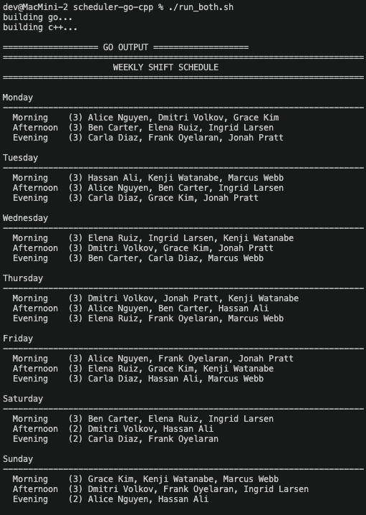
Figure 4. Go implementation, weekly schedule.
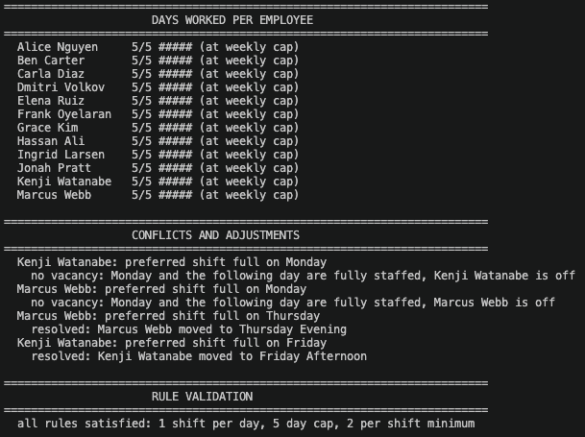
Figure 5. Go implementation, days worked, conflict resolution, and rule validation.
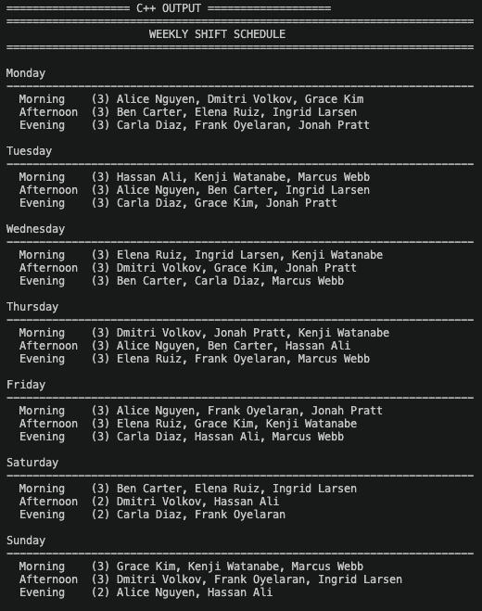
Figure 6. C++ implementation, weekly schedule.
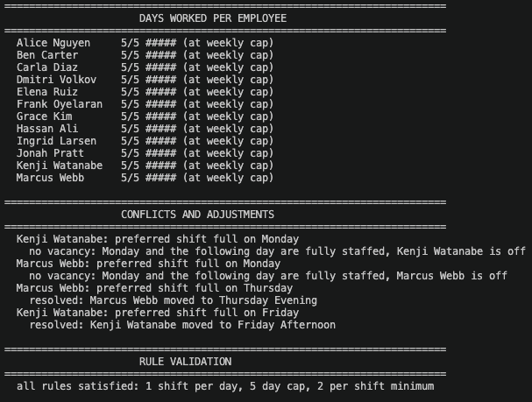
Figure 7. C++ implementation, days worked, conflict resolution, and rule validation.
Verification
The repository includes run_both.sh, which builds both implementations, runs each against the shared input, and compares the results byte for byte.
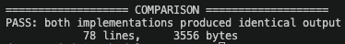
Figure 8. Automated output comparison.
Four conflicts occurred, visible in Figures 5 and 7. Two were resolved by same-day reassignment: Marcus Webb moved to Thursday Evening and Kenji Watanabe moved to Friday Afternoon. The other two, both on Monday, were reported as no-vacancy outcomes because every shift that day and the following day was already at capacity, so the company required no additional coverage.
The program also validates its own results at runtime. Three concurrent checks confirm that no employee works twice in one day, that no employee exceeds five days, and that every shift meets the two-person minimum. Both implementations report that all rules are satisfied, visible at the bottom of Figures 5 and 7.
Every employee finished the week at exactly five days, which is the weekly cap. That is expected rather than coincidental: twelve employees at five days each supply sixty assignments, and the schedule requires between forty-two and sixty-three, so the algorithm consumes the available capacity almost entirely. It also establishes a limitation worth naming. This input is close to fully subscribed, so the schedule is feasible but has little slack; a roster with fewer employees or more unavailable days would produce understaffed shifts, which the program reports as a warning rather than silently accepting.

