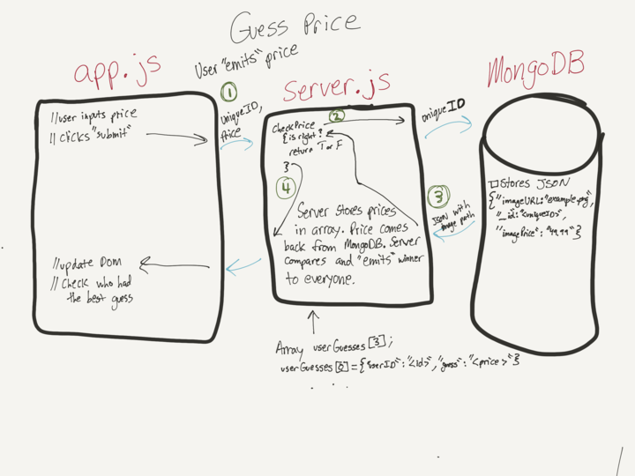

Fig1. Our MVC model

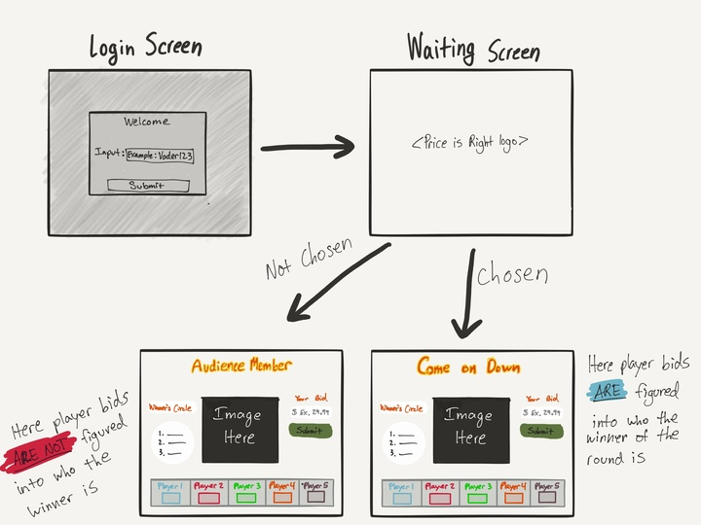
Fig2. Flow Chart 1
First, player has to log in . Then the player has to wait until game has minimum 6 players to start. We will pick 5 player randomly and one will become spectator

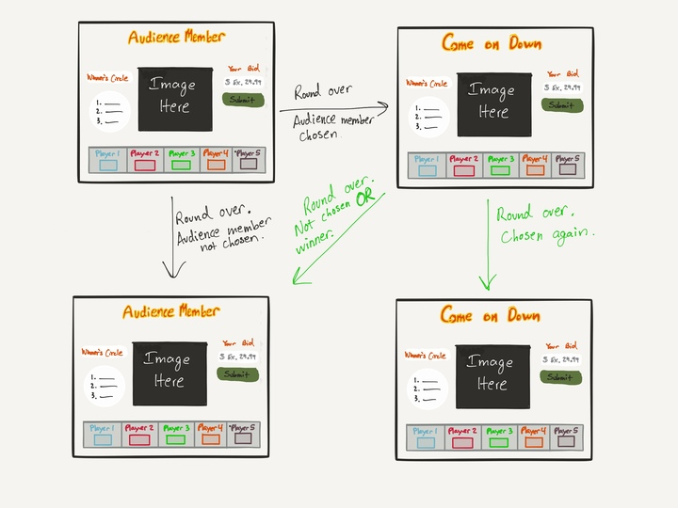
Fig 3: Flow Chart 2.

When one round is over, we display the winner of that round into the winner’s circle. He/she ( the winner) will become the spectator for the next 2 rounds. Once again, we wait for another player to join the game.

THIS IS THE ACTUAL GAME BASED ON OUR FLOW CHART AND MODEL
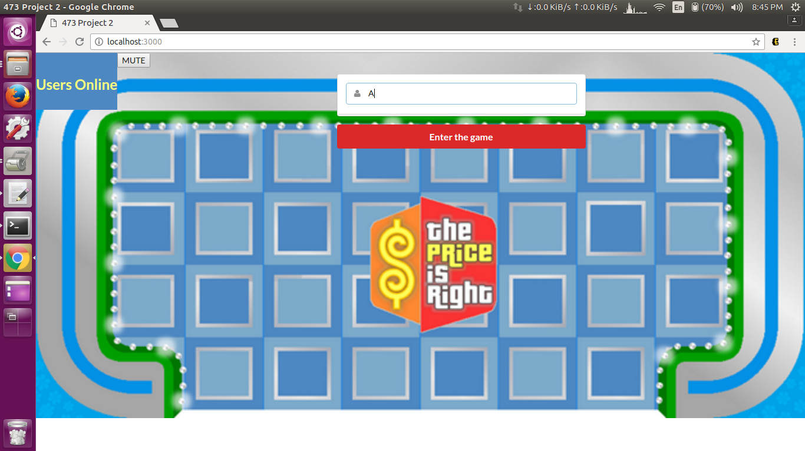
Fig4: :Log-in page

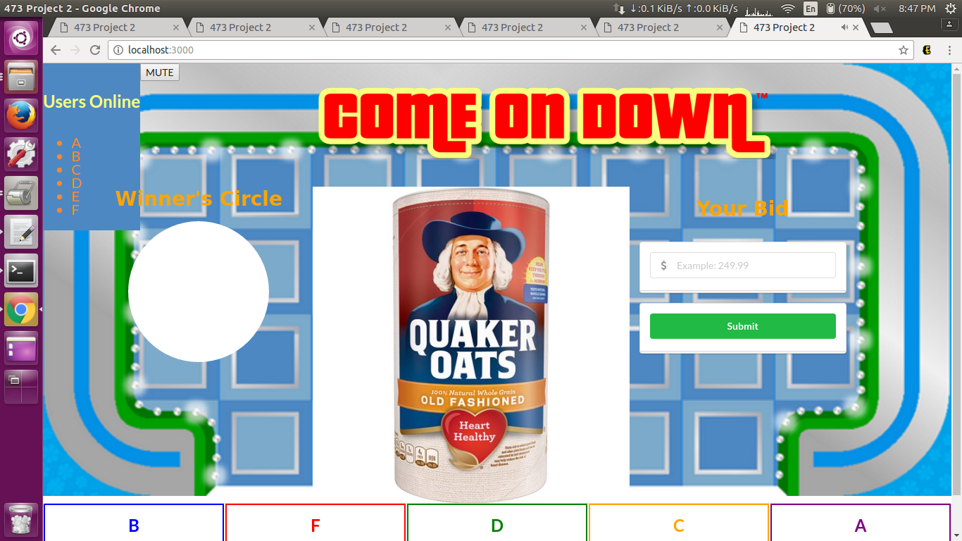

Fig5: Round 1 start when we have minimum 6 players. We picked randomly ; therefore, in this case, E is our spectator.

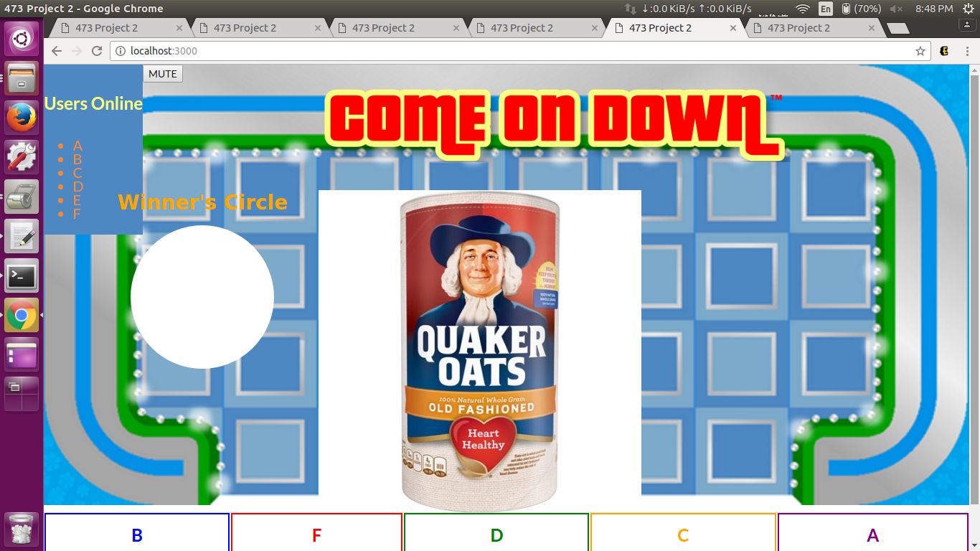
Fig 6: E is our spectator so in his view, there is no bidding box.
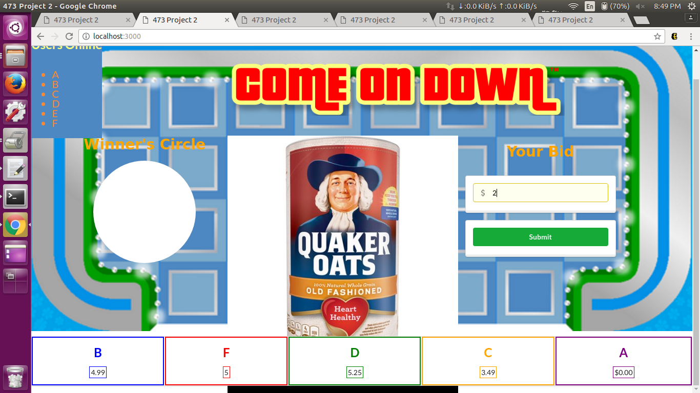
Fig 7: Display the bid of each player

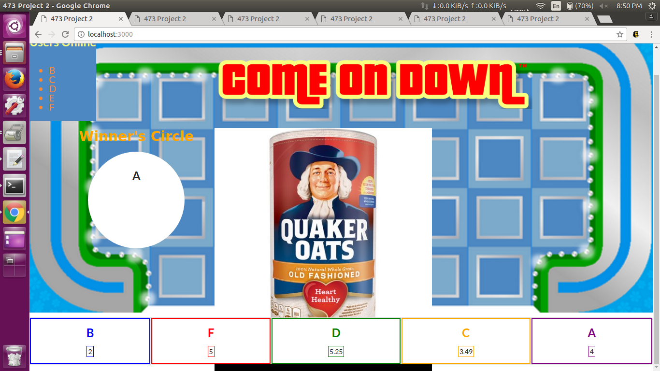
Fig 8: Round 1 got winner. Winner is A. Right after announcing A is the winner, we change the view of A to become a spectator’s view

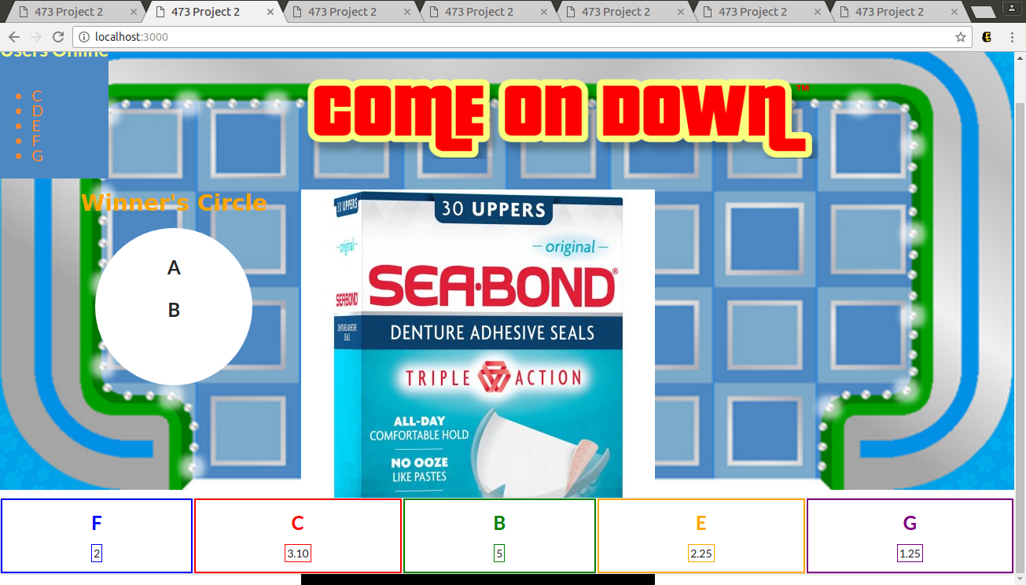
Fig 9: Round 2 starts . G joins the game. In this round, B is the winner. Once again, B’s view becomes spectator’s view

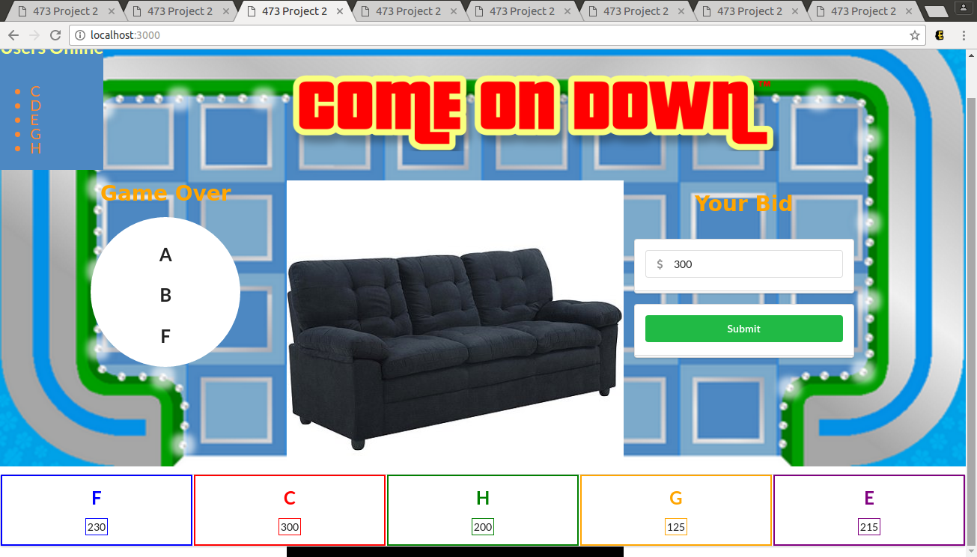
Fig 10: Round 3 starts. H joins the game. In this round , F is the winner. When we have 3 winner in the winner circle, the game is over.

