DCS-BIOS MATRIC Middleware

This documentation is preliminary and subject to change

# What is it?

DCS-BIOS MATRIC Middleware (DBMM) is an application that uses DCS-BIOS to read data from DCS combat simulator and forwards variables to MATRIC.   
This enables MATRIC users to bind control states to actual simulation state. Example let's say you have master caution button in MATRIC deck bound to appropriate variable. Once master caution goes on in simulation the same will happen in your MATRIC deck.

DBMMM is free and open source app, available at

# Wasn't this done before in MATRIC?

Yes it was, however, there was no general way of doing it and you had to make your own DCS Lua export script. Using DCS-BIOS which is de facto standard for DCS cockpit builders removes much of the complexity involved in integration DCS with MATRIC.

# Setting up DBMM

## Prerequisites

You need to have DCS-BIOS installed, for instructions – please refer to DCS-BIOS documentation

MATRIC Windows server – version 2.8.60 or higher, get it at <https://matricapp.com/#download>

You need to enable 3rd party integration in MATRIC server settings

## DBMM download

You can download DBMM here

[standalone version] – Larger download with .net runtime included

[framework dependent] – Much smaller download, but you need to have .net 8 desktop runtime installed on your PC (<https://dotnet.microsoft.com/en-us/download/dotnet/8.0>)

## DBMM configuration

DBMM is a simple app with very clear purpose so it is very simple to use if everyting else is set up

## Main screen

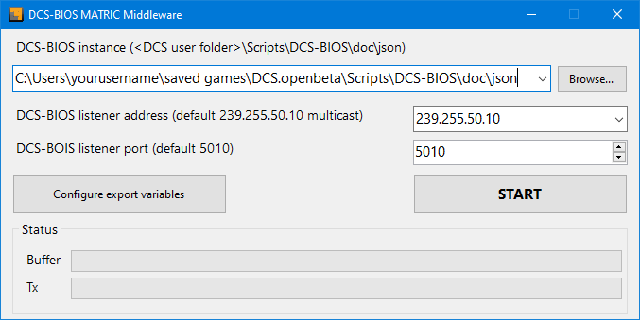

### DCS-BIOS json files path

DBMMW will try to detect your DCS-BIOS installation, usually in Saved Games\DCS\Scripts\DCS-BIOS. **The path needed for DBMM is the path to DCS-BIOS docs\json** folder where per-aircraft configuration files are located.

### BIOS listener address

By default, this is set to UDP multicast address (DCS-BIOS default) in general you won't need to change that

### BIOS listener port

By default this is set to 5010 (DCS-BIOS default)

### Start button

Starts listening to DCS-BIOS and sending updates to MATRIC.  
**It is highly recommended to configure variables before starting the process because if you don't ALL DCS-BIOS variables will be sent to MATRIC which will have negative impact on performance.**

All the DCS-BIOS related settings are saved when you click start so next time you start the app no configuration is needed.

### Configure export variables button

Clicking this button opens the variables configuration window

## Variables configuration window

This is where you can select DCS-BIOS variables that will be forwarded to MATRIC. This is per-module configuration. If you do not select a subset of variables then all variables will be exported which will negatively impact performance.

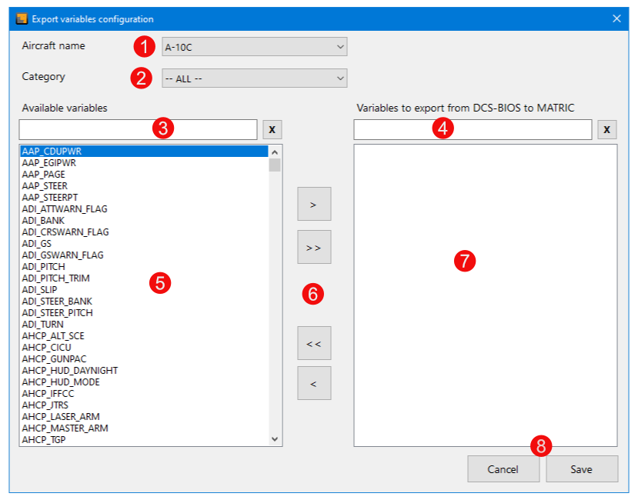

1. Select module (aircraft)
2. Select variable category
3. Filter available DCS-BIOS variables (makes it easier to find what you need when the list is large)
4. Filter variables selected for export (makes it easier to find what you need when the list is large)
5. List of available DCS-BIOS variables for selected module and category. You can select variables by clicking, Ctrl+Click and Shift+Click for multiple selection
6. Move buttons from top to bottom:
   * Add selected to export list
   * Add all variables to export list
   * Remove all variables from export list
   * Remove selected variables from export list
7. Cancel – returns to main screen without making changes, Save – saves the variables configuration and returns to Main screen