DCS BIOS MATRIC Middleware
  - User manual

About the middleware
DCS-BIOS MATRIC Middleware (DBMM) connects your DCS simulator to MATRIC. Indicators and displays on a MATRIC deck can follow the state of the cockpit. For example, a master caution indicator can light up on your deck when it lights up in the simulator.

Before you start
Install and configure DCS-BIOS for your DCS installation. Install MATRIC Server on the same PC and enable third-party integration in its settings. Restart MATRIC Server if its settings ask you to do so.

Download and install
Download DBMM from the project releases page and extract the archive to a folder on your PC. The standalone download includes the runtime. The framework-dependent download requires the .NET 8 Desktop Runtime for Windows x64.
Download DBMM
Download MATRIC
Download the .NET 8 Desktop Runtime

Quick start
- Open DBMM and check the DCS-BIOS instance folder. Use Browse if the detected folder is not the one you use.
- Leave the listener address and ports at their defaults unless your DCS-BIOS setup uses different values.
- Open Configure export variables and choose the variables your MATRIC deck needs. Save your selection.
- Click START. Load a cockpit in DCS and check the DCS-BIOS, MATRIC, and Module lines in the Status area.
- Click STOP when you want to stop the connection or change the folder, address, or ports.
Selecting only the variables used by your deck helps keep the workload down while DCS is running.

Project and license
DBMM is free and open source under GPL-3.0.
Project source and releases

Main screen
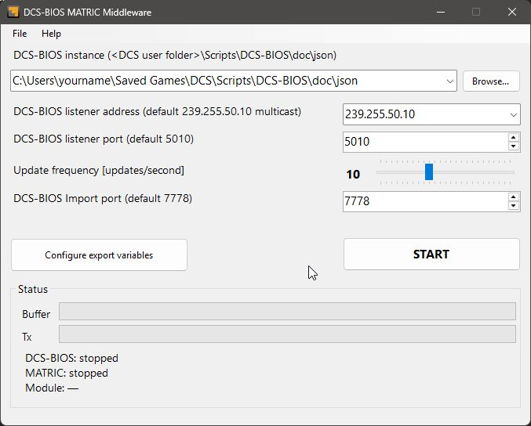
The main screen before starting the connection.
Control | What to do
DCS-BIOS instance | Choose the doc\json folder inside your DCS-BIOS installation. It contains the module definitions. The path in the screenshot is an example.
Listener address | Keep 239.255.50.10 unless your DCS-BIOS setup uses a different multicast address.
Listener port | The default is 5010. Match this to the output port in your DCS-BIOS setup.
Update frequency | Choose how often values are sent to MATRIC. You can adjust this slider while the connection is running.
Import port | The default is 7778. Match this to the input-command port in your DCS-BIOS setup.
START saves these settings and starts the connection. The button changes to STOP. Stop the connection before editing the folder, listener address, or ports.

Connection status and help
The Status area shows connection activity and the detected module. Before you click START, both connections show stopped and Module shows a dash.
- DCS-BIOS: receiving means simulator data is arriving. Waiting for stream means no recent data has arrived; check that DCS and DCS-BIOS are running.
- MATRIC: responding means MATRIC is available. Waiting / not responding means DBMM is waiting for MATRIC; check that MATRIC Server is running and third-party integration is enabled.
- Module shows the detected DCS module once a cockpit is identified. Buffer shows pending updates; Tx shows updates sent.
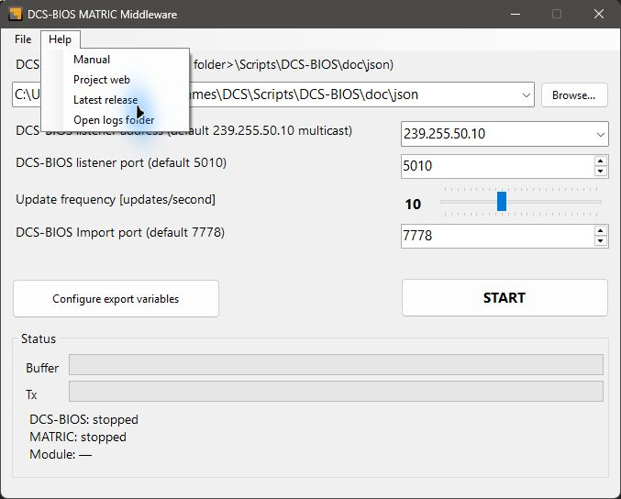
Help includes the manual, project links, and Open logs folder.
If a configuration warning or connection error appears, choose Help > Open logs folder. The newest log identifies the affected file or control. The app can continue with the definitions it successfully loaded.

Share your variable selections
Use File > Export variables list to save your selections to a file. Use File > Import variables list to add selections from a shared file, for example one supplied with a MATRIC deck. Imports add to your existing selections.

Choose variables to export
Open Configure export variables. The Aircraft name dropdown selects the module to configure. Choose a Category, or leave -- ALL -- selected to search across the module.
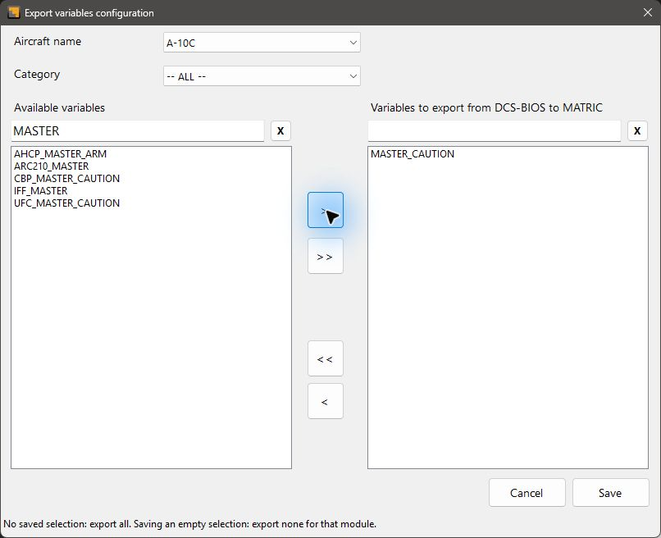
Example: search for MASTER and add MASTER_CAUTION to the export list.
Search the available variables on the left or the export list on the right. Use X beside a search box to clear it. Searching changes what is shown and keeps your selections intact.
Select variables with a click, Ctrl+Click, or Shift+Click. The arrow buttons work as follows:
- > adds the selected available variables. >> adds all currently shown available variables.
- < removes the selected exported variables. << clears the entire selection for this module.
Save keeps your changes and applies them to a running connection. Cancel discards your edits. You can configure CommonData and the metadata modules separately.
A module with no saved selection exports all its variables. To export none for a module, clear its selection with << and Save. Separately selected common or metadata variables may still be exported. The reminder at the bottom of the window explains this distinction.

