OSB Overlay by MATRIC [draft]

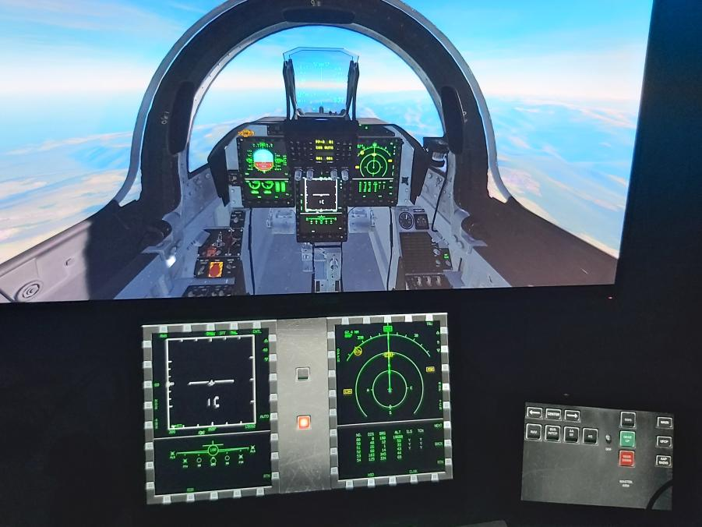

Contents

What is it? 2

How much does it cost? 2

Why? 2

How does it work? 3

Installation and setup 3

VJoy setup 3

Binding to DCS 4

Using OSB OVerlay 4

Advanced 4

## What is it?

On Screen Buttons Overlay by MATRIC is an application that draws an overlay - a semi transparent window on top of all applications with clickable buttons that act as virtual joystick buttons.

## How much does it cost?

Absolutely free, no ads, no small print, source will be made available on github

## Why?

OSB Overlay is primarily created to work with DCS (Digital Combat Simulator) multi functional display export. In DCS you can export MFD screens to secondary monitor giving you a much better view of the MFDs while you focus on primary cockpit view. However, you can not control exported MFDs but instead have to click the cockpit buttons on primary.

This is where OSB Overlay comes in: we can create an overlay with clickable buttons thus making the exported displays even more useful. If you have a touch screen monitor - it works even better - you don't have to use the mouse at all!

## How does it work?

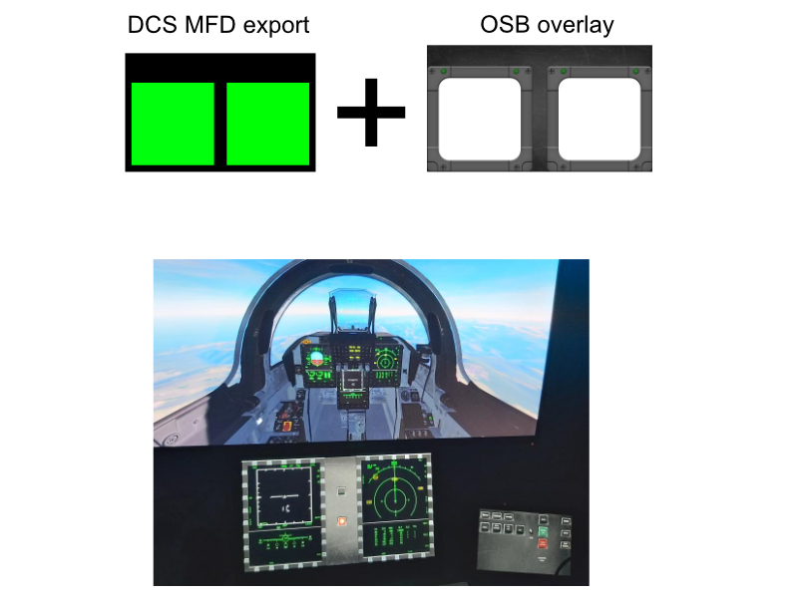

OSB overlay uses vjoy - a virtual joystick device to emulate joystick buttons. A configuation file in json format controls the overlay window size, position and buttons placement. Overlay transparency is defined by a transparent 96dpi PNG mask image.

## Installation and setup

### VJoy setup

VJoy setup is included in OSB Overlay setup and device #8 will be created by default for OSB Overlay.

**IMPORTANT:** if you have Saitek (now Logitech) HOTAS, it might stop working after vjoy installation. If that happens, unplug the device, reinstall the drivers and plug it in. It is a known vjoy issue :(

OSB overlay comes with several configurations and mask images suitable for F-18, F-16, A-10 and JF-17 MFD exports, however you might need to adjust the window size and position to correspond to your export configuration.

Configurations are set in My Documents\OSB by default. You can edit them in any text editor as they are just simple .json files.

### Binding to DCS

Simply run the OSB Overlay, open settings in DCS and bind the OSB Overlay buttons to desired DCS commands. Select the command, set focus on virtual device and press the button, just like configuring a physical joystick.

## Using OSB OVerlay

To change the active configuration you can right click on the OSB Overlay and choose "Load config" or click special loadConfig button if configured to choose the active config.

**NOTE:** You can also create a shortcut to OSB Overlay with a parameter - path to config file to start OSB Overlay with desired configuration.

To exit application, right click and choose exit or click special Exit button if configured

To reposition the window, right click the overlay window, check "Move Window" in the context menu and position it yourself (drag while holding left mouse button). New position will be saved to active configuration once you uncheck „Move Window“.

To reload active configuration (useful when editing config to see your changes) right click and choose „Reload config“ or click special reload button if configured

# Advanced

Config file structure:

VJDeviceId - vjoy device id that will be used by configuration

maskBitmap - mask bitmap to display (MFD bezel)

x - left edge of the overlay window in pixels

y - top edge of overlay window in pixels

height - Overlay window height

width - Overlay window width

buttons - a array of button definitions

Button structure consists of

joyBtnId - vjoy virtual device button id (number from 1 to number of configured buttons

imageOff - file name of the image that will be used for button when it is not pressed,

imageOn - file name of the image that will be used for button when button is pressed,

x - left edge of the button

y - top edge of the button

width - button width

height - button height

In addition to OSB virtual joystick buttons, you can optionally configure application buttons. Application buttons basically perform the same functions as right click context menu (Load config, reload config, exit application):

reloadButton: {button structure, joyBtnId ignored}

lodButton: {button structure, joyBtnId ignored}

exitButton: {button structure, joyBtnId ignored}

Example configuration:

{

    "VJDeviceId": 8,

    "maskBitmap": "2mfcd.png",

    "x": 0,

    "y": 0,

    "width": 1920,

    "height": 1080,

    "reloadButton": {

        "joyBtnId": -1,

        "imageOff": "green_sc_up.png",

        "imageOn": "green_sc_down.png",

        "x": 860,

        "y": 5,

        "width": 100,

        "height": 100

    },

    "exitButton": {

        "joyBtnId": -1,

        "imageOff": "red_down.png",

        "imageOn": "red_up.png",

        "x": 1060,

        "y": 5,

        "width": 100,

        "height": 100

    },

    "loadButton": null,

    "buttons": [

        {

            "joyBtnId": 1,

            "imageOff": "osb_up.png",

            "imageOn": "osb_down.png",

            "x": 210,

            "y": 183,

            "width": 90,

            "height": 90

        },

        {

            "joyBtnId": 2,

            "imageOff": "osb_up.png",

            "imageOn": "osb_down.png",

            "x": 310,

            "y": 183,

            "width": 90,

            "height": 90

        },

. . . OMMITTED FOR BREVITY . . .

    ]

}