**Capstone Project Background Research**

Define scope of project

Develop an application for an android phone to control a quadrotor UAV flying in an indoor environment. Application controller should be able to control the UAV to take-off, land, and fly to a specific location. The android application can send user instructions to the quadrotor via wireless communication. The quadrotor controls the rotors to fly with the aid of on-board sensors. The tilting and turning of the phone can be interpreted as the instructions to dictate the quadrotor to move. The camera on the quadrotor should be able to send the video to the mobile phone. Advanced feature would be an autonomous tracking function, which enables the quadrotor to track a target autonomously via image processing.

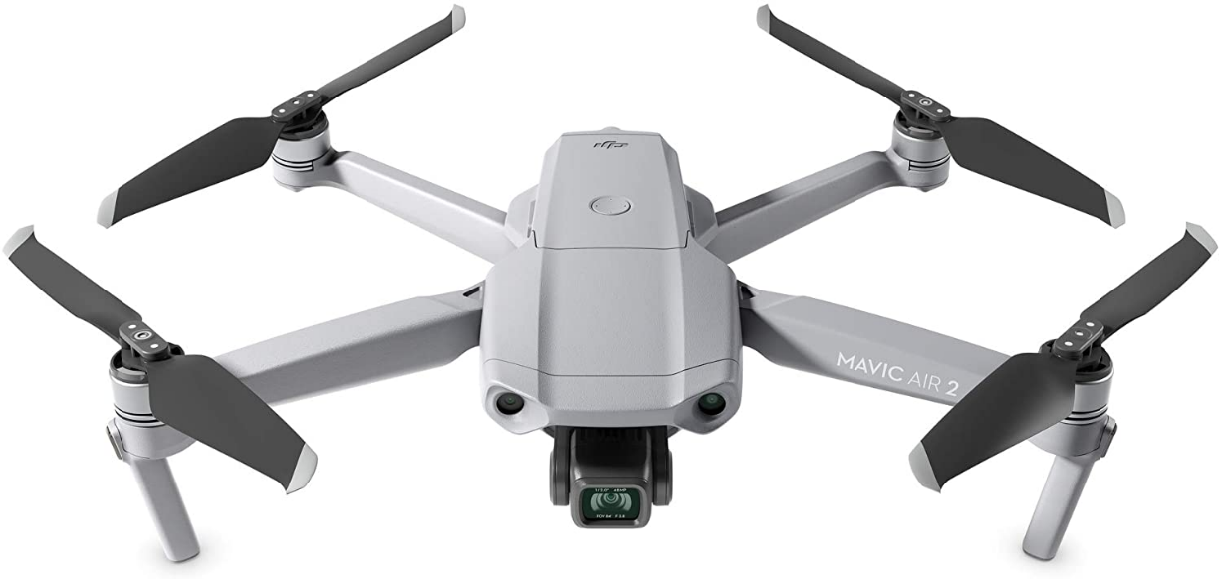

**What is a Drone**

Drones are unpiloted air or space crafts otherwise known as a UAV (unmanned aerial vehicle). Drones are flying robots that can be remotely controlled or programmed to fly autonomously. The most common type of drone is a quadcopter, which has four propellers. The drones fly using flight controllers, motors, propellers, GPS and other onboard sensors, Drones can be equipped with a number of sensors, including distance sensors (ultrasonic, laser, lidar), time-of-flight sensors, chemical sensors, and stabilization and orientation sensors. Drones require a controller, which is used remotely by an operator to launch, navigate and land it.

Drones are used in a wide range of industries serving many different purposes e.g. military use, photography, surveillance, personal use, farming, and videography [1]. Drones are useful because they do not put a pilot’s life at risk and they don’t require rest, which means they are able to fly until they need more fuel/power. Other applications of drones are monitoring storms and hurricanes, in search-and-rescue operations and in-air 3D mapping of terrains.

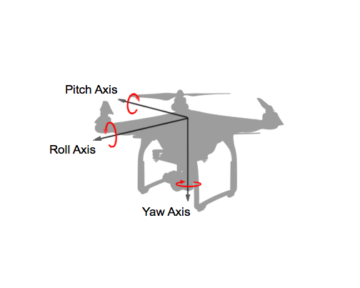**How do drones fly**

Rotation around the front-to-back axis is called roll.

Rotation around the side-to-side axis is called pitch.

Rotation around the vertical axis is called yaw.

Figure 1

Drone work by using rotors that are connected to motor that rotate blades at high speeds. One set of rotors will rotate clockwise {1,3], and the other set rotating will rotate anti-clockwise {2.4} Figure 2.

To turn in a clockwise direction, the speeds of rotor 2 and 4 are increased and the speeds for rotors 1 and 3 are decreased. To turn anti clockwise, the speeds of rotors 1 and 3 are increased and the speed for rotors 2 and 4 are decreased. To pitch forward the drone will increase the speeds of rotors 3 and 4 and reduce the speeds of rotors 1 and 2 with resulting in the net force pitching the nose of the drone down and making it move forward.

To lift off the ground the drone uses all four motors and blades to generate a net force upwards that is greater than its own weight. To hover the drone, the upward force generated by the thrust of the propellers is equal to the gravitational pull and weight of the drone.

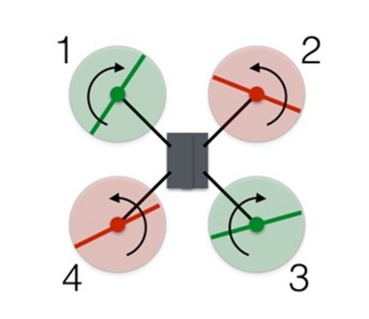

Figure 2

The drone is controlled by a pilot using a controller which has a wireless transmitter inside it. The transmitter works by alternating the voltage delivered to the motors from the battery. If the voltage in the motor is increased the propeller will rotate faster. The flight controller takes the received commands and combines it with data from the gyro to calculate what speed each motor should be set to.

Every drone has a built-in flight controller that keeps it stable. If a gust of wind tips it over, the flight controller will instantly adjust the propeller speeds to re-level it.

In recent years there has been a boom in the drone hobbyist community with many people either buying kits or building their own drones from the ground up.

The main parts of these types of drones are:

* Frame
* Electronic speed controllers (ESC)
* Flight controller
* GPS module
* Battery
* Antenna
* Transmitter and Receiver
* Cameras
* LiPo battery
* Sensors
* Ultrasonic sensors
* Collision avoidance sensors
* Accelerometer which measures speeds
* Altimeter which measures altitude

ESC are electronic circuits that controls a motor’s speed and direction. To work out the position of the drone, its uses GPS, altimeter and accelerometer simultaneously.

An onboard altimeter communicates the altitude information. The altimeter also helps keep the drone at a specific altitude. The drone can be equipped with visual sensors that can offer still or video data. The drone can be equipped with RGB sensors which can collect blue, green and red wavelengths. Some drones use obstacle detection and collision avoidance sensors with some sensors allowing drones to be able to detect in all six directions: front, back, below, above and side to side.

Flight Controllers are small board in drones which direct the RPM of each motor. The flight controller takes in input from the pilot and calculates how to direct the motors. It can contain an accelerometer and a gyroscope. The flight controller is capable of self-levelling the drone and it has different modes of flight programmed into it.

**Computer vision**

Computer vision involves the manipulation of image data. Computer vision is a field of artificial intelligence that uses digital images from cameras and videos and combines it with machine learning models to try accurately identifying and classify objects.

Computer vision trains computers to interpret and understand the visual world taking images as input and giving the output in the form of information on the object. Computer vision applies machine learning to recognise patterns for interpretation of images

Deep learning trains computers to learn on its own by recognizing patterns using many layers of processing, the machines are fed hundreds or thousands of related images to train it to recognize specific objects. Deep learning is a type of machine learning that trains a computer to perform humanlike tasks e.g; recognizing pictures, identifying speech or making predictions.

Image processing is a subset of computer vision. The computer vision framework utilizes the image processing algorithms to attempt to perform imitating of human vision

Some applications of image processing are:

* Image enhancement (Photoshop, level and contrast correction, noise reduction, removing blur and red-eye removal)
* Biometrics (fingerprints, iris scanning, handwriting and facial recognition. The biometric systems using pattern recognition)
* Surveillance: number plate recognition used on roads
* Guidance: controlling the motion of an autonomous car or drone based on imagery from a camera and other sensor

Computer vision software:

* ImageJ is a GUI-driven package written in Java. It is an open platform for scientific image analysis
* OpenCV works with in C++ and Python. An easy to use software which is multi-platform, allowing for applications to be built in both Windows and Android. It is one of the most popular computer vision libraries
* Matlab can be used to create image processing applications. It allows quick prototyping. To use Matlab you must purchase it

For the capstone drone project, one of the objectives is making the drone be able to fly autonomously reaching a desired location in an unsupervised manner without any human intervention. In recent years there has been an increase into research into the autonomously modelling and control of quadrotor [2]. Using computer vision and the embedded flight controller the drone will be able to fly autonomously in an indoor environment. [3] [4]

**R.O.S**

ROS is not an operating system, instead it is a framework that sits on top of the O.S. which allows it to abstract the hardware from the software [5]. ROS is an open source project which provides services such as low-level device control, hardware abstraction and message-passing between processes. It can be written in C++ or Python. It is a collection of tools and libraries that can be used to simplify the task of creating robot. It was originally developed in 2007 at the Stanford Artificial Intelligence Laboratory

ROS is made up four different elements

* Plumbing

-Process management

-Device drivers

* Tools

-Simulation

-Visualization

-Graphical User interface

* Capabilities

-Planning

-Mapping

-Control

-Perception

* Ecosystem

-Package organization

-Software distribution

Gazebo is a powerful 3D robotics simulator that can be used to test algorithms, design and simulate robots and train AI. Gazebo allows the user the ability to create complex indoor and outdoor environments that they can use to test out robots. Using Gazebo, a user could learn how to pilot a drone to fly in an indoor environment with objects the drone has to avoid, without fear of breaking the drone.

**Concerns**

The rise of people crafting or purchasing their own drones, the drone industry has started to boom. However there have also been some concerns that have risen with more people being able to obtain drones.

Growth in the drone market has also led to concerns of privacy and safety when it comes to drones. Drones allow users to directly fly a camera almost anywhere they want. Users can could the drone to spy on other people’s property. There are some laws prohibiting drones to fly in the certain places. Drones users have been known to fly drones in airspaces and interfere with aeroplanes [6]. Drones can crash into people and damage property. Drones fly at fast speeds and can cause nasty injuries to people if they collide with them.

References

[1] S. Bouabdallah, C. Bermes, S. Grzonka, C. Gimkiewicz, A. Brenzikofer, R. Hahn, D. Schafroth, G. Grisetti, W. Burgard, and R. Siegwart. Towards palm-size autonomous helicopters. In International Conference and Exhibition on Unmanned Areal Vehicles (UAV), Dubai, UAE, 2010

[2] E. Altug, J.P. Ostrowski, and R. Mahony. Control of a quadrotor helicopter using visual feedback. In Proc. of the IEEE Int. Conf. on Robotics & Automation (ICRA), 2002.

[3] O. Bourquardez, R. Mahony, N. Guenard, F. Chaumette, T. Hamel, and L. Eck. Image-based visual servo control of the translation kinematics of a quadrotor aerial vehicle. Robotics, IEEE TRO, 25(3) 2009

[4] S. Ahrens, D. Levine, G. Andrews, and J.P. How. Vision-based guidance and control of a hovering vehicle in unknown, GPS-denied environments. 2009

#### [5] R.Tellez (2019,Sep 20) What is ROS? [Online] Available: <https://www.theconstructsim.com/what-is-ros/>

[6] J. Antunes (2018, Feb, 21) Addressing Privacy and Safety Concerns About Drones Available: <https://www.commercialuavnews.com/infrastructure/addressing-privacy-safety-concerns-drones-percepto>