Drone Parts

Frame

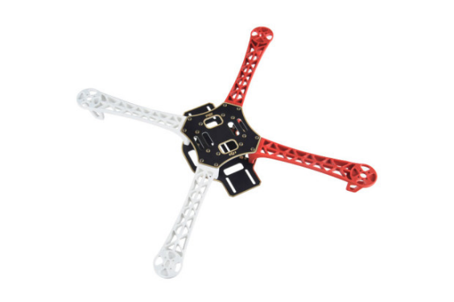YoungRC F450 Drone frame - £20.21

Motors

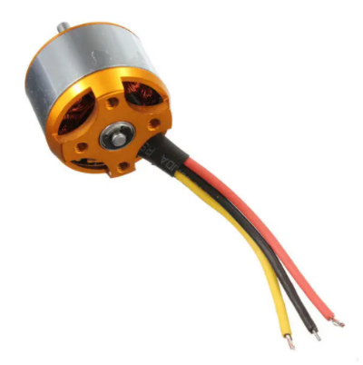4PCS Racerstar BR2212 1000KV 2-4S Brushless Motor For RC Model £18.53

ESC

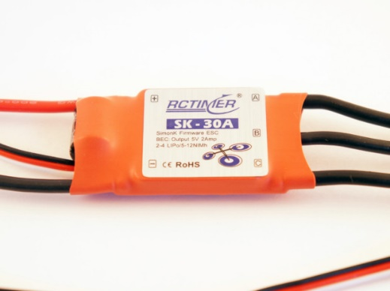4X XXD HW30A 30A Brushless Motor ESC For Airplane Quadcopter £13.21

Battery

ZOP Power 11.1V 2200mAh 30C 3S Lipo Battery XT60 Plug £11.01

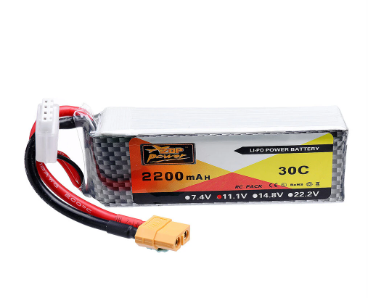

Battery Charger

2s 3s Lipo Balance Charger 15W 100-240V £17.99

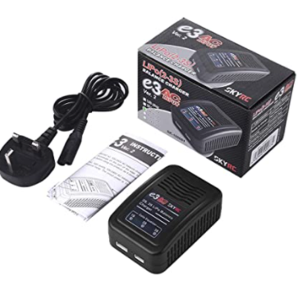

Camera

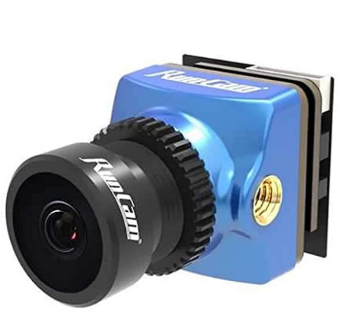9imod RunCam Phoenix 2 Nano 1000TVL 1/2" COMS Sensor 2.1mm ​(M8)​ FOV 155° 4:3/16:9 PAL/NTSC Switchable FPV Camera For RC Racing Drone £28.17

https://www.amazon.co.uk/9imod-RunCam-Phoenix-1000TVL-Sensor/dp/B08DY9LMLX/ref=sr_1_5?camp=1789&creative=9325&dchild=1&keywords=runcam+phoenix&linkCode=gs3&linkId=0eb5a6d76251b93652e6a02603d5144f&qid=1602855833&sr=8-5&tag=osclia-21

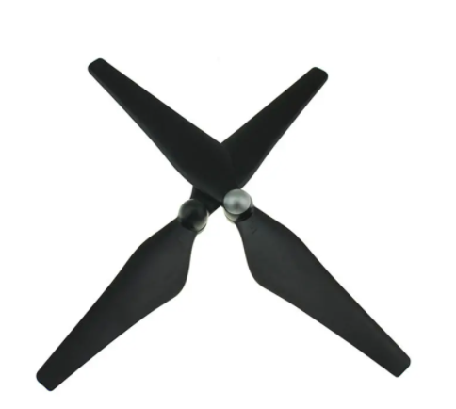Propeller

1 Pair New Upgraded 1045 Propeller CW CCW Blade £2.51

Flight Controller

Arduino and NodeMcu esp8266 . Already owned

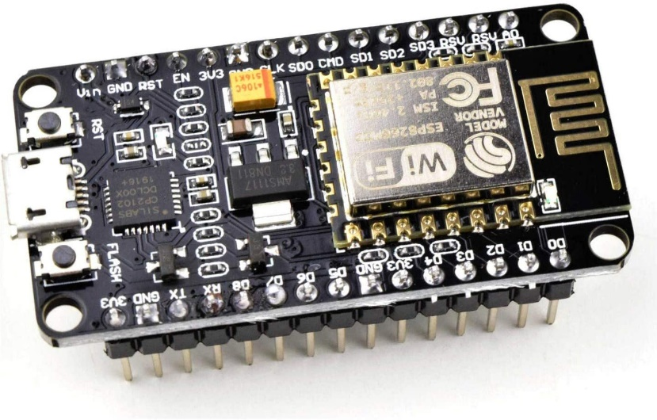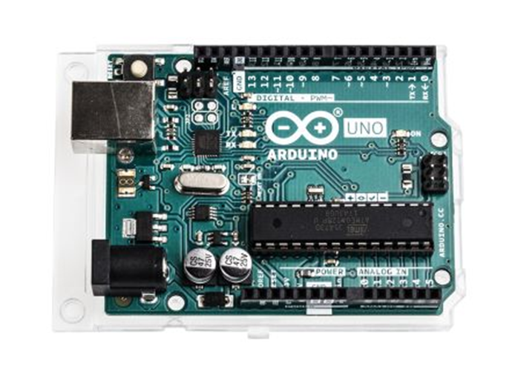

The total £136.46